RESUME
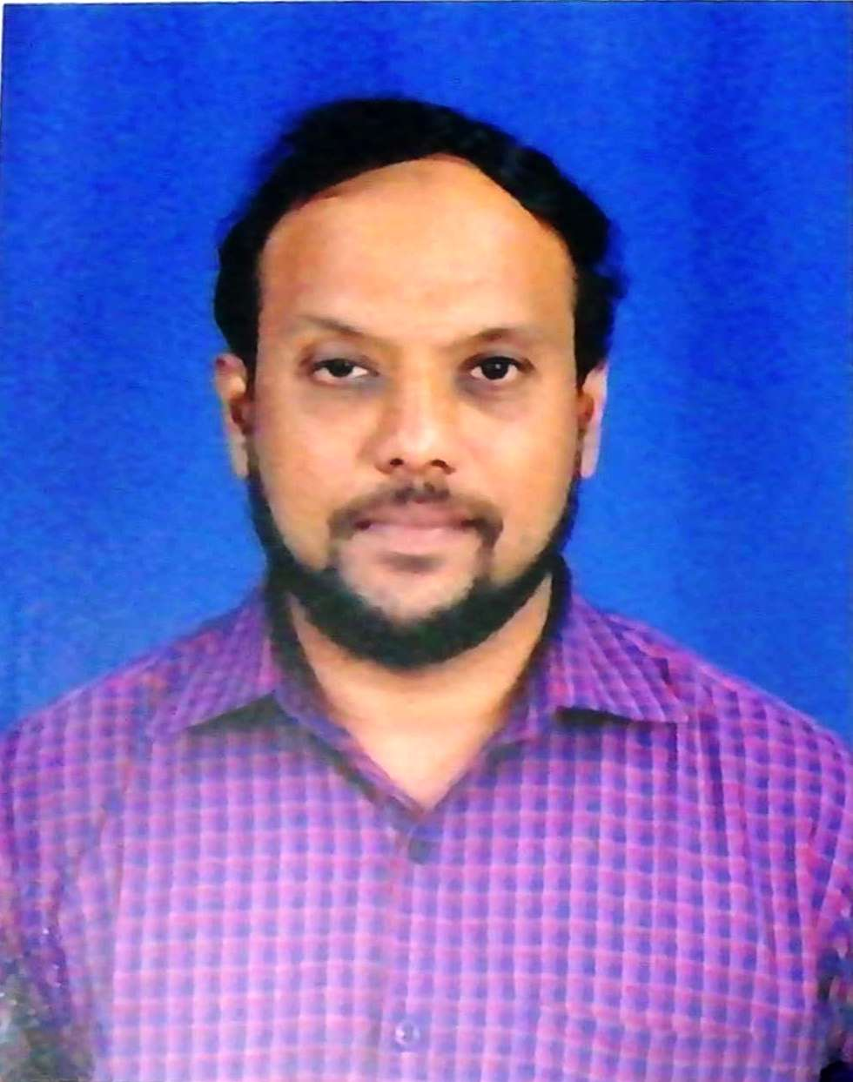

N.Mohammed Raffic

Assistant Professor

Department of Mechanical Engineering

Nehru Institute of Technology

Email: nitmohammed@nehrucolleges.com

Ph: 094898 70472, 099948 52699

Google Scholar Profile: https://scholar.google.com/citations?user=S_R635wAAAAJ&hl=en
Vidwan Profile: https://vidwan.inflibnet.ac.in/profile/260786

Objective
Seeking a challenging and rewarding opportunity in the areas of research which is inline with my academic background and to apply the acquired knowledge for the upliftment of the Society.
Education
Name of the Degree | Specialization | Year of Passing | Name of the College | Name of the University | % of Marks / Grades obtained | Class obtained
B.E., | Mechanical  Engineering | 2005 | C.S.I College of Engg | Anna University , Chennai | 67 % | FIRST
M.E., | Engineering Design (PT) | 2013 | Regional Centre , Madurai | Anna University , Chennai | 8.17 | FIRST
Ph.D  (Pursuing) | Mechanical  Engineering | - | Anna University , Chennai | Anna University , Chennai | - | Received Provisional Confirmation

WORKING EXPERIENCE
Name of the College | Designation | Joining Date | Relieving Date | Experience
 |  |  |  | Years | Months | Days
Dr.Nallini Institute of Engineering & Technology  Nehru College of Aeronautics & Applied Sciences  Nehru Institute of Technology  Nehru Institute of Technology | Lecturer  Lecturer  Assistant Professor  HoD (i/c) | 26-06-2009  18-01-2011  23-05-2011  26.10.2021 | 31-12-2010  22-05-2011  25.10.2021  Till Date | 01  00  10  0 | 06  04  05  05 | 05  04  02  02
Total |  |  |  | 12 | 09 | 23

Areas of Interest
- Additive Manufacturing
- Topology Optimization
- Computational Fluid Dynamics
- Hybrid Composites
- MCDM

Examinations
- Anna University Theory and Practical Examinations

S.No | Position Held | Semester’s
1 | Overall EMS Coordinator | Nov/Dec 2014 – Till Date
2 | Assistant EMS Coordinator | Nov/Dec 2012 – Apr/May 2014
3 | Reserved Hall Superintendent | Nov/Dec 2011 – Apr/May 2012

- State and Central Government Examinations
Acted as Centre Superintendent and SPOC for the State and Central government examinations conducted at the institute.
S.No | Date | Name of Examination | Category
1 | 28/12/2014 | Postman / Mail Guard Examination – Indian Postal Service | Central Government
2 | 14/11/2015 | Postman / Mail Guard Examination – Indian Postal Service | Central Government
3 | 31/01/2016 | Assistant Engineer Exam – TNEB | State Government
4 | 24/04/2016 | Multi Tasking Staff Examination – Indian Postal Service | Central Government
5 | 11/12/2016 | Postman / Mail Guard Examination – Indian Postal Service | Central Government
6 | 26/03/2017 | Batch Trade Apprentice – Ordanance Factory Board | Central Government

Guest Lectures / Webinars Delivered
- Presented a webinar on “Additive Manufacturing – Fused Deposition Modelling” for the students of Mechanical Engineering at SVS College of Engineering, Coimbatore on 2nd July 2020.
- Handled Two days classes on “Engineering Graphics” for the students of Government College of Engineering, Thalassery as per the syllabus of Kerala Technological University.

FDP/STTP/Workshops Attended (External)

- Attended One week FDP on “Internet of Things” conducted by NITTTR, Chandigarh from 10/04/2020 – 14/04/2020.
- Attended Online workshop on “Research Scopes in Composite Material” conducted by Chennai Institute of Technology on 14/05/2020.
- Attended webinar on “3D printing technologies and challenges” conducted by Sreenidhi Institute of Science & Technology, Hyderabad on 20/05/2020.
- Attended webinar on “Case studies on Biomedical Applications of 3D printing” conducted by Sreenidhi Institute of Science & Technology, Hyderabad on 23/05/2020.
- Attended One Day FDP on “Intellectual Property Rights and Innovation” at Chendhuran College of Engineering and Technology, Pudukkotai on 21/09/2019.
- Attended Two Days Workshop on “Hands on Training in LATEX & MATLAB” at Amrita School of Engineering, Coimbatore on 03/05/2019 – 04/05/2019.
- Attended One Week FDP on “Dynamics of Machines” at Madras Institute of Technology , Chennai from 18/06/2018 – 25/06/2018.
- Attended One Week Short Term Course on “Vibro-Acoustics” at Indian Institute of Technology , Mumbai from 04/12/2017 – 08/12/2017.
- Attended One Day FDP on “Insights in to Research” at SRM University, Chennai on 29/07/2017.
- Attended One Day Workshop on “3D Printing” at IITM Research Park , Chennai from 03/05/2019 – 04/05/2019.
- Attended Three Days Workshop on “ A Hands on Training – Engineering Simulation using ABAQUS” at Ramco Institute of Technology , Rajapalayam from 15/06/2017 -17/06/2017
- Attended One Day National Level Workshop on “Optimization and Simulation in Research” at Anna University, Chennai on 16/03/2017.
- Attended Two Days Workshop on “Hands on Training in LATEX & MATLAB” at Amrita School of Engineering, Coimbatore on 03/05/2019 – 04/05/2019.
- Attended Two Days Workshop on “NPTEL Courses” at Indian Institute of Technology , Madras from 05/04/2011 – 06/04/2011.

Workshops / Seminars Organized
- Organized One Day Workshop on “Computational Fluid Dynamics “ for the students of Mechanical and Aeronautical Engineering on 13/09/2017.
- Organized One Day Workshop on “Solidworks“ for the students of Mechanical Engineering on 12/08/2013.

FDP/STTP/Workshops Attended (Internal) – Around 20

Additional Responsibilities
- Acted as IIPC Coordinator from 2012 -2014
- Acted as Symposium Coordinator for Mechism12K
- Acted as Co- Coordinator for Polyfest 2018 – National Level Contest
- Acted as Class Advisor for 2010 -2014 , 2012 – 2016 (B Section – 7th and 8th Sem) , 2015 -2019 students on mechanical engineering

Publications
- Mohammed Raffic N, Ganesh Babu , M. Shinilnath R. A. B. Rajkumar S. RadhaKrishnan ,“Contribution Of Experimental Design And Multi Response Optimization Techniques To Optimize Diesel Engine Design And Operating Variables” , Vidyabharati International Interdisciplinary Research Journal (Special Issue), October 2021.

- Mohammed Raffic N , Ganesh Babu , Rajasekaran Saminathan , Afaf M. Babeer , Hadidi H. , Akshay Y.P. , “Experimental investigation on compression strength of EPOXY/PVC blend with different fibre glass reinforcements” , Materials Today : Proceedings , August 2021.

- Ram Kumar A.C. , Mohammed Raffic N , Ganesh Babu K. , Selvakumar S. “Static structural analysis of spur gear using ANSYS 15.0 and material selection by COPRAS, MOORA techniques” Materials Today Proceedings , April 2021 , Volume 47 , Pages 25-36.

- Gulja.S.Nair , N.Mohammed Raffic Dr.K.Ganesh Babu P.Madhan S.Radha Krishnan, “Potential Applications of IoT in Soil and Water Management System – Review”, International Conference On Innovative Agricultural Engineering And Food Technology Strategies For Profitable Agriculture (ICAEFT) , December 2020. (Published in Conference Proceedings).

- N.Mohammed Raffic Dr.K.Ganesh Babu S.Srinivasanc Dr.S.Thirumurugaveerakumar R.Bharathi Kanna , “ Experimental Investigation on Surface Roughness and Cutting Tool – Workpiece Interface Temperature for AA6061 using CRITIC and TOPSIS Techniques”, International Conference on Recent Advances in Design, Materials and Manufacturing, Materials Today Proceedings , October 2020.

- S.Srinivasan , Dr. S. Thirumurugaveerakumar , N. Nagarajan , N. Mohammed Raffic , Dr. K. Ganesh Babu, “A Review of Optimization Techniques in Machining of Composite Materials” , International Conference on Recent Advances in Design, Materials and Manufacturing, Lecture Notes in Mechanical Engineering October 2020.

- N Mohammed Raffic Dr.K Ganesh Babu Dr.S Selvakumar S.Radhakrishnan , “Experimental Investigation on the Effect of Fused Deposition Modelling Parameters for HIPS Material by Experimental Design and MRO Techniques “ , International Conference on Recent Developments in Materials and Applications , IOP Conference series – Materials Science and Engineering , September 2020.

- N.Mohammed Raffic Dr.K.Ganesh Babu Dr.S.Selvakumar S.Radhakrishnan K.Hari Prasanth , “Mono Optimization of Fused Deposition Modeling Parameters for HIPS Material by Designed Experiments” , International Conference on Recent Developments in Engineering , Danish Ahamed Institute of Technology , July 2020.
- S.Selvakumar, B. Ganesh Babu, N.Mohammed Raffic, K. Ganesh Babu, “
Experimental Investigation on Mechanical Behavior and Microstructural Characterization of AA7075 Reinforced with TiB₂ Particles Produced Via Stir Casting Process”, International Research Journal of Engineering and Technology (IRJET) Volume 7, Issue 7, July 2020.

- Rosy Subha Hannah.R Mohammed Raffic.N Dr.K.Ganesh Babu Sreeshin M Anthony Mario Rozario , “Study on Various Types of Nose Cone Profiles at Supersonic Speed through Analytical, Experimental and Numerical Simulation Methods “ , Volume 14 , Issue 6 , 2020, pp 2651 – 2675.

- S.Srinivasan , Dr.S.Thirumurugaveerakumar , N.Mohammed Raffic , Dr.K.Ganesh Babu “ Mono and Multi Response Optimization of End Milling Parameters for AA6061 by Taguchi based GRA and TOPSIS Methodology”, Journal of Xidian University , Volume 14 , Issue 6 , 2020, pp 137-166.

- N.Mohammed Raffic , Dr.K.Ganesh Babu, Arjun.C , AshiqNowfel, “Pilot Testing of FDM Samples by Taguchi’s L₄ Orthogonal Array and Multi Response Optimization using GRA and DEAR Approaches” , , International Research Journal of Engineering and Technology , Vol 7 Issue : 05 , May 2020.

- S.Radhakrishnan , M.Pichumani ,Mohammed Raffic.N, Dr.K.Ganesh Babu, “Multi Response Optimization of Hard Turning Process Parameters for OHNS Steel by Taguchi Based Grey Relational Analysis and Assignment of Weights Method” , International Research Journal of Engineering and Technology , Vol 7 Issue : 05 , May 2020
- Allocious Britto RajKumar.R, Mohammed Raffic.N, Dr.K.Ganesh Babu,Vignesh.V, “Comparative Study on Effective Turbulence Model for NACA0012 Airfoil Using Spallart – Allmaras as a Benchmark”, International Journal of Trend in Scientific Research and Development”,Volume - 4, Issue - 3(APRIL-20).

- T.Banu ,Dr.K.Ganesh Babu, N. Mohammed Raffic, A. J. MahaBoopBadhusa , “Experimental Investigation on Mechanical Behavior of Banana, Coconut and Glass Fibre Reinforced Composites”,International Journal of Scientific Research and Engineering Development, Volume 3 Issue 2, Mar-Apr 2020.

- S.Selvakumar , Dr.B.GaneshBabu , N. Mohammed Raffic , Dr.K.Ganesh Babu ,“ Experimental Investigation on Effect of FSW Parameters on Hardness and Microstructure of AA 6061 and AA 5083” , International Journal of Research in Engineering, Science and Management, Volume-3, Issue-2, February -2020.

- T. Banu, Dr.K. Ganesh Babu, N. Mohammed Raffic, A. J. MahaBoopBadhusa , “Investigation On Drag Force Reduction by Aerospikes Using CFD”, International Journal of Research in Engineering, Science and Management, Volume-3, Issue-2, February -2020.

- N.Mohammed Raffic, Dr.K. Ganesh Babu, S. Selvakumar, AllociousBrittoRajkumar , “Experimental Investigation of Gyroscopic Couple by Response Surface Methodology”,International Journal of Research in Engineering, Science and Management, Volume-3, Issue-1, January-2020

- N.Mohammed Raffic, Dr.K.Ganesh BabuP.Madhan, “Application Of Taguchi’s Experimental Design And Range Analysis in Optimization Of FDM Printing Parameters For PET-G, PLA and HIPS” , International Journal of Scientific & Technology Research Volume 8, Issue 09, September 2019, ISSN 2277-8616 (SCOPUS INDEXED)

- C. Shobha , Dr. K. Ganesh Babu ,N.Mohammed Raffic, “Optimization of Turning Process Parameters for EN24 Steel Alloy using Experimental Design” , International Journal of Trend in Scientific Research and Development, Volume: 3 , Issue: 3 , Mar-Apr 2019.

- N.Mohammed Raffic , Dr.K.Ganesh Babu , Arjun Kumaran , Kiran G.R , “Parametric Optimization Study of ABS Material Using FDM Technique for Fatigue Life Prediction”,International Journal of Research in Advent Technology, Vol.6, No.11, November 2018.

- Mohammed Raffic.N, GaneshBabu.K, ArumKumar.K.N,“Design Evaluation and Optimization of IC Engine Connecting Rods – A Review”, International Journal of Trend in Scientific Research and Development”,Volume - 2, Issue - 3(MAR-18), PP 88-96.

- Mohammed Raffic.N ,Ganesh Babu.K ,ArunKumar.N , “ Study of Connecting Rod Behavior and Analysis Methods – Review”, International Journal for Research & Development in Technology” , Volume-9,Issue-1(JAN-18) ISSN (O) :- 2349-3585.

- N.Mohammed Raffic , Dr. K.Ganeshbabu , ManojKannan.M , Arul Mani.G , NandhuKrishnan.R , Midhuvin George, “Effect of FDM Process Parameters On Vibration Properties Of PET-G and ABS Plastics”,International Journal on Mechanical and Production Engineering Volume 3: Issue 1: March 2017, pp 28 - 38

- N.Mohammed Raffic , Dr. K.Ganeshbabu , Palaniappan P. L , RajeshKannan P , Santhanabharathi N S , Venkatramanan S “ Effect Of FDM Process Parameters in ABS Plastic Material”, International Journal on Mechanical and Production Engineering, Volume 3: Issue 1: March 2017, pp 14 - 23.

Journal Peer Reviewer Roles
- InSc – Journal of Mechanical Engineering
- Open Journal of Optimization
- Advances in Science, Technology and Engineering Systems Journal
- World Journal of Engineering and Technology
- Materials Science and Applications

Awards & Recognitions
- Received Young Researcher Award from Institute of Scholars (InSc) , Bangalore for the Month of July 2021.
- Awarded Overall Coordinator – EMS during ASPIRE 2015
- Certified for Best Library Utility for the year 2018 – 2019.
- Received Certificates and Cash awards for achieving high Pass Percentage for different subjects.

Personal Details
Date of Birth: 10th Feb 1984
Age: 38
Father’s Name: Mr.M.Noor Mohamed (Late)
Languages Known: Tamil, English
Martial Status: Married

Declaration:
I hereby declare that all the above information furnished by me in this resume is correct to the finest possible extent till date.
(N.Mohammed Raffic)

