Dr Rekha Maitra-Doctor of Philosophy in Tourism and Hospitality (PHDTS), IGNOU
Member-National Rural Tourism Council, Team Leader- Capacity building WICCI
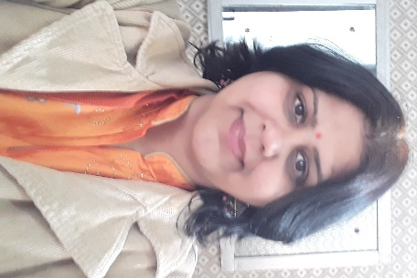
Dr Rekha is an experienced faculty in Hospitality and Tourism Teaching. She is working as an Associate Professor in Bachelor in Travel &Tourism (BTTM) department at DAV Centenary College, Faridabad. She worked as an Adjunct Faculty for B. Voc TTM with Jai Hind College, Mumbai, 2020-2021. She is associated with IGNOU, U.O.U., Galgotias, Amity University, and IHM as Paper Setter and Examiner.
Rekha worked with leading colleges of Hotel Management in Delhi and NCR for 18 years. She was felicitated with a certificate of appreciation for ten years of service with MREI on 1st January 2020. She has been conducting Webinars for reputed Universities, i.e. IEC University, Greater Noida, DY Patil University, Mumbai, SVSU, Gurugram, IISM Ranchi, and Deewan Institute of Hotel Management, and Meerut as an Expert.
She was also invited by Sunder deep Group of Institutions, Ghaziabad and Jaypee Siddharth, for an Expert talk. She has made 19 publications in Journals, Books, and Magazines. She received the Indian Hospitality Congress Award, i.e., Aspiring Researcher of Tourism and Hospitality 2014 Award. She is a Life Member of the Indian Hospitality Congress, Indian tourism Hospitality Congress and Professional Housekeeping Association in the Individual category.
She is on the Editorial Board of ARC (International Journal of Research in Tourism and Hospitality (IJRTH) and Asian Mirror International Journal of research. She rendered services to Tata Mc Graw Hill Publications, Oxford Publications, and Sage Publications as a Book Reviewer.

