Short Bio-Data
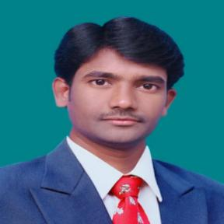
Dr. Guntha Karthik
Associate Professor, Stanley College of Engineering and Technology for Women, Abids, Hyderabad.
Executive Officer, Eudoxia Research Centre
Mobile.No:9052611677/8596956466
Email: gunthakarthik@rocketmail.com

Dr Karthik, Completed B.Tech and M.Tech from Jawaharlal Nehru Technological University, Hyderabad. Dr. Karthik completed his Ph.D. under the supervision of Prof Singam Jayanthu, (Former Scientist of CSIR-CIMFR & NIRM) from NIT Rourkela during 2013-18. He has published various Technical papers in 16 International and 5 National Journals. Also, he presented papers in 12 International conferences and 24 National conferences Published one Patent. Research areas of interest include Landslides, Slope Stability, Internet of Things, Wireless Sensor Networks, and soft-computing. He was conferred with Young Scientist-2019 organized by International Association of Research and Development organization (IARDO) and Homi J Baba Award 2020 by Eudoxia Research Centre. He worked as Assistant Professor in Electronics and Communication Department at K L University, Vijayawada, from June 2018-June 2019. Dr Karthik is also a member in various Professional bodies such as UACEE, IAENG, IDES, IFERP, IETA and ASR. He is also extending his services as an Editorial Board member in various international Journals Such as SCIREA Journal of Electrics, Communication and Journal of Advances in Wireless Communications and Networks etc. He is also extending his services as Executive Officer and Associate Research Professor for Eudoxia Research Centre, Global General Secretary of International Electronic Device Development Association (IEDDA) and Reviewer for the AICTE Student Learning Assessment (SLA) project in Emerging Area (IoT).

