CURRICULAM VITAE
KAVITA GAUTAM
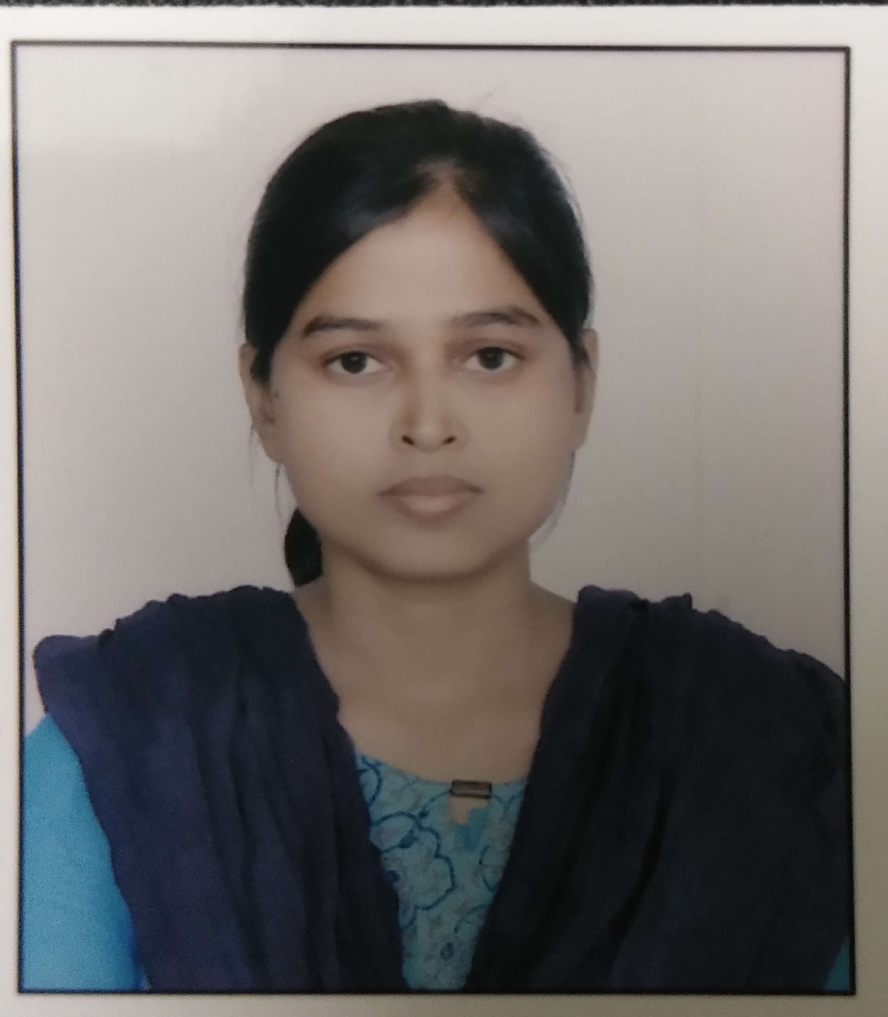
Address : Vill.–Chandipur, Post-Madhoganj,
Dist- Hardoi- 241302
Mob. No. : +91- 8924922367, +91-8299611633
E.mail Id : kavita52526@gmail.com
Career Objective:
To work in an intellectually motivated environment in an organization which shall offer challenges to solve unstructured problems and set up better system. An environment where I can put into creative use of my ability and experience so as work progressively to accomplish the company’s objectives and subsequently attain for myself higher responsibility levels.
Academic Qualification:-
Presently Working as an Assistant Professor in the Department of Social Work at Prof Rajendra Singh (Rajju Bhaiya) University, Prayagraj
CCC : Qualified in September, 2018
Ph.D. Status : Ph.D. (Submitted) from Department of Social Work, University of
Lucknow, Lucknow.
Fellowship : Rajiv Gandhi National Fellowship (UGC)
UGC NET : Social Work June 2013
Post-Graduation : Social Work, from University of Lucknow in 2013 First division.
Graduation : Social Work, B.A.(Hons.) from University of Lucknow in year 2011 First division .
Intermediate : Physics, Chemistry, Biology, English, Hindi. From U.P. Board in year 2008 first division.
High School : Mathematics, Science, Social science, English, Hindi, Art from U.P. Board in year 2005 second division.
Three Month Computer Certificate (April, 2010) in Computer Application from Computer
Training Institute (CTI), Reserve Police Lines Lucknow.

Publications:-
- Research Paper “Role of Communication in HIV/AIDS Prevention”publish in Socio-Economic Perspective Journal. (ISBN No. 2321-5607 with Page No. 67 to 75)
- Chapter “MahilaUtpidanRokane me Panchayati Raj SansthaokiBhumika” publish in book “BhartiyaSamajVanchanavamSamaveshan” writer Dr.Arun Kumar Singh. (ISBN No. 978-83-80550-46-6 with Page No. 430 to 455)
- Research Paper “Problems and Challenges for women at workplace - A study on Working Women at shopping malls in Lucknow” publish in International Journal of Social Science and Economic Research Journal. (ISBN No. 2455-8834 with Page No. 6215 to 6231) Dated : 30-09-2019

Extra Activity:-
- International Workshop on publishing in World Class Journals, dated 8-10-2015, Departmentof Business Administration Faculty of Commerce University of Lucknow.
- 3rd Indian Social Work Congress 2015, “Community Engagement Social Responsibility
And Social Work Profession, dated 24-10-2015 to 26-10-2015, Department of Social Work Jain Vishwa Bharti Institute Ladnun, Rajasthan. I presented paper on “Role of Communication in HIV/AIDS Prevention”.
- National Seminar on “Sexual Harassment of Women at Workplace in India : Emerging Perspective and Issue”, dated 12-13 March, Organised by Dr.Rajendra Prasad Memorial Girls Degree College, Lucknow.
- 4th Indian Social Work Congress, dated 22-24 October 2016, “Social Development and Social WorkProfession” Department of Social Work, Mahatma Gandhi KashiVidyapith Varanasi. I presented paper on “Bharat me Gair Krishi Rojgar me Mahilao ki Badhti Hissedari ”.
- Research Methodology Workshop 20-26 December 2016, “Qualitative and QuantitativeAspects of Research Methodology” Department of Sociology, Lucknow University, Lucknow
- XXX Annual National Conference of Indian Society of professional Social Work 9-11February 2017 “Social Stress, Resilience and Mental Health” Department of Psychiatry, GMCH Chandigarh. I presented paper on “Stress Management at Workplace”.
- National Seminar of “Gender Equity and Empowerment of Women, dated 17-18 March, 2017 Organised by Department of Social Work, University of Lucknow. I presented paper on “Need for Gender Equity in India for Overall Development of Women”.
- Participate in “Youth Conclave on eve of World Hepatitis Day” on 27 July 2017 at University of Lucknow.
- Participate in National Workshop on Research Methodology 21-27th, August 2017 organised by Department of Humanities and Social Sciences MNNIT Allahabad.
- Participate in Seven Days Workshop onData Analysis Using SPSS,10-16th, October 2017 organised by Department of Statistics,University of Lucknow.
- Participate in “Youth friendly Health Services” on 31Oct to 4th November and 6 November 2017 at University of Lucknow.
- 5thIndian Social Work Congress 2017,Social Work Profession and Social Realities: Responses and Ripostes, dated 10-12 Nov 2017, Department of Social Work SreeSankaracharya University of Sanskrit, Kalady, Kerela. I presented paper on “Problems and Challenges faced by Working Woman at Workplace (In the context of security) A Study on Working Women in Shopping Mall of Lucknow”.
- Paper Presented in International Conference on Vision 2022: A New India, Dated 27-28 January 2018, Faculty of Commerce, University of Lucknow, Lucknow. I presented paper on “Challenges of Women in Higher Education”.
- Paper Presented in National Seminar on Human Security in India: Challenges and opportunities Dated 10-11 February,Department of Sociology, Mahatma Gandhi KashiVidyapith, Varanasi. I presented paper on “Status of Violence against Pregnant Women in India”.
- Participate in “Inter-Disciplinary Workshop on Women’s Empowerment” on 8th March 2018 at University of Lucknow.
- Paper Presented in National Conference on Jal Sarakshan: Vartman Chunautiya evam Samadhan, Dated 22nd March 2018, Department of Social Work, University of Lucknow, Lucknow. I presented paper on “Effects of Water Pollution on the Environment and Human Life”.
- Participate in Workshop on Gender Justice held 08 August to 15 September 2018 Department of Social Work, University of Lucknow, Lucknow.
- 6thIndian Social Work Congress 2018, Human Development and Social Inclusion: Imperatives for Social Work Education and Practice, dated 01-03 Nov 2018, Department of Social Work University of Delhi. I presented paper on “Work Life Balance among Women in India”.
- National Conference on “Violence against Women: Prevalence, Provision and Wayout dated 29-30 March, 2019 Organised by Department of Social Work, University of Lucknow. I presented paper on “Technology related Violence against Women”.
- 15 days work experience as volunteer ship in PRATHAM NGO in year 2009
- National Institute of Public Cooperation and Child Development Regional Centre,
Lucknow, Workshopof 2 days.
- Participate Program “Rally & Road Show, World AIDS Day2011” NGO’s from Family
Planning Association of India Lucknow Branch.
- Participate in 5 Days Training Program “Ministry of Youth Affairs & Sports, Govt. of
India” NGO’sfromNehru Yuva Kendra.

- Participate as a Resource Person on “Development of Field Work Manual-Cum-Journal” in Department Of Social Work at Mahatma Gandhi Kashi Vidya Pith, Varanasi, Dated- 01 -05 October 2019.
Hobbies:
- Reading Books, Listening to Music, Writing Poems

Personal Profile:-
Date of Birth : 15th Jul 1991
Gender : Female
Father’s Name : Late Sri. Roopnarayan
Mother’s Name : Mrs. Dayavati
Marital Status : Single
Language Known : Hindi, English
Nationality : Indian

Strengths:-
- A person with good communication and interpersonal skills.
- Intuition for hard work and learning new things
- Able to work under pressure of deadlines.
- Competence in the chosen field of interest.
- Good Reasoning and Analytical ability
- Highly motivated, flexible and adaptable

I here by declare that all the statements made by me in this application are true to the best of my knowledge and belief.
Date-
Place- Prayagraj
(Kavita Gautam)

