**REMOTE CONTROLLED FLOOR MOPPING MACHINE**

|  |  |
| --- | --- |
| Abstract  One of the regular daily tasks is cleaning the floor of dust. Not just at home, but also in workplaces or retail establishments, this practice occurs. There are times when other tasks are neglected because cleaning up after dust takes a while. In order to overcome this problem, we are working to create a floor cleaning robot that can remotely travel, remove dust, and polish floors. This floor cleaning machine was created with basic cost and effort reduction, environmental friendliness, and user-friendliness in mind. The machine will be made of straightforward construction and run by electricity. This work has great potential to advance humankind's way of life. A brief overview of the literature on remote control floor mopping machines has been done in this essay. The introduction to floor cleaning machines is presented in the first section. The literature review on this topic is presented in the second section, which is followed by a conclusion and the sources used for the literature study.  Keywords: Arduino Uno, Bluetooth, Remote Controller, Mop, Clean, Cost-Benefit, Motor, PVC, Wheels | **Authors**  **Riazul Zannah**  Student  Department of Mechanical Engineering  Jain Deemed-to-be University  Bangalore, India.  [riazul9242@gmail.com](mailto:riazul9242@gmail.com)  **Muhtasim Zaman**  Student  Department of Mechanical Engineering  Jain Deemed-to-be University  Bangalore, India.  [muhtasimzaman@gmail.com](mailto:muhtasimzaman@gmail.com)  **Sonat Ray**  Student  Department of Mechanical Engineering  Jain Deemed-to-be University  Bangalore, India.  [sonatrayemu@gmail.com](mailto:sonatrayemu@gmail.com)  **Dr. Nagraj Patil**  Associate Professor  Department of Mechanical Engineering  Jain Deemed-to-be University,  Bangalore, India.  [nagaraj.patil@jainuniversity.ac.in](mailto:nagaraj.patil@jainuniversity.ac.in) |

1. INTRODUCTION

The market has remote controlled floor mopping machines. Unfortunately, all the devices are way much costly. The cheapest available floor cleaning machine comes at around 21,000 rupees. This is not easy for all the people to afford a floor cleaning machine. But a floor cleaning machine is very much important for every house. It is very difficult to clean the floor of the whole house regularly for a person. Sometimes it is seen that housewives who work a lot household works fall into serious injuries due to heavy work load. Cleaning floor makes heavy damage to the hips and later it becomes a risk for life. Considering all these things, we have planned to develop a floor cleaning machine which can mop the floor as well as clean the floor with detergent, and the most unique part where we have paid the main attention is the cost. We are successful to develop a machine for use under 10,000 rupees. Now, every middle-class family can afford a personal floor cleaning device. It will reduce the hard work for a person whereas increase the work output. It will clean the whole floor itself. We just have to control the device either with remote or our smartphone. We have used Arduino Uno, Bluetooth module, IR sensor, dual motor driver module, servo motor, submersible mini water pump, 12V rechargeable battery and some more other important parts to it. This is just a prototype. We will add more sensors and parts depending on the needs.

1. LITERATURE SURVEY

This section covers the earlier research that was used in the optimization process. A few carefully chosen surveys have been highlighted here out of many case studies:

**R. Senthil Kumar et al [1]** have introduced Clean-bot which is a floor cleaning robot that can be operated by a smartphone. It uses a set of instructions from the phone to automatically clean a dirty floor. The device exchanges commands with the Arduino UNO microcontroller using Bluetooth technology using an HC05 Bluetooth module.

**Mohd. Shahbaz Khan et al [2]** have said that the primary goal of this research is to automate a labor-intensive task because cleaning may be harmful to one's health and demands a lot of patience and labor from many people. Cleaning also takes a lot of time.

**Nikhil Murlidhar Chopade [3]** has mentioned this project is quite helpful in our daily lives. Anyone may use this machine easily because it is very simple to run and build. To shorten the cleaning time, this floor cleaning machine has a damp cotton mop, swiping brushes, wipers and a vacuum cleaner. This computer is also reasonably priced in its entirety.

**C.R. Balamurugan et al [4]** made a study and this study has provided a thorough assessment of the technical benefits that have aided a variety of real-world situations. For the convenience of the majority of the population, who are quite busy with their duties. As a result, the goal of producing a floor cleaner has been developed.

1. METHODOLOGY

Project construction is simple and effective. Price is less compared to other available devices. The machine is very easy to use. The machine consists of some hardware which are very easy to get from market and not much costly as the target is to build a budget friendly gadget.

1. Arduino Uno: Arduino Uno is the main part of our device where we have completed all our coding. People can use Raspberry pie also to code the device. This board is very easy to code and make your device run. It can be coded to control the device using a remote or with our smartphones with the help of Bluetooth-module. Better to use the latest model always as technology is getting advanced in every aspect day by day.

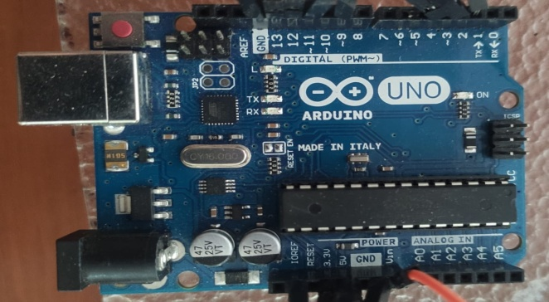

**Figure 1:** Arduino UNO

1. Batteries : We are using a 12V sealed rechargeable battery. This is a lead battery. Batteries with different Ampere can be used in this device depending on the work load we wish to put on the device. It is mandatory to check if the battery has the correct power supply to different electric parts or not. Otherwise, many system difficulties may occur.

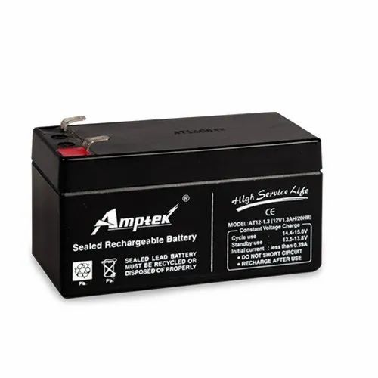

Figure 2: Batteries

1. DC Motor : We have used three DC motors in our prototype. Two DC motors to run two wheels on the back and the other is to run the Propeller attached on the back top side of the prototype. We can attach DC Motors of different rpm regarding our needs. Here we have used 100 rpm and 60 rpm motors. 100 rpm for wheels and 60 rpm for the propeller.

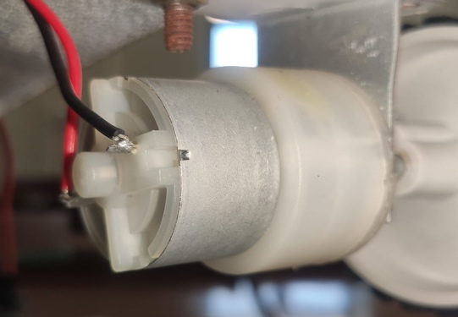

**Figure 3:** DC Motor

1. Dual Motor Driver Module: We have used a dual motor driver module to spread the required voltage to different parts of the device as different parts run at different voltage. For this gadget, dual motor driver module is a mandatory component.

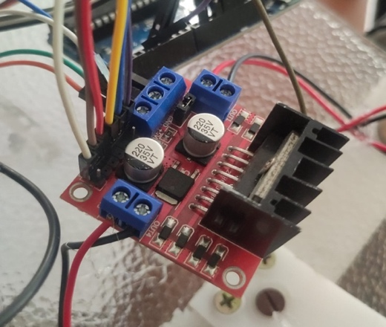

**Figure 4:** Dual Motor Driver Module

1. Wheels:We have used two 360-degree mini wheels in the front and two 3.5cm radius wheels on the back side of the vehicle. These wheels have good grips so that it can have good friction with the land and those 360-degree mini wheels help to move on any direction easily with less friction so that device can consume less power.

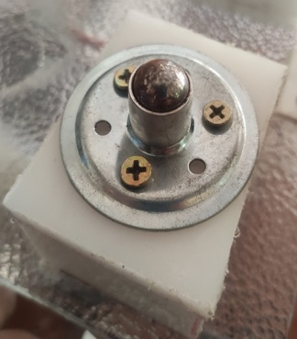 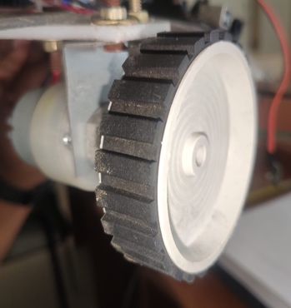

**Figure 5:** Wheels

1. Infrared IR Remote: An IR Sensor is used here to control with the remote. This remote controls the wheels of the device to move and rotate the way we wish the device too. We can control this device with our smartphones also using Bluetooth-module.

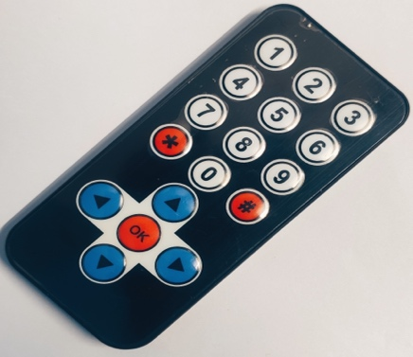

**Figure 6:** IR Remote

1. Submersible Mini Water Pump: We are using a Submersible Mini Water Pump to pump water from the tank we have attached to the device so that it can deliver the desired amount of water when needed to clean the floor while mopping.

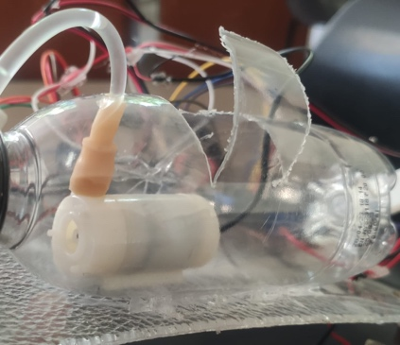

Figure 7: Submersible Mini Water Pump

1. Motor + Propeller: Here we have a 60 rpm DC Motor and a three-blade propeller which can make the floor dry again after cleaning. We can attach a heating coil also if we wish to provide warm air through the propeller to dry the floor in less time.

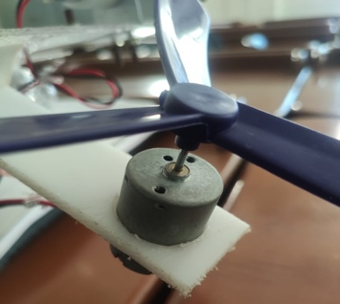 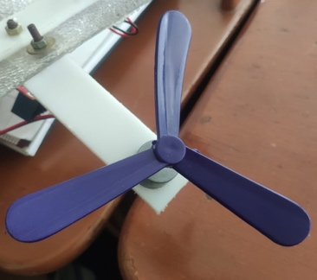

**Figure 8:** Motor + Propeller

1. Metal Gear Servo Motor: A metal gear servo motor is also used in our device which help the cleaner and mop move upward and downward. This is because, we do not need the mop and the cleaner to touch the ground all the times. We can move the brush downward to clean the floor using the motor and move and hold it up again when the work is done. It makes the motion of the device easy as the brush will not touch the floor.

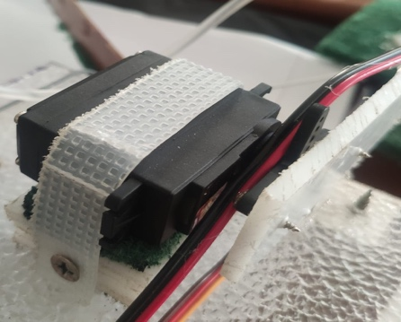

Figure 9: Metal Gear Servo Motor

1. PVC Pipe and Flow Control Valve: We have connected a PVC pipe to the Submersible Mini Water Pump to the brush which pumps the water to the pipe and this pipe delivers the water to the cleaning part (brush). We have also attached a Flow Control Valve to the PVC pipe so that we can control the water flow.

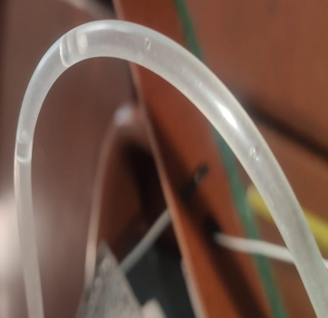 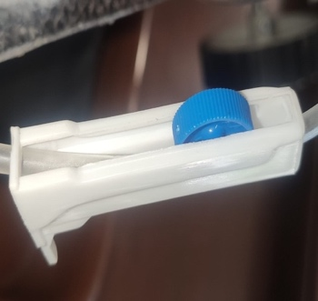

**Figure 10:** PVC Pipe and Flow Control Valve

1. PVC Plastic Sheet: We have used PVC plastic sheet to construct the main body of device so that we can construct the device at cheap price but effective. This sheet is very easy to get in the market. We can easily cut and shape it according to our necessity for the gadget. For a budget-friendly construction, this PVC sheet can be a good choice.

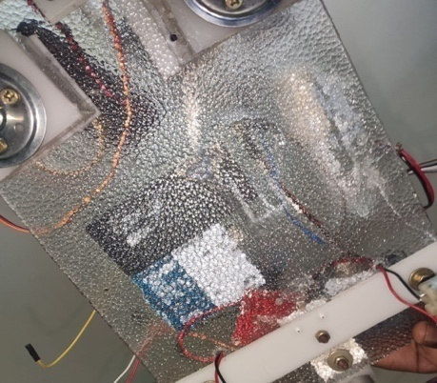

Figure 11: PVC Plastic Sheet

1. Construction Process: To create the body of our device, we must first use a hacksaw blade to cut our PVC sheet into the desired shape. We have cut the PVC Sheet in (8x12)” shape for the body. To assemble the body, we primarily used screws and super glue to affix all the parts. Two separate 100rpm DC motors screwed to the body and connected to the wheels each serving as the power source for each of the rear wheels. Two 360-degree wheels have been used at the front and screwed onto the PVC Sheet body. On the front of the PVC Sheet Body, we attached a servo motor with a screw, as well as a brush and mop. To help the floor dry more quickly after wiping it with water, we attached a 4” piece of plastic to the back of the board at a 30-degree angle with the sheet's plane. On top of this, we mounted a 60rpm motor with a propeller attached. With the glue, we joined the Arduino board, battery, and 250 ml water bottle to the device's body. The water bottle we used as a water tank. We have used glue to attach the submersible mini water pump inside the water tank which helps to pump the water. Thus, our final prototype is made with simple steps and components.
2. Final Prototype: This is the final prototype of our project which has a mop and a cleaner in the front. It has to be modified more according to the uses and need. We will try to change the design more and add more sensors to it so that it can operate with good accuracy and speed.

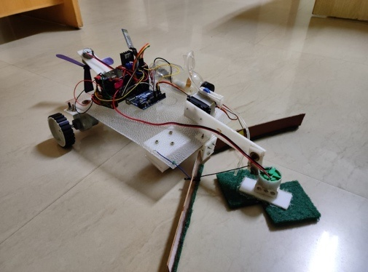

Figure 12: Final Prototype

1. RESULT

We have run the device in different places to clean the floor and to mop water from the floor to one side. This device has successfully completed the work in a very less time. The device can clean a 150 sq ft room within 15 minutes. The cost will be just around 10,000 rs in India. Overall, it can serve people with great accuracy and speed.

1. DISCUSSION

We have tried to reduce the cost so that it can be very much appropriate for all the families in India. India is a fast-developing country, and we should start increasing the use of devices in our household works also but need to focus on the cost as well. After doing a cost-benefit analysis, this device passes the quality regarding the price to serve the nation. We should start using these devices in household works, industrial works and in different institutes as well. It will develop the lifestyle of the general people of India.

1. CONCLUSION

This is a cheap and user-friendly remote controlled floor mopping machine. It can mop the floor as well as clean the floor. The available floor mopping machines are way much priced but this one is for priced cheap so that all middle-class families can afford this device and have their houses clean. It can be used in different institutions and industries as well.

**REFERENCES**

1. R.Senthil Kumar, Vaisakh KP, Sayanth A Kumar, Gaurav Dasgupta “Remote Controlled Autonomous Floor Cleaning Robot” International Journal of Recent Technology and Engineering (IJRTE) ISSN: 2277-3878, Volume-8, Issue-2S11, September 2019
2. Mohd. Shahbaz Khan, Nagageetha, M.Gurunadha Babu “Bluetooth Control Cleaning Robot using Arduino” International Journal of Innovative Technology and Exploring Engineering (IJITEE) ISSN: 2278-3075, Volume-8, Issue-11S2, September 2019
3. Nikhil Murlidhar Chopade, Student, Mechanical Department, DES’sCOET Dhamangaon Rly, India “Modified Floor Cleaning Machine”InternationalJournal of Emerging Technologies in Engineering Research (IJETER) Volume 5, Issue 4, April (2017)
4. C.R.Balamurugan, P.Kirubha, S.ArunKanna, E.R.Hariprasath, C.Anupriya Department of EEE/Karpagam College of Engineering/Coimbatore, India “Bluetooth Based Automatic Floor Cleaning System” International Journal of ChemTech Research CODEN (USA): IJCRGG, ISSN: 0974-4290, ISSN(Online):2455-9555 Vol.11 No.04, pp 55-62, 2018
5. Raveena Ishalavath M, Sandhyashree N, Rakshitha R, Arpitha Shankar Design and Development of an Automated Floor Cleaning Robot for Domestic Application 2020 International Journal of Engineering Research & Technology (IJERT).
6. Meghana K, Harshitha V, Mahima Padmanabha B, Nagesh N Dikshit, B R Santosh Kumar. A SURVEY ON AUTOMATIC AND MANUAL FLOOR CLEANING ROBOT 2019 JETIR April 2019, Volume 6, Issue 4
7. Puneet Kaushik, Mohit Jain, Gayatri Patidar, Paradayil Rhea Eapen, Chandra Prabha Sharma. Smart Floor Cleaning Robot Using Android International Journal of Electronics Engineering (ISSN: 0973-7383) Volume 10 • Issue 2 pp. 502-506 June 2018-Dec 2018
8. Yuda Irawan, Muhardi Muhardi, Rian Ordila, Roni Diandra Automatic Floor Cleaning Robot Using Arduino and Ultrasonic Sensor 2021- Journal of robotics and control (JRC) Vol2 no-4
9. M. Ranjit Kumar and N. Kapilan, "Outline and Examination of physically worked floor cleaning machine," IJERT ISSN: 2278- 0181 Vol. 4 Issue 04, April-2015.
10. Sandeep. J. Meshram, Dr. G.D. Mehta - “Design and Development of Tricycle Operated Street Cleaning Machine” - Journal of Information, Knowledge and Research in Mechanical Engineering ISSN 0975 – 668X| Nov 15 to Oct 16 | Volume– 04, Issue- 01.
11. Dr.J.HameedHussain, R.Sharavanan- Floor Cleaning Machine by Remote Control. International Journal of Pure and Applied Mathematics Volume 116 No. 14 2017, 461-464
12. Design and Development of Cleaning System by Sahil Bharti, 2S.R. Sadhave.