CURRICULUM VITAE  RUPA SINHA  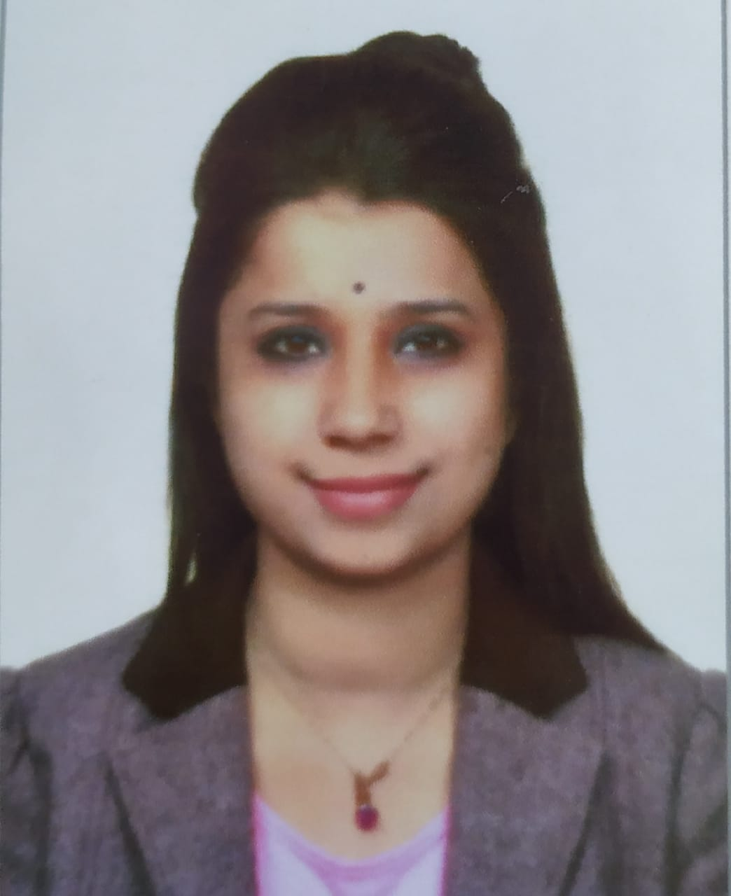  Email:  rsinha.bwn@gmail.com  Mob. No:  +91 7797307931  +91 7439306614  Present Address  G/G-1, Ashrita apartment, 4th Floor, Jorda Bagan, Baguiati, Kolkata- 700059  Personal Data  DOB : 30/07/1991  Sex : Female  Nationality : Indian  Marital Status: Married  Languages Known  English, Hindi, Bengali  Areas Of Expertise  Teaching  Supervising  Examinations Conducting  Administrative skills  Organizational skills  Team Handling  Acted as HOD  Conducted Seminar, workshop,  Examiner and paper setter  Acted as a guide for project management, and Dissertation  Coordinator for Summer Training and OJT | CAREER OBJECTIVE  To be part of an organization where I can apply my skills, knowledge and develop my career to achieve organization’s goals and create mutual benefits.  EDUCATIONAL QUALIFICATIONS  Qualified For Assistant Professor (UGC NET, November 2017) in Tourism Administration and Management.  TEACHING EXPERIENCE  - Working as an assistant Professor in SRM University, Sikkim since 1st April, 2021 to till date.  - Worked as an assistant Professor in Institute of Management Study (MAKAUT) as an assistant Professor since 2nd august 2018 to 31st March, 2021  - Worked as an assistant Professor in Tourism Management (Full Time) in Swami Vivekananda Institute of Management and Modern Science. (MAKAUT) from Feb to June, 2018.  - Worked as a faculty of tourism management in Trade Wings Institute of management (Kolkata) (Visiting faculty) since JulyFull 2017 to Jan 2018.  INDUSTRIAL TRAINING  Company : Kuoni, SOTC  Project patterns : Holiday Specialist Programme  Area : Tourism Management  RESEARCH INTEREST & EXPERIENCES  Heritage Management, Indigenous culture, Aboriginal Heritage Preservation & management, Sustainability, Destination Development, Community Based Tourism, Cultural & Heritage Tourism.  Worked as a research scholar on the topic of ‘To analyze the scope and significance of Cultural Tourism in Murshidabad, West Bengal since 2015 to November, 2019.  HOBBIES  Travelling  Swimming
  Educational qualifications | Institutes  and university | Year of passing | Percentage of marks
  Ph. D | Pacific Academy of Higher Education and Research University, Rajasthan, India | 2019 | -
  MBA (Tourism administration &Management) | Centre For management Studies, Burdwan University | 2014 | 72.60%
  B.A(History(H) | Vivekananda Mahavidyalaya Burdwan University (WB state university) | 2011 | 49%
  W.B.C.H.S.E (Higher Secondary) | Dubrajpur Girls High School, West Bengal | 2008 | 67.60%
  W.B.B.S.E(Secondary) | Dubrajpur Girls High School, West Bengal | 2006 | 68.5%
Strength:  Time management  Easy Learner  Hobbies:  Travelling, painting, cooking, gardening  Subject of interest  Human Resources Management, Marketing Management, Principles of Management, Airfare & Ticketing, Tourism principal & practice, Tourism product, cultural and Heritage Tourism in India, Tourism Planning and Policy, Travel agency and Tour Operation, Hotel Management, Geography and International Tourism, Fundamental of Management  GDS(Galileo). Tourism Marketing, International Tour operation, IATA course  Key Skill and Competencies  Tourism administration & management, Team management, Relationship management (Industry experience).  Academic experience (Tourism Faculty) | PUBLICATION  - Marketing Cultural Tourism in a Developing Country: The Case of Murshidabad, West Bengal, India - Tourism, Culture & Communication, 2021, Vol-21, E-ISSN- 1943-4146  - Sriniketan: The Future Cultural Destination of India, 2021, Springer, ISBN: 978-981-16-1669-3  - Exploring the popularity of Sikkimese ethnic fusion food : an explorative approach- Journal of Fundamental & Comparative Research, 2022, ISSN : 2277-7067  - Pro-Poor Tourism in India: Reality or hyperbole, Psychology & Education, 2021, 58(2), 9672-9682  - Changes in Tourism Destination Promotion with the Technological Innovation: A Study on an Indian Context, Emerald insight, ISBN: 978-1-83982-689-4, https://www.emerald.com/insight/content/doi/10.1108/978-1-83982-688-720201014/full/html  - Heritage Festivals: an important factor to promote cultural tourism (A study of Murshidabad, WB)- published by Annals of Art, Culture & Humanities (ISSN – 2455- 5843, vol- 3  - Local resident’s notion on the contribution of cultural tourism in Murshidabad, WB. (Published paper by IJRAR, E ISSN – 2348-1269, Vol.5  - Role of Local Community in Heritage Management for Sustainable Cultural Tourism Development: A Case Study on Lalbagh Region, Murshidabad, West Bengal. Community Participation in Tourism Development in Emerging Countries (eds.) Dr. G.B. Sinnoor and Dr. M. Zohair; Excel India Publishers, ISBN NO: 978-93-88237-38-3  - To study resident’s perception of cultural heritage tourism in Murshidabad, WB (Trend, Issues and women in hospitality and tourism industry, published by RET international academic.) ISBN NO: 978-93-85642-06-7  UNDER COMMUNICATION  - Sustaining Livelihoods and Culture through Tourism Development: The Case of Sriniketan in West Bengal, India (under review-Asia Pacific Journal of Management)  - Technology Application in the Tourism and Hospitality Industry: Comparing the Contexts of Bangladesh and India (accepted by Springer)  - Heritage Tourism Being a Tool to Rejuvenate Indigenous Culture: Selected Case Studies on Indian Context.  - The Paradigms of Workation for Novel Destination Development: An Explorative Study Based in Himachal Pradesh (Accepted by International Journal of Hospitality and Tourism Studies)  - Evaluating the key outcomes of emotional intelligence in higher education institutions: An empirical study (Springer- Higher Education Journal)
INDUSTRIAL SERVICE

- UAE Exchange & Financial Services LTD as a deputy product head since 14 jan2014 to 30thJune 2014
- Woodstock India (DMC) as a tour executive since Jan 2015 to June 2015
- Bharti Airtel India Ltd as a Relationship Officer Since Jun 2015 to Dec, 2016

CONFERENCE AND SEMINAR
- Hagia Sophia city International Conference on Culture, civilization and Multidisciplinary studies in social Sciences, Istanbul (Presented Research paper)
- Hagia Sophia 3rd International conference on multidisciplinary scientific studies, 2021 chaired a session (invited as key note speaker by Ministry of Internal Affairs, Turkey).
- Invited as Key- Note Speaker by NIMS on National Tourism Day, 2022 (Scope & Significance of Culture & Heritage Tourism -Post Pandemic)
- Taken a session on ‘Sustainable Resources Management on North – Eastern State Tourism’ 2021 Invited as key note speaker by National Institute of Disaster Management, Ministry of Home affairs Govt of India.
- TOURMAN Conference, Greece (Presented Paper) International conference on Hospitality and Tourism, 2021
- International conference on AIMS Delhi (Presented paper)
- International tourism Research colloquium, Pondicherry University (Presented Paper)
- International Conference on Development of Cultural Tourism in and around Santiniketan & Birbhum, Viswa Bharati University (Presented paper)
- International conference on Responsible Tourism Practices in India: Issues & Challenges, Dec 2019 –central university of Pondicherry (presented paper)
- International Conference on Community Involvement in Tourism Development in Emerging Countries, Central University of Karnataka (Got best Paper award)
- National Tourism and Heritage Seminar 2019 at NSHM, Durgapur (Presented Paper)
- International conference with collaboration with Lincoln University on Health tourism (Presented paper)

CERTIFICATION AND TRAINING

- Diploma in information technology (Proficiency in MS Office)
- Completed NPTEL certification (FDP) on qualitative research Methods and Report writing (IIT madras)
- Received Research excellency award, 2020 from Institute of scholars, India
- Translated MOOCs study materials on regional language by IGNOU
- 2019-2021
- Attended 3 Days FDP on Research Methodology on Social Science Conducted by IIMC
- Attended SPSS workshop conducted by Global Institute of Statistical Solutions
- Attended AMOS workshop conducted by Global Institute of Statistical Solutions.

RESEARCH GUIDE & Reviewer

- 02 -M. Phill scholar (Awarded) 2019-2021 --- Maulana Abul Kalam Azad University of Technology, Kolkata, west Bengal
- Accredited PHD Guide at MAKAUT (Maulana Abul Kalam Azad University of Technology, West Bengal)
- Accredited PHD Guide at SRM University, Sikkim ( 2 scholars got registered in Ph.D programme)
- Reviewer of Prestige International Journal of Management & IT- Sanchayan
- Reviewer of Academy of Strategic Management Journal
- Reviewer at International Journal of Tourism Policy
- Review Editor at Frontiers in Sustainable Tourism
- Reviewer at Springer Nature Book Series
- Reviewer at IIP international Publisher for Book Series

DECLEARATION

I hereby declare that information provided above is correct to best of my knowledge

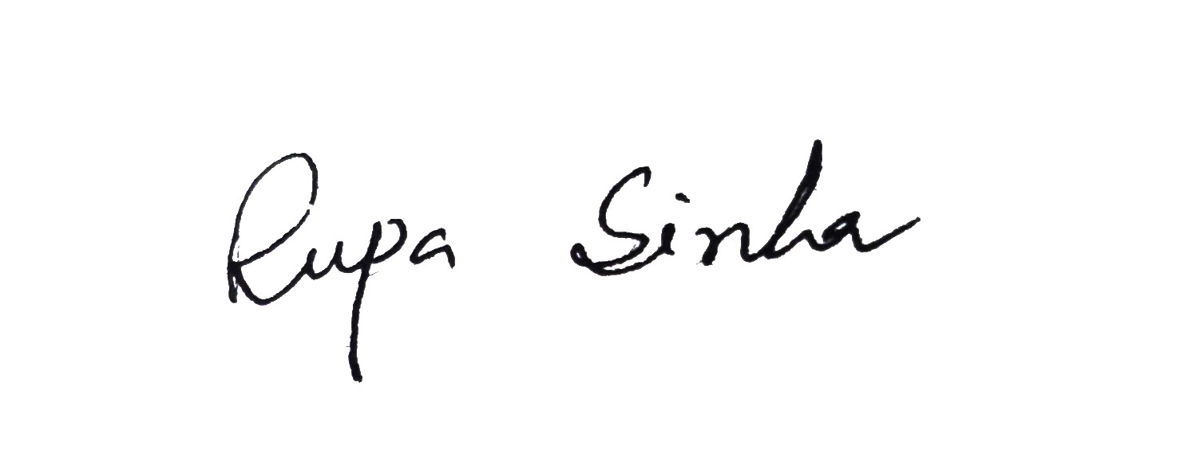
Place: Sikkim ( Rupa Sinha)
Date: 04.09.2021

