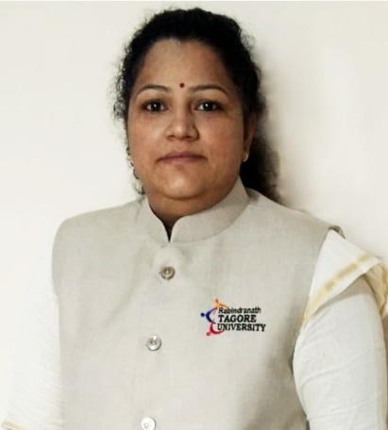

***Dr. Pooja Chaturvedi***

**B. Com, PGDT (IGNOU), M. Com, MBA (Marketing & Retail), PhD (Management)**

**Rabindranath Tagore University (Formerly known as AISECT University), Bhopal**

Dr. Pooja Chaturvedi is a prominent name in the field of education who has been mentoring students for the past 14 years. She has vast experience in academic and administrative fields as well. Presently working as Professor and Deputy Registrar (Academics) in Rabindranath Tagore University, she has done her Ph.D. in Management and MBA in Marketing. She is also a certified trainer of Statistics. She has edified various Management Colleges of Bhopal and many of her research papers have been published in journals of repute (3 in Scopus and 7 UGC Care). She has authored and co-authored four books, and drafted numerous chapters of different books including translation of files provided by **Swayam NPTEL**. She has presented her research papers in National and International conferences and bagged the ‘**Best Paper Award’**. She is a guide for Ph.D. and M.Phil. scholars and is a lifetime Professional member of Institute of Scholars (InSc). She is a part of advisory committee of Shodhaytan Journal, reviewer of INSC International Journal under the stream of management and social sciences and a life time member of Bhopal Management Association and Indian Accounting Association. Recently she bagged **Young Researcher Award-2022.**