**Dr. S. ArunMDS**

**Endodontist & Conservative/Restorative Dentist**

**Profile**

Salem

Contact No: 8072590530, 8098856702

Email id: dr.arun3393@gmail .com

**Personal profile**

D.O.B: 06-11-1987

Nationality: Indian

Religion: Hindu, Married

**OBJECTIVE**

To enhance and develop my clinical skills, concepts in an organization and tackle professional challenges ethically.

**EDUCATION**

**Masters in Dental Surgery**

MDS in Conservative dentistry and Endodontics pursued from SRM Dental College Ramapuram Chennai (July 2013- July 2016).

**Bachelor of Dental Surgery**

BDS pursued from Vinayaka Mission Dental College Salem (August 2005–August 2010).

**AREAS OF INTEREST**

* Aesthetic and smile designing
* Cosmetic corrections
* Dental jewel placements
* Management of the fractured tooth
* Teaching and clinical skill on microscope.
* Locating extra canals
* Experienced with more than 50000 RCTs
* Placing PRF (Regenerative Endodontics) more than 100 patients.
* Research activities.
* All Clinical Cases with successful outcome.

**Association:**

1. Registered under the Dental Council Tamil nadu since 2010.
2. Membership in Indian Association of Conservative Dentistry and Endodontics (IACDE) since 2013.
3. Membership in Indian Endodontic Society (IES) since 2014.
4. Membership in Indian Dental Association (IDA) - Salem branch since 2010.
5. CDE Convenor – IDA Salem branch from 2019 to present.
6. Membership in Institute of Scholars (InSc) from 2021.

**CREDENTIALS**

* **Chair person:** National conference – 1 (IACDE National Conference 2018)

State conference – 5

* **State Conference IDA:** Cultural chairman and Organising committee member.
* **International Conference:** Co-ordinator in Roots Summit 2014.
* **Scientific Presentations:** State, National Level Paper, Posters.
* **Debate:** Participated in a topic Amalgam vs Composite in 2015.
* **Research:** Comparative evaluation of cytotoxicity and anti-inflammatory effect of different root canal sealers with and without the addition of pachymic acid an *in vitro* study.
* **Publications: Journal of Endodontics JOE – impact factor- 4.171 & citation index 7**. Total publication – 10 (Scopus, Pubmed and web of sciences indexed)
* **National Webinar:** Organising Joint Secretary 2020.

**Achievements**

* 15-03- 2022 - Young researcher award by **InSc**
* 12-11- 2021 – Moderator National Webinar conducted by **GSK**.
* 4-11-2020 – **Organising Joint Secretary** in AURUM QUEST n DENT – **National** webinar on Gold Restorations.
* 1-12-2019 & 2-12-2019 – **Key note speaker** at IDA TN **State** conference.
* 2-11-2019 & 3-11-2019 – **scientific convenor** at **International** IDA FDI CDE programme at Yercaud
* 11-9-2019 – **Guest speaker** - Tobacco awareness among publics in NSS programme under swatch bharat scheme at salem.
* 1-12-2018 & 2-12-2018 – **chair person** in TN-IDA **state** conference at Trichy.
* 11-11-2018 to 14-11-2018 – **Chair person** in IACDE **National** conference at Vijayawada.
* 2-11-2018 & 3-11-2018 – **Cultural chairman** in TN-IDA students **state** conference hosted by VMSDC Salem..
* 25-3-2018 – **Chair person** in UG Indian Dental convention **National** conference at Vels University Chennai.
* 18-11-2016 – **Joint secretary in organising committee** of IDentiphy **state** CDE PGM & workshop.

**Reviewer in journals:**

* International journal of science annals (IJSA) – from 2020
* Journal of academy of dental education(JADE)- from 2020

**Publications:**

1. A comparative evaluation of effect of the addition of the pachymic acid on the cytotoxicity of four different rootcanal sealers - An Invitro study. International Journal of Endodontics 2017 Jan;43(1):96-99.
2. Musculoskeletal Disorders and Mental Health-related Issues as Occupational Hazards among Dental Practitioners in Salem City: A Cross-sectional Study.

Journal of pharmacy and bioallied sciences; 2017,oct;9(1);s200-s202.

1. An invitro study on the antimicrobial effect of pachymic acid on E.feacalis and candida albicans when added to resin based root canal sealers.

International journal of phytopharmacology 10(3),67-74.

1. Conservative Management Of Complicated Anterior Tooth

Fracture: Case Series.International journal of advanced science and technology 2020,29(7) :13618-13626.

1. Comparative Evaluation Of Remaining Dentinal Thickness After Protaper Next, Neoendo Flex Mtwo Rotary Files Preparation Using Cbct .Journal of critical reviews.2020,7(11) 2020:2394-5125.
2. Comparative Evaluation Of Pushout Bond Strength Of Fiber Post In Different Regions Of Root Dentin Using Self Adhesive And Self Etch Resin Cements – An *Invitro* Study.International journal of psychosocial rehabilitation 2020,24(7), 2020,1474-7192
3. International journal of current research and review
4. Evaluation of inhibitory effect of self etch adhesives incorporated with PA on Cysteine Cathepsins present in dentin hybrid layer using gelatin zymography: An invitro study. Journal of pharmacy and Bioallied sciences. ( Pubmed and Scopus indexed)

**CURRENT POSITION**

* Director – Dr. Aruns S.S Multi-Specialty Dental Care & Root canal centre.
* Consultant – Endodontist & Esthetic dentist
* Experience: 5years and 6 months in clinical and academic.(From 2016 July)
* At present working as Associate Professor in Vinayaka Mission sankarachariyar Dental College Salem.

**DECLARATION:**

I solemnly declare that the information furnished above is true to the best of my knowledge and belief.



Place: Salem

Dr. S. Arun

**CASE PHOTOS – COSMETIC CORRECTIONS**

**Smile Corrections - Veeners**

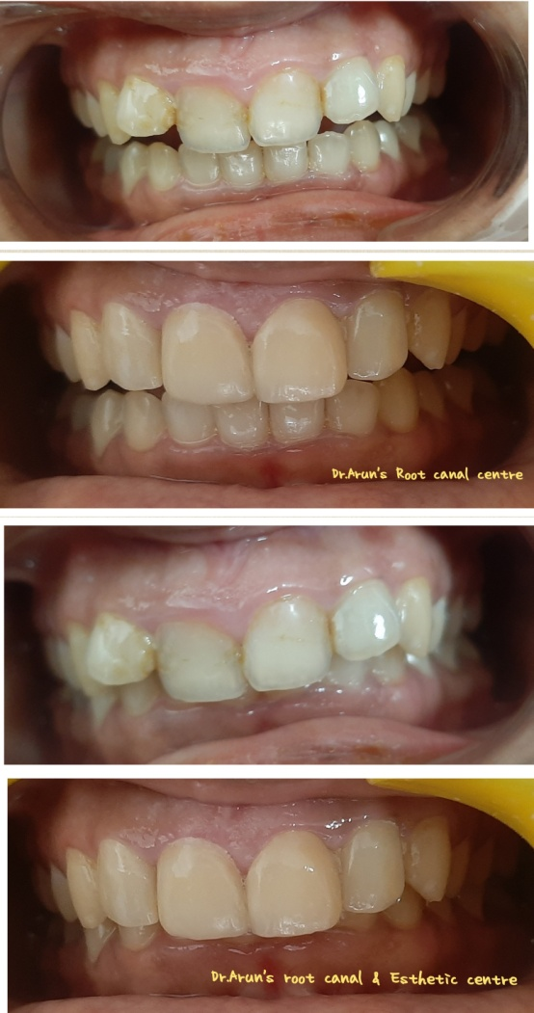

**Smile Corrections - Veeners**

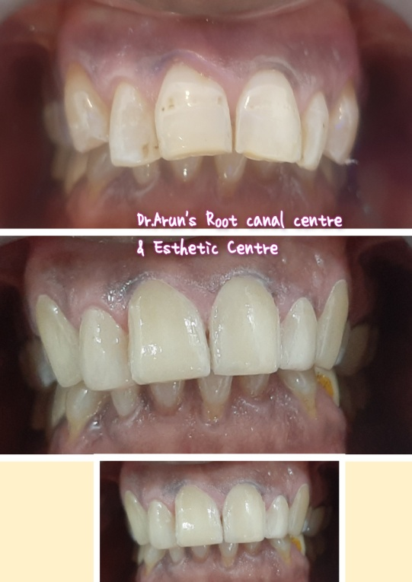

**Space Closure - Crown**

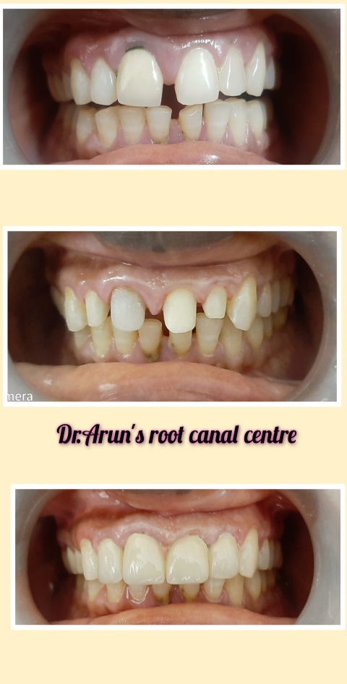

**Composite correction - 21**

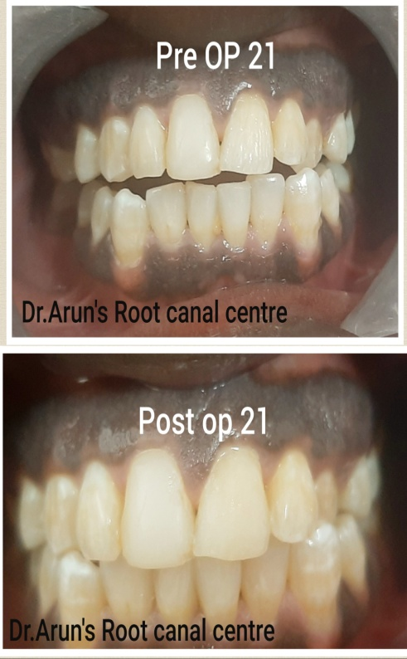

**Smile Corrections – Emax crown**

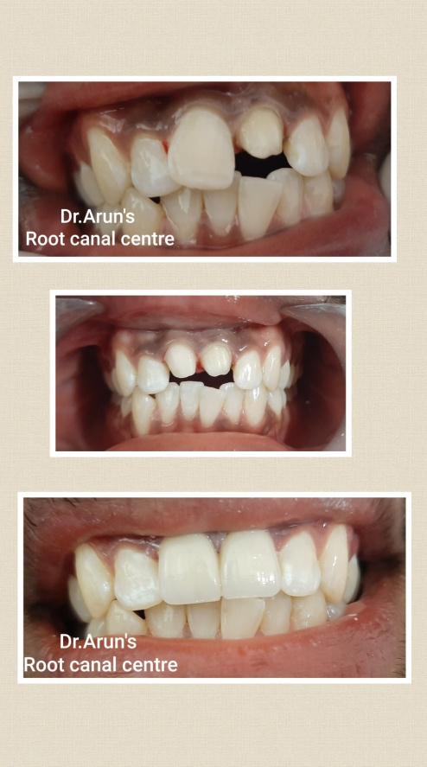

**Composite corrections – 11,21**

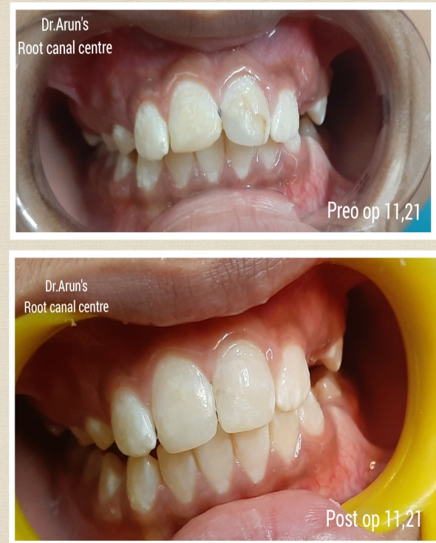

**Teeth replacement**

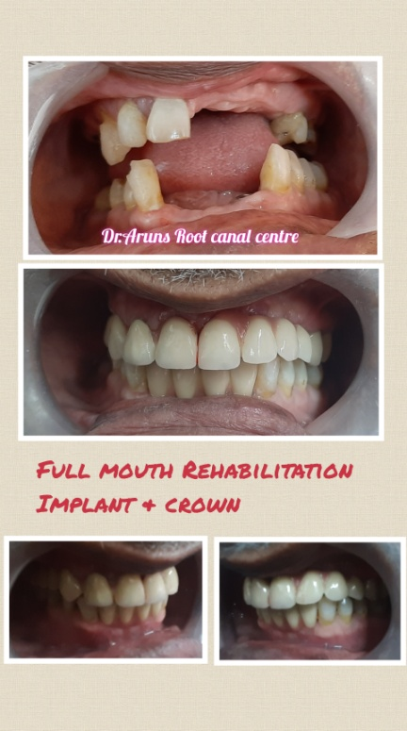

**Smile Corrections - Veeners**

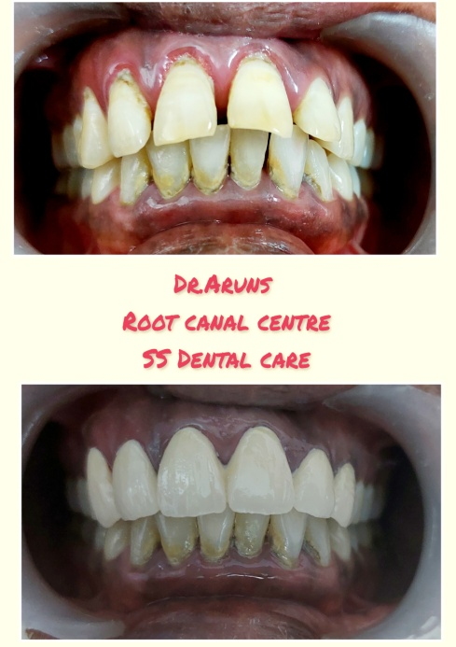

**Teeth Replacement**

