RESUME
Dr.T.Srinivasarao
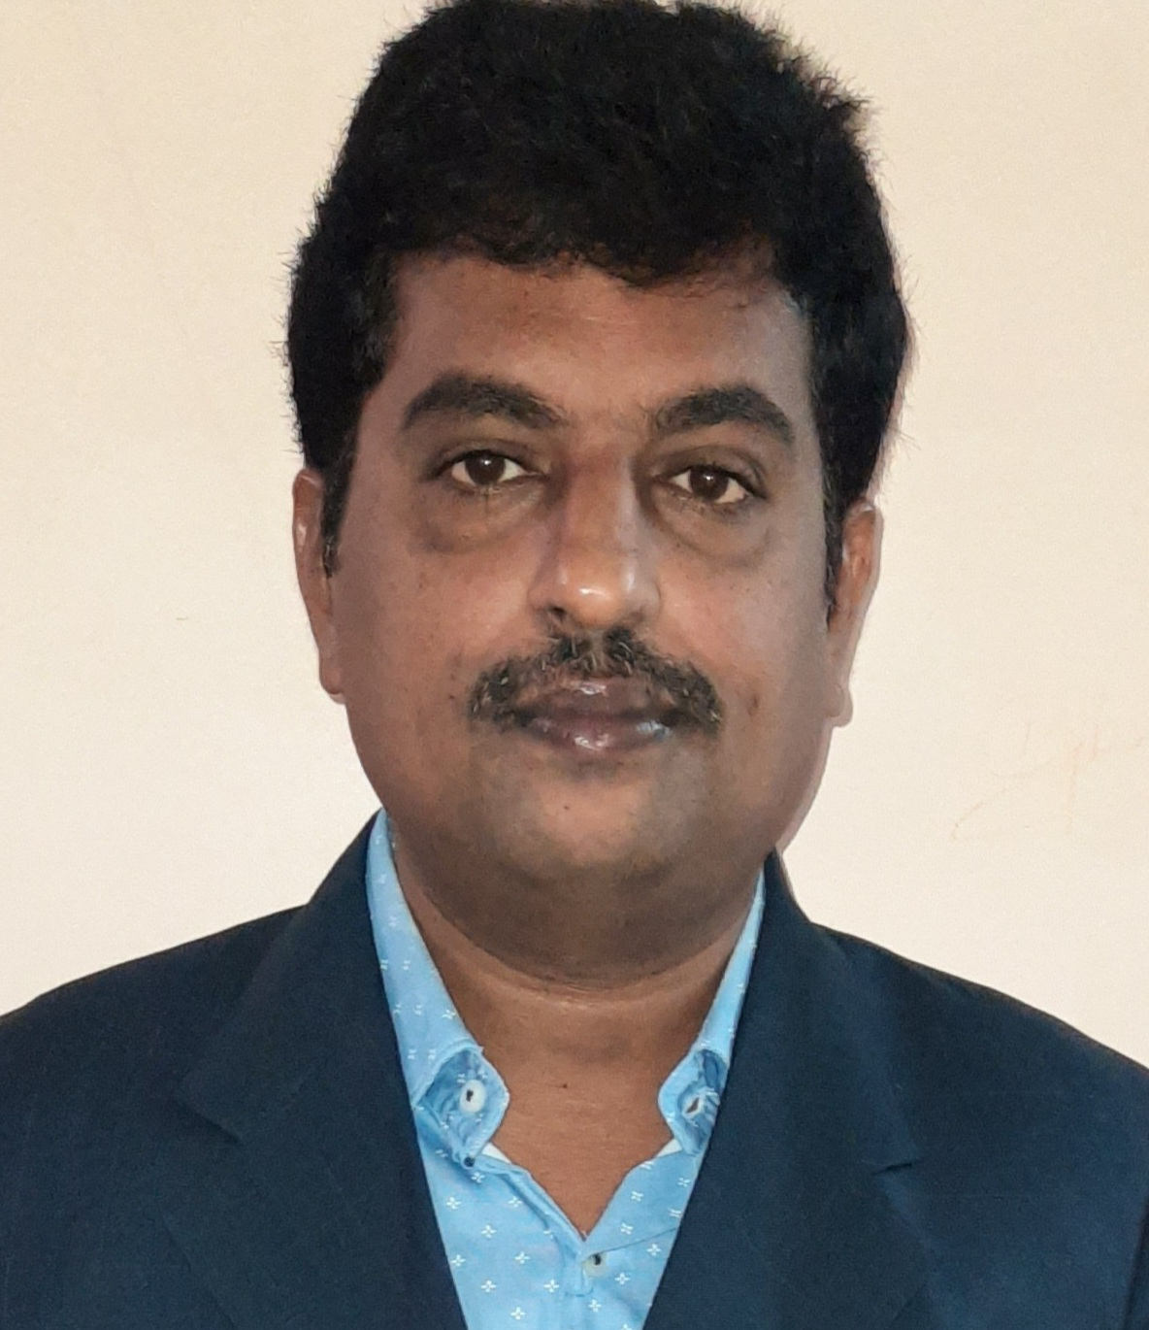

S/o T.KasivisweswaraRao,
5-500F,GayatriNagar,
Weavers colony road,
E-Mail : srinivas123fast@gmail.com
Mangalagiri-522503 Mobile No : 9490710705
Objective :
Intend to build a career with leading corporate of Hi-Tech environment with committed and dedicated people, which will help me to explore myself fully and realize my potential. Willing to work as a key player in challenging and creative environment.
Summary :
• Having 19 Years of experience in teaching field.
Interested Subjects:
  - Computer Networks(2).
  - C & Data Structures(5).
  - Data Warehousing and Data Mining.
  - Cryptography and Network Security.
Pedagogic Credentials :
Qualification | Percentage of marks obtained | Class | Studied
S.S.C(1996) | 75.6% | Distinction | Nirmala High School, Mangalagiri
Intermediate(1998) | 80.7% | Distinction | Nalanda Junior College, Vijayawada
B.Tech(1999-2003) | 59.64% | Second Class | SSIET,Nuzvid
M.Tech(2005-2007) | 71.45% | Distinction | JNTU, Kakinada
Ph.D(2012-Jan,2019) | A Novel Video Watermarking Model Using Integrity Verification and Security Methods | Awarded on Jan 30,2019 | Acharya Nagarjuna University, Guntur

Employment Scan :
- Two years in A.S.R Engineering College, Tanuku during 17/8/2003 To 13/7/2005
2) Five years in B.V.C Engineering College, Odalarevu during 14/7/2005 To 31/5/2010
3) Five years in Usha Rama College of Engineering & Technology, Telaprolu during 1/6/2010 To 01/07/2015 as IT HOD
4) Two years in Andhra Loyola Institute of Engineering & Technology, Vijayawada during 02/07/2015 To 31/05/2017 and ratified as Assistant professor on 28/12/2015.
5) Three years in KLUniversity, Vaddeswaram during 15/06/2017 to 13/07/2020
6) Working as Associate Professor in Gudlavalleru Engineering College from 16/07/2020 to till date
Technical Knowledge :
Programming Languages : C, DS, Java
Web Technologies : HTML, XML, Java Script, Beans, Servlets, JSP
Operating Systems : Windows XP, UNIX
Personnel Strengths :
Strengths : 1) Ability to work in teams
2) Adaptability to work in different conditions
Interests : 1) Serving for society
Patent :
1. Patent titled “ Artificial Intelligence Based Pest Control System for Agriculture Crops” was Published on 27/03/2020 with Application No :202041011478 A
2. Patent titled “ Data Mining for discovering Informative knowledge in complex data” was Published on 22/11/2019 with Application No :201941047156 A
3. International Patent(Australian) titled “A system and method for classifying snake images using Convolutional neural network” was Granted on 27/08/2021 with Application No :2021102271
Book :
- Dr.T.Srinivasarao, “Cyber Crime", (Book) published by Navya Publications in DEC 2020 with ISBN 978-81-947246-1-2
Guest Lecture :
- A Guest Lecture talk given on Wireless Sensor Networks on 15-07-2020 at J.B. Institute of Engineering and Technology, Moinabad, Telangana
Journals:
- My Paper entitling “ A Novel Multi-View Deep Learning Framework For Predicting Patient Expenditure In Healthcare” had published in The International Journal of Analytical and Experimental Modal Analysis (IJAEMA), Vol.15, Issue 6, April,2022,ISSN No: 0886-9367 , pp. 641-648
- My Paper entitling “ Detection of Vehicles and Pedestrians Using Haar Cascade” had published in Stochastic Modeling and Applications(SMA),Vol. 26, Number 3,April, 2022 ISSN No: 0972-3641 , pp. 139-147
- My Paper entitling “ IOT BASED PULSE OXIMETER” had published in JOURNAL OF EDUCATION: RABINDRABHARATI UNIVERSITY (JE), July, 2021,ISSN No: 0972-7175 , pp. 104-108
- My Paper entitling “ Iris Flower Classification using Machine Learning “ had published in International Journal of All Research Education and Scientific Methods(IJARESM), Vol. 9, Issue 6,June, 2021,ISSN No: 2455-6211, pp. 2082-2090
- My Paper entitling “ A lightweight hybrid scheme for security of big data “ had published in Materials Today: Proceedings
- My Paper entitling “ Analysis of Http Cookie Hijacking in the wild “ had published in International Journal of Innovative Technology and Exploring Engineering (IJITEE), Vol. 9, Issue 7, May, 2020,ISSN No: 2278-3075, pp. 859-863 ,DOI:10.35940/ijitee.F4011.059720
- My Paper entitling “ A Systematic approach for data hiding using Cryptography and Steganography “ had published in International Journal of Emerging Trends in Engineering Research (IJETER), Vol. 8, Issue 4, April, 2020,pp. 1326-1332 , ISSN No : 2347 - 3983,DOI:10.30534/ijeter/2020/63842020
- My Paper entitling “ An IOT based automatic accident detection and tracking system for Emergency services” had published in Journal of Advance Research in Dynamic and Control Systems (JARDCS), Vol. 12, Issue 2, March, 2020,pp. 111-117 ,ISSN.No:1943-023X,DOI:10.5373/JARDCS/V1212/S202010013
- Published a paper entitled “An Intelligent MLFQ Scheduler Prediction Using Neural Approach “ in IEEE Xplore in Dec 2019 , URL : https://ieeexplore.ieee.org/document/8939098,DOI:10.1109/ICoAC44903.2018.8939098
- My Paper entitling “Cloud based Interactive Kinematic Simulation of Tiles Display Stand” had published in International Journal of Innovative Technology and Exploring Engineering (IJITEE), Vol. 08,Issue 9, July, 2019,pp. 2629-2632, ISSN: 2278-3075 by Blue Eyes Intelligence Engineering & Sciences Publication,DOI: https://doi.org/10.35940/ijitee
- My Paper entitling “ Efficient scheduling Measures for improving real time systems using prediction process” had published in Journal of Computational and Theoretical NanoScience (JCTN), Vol. 16,Number 5, June, 2019,pp. 1876-1880 by American Scientific Publishers,ISSN.No:1546-1955,DOI:1166/jctn.2019.7818
- My Paper entitling “Block chain and Smart-Contracts Modeled In a Swarmesb Ecosystem” had published in Journal of Advanced Research in Dynamical & Control Systems(IJARDCS), Vol. 10, 09-Special Issue, July, 2018,pp. 989-995
- My Paper entitling “Based on Distance Comparison Shortest Path Algorithm” had published in International Journal of Pure and Applied Mathematics (IJPAM),Volume 118 ,No. 20, April, 2018, PP.853-860,ISSN: 1314-3395
14) My Paper entitling “Dos flooding attack control in Information-centric networks” had published in International Journal of Engineering & Technology(IJET) , Volume 7,Number 1.1, Jan 2018 ,pp.303-305,ISSN.No:1793-8236,DOI: 10.7763/IJET
15) My Paper entitling “Efficient Smart Emergency Response System for Fire Hazards using IoT” had published in International Journal of Advanced Computer Science and Applications(IJACSA) , Volume 9, Number 1, Jan 2018 pp. 314-320, ISSN: 2156-5570(SCI), DOI:10.14569/IJACSA.2018.090143
16) My Paper entitling “Hash Method Elimination Of Data Duplication In Storage Clouds Using Contents Based” had published in International Journal of Pure and Applied Mathematics(IJPAM) , Volume 117, Issue 17, December 2017 pp. 109-114, ISSN: 1314-3395
17) My paper entitling “ Buried pipes detection through ground penetrating radar images” had published in International Journal of Mechanical Engineeing and Technology(IJMET) , Volume 8, Issue 12, December 2017 pp. 61-68, ISSN: 0976-6359
18) My paper entitling “Deleting data with Encryption Standards ” had published in International Journal of Computer Trends and Technology(IJCTT) ,Special Issue, April,2017 pp. 88-92, ISSN: 2231-2803
19) My paper entitling “A novel compressed video watermarking model using hash based encryption and decryption algorithm ” had published in International Journal of Control Theory and Applications(IJCTA) Volume 9, Number 43,Dec,2016 pp. 577-588, ISSN: 0974-5572
20) My paper entitling “Prevention of Arbitrary data tuples in open nets using Apache Spark” had published in Indian Journal of Science and Technology(IJITR) ,Volume 4 ,Issue 5,Aug-Sep,2016,pp.3886-3888,ISSN:2320-5547
21) My paper entitling “A Hybrid Scheme Based On Big-Data Analytics Using Intrusion Detection System” had published in Indian Journal of Science and Technology(IJST), Volume 9 ,Issue 33,Sep,2016, pp.1-4,ISSN:0974-5645,DOI: 10.17485/ijst/2016/v9i33/97037
22) My paper entitling “An efficient i-encrypted Video Watermarking scheme using Enhanced PCA-SVD-DWT block Embedding and Extraction model” had published in Journal of Theoretical and Applied Information Technology(JTAIT) , Volume 93, Number 1, Nov,2016,pp .123-132, ISSN : 1992-8645
23) My paper entitling “ Integrity based Video Watermarking using Gaussian Based DWT Embedding and Extraction process.” had published in International Journal of Applied Engineering Research (IJAER), , Volume 11, Number 5(2016) ,pp. 3235-3240, ISSN :0973-4562 , Research India Publications,DOI:10.37622/000000
24) My paper entitling."A Smart Intelligent Way of Video Authentication Using Classification and Decomposition of Watermarking Methods" had published in International Journal of Computer Trends and Technology (IJCTT) , V10(3), April 2014.,pp.136-142, ISSN:2231-2803. www.ijcttjournal.org. Published by Seventh Sense Research Group.
My Citations Details:
https://scholar.google.co.in/citations?user=9oXyGUcAAAAJ&hl=en
http://orcid.org/0000-0003-4767-5948
https://www.scopus.com/authid/detail.uri?authorId=57200289050
https://publons.com/researcher/1837314/drtumma-srinivasarao/publications/
https://www.researchgate.net/profile/Tumma-Srinivasarao
International Conferences :
- Presented a paper entitled “ A light weight hybrid scheme for security of big data” at International Conference on Research in Science, Engineering, Technology and Management (ICRSETM- 2020) Organizing by Vaagdevi College of Engineering, Warangal on 28/12/2020,ISSN NO:2214-7853
- Presented a paper entitled “Survey on Biological Environmental Sequence Analysis using Association Technique “ at International Conference on Computational Intelligence(ISCI 2019) Organizing by CMR College of Engineering and Technology, Hyderabad on 02/11/2019(https://link.springer.com/chapter/10.1007/978-981-15-5400-1_71)
- Presented a paper entitled “An Intelligent MLFQ Scheduler Prediction Using Neural Approach “ at International Conference on Advanced Computing(ICoAC 2018) Organizing by Anna University , Chennai during 13/12/2018 To 15/12/2018, DOI: 10.1109/ICoAC44903.2018.8939098
- Presented a paper entitled “A Review on Class Imbalanced Learning Problems and Related Methods in Big Data” at National Conference conducted by Bhaderwah Campus, University of Jammu during 26/08/2016 To 27/08/2016
- Presented a paper entitled “A smart Intelligent way of PCA based scheme using wavelet Transform” at International Conference conducted by Lingaya’s University, Faridabad during 12-13th Jan-2012.
- Presented a paper entitled “Performance Composition Protocol with QOS awareness in MANET” at International Conference ICNB-2010 Raghu Engineering College, Vizag on 4th Feb-2010

National Conferences:
- Presented a paper entitled “Ad-hoc Networks” at National Conference Organized by B.V.C.Engineering College, Odalarevu on 8th March-2008
- Presented a paper entitled “Performance Composition of Routing Protocols for Mobile Ad-Hoc Networks ” at National Conference Organized by S.R.K.R.Engineering College, Bhimavaram During 22nd-23rd Feb-2008
- Presented a paper entitled “Organizational Forms of Dataware Housing, an Explorative Analysis” at National Conference Organized by Oxford Engineering College, Trichy on 5th April-2007
- Presented a paper entitled “Information System Security” at National Conference Organized by Bhilai Institute of Technology, Durg During 16-17th March-2007

Workshops:
- Attended online Five days National level Online Faculty Development Program on “Recent Trends in Cyber Security and Machine Learning” organized by Dept. of Computer Science & Engineering, Shri Vishnu Engineering College for Womenfrom 01-06-2022 to 05-06-2022.
- Attended online Five days National level Online Faculty Development Program on “Deep Learning for Real Time Research Applications” organized by Dept. of Computer Science & Engineering, Seshadri Rao Gudlavalleru Engineering College in association with CCE, NITW from 03-01-2022 to 07-01-2022.
- Attended online six days National level Online Faculty Development Program on “Practicing Cloud Computing with AWS” organized by Department of CSE and CS&IT, KL Deemed to be University during 13.09.2021 to 18.09.2021.
- Attended online six days National level Online Faculty Development Program on “Multi-Technologies” organized by Department of Computer Science and Engineering, RISE Krishna Sai Prakasam Group of Institutions under IQAC during 28.06.2021 to 03.07.2021.
- Attended AICTE-ISTE Sponsored one week Induction /Refresher Program (Online) on Advanced Training Programon Teaching from 9th Feb To 15th Feb 2021 at Mallareddy Engineering College , Secunderabad
- Attended online FDP program Organized by AICTE Training and Learning Academy (ATAL) on Data Sciences from 19th Jan To 23rd Jan 2021 at Gudlavalleru Engineering College , Gudlavalleru
- Attended online FDP program from 17th Dec To 19th Dec 2020 on Artificial Intelligence at St. Martyn’s Engineering College , Hyderabad
- Attended online FDP program Organized by AICTE Training and Learning Academy (ATAL)on Internet of Things (IoT) from 7th Dec To 11th Dec 2020 at Gudlavalleru Engineering College , Gudlavalleru
- Attended online National Level Webinar on Intellectual Property Rights & Patents - A View organized by IQAC, Gudlavalleru Engineering College, Gudlavalleru held during 10 - 12 August 2020.
- Attended online FDP program on Cyber Security from 22nd July To 26th July 2020 at Gudlavalleru Engineering College , Gudlavalleru
- Attended online FDP program on IOT with Artificial Intelligence from 27th May To 29th May 2020 at Sir C R Reddy College of Engineering, Eluru
- Attended online One week FDP program on Tools explored in disruptive Technologies from 11th May To 16th May 2020 at Sai Ram Institute of Technology, Chennai
- Attended online One week FDP program on Research Challenges and Opportunities Post COVID-19 from 4th May To 9th May 2020 at Vasavi Engineering College, Tadepalligudem.
- Attended online One week FDP program Organized by AICTE Training and Learning Academy (ATAL) on Block Chain from 20th April To 24th April 2020 at JNTUA College of Engineering, Pulivendula
- Attended two week FDP program on Cyber attacks and Security organized by Indian Servers in association with NSF Research Group from 3rd June 2019 to 14th June 2019, at KL University, Vaddeswaram.
- Attended a Two day Program on Pega Awarenes Workshop on 28th and 29th May 2019 at Pega Systems World wide India Private Limited Organized by Pega University Academic Program(UAP) team.
- Attended a six day Workshop on Cyber Security training program Conducted from 23rd Oct to 28th Oct 2017, at KL University, Vaddeswaram.
- Attended a five day Workshop on Faculty Skill Enhancement Program Conducted from 19th June to 23rd June 2017, at KL University, Vaddeswaram .
- Attended a two day Workshop on Web Development Using ANGULAR JS Conducted from 17th Feb to 18th Feb 2017, at Andhra Loyola Institute of Engineering and Technology, Vijayawada
- Attended a five day Faculty Development Program on Data Science and Big Data Analytics Conducted by ICT Academy from 14th Nov to 18th Nov 2016, at SRK Institute of Technology, Vijayawada .
- Attended a three day Faculty Development Program on Advancements in Cloud computing services and its applications at CSE Dept, Andhra Loyola Institute of Engineering and Technology, Vijayawada from 17th -19th Nov 2016
- Attended a two day workshop on Big Data Analytics Using Hadoop at IT Dept, Andhra Loyola Institute of Engineering and Technology, Vijayawada from 16th -17th Sept 2016
- Attended a one week Faculty Development Program on Big Data Analytics at Shri Vishnu Engineering College for Women, Bhimavaram during 2nd-6th Aug 2016
- Attended a two day workshop on Big Data Analytics at CSE Dept, Andhra Loyola Institute of Engineering and Technology, Vijayawada from 22nd -23rd July 2016
- Attended a one day workshop on NBA Orientation Program at Andhra Loyola Institute of Engineering and Technology, Vijayawada on 6th June 2016
- Attended a one week Faculty Development Program on Outcome Based Education at Dhanekula Institute of Engineering & Technology, Ganguru during 6th to 11th June 2016
- Attended a Three day Faculty Development Program on Groovy on Grails at Andhra Loyola Institute of Engineering and Technology, Vijayawada on 21st -22nd and 24th March 2016
- Attended a one day IEEE National workshop on “Understanding 5G: Perspectives on Future Technological Advancements in wireless communication at Potti Sriramulu of Engineering and Technology, Vijayawada on 8th August 2015
- Attended a one day workshop on Trendy HTML 5 at KL University, Vijayawada on 1st Feb 2014
- Attended a one day NPTEL workshop on Technology Enhanced Learning at IITMadras, on 20th Sept 2013
- Attended a one week Faculty Development Program on Campus Connect at Swarnandhra college of Engineering & Technology, Narsapur during 8th -12th July 2013
- Attended a One day Faculty Development Program on LATEX at Dhanekula Institute of Engineering and Technology, Ganguru, on 4th May 2013
- Attended a two day workshop on Android at UshaRama College of Engineering and Technology, Telaprolu during 19th -20th Dec 2012
- Attended a two day workshop on Cyber Security & Malware Analysis at UshaRama College of Engineering and Technology, Telaprolu during 25th -26th Dec 2012
- Attended a two day workshop on Cloud Computing at Gitam University, Vizag during 7th -8th Sept 2012
- Attended a two day workshop on Soft Computing Techniques & Data Engineering at Gitam University, Hyderabad during 30th -31st March 2012
- Attended a one day workshop on Soft Computing at Adikavi Nannaya University, Rajahmundry on 27th Jan 2012
- Attended a Two day Faculty Development Program on Recent Advances in Modeling Language & Network Programming at Narasaraopeta Engineering College , Narasaraopeta during 3rd to 4th Dec 2010
- Attended a One day Faculty Development Program on Image Processing & MATLab at B.V.C Engineering College, Odalarevu, on 1st Dec 2009
- Attended a One week Faculty Enablement Program on Campus Connect at Infosys Technologies, Hyderabad during 16th to 20th Nov 2009
- Attended a one day workshop on FP Restructuring Session at DVR & Dr. HS MIC College of Technology, kanchikacharla on 10th Aug 2009
- Attended a Two week Faculty Development Program on Transform Techniques in signal Processing at Lakkireddy Balireddy College of Engineering , Mylavaram from 8th -20th June 2009
- Attended a two day workshop on Mobile & High Performance Computing at University College of Engineering and Technology, JNTU Kakinada during 25th -26th March 2009
- Attended a three day workshop on Train the Trainer Program on Infratsructure Management Services at Infosys Technologies Limited, Hyderabad during 6th -8th Aug 2008
- Attended a two day workshop on Image Processing, Pattern Recognition & Neuro Computing at B.V.C.Engineering College, Odalarevu during 12th -13th April 2008
- Attended a two week Faculty Enablement Program on Data Mining at SONA College of Technology during 12th -23rd Nov 2007
- Attended a three day workshop on Object Oriented Analysis and Design using the UML with Fundamentals of Rational Rose during 21st -23rd Sept 2006
- Attended a two week Faculty Enablement Program on Foundation Program-Generic Courses at Infosys Technologies Limited, Hyderabad during 2nd -14th April 2006
Achievements :
- Certified on CCNAv7: Introduction to Networks on 29th Dec 2020
- Awarded from InSc (Institute of Scholars)for Research Excellence Award on 20th December 2020
- Acting as a member of Board Of Studies for Usha Rama College of Engineering & Technology, Telaprolu from May 2019
- Won a best paper award entitled “Performance Composition Protocol with QOS awareness in MANET” at International Conference ICNB-2010 Raghu Engineering College, Vizag on 4th Feb-2010
Professional Bodies :
- Life member of ISTE (Membership No-LM 58377),
- Life member of CSI (Membership No-00174154),
- Life member of IACSIT(Membership No-80345535),
- Life member of IAENG(Membership No -235066)
- Life member of InSc(Membership No -InSc20202099)
My Conributions to the Colleges :
Acted as a Dept exam incharge, as a Point Of Contact for Infosys Campus Connect , as a Dept NBA Co-Ordinator, as a IT HOD ,as Student Branch Counsellor Of CSI, Acted as a Pega Professor Incharge(Placement activity)
Personal Profile:
Name : Tumma SrinivasaRao
Father : T.Kasivisweswara Rao
Gender : Male
D.O.B : 01/06/1981
Nationality : Indian
Declarations : I hereby declare that the information furnished above is true to the best of my knowledge.

Place : Signature

