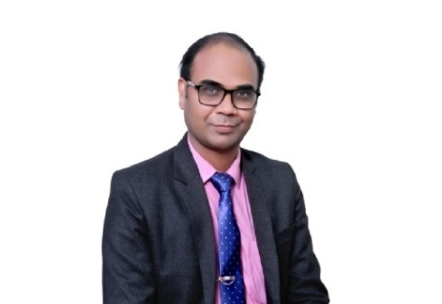

**Prof.(Dr.) Nalini Kanta Sahoo**

**M.Pharm, Ph.D., FSASS, SRAP, (Post-Doc)**

**Principal,**

**SRM Modinagar College of pharmacy,**

**SRMIST (Deemed to be University),**

**Delhi-NCR**

Prof. (Dr.)Nalini Kanta Sahoo, working as Professor & Principal in one of the leading college (SRM Modinagar college of Pharmacy) under the ambient of SRMIST (Deemed to be University), Delhi-NCR Campus, which is NAAC A++, category –I by MHRD, NIRF ranking 15. He is at present with experience of 15 years in Academics, Administration and Accreditation, Training and Research. He completed Ph.D from Siksha ‘O’Anusandhan University (NIRF rank-24th). He Completed course in “Statistical reasoning and algorithms in Pharmacovigilance” (SRAP), Uppsala Monitoring Centre, Sweden”. He is pursuing Post doctoral research under the supervision of **Prof. (Dr.) Bui Thanh Hung, Director of Artificial Intelligence Laboratory, Faculty of Information Technology, Ton Duc Thang University, Vietnam.**

He has four design patents published and one granted to his credit along with 61 research and review articles in International journals of high repute (maximum covered in Scopus, WoS, pubmed).He published two books of international repute. He attended more than 52 International and national conferences. He is serving as scientist with Vision Science Research Sdn.Bhd., Malaysia (Grant No.VSRIR2019070407). He is Editorial board member of 63 International journals.

He has many Awards & achievements to his credits like Maulana Abul Kalam Azad Excellence Award of education -2020 from Prof.Anil D.Sahasrabudhe, Chairman,AICTE, Dynamic Pharma teacher award” for outstanding contribution in Pharmacy profession by Indian Pharma Educational Society (IPES), Lucknow in collaboration with Pharmatutor and St.Dominic College of Asia, Philippines and **Best research paper SCI indexed journal “Journal of Analytical chemistry-Springer” by Novel Research,Academy,Division of Swertia publications, Govt. of India.**

**Also Received Best teacher award for Zero investment innovations for education initiatives (ZIIEI) from Education minister Sri Ramesh pokhariwal , Won 1st Prize DST (SERB) sponsored** two day national level seminar on held in Jayamukhi college of Pharmacy and Received Best professor “Pharmacy” ITAP Awards 2018 by Tutor Pride Pvt.Ltd. from former Chief Minister of Andhra Pradesh Sri K.Rosaiah on the occasion of Gandhi Jayanti at Trident hotel, Hyderabad.

He is life time member of many associations like Indian Society of Analytical scientists (ISAS), Hyd. Chapter, Asia Society of Researcher (ASR), National Forum of Pharmacy Students, APTI, Healthcare & Biological Sciences Research Association (HBSRA), Eurasia research, Foundation for health and environmental research (FHER), Institute of scholars (InSc) and Teaching and Education Research Association and so many.