Biography

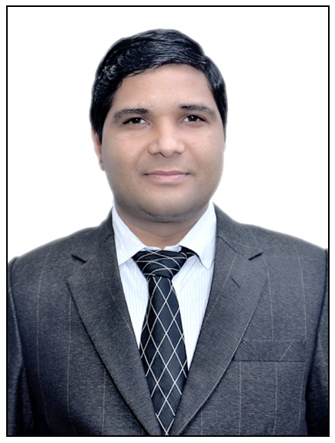
Dr. Pankaj Dadheech completed his Ph.D. degree in Computer Science & Engineering from Suresh Gyan Vihar University (Accredited by NAAC with ‘A’ Grade), Jaipur, Rajasthan, India. He completed his M.Tech. degree in Computer Science & Engineering from Rajasthan Technical University, Kota and he has completed his B.E. in Computer Science & Engineering from University of Rajasthan, Jaipur. He has more than 16 years of experience in teaching. He is currently working as an Associate Professor & Deputy Head in the Department of Computer Science & Engineering (NBA Accredited), Swami Keshvanand Institute of Technology, Management & Gramothan (SKIT), Jaipur, Rajasthan, India (Accredited by NAAC A++ Grade). He has Published 21 Patents & Granted 4 Patents at Intellectual Property India, Office of the Controller General of Patents, Design and Trade Marks, Department of Industrial Policy and Promotion, Ministry of Commerce and Industry, Government of India. He has Published & Granted 4 Australian Patents at Commissioner of Patents, Intellectual Property Australia, Australian Government. He has Published & Granted 1 German Patent. He has also Registered & Granted 2 Research Copyrights at Registrar of Copyrights, Copyright Office, Department for Promotion of Industry and Internal Trade, Ministry of Commerce and Industry, Government of India. He has presented 59 papers in various National & International Conferences. He has 61 publications in various International & National Journals. He has published 6 Books & 11 Book Chapters. He is a member of many Professional Organizations like the IEEE Computer Society, CSI, ACM, IAENG & ISTE. He has been appointed as a Ph.D. Research Supervisor in the Department of Computer Science & Engineering at SKIT, Jaipur (Recognized Research Centre of Rajasthan Technical University, Kota). He has also guided various M.Tech. Research Scholars. He has Chaired Technical Sessions in various International Conferences & Contributed as Resource Person in various FDP’s, Workshops, STTP’s, and Conferences. He is also acting as a Guest Editor of the various reputed Journal publishing houses, Conference Proceedings and Bentham Ambassador of Bentham Science Publisher. His area of interest includes High Performance Computing, Cloud Computing, Information Security, Big Data Analytics, Intellectual Property Right and Internet of Things.

