RESUME
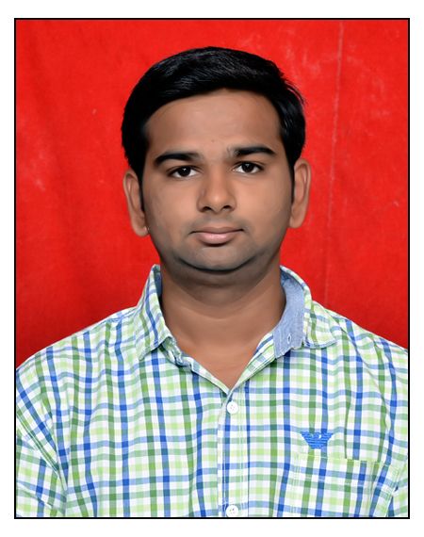
Mr. SANTOSH REDDY P
Grace Cottage, 3rd B Cross,
Kallumantapa,
Horamavu,
Bangalore.
Mail-ID: pathireddy.santosh@gmail.com
Phone : +91 9731362834

Objective
To utilize my teaching skills towards a challenging career in growth oriented and leading edge that will provide mutual benefits and where from I can utilize my capabilities to the fullest benefits of the organization and society
Professional Experience
- Working as Assistant Professor, in CSE Department, BNMIT, Bangalore, Karnataka, from Sep 16, 2021 to Till Date.
- Worked as Assistant Professor, in CSE Department, SVIT, Bangalore, Karnataka, from July 22, 2019 to Sep 15 2021.
- Worked as Assistant Professor, Department of CSE, School of Engineering, Presidency University, Bangalore, Karnataka from July 05, 2018 to June 28,2019.
Academic Chronicle
Ph.D(Computer Science & Engineering) Pursuing
Presidency University, Completed Course Work
Bangalore.

M.Tech (Computer Science and Engineering) (July 2017)
Shri Dharmasthala Manjunatheshwara College of Engineering and Technology, Dharwad. Karnataka.
Scored: 71.92%

B.E (Computer Science and Engineering) (June 2015)
Ballari Institute of Technology and Management, Bellary, Karnataka
Scored: 72.93%

Diploma(Computer Science and Engineering) (Dec 2011)
Sanjay Gandhi Polytechnic, Bellary, Karnataka
Scored: 67%

SSLC (Karnataka State Board of Examinations), (Apr 2008)
Vianney Vidyalaya, Bellary, Karnataka
Scored: 59.36%

Patent

- Indian Patent: “Vehicular Blind spot detection and alert system using Artificial Intelligence and methods thereof”.

- International Patent: “AWS-Cloud Data Performance Improved Using Machine and Deep Learning Programming”.

Text Books Published
- P Mansoor, Y Nuzhat Afreen, Santosh Reddy P, “Advance Machine Learning” LAP LAMBERT Academic Publishing, ISBN: 978-620-4-20850-3, 2021.

Paper Published & Presented
- Presented and published a paper titled “A Survey on prediction of survival time on Pancreatic Cancer using machine learning paradigms towards Big data Analytics” in International Conference on Emerging Trends In Science & Technology For Engineering Systems on 19th July 2020 at SJCIT Bengaluru (Scopus Indexed Volume 7 Issue 8 2020).
- An efficient classification algorithms for lung cancer prediction using big data Analytics(Scopus Indexed Volume 11 Issue 7 July 2020).
- The study on lung cancer prediction using data mining techniques towards HDFS(Scopus Indexed Volume 11 Issue 7 July 2020).
- Presented a paper titled “Distributed File System on Medical data using Machine Learning Techniques for Health Care Surveillance” in International Conference on Intelligent Computing, Information & Control System on 03rd July 20201 at Care College of Engineering(Springer).
- Presented a paper titled “An Efficient Novel Approach for Detective of Recolored Image Using Deep Learning for Identifying the Original Images in Public Surveillance” in International Conference on Intelligent Computing, Information & Control System on 03rd July 20201 at Care College of Engineering(Springer).
- Presented and published a paper in IJERT titled “An Energy Efficient and Robust Asymmetric key chain Protocol for Key Management in HSN’s” in National Conference on Electronics, Signal and Communication was held on 29th May 2017 at GSSSIT, Mysore (ISSN: 2278-0181).
- Detection of Leaf Disease and Pesticides Recommendation Using CNN, Published in IJRESM.(Volume-3, Issue-6 June 2020)
Workshops Attended

- Two days workshop on Wireless Communication Networks and Simulation Using ns-3, SDMCET, Dharwad.
- Two days Workshop on Research Trends in Image Processing and Machine Learning based on mathematical modeling sponsored by TEQIP in SDMCET, Dharwad.
- 5 Days workshop on OBE & NBA Accreditation sponsored by TEQIP 1.3 in DBIT, Banglore.
- 5 Days Workshop on Data Science Concepts-Theoretical and Practical Approach in Dayananda Sagar University.
- 5 days Workshop on Online Learning and Assessment System in Institution of Engineers(India).
- 5 Days Workshop on Big Data sponsored by AICTE in M S Ramaiah Institute of Technology.
- 5 Days Workshop on Machine Learning Conducted by BMSIT&M, Bangalore.
- 5 Days Workshop on Data Science Conducted by ATAL.
- 5 Days Workshop on Data Science & Data Analytics Conducted by ATAL(Dr. AIT).
Subject Handled

- Object Oriented programming(Core Java)
- Internet Technologies(Web Application Development)
- Computer Programming.
- C# and .Net
- Python
MOOC Courses:
- Big Data Analytics in NPTEL.
- Python Basics, Data Structures, in Coursera.
- Responsive Website basics in Coursera.
- Machine Learning (IBM) in Coursera.

Roles and Responsibilities
- Worked as Criterion Coordinator for NBA at Sai Vidya Institute of Technology for Criterion 2-Teaching Learning Process
- Worked as NAAC Co-Ordinator for Criterion 3, Department Level @SVIT.
- Assisted in the development of course curriculum and course materials at department level at Presidency University.

INDUSTRY COURSES:
- Automation Testing
PERSONAL DETAILS
Name : Mr. Santosh Reddy P
Father Name : Mr. Govinda Reddy P
Marital Status : Single
Date of Birth : 08-11-1992
Language Known : English, Kannada, Telugu, Hindi
Hobbies : Music

DECLARATION

I hereby declare that the information furnished above is true to the best of my knowledge.

Place: Bangalore
Date: 07/10/2021
Santosh Reddy P

