PROFILE

S. Ashok Kumar
8/443 AVP Layout,
3rd Street, Kumar Illam
Gandhinagar (Post)
Tirupur – 641603

Mobile:98422 82876
Email:ashokatparks@yahoo.co.in
avpcsdept@gmail.com

Ashok Kumar. S

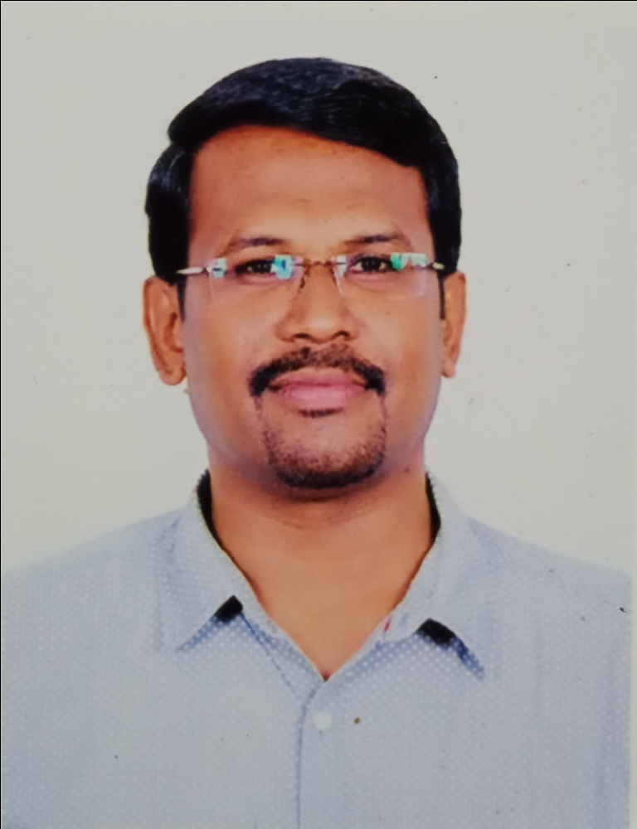

Educational Qualification
Degree | University / Institution | Year of Passing | Class Obtained
PhD | Bharathiar University, Coimbatore | Pursuing | -
M.Phil | Bharathiar University, Coimbatore | 2007 | Commended
MCA | Maharaja College of Engineering, Coimbatore | 2001 | First Class
B.Sc | Chickkana Arts and Science College, Tirupur | 1998 | First Class

Details of Publications
- Number of Books Authored (With ISBN) - 04
- Number of Book Materials Published - 04
- Number of Papers in Referred Journals - 06
- Number of Papers in International Conferences - 06
- Number of Papers in National Conferences - 22
- Number of Workshops, Seminars, FDPs Attended - 80+

Patent Application Publication:
Application No.202241003698 A, “Security model to predict threat in android applications and IoT” Pg.No. 6314, Issue No:05/2022 dated 04.02.2022

Awards Received:
“Leadership Excellence Award”, IOT Academy, Coimbatore on 25/06/2022

Experience
S.No. | Name of the Institution | Designation | Period
S.No. | Name of the Institution | Designation | From | To | Total
1. | AVP College of Arts and Science, Tirupur | HoD & Associate Professor in CS + Administrative Officer | 20.01.16 | Till Date | 6.6 Years
2. | Sasurie College of Engineering, Vijayamangalam | HoD & Associate Professor in  Computer Applications | 02.07.07 | 28.05.15 | 7 Years
3. | Park’s College, Tirupur | Lecturer in  Computer Applications | 13.06.02 | 01.07.07 | 5 Years
4. | Nehru College of Arts and Science, Tirupur | Lecturer in  Computer Science | 19.06.01 | 12.06.02 | 1 Year
Total Experience: 19 Years 6 Months

Important Responsibilities Held

S.No. | Responsibility | Institution
1. | NAAC& IQAC Committee – Member | AVP College of Arts & Science
2. | Member of the Senate– Teachers Category, Bharathiar University | AVP College of Arts & Science
3. | Administrative Officer | AVP College of Arts & Science
4. | Head of Department – Computer Science | AVP College of Arts & Science
5. | Head of Department - MCA, B.Sc(CT), B.Tech (IT) | Sasurie College of Engineering
6. | AICTE Approvals – Convener | Sasurie College of Engineering
7. | NAAC Steering Committee – Coordinator | Sasurie College of Engineering
8. | NAAC& IQAC Committee – Member | Parks College
9. | Autonomous Steering Committee – Member | Parks College
Membership of Scientific & Professional Societies

(a) Life Member : ISTE Membership Number: LM 65054
(b) Life Member : IACSIT Membership Number: 80340464
(c) Life Member : IAENG Membership Number: 110955

Other Details
- Organized around 72 Association Programmes that includes Seminar, Guest Lecture, Workshop, Hardware Exhibition, Mini Project Exhibitions and Symposium.
- Wipro’s Mission 10X Certified Faculty Trainer
- Resource Person at Faculty Development Programmes on Teaching Methodologies and Teaching Pedagogies
- Given Guest Lectures on Recent Trends at various locations.
- Guided 60 Undergraduate and 87 Postgraduate projects.
- Been as a Jury and resource person for various events at Symposiums, Conferences, Seminars and Workshops.
- Question Paper setter at two autonomous institutions.

Personal Details

Date of Birth : 13-07-1978
Gender : Male
Nationality : Indian
Mother Tongue : Tamil
Languages known : Tamil, English, Hindi

The information furnished above is true to the best of my knowledge.

Date:
Place: Tirupur Signature

