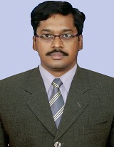
CURRICULUM VITAE

Dr. B.Somasekhar
E.mail: bssekharme@gmail.com
Ph No: 9440228653
Anil Neerukonda Institute of Technology & Sciences
Asso. Professor, Dept. of ECE
Sangivalasa; Bheemunipatnam Mandal
Visakhapatnam - 531162
D.No: 18-141, Port Colony,
Near Venkateswaraswamy Temple
Madhurawada,
Visakhapatnam-530 048

Educational Qualifications

- Ph.D : ECE, JNTU Kakinada , Feb-2017

- M.E : A.U. College of Engineering, Andhra University, 2005

- B.E : A.U. College of Engineering, Andhra University, 1999

MEMBERSHIP

- Life Member of ISTE
- Member of IEEE

EXPERIENCE: 22.1 yrs

Teaching Experience (UG & PG) in Various Engineering Colleges: 22.1 Years

- Working as Asso.Professor in Anil Neerukonda Institute of Technology & Sciences, Visakhapatnam, from June 2017 to till date
- Worked as Asso.Professor in NS Raju Institute of Technology, Visakhapatnam, from Dec. 2016 to May 2017.(0.6 yrs)
- Worked as Asso.Professor & H.O.D in S.V.P.Engineering College, Visakhapatnam, from Sept. 2009 to Dec. 2016.(7.3 yrs)
- Worked as Asso.Professor in Chaitanya Engineering College, Visakhapatnam, from July 2006 to March 2007 and July 2008 to Sept 2009.(2.6 yrs)
- Worked as Asst.Professor in VITAM College of Engineering, from Apr 2001 to July 2006.(5.2 yrs)
- Worked as Lecturer in VITAM College of Engineering, from Nov 1999 to March 2001 (1.5 yrs)

ACHIEVEMENTS

- Nominated as a panel member by JNTUK, for ratification of Asst.Professors to VIET.
- Reviewer for INDISCON 2020
- Recognized as Guide by the Andhra University in the year 2019, to guide Ph.D candidates. Four Ph.D candidates allotted under my supervision.
- Attended Doctoral Committee meeting on 17.06.2021 (on line through zoom) to conduct on-line comprehensive examination of Ph.D, thesis.
- Attended Doctoral Committee meeting (09.12.2017) at Sathyabama University, Chennai to finalize the course work and proposal thesis abstract.
- Best teacher award for the academic year 2012-13.
BOOKS / MONOGRAPHS PUBLISHED

- Published book on “ Investigations MIMO OFDM wireless Communication System” LAMBERT Academic Publishing, 2020
- Published book on “ Investigation on PAPR Reduction & Interference Mitigation in MIMO OFDM” LAMBERT Academic Publishing, 2018

OTHER ACTIVITIES

- Asst. Controller of examinations and spot coordinator
- IQAC member
- Research Coordinator in ANITS Engineering College from 05.07.2017 to till date
- Proposal Uploaded for AICTE-Faculty Development Program – 2017 in NS Raju Institute of Technology, Visakhapatnam
- Chief Superintendent (II/IV B.E/B.TECH), Advanced Supplementary University Exams, June-2016, (I-Semester) in S.V.P Engineering College, Visakhapatnam.
- Chief Superintendent (II/IV B.E/B.TECH), University Exams for the academic year 2015-16, (II-Semester) in S.V.P Engineering College, Visakhapatnam.
- Chief Superintendent, Staff Selection Commission, Dec – 2015 in S.V.P Engineering College, Visakhapatnam.
- Asst. Chief Superintendent, University Exams for the academic year 2015-16, (I-Semester) in S.V.P Engineering College, Visakhapatnam.
- Asst. Chief Superintendent, AP EAMCET-2015 in S.V.P Engineering College, Visakhapatnam.
- Asst. Chief Superintendent, EAMCET-2014 in S.V.P Engineering College, Visakhapatnam.
- Asst. Chief Superintendent, (II/IV B.E/B.TECH), University Exams for the academic year 2013-14, 2014-15 (I-Semester) in S.V.P Engineering College, Visakhapatnam.
- Nodal officer for AICTE-EETP-BSNL Program from the Academic year 2013-14
- Member in Faculty Recruitment
AREAS OF INTERESET

- Wireless Communications & Networks
- Cognitive Radio Networks
- Massive MIMO, mmWave, NOMA

manuscripts – REVIEWED (International)

- Springer – IJWPC-2015 : Secure Cognitive Relay Network: Joint the Impact of Imperfect Spectrum Sensing and outdated Feedback ( Annexure – 1)
- Adaptive Separation and Recognition of Subcarrier for Wireless Link of Satellite Communication, 7th International Conference on Electronics, Communications and Networks (CECNet 2017) Nov. 24-27, 2017, National Dong Hwa University, Hualien, Taiwan ( Annexure – 2)
- Optimizing Energy consumption of Sensor Networks Based on Regionalized Compressive Sensing, 7th International Conference on Electronics, Communications and Networks (CECNet 2017) Nov. 24-27, 2017, National Dong Hwa University, Hualien, Taiwan ( Annexure – 3)
ONGOING WORKS
- Channel estimation in MIMO –OFDM and Massive MIMO

INTERNATIONAL JOURNALS (10)

- B.Somasekhar, A.MallikarjunaPrasad, K.MuraliKrishna, “Peak-to-Average-power Ratio reduction using Low-Complexity MIMO SFBC CI-OFDM System” Wireless Personal Communications (Springer - Journal) vol.78, No.9, pp.571-580, Oct. 2014.
- B.Somasekhar, A.MallikarjunaPrasad, “Modified SLM based concurrent PAPR reduction algorithm for STBC MIMO-OFDM systems” International Journal of Electronics and Communication Engineering and technology (IJECET) Vol. 5, Issue 10, October (2014), pp. 86-99, Journal Impact Factor (2014): 7.2836.
- B.Somasekhar, A. MallikarjunaPrasad, “BER Analysis and Interference cancellation in SFBC MIMO-OFDM with timing offset” International Journal of Applied Engineering and Research (IJAER)-(Scopus Index) vol.10, No:4, pp. 8795-8801, 2015 . SJR – 0.125
- B.Somasekhar, A. Mallikarjuna Prasad “Performance Evaluation of Pilot Aided Channel Estimation for MIMO/OFDM Systems” International Journal of computer science and information security- IJCSIS (Thomson Reuters) journal vol.14, No: 3, pp.158-162, March 2016. Journal Impact Factor (2016): 0.519.
- B.Somasekhar, Ch.MohanaKrishna, Y.RamanaMurthy “Investigations on performance of Wavelet and Fourier Transform based Channel Estimation in MIMO-OFDM System” International Journal of Engineering & Technology (Scopus Index) vol. 7, No:2.21, pp.228-231, Apr.2018
- B.Somasekhar, P.ChayaDevi, Ch.MohanaKrishna, Y.RavisaiTeja “Spectrum Sensing In Cognitive Radio: A Bayesian Approach For Maximizing Spectrum Utilization” Journal of Applied Science and Computations (UGC Approved) vol. 5, No:2.21, pp.920-928, Dec.2018
- B.Somasekhar, T.L.Priyanka , K.Triveni, B.Manikanta, G.Deepthi “Clipping Noise Based Tone Injection-An Approach to Reduce PAPR in OFDM System” International Journal of Management, Technology And Engineering (UGC Approved) vol.9, No:5, pp.2835-2838, Apr.2019, Impact Factor: 6.3
- B.Somasekhar, Ch.Saikishore, A.Pratyusha, Nithinkumar “Suboptimal Energy Efficient Resource Allocation to maximize Energy Efficiency in OFDM system” International Journal of Management, Technology And Engineering (UGC Approved) vol.10, No:3, pp.92-97, March.2020. Impact Factor: 6.3
- B.Somasekhar, CH.SaiKishore, D.TarunRamSai, Ch.Asha, S.Manasa, C.Nalanda “Inter Carrier Interference Mitigation in Space Frequency Block Code MIMO-OFDM System” International Journal of Advanced Science and Technology (Scopus) Vol. 29, No. 9s, (2020), pp. 3305-3314
- K.Ramesh Chandra, B.Somasekhar “ An Effective Combination of terahertz band NOMA and MIMO system for power efficiency enhancement” International Journal of Communication Systems (Wiley) Apr.2022 Impact Factor: 2.047
INTERNATIONAL CONFERENCES (8)
- G.Santhi Swaroop Vemana, Mohan Krishna.Ch and Somasekhar.B “ICI Cancellation in SFBC-MIMO OFDM with Carrier Frequency/Timing Offset over Rayleigh Fading Channel” IEEE Int. conf. International Conference on Energy, Communication, Data Analytics and Soft Computing (ICECDS 2017) - Aug. 2017, pp. 1437-1442
- Mohanakrishna.Ch, Somasekhar.B and V.G.Santhi Swaroop “A Study on PAPR Reduction and Channel Estimation in MIMO-OFDM system Using Wavelet Transform” IEEE Int. conf. International Conference on Energy, Communication, Data Analytics and Soft Computing (ICECDS 2017) – Aug. 2017, pp. 1707-1711
- B.Somasekhar, A.MallikarjunaPrasad “Enhanced Method to reduce PAPR in MIMO OFDM system-MCMA Approach” IEEE Int. conf. Electrical, Electronics, Signals, Communication & Optimization (EESCO), Jan. 2015, pp. 1679-1684.
- B.Somasekhar, A.MallikarjunaPrasad, “Modified SLM and PTS approach to reduce PAPR in MIMO OFDM” International Conference On Electronics, Communication and Computational Engineering IEEE Int. conf - ICECCE 2014, pp 1229-1233, Nov.2014, Hosur
- B.Somasekhar, A.MallikarjunaPrasad, K.MuraliKrishna, T.Ravibabu “Selected mapping Clipping and differential scaling for reduction of PAPR in OFDM systems” proceedings in Advances in Recent Technologies in Communication and Computing, ARTCom-2012 (ACEEE – SPRINGER), IET-DIGITAL library, UK, pp. 160-163, Oct. 2012, Bangalore
- Presented a paper on “Performance evaluation of different digital modulation schemes in AWGN channel with antenna diversity reception in mobile communications” at International conference on recent advances in computer sciences March 30th-31st 2012; ICRACS-2012; GIET- Rajahmundry.
- Presented a paper on “A Novel approach for Peak-to-Average-Power ratio reduction in OFDM systems” at Baselios Mathews – II college of Engineering, Kollam-Kerala (International Conference on Emerging Technological Trends (ICETT-2012); 20th-21st Feb-2012)
- A Three-Day International conference on “Machine Intelligence Application to Power, Signal Processing, Communication and Control (MIPSCCON-2011) held at GMRIT, Rajam, Srikakulam (7th – 9th Apr. 2011)

NATIONAL CONFERENCES (3)

- Presented a paper Presented a Presented a Paper on “An enhanced Peak-to-Average-Power ratio reduction in OFDM system using cyclic prefix” at Andhra University, Visakhapatnam (ACNCN-2012; Conference on advances in communication, navigation and computer networks 17th-18th march,2012)
- Presented a Paper on “Analysis of BER and PAPR in OFDM with new companding transform” at B.V.C Engineering college, Amalapuram (A National conference on Emerging Technologies in Electronics & Communications – NCETEC-2011; 3rd- 4th December 2011)
- A Two-Day National conference on “Automation, Communication & Computing” (NCACC-2010) held at GITAM University.(9th & 10th Dec. 2010)

WORKSHOPS & TRAINING PROGRAMS ATTENDED (17)

- Attended a one day workshop on “ Awareness program on Strengthening of MSMEs” on 19th March 2022 at Daspalla, Visakhapatnam.
- Participated a one day webinar on “Research Findings – Submission to Successful publication” organized by Dept. of ECE Miracle Educational Society Group of Institutions, on 6th May 2020 (11.00 A.M to 1.00 P.M)
- Attended a two week AICTE sponsored Faculty Development Program on “Engineering Challenges for Making Digital India: Internet of Things & Applications” organized by the Dept. of ECE ANITS, during 11th – 24th June-2019.
- Attended one week Faculty Development Program on “5G Wireless communications” organized by the Dept. of ECE ANITS in association with NIT Warangal (Under the scheme of Electronics & ICT Academy) during 5th – 10th Jan-2018.
- Attended a one day workshop on “Outcomes Based Education” organized jointly by IETE Visakhapatnam Center and Dept. of ECE ANITS on 23rd Dec-2017.
- Attended a one day National workshop on “Innovation & Incubation Centers in Engineering Colleges”, 9th March, 2017, organized by S.R.K.R.Engineering college, Bhimavaram, in association with AIM, NITI Aayog, Govt. of India.
- Attended a three day National workshop on “Advanced Antenna Design” (NWAAD) during 19th – 21st oct-2016 organized by AU College of Engineering (A), Visakhapatnam
- Attended a two day workshop on “Advances in Signal and Image Processing, Computer Vision” from 27th to 28th Feb. 2014 at ANITS Engineering college, under AICTE-RPS
- Attended a two day national workshop on “Advances in Signal Processing” from 30th Aug 2013
to 31st Aug 2013 held at Andhra University college of Engineering, Visakhapatnam.
- Attended one day workshop on “MATLAB & simulink for Engineering Education” 7th Feb 2013
held at Fortune Inn, Visakhapatnam.
- Attended a six day training program on “ Digital Communication ” from 25th to 30th June 2012 held at M.V.G.R. College of Engineering, Vizianagaram, Organized by A.P.State Counicl of Higher Education in association with JNTU, Kakinada
- A Two-Day National level workshop on “Soft-Computing Applications to Communications And Management” SAKAM jointly organized by Dept. of E.C.E & E.I.E on 28th & 29th Apr. 2012 AITAM, TEKKALI, Srikakulam.
- A Two-Day National workshop on Optimization Techniques in engineering applications organized by Dept of Electronics and Communication Engineering, GMRIT, RAJAM , 12-13 March 2009.
- ISOI National Workshop on Embedded Systems Design Using Micro-Controllers and Micro & Nano systems held at Andhra University on 6th and 7th – December 2008
- Recent Developments in Information and Communication Technology 12th & 13th September 2008, AITAM, TEKKALI, Srikakulam.
- A Two-Day National workshop on Applications of Micro Processors and Microcontrollers organized by Dept of ECE &EEE, GMRIT, RAJAM , 18-19 February 2008.
- Workshop on Latest Technologies in Electronic Communications WOLTEC – 05 during 12th – 13th March 2005, organized by Dept of Electronics and Communication Engineering, MVGR College of Engg. VIZIANAGARAM.
WORKSHOPS & EVENTS ORGANIZED (10)

- One-Day workshop “GATE Awareness Program” was organized in Sanketika Vidya Parishad Engineering College, on 26th Feb. 2014
- Organized two week ISTE workshop on Signals & Systems from 02.01.2014 to 12.01.2014 in collaboration with IIT Kharagpur at Sanketika Vidya Parishad Engineering College.
- Organized a two day workshop on Embedded Systems & VLSI product design from 29th to 30th July 2013 at Sanketika Vidya Parishad Engineering College.
- Organized two week ISTE workshop on Analog Electronics from 04th to 14th june 2013 in collaboration with IIT Kharagpur at Sanketika Vidya Parishad Engineering College.
- A two day technical youth fest Sanketh-13 was organized in Sanketika Vidya Parishad Engineering College, from 14th to 15th March 2013.
- A three day technical youth fest Sanketh-12 was organized in Sanketika Vidya Parishad Engineering College, from 15th to 17th March 2012.
- A One-Day workshop on “RADAR Antennas for Defense Applications” was organized in Chaitanya Engineering College, on 23rd January 2009.
- A One-Day workshop “Embedded Systems” was organized in Chaitanya Engineering College, on 18th Oct. 2008.
- A Two-Day workshop on MATLAB Programming & Practice was organized in Chaitanya Engineering College, from 24th Sept. 2008 to 25th Sept. 2008.
- A One-Day workshop ZENCOM was organized in VITAM college of Engineering, 2003

Personal Details

Father’s Name : B.E.D. PRASAD
Date of Birth : 01st June, 1977
Marital Status : Married
Nationality : Indian

DECLARATION:
I solemnly declare that all the above particulars are true, complete and correct to the best of my knowledge and belief.

(Dr. B.Somasekhar)

Annexure – 1

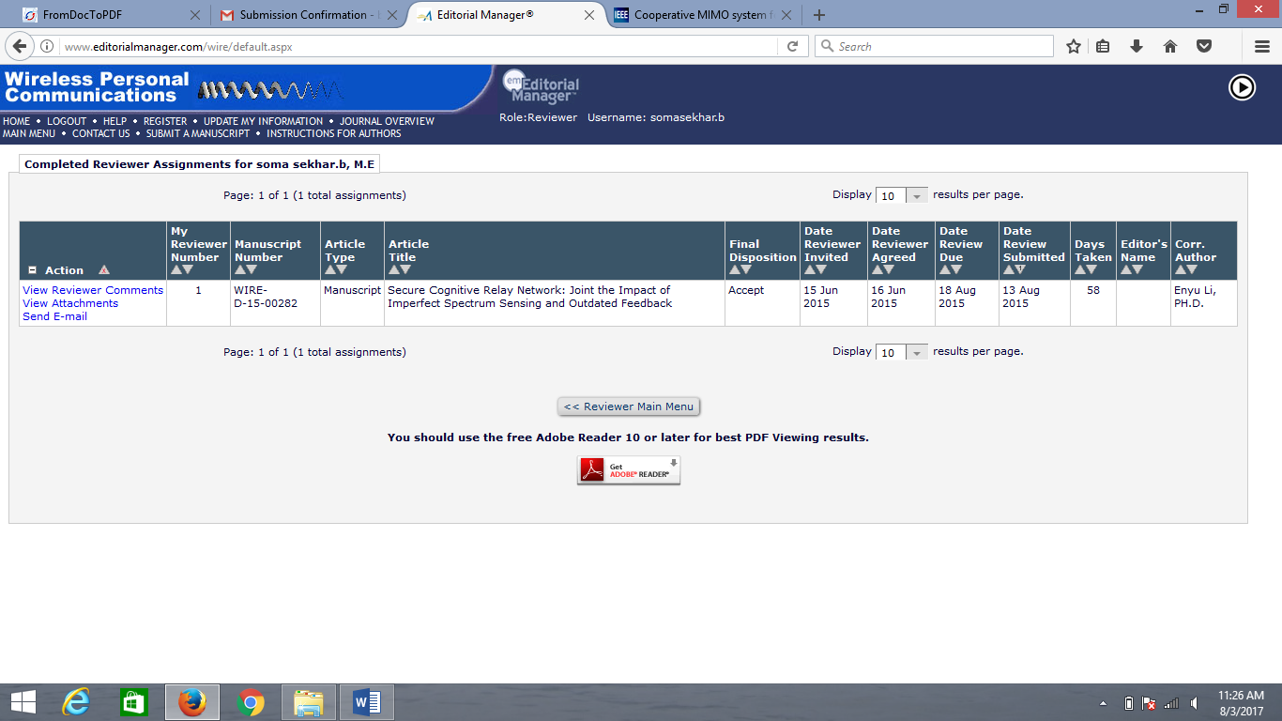

Annexure – 2
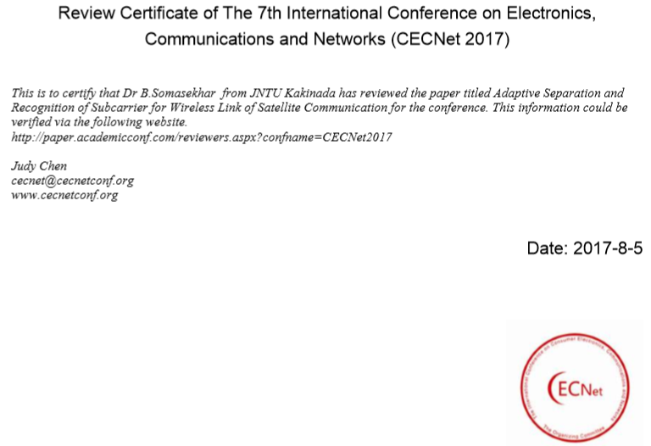

ANNEXURE – 3

