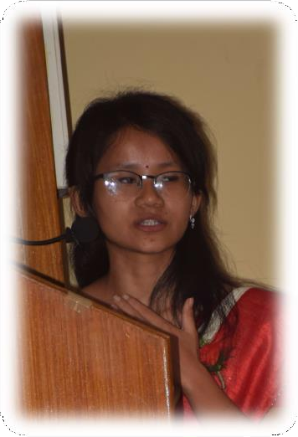***Swastika Subba***

Contact: +91-62991-50946

E-mail: *s*[*wastikasubba2020@gmail.com*](mailto:wastikasubba2020@gmail.com)

**Permanent Address: c/o Leela Chettri, Development Area MW, Jeevan Thing Road, Opposite to Old Shopping Complex, Near ENT clinic, Gangtok, Sikkim-737101**

**Correspondence at 37, R K Nagar, Garia, PO: Laskarpur, PS: Bansdroni, Kolkata-153**

***Date of Birth:* February 6th, 1998**

# About me

I personally believe that writing is a light as well as hope to shape the entire world. Since from very small age writing has always been my favorite hobby, apart from this I love reading and making creative items cause I feel that if I can keep art alive than my soul is in solitude.

# Educational Qualification-

|  |  |  |
| --- | --- | --- |
| **Class** | **Educational Institute** | **Mar s Obtained in Year** |
| Secondary | Palzor Namgal Senior Secondary Girls School  Affiliated To Council For Secondary Board Examination, New Delhi | 7.0 CGPA in 2014 |
| Higher Secondary | Greendale Senior Secondary School Affiliated to Council For Secondary Board Examination, New Delhi | 67% in 2016 |
| Bachelor of Science in Genetics (Hons) | Institute of Genetic Engineering  Affiliated to Maulana Abul Kalam Azad University of Technology, WB | 6. 9 DGPA in 2019 |
| Master Of Arts in Psychology(MAPC) | Indira Gandhi National Open University (IGNOU) | Pursuing |
| Certificate in Biochemic Medical Science | Humanity, Institute for Advanced Medical and  Cultural Research | Pursuing |
| Certificate in Vedic Art Therapy | Elena Zelencia | 2021 |
| Certificate in Graphology | Sudhir Khollam | 2021 |
| Diploma in Art Therapy | Elena Zelencia | 2021 |
| Diploma in Psychiatry | IIT Kanpur, NPTEL | 2022 |
| P.G. Certificate in Dialectic Behavioural Therapy | Udemy | 2022 |
| Diploma in CBT | Achology | 2020 |
| Diploma in Modern Applied Psychology (DiMAP.) | The Academy of Modern Applied Psychology | 2022 |

***Working experience:***

1. Former Academic Content writer at Assurex e-Consultants (2019-2020)
2. Academic Content writer at Sunflower Tech (2020-)
3. Volunteer writer at The Craze Venture (2020-)

# Achievement

* 1. Dr. Schussler Memorial Award for Best Presentation in the Year 2019 conducted by Indian School of Complementary Therapies and Allied Sciences, WB in Collaboration with H.I.A.M.C.R.
  2. Titled 1st in the scientific model competition held by National Innovation Foundation in the year 2010.
  3. Winner of Scientific Model program held by Bee Fest in 2012.
  4. Won 1st prize on the theme program “Udaan” on the occasion of the Rajiv Gandhi Birth Anniversary in the year 2011.

# Research and Articles

1. Individualization, Medico-Social Approach published in the journal of International Journal for Trends in Scientific Research and Development
2. Effects of Thoughts on Health, published under Scientia, International Journal for Interdisciplinary Research.
3. CoVID-19, A Man Made Disaster & Its Treatment in IJTSRD
4. CoVID-19, The Facts, Hidden Secrets, Treatment & Prevention in IJAR
5. Religion and Violence in IJCRT

***Book Chapters***

1. Individualization, Medico-Social Approach in IIP proceedings

# Blogs

1. History of Infectious Disease, under H.IA.M.C.R.
2. Government Hiding Behind the Curtain, in TCV
3. An interview from the Ground Zero to Investigate the Disharmony in the World in TCV

# Hobbies

1. Writing short stories, poems
2. Writing Contents regarding Social, Educational, Medical activism
3. Reading Novels
4. Painting & Sculpture
5. Creating hand-made crafty stuff