RESUME

Education

First class in M.Sc Physics from Tezpur Central University;Tezpur, Assam

with Specialisation in Condense matter Physics and Material science.

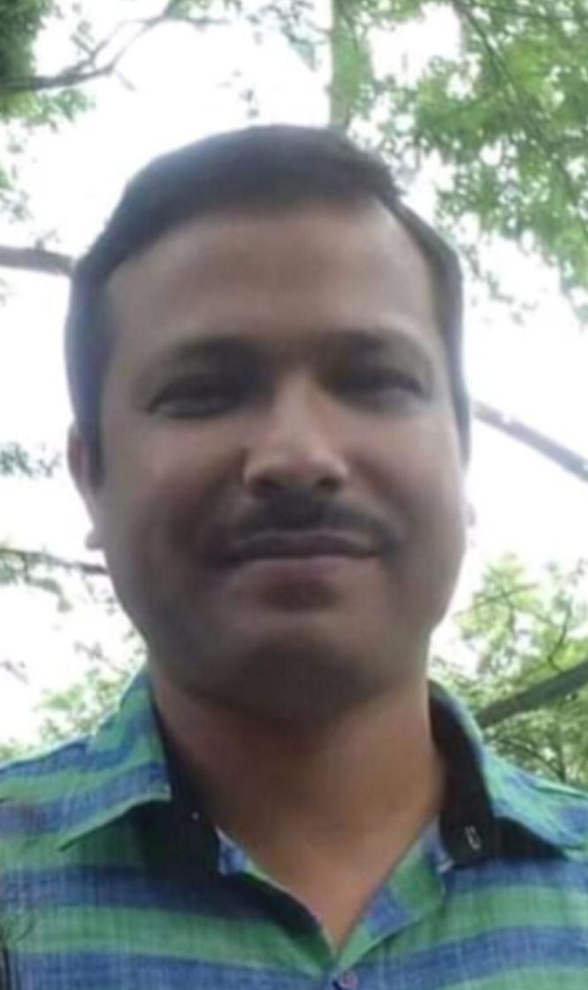

Name:- Sri Hemendra Kumar Nath.

Intended : Teaching

Birthday :- 30.01.77

Live in :- Tezpur

Phone no. :- 9954059823

email id :- lakhya.e@gmail.com WORK EXPERIENCE

2020 - Present :- Working as a Asst. Teacher under Govt. of

Assam.

2016 - 2020 :- Worked as a PGT in Pathsala under CBSE

2013 - 2016 :- Worked as a PGT in JNV Tawang & JNV William

nagar.

2001- 2013 :- Worked as a Asst. Prof. in a College in Dhekiajuli

on Adhock basis. During these time one UGC

sponsors Minor research project was complete.

PROFESSIONAL SKILLS :-

Teaching :- 1) Science and Mathematics (up to 12th standard).

2) Physics (up to degree level).

Language :- English , Hindi, Assamese, Bengali.

SELF - EVALUATION

I am expecting to receive my Doctor of philosophy, degree in Material Science from any recognised University within coming 5 years.

One of my career goals include to Publish & Edit the various research Books in conceen

specific area.