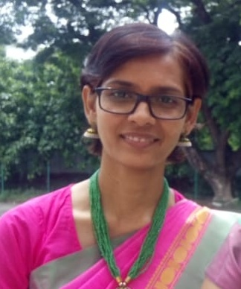

Dr. Shan Eugene Palakkal 182E, R C Queens Park
Melody, Blk-D, Door No.B2(2nd flr)
Madhavaram High Road, Chennai -60
----------------------------------------------------------------------------------------------------------------

CAREER OBJECTIVES
- To be a part of high caliber professionals in a progressive institution, thereby sharpening my own skills, while at the same time contributing my best to the overall development of the institution.
- To learn and excel in the assigned job and the willingness to take up responsibilities, thereby assuring quality outputs adding to the betterment of self, institution and society as a whole

Personality traits -
An exceptional communicator; Versatile and an individual who adapts well to new situations; good commitment drive; a hardworking flexible approach seeking to utilize education and potential within progressive and responsible position; Sportsmanship and team spirit.

ACADEMIC CREDENTIALS :
EXAMINATIONS/ YEAR OF INSTITUTION DIVISION
DEGREE PASSING
----------------------------------------------------------------------------------------------------------------
1. Ph.D. Awarded on University of Kerala
3rd May 2011 Thiruvananthapuram
Thesis : Custodial Violence in Kerala (1996-2006) – A Historical Perspective

2. M.Phil June University
Kerala University 2003 College ‘A’ Grade
Trivandrum-34
Dissertation - Human Rights Violations In Kerala: Historical Perspective:1956-2000

3. M.A. April Meenakshi 1st
University of Madras 2001 College For Women
Chennai- 24
Project - History of Tamil Nadu Archives

4. B.A. 1999 Meenakshi 2nd
University of Madras College For Women
Chennai-24

5. A.I.S.S.C.E. 1996 Tagore School 2nd
(12th) CBSE New Delhi-64

Subjects - English, Physics , Chemistry, Biology , Mathematics

PROFESSIONAL EXPERIENCE
- Presently working as Assistant Professor, Dept. of History, at Stella Maris College, Chennai Since November 2010.
- Worked as Project Fellow (MRP-UGC) in the Dept. of Indian History, University of Madras from December 2009 to December 2010.
- Lecturer in Indian History, Government Law College, Ernakulam, Kerala from June 2009 -December 2009
- Lecturer in Dept. of History and Archaeology, Union Christian College, Aluva, Kerala from May 2008-May 2009
- High School Teacher in Social Studies at Christ Nagar Senior Secondary School, Thiruvallom, Thiruvananthapuram from May 2007-April 2008
- Worked as Senior Executive Officer in V3 Global Ltd., Kochi - 682 031 from 2003-2004

PROFESSIONAL QUALIFICATION
- passed State Eligibility Test (SET) in 2005.

TECHNICAL SKILLS
- GNIIT Course, 1997-1999, NIIT Chennai.

INTERESTS AND ACTIVITIES :
- Creative Writing, Reading, Travelling, Music, Outdoor games.

NAME : Dr. Shan Eugene Palakkal
SPOUSE NAME : Mr. Elvis Padua
DATE OF BIRTH : 5th August 1978
NATIONALITY : Indian (Christian)
COMMUNITY : Forward Caste (FC)
SEX : Female
E-MAIL ADDRESS : shan.eugene@gmail.com,
shaneugenepalakkal@stellamariscollege.edu.in
PHONE NUMBER : 09380730025

