PERSONAL INFORMATION | Abderrahim Bouderbane
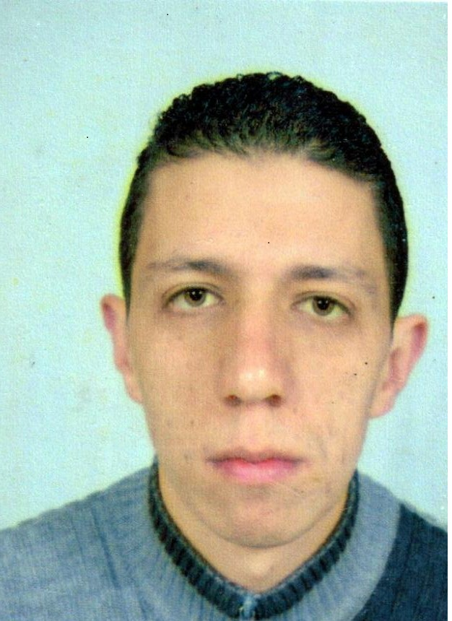 |   76 BOULFELFEL BROTHRES STREET EL-KHERBA MILA - Algeria -
 |  +213672284964

abderrahim.bouderbane@yahoo.com/ abderrahim.bouderbane@gmail.com
 | Sex Male | Date of birth 17/10/1986 | Nationality Algerian

Curriculum Vitae

WORK EXPERIENCE

2009-2015  2013-2015  2014-2016  2013-2015  2015-2016  2017  2017  2018 | Part-Time Teacher at University of Frères Mentouri Constantine
- Teaching the modules of Oral Expression, Written Expression, Translation, and English for Business.

Teaching the modules of Oral Expression, Written Expression, English for Specific Purposes and Research Methodology.

Part-Time Teacher at Mila University Centre
Teaching the modules of Written Expression and Oral Expression and being responsible for a team of 4 teachers of the module Written Expression.

Teaching English as a Second Language in the Intensive Centre of Languages in Constantine University Algeria.

Working a freelance translator for Lan-bridge translation company for two years.

Teaching English to students of economicsat the department of economics at Mila university centre.

Full-Time assistant teacher at Mila University Centre.
Assistant of the head of department of foreign languages at Mila university Centre.
Headmaster of the department of foreign languages at Mila University Centre
2019 to present Associate professor at Mila University Centre

EDUCATION AND TRAINING

2004-2007  2007-2009  2009-2016 | Bachelor of Arts in English option Applied Linguistics  Master of Arts in English option Applied Linguistics  PhD in English option Applied Linguistics
2004-2007  2007-2009  2009-2016 | University of Frère Mentouri Constantine- Algeria

PERSONAL SKILLS

Mother tongue(s) | Arabic
Other language(s) | UNDERSTANDING |  | SPEAKING |  | WRITING
Other language(s) | Listening | Reading | Spoken interaction | Spoken production
English | C1 | C1 | C1 | C1 | C1
French | C1 | C1 | C1 | C1 | C1
Levels: A1/2: Basic user - B1/2: Independent user - C1/2 Proficient user
Common European Framework of Reference for Languages

Communication skills | • Good communication skills gained through my experience as a part time teacher and as teacher responsible for a 4 teachers’ at Mila University Centre.

Organisational / managerial skills | • Very good organizational and managerial skills gained through experience in teaching and learning.  • Good leadership gained through working as a responsible for the team of Written Expression Subject in the academic year 2013-2014.

Job-related skills | • Ability to work under any condition and in any situation.  • Good problem solving skills gained through guiding and supervising 29 students during the making of their BA final graduation research projects.  • Highly motivated to work with people from different countries and with different nationalities.

Computer skills | • Good command of Windows applications.  • Excel, Microsoft Word 2010, and Power point presentation.

Hobbies | • Practicing sport ( football, jogging)  • Reading books and watching movies.  •Travelling and visiting new places.

Publications | • Bouderbane, A. (2022). ‘enhancing the quality of teaching and assessement : teaching English in Algeria.’ The challenges and opportunities of teaching English world wide in the COVID-19 pandemic. Eds. Ferit Kılıçkaya, Joanna Kic-Drgas and Rachel Nahlen. New Castle Upon Tyne, U.K : Cambridge Scholars Publishing ; pp.5-10.  • Bouderbane, A. (2021). ‘The Impact of Rhetorical Argumentation on Achieving the Mastery of Fluency and Accuracy in Communicative Competence: A Case Study of 2nd Year Students at the University Des Frères Mentouri, Constantine. International Journal of English Language Teaching, 8(1), 1-10. Available from: https://doi.org/10.5430/ijelt.v8n1p1.  • Bouderbane, A. (2020). Student Social Background and Teacher Expectations: The Self-Fulfilling Prophecy. Cross-Cultural Communication, 16(1), 17-22. Available from: http// www. cscanada.net/ index. php / ccc / artice / view / 11500 DOI: http://dx.doi.org/10.3968/11500  •Bouderbane, A(2020) The effects of economic slowdown during COVID-19 pandemic on higher education sector: a case study of Algerian universities. The 18th International Student Scientific Conference:Economics and the Challenges of the 21st Century.University of Worclaw, Poland.https://www.wshleszno.pl/pliki/grafika/agendy/Harmonogram-XVIII-MSKN.pdf  • Bouderbane,A, (2020) "The effects of language etiquette culturally-bound expressions on EFL students at Mila University Centre.” UBT International Conference. 264https://knowledgecenter.ubt-uni.net/conference/2020/all_events/264.  • Bouderbane, A. (2014). A Comparison Between the Impact of Rhetorical Argumentation and Narrating Stories as Communicative Tasks on Achieving the Mastery of Fluency and Accuracy. Cross-Cultural Communication, 10(6), 177-183. Available from: http//www. cscanada.net/ index.php/ccc/ar t i c l e /view/5067 DOI: http://dx.doi.org/10.3968/5067

Internships • A short- Stay internship for a month, from 2nd of March 2015 to 31st of March 2015, at the Universidad
De Granada Facultado Di Tradiccion ya Interpretacion, Spain.

