CURRICULUM VITAE

Mr. S.SATHISHKUMAR
C/O Dr. Jawahar Paulraj
Ph.D. Research Scholar [Full Time]
Department of Mechanical Engineering
National Institue of Technology
Agartala-Tripura-799046,India.
Mobile: +91-9994274071
E-mail: kssathishkumar.93@gmail.com
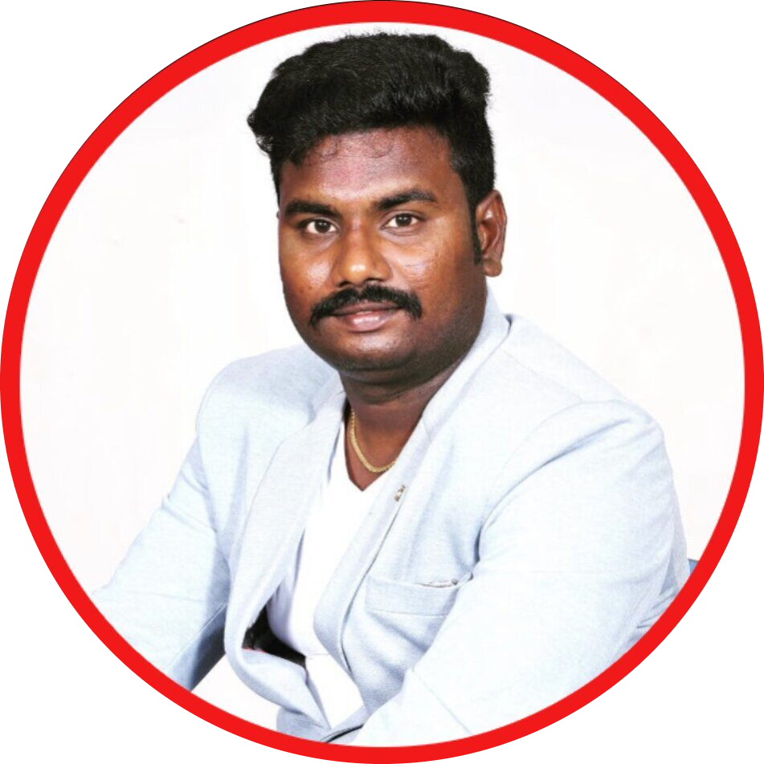

ACADEMIC PROFILE
Ph.D. : Polymer Biomaterials
Junior Research Fellow (2021-Ongoing)
National Institute of Technology, Agartala
Research Area : PEEK Based Biomaterials for Hip Replacement Applications
Supervisor: Dr.Jawahar Paulraj
Assistant Professor, Department of Mechanical Engineering.
M.B.A : Operations Management (2019)
University of Madras – Distance Education
Thesis Tittle : Autonomous Maintenance of Medium Scale Industries
M.E : Engineering Design (2016)
Anna University, Tamil Nadu, India.
Thesis Tittle : Material Development for Thermo Mechanical Strained Structural Application
B.E : Mechanical Engineering (2014)
Anna University, Tamil Nadu, India.
H.SC : Mathematics, Biology (2010)
V.R.C.K.S.Govt Higher Sec School-State Board,Tamil Nadu, India.
AWARDS AND FELLOWSHIPS
- Research Excellent Award, Institute for Exploring Advances in Engineering (IEAE) is an emerging technical professional organization ,Karnataka, India
https://www.insc.in/awards/singleinfo.php?tid=317
INDUSTRIAL EXPERIENCE
- Nil
TEACHING EXPERIENCE

S/No | Institution | Post & Department | Duration | Month of Experience
1 | Vel Tech (Owned By RS Trust) Engineering College, Tamil Nadu, India | Assistant Professor Under the Mechanical Engineering Department. | 02-08-2016  To  25-01-2020 | 41
2 | Vel Tech Rangarajan Dr.Sagunthala R&D Institute of Science and Technology. Deemed By University, Tamil Nadu, India. | Assistant Professor Under Mechanical Engineering Department | 25-01-2020  To  05-02-2021 | 12

RESEARCH INTERESTS
- Solid Mechanics
- Polymer Composites
- Biomaterials
- Material Characterization
- Tribology
- Fatigue
- Computer Aided Engineering Tools
- Optimization Techniques
RESEARCH ACHIEVEMENTS
- International Journal Published : 23
- International Conference Paper Presentation : 05
- National Conference Paper Presentation : 01
- Faculty Development Program & Workshop Participation :10
SKILLS SUMMARY
- AutoCAD, Pro-E, CATIA V5 R20, ANSYS, MSC ADAMS.
- Efficient Communication Skills
- Flexible and Adopt to any environment
- Critical Thinking & Decision Making Ability
MEMBERSHIPS IN PROFESSIONAL BODIES
- International Society for Research and Development
Fellow Member - M4150904028
- IAENG -International Association of Engineers
Fellow Member - 191976
- Indian Society for Technical Education (MISTE) – LM 127692
PERSONAL
Date of Birth : 24th July 1993
Nationality : Indian
Sex : Male
Marital Status : Un-married
Father’s Occupation : Farmer
Address : S. Sathishkumar
S/O Sankar
88,Mettu Street
Kovilur Village and Post
Cheyyar Taluka
Tiruvannamalai District -604404
Tamil Nadu- India

Ph: 9994274071,9444665285

