RESUME
Dr. S. PRABAVATHY B. Sc., M.C.A., Ph.D.  Mail ID : prabavathy.mk@gmail.com  Mobile : 9952228833  Scopus ID : 57270123100  Orcid ID : 0000-0002-4729-3264  Vidwan-ID: 174965 | 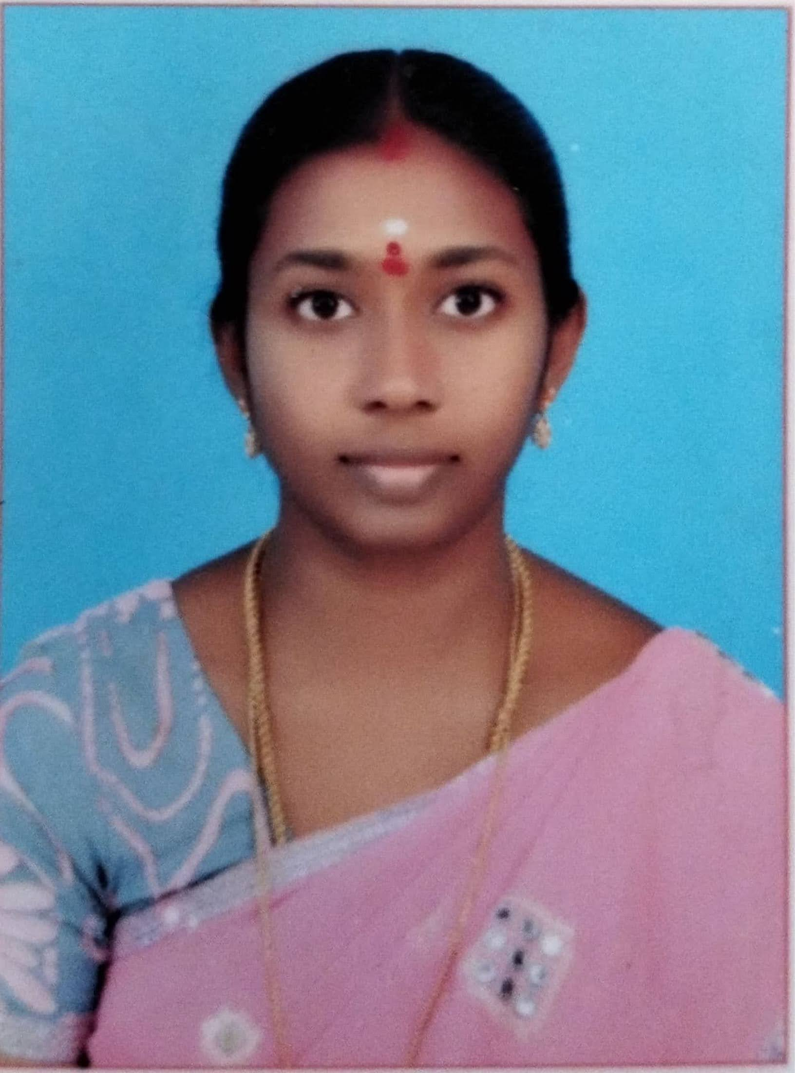

CAREER OBJECTIVE
- Hardworking and committed with strong co-ordination skills.
ACADEMIC PROFILE
Course | Year | Institution | Board / University | Class
Ph. D. (Computer Applications) | 2021 | Annamalai University, Chidambaram. | Annamalai University | Awarded on 12.11.2021
M.C.A. | 2007 | Kamaraj College, Thoothukudi. | Manonmaniam  Sundaranar University | Distinction
B.Sc.,  (Computer Science) | 2004 | A.P.C Mahalaxmi College for Women, Thoothukudi. | Manonmaniam  Sundaranar University | II
HSC | 2001 | VGHSS, Thoothukudi. | State Board | I
SSLC | 1999 | VGHSS, Thoothukudi. | State Board | I

EXPERIENCE
- Working as Assistant Professor of Computer Applications, Arulmigu Subramania Swamy Arts and Science College, Vilathikulam, Thoothukudi, from 19.01.2022 to till date.
- Worked as Assistant Professor of Computer Science, A.P.C. Mahalaxmi College for Women, Thoothukudi, from 01.06.2018 to 19.01.2022.
- Worked as B.T. Assistant in Geetha Matric Hr. Sec. School, Thoothukudi, from 07.08.2017 to 21.04.2018.
- Worked as Assistant Professor of Computer Science, Nethaji Subash Chandra Bose College for Women, Thiruvarur, from 15.06.2015 to 13.04.2017.
RESEARCH AREAS
- Musical Instruments Sound Classification.
- Signal Processing.
- Image Processing.
PROFESSIONAL MEMBERSHIP
Editorial Member in Blue Eyes Intelligence Engineering and Sciences Publication.
Reviewer in Asian Journal of Electrical Sciences.
ACTIVITIES
- Co-convenor in One Day Online Webinar on “Development of Soft Skills” at Arulmigu Subramania Swamy Arts and Science College, Vilathikulam on 22nd February 2022.
SEMINAR / CONFERENCE ORGANIZED
- Organized State level Seminar on “Digitized India” in Nethaji Subash Chandra Bose College for Women, Thiruvarur held on 12th August 2016.
- Organized International Seminar on “Prospective Areas of Research in Computer Science with Healthcare Data” at A.P.C. Mahalaxmi College for Women, Thoothukudi held on 9th and 10th August 2018.
- Organized International Conference on “Recent Trends in Multi-Disciplinary Research (ICRTMDR-2018)”, at A.P.C Mahalaxmi College for Women, Thoothukudi on 19th & 20th December, 2018.
- Organized International Conference on “Recent Trends in Multi-Disciplinary Research (ICRTMDR-2021)”, at A.P.C Mahalaxmi College for Women, Thoothukudi on 8th & 9th April, 2021.
- Organized National Science Day at Arulmigu Subramania Swamy Arts and Science College, Vilathikulam on 2nd March 2022.
LIST OF PUBLICATIONS
- Energy Aware Clustering for Biomedical Wireless Sensor Networks, Journal of Physics, IOP Conference Series. [Accepted] [Scopus & UGC Care]
- Detection of Oral Lichen Planus using Machine Learning Technique, Design Engineering, September 2021, pp. 7525-7533. [Scopus & UGC Care]
- Musical Instruments Sound Classification using GMM, London Journal of Social Sciences, United Kingdom on June 2021.
- Analysis of Oral Epithelial Dysplasia using Machine Learning Technique, Information Technology in Industry, ISSN: 2203-1731, Vol. 9, No. 3, May 2021, pp. 618-621. [Web of Science & UGC Care]
- Classification of Musical Instruments Sound Using Pre-Trained Model with Machine Learning Techniques, Asian Journal of Electrical Sciences, ISSN: 2231-6108 Vol. 9 No. 1, June 2020, pp. 45-48.
- Classification of Musical Instruments using SVM and KNN, International Journal of Innovative Technology and Exploring Engineering (IJITEE), Volume-9 Issue-7, May 2020. [Scopus & UGC Care]
- Musical Instruments Classification using Pre-Trained Model, International Research Journal of Engineering and Technology (IRJET), Volume: 07 Issue: 05, May 2020.
- An Enhanced Musical Instrument Classification using Deep Convolutional Neural Network, International Journal of Recent Technology and Engineering (IJRTE), Volume-8 Issue-4, November 2019. [Scopus & UGC Care]
- Recognition of Musical Instruments by Machine, International Journal of Science, Engineering and Management (IJSEM), Vol 2, Issue 12, Dec. 2017.
- Code Translation from C++ to JAVA, Sankhya - International Journal of Management and Technology, Vol.4, Issue.2, October 2015.
BOOK CHAPTERS
- Classification of Histopathological Variants of Oral Squamous Cell Carcinoma Using Convolutional Neural Networks, in Big Data Management in Sensing: Applications in AI and IoT , River Publishers, 2021, pp.1-14. [IEEE]
- Musical Instrument Sound Classification Using GoogleNet with SVM and kNN Model, In: Chen J.IZ., Tavares J.M.R.S., Iliyasu A.M., Du KL. (eds) Second International Conference on Image Processing and Capsule Networks. ICIPCN 2021. Lecture Notes in Networks and Systems, vol 300. Springer, Cham. [Scopus & UGC Care]
PRESENTATIONS IN INTERNATIONAL CONFERENCE
- Musical Instruments Sound Classification using GMM, 3rd London International Conference, organized by UKEY Consulting and Publishing, London, United Kingdom on 3rd to 5th June 2021.
- Musical Instrument Sound Classification Using GoogleNet with SVM and kNN Model, 2nd International Conference on Image Processing and Capsule Networks (ICIPCN 2021) organized in association with King Mongkut’s University of Technology Thonburi, Thailand, Dayeh University, Taiwan and Tribhuvan University, Nepal on May 27th and 28th, 2021. [Springer]
- Computer Aided Diagnosis for Identifying Oral Epithelial Dysplasia Using HOG and LBP Features, International Conference on Recent Trends in Multi-Disciplinary Research (ICRTMDR-2020), organized by A.P.C Mahalaxmi College for Women, Thoothukudi on 8th and 9th April 2021.
- SVM based Musical Instrument Sound Classification using MFCC and Sonogram, International Conference on Recent Trends in Multi-Disciplinary Research (ICRTMDR-2020), organized by A.P.C Mahalaxmi College for Women, Thoothukudi on 27th & 28th February, 2020.
- Recognition of Musical Instruments by Machine, International Conference on Recent Advancements in Information, Science & Engineering (ICRAITSE-17), organized by A.P.C Mahalaxmi College for Women, Thoothukudi on 14th & 15th December, 2017.
ONLINE CERTIFICATION COURSE
- Completed twelve weeks NPTEL Online Certification Course on “Internet of Things”.
PATENT
- Published Indian Patent “A NOVEL APPROACH FOR DETECTION OF FAULTY NODE USING (TWFDS)” on 26th March 2021.
- Published Indian Patent “CONSTRUCTION OF APP USING AUGMENTED REALITY AND VIRTUAL REALITY- BLUE PRINT” on 10th December 2021.
- Published Indian Patent “HEALTH MONITORING SYSTEM FOR BOVINES, BOAR OR BIRDS BASED ON ARTIFICIAL INTELLIGENCE AND IOT” on 15th April 2022.

FACULTY DEVELOPMENT PROGRAM
- Attended seven days FDP on “Case Writing and Case Teaching” conducted by Annamalai University from 5th to 11th February 2020.
- Attended six days FDP on “Introduction to Artificial Intelligence and Machine Learning” conducted by Geethanjali College of Engineering and Technology, Keesara from 25th to 30th May 2020.
- Attended a FDP on “Importance of Academic Identities and VIDWAN” conducted by A.P.C. Mahalaxmi College for Women, Thoothukudi on 25th February 2021.
- Attended five days FDP on “Advancement of Intelligent System and Computation” conducted by JIS College of Engineering, West Bengal from 20th to 24th April 2021.
- Attended three days FDP on “Machine Learning” conducted by G.U.Pope College of Engineering associate with DevTown Pvt. Ltd. From 15th to 17th March 2022.
SEMINARS / WORKSHOPS
- Attended an International Seminar on “Recent trends in Computing Technology” conducted by Wavoo Wajeeha Women’s College of Arts and Science, Kayalpatnam on 22nd August 2019.
- Attended two days Hands-on Workshop on “Deep Learning in Various Research Domains” conducted by Mepco Schlenk Engineering College on 14th and 15th February 2020.
- Attended a National workshop on “Research Report writing” conducted by Kamaraj College, Thoothukudi on 6th April 2019.
- Attended a Workshop on “Scholarly Writing and Publishing Research Papers” conducted by V.O.Chidambaram College, Thoothukudi on 2nd February 2019.
WEBINAR
- Attended an International Seminar on “Innovative and Inspire the What and How of Ideas” conducted by A.P.C Mahalaxmi College for Women, Thoothukudi on 4th March 2020.
- One day Webinar on “Recent Trends in Machine Learning” conducted by Kamaraj College, Thoothukudi on 5th February 2021.
- One day Webinar on “Protect your Information in the Digital Age” conducted by A.P.C. Mahalaxmi College for Women, Thoothukudi on 20th April 2021.
PERSONAL DETAILS
Date of Birth : 02.10.1983.
Father’s Name : Mr. S. Selvajeyapandi
Husband’s Name : Mr. K. Manikandan.
Language Known : Tamil, English.
Mobile Number : 9952228833
Address for Communication : 13/2A/11C, Sundaravelpuram 1st street,
Thoothukudi – 628002.
Thoothukudi District.
Tamilnadu.
India.

S. Prabavathy

