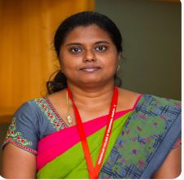
C.Santhiya,
Assistant Professor,
Department of Computer Science and Engineering,
Madurai-15
csit@tce.edu

C.Santhiya received her (B.Tech Information Technology ) from Periyar Maniammai College of Engineering,Thanjavur, Anna University, Tamil Nadu, India; and M.E. (Computer Science and Engineering) from Velammal College of Engineering, Chennai, Anna University, Tamil Nadu, India. Currently, she is working as an Assistant Professor in the Department of Computer Science and Engineering, Thiagarajar College of Engineering, Madurai, Tamil Nadu, India. Her research interest covers distributed computing, Algorithms and Software Engineering.

