|  |  |
| --- | --- |
| **C:\Users\ACER\Desktop\3848.jpg** | Dr. V. RADHIKA |

**Career objective**:

To impart quality education with emphasis on Electronics and Communication Engineering and applying my skills to grow professionally by being resourceful, innovative, and flexible.

**Personal Details:**

**Name** : Dr. V. RADHIKA

**Parents**  : Er. V. Narayana

Smt. V. Dwaraka Mayee

**Address for correspondence** : D.NO.3-17-47/22A, Lakshmi Nagar,Godari Gunta, Kakinada,

East Godavari District, Andhra Pradesh, 533003.

**E-mail**  : radhikav139@gmail.com

**Nationality** :Indian

**Religion**  : Hindu

**Date of Birth**  : 13th August, 1972

**Acedamic summary:**

|  |  |  |  |
| --- | --- | --- | --- |
| **Qualifying Examination** | **University** | **Year of Passing** | **Marks/ Percentage** |
| Ph.D in ECE | JNTUK, Kakinada | 2019 Ph.D Awarded | --- |
| M.Tech | JNTU, Kakinada | 2008 | 68.2% |
| AMIETE | IETE, New Delhi | 2002 | 52% |
| DECE | GPTW, Kakinada | 1991 | 61% |
| SSC | MGH School, Kakinada | 1987 | 78.8% |

**Memebership :**

1. Member in IEEE, Membership number : 98322651
2. Life time Fellow member in IETE , **F087544**, IETE, 2, Institutiona Road, Lodi Road, New Delhi and **Governing body member at Kakinada centre (2018-2020).**
3. Life member **INSc2020CF2F** , Inse Society of Research Scholors, Chikbhalapur, Karnataka

**Acedamic Focus:**

**Subjects Taught** : **(For Under graduation course) -** Electro magnetic Waves and Field Theory (EMTL), Digital Image Processing (DIP), Electronic Devices and Circuits(EDC), Pulse and Digital Circuits (PDC), Bio Medical Instrumentation (BMI), Digital Logic Design (DLD), MicroProcessors and Micro Controllers (MPMC), MicroProcessors and Multi core chips (MPMC), Wireless Communication Networks (WCN), Digital Signal Processing (DSP), Antenna and Wave Propagation (AWP), Television Engineering (TVE), Electro Magnetic Fields.

**For Post Graduation Course** – Bio medical Instrumentation (BMI), Digital Control Systems (DCS), Navigation Systems,Digital System Design (DSD),Embedded Systems (ES), Non-Linear and Optimal Control Systems (NLOCS).

**Laboratories handled** **For Under Graduation Course** - Digital Signal Processing, Electronic Devices and Circuits, Pulse and Digital Circuits, Networks, MicroProcessors and Micro Controllers, and etc.

**Post Graduation Course** - Tansducers and Instrumentation, Design and Simulation, Process Control Design.

**Research focus**: Image Processing, Signal processing, Image Watermarking, Bio metrics for

security and Authentication, Robotics

.

**Experience summary:**

|  |  |  |
| --- | --- | --- |
| **Name of the Post** | **Employer’s name and address** | **Period** |
| Associate Professor | Pragati Engineering College | 10th Feb,2022 – Till dated |
| Professor | Srinivasa Institute of Engineering and Technology, Cheyyeru, Amalapuram | October'2019- 09th Feb,2022 |
| Assistant Professor | UCEK, JNTUK, Kakinada | June’2015 - October'2019 |
| Lecturer (Adhoc) | UCEK, JNTUK, Kakinada | June’2010 - May’2015  (with break of 4 working days) |
| Assistant Professor | KIET, Koringa, Kakinada | June’2004 - Dec’2009 |

**Achievements:**

1. Worked as a reviewer to the International Conference, 2022 10th EEE Conference on Systems, Process & Control (ICSPC,2022), 17th, December 2022, Malacca, Malaysia.
2. Worked as a reviewer to the Journal of Electronic Imaging (JEI) during the calendar year of 2021.
3. Worked as a reviewer to the Journal of Applied Remote Sensing (JARS) during the calendar year of 2021.
4. Worked as a reviewer to the title manuscript # Access-2021-10600 entitled "Accurate MR Image Super-Resolution Using Deep Networks and Gaussian Filtering in the Stationary Wavelet Domain" for IEEE Access.
5. Worked as a reviewer to the "Concurrency and computation: Practice and Experiance" Willey publication.
6. Worked as a reviewer to the title " a novel three transistor sram cell design and analysis", Journal of Science and Technology, Journal of Engineering Science and Technology, Journal of Engineering, Taylor’s University,
7. Worked as a reviewer to the title " First-order Moment-based 2D Discrete Cosine Transform", Concurrency and Computation: Practice and Experience, CPE 20-0797, Research Article, 15th June, 2020.
8. Worked as a reviewer to the title " Modified Dual Path Network With Transform Domain DataFor Image Super-Resolution", IEEE Access, regular Manuscript, Access-2020-15217, 16th March, 2020.
9. Worked as a reviewer to the title " Algorithm for Multi-source Information Fusion Based on (Fuzzy) Partial Order Relation", [Asian Journal of Mathematics and Computer Research](http://www.ikpress.org/journal/44).
10. Worked as a reviewer the title " Adaptive Compressive Imaging using Non-Random

Dictionaries", IEEE Access, Access-2020-08357 , Regular Manuscript, 10th, Feb, 2020.

1. Worked as a convenor to the Seminar conducted on title" Development of Novel Methodology", at Srinivasa Institute of Engineering and Technology, cheyyeru, Amalapuram on 18th of December, 2020.
2. Worked as a reviewer to the IEEE Access  manuscript # Access-2020-19909 entitled "Modified Dual Path Network With Transform Domain Data For Image Super-Resolution".
3. Achieved Best Researcher Award from Internationa Journal for Innovative Engineering and Mangement Research 2020 - Elsevier SSRN, (since1994), on 14th March, 2020.
4. Worked as a coordinator to the College stdents National Level Technical symposium "Aavishkar-2020".
5. Worked as a reviewer to the Journal of Applied Remote Sensing (SPIE) (SCI)during 2019.
6. Worked as a coordinator to the Faculty Development Pogramme(FDP) on "Problem Solving Algorithms in Python", at Srinivasa Institution of Engineering and Technology during 20th Jan, 2020 to 25th Jan,2020.
7. Worked as a reviewer to the IEEE ACCESS and IEEE sinica International Scopus Journals in 2018 and 2019.
8. Worked as a coorinator to the Two National level workshop on "Disaster Management and Awareness programme", on 6th and 7th December, 2019.
9. Acted as Resource Person “ Software Project Development through Python” During 6th-11th July’2018 conducted by Department of Electronics and Communication Engineering, University College of Engineering Kakinada(A) , JNTUK,Kakinada.
10. Awarded Exellent grade in a one week workshop held on “Advance Antennas & Design”, at University College of Engineering, JNTUK in association with NITWarangal during 9th October to 14th October, 2017.
11. Worked as a reviewer to the Journal of Optical Engineering (SCI) during 2017.
12. Worked as a reviewer to the Journal of Medical Imaging (SCI) during 2016.
13. Guided a student to participate in “ Recent trends & applications in Mathematics and statistics” in UGC Sponsored Two Day National Seminar on 28th to 29th Sep’ 2016.
14. Worked as a reviewer to the Journal of Electronic Imaging(SCI) in 2015.
15. Guided the students in Robotics Projects and particularly in **Robo Arm** project.
16. Appied twice for DST for Women project.

**Patent publication:**

1. Dr V.Radhika, Patent is published in " The Patent office Journal No. 10/2021, Dated 05/03/2021

**List of Publications:**

**International Conferences**

1. V. Radhika, K. Veeraswamy, " Image Fusion using Multi Resolution Transforms and Human Visual System", International Conference on Advances in Smart Sensor, Signal processing and Communication Technology (ICASSCT-2021), IOP Science proceedings, Goa university, Goa, 19th - 20th ,March, 2021.
2. Radhika V, Veera Swamy K., Srininvas Kumar S, “Image fusion algorithms using Human Visual Syatem in transform domain,” International Conference on Advanced Material Technologies (ICAMT)-2016, Proceedings of Elsevier materials Today, 2016. PP. 129-139.
3. Radhika V, Veera Swamy K., Srininvas Kumar S, “Image Fusion using Uniformity in HT domain,” ICICT 2016,  12 - 13, December, 2016. Bangkok,Thailand.Indexing: SCOPUS,ISI Proceedings,EI-Compendex, DBLP,Google Scholar and Springer link.
4. V. Radhika , K. Veera swamy, S. Srinivas Kumar. “ Performance Evaluation of Statistical measures for Image Fusion in Spatial Domain”, 2014 First International Conference on Networks & Soft Computing, 978-1-799-3486-7/14 2014 IEEE, pp. 381–388.
5. V. Radhika, K. Veeraswamy, B. Chandra Mohan, Y. V. Bhaskar Reddy, "Robust Digital Image Watermarking using Human Visual System”. International Conference on VLSI Design and Communication Engineering,2011.
6. V. Radhika , K. Veera swamy, S. Srinivas Kumar. “Uniform based Approach for Image Fusion” ICECCS 2012, CCIS – 305,Springer Berlin Heidelberg pp. 186 -194.

**International Journals**

1. V. Radhika, K. Veeraswamy, " Image Fusion using Multi Resolution Transforms and Human Visual System", Journal of Physics: Conference series, 1921 (2021) 012005, IOP Publishing,

doi:10.1088/1742-6596/1921/1/012005,2021, pp. 1-14.

1. Radhika Vadhi, Guru Vishnu Kesari, " Image Fusion method based on Regional features and Improved Bi- Dimensional Intrinsic Mode Function", Journal of Image Processing, Volume 7, No. 3, ISSN: 2349-4530, July-September 2020, pp. 14-24.
2. V.Tejeswarabapaiah, P. Nagaraju, V. Radhika, " Human Identity based on Ear Recognition", International Journal for Innovative Engineering and Management Research, Vol. 08, Issue 11, 2019, pp. 137-141.
3. Veera Swamy. K, Radhika.V, Hima Bindu.Ch, " Performance Assessment of Image Fusion Algorithms using Statistical Measures in Slant Transform Domain", International Journal of Recent Technology and Engineering (IJRTE), ISSN: 2277-3878, Volume-7 Issue-5, January 2019, pp. 327-331.
4. Radhika V, VeeraSwamy K, “Performance Assessment of Image Fusion Algorithms using Statistical Measures in Hadamard TransformDomain”,Journal of Advanced Research in Dynamical and Control Systems, Vol. 9. Pp. 2917-2927, Sp– 18 / 2017.
5. Radhika V, VeeraSwamy K., Srininvas Kumar S, “ Image fusion algorithms using block based transforms,” Journal of Signal Processing, Springer Journal, Vol. 90, pp. 947-957 DOI: 10.1007/s11265-017-1252-8, 2018.SCI Journal, Impact Factor: 0.508.
6. V. Radhika , K. Veera swamy, S. Srinivas Kumar. “Smoothness measure for image fusion in Discrete Cosine Transform”, IJACSA, Vol. 7 , no. 5 ,2016, pp. 103- 111.
7. V. Radhika , K. Veera swamy, S. Srinivas Kumar. “Image Fusion Technique based on Hadamard Transforms using HVS”, ETASR, Vol. 6 no. 4, 2016, pp. 1075-1079.
8. V.Radhika, K.Padmapriya
9. V. Radhika , K. Veera swamy, S. Srinivas Kumar. “Image Fusion using HVS in Discrete Wavelet Transform domain”, ICGST, Vol. 16, no. 16, 2016, pp. 1-13.
10. Radhika Vadhi, Guru Vishnu Keasari, “ Recital Evaluation of Registered imagefusion algorithms on SIFT and improved Bi-Dimensional intrinsic mode function”, International Journal of Research and Analytical reviews (IJRAR), Vol 9, issue 1, E-ISSN:2348-1269, P-ISSN:2349-5138, 2022.

**National Conferences**

1. V. Radhika, " Performance Evaluation of Image Fusion based on Multi-Resolution Transforms using Smoothness approach",4th National Coference on Communications and Signal Processing (NCCSP - 2020) (Online mode), 13th -14th November,2020.

2. Radhika Vadhi, “ Application of Statistical Measures in Image Fusion”, 2-Day National Seminar on Recent Trends and Applications in Mathematics and statistics,Pithapur Rajah’s Government College (Autonomous), Kakinada- 28th to 29th Sep’2016.

3. Radhika Vadhi, K.Honey, R. Tejaswini, “Fractional Edge Detection Using Fractional Differentiation in Image Processing”,UGC Sponsored Two-Day National Seminar on Recent Trends and Applications in Mathematics and statistics,Pithapur Rajah’s Government College (Autonomous), Kakinada- 28th to 29th Sep’2016.

**Chapter Contribution**

1. Contributed a chapter in "Distributed Artificial Intelligence : A Modern Approach", Taylor & Francis Group,LLC, Caralogue #359858, ISBN: 978-0-367-46665-7.

2. Contributed a chapter in "Federated Learning for IoT Applications", Springer Nature Switzerland AG, Scopus Indexed,

Yours faithfully

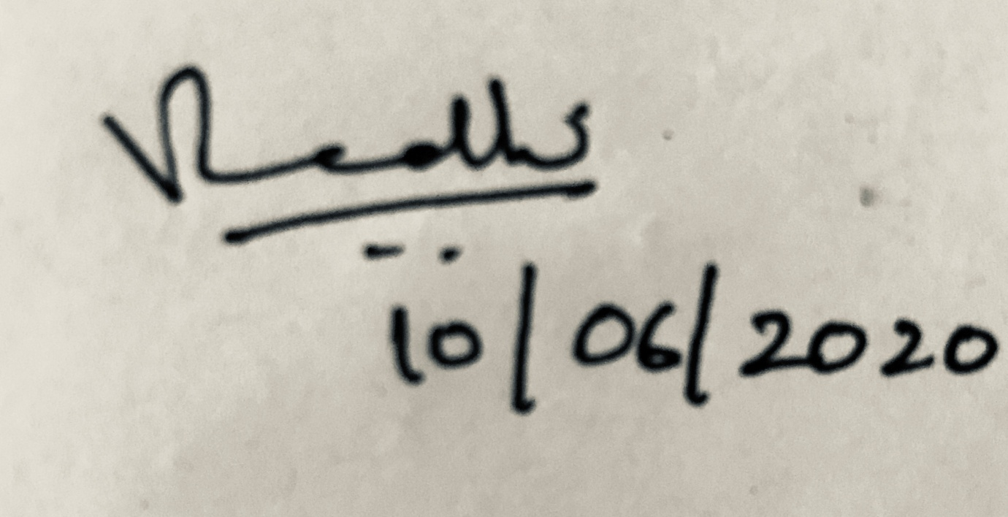

Dr. V. Radhika