About Editors

Dr. P. SUJATHA
Associate Professor
Dept. of Geography
Bharathi Women’s College (A), Chennai, Tamil Nadu. India
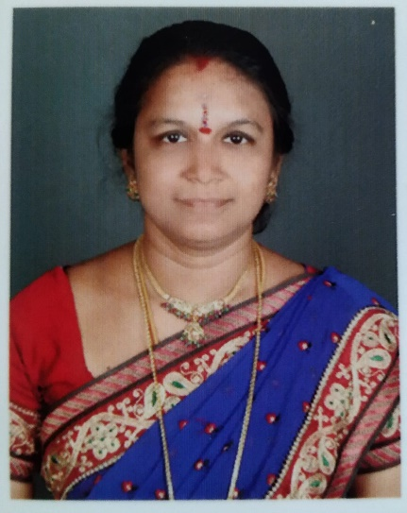

Dr. P. Sujatha, M. Sc. (Geography), M.B.A. (Systems), M.Phil.(Population studies), Ph. D. (Tourism & GIS)
Dr. P. Sujatha is a highly accomplished individual with a diverse educational background. She holds a Bachelor's degree from Bharathi Women's College and has pursued postgraduate studies at the University of Madras. She also earned an M.Phil. Degree from Vinayaga Mission at Periyar University and completed her Ph.D. at the University of Madras, focusing on Tourism and Geographic Information Systems (GIS).
The editor has a strong educational background, having obtained Higher Education from the prestigious University of Madras in Chennai. With 15 years of experience in Teaching, Research, and Innovation, the editor has established themselves as a seasoned professional in their field. They have made significant contributions to academia through their publications, presentations, and active participation in workshops and training programs.
As an accomplished author, the editor has published 5 books on Climatology and Physical Geography, showcasing their expertise and knowledge in these subjects. Additionally, their research prowess is evident from their 26 research publications, which have been cited multiple times in UGC listed journals. This indicates the impact and recognition of their work within the scholarly community.
The editor's dedication to sharing their research extends beyond publications. They have presented their findings at both national and international conferences, highlighting their ability to engage with a diverse audience and contribute to the wider academic discourse.
Moreover, the editor's commitment to professional development is demonstrated by their active involvement in workshops and training programs. They have participated in five such events, further enhancing their skills and knowledge in their field.
The editor's expertise also extends to conducting training programs, Faculty Development Programs, and workshops themselves. This showcases their ability to share their knowledge and experience with others, contributing to the growth and development of fellow academics and researchers.
Furthermore, the editor has utilized the online platform effectively, conducting 21 webinars focused on health awareness campaigns. This highlights their versatility in utilizing various mediums to disseminate important information and promote awareness in society.
Overall, the editor's profile reflects a highly accomplished professional with extensive experience in teaching, research, and innovation. Their publications, presentations, and active involvement in academic activities demonstrate their commitment to advancing knowledge and contributing to their field.

