**CURRICULUM VITAE**

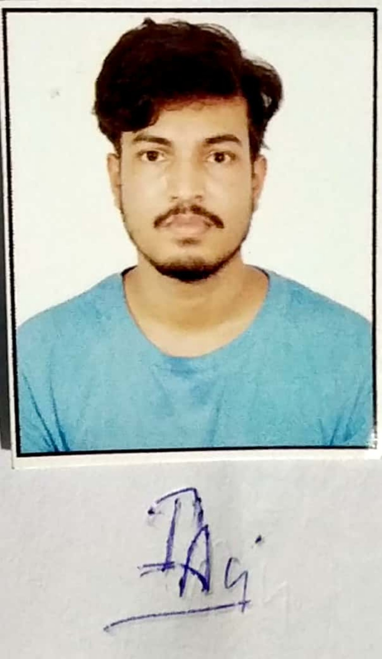

**IRSHAD ALI SAUDAGAR**

Father name Dr. M. A. Saudagar

Residential Address: C/o, Dr. M. A. Saudagar, Near Khushbu Masjid, Rghuraj

Marg, Ghoghar, Rewa, M.P. 486001

Mobile: 7828153660, 7000744779

E-MAIL ID. [SUFIYA002@GMAIL.COM](mailto:SUFIYA002@GMAIL.COM)

**CAREER OBJECTIVE**

To succeed in an environment of growth and excellence and earn a job which provides me job satisfaction and self development and help me achieve personal as well as organizational goals. To excel in any of relevant field through hard work, research, skills and perseverance. To serve my parents, and my country with the best of my abilities.

**EDUCATION HISTORY**

|  |  |  |  |  |
| --- | --- | --- | --- | --- |
| **S.N.** | **EDUCATIONAL QUALIFICATIONS** | **SCHOOL/COLLEGE** | **YEAR** | **PERCENTAGE** |
| 1. | M.Sc. BIOTECHNOLOGY | PENTIUM POINT TECHNICAL COLLEGE , REWA | 2017 | 67.36% |
| 2. | B.Sc.  BIOTECHNOLOGY | PENTIUM POINT TECHNICAL COLLEGE , REWA | 2015 | 62.83% |
| 3. | HIGHER SECONDARY EXAMINATION | GOVT. BOYS HIGHER SECONDARY SCHOOL, BAGHRAJI, JABALPUR | 2010 | 71% |
| 4. | HIGH SCHOOL EXAMINATION | GOVT. BOYS HIGHER SECONDARY SCHOOL, BAGHRAJI, JABALPUR | 2008 | 63.4% |
| 5. | Ph.D (Biotechnology) | Y. B. N. University, Ranchi | 2020 | Perusing |

**Work/ Experience**

* Completed six month Internship/Training from January 2017 to June 2017 at Rapture Biotech, Noida on the topic, Bacterial Waste Water Treatment.
* Worked seven months from November 2018 to May 2019 as Project Assistant in a project under Dr. Hari Om Saxena, Scientist – D, Silviculture, Forest Management and Agroforestry Division, at Tropical Forest Research Institute, Jabalpur.
* Worked From October 2019 to November 2021 as Project Assistant in a National Bamboo Mission funded project Under Dr. Fatima Shirin, Scientist-G, Genetics and Tree Improvement Division, at Tropical Forest Research Institute, Jabalpur.
* Working From November 2021 as Junior Project Fellow in Forest Genetic Resources project funded by AICRP, CAMPA, New Delhi, Under Dr. Fatima Shirin, Scientist-G, Genetics and Tree Improvement Division, at Tropical Forest Research Institute, Jabalpur.

**Technical Skills**

**Water Treatment Techniques**

Alkalinity test in Water sample, Total hardness of water, BOD, COD, pH and TDS Test in Sample, Coliform bacteria test, EMB and triple Sugar Test of Sample.

**Food Techniques**

Isolation of Probiotic Bacteria, Microbial contamination from packed samples, PH, TDS and water content, Quantitative and qualitative analysis of Carbohydrate, Protein and Fats in different food samples.

**Microbiology Techniques**

Isolation and Identification of pure Bacteria and Fungus from different sources, Serial Dilution Techniques and CFU count, Solid and Liquid Media preparation for Bacteria and Fungus, Inoculation, Spreading and Streaking, Minimum Inhibitory Concentration (MIC), Anti Microbial Activity of different Antibiotics and plant samples by Disc and well diffusion method, Preservation of pure colony, Different Biochemical Tests and Gram Staining.

**Molecular Biology Techniques**

Sterilization Techniques, Preparation of different Reagents, TBE and TAE Buffers, DNA isolation from Plants, and Bacteria, Qualitative and Quantitative Analysis of Isolated DNA, Disease Diagnosis by PCR, Agarose Gel Electrophoresis of PCR Products, Chromatography techniques.

**Plant Tissue Culture Techniques**

Preparation of medium, sterilization techniques, Inoculation of explants, Sub-culturing, Hardening Process, etc.

**Equipment handling**

Autoclave, Vortex, Water Bath, Incubator, Laminar Air flow, Centrifuge, Chromatography (TLC), PCR, Spectrophotometer, Electrophoreses, Microscope, Colony Counter, Soxhlet.

**COMMUNITY INVOLVEMENT & RECOGNISED ACHIEVEMENTS**

2003 Participated in bhartiya Sanskrati Gyan Pareeksha

2004 Pratham Sopan Certificate In Bharat Scout And Guied M.P.

2004 Participated in Bhartiya Sanskrati Gyan Pareeksha

2005 Participated in Bhartiya Sanskrati Gyan Pareeksha

2006 Dwatiya Sopan Certificate In Bharat Scout And Guied M.P

2006 Participated in Bhartiya Sanskrati Gyan Pareeksha

2006 2nd Rank In Essay Writing At Jansankhya Sikhsha Saptah

2006 2nd Rank In Essay Writing At Govt. Boys H. S. School, BAGHRAJI, Jabalpur.

2006 Certificate Of Combined Annual Training Camp [N.C.C., Jabalpur]

2007 ‘A' Certificate In N.C.C. Jabalpur, M.P.

2008 Tratiya Sopan Certificate In Bharat Scout And Guied, Rajya Mukhyalay,

Bhopal, M.P.

2013 Attend National Conference Of Biotechnology, Biodiversity & Environment at

Rewa, M.P.

2016 Participated in College Level Science Day Competition at Rewa, M.P.

2017 2nd rank in “Clay modeling in inter district level competition of Youth Festival”

at APSU, Rewa, M.P.

2017 2nd rank in Collage making in “University level competition of Youth Festival”

at APSU, Rewa, M.P.

2019 Presented at International Conference on “Multi-Disciplinary Approach towards

Sustainable Development: Role of Government, Academicians, Corporate, Civil

Societies and Citizens” is being organized at IIFM, Bhopal on 21st and 22nd

February, 2019.

2019 Oral Presentation at “International Conference on Advances and Innovations in

Biotechnology for Sustainable Development” from 5-7 April, 2019 in AKS

University, Satna, M.P.

2019 1st rank in Poetry Writing in Satarkata Jagrukta Saptah at TFRI, Jabalpur.

2019 1st rank in Essay Writing in Satarkata Jagrukta Saptah at TFRI, Jabalpur.

2020 Participated in quiz in Rajah Sefroji government college, Thanjavur.

2020 Attended National Webinar on Bamboo cultivation and product development at

RDVV, Jabalpur.

2021 Participated in Pre State Level 10 M Pistol Shooting at 7TH GFG M.P. Pre state

Shooting Competition, Jabalpur, M.P.

2021 Participated in State Level 10 M Pistols Shooting at 23RD M.P. STATE

Shooting Championship, Indore, M.P.

2022 Young Research Fellow Award 2021

**Research Activities**

* Abstract entitled “Management of poor waste Car-wash water through treatment by *Saccharomyces cerevisiae*”, **Irshad Ali Saudagar**, Vikram Dhurvey and Dr. Vinod Gupta Published in International Conference on Advances and Innovations in Biotechnology for Sustainable Development *p145,* 2019*.*
* Abstract entitled “Waste water treatment by *Saccharomyces cerevisiae*”, **Irshad Ali Saudagar** and Dr. Vinod Gupta, published in International Conference on “Multi-Disciplinary Approach towards Sustainable Development: Role of Government, Academicians, Corporate, Civil Societies and Citizens” is being organized at IIFM, Bhopal on 21st and 22nd February, *p167*, 2019.
* Chapter entitled “Bamboo as green gold: an overview published in training program bamboo nursery and management, TFRI, Jabalpur, 2019.
* Chapter entitled “A brief account of important NTFPs of Madhya Pradesh Published in GSDP manual value addition and marketing of NTFPs: NTFPs products/medicinal plants”, TFRI, Jabalpur, 2019
* Article entitled “बुद्धिवर्द्धक मालकांगनी” Published in Vansangyan, 8(3): 33-35.मरावी सु, नामदेव उ, **सौदागर इ अ,** नसीर मोहम्मद, शिरीन फा (2021).
* Abstract entitled “Influence of genotypes and other factors for adventitious rhizogenesis through macropropagation in Bamboos”, Fatima Shirin, **Irshad Ali Saudagar**, Sushma Maravi, P. K. Rana, Pramod Kumar and G. Rajeshwar Rao, Published in National Bamboo Seminar, E- Abstract Book Page 14 (2021).
* Abstract entitled “Macropropagation of an ornamental bamboo –Bambusa nana Roxb. through culm cuttings”, **Irshad Ali Saudagar**, Trilok Gupta, Vineet Mehra, M.K. Sonkar, and Fatima Shirin, Published in National Bamboo Seminar, E- Abstract Book Page 16, (2021).
* Abstract entitled “Effects of different plant growth hormones on in vitro axillary bud break of *Bambusa bambos* L. Voss and *Dendrocalamus strictus* Nees”, Fatima Shirin, **Irshad Ali Saudagar,** Deepti Bhadrawale, Shalu Panika, Rama Soni and Trilok Gupta, Published in National Bamboo Seminar, E- Abstract Book Page 20, (2021).
* Abstract entitled “an improved method for in vitro shoot multiplication of *pseudoxytenanthera stocksii*”, Fatima Shirin, Deepti Bhadrawale , Jay Prakash Mishra, **Irshad Ali Saudagar**, Shalu Panika, Trilok Gupta and Sushma Maravi, published an oral presentation in National symposium on Trends in Plant Biotechnology & Agriculture held in TIET, Patiala on February 6-8, 2020.
* Abstract entitled “Effect of genotypes and locations on various phytochemicals in *Gmelina arborea* Roxb. (Khaimer) : an important ingredients of Dasamula formulation”, Fatima Shirin, Niraj Yadav, Sushma Maravi, **Irshad Ali Saudgar** and Trilok Gupta, published in national conference on Challenges and recent....new drug development to be held on 26-27 February, 2021.
* Bulletin entitled “बांस की विभिन्न प्रजातियों का प्रवर्धन एवं प्रबंधन” डॉ. फातिमा शिरीन, **इरशाद अली सौदागर,** डॉ. प्रमोद कुमार Published in 2021.
* Bulletin entitled “Propagation and Management of different species of Bamboos”, Dr. Fatima Shirin, **Irshad Ali saudagar**, Devshree Gupta, Dr. Pramod Kumar published in 2021.
* Abstract entitled “Macropropagation of *Dendrocalamus strictus* (Roxb.) Nees through culm cavity method”, **Irshad Ali Saudagar**, Vineet Mehra, Trilok Gupta, Nikhil Verma and Fatima Shirin (2021) In Abstract Book of National conference on clonal forestry in eco-restoration, Prayagraj, Page 39.
* Abstract entitled “Selection of CPTs of *Madhuca longifolia* from different agroclimatic zones of Madhya Pradesh for assemblage and conservation”, Surendra Singh Ghoshi, **Irshad Ali Saudagar,** Shruti Thakre, P K Rana, Trilok Gupta and Fatima Shirin (2021) In Abstract Book of National conference on Value addition and marketing of NTFPs, Jabalpur, 16th December, 2021, Page 25.
* Abstract entitled “Vegetative propagation of *Plumbago zeylanica* useful RET medicinal plant for conservation”, Upasana Namdev, **Irshad Ali Saudagar**, Sharmishtha Gangopadhyay, Sushma Maravi, Mukesh Kumar Sonkar and Fatima Shirin (2021) In Abstract Book of National conference on Value addition and marketing of NTFPs, Jabalpur, 16th December, 2021, Page 30.
* Abstract entitled “Characterization and evolution of conservation practices on phytochemicals in different seasons of *Kaempferia parviflora”,* **Irshad Ali Saudagar** and Fatima Shirin (2022) In Abstract Book of Advances in smart agriculture and biodiversity conservation for sustainable development, Jaipur, March 04 - 06, 2022, Page 235.
* डॉ फातिमा शिरीन एवं **श्री इरशाद अली सौदागर** (2021) जुगनू : विलुप्त चमक और उसका संरक्षण . तरुचिंतन 83-84
* Research paper entitled “Comparison of Adventitious Rooting potential of culm cuttings in *Bambusa wamin, Bambusa vulgaris* var. striata and Bambusa vulgaris var. green” ,Fatima Shirin, **Irshad Ali Saudagar**, Trilok Gupta, Deepti Bhadrawale, Naseer Mohammad And G. Rajeshwar Rao, Published in Indian Forester 147(4): 421-425, 2021.
* Research paper entitled “Influence of localities and tree girth classes on morphological and biochemical parameters of fruits and seeds of *Madhuca longifolia”*. Fatima Shirin, Deepti Bhadrawale, **Irshad Ali Saudagar**, PK Rana, Naseer Mohammad and G. Rajeshwar Rao. (2020) Indian Journal of Tropical Biodiversity 28 (1&2): 31-40
* Research paper entitled “Influence of genotypes on adventitious rhizogenesis through macropropagation in *Bambusa vulgaris* and *Bambusa nutans”.* Fatima Shirin, **Irshad Ali Saudagar,** Vineet Mehra, Sushma Maravi, Mukesh Kumar Sonkar, Pramod Kumar and G. Rajeshwar Rao (2021) Indian Journal of Tropical Biodiversity 29 (1): 47-53.
* Research paper entitled “[Seasonal and hormonal variation during adventitious rhizogenesis in five commercially important bamboo species for production of quality planting material](https://www.tandfonline.com/doi/abs/10.1080/13416979.2021.1935548)”. Fatima Shirin, Jay Prakash Mishra, Deepti Bhadrawale, **Irshad Ali Saudagar**, Trilok Gupta and Nanita Berry (2021). Journal of Forest Research, <https://doi.org/10.1080/13416979.2021.1935548>
* Attended two days (5-6 Jan. 2022) online training programme on “Plant Biotechnology” sponsored by MoEFCC, New Delhi.
* Received **Young Research Fellow Award 2021** by the Agricultural Technology Development Society on the occasion of International conference on Advances in smart agriculture and biodiversity conservation for sustainable development, Jaipur, March 04 - 06,2022

**OTHER SKILLS AND CERTIFICATES**

**Computer Skills:**

* Microsoft XP applications (Word, Excel, Office, PowerPoint, Outlook, Access)
* Microsoft Office Document Imaging and Scanning

**Operating Skills:**

* Instrumentation at Laboratory
* MOLECULAR Techniques
* MICROBIOLOGICAL Techniques

**PERSONAL DETAILS - IRSHAD ALI SAUDAGAR**

Father name Dr. M. A. Saudagar

Mother name Smt. Firdous Barin

Marital status Single

Gendar Male

Residential Address: C/o, Dr. M. A. Saudagar, Near Khushbu Masjid, Rghuraj

Marg, Ghoghar, Rewa, M.P. 486001

Mobile: 7828153660, 7000744779

E-MAIL ID. [SUFIYA002@GMAIL.COM](mailto:SUFIYA002@GMAIL.COM)

Date of Birth: 13 JULY 1993

Nationality: INDIAN

**PERSONAL COMPETENCIES**

* Ability to work in a fast-paced environment to set deadlines
* Excellent oral and written correspondence with an exceptional attention to detail
* Highly organised with a creative flair for project work
* Enthusiastic self-starter who contributes well to the team

**Hobbies**

Writing and Reading Articles, Management of Reseach work, Gardening, Pistol Shooting, Listening Music.

**REFERENCE**

**Mr. Mayank Bhardwaj**

**Rapture biotech, D-201, Sector-10, Noida, 201301**

[**www.rapturebio.com**](http://www.rapturebio.com) **, EMAIL-** [**info@rapturebio.com**](mailto:info@rapturebio.com)

**Declaration**

I hereby declare that the information given here with is correct to my knowledge and I will responsible for any discrepancy.

Date: (Name)

Irshad Ali Saudagar