Dr.Venkatesh.S venkat_iomau@hotmail.com
Phone No: 98407 56646

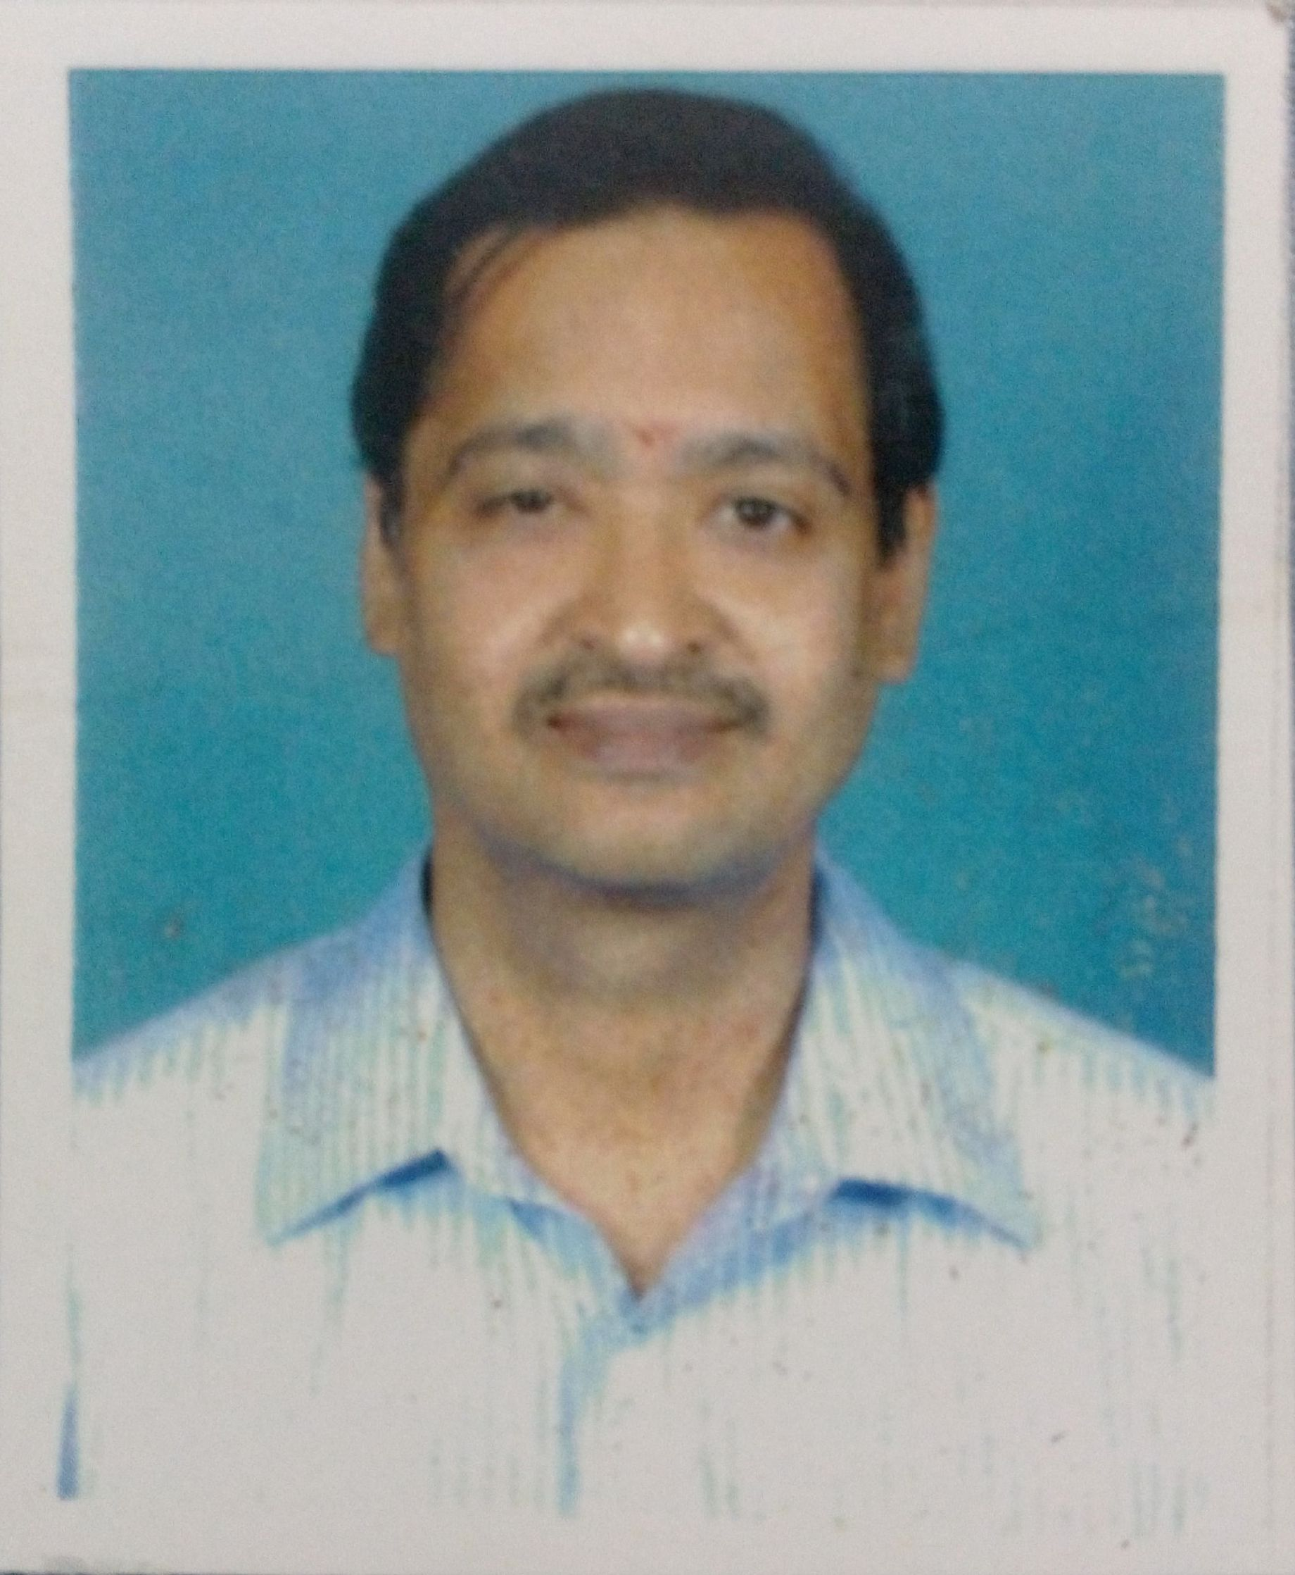
Career Objective

Motivated to become a skilled, dedicated Professor where my skills and research abilities can be translated into a meaningful and intellectual growth of the institution and myself.

Profile

A Bachelor of Science in Zoology from Ramakrishna Mission, Vivekananda College, Madras University, Chennai, Master’s degree in Biosciences from Sri Satya Sai Institute of Higher Learning, Prasanthinilayam, A.P., Master of Philosophy in Environmental Science and Engineering from Central University, Pondicherry, and Doctor of Philosophy from Anna University, Chennai.

Academic Experience

INSTITUTION | DESIGNATION | DURATION | YEARS OF EXPERIENCE
RGR Academy, Chennai | Educational Entrepreneur | Jan 2003 to Apr 2017 (Part-Time) and May 2017 to till date (full-time) | 18 years
Vel Tech High Tech Dr Rangarajan Dr Sakunthala Engineering College, Avadi | Associate Professor | 11 May 2016-  13 April 2017 | 11 months
Vel Tech High Tech Dr Rangarajan Dr Sakunthala Engineering College, Avadi | Assistant Professor | 05 March, 2010-  10 May 2016 | 6 years 2 months
Abacus Montessori School, Perungudi, Chennai | Post Graduate Teacher | Jun 2009- Feb 2010 | 8 months
Sushil Hari International Residential School, Kelambakkam, Chennai | Post Graduate Teacher | June 2006- Jun 2009 | 3 years

- Employed as Assistant Professor (Chemistry department) in Vel Tech High Tech Dr Rangarajan Dr Sakunthala Engineering College, Avadi (Affiliated to Anna University, Chennai) from March 2010 to May 2016. Promoted as Associate Professor from May 2016 to April, 2017.

- Employed as post graduate teacher (Chemistry department) in Abacus Montessori School, Perungudi, Chennai from June 2009 – Feb 2010

- Employed as post graduate teacher (Chemistry department) in Sushil Hari International Residential School, Kelambakkam, Chennai from June 2006 –June 2009

Subjects Handled

Chemistry, Biology, Biochemistry, Biotechnology and Environmental Science

Academic Awards and Achievements

- Awarded Jawaharlal Nehru Memorial fund Scholarship (JNMF - SRF) from Jan 2000-dec 2002 for Doctor of Philosophy

- Qualified SLET (State Level Educational Test) held in March 1997 conducted by Bharathidasan University, Tirichirappali, Chennai. Subject: BIOCHEMISTRY

- Awarded general proficiency prize in B.Sc. (Zoology) for securing first place in University Examination

Academic Qualification

Category | Name of the Degree | Specialization | Year of  Passing | Name of the  College | Name of the  University | % of Marks  / Grades obtained | Class obtained
UG | B. Sc | Zoology | 1994 | R.K.M Vivekananda College, | Madras University | 84 | I
PG | M.Sc | Biosciences | 1996 | Sri Sathya Sai University, Prasanthinilayam | Sri Sathya Sai University | 4.88/5.00 (CGPA) | I
PG | M.Phil | Environmental Science and Engg. | 1997 | Pondicherry | Central University | 9.3 (CGPA) | I
 | PhD | Biogeochemistry | 2005 | Anna University, Chennai | Anna University

- Doctor of Philosophy from Institute of Ocean Management (IOM- Koodal Building), Anna University, Chennai (1999-2005)

Thesis title: Studies on biogeochemical cycling of methane and nitrous oxide and its possible mitigation strategies from wetland rice paddy ecosystems of South India

- Master of Philosophy (M.Phil) in Environmental Science and Engineering from Centre of Pollution and Energy Technology (CPET), Central University, Pondicherry (1996-1997)

Thesis title: Treatment of vegetable waste with high solids anaerobic digesters
Class/Division: 1st Class

- Post graduate in Biological Sciences from Sri Sathya Sai Institute of Higher learning, Prasanthinilayam, A.P. (1994-1996)

Thesis title: Studies on the in vitro buffering properties of blood of Pila globosa and its immunological properties
Class/Division: 1st Class

- Bachelor’s degree in Zoology from Ramakrishna Mission, Vivekananda College, Madras University, Chennai (1991-1994)

- Senior School Certificate Exam from Hindu Senior Secondary School (CBSE), Chennai (1990-1991)

- Short Course

- Attended a training course on “Studies on methane and nitrous oxide measurements in rice paddy ecosystems” in NPL- New Delhi

- Attended an eight-week course in biochemistry, biochemical and biophysical methods and instrumentation, immunology (Dec 1994 &1995)

- Attended a short-term course in Food Microbiology from 2nd -5th Feb 1993 conducted by Madras University

- Computer Skills

Operating Platform: Windows NT, Windows 95, 98, 2000, 2007 & 2008

Work Experiences:

Professional Experience

Junior Project Associate (JPA) in DOD sponsored project on “No Impact Zone” studies on Pulicat lake (1998-1999) from institute for Ocean Management, Anna University, Chennai

Project Team member of DST sponsored project on “In vitro buffering properties of blood of Pila globosa” (1995-1996) from Sri Sathya Sai University, Prasanthinilayam, A.P.

Research Experience

- Department of Ocean Development funded project on “No Impact Zone” studies on Pulicat lake (1998-1999)

  - Involved in the analysis of physical, chemical and biological parameters of surface waters and sediment samples of Pulicat lake

- Jawaharlal Nehru Memorial fund Scholarship (JNMF - SRF) on “Studies on the biogeochemical cycles of methane and nitrous oxide and its possible mitigation strategies from wetland trice paddy ecosystems of South India” (Jan 2000-Dec 2002).

  - Involved in the studies of biogeochemical process of methane cycling from anoxic soils of rice paddies from fields and in microcosms

  - Involved in the studies of various precursors (Hydrogen, acetate, and other fatty acids) on Methanogenesis

  - Involved in the studies of effect of inhibitors (chloroform) and other terminal electron acceptors (Fe³⁺, Mn²⁺ and NO₃⁻) on methane emission

  - Involved in the studies of nitrous oxide emission form anoxic soils of rice paddies from field and in microcosms

- Department of Science and Technology (DST) funded project on “In vitro buffering properties of blood of Pila globosa” (1995-1996)

  - Involved in the studies of antigenic properties of blood containing haemocyanin between normal and aestivating Pila globosa

  - Involved in the studies of in vitro parameters of blood determining the acid-base of normal and aestivating Pila globosa

Publications – Conferences, Workshops and Journals

JOURNALS
- Jayashree. R, Christy. A and Venkatesh. S (2018), “Personalized recommendation system for ranking in question-answering websites with splay tree by avoiding tumbleweed badge”, Int. J. Trust Management in Computing and Communications, Vol. 4(2), pp: 172-191.

- Venkatesh.S and Jayashree.R (2015) “Seasonal variation of methane fluxes from rice paddy ecosystems of South India” Journal of Chemical and Pharmaceutical Sciences 9(1) 626-632.

- Venkatesh.S and Jayashree.R (2015) “Evaluation of performance efficiency of high solid anaerobic digesters of different design with vegetable waste as substrate” Journal of Chemical and Pharmaceutical Sciences 8(4) 841-846.

- Venkatesh.S (2014) “Effect of biopesticide on nitrous oxide fluxes from wetland rice paddy ecosystems of South India” International Journal of ChemTech Research 6, (9), 4318- 4323.

- Venkatesh.S and Raju.S (2014) "Novel treatment of biodegradable market waste with laboratory scale anaerobic digesters using PVC pipes" Pollution Research, 33 (3), 613-617.

- Venkatesh.S and Jayashree. R (2014) “Studies on the influence of Solid porous support systems (SPSS) on high solid digestion (HSD) of vegetable market waste” Pollution Research, 33 (3), 591-596.

- Venkatesh.S (2013) “Impact of Nitrogen Fertilizers on Methane Flux to the atmosphere from the Paddy Ecosystems” Mu. Ramkumar (ed.), On a Sustainable Future of the Earth’s Natural Resources, Springer Earth System Sciences, Chapter 27, 455-466.

- Venkatesh. S (2011) ‘Studies on DIEL Variation of Methane Fluxes from Rice Paddy Ecosystems of South India’ International Journal of Biometrics and Bioinformatics, Vol. 3, No. 4, pp. 84-92.

- Jithesh, M.N., Venkatesh, S. and Krupanidhi, S. (1996) Studies on the hemocyanin of Pila globosa. Indian Journal of Comparative Animal Physiology 14.2, 52-59.

- Venkatesh, S. and Krupanidhi, S. (1996). Studies on the buffering properties of the blood of Pila globosa. Indian Journal of Comparative Animal Physiology, 14.2, 60-66.

CONFERENCES

- Venkatesh.S (2012) ‘Seasonal variation of nitrous oxide from wetland rice paddy ecosystems of south India’ National Conference on Green technology, Organized by NIT, Suratkal.

- Venkatesh.S (2012) ‘Studies on the treatment of vegetable waste with high solid anaerobic digesters’ International conference on Renewable energy utilization (ICREU 2012) organized by CIT, Coimbatore and Oklahoma State University, USA.

- Venkatesh.S (2012) “Studies on the influence of biological fertilizers to mitigate methane emission from wetland rice paddy ecosystems of South India” International Open Science Conference Global Environmental Change- Challenges and Innovations, Madras University.

- Venkatesh.S (2011) ‘Comparative studies on impact of azolla (floating fern) and azospirillum (free living soil microbe) on methane emission from wetland rice paddy ecosystems of south India–a measure to mitigate methane emission’ International Congress of Environmental Research (ICER 2011) organized by Journal of Environmental Research and Development and Sardar Vallabhbhai National Institute of Technology (SVNIT), Surat

- Venkatesh.S (2011) ‘Role of Azospirillum (Free living soil microbe) in mitigating methane emission from wetland rice paddy ecosystems of south India’ International Conference on Sustainable Manufacturing: Issues, Trends and Practices (ICSM2011), Organized by BITS, Pilani.

- Venkatesh.S (2011) ‘Studies on impact of nitrogen fertilizers on methane fluxes from rice paddy ecosystems of south India’ International Conference on Earth Future 2011 organized by Periyar University (Salem) and AvH, Germany.

- Venkatesh.S (2011) ‘Studies on impact of free-living soil nitrogen fixers on methane fluxes from rice paddy ecosystems of south India international conference on impact of physical sciences on biology organized by Queen Mary’s college, Chennai.

- Venkatesh.S (2011) ‘Studies on impact of azolla (biofertilizer) on methane fluxes from rice paddy ecosystems of south India’ International Conference on Emerging Green technologies (ICEGT 2011) organized by Periyar Maniammai University (Vallam) and Ministry of Earth Sciences.

- Venkatesh. S (2011) ‘Studies on the influence of Solid porous support systems (SPSS) on high solid digestion of vegetable market waste’ International Conference on Society, Technology & Sustainable Development (ICSTSD 2011) organized by Amrita Vishwa Vidyapeetam University, (Kochi) and University of Buffalo, USA.

- Venkatesh. S (2011) ‘Studies on impact of azospirillum (biofertilizer) on methane fluxes from rice paddy ecosystems of south India’ International Conference on Recent Advances in Chemical Engineering and Technology (RACET 2011) Organized by Cochin University and Indian Institute of Chemical Engineers (IiChE), Kochi, pp.

- Venkatesh.S (2011) ‘High Solid anaerobic digestion with phase separation – An alternate novel method to treat vegetable market waste’ CSIR sponsored National conference on recent applications of nanomaterials in chemistry and environmental research (Rancer 2011) organized by Kongu Engineering College, Perundurai

- Venkatesh.S (2010) ‘Studies on the impact of bio-film support media (BSM) on high solid digester (HSD)’ National conference on Alternate energy Resources and Applications organized by Sriram Engineering College, Chennai.

- Venkatesh, S. and Ramesh, R. (2003) Studies on the impact of biological fertilizers on methane emission from rice paddy microcosms. International Conference on coastal and freshwater Issues (COFIS) December 8-10, Anna University, Chennai.

- Ramesh, R. and Venkatesh, S. (1998) Methane Asia Campaign (MAC-98) – Methane measurements in rice paddy ecosystems. Scientific report No. 19, 32-38.

WORKSHOP AND SEMINAR

- Participated in a workshop on Environmental Awareness conducted by University of Madras on Feb. 18th 1993

- Participated in Intercollegiate Seminar on Health and Environment conducted by University of Madras on 15th Aug 1993

- Participated in Science Exhibition conducted by Department of Biotechnology, Pondicherry University on March 3rd 1997

Instrumentation Handled

- UV Spectrophotometry
- Gas Chromatography (Analysis of methane using FID and nitrous oxide using ECD detectors) Model – HP 5890 and HP 6890
- Microbial culture techniques (Mixed culture, isolation and pure culture methods)
- Ion Chromatography (Analysis of fatty acids like acetate, formate and analysis of cations and anions in water and sediments samples)
- Flame photometer
- Electrophoresis (SDS-PAGE, Tube gel electrophoresis, Rocket electrophoresis)
- Double radial immunodiffusion, Single radial immunodiffusion
- Blood gas analyzer
- Particle size analyzer

PERSONAL INFORMATION

Date of Birth : 09-02-1974
Sex : Male
Father’s name : Late Sri V. Srinivasamurthy
Nationality : Indian
Category : General (OC)
Languages Known : English, Tamil
Marital Status : Married
Address for Communication : C1/2, Orchid Chengacherri,
No 6, Munusamy Street,
Ganapathipuram, Radha nagar
Chrompet, Chennai
Pin Code: 600 044.
Tamil Nadu, India.

I believe that “matter is not taking the right decision, what matters is taking the decision and making it right”. All the details provided all true in all respects.


(Venkatesh. S)

