CURRICULUM VITAE

Dr. JAYA NAIK Phone : +91 824 224 9256
Assistant Professor Fax : +91 824 224 8366
Dept. of Fisheries Engineering & Technology Mobile: +91 9964482368
Karnataka Veterinary, Animal and Fisheries Sciences University E-mail: jayanaik23@.yahoo.com
College of Fisheries, Mangalore - 575 002 India

Educational Qualifications
2000 B.F.Sc. Fisheries Science, College of Fisheries, Mangalore, UAS, GKVK, Bangalore,
India
2003 M.F.Sc. Industrial Fishery Technology, College of Fisheries, Mangalore UAS, GKVK,
Bangalore, India
2012 Ph.D Fish Processing Technology, College of Fisheries, Mangalore, KVAFSU,
Bidar, India.
Positions held
- Worked as a Senior research fellow in the Dept. of Fishery engineering on the topic entitled “ Selectivity studies on the bottom trawl off Mangalore” (March 2003 to June 2004).

- Worked as a Fisheries Scientist in the Agricultural Engineering College, Raichur, on the topic entitled “Preservation and value added products prepared using marine and fresh water fishes along west coast of India. (25th Feb, 2005 to 25th Jan, 2007)

- Worked as a Research scholar in the department of Fish Processing Technology for the topic entitled “ Influence of freshness of fish on the quality of prepared products : A comparative study for lean and fatty fish Funded by University of Grants commission, New Delhi. (01-04-2008 to 05-10-2010).

- Assistant Professor of Fishing Craft, KVAFSU, College of Fisheries, Mangalore since 02-06-2011
Awards and Fellowships
1. Rajiv Gandhi National Fellowship (RGNF) from University Grants Commission (UGC), New Delhi, during 2008-2011 for Ph.D. degree programme in Fish Processing Technology at College of Fisheries, Mangalore.
Training/workshops/ Conducted/ Attended
- Conducted on the “Use of GPS Navigator and Fish Finding Equipment”: In the Dept. of Fishery engineering (11.04.02 to 15.04.02) for the fisher folk of coastal Karnataka.
- Conducted a training programme on “Awareness on Responsible fisheries for the Fisher folk of coastal Karnataka”: In the Dept. of Fishery engineering (29-07-03, 31-07-03, 02-08-03, 06-08-03, 07-08-03 and 08-08-03) for the fisher folk of coastal Karnataka.
- Short course on “Coastal and Marine Environmental Management”: at College of Fisheries, Mangalore (Feb 16th to 25, 2006).
- Participated in the Training Programme of ICAR sponsored “Innovative Approaches to e-learning” Organized by NAARM, Hyderabad during 11-20th September 2012.
- Involved in Organizing “Global Symposium on Aquatic Resources for Eradicating Hunger Malnutrition-Opportunities and Challenges” held during 3rd -6th December, 2012 at Mangalore, Karnataka, INDIA. AFSIB.
- Participated in “Moving towards sustainability an interactive trainers training workshop” held during 3-5 September, 2013 at Geological Survey of India, Mangalore.
- Participated in the ICAR funded Winter school on “ICT-Oriented Strategic Extension for Responsible Fisheries Management” organized by the Central Marine Fisheries Research Institute (CMFRI), Kochi during 5-25 November,2013.
- Had participated and presented a paper in the National conference on Strategies for Bridging the Yield gap in Fisheries and Aquaculture” organized by Professional Fisheries Graduates Forum (PFGF), India during 24-25, March 2014 at the College of Fisheries, Mangalore. India.
- Training programme conducted on “Responsible fishing and conservation of Fisheries” for the fisher folk of coastal Mangaluru of Karnataka. Funded by Agricultural Technological Management Agency, Dept. of Agriculture, Dakshinna Kannda District (24-26 July, 2014).
- Training programme conducted on “Responsible fishing and conservation of Fisheries” for the fisher folk of coastal Karwara and Ankola of Karnataka. Funded by Agricultural Technological Management Agency, Dept. of Agriculture, Uttara Kannda District (25-26 July, 2016).
Thesis/dissertation
- Master’s (M.F.Sc) Thesis: “Studies on the effect of sweep line and bridle lengths off
Commercial HOBT operated along Mangalore Coast”
- Ph.D Thesis: “ Influence of freshness of fish on the quality of prepared products: A
Comparative study for lean and fatty fish”

List of Publications:
- Jaya Naik, B. Hanumanthappa, R. M. Prabhu and S. Varadaraju, 2004. Effect of variation in bridle lengths of bottom trawls on the fish catch along Mangalore coast: Envi. & Ecol., 22(4): 787-790.
- Jaya Naik, B. Hanumanthappa, R.M. Prabhu and D. Shashikala Bai, 2006. Studies on some of the commercially important fishes caught in the HOBT rigged with different categories of bridle lengths: J. Curr. Sci., 9(1): 261-266.
- Jaya Naik, B. Hanumanthappa, C. V Raju, S.H. Badami and R. M Prabhu, 2006. Studies on the effect of variation in sweep line lengths of bottom trawls over fish catch along Mangalore coast: J. Curr. Sci., 9(1): 267-270.
- S. Varadaraju, M.K. Nagaraj, R.M. Prabhu and Jaya Naik, 2009. Suitability of coastal water for brackish water shrimp farming Along Dakshina Kannda District, Karnataka State: Envi & Ecol., 27(3A): 1258-1261.
- Jaya Naik, C.V Raju, K.V Basavakumar and T.H. Shankarappa, 2010. Quality changes during freezing and frozen storage of mackerel (Rastrelliger kanagurta) and Pink perch (Nemipterus japonicus) in summer season: Envi. & Ecol., 28(4): 2396-2400.
- Renukaswamy, H.M, C.V.Raju, Jaya Naik, K.J.Maheswara and M.H.Bhandary, 2010. Preparation of ready to eat products from salted and dried Anchovies (Stolephorus spp): J. Aqua. Biol., 25(2): 148-151.
- Jaya Naik, C.V. Raju, Esha Naik, N. Rajendra Naik and Kamalesh Panda, 2011. Changes in the quality during fall season in freezing and frozen storage of mackerel (Rastrelliger kanagurta) and Pink perch (Nemipterus japonicus): Agrovet Buzz., 3(6): 38-40.
- K.J. Maheswara, C.V.Raju, Jaya Naik and H.S. Adarsha, 2011. Thermal Processing of Tuna in curry packed in Tin-Free-Steel can: Envi.& Ecol., 29(3A): 1440-1443
- K.J. Maheswara, C.V.Raju, Naik, J., Prabhu, R.M and Panda, K., 2011. Studies on Thermal Processing of tuna-A comparative study in Tin and Tin-Free-Steel cans., AJFAND., 11(7): 5539-5560.
- Jaya Naik, C.V. Raju, B. Hanumanthappa, Manjunatha, A.R and Mohan Kumar, K.C., 2013. A comparative study on final quality of smoked products prepared using iced Mackerel (Rastrelliger kanagurta) and Pink perch (Nemipterus japonicus) during summer season. Trends in Biosciences 6(6): 879-885.
- Jaya Naik, C.V. Raju and A. R. Manjuntha, 2014. Studies on the quality of canned fishery products prepared using ice stored mackerel and pink perch. Ind. J. Sci. Res. and Tech. 2(4):71-78.
- Jaya Naik, C.V. Raju, Manjunatha, A.R and Mohan Kumar, K.C., 2014. Importance of temperature in relation to quality changes of commercially important fishes of Indian mackerel (Rastrelliger kanagurta) and pink perch (Nemipterus japonicus) during winter season. Trends in Biosciences 7(8): 2839-2844.
- Manjunatha, A.R., Hanumanthappa, B and Jaya Naik, 2014. Studies on the catch composition of purse seine gear operated along Mangalore coast. National Journal of Life Sciences. 11(2): 191-194.
- Jaya Naik and C.V. Raju, 2015. Quality changes during ice storage of fishes Indian Mackerel (Rastrelliger kanagurta) Pink perch (Nemipterus japonicus) during summer season. The International Journal of Science and Technoledge. 3(6): 238-242.

- Jaya Naik*, C. V. Raju and Mansing Naik, 2016. Studies on the effect of iced mackerel and pink perch used for canning by using brine solution in TFS cans. J. Exp. Zool. India Vol. 19(1), pp. 1235-1240.

- Jaya Naik, C. V. Raju and Mansing Naik., 2017. Studies On The Quality Of Smoked Product Prepared Using Iced Mackerel (Rastrelliger Kanagurta) And Pink Perch (Nemipterus Japonicus) Stored At Refrigerated Temperature (4⁰c). Biochem. Cell. Arch. Vol. 17, No. 1, pp. 193-198.

- Jaya Naik, C.V. Raju, Mansingh Naik and Rajiv H. Rathod., 2017. Studies On The Chemical And Organoleptic Changes In The Final Quality Of Canned Products Prepared Using Ice Stored Mackerel And Pink Perch. Biochem. Cell. Arch. Vol. 17, No. 1, pp. 219-223.

- K. J. Maheshwara*, Jaya Naik, Arun Balamatti and T. D. Jagadish, 2017. Biochemical And Shelf Life Study Of Quality Of Fish Sausage In Ambient And Refrigerated Storage. Biochem. Cell. Arch. Vol. 17, No. 1, pp. 265-270.

- K. Halesha, H. N. Anjanayappa, Mansing Naik, Jaya Naik , D. P. Rajesh and P. Nayana, 2017. Breeding Biology Of Rainbow Sardine, Dussumieria Acuta From Mangaluru Region. Biochem. Cell. Arch. Vol. 17, No. 1, pp. 327-331.

- N. Rajendra Naik*, S. M. Shivaprakash, H. N. Anjaneyappa, S. R. Somasekhara, Jaya Naik and s. Benakappa, 2017. Reproductive biology of the commercially important Indian squid Uroteuthis (Photololigo) duvaucelii (d’ Orbigny [in Ferussac & d’ Orbigny], 1835) off Mangalore, south-west coast of India. Indian J. Fish., 64(1): 75-79.

Chapter Published in the Book
- L.Suragihalli Siddappa, C.V Raju, Jaya Naik, M.H. Bhandary and Basavakumar, 2008. Preparation of value added products by utilizing low value deep sea fish Bull’s eye (Priacanthus hamurur). ENVOINFORMATICS, Chapter-28., P; 171-175.

Abstracts Published
- C.V.Raju, Udaykumar Nidoni, Jaya Naik and Yatheesh, 2005. Studies on the control of pack weight by blanching in the canning of octopus (O. vulgaris). The seventh Indian Fisheries Forum.
- Jaya Naik, C.V Raju, B. Manjanaik and Maheswara, K.J., 2009. Influence of freshness of fish on the quality of chilled raw material: A comparative study for lean and fatty fish. National Seminar on Indian Marine Fisheries Sustainability at cross roads.
- Chandra, M.V, C.V. Raju, Jaya Naik and Prabhu, R.M., 2009.Indigenous polymer coated Tin-Free0Steel cans for thermal processing of Ribbon fish (Trichiurus lepturus) and its quality evaluation during storage, (2009): National Seminar on Indian Marine Fisheries Sustainability at cross roads.
- Maheswara, K.J., Raju, C.V., Jaya Naik and Manjanaik, B., 2009. Studies on thermal processing of tuna-A comparative study in conventional tin can and tin free steel cans. National Seminar on Indian Marine Fisheries Sustainability at cross roads.
- Jaya Naik, C.V Raju and R.M. Prabhu., 2010. Changes in the quality of smoked products prepared using chilled pink perch. Work shop on role of low value fish species in strengthening food security in India.
- Yatheesh, C.V.Raju, Jaya Naik, S.H.Badami and M.V. Chandra, 2010. Canning of octopus in different filling media. Work shop on role of low value fish species in strengthening food security in India.
- Maheswara, K.J., C.V, Raju, Jaya Naik and S.H. Badami, 2010. Curry as a filling medium for canned tuna fish products packing in tin free steel (TFS) cans: Work shop on role of low value fish species in strengthening food security in India.
- Nissamuddeen, N., Raju, C.V., S.H. Badami, Jaya Naik and Chandra, M.V., 2010. Studies on the canning of mackerel (Rastrelliger kanagurta) in oil and natural style. Work shop on role of low value fish species in strengthening food security in India.
- Jaya Naik, C.V.Raju and R.M. Prabhu, 2010. Quality changes in canned products prepared using chilled mackerel and pink perch. Indian Aqua-Invest Congress and Expo.
- C.V.Raju, B.A. Shamasundar and Jaya Naik, 2010. Nisin as preservative in fish paste products stored at refrigerated temperature. Indian Aqua-Invest Congress and Expo.
- C.V.Raju, B.A. Shamasundar and Jaya Naik, 2010. Effect of K-sorbate stored at ambient and refrigerated temperatures. Aqua-Invest Congress and Expo.
- Jaya Naik, C.V.Raju, Mohan Kumar, K.C and B.Hanumanthappa. 2014. Influence of freshness of fish on the quality of prepared products by using Pink perch (Nemipterus japonicus). “National conference on Strategies for Bridging the Yield gap in Fisheries and Aquaculture” organized by Professional Fisheries Graduates Forum (PFGF), India during 24-25, March 2014 at the College of Fisheries, Mangalore. India
- Manjunath, A.R., Hanumanthappa, B., Jaya Naik, Jagadeesha, T.D and Mohan Kumar, K.C. 2014. Studies on the catch composition of Purse seine gear operated along Mangalore coast. “National conference on Strategies for Bridging the Yield gap in Fisheries and Aquaculture” organized by Professional Fisheries Graduates Forum (PFGF), India during 24-25, March 2014 at the College of Fisheries, Mangalore. India.
Popular articles
- Jaya Naik, C.V.Raju and B. Mnajanaik., 2009. Potential application of Irradiation in relation to fish and fishery products: Aquafind.
- K. Pau Biak Lun and Jaya Naik, 2009. The importance of Bacteriophage in Aquaculture: Aquafind.
- N. Rajendra Naik, V. Kamalendra and Jaya Naik, 2009. Mangrove Ecosystem and its Importance in fisheries: Aquafind.
- Manjanaik, B and Jaya Naik, 2010. Role of Non-Governmental Organization (NGOs) in fish health management. Aquafind.
- N. Rajendra Naik, S. Benakappa, Jaya Naik and H. N. Anjaneyappa, 2010. Application of
Remote sensing technology in locating potential fishing zones (PFZ). MPEDA News letter.
- N. Rajendra Naik, S. Benakappa, Jaya Naik and V. Kamalendra, 2010. Present scenario of
Marine Fisheries in India: Agrovett Buzz.
- Jaya Naik, Chandra, M.V and C.V. Raju., 2010. Loss of quality during the manufacture of canned fish products: Aqua International.
- Jaya Naik, B.Hanumanthappa and Varadaraju, S., 2013. Present status of Coracles and its importance river. Aqua International.
- Jaya Naik, C.V. Raju, N. Rajendra Naik and Naresh, K. Mehta, 2014. Radiation Technique to Improve the Quality of Fishery Products in Fish Processing Technology. Aqua find

Research Bulletins/ Leaflets
- C. V. Raju, Udaykumar Nidoni, Jaya Naik and S.K. Nanda. Fish sticks from pink perch
minced meat: AICRP on PHT
2. C. V. Raju, Udaykumar Nidoni, Jaya Naik and S.K. Nanda. Fish Sausage: AICRP on PHT
3. C. V. Raju, Udaykumar Nidoni, Jaya Naik and S.K. Nanda. Crab cutlets: AICRP on PHT
4. C.V.Raju, Maheswara, K.J, Chandra, M.V and Jaya Naik. Onna Meenina Thayarike Mathu
Adhara gunnamattda vidhanagalu: RKVY Project.
- C.V.Raju, Jaya Naik, Maheswara, K.J and Chandra, M.V. Mathsya Sampanmulagalinda
Thayarisabahudada vividha moulyavardhitha thinisugalu: RKVY Project.
- C.V.Raju, Chandra, M.V., Jaya Naik and Maheswara, K.J. Seegadiya Uppinakai Udyamake
Avakasha: RKVY Project.
Training manual
- C.V.Raju, Jaya Naik and Maheswara, K.J,. Meenina Uthpanagallu mathu Udyamasheelathege Eeruva Avakashagalu. RKVY Project.
The following are the Demonstrations shown to the Fisher folk of coastal Mangaluru as a training organizer
Sl. No. | Date | Type/ Nature of Work | Brief work carried out
1 | 24-07-2014 | Demonstration | Ddstr Methods during installation and fixing of fish finder on board fishing vessel to the fishermen during the training programme
2 | 24-07-2014 | Demonstration | Demo Construction of FRP boat techniques in the boat building yard to the trainee fishermen
3 | 25-07-2014 | Demonstration | Demo Chart work and Rule of road for the benefit of fishermen during the training programme
4 | 25-07-2014 | Demonstration | Demo To overcome Disaster management happening on board fishing vessels to the fishermen of Coastal Mangalore
5 | 13-11-2014 | Demonstration | Demo The Plane Table surveying practical for the training officials during the training programme

The following are the group discussion conducted for the Fisher folk of coastal Mangaluru as a training organizer
Sl. No. | Date | Type/ Nature of Work | Brief work carried out
1 | 24-07-2014 | Discussion meeting | As a As a group leader discussed a meeting on Fishery Resources conservation and Adoption of the Horse power of the engine for the benefit of fishermen during the training programme.
2 | 25-07-2014 | Discussion meeting | As a As a group leader discussed a meeting on One rule of fishing ban along south west coast of India, Adoption of Square meshes at its cod end and its uses to the fishermen during training programme
3 | 25-07-2014 | Discussion meeting | As a As a group leader conducted a meeting on how to get the Diesel subsidies for the Registered boat and the procedure to be followed were discussed for the benefit of fishermen.

* I have participated in Exhibition of “Januvaru, Matsya, Krishi & Totagarika Mela-2011 during 28-30th December, 2011 at KVAFSU, Nandinagar campus, Bidar. I have explained the Fisheries Activities like Harvesting, use of Modern equipments in Fisheries, Processing, Product preparation and its uses in the exhibition.

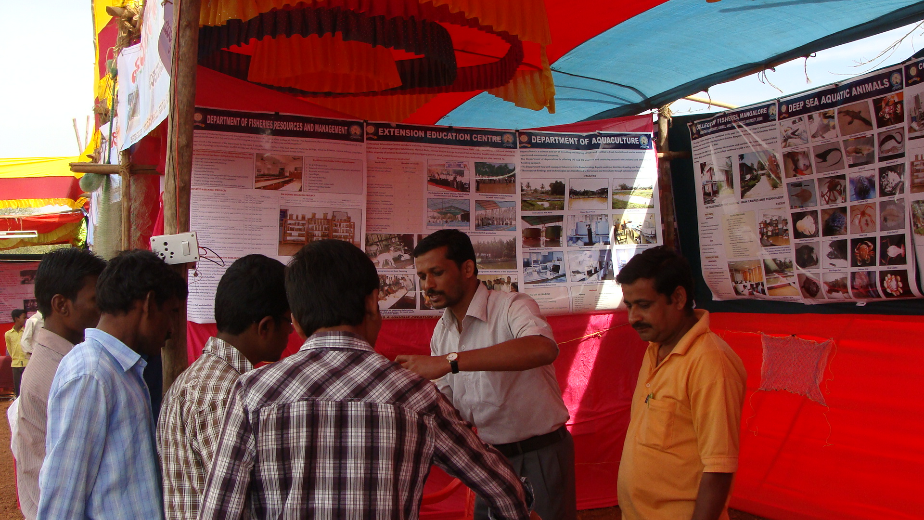

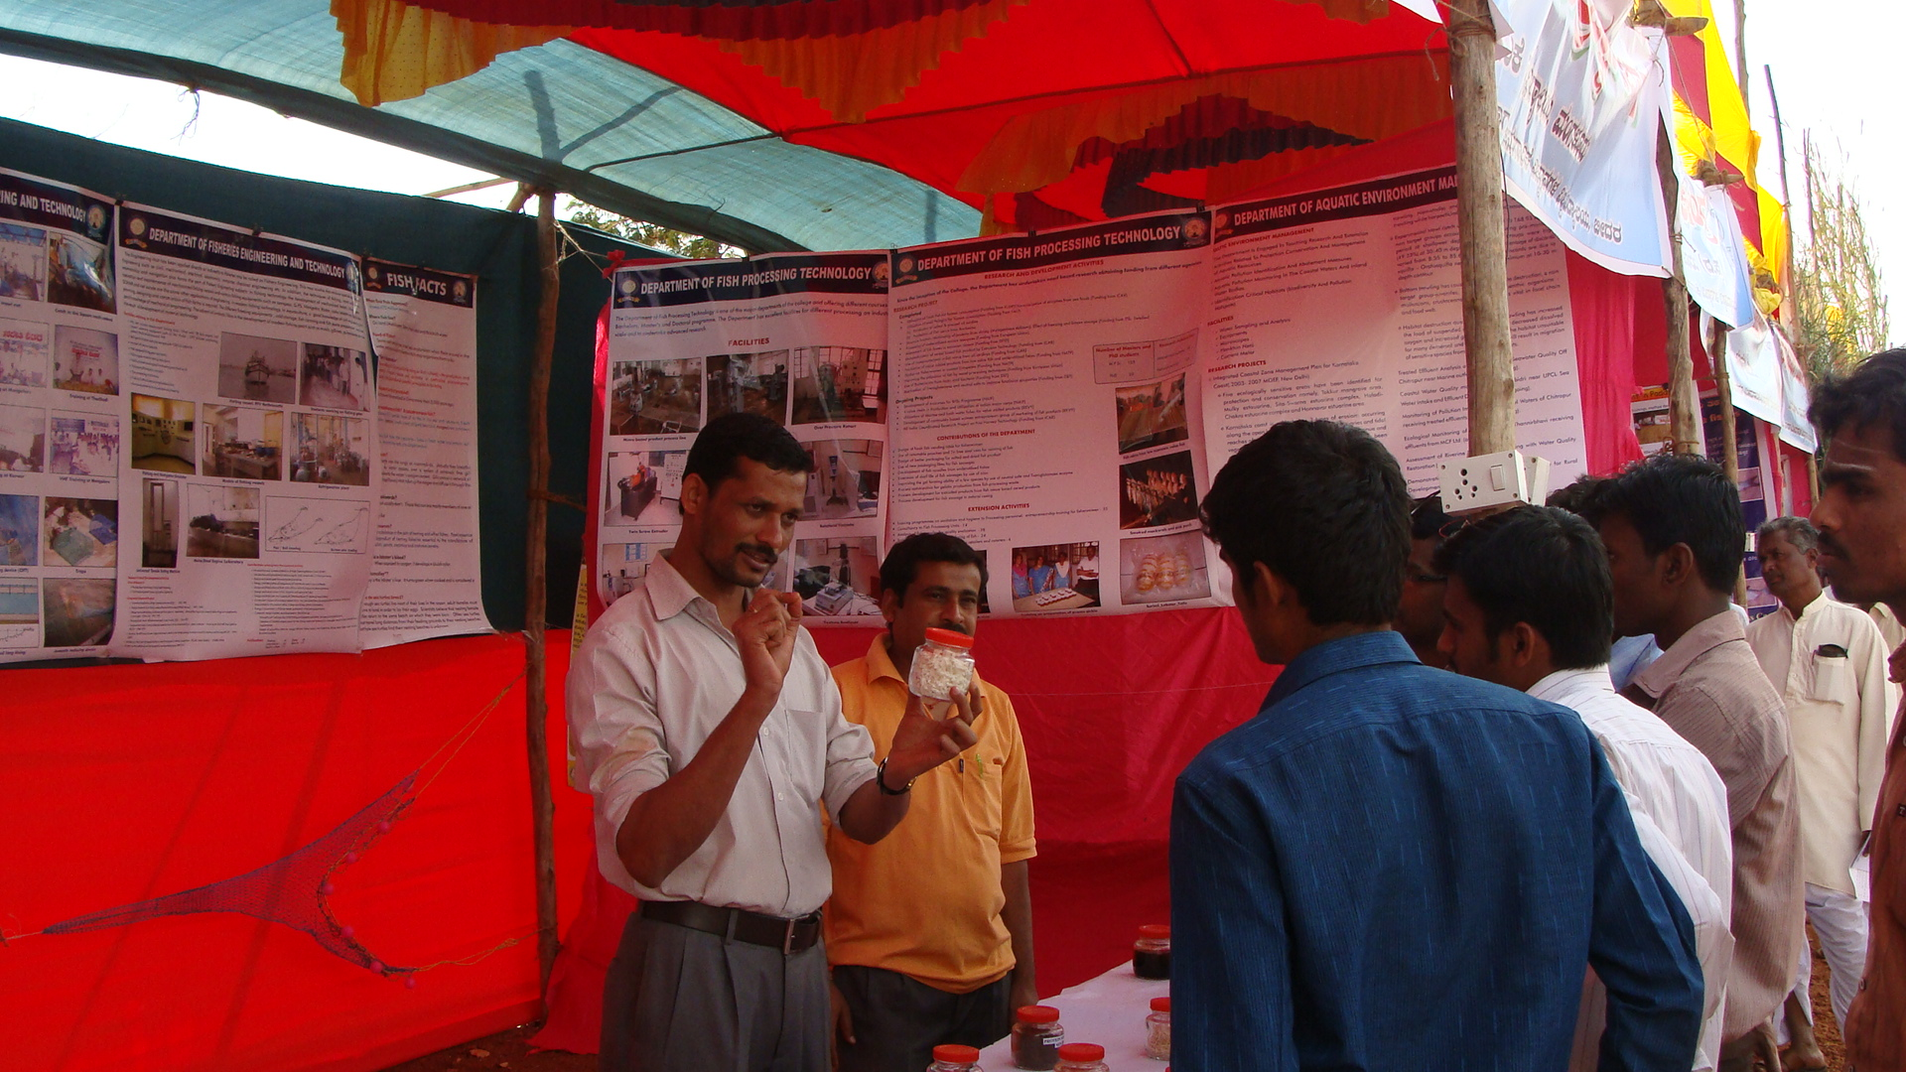

* I have been worked as Associate Coordinator for the training programme Responsible fishing for effective management to fisheries resources (24-07-2014 to 26-07-2014) up to one week duration
I also worked as Assistant Coordinator for the training programme “Recent Developments in Engineering Techniques for Aqua farm” (10-11-2014 to 19-11-2014) for a period of more than one week duration.
* I gave a T V talk on the topic entitled “Applications of simulator in fishing Navigation” for V₄ channel on 24-07-2014. I have explained the benefit of simulator during my talk which could help the fishermen community to adapt and make use of the modern simulator for the Fishing and Navigation purposes.
* I have been worked as resource person for the topic entitled “Developmental stages in growing Marine Fisheries along Coastal Karnataka” on 25-07-2014 during the training programme for the fisher folk of Coastal Mangalore.

The following are the on farm training programme conducted for the Fisher folk of coastal Mangaluru as a training organizer

Sl. No. | Date | Type/ Nature of Work | Brief work carried out
1 | 26-07-2014 | On farm Visit | Visite Visited to Baliga Net Making Factory along with Fishermen for explaining various activities in the factory at Udupi Districts.
2 | 26-07-2014 | On farm Visit | Visi Visited to Fish farming at Kundapura of Udupi along with fishermen for explaining various activities in the fish farm.
3 | 16-11-2014 | On farm Visit | Visite Visited to shrimp farming at Kundapura along with fishermen for explaining various activities like feeding, stocking and aeration etc. to the fisheries officers

