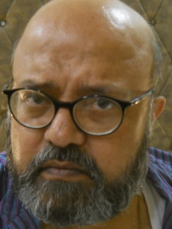

Name :- **SANDIP GHOSAL.**

Father’s Name :- Ranjit Kumar Ghosal.

Address :- 20/20 A, SIL LANE , Kolkata -700015

Educational Qualification :- B.sc. ( Calcutta University )

College :- Rahara Ramkrission Mission Vivekananda Centenary College .

School :- Patha Bhavan. ( Ballygunj Kolkata ).

Professional Qualification :- MDP ( Indian Institute Of Management . Indore)

D.O.B. :- 12 Th. October 1966

Other courses Completed: - INDOLOGY ( Bhartatattba ) ;

( Ramkrishna Mission Institute Of Culture. Goal Park Kolkata.)

MAJOR RELIGIONS OF THE WORLD .

( Ramkrishna Mission Institute Of Culture. Goal Park Kolkata.)

**Associated With :- NATIONAL EDUCATION COUNCIL. WEST BENGAL.**

Work Experience: - Corporate . STATE BANK OF INDIA . ( Group). ( Retd.)

Profile:- **“ A POET & A STORY TELLER ”.**

Mobile:- **9836079713**

E- mail :- [ghosalsandip5@gmail.com](mailto:ghosalsandip5@gmail.com)

Face Book Link :- <https://www.facebook.com/sandip.ghosal.5205>