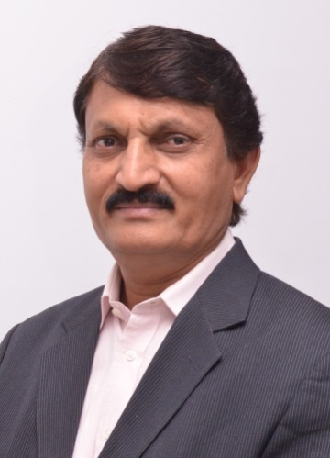**Dr. R. R. Deshmukh,** Professor & Former Head, M.E., M.Sc. (CSE) Ph.D., PEIN Fellow, FIETE in Department of CSIT, Dr. B. A. M. University, Aurangabad, (MS), India. *He is a Visiting Professor, Southern Federal University, Rostov, Russia and Member, Curriculum Advisoary Board, Namibia University, Namibia*. He is Principal Program Coordinator for the DST-FIST program in department sanctioned by Department of Science and Technology, New Delhi, Government of India. He is a Sectional President of ICT Section, The Indian Science Congress Association. He is a Fellow member and working as Chairman, IETE Aurangabad Centre. He is Coordinator of Information Technology and Computer Science Dyanmandal, Maharashtra State Marathi Vishvakosh Nirmiti Mandal, Mumbai, Government of Maharashtra He is a University Coordinator for MHRD scheme on Global Initiative of Academic Networks (GIAN). He was the Member of CSI Best Thesis Award Panel Committee, CSI, INDIA. He is a Chairman, Board of Studies in Computer Science and Engineering and Member of Academic Council, Dr. B.A.M. University, Aurangabad(MS) He has been elected as sectional member of ICT section of Indian Science congress Association. He was an Observer, Maharashtra State Eligibility Test for Lecturers (SET) Exam. He is life member of ISCA, CSI, ISTE, IEEE, IAEng, CSTA, IDES and a Senior Member of ACEEE. He was Vice-Chairman of IETE Aurangabad Centre and member of Management Council of Dr. B. A. M. University. He has worked as a Member of Academic Council and Chancellor’s nominated Senate member of Dr. B. A. M. University, Aurangabad. Commitee member, All India Board of Information Technology Education(AIB-ITE) and Member of Grievience Commitee, All India Council for Technical Education (AICTE). He has published 02 and filed 01 Indian patents, edited twelve books and published more than 160 research papers in reputed International/National peer reviewed Journals/conferences. He is a Member of Editorial Advisory Board for ISCA journal ‘Everyman’s Science’. He is reviewer and editor of several journals at national & international level. He has organized several workshops and International Conferences. He is nominated as a subject expert on various academic & professional bodies at national level government bodies. He has worked as Chairman, Ad-hoc Board of Computer Science & IT, Chairman, Ad-hoc Board of Bio-informatics, Faculty member for Engineering, Science & Management Faculty & Member of various committees at university level. He has completed two major research projects from UGC and DST received grants of more than 1.35 Cr. His areas of specialization are HCI, Speech Signal Processing, Data Mining, GIS and Remote Sensing etc. He has received “Best Teacher Award” for Outstanding Excellence and Remarkable Achievement in the field of Teaching, Research and Publication from IRDP Group of Journal, Chennai. He received the “BHARATRATNA MOTHER TERESA GOLD MEDAL” Award 2015 for outstanding service in Education and Research to strengthen India’s Unity and economic development. He was Coordinator for AVISHKAR organization committee at University Level from 2010 to 2015.He won First prize in Inter University State Level Research Festival “AVISHKAR - 2009” under H. L. F. A. category at Teacher level & for the Team Management. His profile has been published in the 32nd Edition of Marquis Who’s Who in world 2014 which consists profiles of more than 55,000 people working in different areas around the world. He has successfully organized one week course on “Perception and modeling of Three Dimensional Scenes” under MHRD Scheme’s GIAN Program. He is National Executive Committee Member and Chief Editor of CSI Journal of Computing, Computer Society of India.