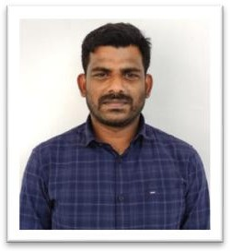

**VIGNESH.K.,M.Sc.,**

**Qualification: M.Sc., MEDICAL PHYSICS**

**Lecturer/ RSO Level-1 Radiodiagnosis ACS Medical College & Hospital Chennai**

**Contact:** +91-9994525618

*E-mail:* [vigneshmphy9@gmail.com](mailto:vigneshmphy9@gmail.com)

Academic Performance: NSS Coordinator, NPTEL SPOC, NAAC Criteria 2&4 Admin