**Indrajit Bandyopadhyay**

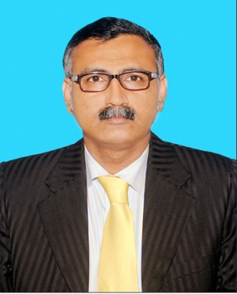

Indrajit Bandyopadhyay, Senior Manager & HOD - University, ICA Eduskills Private Limited is an instructor turned administrator of business schools involved in imparting training in the area of business management, economics, commerce and data sciences. Before joining to ICA Eduskills, he served Usha Martin Education & Solutions Limited as Registrar and CFO. He is an honors graduate in economics and a post graduate in business management with specialization in finance. He has almost three decades of teaching experience in undergraduate and post graduate level, acted as a profit center head along with a decade old experience in industry in handling the business verticals of software development, digital marketing, e-commerce and elevator industry. He is on the Board of Studies of Amity College of Commerce and Finance, Amity University, Kolkata as an industry expert and Techno India University and Sister Nibedita University as chairman for its undergraduate program of commerce and business administration. He has served the institutions and universities like AIES, ICFAI group, IIMS, UMESL, Manipal University, Kalyani University, MAKAUT, and West Bengal University of Health Sciences in different capacities like academic head, dean of studies, registrar, paper setter, moderator, member of academic councils, syllabus and examination committees etc. Indrajit is a life member of All India Management Association and Operations Research Society of India and acting professionally as a blind peer reviewer of three international research journals published from Pune and New Delhi respectively. He has been honored to be invited by universities and business schools like University of Mumbai, Suresh Gyan Vihar University, Jaipur, P K Roy Memorial College, Dhanbad, Jharkhand, AKS University, Satna, MP, Kalyani University, West Bengal, GJIMT, Chandigarh, IIFTR, Indore, SVIM, Indore, and so many, as key speakers in their national and international conferences and faculty development programs. His research area of interest is foreign direct investment and its interrelationship with macro economic parameters with special reference to India.