**Paper Title with Number:**

**Date:**

**Authors Profile Format**

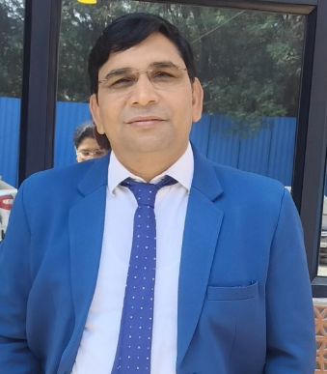

*Kanta Prasad Sharma (Member, IEEE) has published research manuscripts with SCI and SCOPUS indexing international journals and conference proceedings. His research interests include navigation and communication, wireless sensor networks, finger control technology and deep learning with image processing. He is a member of ACM and the Computer Society of India. He is a member of the reviewer and editorial board of more than 22 international and national journals and a TPC member of various international conferences.*

***Note: (Official Mail id is mandatory)***

**Author’s full name must (i.e, Expansion of initials):** Dr kanta Prasad Sharma

**Designation:** Associate Professor

**Department:** Computer Science & Engineering

**Affiliation details:** Amity School of Engineering & Technology, Amity University Greate Noida Campus , UP, Inida

**Official Mail id:** [**tokpsharma@gmail.com**](mailto:tokpsharma@gmail.com)**,** [**kpsharma@gn.amity.edu**](mailto:kpsharma@gn.amity.edu)

**Orcid ID:** [**https://orcid.org/0000-0003-3976-5839**](https://orcid.org/0000-0003-3976-5839)

**Digital Signature:** 

|  |  |
| --- | --- |
| **Payment Details:-**  Account number pay to **P. NAGALAKSHMI**  Bank Account number – **611097894**  Bank name – **Indian Bank**  Brach – **MAHAMAHAM (2499) KUMBAKONAM**  IFSC CODE – **IDIB00M285**  GPAY / Phonepe - **9790559100** |  |