Impact of Manager's Behavioral Integrity on Employee Perception of Fairness

Dr. Aswathi Nair, Prof.Mohana Sundaram, Dr. Prakash. A

Introduction
In the recent past, there has been financial and economic downturn which was partly attributable to the moral and law related gaps by the C-suite executives of Multinationals. The impairment imposed by Satyam Computers in 1990s, followed by Sahara India Pariwar case in 2012 and continued instances of Nirav Modi frauds, Shivinder Mohan Singh (formerly with Fortis Healthcare, Religare and Ranbaxy Laboratories) Scam, and more recently Kingfisher airlines scam in 2017, the crisis became evident. The damages wrecked on all the stakeholders make it ostensible that “bad ethics” could lead to disastrous effect on the outcomes and strengthen the argument that “virtuous behavior” is also “respectable business”.

The word ‘Behavioral Integrity’ (BI), is distincted as the resemblance amongst the alignment of the words and deeds of an individual. Trust is a sophisticated concept understood as a widespread diversity of affectiveness, emotiveness and cognition. An examination of the value of Manager’s BI highlights the influence, trust and reliability on employee’s Organizational Commitment.

The objective of the study is to comprehend the Impact of Manager's Behavioral Integrity on Employee Perception of Fairness. We ran a survey of 151 personnel working with diverse corporates from top, middle and start-level management. Questionnaires were mailed to them; the data was collated, and the results were analyzed by means of the factor analysis method. Studies reveal a positive relationship between the Manager’s Behavioral Integrity and Employees’ perception of Fairness. The topic is widely discussed in Corporate and Academic Circles.

Numerous theories on leadership highlighting the standing of ethical aspects of the leader’s behaviors such as behavioral integrity, servant leadership, ethical leadership etc. Relationship among employees burn out, employee engagement, absenteeism, turnover likelihood, job satisfaction, work life balance, life satisfaction affects the Employee Value Proposition (EVP) and the desirability of the employer as a preferred workplace by employees. Trust would be considered as a process of understanding and responsiveness of leadership behaviors.

The Manager's and Employees' positive organizational behavior is important for the enterprise as that stimulates employee-employer trust building and efficiencies.

Literature Review

The manager plays an important role in building work-life balance which brings trust among employees. The manager understands capability of employees and to extend support helps the employees to achieve work-life balance. The manager's unresponsive actions could lead to stress among employees resulting in negative productivity and impact on work life balance leading to company's negative performance.

Manager-Employee trust relationship could be built on sharing information and knowledge of work processes and values. Such positive organizational behavior could bring in mutual trust. It needs manager’s support and pro-active interaction with the employees.

Managers need to be cooperative and understand employee's family responsibilities. Next organizational policies and situational factors which brings in work-life culture that requires managerial support and helps build manager-employee trust relationship.

Management Conduct that build Employee-Employer Reliance.
The Organizational accomplishment is positively the unbiased trust. The employees would not be able to perform should they believe that they could not trust their manager. The trust factor may bring down the organization social costs.

The Trust factor may lead to optional effort by the employees. Trust in leadership could lead to employee attitude towards work, social behavior and job performance.

The leadership could be a characteristic social process and the goodwill earned through social interactions could lead to social capital development. Trust could be built by the leader through building social relationship, concern towards employee and respect for employee.

Leaders may observe and bring in the change in employee's work attitude and values to perform better to meet the organizational expectations. The transformational leadership displays vision, provides a behavioural role model, supports the employees, forms groups & group goals, and sets high expectation level and knowledge sharing. This would result in organizational social behavior and may instill trust in employees.

Objectives
- To explore the alignment of Manager’s words and Promise Keeping to Employees.
- To inspect whether workers are respected in their organization by the Management.
- To examine whether values are practised in the Organization.

RESEARCH METHODOLOGY

This section covers research design and apparatuses for analysis.

Research Design
A cross-sectional survey design was used in this study. Primary source of data was collected using the structured questionnaire.
Sample
The data collection was conducted from 151 respondents comprising of 122 male and 29 female respondents respectively. The survey covered all levels of management (top, middle and entry) with respect to Information Technology, Health care, Retail and Banking sectors.
Application of Tools.
The technique used for data collection was Random sampling. Questionnaire was mailed out to the sample size. The data were analyzed using descriptive statistics and inference statistics. In order to check whether the questionnaire provides an accurate and stable representation of the construct, Cronbach Alpha was used for reliability testing. It turns out to be 0.944 for 15 items which shows a good standard of reliability.
Tools used for analyzing the data are correlation analysis, descriptive statistics and t test.

Data Analysis:
The mean and standard deviation for all the variables is shown in the table below. The mean scores lie between 2.48 and 2.91 whereas the standard deviation lies between 1.07 and 1.48 respectively.

ANALYSIS OF DEMOGRAPHIC VARIABLES

DISPERSAL OF GENDER-RELATED SEGMENTS:

Table : 1 SEGMENTS
 |  | Frequency | Percent | Valid Percent | Cumulative Percent
Valid | MALE | 122 | 80.8 | 80.8 | 80.8
Valid | FEMALE | 29 | 19.2 | 19.2 | 100.0
Valid | Total | 151 | 100.0 | 100.0

Among the 151 respondents, around 81% are male and 19% are female respectively.

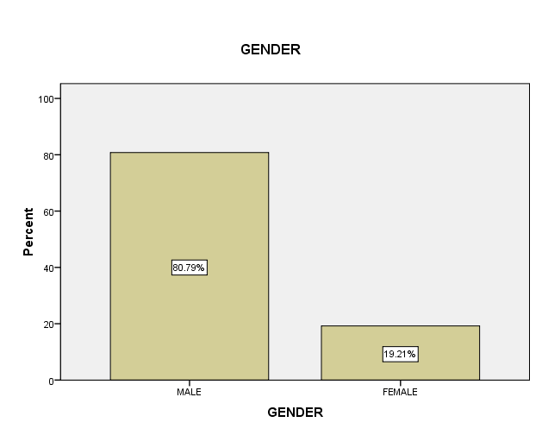

AGEWISE DISTRIBUTION OF THE RESPONDENTS
Table : 2 LENGTH OF LIFE
 |  | Frequency | Percent | Valid Percent | Cumulative Percent
Valid | LOWER THAN 30 YEARS | 87 | 57.6 | 57.6 | 57.6
Valid | 31 - 40 YEARS | 55 | 36.4 | 36.4 | 94.0
Valid | 41 - 50 YEARS | 8 | 5.3 | 5.3 | 99.3
Valid | HIGHER THAN 51 YEARS | 1 | .7 | .7 | 100.0
Valid | Total | 151 | 100.0 | 100.0

Eighty-seven respondents belong to the age group of less than 30 years, contributing to 57.6% followed by 55 respondents in the age group of 31-40 years contributing to 36.4% respectively. Very few percentage (6%) contributes above 41 years of age.

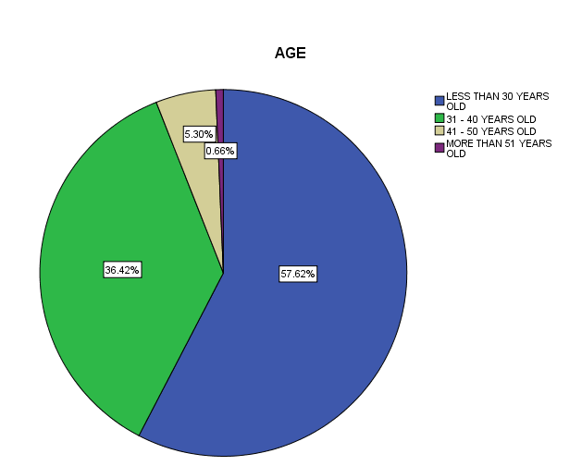

DISTRIBUTION OF RESPONDENTS BASED ON DESIGNATION

Table : 3 DESIGNATION
 |  | Frequency | Percent | Valid Percent | Cumulative Percent
Valid | TOP MANAGEMENT | 11 | 7.3 | 7.3 | 7.3
Valid | MIDDLE | 82 | 54.3 | 54.3 | 61.6
Valid | ENTRY LEVEL | 58 | 38.4 | 38.4 | 100.0
Valid | Total | 151 | 100.0 | 100.0

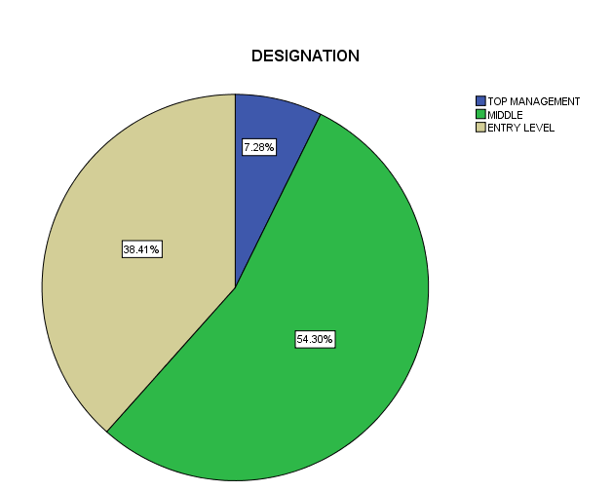

The respondents were classified as top, middle and entry level management. Around 93% of the respondent belongs to middle and entry level management and only 7% contributes to the top management.

DISTRIBUTION OF RESPONDENTS BASED ON COMPANY

Table : 4 COMPANY
 |  | Frequency | Percent | Valid Percent | Cumulative Percent
Valid | IT | 66 | 43.7 | 43.7 | 43.7
Valid | RETAIL | 62 | 41.1 | 41.1 | 84.8
Valid | HEALTHCARE | 18 | 11.9 | 11.9 | 96.7
Valid | BANK | 5 | 3.3 | 3.3 | 100.0
Valid | Total | 151 | 100.0 | 100.0

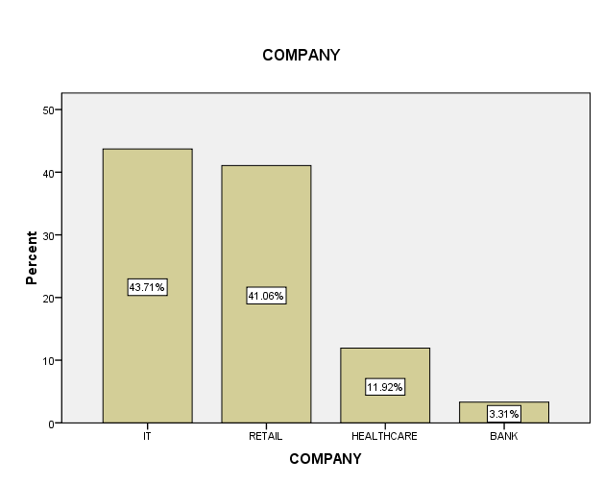
The classification of respondents based on the type of companies they are working in were analyzed and found that 44% contribute to IT sector followed by 41% in retail, 12% in health care respectively. Very minimal response was from Banking sector.

DISTRIBUTION OF RESPONDENTS BASED ON JOB TENURE.
Table 5 : JOB TENURE
 |  | Frequency | Percent | Valid Percent | Cumulative Percent
Valid | 0-5 | 116 | 76.8 | 76.8 | 76.8
Valid | 6-10 | 24 | 15.9 | 15.9 | 92.7
Valid | 11-15 | 9 | 6.0 | 6.0 | 98.7
Valid | MORE THAN 16 | 2 | 1.3 | 1.3 | 100.0
Valid | Total | 151 | 100.0 | 100.0

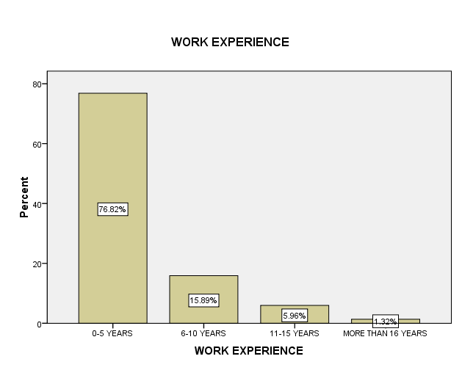

Seventy-seven percentages of respondents are in less than five years of experience followed by 16% of the respondents with experience between 6 and 10 years. Only 7.3 % of the respondents were in the experience of more than 11 years.

Table 6: Descriptive Statistics Analysis.

 | Mean | Std. Deviation
Employees knowledge of mission statement | 2.91 | 1.17
Participative value setting | 2.68 | 1.07
Belief in core values | 2.83 | 1.18
Employee engagement | 2.79 | 1.17
Trust top management | 2.90 | 1.23
Top management is perceived as ethical | 2.79 | 1.24
Word-deed placement | 2.67 | 1.08
Promise keeping of managers | 2.74 | 1.15
employee ownership and organizational commitment | 2.62 | 1.11
Management do not adopt unethical business practices | 2.48 | 1.48
Organizational support to employees | 2.77 | 1.31
Mechanics to check the Transparency | 2.66 | 1.32
Employee-organization fitment | 2.78 | 1.30
HR Practices | 2.87 | 1.30
Open communication | 2.79 | 1.28

This demonstrates that all the variables are in agreement with the statement with a maximum standard deviation of 1.3.

Table: 7 Correlation between word deed placement and promise keeping of managers
Word-deed placement | Promise keeping of managers
Pearson Correlation  Sig. (2-tailed) | .746**
Pearson Correlation  Sig. (2-tailed) | .000

In order to assess the null hypothesis that there is no association between word deed alignment (behavioral integrity) and promise keeping, the researcher used the t test. As the p value (0.000) is less than the level of significance at 1%, there is no sample evidence to accept the null hypothesis.

Table : 8 Correlation analysis
 |  | Trust top management | Top management ethical | employee ownership and organizational commitment | Management do not adopt unethical business practices | Organizational support to employees | Mechanics to check the Transparency | HR Practices | Open communication
Trust top management |  | 1
Top mana- ethical |  | .729** | 1
Top mana- ethical |  | .000
Employee ownership &OC |  | .344** | .367** | 1
Employee ownership &OC |  | .000 | .000
Management do not adopt unethical business practices |  | .441** | .581** | .508** | 1
Management do not adopt unethical business practices |  | .000 | .000 | .000
Organizational support to employees |  | .593** | .684** | .336** | .610** | 1
Organizational support to employees |  | .000 | .000 | .000 | .000
Mechanics to check the Transparency |  | .407** | .521** | .453** | .758** | .612** | 1
Mechanics to check the Transparency |  | .000 | .000 | .000 | .000 | .000
HR Practices |  | .686** | .712** | .288** | .462** | .555** | .397** | 1
HR Practices |  | .000 | .000 | .000 | .000 | .000 | .000
Open communication |  | .599** | .647** | .375** | .512** | .685** | .494** | .541** | 1
Open communication |  | .000 | .000 | .000 | .000 | .000 | .000 | .000
**. Correlation is substantial at 0.01 (2-tailed).

The researchers used the correlation analysis to investigate whether the employees are respected in their enterprise by the Administration and tested the above variables. All the variables are significant at 1% level. There is a high correlation between the employee compliance due to perception of fairness and mechanics to check the Transparency (0.758) followed by the ethical perception about top management (0.729) respectively.

Table: 9 Correlation analyses on the values practiced in the organization.
 |  | Employees knowledge of mission statement | Participative value setting | Belief in core values | Employee engagement | Employee-organization fitment
Employees knowledge of mission statement |  | 1
Participative value setting |  | .552** | 1
Participative value setting |  | .000
Belief in core values |  | .667** | .494** | 1
Belief in core values |  | .000 | .000
Employee engagement |  | .581** | .417** | .731** | 1
Employee engagement |  | .000 | .000 | .000
Employee-organization fitment. |  | .438** | .581** | .456** | .453** | 1
Employee-organization fitment. |  | .000 | .000 | .000 | .000
**. Correlation is substantial at 0.01 (2-tailed).

There is a high correlation between the Employee engagement (0.731), followed by the belief in core values (0.667) respectively. As per the t test result, it is clear that the p values are less than the level of significance at 1% (0.01). Therefore, null hypothesis is rejected.

Discussion

As the analysis indicates a positive relationship between all the variables of Behavioral Integrity of Managers and perceived Employee fairness the implications and applicability of the same are discussed as below.

The first objective of the research is to check the alignment of Manager’s words and Promise keeping to Employees. It has the following key variables:
- Promise keeping of managers
- Word-deed placement

To explore whether there is an alignment of words and Promise keeping to Employees, the researcher used the correlation analysis and tested its significance at 1% level. The result shows a positive relationship between the manager’s deliveries on promise keeping to employees. This means that there is a cordial working ambience of employees and managers when managers are perceived to keep their promises and honor the commitment with employees.

The second objective of the research is to examine whether employees are treated with respect in their organization by the Management. It has the following variables.

- Trust top management
- Top management is perceived as ethical.
- Employee ownership and organizational commitment
- Management do not adopt unethical business practices
- Organizational support to employees
- Mechanics to check the Transparency
- HR Practices
- Open communication

The high correlation between the employee compliance due to perception of fairness and Mechanics to check the Transparency seconded by ethical perception about top management denotes that the employees perceive their organizations as a fair place to work. Employees display organizational citizenship behavior when they are treated fairly in the organization. The lack of discrimination, practice of inclusion by top management and lack of adoption of unethical practices will build the organization internally with committed employees.

The final objective is to examine whether values are practiced in the organization.
It has the succeeding crucial variables:
- Employee’s knowledge of mission statement.
- Participative value setting.
- Belief in core values.
- Employee engagement.
- Employee-organization fitment.

The above variables were analyzed using correlation and tested at 1% level of significance using t test. There exists a relationship between the staffs’ knowledge of mission statement, belief in core values, participative value setting, employee engagement, employee-organization fitment.
The high correlation between the Employee engagements seconded by the belief in core values shows that employees like to stay in organizations where the core values are practiced.

The examination of the variables of second and third objectives which is meant to check the perception of fairness indicates that the employees perceive their organization as an unbiased place to work when all the variables are satisfactorily implemented.

The gender profile should have been more diverse to arrive at an accurate conclusion that both the genders agree that behavioral integrity of management will lead to organizational fairness.
The opinion of the survey to a great extent resonate the attributions of the millennials and Gen Y cohorts and less of the baby boomers.

Since the survey was designed to find out the integrity of the Managers, the focus group was on entry level and mid-level cadres. We were able to cover the major industries of Karnataka with the key segmentation representing software domain. The focus was on administration’s perception of fair-mindedness and hence the focus tenure was less than 5 years .When the new comers believe that the organization is fair, the flight risk of the company takes a back seat.

Conclusion

As a natural transition from the analysis and discussion, it can be concluded that organizational commitment, conviction in supervisors, and organizational commitment are highly anticipated behaviors among workforces by any organization. A substantial aspect that energizes these behaviors is the perception of fairness within the company. This to a great extent reflects how an employee feels valued at work which correlates with the approach of the management towards its employees. Hence, it is imperative to understand how staffs appraise fairness in organization based on Manager’s Behavioral Integrity. Manager’s behavioral integrity would enhance employee's organizational identification. Managers need to align their words and actions to form leader-employee interactions which will enhance the employer branding and employee value proposition of the enterprise. The current research shows that the manager’s behavioral integrity has a significant influence on employee’s perceived organizational practices.

References
Adler, Paul & Kwon, Seok Woo. (2002). Social Capital: Prospects for A New Concept. Academy of Management Review. 27. 17-40. 10.5465/AMR.2002.5922314.
Anderson, S. E., Coffey, B. S., & Byerly, R. T. (2002). Formal organizational initiatives and informal workplace practices: Links to work–family conflict and job-related outcomes. Journal of Management, 28, 787– 810.
Batt, R., & Valcour, P. M. (2003). Human resources practices as predictors of work–family outcomes and employee turnover. Industrial Relations, 42, 189 –220.
Bijlsma, K. and Koopman, P. (2003), "Introduction: trust within organizations", Personnel Review, Vol. 32 No. 5, pp. 543-555
Clark, S. C. (2001). Work cultures and work/family balance. Journal of Vocational Behavior, 58, 348 –365.
Collins, M. H., Hair, J. F., Jr., & Rocco, T. S. (2009). The older-worker—younger-supervisor dyad: A test of the Reverse Pygmalion effect. Human Resource Development Quarterly, 20(1), 21-41.
Dirks, K. T., & Ferrin, D. L. (2002). Trust in leadership: Meta-analytic findings and implications for research and practice. Journal of Applied Psychology, 87(4), 611-628.
Eversole, Barbara & Venneberg, Donald & Crowder, Cindy. (2012). Creating a Flexible Organizational Culture to Attract and Retain Talented Workers Across Generations. Advances in Developing Human Resources. 14. 607-625. 10.1177/1523422312455612.
Golembiewski, R. T., & McConkie, M. (1975). The centrality of interpersonal trust in group processes. In C. L. Cooper (Ed.), Theories of group processes (pp. 131– 185). New York, NY: Wiley.
Jung, DI & Avolio, Bruce. (2000). Opening the black box: an experimental investigation of the mediating effects of trust and value congruence on transformational and transactional leadership. Journal of Organizational Behavior. 21. 949-964.
Kent, Thomas & Crotts, John & Azziz, Abdul. (2001). Four Factors of Transformational Leadership Behavior. Leadership & Organization Development Journal. 22. 221-229. 10.1108.
Kramer, R. M. (1999). Trust and distrust in organizations: Emerging perspectives, enduring questions. Annual Review of Psychology, 50, 569-598.
Mayer, Roger & Gavin, Mark. (2005). Trust in Management and Performance: Who Minds the Shop While the Employees Watch the Boss?. Academy of Management Journal. 48. 874-888. 10.5465/AMJ.2005.18803928.
Podsakoff, P. M., MacKenzie, S. B., Moorman, R. H., & Fetter, R. (1990). Transformational leader behaviors and their effects on followers' trust in leader, satisfaction, and organizational citizenship behaviors. The Leadership Quarterly, 1(2), 107-142.
Posner, B. Z., & Kouzes, J. M. (1993). Psychometric properties of the Leadership Practices Inventory—Updated. Educational and Psychological Measurement, 53(1), 191-199.
Thompson, C. A., Beauvais, L. L., & Lyness, K. S. (1999). When work–family benefits are not enough: The influence of work–family culture on benefit utilization, organizational attachment, and work–family conflict. Journal of Vocational Behavior, 54(3), 392-415.

