Tools of Recombinant DNA Technology

Koushik Ganguli
Department of Botany
Visva-bharati (A Central University)
Santiniketan, Bolpur, India
Itzmekoushik.personal@gmail.com

Dr. Anjalika Roy
Department of Botany
Visva-bharati (A Central University)
Santiniketan, Bolpur, India
anjalika.roy@visva-bharati.ac.in

ABSTRACT

In the Rat-race of development, technology is the main weaponary which is also shaping the field of biology rapidly.Application of recombinant DNA technology is a major artillery of biotechnology resulted a new oppurtunities in the field of agriculture, medicine and bioremediation. The new genes are cloned and expressed to produce recombinant drugs which play key role aginst human lethal diseases or recombinant plant for food sufficiency. Human genome project is a another breakthrough of RDT to retrieve information of genetic variants for future medical care.Gene knockout helps in gene therapy and DNA profiling helps in solving criminal cases etc.

INTRODUCTION
Through conventional techniques, the approach of overcoming medical, agricultural and environmental problems are now replaced by RDT which put forward a new revolution in modern era. Making a new combination of DNA by manipulating through biotechnological and biochemical means is known as recombinant DNA technology. It may be insertion(s) or/and deletion(s) of DNA. To insert a gene of interest first the gene should be identified and then isolated. This process of recombination also known as genetic engineering and the product is called recombinant DNA.In 1973 Paul Berg developed first recombinant DNA molecule by combining genomic content of two viruses, SV40 and lambda phage Later, in 1973, the first recombinant plasmid DNA molecule produced by Boyer, Chang, Cohen and Helling [1].

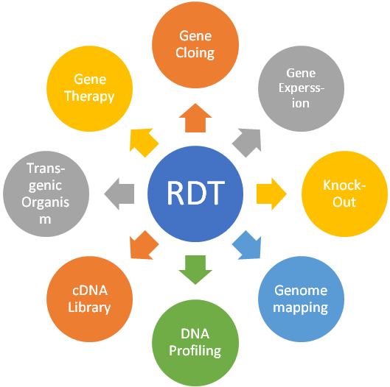
Figure 1: Functional aspects of Recombinant DNA Technology

GENE CLONING

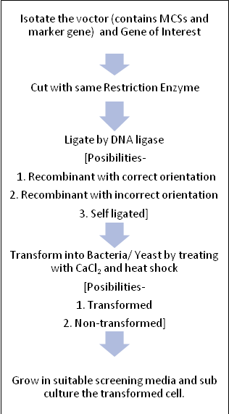
The recombinant DNA technology was started with Gene cloning. The techniques are done to assemble DNAs and to replicate in a host body are called gene cloning. In this method one DNA copied into several copies. DNA cloning's key component is the selective amplifying of the desired DNA fragments, which results in a significant rise in the number of copies of the chosen DNA sequences. In actuality, a DNA polymerase operating on one or more varieties of template DNA molecules catalyses several rounds of DNA replication. Cell-based and cell-free DNA cloning are essentially two distinct DNA cloning methods [2]. If the cloning is done in vivo or inside a cell, then it is called cell based cloning. It is done inside the bacteria because, bacterial cell proliferation rate is high. For cell based cloning, the vector should contain Multiple Cloning Sites (MCSs) and any one or more marker gene for screening. Later, the cell free gene cloning technique was invented by Kary Mullis called Polymerase Chain Reaction or PCR. In PCR, all the important raw material (e.g., Gene of Interest, dNTPs, Primer, Taq Polymerase, Mg²⁺ and buffer) has to provide into a PCR tube and placed in the PCR machine or Tharmocycler [3].This method is only for increasing copy number of a gene.
Therefore gene cloning is mainly used to multiply a segment of DNA.
Figure 2: Method of cell-based Gene Cloning

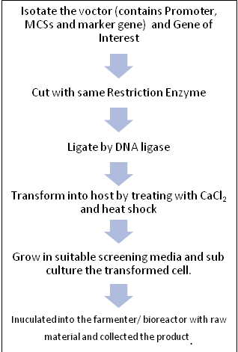
GENE EXPRESSION
Gene expression is producing either RNA molecules for proteins production or non-coding RNA molecules with other roles like silencing etc. The production of RNA molecules and proteins, as well as their quantity, are controlled by gene expression, which also serves as a "on/off switch" and a "quantity control". The environment controls and significantly changes gene expression. Many genes produce RNA and proteins that control the expression of other genes.Gene expression is very much similar to cell based gene cloning. This technique is done to synthesize protein by expressing a particular gene in host body in laboratory condition. E.g., Insulin production.
Gene expression system categorised on the basis of the host nature: Eukaryotic Expression system and Prokaryotic expression system. Prokaryotic expression system, particularly E. Coli, is widely used system [3]. Now a days, it is very popular technique to produce vaccine,Growth hormones, Recombinant protein, Antibodies, Anticancer drugs, Vectors, [4].
Figure 3: Method of gene expression

GENE KNOCK OUT
Gene knock out is a method to lost a particular activity by removing the complete gene. The gene knock out technique processes are TK/Neo^{R} cassette also called replacement vector or CRE/LoxP recombination.TK and Neo^{R} both are screening marker gene.TK or Thimidine kinase is shows sensitivity to glasciclovir and Neo^{R}is resistant to Neomycine [3].
Cre-Lox is a Site-specific recombinase technology, used to perform out INDELs, translocations, and inversions in the DNA of cells. It facilitate the DNA alteration to be directed toward a certain cell type or to be started by a certain outside input. Both eukaryotic and prokaryotic systems employ it. Cre recombinase, the only enzyme in the system, recombines two short target sequences known as Lox sequences. It is possible to use this system without adding any additional supporting proteins or sequences. Bacteriophage P1 is the source of the Cre enzyme and the initial Lox site, often known as the LoxP sequence. Genes can be switched for other genes or active, repressed, or both, depending on where Lox sequences are positioned. Many different kinds of alterations may be done at the DNA level. The Cre enzyme's activity can be regulated to only express in a certain type of cell or to be activated by an outside stimulus, such as a chemical signal or a thermal shock. When mutations are fatal if expressed worldwide, these focused DNA alterations are helpful in cell lineage tracking. The FLP-FRT recombination system and the Cre-Lox system function and are used in very similar ways. [5].
It is used to study function of gene. Sometimes used for gene therapy and development of recombinant organism.

GENOME MAPPING
Gene locations and the distances between them on a chromosome are found and recorded using genome mapping. A crucial foundation for the Human Genome Project (HGP) was laid via genome mapping. Mapping provides an estimation of the (physical) distance between specific known DNA sequences on a chromosome. The number of base pairs between these recognised DNA sequences on a chromosome is used to indicate their distance from one another. These include:
- Restriction mapping: By cutting an unknown length of DNA into segments and then locating the breakpoints, the technique known as restriction mapping can map the segment. . The basis of this technique is a type of proteins utilised known as restriction enzymes (REs), which can break or digest DNA molecules at specialised sequences known as restriction sites. Now, Gel electrophoresis, a laboratory technique which separates DNA fragments based on size, can be used to analyze the fragments produced after a DNA fragment has been broken using a RE. Restriction mapping is two types: fingerprint mapping (the mapping of restriction sites along a DNA strand in relation to one another) and optical mapping (a method for high-resolution analysis of huge eukaryotic genomes' structural features).
- FISH: Fluorescence in situ hybridization (FISH) is the most reliable method for finding specific DNA sequences, diagnosing genetic illnesses, mapping genes, and discovering new oncogenes or genetic abnormalities causing various cancers. In cells that are in metaphase or interphase, FISH can identify particular DNA sequences at particular places. Schwarzacher et al. (1989) and Yamamoto and Mukai were the first to use this method on plant chromosomes after it was first created for mammalian chromosomes [32].
- STS mapping: The term "Sequence-Tagged Site" (STS) refers to a relatively short, readily PCR-amplified sequence (200 to 500 bp) that can be specifically amplified by PCR, detected in the presence of all other genomic sequences, and whose location in the genome is mapped [33].

DNA PROFILING
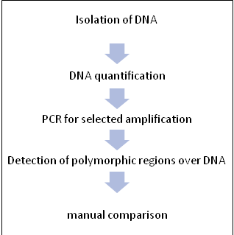
DNA profiling is a method of compairing two or more DNA sequences. It is possible to identify the same individual belongs to same perents through DNA fingerprinting. DNA profiling play a centre stage role in Forensic Science and criminal investigation. In the year of 1984, a British Geneticist named Dr. Alec Jeffreys developed a technique to individualize two different people by their DNA. Jeffery’s technique was basically depending on VNTR (Variable Number of Tandem Repeats). In this case he uses some non-coding (introns) regions of DNA which was highly variable between two people. Jeffery analysed some repetitive sequence present over DNA which is highly polymorphic.
Figure 4: DNA profiling procedure
Later other DNA profiling techniques like RFLP, RAPD, STR, SNP etc. are introduced. But these all techniques are depending on VNTR. DNA profiling has a potential application like in kidnapping cases, identifying of missing person, Disaster Victim Identification, Biological parent identification, Criminal identification etc.DNA profiling can't distinguish between monozygotic twins as they share same genomic data of both parents.

cDNA LIBRARY
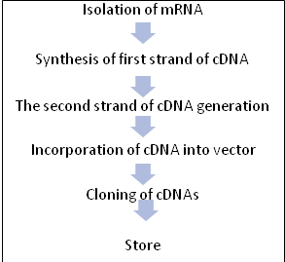
A messenger ribonucleic acid (mRNA) that has been entirely translated and solely includes the expressed genes of an organism produces complementary DNA (cDNA). The term "cDNA clones" refers to copies of such mRNAs in DNA. A cDNA library is a collection of cloned cDNA fragments introduced into various host cells, each of which makes up a small piece of the organism's transcriptome.As opposed to DNA, mRNA is used to create cDNA libraries. To translate DNA information into protein, messenger RNA transports the information from ribosomes. Reverse transcriptase, an enzyme that creates a DNA copy of an mRNA, is applied to these mRNA molecules to produce a cDNA library (i.e., cDNA). An untranscribed area is included in a genomic library, whereas a cDNA library only contains a sample of the transcribed genes.
Figure 5: cDNA library making procedure

TRANSGENIC ORGANISM
Genetically modified organisms (GMOs) or transgenic organisms are the organisms whose genomic makeup has been altered by using genetic engineering techniques. Animals, plants, microbes, and many other types of species have undergone genetic modification (GM). Genes have been moved between members of the same species, between species (resulting in transgenic creatures), and even between kingdoms. Endogenous genes can be strengthened, changed, or taken out, as well as new genes.The creation of GMOs has become significantly easier thanks to recent developments in genome editing technologies, particularly CRISPR/Cas system [31].
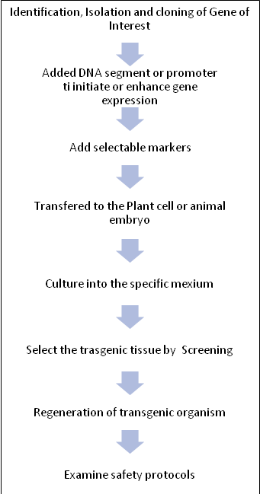
The DNA must be transported across the cell membrane without damaging the cell in order to create a transgenic cell. In some circumstances, introducing DNA to the medium and momentarily expanding the membrane's porosity, such as by electroporation, might result in the transfer of naked DNA into the cell. Using a specialised needle and bigger cells, bare DNA may microinjected into a cell. In other procedures, DNA is transported across the membrane using vectors. Vectors for the transformation of DNA may be various types e.g., Vesicles consisting of lipids or other polymers that enclose DNA, infectious viruses and bacteria, which naturally transfer their own DNA into a host cell, and modified viruses and bacteria which can transport any Gene of Interest (GOI). The foreign DNA must be absorbed into the host's chromosomes when the goal of an experiment is to create a stable (i.e. heritable) transgenic organism. For this, the foreign DNA has to enter the host's nucleus and unite with a host chromatid. In certain animals, the foreign DNA is inserted randomly into a chromatid, likely wherever strand breaks and non-homologous end joins. By placing DNA that is identical to the host's DNA at that locus on each side of the foreign DNA, it is possible for other species to direct the foreign DNA to a specific locus. Homologous recombination is then used to insert the foreign DNA into the host's chromosomes.A stable (i.e. heritable) transgenic eukaryote must be created when the goal of an experiment is to develop one. For successful transgeneic, the foreign DNA has to penetrate the host cell's nucleus and unite with a chromatid. In certain animals, the foreign DNA is randomly inserted into a chromatid, likely wherever strand breaking and NHEJ (Non-Homologous End Joining) happen to take place. The foreign DNA can be directed to a particular locus in another species if it is flanked by DNA that is identical to the host's DNA at that locus. After then, homologous recombination occurs to integrate the foreign DNA into the host's chromosomes.
Figure 6: Transgenic organism development

GENE THERAPY
Gene therapy is a branch of medicine that focuses on altering a cell's genetic makeup to have a therapeutic impact or to treat a disease by replacing or repairing damaged genetic material [6]. French Anderson, the inventor of gene therapy, used gene transfer for the first time therapeutically and directly inserted human DNA into the nuclear genome in a study that began in September 1990 [7].

Gene therapy is differentiated into two types depending on treated cell type: Somatic gene therapy, when genetic therapeutic treatment is done on any body cell that doesn’t produces gametes and germline gene therapy, when genetic therapeutic treatment is done on gamete mother cells. On the basis of therapeutic methods, it may differentiate into three categories; Gene augmentation therapy, Gene inhibition therapy and Killing of specific cells. Gene augmentation therapy is used when a loss of function mutation caused into the cell thus the protein production obstructed. This treatment replenishes the cell's DNA with a functioning copy of the missing gene. The new gene creates a functional protein in high enough quantities to replace the lost protein. Gene inhibition therapy is used to inhibit a gene mutated as gain of function and/or affecting any other metabolic reactions. Killing of specific cells as the name suggests it is a killing technique. it preferred for conditions like cancer that may be treatable by destroying specific cell types.

APPLICATONS OF RECOMBINANT DNA TECHNOLOGY

Food and agriculture: Major advancements in recombinant DNA technology have made it feasible to produce unique enzymes that are appropriate for certain food processing settings. Due to their specialised functions and uses in the food industry, several significant enzymes, such as lipases and amylases, are accessible for the specific manufactures. Another significant accomplishment made possible with the use of recombinant DNA technology is the generation of microbial strains. Numerous microbial strains have been created that can manufacture enzymes, specifically proteases, by targeted engineering. Some fungal strains have undergone modifications to reduce their capacity to produce hazardous compounds [8]. DspB, a protein created from T7, can hydrolyze the exopolysaccharides of Staphylococcus and E. coli. The bacterial population declines as a result of DspB's activity [9].
Health and diseases: RDT has a wide spectrum of use in health and disease treatment.

1.Gene therapy Advanced medical technology with therapeutic potential includes gene therapy. The first successful study of gene therapy for the treatment of a genetic condition offered a more reliable path toward healing the most lethal hereditary disorders [11,12]. A focused approach with the potential to be therapeutically beneficial is gene transfer to a few cells at anatomically distinct places. For severe autosomal recessive dystrophies including congenital blindness and Leber congenital amaurosis, it shown amazing outcomes (LCA) [13]. Gene therapy for the treatment of cardiovascular disorders is a significant medical research method. Gene therapy will open up new possibilities for therapeutic angiogenesis, myocardial protection, regeneration, and repair, prevention of restenosis after angioplasty, avoidance of bypass graft failure, and risk factor management in the field of cardiovascular medicine [30]. Wiskott-Aldrich Syndrome is brought on by a mutation in the gene that codes for WASP, a protein that controls the cytoskeleton (inherited immunodeficiency). When matched donors are not available for stem cell transplantation, the condition is treated by injecting autologous HSPCs that have undergone ex vivo gene therapy [14].One of the main oncogenic pathways in many malignancies is wnt signalling. An appealing therapeutic strategy for treating cancer is to target the Wnt system, and LGK974 potently blocks Wnt signalling, has good effectiveness in rodent tumour models. High levels of LGK974 response are observed in head and neck cancer cell lines with loss-of-function mutations in the Notch signalling system [15].The CRISPR/Cas9 technology has given gene therapy a second chance to shed its bad reputation and establish itself as an effective therapeutic approach. A new age of CRISPR gene therapy is now possible because to the recent introduction of CRISPR technology in clinical trials. However, before contemplating its application in patient care, a number of technological and ethical issues need to be resolved.

2.Antibiotic and vaccine production Antibiotic production is a huge contribution of biotechnology for human health. Along with bacteria and fungi, scientists are also using plant body for the expression and development of different antibodies and their derivatives compounds. Chimeric secretory IgA/G, also known as CaroRx, can be produced by transgenic tobacco plants. This antibody may identify the oral pathogen Streptococcus mutants, which causes tooth decay. Antigen carcinoembryonic, which is still regarded as an effectually described marker in malignancies of the epithelia, may be functionally recognised by the monoclonal antibody T84.66. [16,17]
Recombinant vaccines are more effective and specific than traditional vaccinations. Nasal transfer, which is also a quick and effective strategy for preserving protection against mucosal diseases, is a fearless and painless method of transferring adenovirus vectors expressing pathogen antigens. In order to produce an anti-influenza state, a transgene must be expressed in the airway [18] which serves as a pharmacological vaccination. The idea of oral vaccination using edible plants has gained popularity with the development of HBV vaccine production in plants [34].
Plants have been exploited to manufacture several therapeutic protein products, like casein and lysozyme for enhancing health of children and polymers of protein for tissue replacement and surgery [10]. Additionally, tobacco plants can be genetically modified to make human collagen [34].

Solving environmental issues: Numerous environmental problems can be solved through genetic engineering like the release of genetically modified bacteria for bioremediation in the field, such as the HK44 strain of Pseudomonas fluorescens. The altered strain has a transposon-based bioluminescence-producing lux gene linked within a promoter, a naphthalene catabolic plasmid called pUTK21, and increased naphthalene breakdown as a consequence [19].

1.Phytoremediation: Genetic engineering is also widely used for water purification by detection and absorption of pollutants from drinking water and other samples. For instance, the insertion of the AtPHR1 gene into the garden plants like Verbena sp., Torenia sp., and Petunia sp. altered their capacity to absorb Pi [20]. The improved Pi absorption capacity of the AtPHR1 transgenic plants may make efficient phytoremediation in contaminated aquatic settings. In binary vector pBinPLUS, which has an improved cauliflower mosaic virus 35S promoter, a segment of the AtPHR1 gene was introduced [21]. Agrobacterium tumefaciens was utilised to convert Petunia and Verbena using this plasmid, designated pSPB1898. Recombinant DNA technology has demonstrated its efficacy in eliminating soil pollutants such as arsenic, which is regarded as a major one [22]. Arabidopsis expressed PvACR3, a crucial arsenite [As(III)] antiporter that exhibited increased arsenic tolerance. Unlike wild-type seeds, which often die in the presence of greater than usual concentrations of arsenate [As(V)], seeds of plants genetically altered with PvACR3 may germinate and flourish under these conditions. As reductase is an enzyme found in A. thaliana that reduces arsenic (As). Phytochelatins limit the migration of arsenic in phloem companion cells and root cells. The transporters that take up cadmium (Cd) and retain it are OsNramp5 and OsHMA3 [23]. Brassino-steroid (BR) has a role in controlling physiological and developmental processes in plants. Its action is initiated by activating a cascade of phosphorylation or dephosphorylation [24].

2.Energy production: The creation of hydrogen, an environmentally acceptable energy source, is mediated by a number of microorganisms, including cyanobacteria. Because these enzymes are crucial for the creation of the product, their right use is essential to maintaining the specific manufacturing. However, cutting-edge methods such as genetic engineering, nutrition and growth environment modification, combination culture, metabolic engineering, and cell-free technologies have produced promising results for boosting the hydrogen generation in cyanobacteria and other biofuels. In the fields of bioelectronics, bioremediation, and renewable energy, Geobacter sulfurreducens's conductive biofilms have potential as sources [24-26]. The G. sulfurreducens biofilm became more active when PilZ genes, which encode proteins, were deleted from the genome. The strain with the gene GSU1240 deleted is designated by the designation CL-1ln. Exopolysaccharide and pili production were both improved along with biofilm creation. When cultivated with electrode, the biofilms of the electron acceptor CL-1 were six times more conductive than those of the wild-type. Due to decreased charge transfer resistance at the surface of the biofilm anode and lower formal potential, the high fold conductivity reduced the potential losses in microbial fuel cells thus increases potential energy [27].

FUTURE ASPECTS OF RECOMBINANT DNA TECHNOLOGY

Prokaryotes are used to produce enzymes, however there are a few drawbacks, including posttranslational changes, activation of cell stress responses, instability of proteolytic activity, limited solubility, and resistance to the expression of new genes. Recombinant DNA technology is now undergoing rapid growth, which has drastically altered study areas and offered new, exciting avenues for investigating biosynthetic processes through genetic modification [28].Gene therapy using recombinant DNA technology is a method for both preventing and treating acquired genetic abnormalities. Another revolutionary approach to the prevention of numerous diseases is the development of DNA vaccines. The DNA supplied during this procedure contains genes that produce harmful proteins. In clinical trials, human gene therapy can treat the terrific disease, cancer. High transfection effectiveness in relation to creating gene delivery systems has been the major focus of research. It is still matter of rigorous researche whether transfection might be used for cancer gene therapy with minimum side effects, such as in cases of brain, breast, lung, and prostate cancer. Gene therapy is also being considered for renal transplantation, Gaucher disease, haemophilia, Alport syndrome, renal fibrosis, and a few other conditions [29].

In recent years, it has created methods for medical uses such the treatment of cancer, genetic diseases, diabetes, and many other disorders, especially viral and fungal resistance. Recombinant DNA technology has received great praise for its role in environmental cleanup (phytoremediation and microbial remediation) and for improving plant resilience to a variety of adverse factors (drought, pests, and salt). It significantly improved humans, microorganisms, and plants. For the benefit of the future of recombinant DNA technology, the difficulties in producing end products at the gene level occasionally create significant barriers that must be overcome. Due to the possibility that the human body may reject a particular gene modification, there are substantial issues in the pharmaceutical sector when it comes to developing high-quality end products. It is difficult for us to deal with Bt brinjal's failure. This means that producing a recombinant product is not always a smart idea because several factors could be against it succeeding. Recombinant DNA technology, however, is assisting in the treatment of a number of diseases that are not curable under normal conditions. It is also contributing in the resolution of environmental problems and agricultural self-sufficiency.

REFERENCES
- Halford, N. (2006). Plant biotechnology crops. Chichester: John Wiley & Sons.
- Kumar, P., & Mina, U. (2019). Life sciences: Fundamentals and practice II. New Delhi: Pathfinder Publication.
- Brown, T. A. (2020). Gene cloning and DNA analysis: an introduction. John Wiley & Sons.
- Khan, s., ullah, m. W., siddique, r., nabi, g., manan, s., yousaf, m., & hou, h. (2016). Role of recombinant dna technology to improve life. International journal of genomics, 2016, 2405954. Https://doi.org/10.1155/2016/2405954
- Turan, S., Galla, M., Ernst, E., Qiao, J., Voelkel, C., Schiedlmeier, B., ... & Bode, J. (2011). Recombinase-mediated cassette exchange (RMCE): traditional concepts and current challenges. Journal of molecular biology, 407(2), 193-221.
- Kaji, E. H., & Leiden, J. M. (2001). Gene and stem cell therapies. Jama, 285(5), 545-550.
- Gene Therapy Clinical Trials Worldwide Database Archived 31 July 2020 at the Wayback Machine. The Journal of Gene Medicine. Wiley (June 2016)
- Olempska-Beer, Z. S., Merker, R. I., Ditto, M. D., & DiNovi, M. J. (2006). Food-processing enzymes from recombinant microorganisms—a review. Regulatory toxicology and Pharmacology, 45(2), 144-158.
- Torres, C. E., Lenon, G., Craperi, D., Wilting, R., & Blanco, Á. (2011). Enzymatic treatment for preventing biofilm formation in the paper industry. Applied Microbiology and Biotechnology, 92(1), 95-103.
- Ma, J. K., Drake, P. M., & Christou, P. (2003). The production of recombinant pharmaceutical proteins in plants. Nature reviews genetics, 4(10), 794-805.
- Hacein-Bey-Abina, S., Le Deist, F., Carlier, F., Bouneaud, C., Hue, C., De Villartay, J. P., ... & Cavazzana-Calvo, M. (2002). Sustained correction of X-linked severe combined immunodeficiency by ex vivo gene therapy. New england journal of medicine, 346(16), 1185-1193.
- Hacein-Bey-Abina, S., Le Deist, F., Carlier, F., Bouneaud, C., Hue, C., De Villartay, J. P., ... & Cavazzana-Calvo, M. (2002). Sustained correction of X-linked severe combined immunodeficiency by ex vivo gene therapy. New england journal of medicine, 346(16), 1185-1193.
- Ott, M. G., Schmidt, M., Schwarzwaelder, K., Stein, S., Siler, U., Koehl, U., ... & Grez, M. (2006). Correction of X-linked chronic granulomatous disease by gene therapy, augmented by insertional activation of MDS1-EVI1, PRDM16 or SETBP1. Nature medicine, 12(4), 401-409.
- Aiuti, A., Biasco, L., Scaramuzza, S., Ferrua, F., Cicalese, M. P., Baricordi, C., ... & Naldini, L. (2013). Lentiviral hematopoietic stem cell gene therapy in patients with Wiskott-Aldrich syndrome. Science, 341(6148), 1233151.
- Liu, J., Pan, S., Hsieh, M. H., Ng, N., Sun, F., Wang, T., ... & Harris, J. L. (2013). Targeting Wnt-driven cancer through the inhibition of Porcupine by LGK974. Proceedings of the National Academy of Sciences, 110(50), 20224-20229.
- Stöger, E., Vaquero, C., Torres, E., Sack, M., Nicholson, L., Drossard, J., ... & Fischer, R. (2000). Cereal crops as viable production and storage systems for pharmaceutical scFv antibodies. Plant molecular biology, 42(4), 583-590.
- Vaquero, C., Sack, M., Schuster, F., Finnern, R., Drossard, J., Schumann, D., ... & Fischer, R. (2002). A carcinoembryonic antigen‐specific diabody produced in tobacco. The FASEB journal, 16(3), 408-410.
- Zhang, J., Tarbet, E. B., Toro, H., & Tang, D. C. C. (2011). Adenovirus-vectored drug–vaccine duo as a potential driver for conferring mass protection against infectious diseases. Expert review of vaccines, 10(11), 1539-1552.
- King, J. M. H., DiGrazia, P. M., Applegate, B., Burlage, R., Sanseverino, J., Dunbar, P., ... & Sayler, G. A. (1990). Rapid, sensitive bioluminescent reporter technology for naphthalene exposure and biodegradation. Science, 249(4970), 778-781.
- Matsui, K., Togami, J., Mason, J. G., Chandler, S. F., & Tanaka, Y. (2013). Enhancement of phosphate absorption by garden plants by genetic engineering: a new tool for phytoremediation. BioMed Research International, 2013.
- Horsch, R. B., Fry, J. E., Hoffmann, N. L., Wallroth, M., Eichholtz, D., Rogers, S. G., & Fraley, R. T. (1985). A simple and general method for transferring genes into plants. science, 227(4691), 1229-1231.
- Tamura, M., Togami, J., Ishiguro, K., Nakamura, N., Katsumoto, Y., Suzuki, K., ... & Tanaka, Y. (2003). Regeneration of transformed verbena (Verbena× hybrida) by Agrobacterium tumefaciens. Plant Cell Reports, 21(5), 459-466.
- Clemens, S., & Ma, J. F. (2016). Toxic heavy metal and metalloid accumulation in crop plants and foods. Annu Rev Plant Biol, 67(1), 489-512.Kim, E. J., Youn, J. H., Park, C. H., Kim, T. W., Guan, S., Xu, S., ... & Kim, T. W. (2016). Oligomerization between BSU1 family members potentiates brassinosteroid signaling in Arabidopsis. Molecular plant, 9(1), 178-181.
- Kim, E. J., Youn, J. H., Park, C. H., Kim, T. W., Guan, S., Xu, S., ... & Kim, T. W. (2016). Oligomerization between BSU1 family members potentiates brassinosteroid signaling in Arabidopsis. Molecular plant, 9(1), 178-181.
- Ullah, M. W., Ul-Islam, M., Khan, S., Kim, Y., & Park, J. K. (2015). Innovative production of bio-cellulose using a cell-free system derived from a single cell line. Carbohydrate Polymers, 132, 286-294.
- Ullah, M. W., Khattak, W. A., Ul-Islam, M., Khan, S., & Park, J. K. (2016). Metabolic engineering of synthetic cell-free systems: strategies and applications. Biochemical Engineering Journal, 105, 391-405.
- Leang, C., Malvankar, N. S., Franks, A. E., Nevin, K. P., & Lovley, D. R. (2013). Engineering Geobacter sulfurreducens to produce a highly cohesive conductive matrix with enhanced capacity for current production. Energy & Environmental Science, 6(6), 1901-1908.
- Ferrer-Miralles, N., Domingo-Espín, J., Corchero, J. L., Vázquez, E., & Villaverde, A. (2009). Microbial factories for recombinant pharmaceuticals. Microbial cell factories, 8(1), 1-8.
- Misra, A. (Ed.). (2010). Challenges in delivery of therapeutic genomics and proteomics. Elsevier.
- Edelstein, M. L., Abedi, M. R., Wixon, J., & Edelstein, R. M. (2004). Gene therapy clinical trials worldwide 1989–2004—an overview. The Journal of Gene Medicine: A cross‐disciplinary journal for research on the science of gene transfer and its clinical applications, 6(6), 597-602.
- Lee, J. H., Wang, J. H., Chen, J., Li, F., Edwards, T. L., Hewitt, A. W., & Liu, G. S. (2019). Gene therapy for visual loss: Opportunities and concerns. Progress in retinal and eye research, 68, 31-53.
- Shakoori A. R. (2017). Fluorescence In Situ Hybridization (FISH) and Its Applications. Chromosome Structure and Aberrations, 343–367. https://doi.org/10.1007/978-81-322-3673-3_16
- Olson, M., Hood, L., Cantor, C., & Botstein, D. (1989). A common language for physical mapping of the human genome. Science (New York, N.Y.), 245(4925), 1434–1435. https://doi.org/10.1126/science.2781285
- Khan, S., Ullah, M. W., Siddique, R., Nabi, G., Manan, S., Yousaf, M., & Hou, H. (2016). Role of Recombinant DNA Technology to Improve Life. International journal of genomics, 2016, 2405954. https://doi.org/10.1155/2016/2405954

