An Empirical Study on the Post – Covid Management of Work Life Balance and Adaptation Strategies of Staff Nurses in Private Nursing Homes in Siliguri.
Shomik Saha
Research Scholar, RKDF University, Ranchi.
e-mail-shomiksaha@yahoo.in.
Dr. Somnath Roy Choudhury,
Assistant Professor, Dept. of Management, RKDF University.
ABSTRACT:
Psychological distress and other mental health symptoms risk are highest for the medical services workers(nurses) on the bleeding edge who are straightforwardly engaged with the therapy and care of patients with COVID-19. The steadily expanding number of affirmed and associated cases and sentiments with being deficiently upheld may all add to the psychological weight of attendants. There is high need of adjusting the work and life among these cutting edge laborers to prevent such events to occur. To preserve the mental health of these cutting edge laborers medical attendants as well as associations should cooperate to adjust the work and life. Attendants are tested by work and family responsibility toward the finish of every day. Majority of nurses are working throughout the week and are struggling to achieve work life balance. This study can possibly empower the functioning individuals to consider their stance as far as balance between fun and serious activities and how the staff medical attendants are adjusting their balance between serious and fun activities. Factors, for example, shift work and staffing examples can increment stress in medical services laborers. Frequently work requests and patient requirements overshadow attendants' necessities.
KEYWORDS: Mental Health, Shift Work, Staffing Patterns, Work and Family Commitment.

INTRODUCTION:
Balance between serious and fun activities implies bringing work, whether done at work or at home, and relaxation time into equilibrium to carry on with life to its fullest. It doesn't imply that you go through portion of your time on earth working and a big part of it playing; all things being equal, it implies adjusting the two to accomplish congruity in physical, enthusiastic, and otherworldly wellbeing. With the end goal of this examination relaxation can be considered according to two alternate points of view. Initially, there is an unallocated time they have for the exercises they unreservedly decide to do, and afterward there is a period they spend doing the exercises they partner with delight. Consequently, as far as this definition, the existence part of balance between fun and serious activities is what they do when they are not dedicated to work timetable and when they unreservedly decide to take an interest in those exercises. The articulation Work-life Balance was first utilized in 1970s to portray the harmony between one's work and individual life.
Balance between serious and fun activities is additionally the capacity to oversee balance among work and individual life and to remain useful and cutthroat at work while keeping a blissful, solid home existence with adequate relaxation, in spite of having work pressure and vast exercises which call for your investment and consideration. Balance between serious and fun activities is accomplished when a singular's more right than wrong to a satisfied life inside and outside paid work is acknowledged and regarded as the standard, to the common advantage of the people, business and society.

WORK LIFE BALANCE OF STAFF NURSES:
Sleep disturbances, accidents, and illnesses can result from shift work, especially rotating shifts may disrupt workers' circadian rhythms. Psychological issues related to isolation from family and friends who aren't on the same schedule are also experienced by shift workers. Adequate staffing affects each of us. Shortage of staff increases demands on the employees at the point when a shift or working environment needs more medical caretakers. The nature of administration given by the clinics is of most extreme significance for working on its in-patient rate and the attendants in the clinics assume an imperative part keeping up with this degree of administration. So to work on the nature of its administration and hierarchical viability emergency clinics should guarantee high responsibility from its staff medical caretakers which is inferred assuming they experience a feeling of occupation fulfillment that is straightforwardly impacted by their balance between fun and serious activities.
They are likewise seriously tested by the outer and inner climate to accomplish their objectives really and effectively. Attendants' are assuming a significant part in deciding the quality and cost of medical services. It is contended that they can possibly be essential for answers for key issues in medical services frameworks since, they are assuming vital part in their associations execution. Issues that slow down giving sufficient staffing incorporate resigning medical caretakers, as well as enlistment and maintenance issues. In certain areas, employing freezes might be active Thus for any organization to be successful and to enhance its goodwill it should work on its staff and employees.

Issues with enlistment and maintenance can be somewhat ascribed to the rising intricacy of patient consideration. Patients who are hospitalized today are more broken down than at any other time, however their emergency clinic stay is supposed to be more limited and less exorbitant. Attendants are approached to give the most ideal consideration, in the briefest measure of time, utilizing negligible assets. Besides, the move towards worldwide contest has expanded tension on associations and individual representatives the same to be more adaptable and receptive to change. In any case, it is with regards to current ability deficiencies and the possibility of a maturing labor force that associations should embrace work/life balance practices to draw in and hold ability, from customary sources as well as from undiscovered and various gatherings. These are gatherings whose ways of life can frequently request more prominent consideration regarding work/life balance: working moms, mature specialists and some minority gatherings. There is a requirement for bosses and workers the same to observe adaptable and imaginative arrangements that amplify efficiency without harming representatives well - being, their family connections and different parts of life.
Balance between serious and fun activities strategies regularly incorporate advantages, for example, adaptable work hours, youngster and senior consideration arrangements, paid maternity leave, reception help, leave/downtime, schooling help, wellbeing help, and lodging help. Adaptable work hours, working from home, and occupation sharing additionally may empower balance between serious and fun activities, and for certain, associations might assist with lessening costs for non-business related unlucky deficiencies.

LITERATURE REVIEW:
Marie. G et.al (2015) The author have found that Working ladies are overflowed with work and family responsibilities. The creator estimates most of working ladies are hindered while attempting to adjust their work and day to day life. Medical services Sector is an area of interest on account of shift work, particularly night work, extra time puts parcel of weight on the attendants both at expert and individual front. Research shows that inappropriate work booking and long working hours will more often than not cause unfavorable impact on representative's wellbeing and prosperity. The Objective of this study is to draw out the issues associated with balance between fun and serious activities of female medical attendants working in multi-specialty clinics in Mysore City and pointed toward helping the physical and emotional wellness, work fulfillment and balance between fun and serious activities of female attendants.

Nadeem et.al (2009 The author aim was to investigate the connection between work life struggle and occupation fulfillment in Pakistan. They have secured that position fulfillment is altogether adversely associated with work to family obstruction and family to work impedance. Work fulfillment is additionally observed to be adversely related with pressure in their examination. Nonetheless, the connection of responsibility is positive and unimportant which shows that responsibility doesn't influence the work fulfillment of the representatives in Pakistan. The creators have analyzed from this examination the strategy option ought to be a strong and the board is expected to limit the contention among work and family. So creator says top administration ought to understand the significance of balance between fun and serious activities and its antagonistic impact on work fulfillment in future.
K. Santhana Lakshmi et.al (2012) The Author analyzed the WLB of female medical attendants in clinics by leading a near investigation of Government and Private emergency clinics in Chennai, India. The targets of the review were to recognize the impact of work put climate and stress related issues on the passionate status of female medical caretakers, to investigate the highlights of inspiration drives took on by the emergency clinics, and to analyze the elements which decide the fulfillment of female attendants. He has gathered essential information from the female attendants in Government and Private Hospital. The reaction was gathered from the female attendants through a study and this information was exposed to factual investigation, utilizing apparatuses like Multiple Regression and t-test. The creator reasoned that WLB of both the Government and private medical caretakers was a difficult one. So there was a requirement for the two medical clinics to address the WLB related issues and backing the female attendants to deal with their WLB.

Banu Rashida.A and Duraipandian.K(2014) The authors have reported there is absence of appropriate scales to quantify balance between serious and fun activities, particularly of IT experts in Chennai The examination depends on both essential and optional information. The target of this study is to endeavor for portrayal of age of variables and their impact on WLB to quantify WLB of IT experts. The creators have uncover that adjusting work and family spaces is progressively turning into a troublesome assignment for different representatives and they are worried about the limit between their work and non-work lives. Apparently no exact WLB estimation instrument had arisen such a long ways for IT experts in a metropolitan setting like Chennai.

Satpathy Ipseeta et.al (2014) The authors have introduced a near report on balance between serious and fun activities quandaries looked by medical caretakers working in private and government clinics. This study depends on essential wellsprings of information and somewhat optional sources. The examination is done based on financial profile and general insight towards the individual and expert life. The creators have uncovered that each effective representative needs to go through the quandary of balance between serious and fun activities in private and expert life. For having a fruitful existence, individuals go ahead and additional time for accomplishing the goals of life and during the time spent getting additional mileage in their expert life they need to make a ton of give and take and once in a while mental piece likewise gets mutilated.

Dolai Dolly (2015) The creator inspected that the idea of balance between fun and serious activities is progressively becoming significant in India as an ever increasing number of ladies with youngsters are joining the labor force, and the families are progressively becoming atomic and double worker. The review was directed on the representatives of the protection area, by gathering essential information. The creators estimates that under present market influences and severe contest, the organizations should look for ways of turning out to be more effective, useful, adaptable and imaginative, compelled to further develop results. The creators have uncovered that with expanding contest, the issue of keeping up with balance between fun and serious activities is really difficult for both the representatives as well as the businesses.

RESEARCH DESIGN:
A. Statement of the problem:
Balance between fun and serious activities has turned into an inexorably intrusive worry for the two managers and businesses. Balance between serious and fun activities which essential arrangements with worker capacity to appropriately focus on among work and his way of life, public activity, wellbeing, family and so on and it is for the most part connected with representative efficiency. Worker fulfillment is the fundamental part that rouses the representatives to convey better execution at work environment. Representatives land fulfillment in their position just when they can adjust their work life and individual life. The primary Challenge of balance between fun and serious activities strategies are presence of Family-strong culture in the association and likeness between individual necessities and association's answers. Adjusting work and individual life is one of the difficulties representatives face and battle with. There are many consequences arising due to lack of proper Work Life Balance in an organization such like working hour, stress, disturbed families and health problem.

It is generally observed that nurses in a hospital are found to be facing intense pressure of both work and family life. Thus, this study focuses mainly to tap key problem faced by every nurses in an organization. Testing and multi-confronted pressure among work and home liabilities have implied better significance for laborers in new days, segment and work environment changes, for example, a more noteworthy quantities of ladies in the labor force, insurgency in family structures, a developing reluctance to acknowledge the more hour's way of life, and mechanical turn of events.
B. Objectives of the study:
- To analyze demographic profile of the respondents and study the link between the demographic variables via Work life balance.
- To study the impact of different factors of work life balance (Individuals, family) on the individual nurses.
- To study the different variables that is influencing the work life balance.
- To enquire about the Work life balance of individual nurses by examining the respondent’s answers related to questions like working hours, adequate basic facilities and working environment of the nurses
- To study and analyse the above determinants and to study the present scenario of an organization in context to work life balance and determine till what extend it is responsive in today’ industry.
C. Scope of the study:
The extent of balance between fun and serious activities is wide. To create one's life blissful, it is vital in this day and age to maintain a right harmony between Work and Family. By giving proper and opportune focus to each can produce a feeling of fulfillment in oneself to adjust one's life. There are numerous wellbeing related issues which come up due to not having right balance between serious and fun activities in one's day to day existence. In this way, it is the need to produce such circumstances which assist every individual with holding balance between serious and fun activities. Balance between fun and serious activities has a wide extension and they are as per the following: -
1. To study centers around figuring out the variables influencing the balance between serious and fun activities of representative.
2. To recognize the degree to which the representatives can adjust the individual social and hierarchical work life.
3. To recognize the different measure that are to continue to further develop the work life of representative and to give persuasive climate in which worker are profoundly fulfilled.
d. Methodology:
The basic data collection method adopted for the study, in 05 private nursing homes and 65 respondents in Siliguri was selected for the study as the nurses have difficult time to maintain their work life balance. However, the cannas were further extended in order to develop comprehensive model of dimension of work life balance based on existing literature and field investigation. Through the review of literature theoretical issues of concern area like working hours of employee, family conflict and working environment has been studied. The objective was to construct a theoretical frame work in the light of which outcomes of the data (primary and secondary) could be summed up and interpreted. Interview of the nurses has been conducted in order to understand their ways of balancing their family life and work life.
Primary data has been collected by personal interview of the respondents by means of the structured questionnaires to identify the demographics profile as well as physical and psychological factors affecting their work. Secondary data comprised of informal documents and verbal information available from the management related to human policies and practices of the selected organization and also the section operating under the periphery of the organization has been consulted in order to develop a conception regarding acquisition, maintain, development and retention human resource in an organization. The sampling technique used in the course was descriptive where in the objective is simply to obtain certain information about the nurses.

e. Limitations:
It is a fact that every research study has its own limitations irrespective of area of study. The limitations may attribute due to the restrictions of the researcher to elaborate the whole viewpoint in a single study. Therefore, like other researcher the present study also suffers from some of the limitations, which are enumerated below:
i.The size of the sample of present investigations is limited to the private nursing homes, which puts a limitation on the generalization of result in the broader perspectives.
ii.The study was conduct with limited sample size due to time and cost constrain similar studies with higher sample size could different results.
iii.The sample size comprised of heterogeneous population of all categories of employees of the organization, thus the obtain result cannot be generalized.
ANALYSIS AND INTERPRETATION

(a) (b)
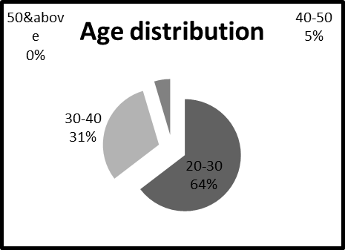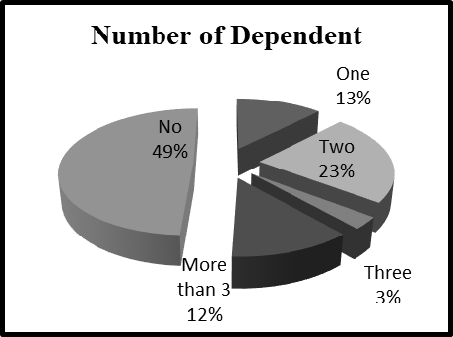
(c) (d)
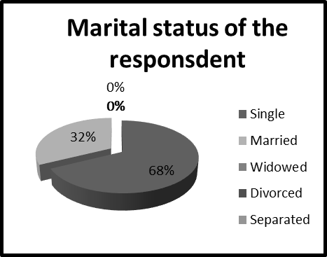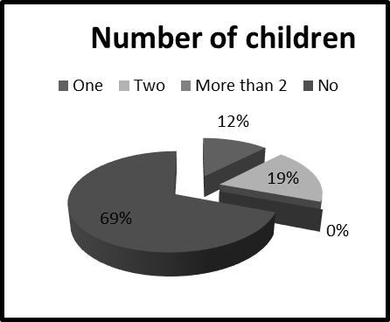

Fig 3.1: Showing the demographic constitution of the respondents

(a) (b)
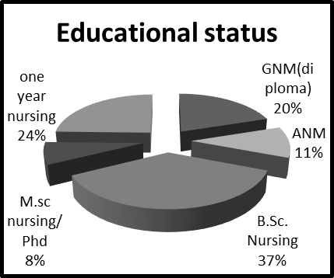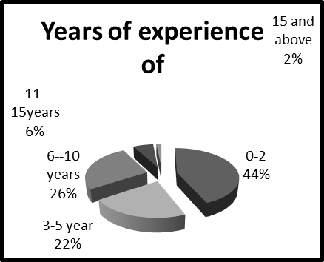

Educational Status: The above figure 3.1.6(a) is showing the educational status of the

Work-Related Information
Figure:3.2 Showing the educational status and years of experience
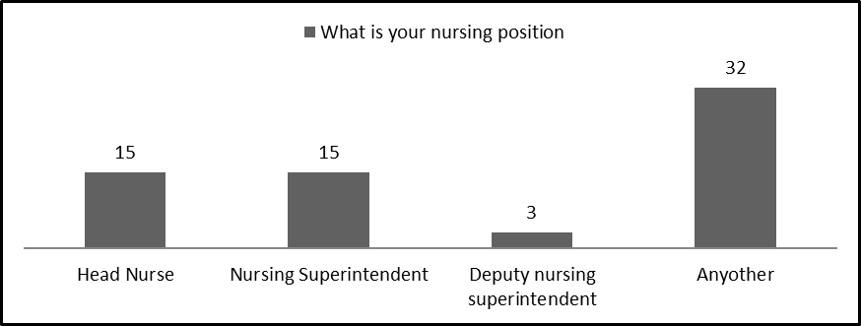
Figure 3.3 Showing the nursing position of the respondents
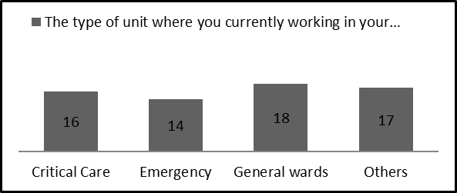
Figure 3.4 Showing the type of unit that respondents are working currently.

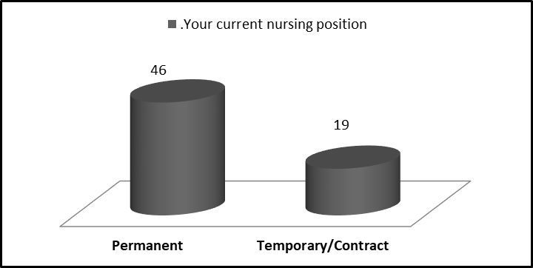
Figure: 3.5 Showing the current nursing position of respondents
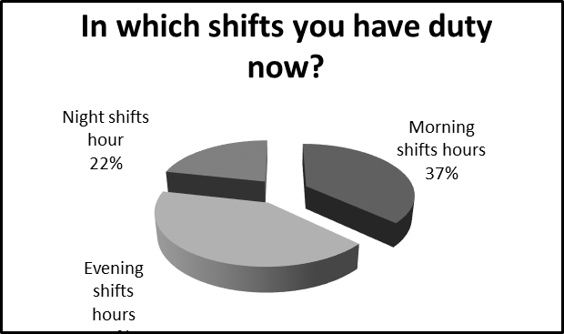
Figure: 3.6 Showing the shift that respondent have their duty.

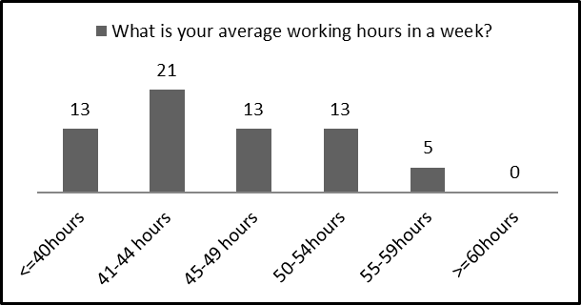
Figure: 3.7 Average working hours in a week
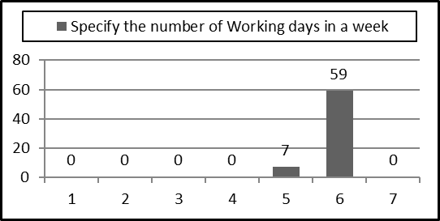
Figure: 3.8 Showing the number of working days of the respondents.
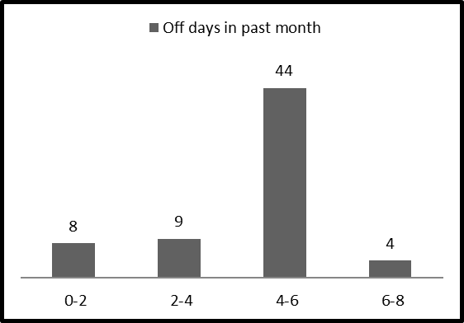
Figure: 3.9 Showing the off days in the past.
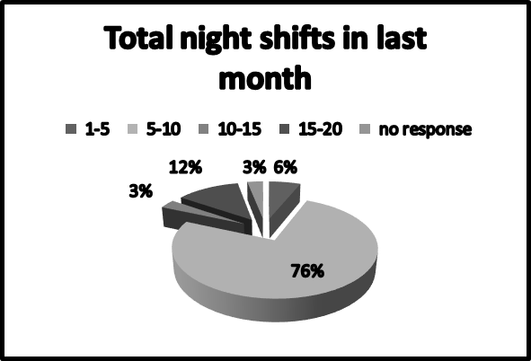
Figure: 3.10 Showing the total night shifts of the respondents.

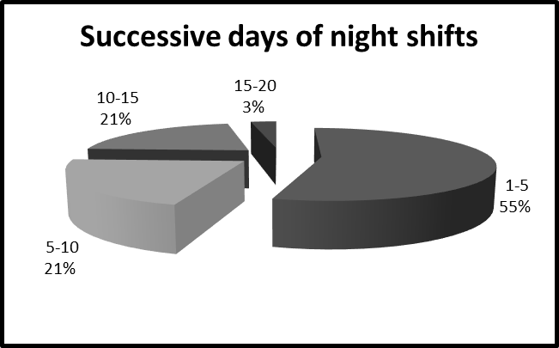
Figure: 3.11 Showing the successive night shift of respondents.

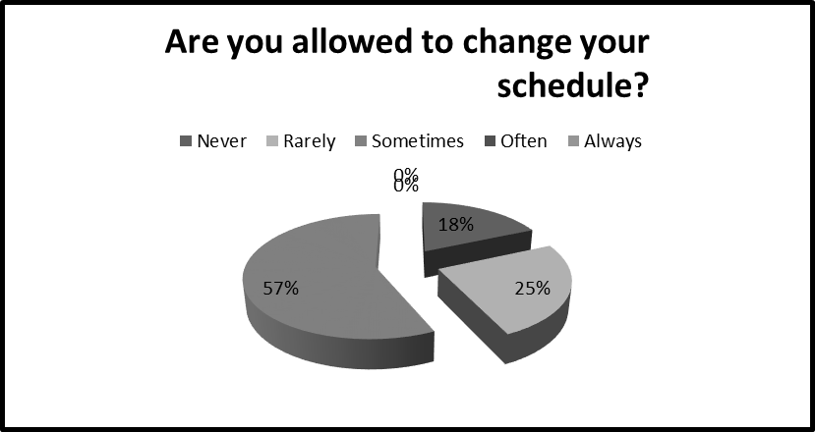
Figure: 3.12 Showing whether the respondents are allowed to change their schedule.

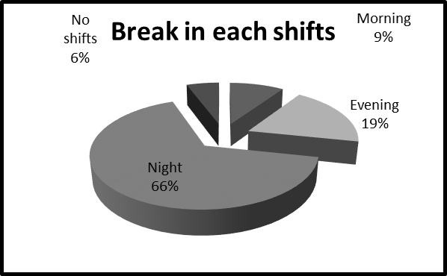
Figure: 3.13 Showing number of break of each shift of respondents

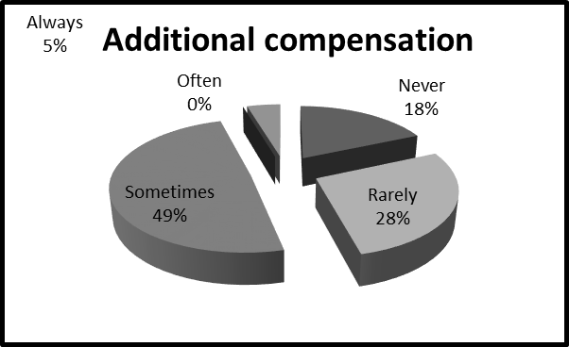
Figure: 3.14 Showing the additional compensation being received by respondents

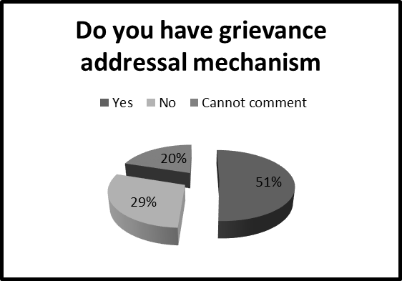
Figure: 3.15 Showing whether respondents have grievance mechanism

(a) (b)
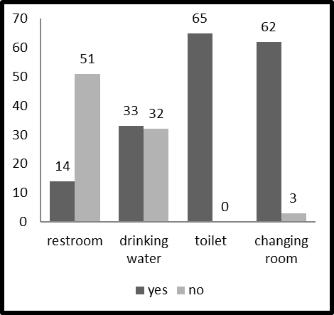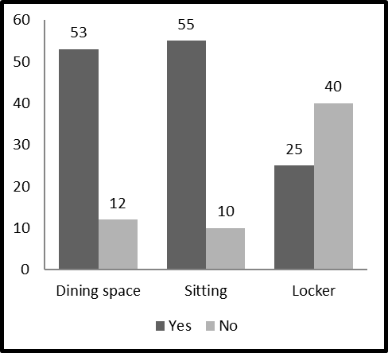

Figure: 3.16 Showing adequate basic facilities of respondents

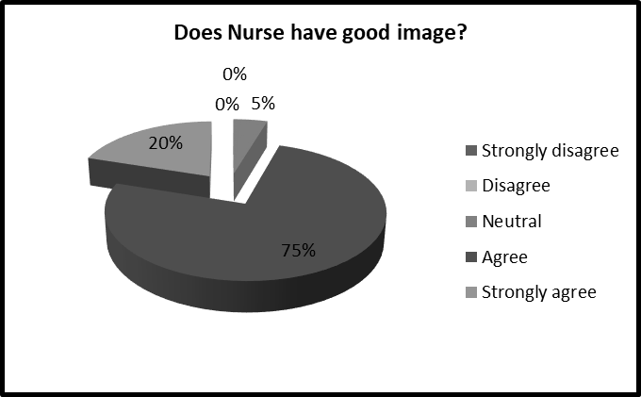
Figure: 3.17 Showing perception whether nurses have good image.

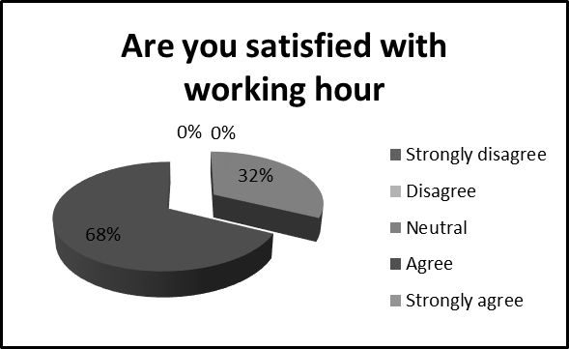
Figure: 3.18 Showing whether respondents are satisfied with working hours of organization.

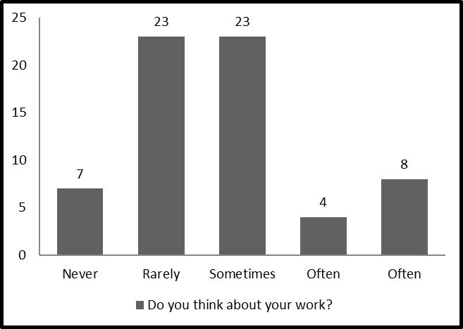
Figure: 3.19 Showing how often respondents think about work

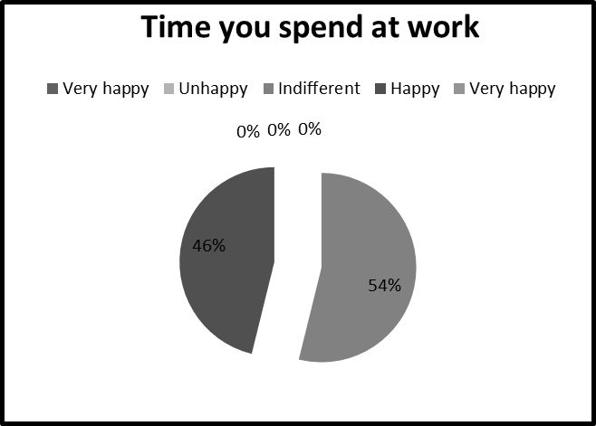
Figure: 3.20 Showing the respondents time spent at work

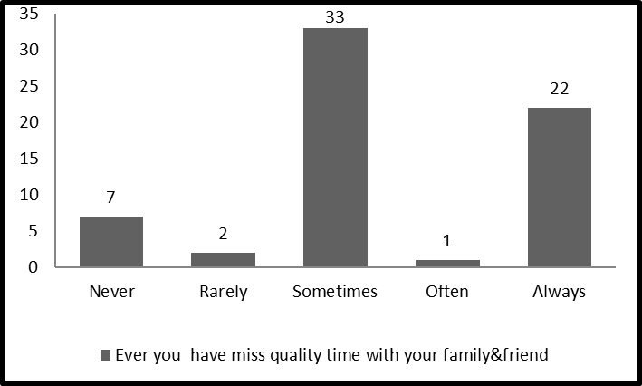
Figure: 3.21 Showing the quality time missed by respondents.
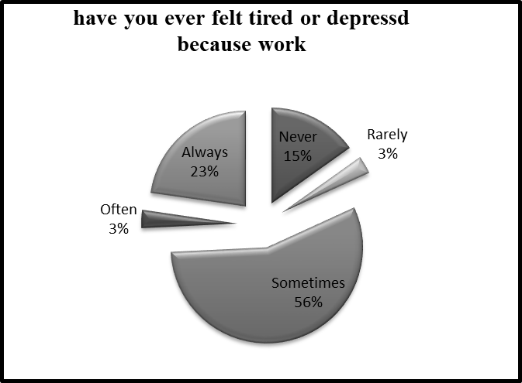
Figure: 3.22 Showing the feeling of tiredness /stress by respondents.

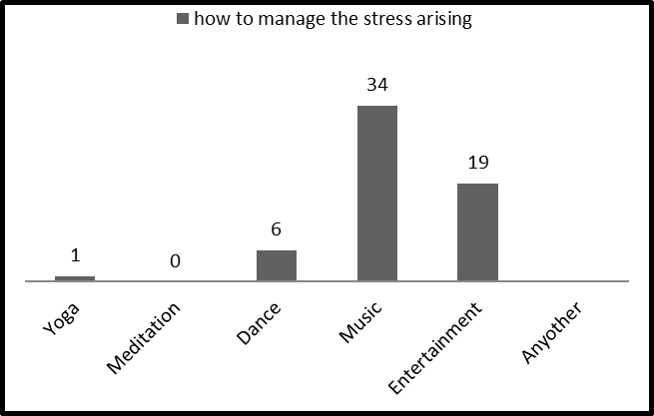
Figure: 3.23 Showing how do respondents manage stress.

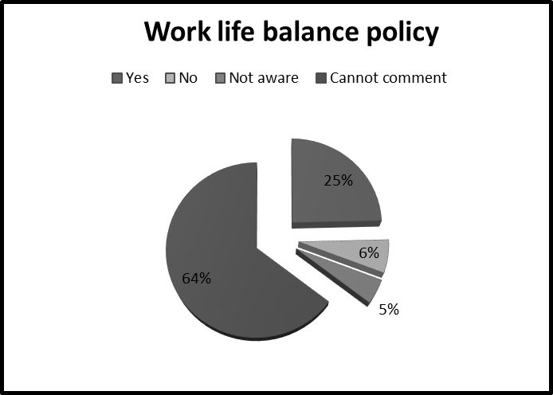
Figure: 3.24 Showing whether the respondents have work life policy

SUMMARY AND FINDINGS
A study demonstrates not simply deciding the proportion and rate as identified in the inquiries put before the respondents yet in addition illuminate the various different perspectives that can added as follows.
- 100% of the respondents are female and 32% of them are married. It is significant that as majority of the respondents are single and they try to take the dual responsibility by managing the both work and family life.
- 64% of the respondents fall in the age group of 20-30 years, which shows the majority of the respondents are young and dynamic for balancing and maintaining the work life balance. Only 5% of respondents are age between 40-50 and trying to maintain and balance their life from past years.
- With regards of the work life balance 5% of the respondents are not aware whether their organization have work life balance scheme or not and 69%said that the cannot comment about work life policy and few of the nurses said their health centre does not have work life balance policy.
- Most of the respondents were not aware of nurse is to patient ratio because different respondent has given response in different from and even some of the respondent have given the ratio in natural number (12) and in different form so it was difficult to analysis. Average nurse is to patient is (1:7).
- In order to maintain and balance their life and to manage their stress 52% of them listen to music while 29% goes for other entertainment.
- Most of the respondents have commented that nurses image can be improving by improving the quality of the service they provide, by treating and caring the patient with humbleness and with good communication.
- At last the overall result is that work life balance helps to maintain the balance between work and their family.

RECOMMENDATION
Analyzing the Empirical Study on the Work life balance of staff nurses in private nursing homes in Siliguri it was found that work life balance plays a vital role in succession of every organization. Few suggestions are made on the basis of the study and the recommendation is enumerated in the following points. Demographic Profile of the respondents shows that around most of the respondents has less educational qualification. Nursing homes should give opportunity for their further study in providing of educational loan or study leave. In the nursing homes about 68% of the respondents are single while 32 are married, thus it is recommended that apart other basic facilities they may be provided with accommodation facilities which may ensure safety to single and young nurses. The Nursing homes should have work life balance policies in order to make aware about maintaining and balancing both work and family life. It is suggested that the Nursing homes need to organize the proper counselling so that the respondent will able to balance their life. The nursing home should adopt the different scheme for balancing the work and professional life.
CONCLUSION
Coronavirus has established a climate where burnout isn't an exception that happens to just a modest bunch of attendants. Presently, most medical attendants experience burnout because of the pandemic, and taking a stab at balance between serious and fun activities as an attendant can appear to be unimaginable. Attendants can go an entire shift without having the option to utilize the bathroom or take a mid-day break or a break period. What's more, they frequently get elected to perform duplicates or downright compelled to. To accomplish work life, balance each medical caretaker ought to define the objective and succeed the both in profession and family. The family and work life are both essential to any representative and on the off chance that these two are not fundamental appropriately it makes anxiety. Balance between serious and fun activities strategies are effectively standard in any association as for significant of balance between serious and fun activities. Some could contend that burnout is inescapable during a pandemic and it's basically impossible to achieve a fitting balance between serious and fun activities. However it might appear to be troublesome and altogether unthinkable, we trust that there's a method for tracking down balance through any situation. Medical services laborers should be prepared very quickly to perform basic exercises in very uncommon circumstances. Notwithstanding the enthusiastic tension, higher responsibility and longer working hours, they likewise face a higher gamble of being tainted. This is additionally convoluted because of an absence of individual defensive gear, testing hardware and the resources to give a protected work space in numerous nations all over the planet. It is basically unrealistic to consistently give all specialists, medical attendants and other medical care laborers with the individual defensive stuff they need, and need should be given to those guardians working with high-risk patients. In any case, these decisions lead to imbalances in disease risk among individuals from the medical services area, the consequences of which are as of now being seen in emergency clinics, nursing homes and the home-care setting.
BIBLIOGRAPHY
1. Anand, V. Rengarajan, V, Renganathan,R.Swathi,B..Udhaya,S “Employee Work life Balance-A study with special Reference to Rural Employees ”Indian Journal of Science Technology, Issue July 2016,Vol-9(27),ISSN(P)0974-6846,ISSN0974-5645.
2. Cavanaugh, A., Raymond A, Noe (1999) “Antecedents and consequences relational components of new psychological contract.” Journal of organizational behavior, Vol- 20, pp 223-340 Issue 3 May 1999.
3. Dolai, D.”Measuring Work Life Balance among the Employees of the Insurance Industry in India”, International Journal of Advanced Research in management and Social Sciences,Vol.4,Issue May(2015),ISSN 2278-62.
4. Felstead A, Jewson N, Phizacklea A, Walter S (2002)” Opportunities to work at home in the context of work life balance.” Human Resource Management Journal. 12(1): 54-76.
5. Greenhaus JH, Collins KM, Shaw JD (2003) “The relation between work–family balance and quality of life.” Journal of Vocational Behavior. 63: 510-531.
6. Jensirani,M.& Muthumani, A”A study on work life balance of nurse in Kovilpati town,” International Journal of Science Technology and management, Vol. 6,Issue 02 February(2017) 2394-1537(O), Issue 2394-1529(P).

7. Lakshmi, K, S, Ramachandran, T. and Boohene, B. “Analysis of Work Life Balance of Female Nurses in Hospitals - Comparative Study between Government and Private Hospital in Chennai, TN., India” - International Journal of Trade, Economics and Finance, Vol. 3, No. 3, June 2012.

8. Lewis, S., Cooper, C. (1987), "Stress in two-earner couples and stage in the life cycle", Journal of Occupational Psychology, Vol. 60 pp.289–303.
9. Marie. G, V., Maiya, U. “A Study on work-Life balance of Female Nurses concerning Multi-speciality Hospitals, Mysore City,” Asia Pacific Journal of Research, Vol.I, Issue XXVIII,June (2015)
10. Muhammadi,N,S. & Abbas, Q,”The Impact of Work-Life Conflict on Job Satisfactions of Employees in Pakistan”. International Journal of Business and Management, Issue may (2009) Vol. 4 (5), 63-83.
11.Rashida B, A. and Duraipandian, K. “Development of an Instrument of Measure Work Life Balance of It Professional in Chennai”, International Journal of Management, Vol. 5, Issue 11, November (2014), pp.21-33. ISSN: 0976-6502 (Printed), ISSN: 0976-6510 (Online).
12, Roshani, P & Bagrecha,C ”Impact of Demographic and work variables on work life balance-A studt conducted for Nurses in Bangalore”, International Journal of Management studies, Vol. IV, Issue-1, June 2017, ISSN: 2249-0302(p), ISSN:2231-2528(O).
13. Satpathy,,I. Patnaik, M,C,B. Jena,S. “A Comparative Study on Work-Life Balance of Nursing Staff Working in Private and Government Hospitals”, International Journal of Innovative Research in Science, Engineering and Technology, Vol.3, Issue 1, January 2014, ISSN:2319-8753.
14. Shabana,P,S &.Kannan, S” A comparative study on work life balance among Nurses with special reference to government and private hospitals in tirunelveli district ,” International Conference on, Innovative Management Practices, Organize by SVCET, Virudhunagar,.Vol.3,Issue 1( 2016) IJARIIE,ISSN:2395-4396(O).
15.Yadav, T,Rani,S.”Work Life Balance Challenge and Opportunities” International Journal of Applied Research, Issue 2015,Vol-1(11),ISSN(P): 2394-7500 ISSN(O):2394-5869.

