Title:
Early report on SARS-CoV2 Outbreak: Classification, Mechanism, Therapeutics, Socio-economic impact and Prevention

Authors:
- Waseem Chauhan, PhD,
Human Genetics and Toxicology Laboratory, Department of Zoology, Aligarh Muslim University, India, chauhan.wassi5@gmail.com
- Shoaib Shoaib, PhD,
Department of Biochemistry, JNMC, Aligarh Muslim University, mhdshoaib949@gmail.com
- Rafat Fatma, PhD,
Human Genetics and Toxicology Laboratory, Department of Zoology, Aligarh Muslim University, India, rafatfatma110@gmail.com
- Najmul Islam, Professor,
Department of Biochemistry, JNMC, Aligarh Muslim University, India, nix7@hotmail.com
- Mohammad Afzal, Professor
Human Genetics and Toxicology Laboratory, Department of Zoology, Aligarh Muslim University, India, ma.afzal1235@gmail.com

Corresponding authors: Waseem chauhan and Mohammad Afzal
Human Genetics and Toxicology Laboratory, Department of Zoology, Aligarh Muslim University, India, chauhan.wassi5@gmail.com, ma.afzal1235@gmail.com

Graphical Abstract:
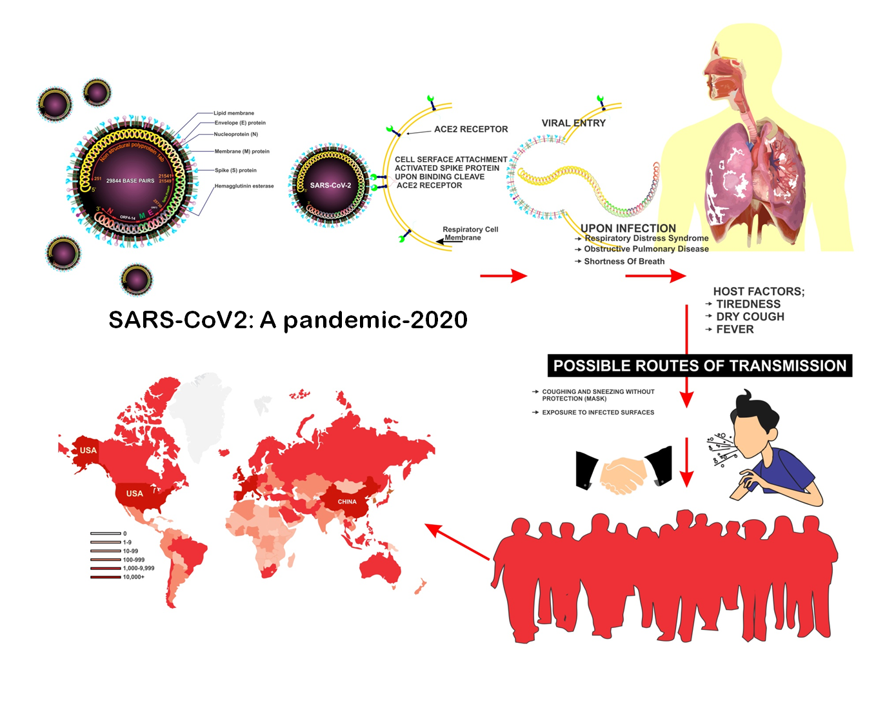
Highlights
- SARS-CoV2 has turned into a global-stress and has caused numerous deaths.
- The virus significantly down regulates ACE-2 protein causing multiple organ failure.
- Classified as betacoronavirus, the virus uses its Spike (S) protein for binding to endothelial cells and enters the cells via endosomes.
- Pre-existing drugs like Chloroquine, Hydroxychloroquine, Lopinavir and Mycophenolate are been reconsidered for the treatment.
- Socio-economic slowdown throughout the world is turning into a bigger threat.

Abstract

The world has faced many health challenges in the past as evident from the previous disease outbreaks such as Smallpox, Plague, Cholera, Influenza, Chikungunya, MERS-CoV, Meningitis etc. The global and regional outbreak of viral infections has been considered as an issue of global concern. The extensive growth and spread of the virus have become a significant worry for the researchers since the virus has affected millions across the globe. Unlike other pathogenic diseases, viral infections are the hardest to deal and mitigate. SARS-CoV2 was first reported in Wuhan province of China, since then the virus is continually spreading all over the globe. Primarily, SARS-CoV-2 spreads through the sputum droplets upon face to face contact and it may exist as asymptomatically, symptomatically and pre-symptomatically in human populations worldwide. The death rate is increasing as a greater number of asymptomatic patients are found to be positive. Emerging data indicates that the most common symptoms include fever, headache, cough and shortness of breath. Pathophysiological findings suggest that the patients may have lymphopenia and elevated levels some cytokines. To detect the presence of SARS-CoV-2, the sputum samples are tested by reverse transcriptase polymerase chain reaction. Till date, there is no effective antiviral therapy for SARS-CoV-2. Although, socio-economic guidelines have now become stringent as social-distancing seems to be the only available option to prevent viral infection. The current situation entails safe, cost effective and more specific therapeutics and preventive strategy. Therefore, several countries are engaged with the development of an effective, safe and target specific drug and vaccine to treat and prevent SARS-CoV-2 infections. This review focuses mainly on the available treatment options and vaccine development.

Keywords: SARS-CoV2, spike protein, ACE-2 receptor, therapeutics, WHO, FDA.

Introduction

The regional and global outbreaks due to virus infections have caused havoc in the past. The outbreak of MERS-CoV (Middle East respiratory syndrome coronavirus) in 2012, H1N1 influenza, 2009 and coronavirus (SARS-CoV) were zoonotic and highly pathogenic [1]. Though these viruses were described for more than 50 years; strain JHM, a prototype of murine Coronavirus was reported in 1949 [2]. These are RNA family viruses, characteristic of crown-shape peplomers ( size 80-160 nM) with positive polarity (27-32 kb). Coronavirus has been classified under the order Nidovirales, family Coronaviridae, subfamily Coronavirinae by International Committee on Taxonomy of Viruses. The high recombination rates of SARS-CoV is beause of to repeatedly developing errors in transcription, and RNA Dependent RNA polymerase (RdRP) jumps [3]. Based on serological and genomic evidence, Coronavirinae is divided into four genera: Alpha, Beta, Gamma and Delta Coronavirus (fig 1). Among the six known human coronaviruses (HCoVs), HCoV-229E and HCoV-NL63 belong to Alphacoronavirus [4,5].
The focus of global attention is the recent outbreak caused due to Coronavirus (SARS-CoV2), COVID-19, with the symptom of pneumonia reported from Wuhan (China). As the information were outbreak by local media, the virus speading from Wuhan food market, grown substantially to infect people in China with high mortality rate at the begning and had led to the infections in ten additional countries as on January 2020 [1]. The cases were suspected of having had direct contact with the seafood market; however, the disease has reached the human-to-human transfer stage to no surprise. Though the virus has infected a variety of economically essential vertebrates, Coronavirus is known to infect human hosts and cause potentially lethal human respiratory infections. Scientific landscapes from asymptomatic progression to symptomatic, infections in respiratory, gastrointestinal, hepatic and neurologic systems symptoms are reported. The sever symptoms of patients were observed as primarly, fever, dry cough, tase and smell, dyspnoea (breathing difficulties ), and headache. The load of virus increasing the disease sevearity resulted in high level of pneumonia, respiratory failure due to alveolar damage caused hemodynamically unstable or may be death. To facilitate the development of diagnostic kits, medicines and vaccines for the treatment of diseases, ICTV (International Committee on Taxonomy of Viruses) classified this virus based on its genetic information and structure in February, 2020, named "severe acute respiratory syndrome coronavirus 2 (SARS-CoV2)" by WHO (2020) caused disease "COVID-19 (coronavirus disease 2019). As till in February, a total of 43,103 confirmed cases and 1,018 deaths had been declared.3 International Health Regulations (IHR, 2005) in a meeting on January 30, 2020, WHO reported that due to the outbreak, the disease has spread to 18 countries. Cascella et al. 2020 reported that the US reported the first case of the disease on February 26, 2020, surprisingly not imported from China. Until now, the most common diagnostic tests for COVID-19 are the "PCR-tests" relying on swabbed samples from the patient's nose and throat [6].
Apart from scientific opinions claiming prior warnings, solutions, drug-effects and vaccine generation protocols which have risen since COVID-19 outbreak, a lot of social-economic factors have culled upon the people across the globe. This review aims to bring the scientific, economic and social world together, aiming to highlight how a combined effort can overcome this grave issue.
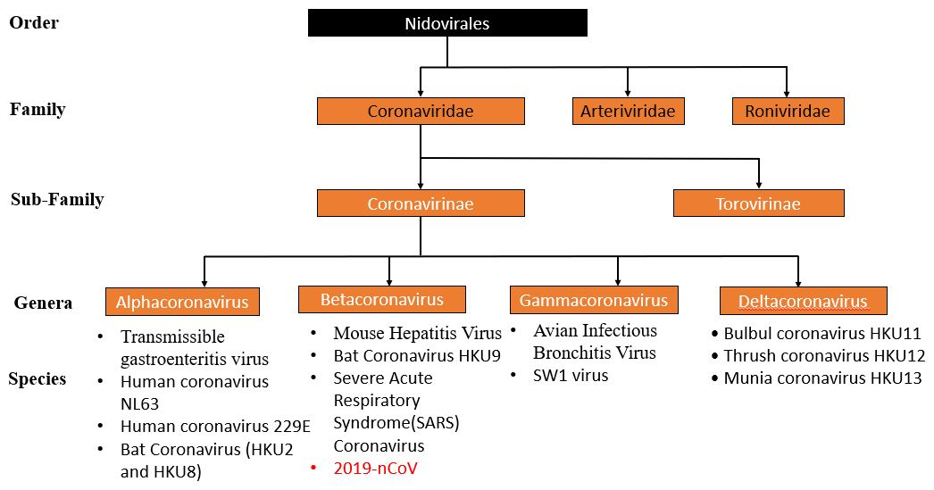
Figure 1: Classification of viruses belonging to the order Nirovirales.

Classification of CoVs
From the past 20 years, many unusual respiratory viruses such as human metapneumovirus, SARS-CoV and human coronavirus NL63, were reported. The ongoing pandemic is caused by Novel Coronavirus (2019-nCoV) [7]. Among several types of coronaviruses were found and few are infected to humans and caused mild symptoms. The two important exceptions are the severe acute respiratory syndrome SARS CoV and new beta coronavirus (Guangdong, China) reported in 2002 caused 8000 infections and 774 deaths in 37 countries. The Middle East respiratory syndrome (MERS) coronavirus (MERS-CoV), first detected in Saudi Arabia originated from camel in 2012 with 858 fatalities and with 2494 laboratory-confirmed cases, and 38 deaths in South Korea [8-10]
Genome organisation and structure of nCoV 2019
Coronaviruses have the largest genome characteristically among all RNA viruses found, consisting of about 30 kb. Also, with its unique mechanism of replication, Coronavirus undergoes recombination at a high frequency. The reads mapping, genome sequences and nucleotide (nt) similarity was 99.8% to 99.9%. The genome (29,870 bp) has 37.99% to 38.02% GC content. The genome organisation, 5' -ORF1a-ORF1b–S–E–M–N–3', was approx similar to well-known SARS-like (SL)-CoV found in bat [11]. CoVs are positive sense, single-strand RNA viruses. All CoVs have unsegmented and similar in genome organisation. The genome size of 2019-nCoV-WH04 is 29844 bp long, and 2/3rd part of this genome is made up of two larges overlapping ORFs (from 251 base to 21541bp) that encodes for polyproteins (pp1a and pp1b). These polyproteins ultimately processed to 16 non-structural proteins (nsp1 to nsp16). Moreover, from 21549 bp to 25730 bp genome encodes for spike protein(S) with the structural proteins: E (envelope), M (membrane) and N (nucleoproteins) with the numerous accessory proteins [12]. The genome expansion in 2019-nCoVs is thought to be mediated by increased replication fidelity like other coronaviruses. Scientists have identified eight different types of strains. More than 2,000 genetic sequences of the virus have been submitted from different labs to the pathogen genome database, Next strain, showing mutations in real-time. Data collected from different part of the world except Antarctica; revealed that the virus is mutating every 15th day on an average as stated by researchers. Charles Chiu, a university professor from the United States, has remarked how the virus is moving throughout the United States. Various studies have suggested that the mutation rate of CoVs depends on the phase of the adaptation to novel hosts that causes high replication fidelity [13-16]. In Order (Nidovirales) RNA processing enzymes improve the fidelity of RNA replication. These processing enzymes include both 3' to 5' exonuclease as well as endonuclease activity [17].

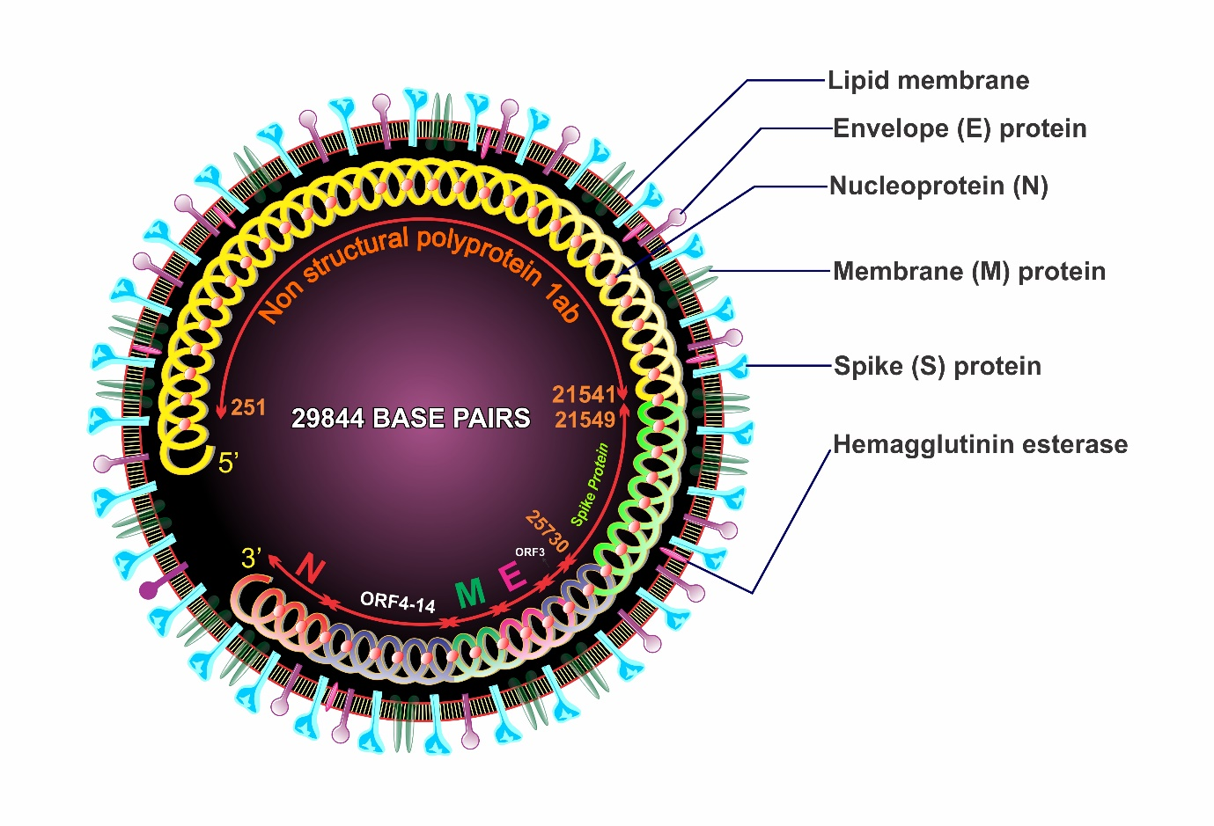
Figure 2: COVID-19 with its characteristic features and structural proteins.

Structural and non-structural Proteins

Evolution of CoVs does not involve only gain and loss of genes but also include recombination and minute changes in the genes that modify proteins sequences. Based on previous reviews based on the evolutionary history of other CoVs (SARS, MERS, etc.) here, we are trying to compare proteins of 2019-nCoV with earlier ones. In comparison to non-structural proteins, structural proteins appear on the surface (fig 2).
In all CoVs, S (spike) protein is essential for infection. S gene located on 21,563–25,384 in the genome of the 2019 novel Corona Virus (Table 1). It has two functionally active units categorise in S1 region and S2 region. S1 region contains NTD and RBD, N terminal and C-terminal receptor-binding domain whereas S2 region consists a transmembrane region with fused peptide and HR1 and HR2 heptad repeats (HR1 and HR2) [18]. Although closely related viruses can have different specificity for the receptor, for example, SARS-CoV2 has specificity for hACE2 (human angiotensin-converting enzyme 2), and HCoVs-229E uses aminopeptidase N (ANPEP). It is still mysterious how these specificities of the receptor exist.

Table-1: - Defining spike protein and its peculiar properties.
S.No. | Characteristics of Spike protein | Values
1 | Gene location | 21,563–25,384
2 | Amino Acid (Size) | 1272
3 | GC content | 37.31%
4 | Similarities with SARS-CoV | 72.3-75.5%
5 | Similarities with Bat-SL-ZC45 | 75.9-80.4%

RBD determines the host range in the CoV S protein [19]. Several distinct features of RBD amino acid sequences include higher aa identities (73.8–74.8% of SARS-CoV) and hACE2 (human angiotensin-converting enzyme 2) using SL-CoVs (76.4–76.9%) and unused hACE2 (61.5–64.1%) in human. SL-CoVs common deletions are not posed by the novel CoV with hACE2 as a receptor [20]. The five critical amino acid residues (Y442, L472, N479, D480 and T487) interacting with hACE2 in SARS-CoV2 while L, F, Q, S, N residues found in RBD with similar polarity [21,22]. Thus, it can be proved that the novel CoVs used hACE2 as a receptor. In a recent study, the RBD of the novel CoV is found to be quite identical at amino acid level to that of SARS-CoV2, advising that a recombination event might have occurred in between the RBD and NTD region of the S gene, promoting the interspecies transmission [11]. S protein and Membrane (M) glycoprotein (size 25-30 KDa) are the other structural proteins, found on the virus surface, binds with the inner layers resulted in mature shapes of the viral particle [23,24]. An Envelope (E) glycoprotein is a small polypeptide consisting of 76–109 amino acids (8.4 to 12 KDa). It controls the assembly, release, and infectivity of mature viruses. Due to its smaller size, it is the last protein to recognized, first in IBV and then in TGEV and MHV [25-27]. Nucleocapsid (N) proteins range from 43-50 KDa looks like beads on a string and from a characteristic shell of identical subunits [28]. N proteins are involved in binding and packaging of RNA genome. Domains 1, moreover, 2, are rich in arginines and lysines, as is typical of many viral RNA binding proteins. Coronavirus ribonucleoprotein complexes are quite sensitive to the action of ribonucleases [29]. N–N monomer interactions provide significant stability to the nucleocapsids [30].
Viral entry into the cell and Internalization via endosome.
Infection begins with the binding of S-protein to the target cell receptor and further embedded viral particle to the membranes allowing the entry of viral genetic material into the host cell cytoplasm. The S1 region contains functional elements that help in membrane fusion (fig 3). The Glycoproteins (S type) are the type of class I fusion proteins and have same mechanism of membrane fusion, implications for therapeutic intervention [22]. The S-protein’s ectodomain is the sole determinant of CoV cell-tropism [31].

Figure 3: Showing entry of SARS-CoV2 into the cell and subsequent release of its RNA into the cell (endothelial cell)

The metallopeptidase angiotensin-converting enzyme 2 (ACE2) is a receptor for SARS-CoVe [32]. Groups of scientists have suggested that host cell entry of SARS-CoV2 depends on the SARS-CoV2 receptor ACE2 and it can be blocked by a clinically proven inhibitor of the cellular serine protease TMPRSS2. This protease is provided by SARS-CoV-2 itself, in order to help the Spike protein [1,33]. Zhou (2020), Hoffmann et al. (2020) and Wong et al. (2004) have conducted experiments on soluble S1–immunoglobulin (Ig) fusion protein for immunoprecipitation with lysates from Vero E6 cells for isolation of the virus. Further proteomic analysis has revealed that the receptor used for binding is ACE2 showing high-affinity to S1 [1,34,35]. Receptor-ligand interaction can initiate the internalization of viral particles into endosomes followed by protonation that catalyzes GP-drived membrane fusion [36]. The S-protein of SARS-CoV2 is considered to be able to both pH-dependent and independent membrane fusion, and several parameters might control which stimulus is required. The initiation for SARS-CoV2 S-driven membrane fusion and their possible cleavage by cellular proteases is still ambiguous.

Coronavirus interaction with angiotensin enzyme cascade.

The RAAS, i.e. renin-angiotensin-aldosterone system (RAAS) is known to play an indispensable role in the regulation of blood volume and systemic vascular resistance (SVR). The organs actively involved in this mechanism are the kidneys, lungs and systemic vasculature and the brain. Upon activation, Juxtaglomerular cells in kidneys convert prorenin to renin. This activation occurs due to lowering in the blood pressure, beta-activation, or reduced sodium ion concentration in the distal convoluted tubule of nephrons. Once released in the blood renin finds its target the angiotensinogen (released by the liver) and cleaves it into inactive precursor angiotensin I which is further converted into angiotensin II by angiotensin-converting enzyme (ACE), found in the vascular endothelium of the kidneys and lungs [37]. The linking step between coronavirus and ACE enzymes, prime damage-causing step, ACE expressed near the surface of various epithelial cells – blood vessels (Prominently), but also lung, intestine, and others. However, it is now widely accepted that ACE protein helps in the entry of the viruses to the cell after being recognized by various coronaviruses (fig 3). According to a report from China to suggest that a mechanism of lung injury during the viral infection may be through inappropriate effects of excess free angiotensin-II protein, which is floating around out there because coronavirus particles occupy the ACE-2 that would typically be soaking it up. If that is the problem, then increasing the amount of ACE-2 protein might paradoxically be the only way to restore some balance to the angiotensin system. In that case, administering more angiotensin receptor antagonists would be an effective way to upregulate the production of ACE-2. Interestingly ACE2 is the receptor, for SARS-CoV and NL63-CoV. (MERS-CoV uses a different receptor) [38]. Spike protein took centre stage as a therapeutic target during previous SARS outbreak, because it causes an immunogenic response in mice. Genomic technology has accelerated since SARS, leading to insights with amazing speed.

Epidemiology, transmission and pathogenesis

The epidemiological studies reported till date is based on serum evaluation of patients from the upper respiratory tract. The symptoms include sputum production, lymphopenia, haemoptysis, diarrhoea, dyspnoea, and headache. Patients marked positive for the virus also showed increased leukocyte number, and higher plasma cytokines, even during the quarantine period patients were diagnosed with high body temperature. Coarse breathing and the sputum from similar patients resulted in a positive real-time polymerase chain reaction test. The method of choice is the RT-PCR for human CoV diagnosis, as multiplex RT-PCR assays were developed in real-time; detect all four respiratory HCoVs and could be further adapted to novel CoVs [39,40]. The patient's symptoms were variable and ranged from mild to severe. According to Huang (2020), onset symptoms were mild fever reported in 25% of total patients under observation, 76% recorded cough. 44% of patients reported fatigue. Less common symptoms were headache, sputum production and diarrhea. Levels of aspartate aminotransferase were also found to be increased by 37% of patients [5]. In China, 84,827 cases confirmed clinically and, in the laboratory, and 4,634 (6%) deaths are reported. In addition to China, there are 21.6M confirmed cases around the world and the number has been continually increasing since then. The countries with most severely infected cases are USA (5.5M), Brazil (3.3M) India (2.6M). On August 15, the epidemiological scenario changed drastically as about ~26% of the confirmed cases were recorded in USA, with maximum deaths. Despite all the possible measures and care, the rise in death is continuing due human to human transmission, the acquired ability of virus. It is unfortunate, albeit too early to say that no antiviral treatment for Coronavirus infection has been proven to be effective. Subsequently, the spread of person-to-person was registered outside Hubei and in countries outside China, including the USA. Pregnant women at an immunosuppressive state are more susceptible to respiratory pathogens and severe pneumonia (e.g., diaphragm elevation, increased oxygen consumption, and edema of respiratory tract mucosa). Although a study on nine pregnant women and their infants showed no maternal-infant transmission of SARS-CoV-2 based on reverse transcriptase-polymerase chain reaction (RT-PCR) [41]. The European CDC gathers and aggregates data from countries worldwide. Consequently, the most up-to-date data for any given country is usually available earlier via the National health agency. It is crucial to determine any prophylactic and therapeutic drugs due to the lack of any approved vaccine of SARS-CoV2. After multicenter clinical trials and cell culture studies Chloroquine, a 70-year-old malaria drug, is theoretically indicative of demonstrating therapeutic effectiveness against COVID-19 (Corona Virus Disease, 2019). As reported by Gao et al. (2020), based on preliminary clinical trials conducted, Chloroquine has been included in the federal recommendations for the treatment of COVID-19 in the People's Republic of China [42].
As already discussed, the zoonotic origin of COVID-19 is attributed to the wet animal market in Wuhan city, which became the epicenter of the disease outbreak. There is a need to search the intermediate host or a direct host to control the disease spread. However, up till now, only mammals and birds are the top suspects. Therefore, it was concluded that asymptomatic people are the most frequent transmitters of the infection. The transmission possibility before symptoms did seem to be uncommon in the beginning, although it cannot be excluded. It is suggested that the implication of quarantine is the well applicable way to control the virus contaminations. Researchers in China after analyzing the data related to the spread of SARS-CoV2 observed that, the close contact between individuals is the mode of infection to spread the virus primarily be within family members, healthcare workers and other close contacts or aerosol transmission in closed spaces. Also, women in their third trimester, confirmed to be infected with the Coronavirus, showed no evidence of vertical transmission of infection to their child. Binding of virus to the lung epithelial cells, destruction of villi projections and subsequent removal of the epithelial layer is the most definite way of lung damage found yet.
Possible therapeutics for SARS-CoV2 treatment
Scientists have studied dozens of compounds which can be used as a possible therapeutic for the treatment of SARS-CoV2. Unfortunately, a swift and valid decision upon selection, clinical trial and distribution of the drug is to be taken. Even specific therapies for SARS-CoV2 by US Food and Drug Administration (FDA) have not been approved, and several agents are under clinical trials with limited clinical experience.
Still, some of the potential approaches include spike (S) based vaccine which somehow abrogates the viral binding. The serine protease inhibitor camostatmesylate, approved in Japan was found to inhibit transmembrane protease serine 2 (TMPRSS2) activity, the crucial step for viral entry in endothelial cells [33]. The binding of viral spike protein down-regulates the ACE-2 protein hence ACE2 receptor can be blocked using anti-ACE-2 antibody or a peptide along with the infusion of soluble ACE-2 this will decrease viral spread as well as protect the lung from injury through its unique enzymatic function [43]. According to the latest report WHO is working on the four most promising therapies: the malaria medications chloroquine and hydroxychloroquine, on an antiviral compound, called remdesivir; use of lopinavir and ritonavir in combination, two HIV drugs along with interferon-beta. No confirmed antiviral therapy for the treatment of COVID-19 is available, while the drugs used previously were proven effective against SARS-CoV and MERS-CoV and highlighting more or less favourable outcomes for treatment and prevention of COVID-19. Herein are drugs which areas of now have been tested to treat viral infection and these drugs include Chloroquine, hydroxychloroquine, lopinavir, remdesivir, mycophenolic acid, bananins, BCX4430, K22, ribavirin, nitazoxanide, etc [44,45].
During this global pandemic, anti-malarial drugs Chloroquine and hydroxychloroquine have drawn more attention than any other drugs to develop an effective COVID-19 antiviral therapy. Both drugs have previously shown to be useful as anti-inflammatory agents for rheumatoid and lupus erythematosus treatments as well [46]. The FDA has approved them and studies disclosed their role in the treatment and their potential as COVID-19 therapies. Lopinavir, a protease inhibitor, has been demonstrated antiviral activity against COVID-19 as it was advocated by a recent in vitro study. In another study, the drug predicts promising outcomes as it shows significant improvement in pneumonia associated symptoms when administered to COVID-19 patients [47]. Lopinavir targets 3CLpro enzyme to effectively combat SARS-CoV and MERS-CoV [48].
Therefore, lopinavir could be an acceptable option for COVID-19 treatment and prevention. Remdesivir, an adenosine analogue has been now considered as an antiviral drug that incorporates into nascent RNA chains to cause premature termination to prevent further viral infection, thus blocking viral transcription [49]. Previously the drug has been showing its therapeutic potential against broad spectrum viruses including SARS CoV and MERS-CoV and in vitro studies revealed that remdesivir is highly effective for the treatment and prevention of COVID-19 [50,51]. Bananins or trioxa-adamantane-triols (TATs) are a class of antiviral compounds which have been known for their therapeutic activities against SARS-CoV2 and some of the bananins inhibit helicase unwinding and ATPase activity effectively. In vitro studies have shown evidence that bananins inhibited replicase 1b protein nsp13 ATPase and DNA helicase enzymes [52].
Mycophenolate or mycophenolic acid is a proven immunosuppressant, tested against Coronavirus to verify its efficacy, and the assessment predicts that it inhibits guanine monophosphate synthesis although reports suggest that its combination with interferon β-1b may be successful against COVID-19 [53]. Galidesivir or BCX4430 an adenosine analogue is a small molecule that serves as an antiviral tool to treat the highly-pathogenic disease ebola [54]. Galidesivir targets RNA-dependent RNA-polymerase, inhibiting the synthesis of viral RNA and being a broad-spectrum antiviral drug hence BCX4430 could be a possible drug candidate for the treatment of novel coronavirus [55]. Ribavirin or Tribavirin, a ribonucleic analogue was found to inhibit RNA-dependent RNA polymerase and possess promising potential against viral infections, including MERS-CoV and SARS-CoV with severe side effects [56]. Recently, in vitro studies reported ribavirin as a preventive agent against novel coronavirus [57]. K22 a small molecule drug exerts potent antiviral activity that specifically targets membrane-bound coronaviral RNA synthesis to inhibit SARS-CoV and MERS-CoV. Thus, K22 could also be considered for screening its potential against novel coronavirus [58].
Nitazoxanide a broad-spectrum antiviral and antiparasitic drug has been used for the treatment of influenza and respiratory infections and in vitro studies revealed its inhibitory potential to treat MERS-CoV. Nitazoxanide a broad spectrum the antiviral and antiparasitic drug has been used for the treatment of influenza and respiratory infections and in vitro studies revealed its inhibitory potential against MERS-CoV and its selection against COVID-19 could be promising [59,60]. Griffithsin a lectin molecule that has been used against MERS-CoV to produce anti-coronavirus drugs which targets spike protein oligosaccharide to inhibit binding with host cells and it could also be a suitable choice for the scientists to develop a safe and potent drug for the treatment of COVID-19 [61,62].
Table (2): - Clinical trials provide an insight into the drugs for the treatment and management of SARS-CoV-2.
Drug | Status | Clinical Trail
Decitabine | Phase II | NCT04482621
Duvelisib | Phase II | NCT04372602
Pulmozyme | Phase II | NCT04432987
Deferoxamine | Phase I/II | NCT04333550
Tramadol | Phase I/II | NCT04454307
Infliximab | Phase II | NCT04425538
Favipiravir | Phase III | NCT04336904
Tocilizumab | Phase II | NCT04445272
Methylprednisolone, Tocilizumab | Phase III | NCT04345445
Hydroxychloroquine  Lopinavir / Ritonavir Azithromycin | Phase II  Phase III | NCT04359095
Lactoferrin | Phase II/III | NCT04421534
Clevudine | Phase II | NCT04347915
Enoxaparin sodium, Fondapariniux, Argatroban | Phase IV | NCT04406389
Melatonin | Phase II | NCT04474483
FT516 | Phase I | NCT04363346
TXA127 | Phase II | NCT04401423
Dapagliflozin | Phase III | NCT04350593
CPI-006 | Phase I | NCT04464395
Pamrevlumab | Phase II | NCT04432298
Hydroxychloroquine | Phase III | NCT04329611
Naproxen | Phase III | NCT04325633
Baricitinib | Phase II | NCT04321993
Tranexamic acid | Phase III | NCT04550338
Clofazimine  Interferon beta-1b | Phase II | NCT04465695
Tofacitinib | Phase II | NCT04412252
DAS181 | Phase II/ Phase III | NCT04354389
Clazakizumab | Phase II | NCT04381052
Chloroquine phosphate | Phase I | NCT04443270
Ruxolitinib | Phase II/ Phase III | NCT04348071
Losmapimod | Phase III | NCT04511819
Thymalfasin | Phase II | NCT04428008
Acalabrutinib | Phase I | NCT04497948
Rivaroxaban | Phase II | NCT04504032
Merimepodib, Remdesivir | Phase II | NCT04410354
Pyronaridine-Artesunate | Phase II | NCT04475107
Remdesivir | Phase III | NCT04280705
Ciclesonide | Phase II | NCT04330586
Nafamostat Mesilate | Phase III | NCT04390594
Prazosin | Phase II | NCT04365257

Vaccines
Earlier episodes of viral infection lead to mild flu like symptoms only, therefore, it seemed to be a weak pathogen for human population but later viral pathogenicity contributed to high transmissibility and complexity of the disease [63]. This urged the world to make efforts towards searching an effective treatment strategy and to develop the vaccine against SARS-CoV-2. Vaccine development may be the most preferable and efficient means to prevent and control SARS-CoV-2 [64]. Currently, there is no existing anti-SARS-CoV-2 drug that can effectively cure SARS-CoV-2 infection [65]. According to WHO data of 25 September 2020, currently more than 160 vaccines are under development and some of these have been considered for human trails. Most of the vaccines are designed on the basis of the explored areas including genomic material, nucleoprotein, membrane protein, and spike glycoprotein [65]. As of now, the spike protein, mRNA and epitope-based vaccines are expected to be the most potential vaccine candidates [66]. Herein, this review also presented COVID-19 vaccines including adenoviral vector vaccine, recombinant subunit vaccine, nucleic acid-based vaccine and inactivated virus vaccine which are currently under clinical trials in various countries [67].
Vaccine | Status | Clinical Trail Reference | Remark
Inactivated SARS-CoV-2 (Vero cell) | Phase I/II | NCT04383574 | Randomized, double blind, placebo inactivated SARS-CoV-2 vaccine, administered to evaluate safety and immunogenicity.
Covax-19™ | Phase I | NCT04428073 | Non-randomized, therapeutic vaccine administered to study safety and immune responses.
Sf9 Cell | Phase I | NCT04530656 | Randomized, double blind, placebo controlled, recombinant SARS-CoV-2 vaccine.
Inactivated SARS-CoV-2 (Vero cell) | Phase III | NCT04510207 | Randomized, double blind, placebo parallel controlled Vero cell based vaccine administered to study protective efficacy, safety and immunogenicity.
aAPC (artificial Antigen Presenting Cells) | Phase I | NCT04299724 | Lentiviral vector system (NHP/TYF) based vaccine, a APC administered subcutaneously to study safety and immune reactivity.
CoronaVac | Phase III | NCT04456595 | Randomized, double blind, placebo controlled, adsorbed COVID-19 inactivated vaccine.
EpiVacCorona | Phase I/II | NCT04527575 | Randomized, blind, placebo controlled and administered intramuscularly to study humoral and cellular response.
Inactivated SARS-CoV-2 | Phase III | NCT04560881 | Randomized, double blind, placebo parallel controlled Vero cell based vaccine.
TMV-083 | Phase I | NCT04497298 | Randomized, placebo controlled, measles vector based vaccine.
CoVac-1 | Phase I | NCT04546841 | Open label, subcutaneous injection containing SARS-CoV-2 derived multipeptide in combination of TLR1/2 ligand XS15.
LV-SMENP | Phase I/II | NCT04276896 | Open label, lentiviral vector system (NHP/TYF) based vaccine, administered subcutaneously.
Inactivated SARS-CoV-2 (Vero cell) | Phase I/II | NCT04551547 | Randomized, double blind, placebo parallel controlled, inactivated SARS-CoV-2 vaccine.
Ad5-nCoV | Phase I | NCT04552366 | Open level, non-randomized, recombinant adenovirus 5 vectored COVID-19 vaccine, administered intramuscularly to evaluate safety and immunogenicity.
VXA-CoV2-1 | Phase I | NCT04563702 | Open label, adenoviral-vector based vaccine administered orally to evaluate safety and immunogenicity.
AZD1222 | Phase III | NCT04540393 | Open label, a non-replicating ChAdOx1 vector vaccine.
Gam-COVID-Vac | Phase III | NCT04530396 | Randomized, double blind, placebo controlled, administered intramuscularly to study efficacy, safety and immunogenicity.
MF59 adjuvanted SARS-CoV-2 Sclamp vaccine | Phase I | NCT04495933 | Randomized, double blind, placebo controlled, adjuvanted SARS-CoV-2 Sclamp Protein Subunit Vaccine.
KBP-201 | Phase I/II | NCT04473690 | Randomized, observer blinded, placebo controlled, vaccine is administered to study safety and immunogenicity.
mRNA-1273 | Phase I | NCT04283461 | Open label, non-randomized, lipid nanoparticle-encapsulated mRNA based vaccine, administered intramuscularly to evaluate safety and immunogenicity.
BNT162b1 | Phase I | NCT04523571 | Randomized, observer blinded, placebo controlled, mRNA based vaccine.
mRNA-1273 | Phase III | NCT04470427 | Randomized, observer blinded, placebo controlled, mRNA vaccine, administered intramuscularly to study efficacy, safety and immunogenicity.
AG0302-COVID19 | Phase I/II | NCT04527081 | Open label, randomized, non-controlled, DNA vaccine, administered intramuscularly to study safety and immunogenicity.

Table (3): - Clinical trials for vaccines against Severe Acute Respiratory Syndrome Coronavirus-2 (SARS-CoV-2) infection.
Socio-economic impact
The tragedies caused by the pandemic situation world-wide seem like a black swan event. The potentiality of severest consequences is supposed to increase even beyond. The rippling effect of COVID-19 is seen in all aspects of human life. The Economic crisis and recession have added to the toll. In order to flatten the curve travel restrictions, shutdowns, ban on congregations, social distancing, and even severe quarantine measures had been taken by the governments of countries around the globe. Primarily sectors like Education, finance industries, agriculture & petroleum and oil were found to have a severe blow. In order to focus solely on COVID research and resolving this grave issue of global concerns, the national funding body in the United Kingdom halted all non-COVID research activities [68]. The requirement of clinically trained staff, increase in working hours of professional medical workers for combatting the critical situation, steps like these were taken by the National Institute for Health in the United States [69]. Institutions like Harvard University has also closed its other non-healthcare departments like arts and science faculties [70]. Malnutrition in developing countries was at its worst. It was pushing people below the poverty line, widening the existing gap in the socio-economic status. Fall in the nutritional indices [71-73]. All these would have significant long-term associations with health indicators. Despite what was naturally accompanying the pandemic lack of provisions was another rising issue adding too many delays in handling the much exacerbating situation. According to the International Food Policy Research Institute, 140 million people will be thrown below the poverty line [74]. Forecasts from the latest Global Economic Prospects (GEP-2020) reported that Covid-19 was to push between 88 and 115 million people into extreme poverty. Suggestions also include a total of 62 million new poor globally in 2020, the Macro Poverty Outlook’s October forecasts suggests that there will be between 78 million and 82 million using the WEO forecast, new poor in South Asia alone.
These forecasts spot lights on the uncertain environments the world population is living in. Reduced income with no decrease in the consumption is likely to worsen the conditions for any growth. While studying the statistical dispersion in the estimates of the new poor with different growth rates and with different assumptions about how COVID impacts the Gini index (1 or 2%) is adjusted to lesser the inequality changes for each country [75].

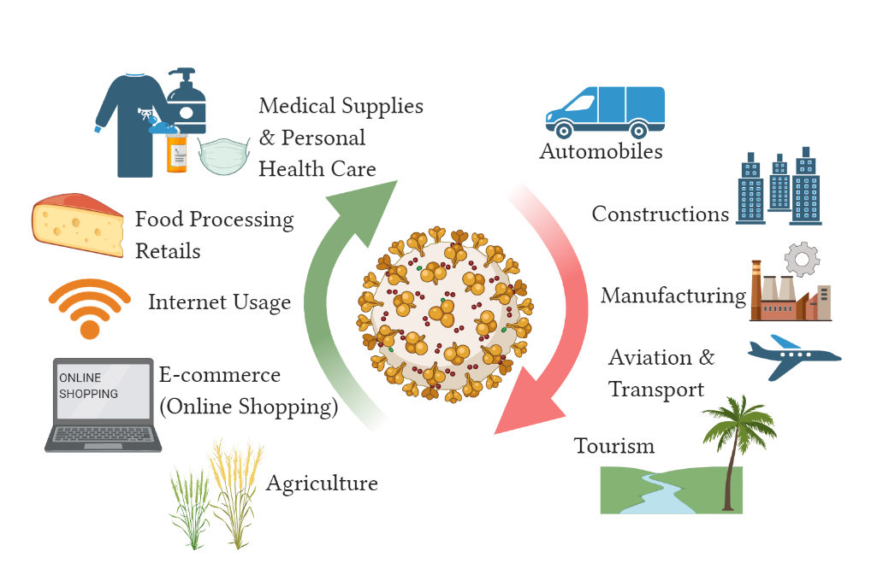
Due to unprecedented issues which had risen due to COVID-19, there was a lack of communication between governments, press and population that was left to take self-measures for their protection. The misinformation circulated among the people who lacked the necessary information to overcome the pandemic worsens the situations. This had affected both developed and developing countries. Europeans also found to be affected by the crisis as one million people had lost their jobs in two weeks; that number could be far higher considering there are many European who work as freelancers and workers without contracts [76,77]. According to the International Fund for Agricultural Development 2011, estimate that 1.4 billion people are trapped in extreme poverty and reside in developing countries. Covid-19 crisis has left South Asia to expect 63% of the new poor, living below $1.90 a day. Continuous revisions in socio-economic database by agencies like Poverty and Shared Prosperity Report 2020 (PSPR2020), World Economic Outlook (WEO), and Macro Poverty Outlook (MPO) reflects upon the new induced poor. Alarming numbers could be added if governments do not take measures of poverty control, adequate food distributions and disbursement of essentials of daily use.

Prevention

Globally, billions of research dollars have been invested to discover an effective therapeutic drug still the current situation has not resulted in the development of an effective and viable treatment options. Therefore, the most suitable option for infection prevention and to control the disease spread is to follow the guidelines provided by the WHO. For the control and prevention of the contagious disease like COVID-19 several essential circumstances were mentioned by WHO likewise education, possible treatment of the infected individuals, isolations, lockdowns, use of masks and sanitizer and home quarantine which lead to minimization of SARS-CoV-2 spread [78].
Until the vaccines promise to fight against the coronavirus, the world population is asked to take precautions and prevent contact with infected people as prevention is better than cure. Washing hands frequently, avoiding contact with domestic as well as wild animals, and keeping distance from symptomatic persons could be proven effective way of preventing SARS-CoV-2 infection. Medical doctors, nurses and laboratory attendants should be provided with personal protective equipment (N95 mask, nitrile gloves, shoe cover, protective goggle etc) as the frontline fighters are more prone to get SARS-CoV-2 infection. Use of the hand sanitizer, avoiding face to face contact and shaking hands especially with symptomatic individuals, maintaining two meters distance, frequent hand washing for 15-20 seconds and avoiding contact with eye, nose and mouth until washed and avoiding immunocompromised individuals from public gatherings also help in prevention and management of SARS-CoV-2. It is hoped that these health guidelines may help in finding an adjunct in the prevention and management of SARS-CoV-2. Respirators such as FFP1, FFP2 and FFP3 are single time-use items until they are found to be contaminated with the coronavirus on their surface [79]. Studies suggested that the use of N95 masks, sanitizer and frequent hand washing by medical staffs in few Wuhan hospitals were reported to effective to provide prevention against SARS-CoV-2 infection [80].

Conclusion
In conclusion, the world population is helpless to survive with a novel and highly contagious virus, SARS-CoV-2. At present, there is no anti-SARS-CoV-2 drug which has found effective completely. Therefore, it is preferable to follow and continue the safety measures provided by the world health organisation unless a safe and effective vaccine and drug is developed. Up to date millions have been diagnosed with SARS-CoV-2 infection and millions may get its infection if the current situations prevail in future. The impact of emergence of this novel virus has not only affected the health status of millions rather it has also resulted in the socio-economic loss. It must be taken into considerations that understanding the genome and viral structure more deeply may open several therapeutic targets and preventive options towards the management of COVID-19. However, it is hoped that several clinical trials shall result in the development of therapeutics and vaccines in near future. Thus, this review focuses mainly to present the data related to therapeutics and vaccines which may curb the exponential growth and spread of SARS-CoV-2.

Conflict of interest

The authors declared that there is no conflict of interest in addition to any competing financial interest.

Acknowledgment
The authors are grateful to acknowledge Professor Mohammad Afzal, chairman, Department of Zoology and Professor Nazura Usmani, Aquatic toxicology Laboratory for the article proofreading and giving valuable suggestions for its improvement. Also, no funding was provided for this work.

References
- Zhou P, Yang XL, Wang XG, Hu B, Zhang L, Zhang W, Si HR, Zhu Y, Li B, Huang CL, Chen HD, Chen J, Luo Y, Guo H, Jiang RD, Liu MQ, Chen Y, Shen XR, Wang X, Zheng XS, Zhao K, Chen QJ, Deng F, Liu LL, Yan B, Zhan FX, Wang YY, Xiao GF, Shi ZL. A pneumonia outbreak associated with a new coronavirus of probable bat origin. Nature 2020;579(7798):270-273
- Weiss SR, Navas-Martin S. Coronavirus pathogenesis and the emerging pathogen severe acute respiratory syndrome coronavirus. Microbiol Mol Biol Rev 2005;69(4):635-64
- Sahin AR, Erdogan A, Agaoglu PM, Dineri Y, Cakirci AY, Senel ME, Okyay RA, Tasdogan AM. 2019 novel coronavirus (COVID-19) outbreak: a review of the current literature. EJMO 2020;4(1):1-7
- Comar CE, Goldstein SA, Li Y, Yount B, Baric RS, Weiss SR. Antagonism of dsRNA-Induced Innate Immune Pathways by NS4a and NS4b Accessory Proteins during MERS Coronavirus Infection. mBio 2019 26;10(2):e00319-19.
- Huang C, Wang Y, Li X, Ren L, Zhao J, Hu Y, Zhang L, Fan G, Xu J, Gu X, Cheng Z, Yu T, Xia J, Wei Y, Wu W, Xie X, Yin W, Li H, Liu M, Xiao Y, Gao H, Guo L, Xie J, Wang G, Jiang R, Gao Z, Jin Q, Wang J, Cao B. Clinical features of patients infected with 2019 novel coronavirus in Wuhan, China. Lancet 2020;395(10223):497-506.
- Cascella M, Rajnik M, Cuomo A, Dulebohn SC, Di Napoli R. Features, Evaluation and Treatment Coronavirus (COVID-19). 2020; Treasure Island (FL): Stat Pearls Publishing; 2020 Jan– PMID: 32150360.
- Su S, Wong G, Shi W, Liu J, Lai ACK, Zhou J, Liu W, Bi Y, Gao GF. Epidemiology, Genetic Recombination, and Pathogenesis of Coronaviruses. Trends Microbiol. 2016;24(6):490-502.
- Peiris JS, Guan Y, Yuen KY. Severe acute respiratory syndrome. Nat Med. 2004;10(12 Suppl):S88-97.
- Chan-Yeung M, Xu RH. SARS: epidemiology. Respirology. 2003 Nov;8 Suppl (Suppl 1):S9-14. doi: 10.1046/j.1440-1843.2003.00518.x.
- Zaki AM, van Boheemen S, Bestebroer TM, Osterhaus AD, Fouchier RA. Isolation of a novel coronavirus from a man with pneumonia in Saudi Arabia. N Engl J Med. 2012;367(19):1814-20.
- Ren LL, Wang YM, Wu ZQ, Xiang ZC, Guo L, Xu T, Jiang YZ, Xiong Y, Li YJ, Li XW, Li H, Fan GH, Gu XY, Xiao Y, Gao H, Xu JY, Yang F, Wang XM, Wu C, Chen L, Liu YW, Liu B, Yang J, Wang XR, Dong J, Li L, Huang CL, Zhao JP, Hu Y, Cheng ZS, Liu LL, Qian ZH, Qin C, Jin Q, Cao B, Wang JW. Identification of a novel coronavirus causing severe pneumonia in human: a descriptive study. Chin Med J (Engl). 2020;133(9):1015-1024.
- Lu R, Zhao X, Li J, Niu P, Yang B, Wu H, Wang W, Song H, Huang B, Zhu N, Bi Y, Ma X, Zhan F, Wang L, Hu T, Zhou H, Hu Z, Zhou W, Zhao L, Chen J, Meng Y, Wang J, Lin Y, Yuan J, Xie Z, Ma J, Liu WJ, Wang D, Xu W, Holmes EC, Gao GF, Wu G, Chen W, Shi W, Tan W. Genomic characterisation and epidemiology of 2019 novel coronavirus: implications for virus origins and receptor binding. Lancet. 2020;395(10224):565-574.
- Jackie Salo .2020, https://nypost.com/2020/03/29/at-least-8-strains-of-the-coronavirus-are-spreading-across-the-globe/?fbclid=IwAR34Kcf79d9IYyrQLMCy6FCfSQZKXJEZuwR-LEeN1b-ReE81BM7pe1OWIu4.
- Eckerle LD, Lu X, Sperry SM, Choi L, Denison MR. High fidelity of murine hepatitis virus replication is decreased in nsp14 exoribonuclease mutants. J Virol. 2007;81(22):12135-44.
- Eckerle LD, Becker MM, Halpin RA, Li K, Venter E, Lu X, Scherbakova S, Graham RL, Baric RS, Stockwell TB, Spiro DJ, Denison MR. Infidelity of SARS-CoV Nsp14-exonuclease mutant virus replication is revealed by complete genome sequencing. PLoS Pathog. 2010;6(5):e1000896.
- Vega VB, Ruan Y, Liu J, Lee WH, Wei CL, Se-Thoe SY, Tang KF, Zhang T, Kolatkar PR, Ooi EE, Ling AE, Stanton LW, Long PM, Liu ET. Mutational dynamics of the SARS coronavirus in cell culture and human populations isolated in 2003. BMC Infect Dis. 2004;4:32.
- Lauber C, Goeman JJ, Parquet Mdel C, Nga PT, Snijder EJ, Morita K, Gorbalenya AE. The footprint of genome architecture in the largest genome expansion in RNA viruses. PLoS Pathog. 2013;9(7):e1003500.
- Graham RL, Baric RS. Recombination, reservoirs, and the modular spike: mechanisms of coronavirus cross-species transmission. J Virol. 2010;84(7):3134-46.
- Ge XY, Li JL, Yang XL, Chmura AA, Zhu G, Epstein JH, Mazet JK, Hu B, Zhang W, Peng C, Zhang YJ, Luo CM, Tan B, Wang N, Zhu Y, Crameri G, Zhang SY, Wang LF, Daszak P, Shi ZL. Isolation and characterization of a bat SARS-like coronavirus that uses the ACE2 receptor. Nature. 2013;503(7477):535-8.
- Li F. Receptor recognition and cross-species infections of SARS coronavirus. Antiviral Res. 2013;100(1):246-54.
- Hu D, Zhu C, Ai L, He T, Wang Y, Ye F, Yang L, Ding C, Zhu X, Lv R, Zhu J, Hassan B, Feng Y, Tan W, Wang C. Genomic characterization and infectivity of a novel SARS-like coronavirus in Chinese bats. Emerg Microbes Infect. 2018;7(1):154.
- Hofmann H, Pöhlmann S. Cellular entry of the SARS coronavirus. Trends in Microbiology. 2004;12(10):466-472.
- Sturman LS. I. Structural proteins: effects of preparative conditions on the migration of protein in polyacrylamide gels. Virology. 1977;77(2):637-49.
- den Boon JA, Snijder EJ, Chirnside ED, de Vries AA, Horzinek MC, Spaan WJ. Equine arteritis virus is not a togavirus but belongs to the coronaviruslike superfamily. J Virol. 1991;65(6):2910-20.
- Liu DX, Inglis SC. Association of the infectious bronchitis virus 3c protein with the virion envelope. Virology. 1991;185(2):911-7.
- Godet M, L'Haridon R, Vautherot JF, Laude H. TGEV corona virus ORF4 encodes a membrane protein that is incorporated into virions. Virology. 1992;188(2):666-75.
- Yu X, Bi W, Weiss SR, Leibowitz JL. Mouse hepatitis virus gene 5b protein is a new virion envelope protein. Virology. 1994;202(2):1018-23.
- Laude H, Masters, PS. The coronavirus nucleocapsid protein. In The Coronaviridae (S.G. Siddell, ed.), Plenum Press, New York and London, 1995, pp. 141–163.
- Macnaughton MR. The polypeptides of human and mouse coronaviruses. Brief report. Arch Virol. 1980;63(1):75-80.
- Narayanan K, Chen CJ, Maeda J, Makino S. Nucleocapsid-independent specific viral RNA packaging via viral envelope protein and viral RNA signal. J Virol. 2003;77(5):2922-7.
- Kuo L, Godeke GJ, Raamsman MJ, Masters PS, Rottier PJ. Retargeting of coronavirus by substitution of the spike glycoprotein ectodomain: crossing the host cell species barrier. J Virol. 2000;74(3):1393-406.
- Li W, Moore MJ, Vasilieva N, Sui J, Wong SK, Berne MA, Somasundaran M, Sullivan JL, Luzuriaga K, Greenough TC, Choe H, Farzan M. Angiotensin-converting enzyme 2 is a functional receptor for the SARS coronavirus. Nature. 2003;426(6965):450-4.
- Hoffmann M, Kleine-Weber H, Schroeder S, Krüger N, Herrler T, Erichsen S, Schiergens TS, Herrler G, Wu NH, Nitsche A, Müller MA, Drosten C, Pöhlmann S. SARS-CoV-2 Cell Entry Depends on ACE2 and TMPRSS2 and Is Blocked by a Clinically Proven Protease Inhibitor. Cell. 2020;181(2):271-280.e8.
- Hoffmann M, Kleine-Weber H, Krüger N, et al. The novel coronavirus 2019 (2019-nCoV) uses the SARS-coronavirus receptor ACE2 and the cellular protease TMPRSS2 for entry into target cells. bioRxiv; 2020. DOI: 10.1101/2020.01.31.929042.
- Wong SK, Li W, Moore MJ, Choe H, Farzan M. A 193-amino acid fragment of the SARS coronavirus S protein efficiently binds angiotensin-converting enzyme 2. J Biol Chem. 2004;279(5):3197-201.
- Smith AE, Helenius A. How viruses enter animal cells. Science 2004;304(5668):237-42.
- Donoghue M, Hsieh F, Baronas E, Godbout K, Gosselin M, Stagliano N, et al. A novel angiotensin-converting enzyme-related carboxypeptidase (ACE2) converts angiotensin I to angiotensin 1-9. Circ Res. 2000;87:E1–9.
- Li W, Moore M, Vasilieva N, Sui J, Wong S, Berne M, et al. Angiotensin-converting enzyme 2 is a functional receptor for the SARS coronavirus. Nature. 2003;426:450–4.
- Emery SL, Erdman DD, Bowen MD, Newton BR, Winchell JM, Meyer RF, Tong S, Cook BT, Holloway BP, McCaustland KA, Rota PA, Bankamp B, Lowe LE, Ksiazek TG, Bellini WJ, Anderson LJ. Real-time reverse transcription-polymerase chain reaction assay for SARS-associated coronavirus. Emerg Infect Dis. 2004;10(2):311-6.
- Gaunt ER, Hardie A, Claas EC, Simmonds P, Templeton KE. Epidemiology and clinical presentations of the four human coronaviruses 229E, HKU1, NL63, and OC43 detected over 3 years using a novel multiplex real-time PCR method. J Clin Microbiol. 2010;48(8):2940-7.
- Chen H, Guo J, Wang C, Luo F, Yu X, Zhang W, Li J, Zhao D, Xu D, Gong Q, Liao J, Yang H, Hou W, Zhang Y. Clinical characteristics and intrauterine vertical transmission potential of COVID-19 infection in nine pregnant women: a retrospective review of medical records. Lancet. 2020;395(10226):809-815.
- Gao J, Tian Z, Yang X. Breakthrough: Chloroquine phosphate has shown apparent efficacy in treatment of COVID-19 associated pneumonia in clinical studies. Biosci Trends. 2020;14(1):72-73.
- Zhang H, Penninger JM, Li Y, Zhong N, Slutsky AS. Angiotensin-converting enzyme 2 (ACE2) as a SARS-CoV-2 receptor: molecular mechanisms and potential therapeutic target. Intensive Care Med. 2020;46(4):586-590.
- Sheahan TP, Sims AC, Leist SR, Schäfer A, Won J, Brown AJ, Montgomery SA, Hogg A, Babusis D, Clarke MO, Spahn JE, Bauer L, Sellers S, Porter D, Feng JY, Cihlar T, Jordan R, Denison MR, Baric RS. Comparative therapeutic efficacy of remdesivir and combination lopinavir, ritonavir, and interferon beta against MERS-CoV. Nat Commun. 2020 Jan 10;11(1):222. doi: 10.1038/s41467-019-13940-6. PMID: 31924756; PMCID: PMC6954302.
- Hung IF, Lung KC, Tso EY, Liu R, Chung TW, Chu MY, Ng YY, Lo J, Chan J, Tam AR, Shum HP, Chan V, Wu AK, Sin KM, Leung WS, Law WL, Lung DC, Sin S, Yeung P, Yip CC, Zhang RR, Fung AY, Yan EY, Leung KH, Ip JD, Chu AW, Chan WM, Ng AC, Lee R, Fung K, Yeung A, Wu TC, Chan JW, Yan WW, Chan WM, Chan JF, Lie AK, Tsang OT, Cheng VC, Que TL, Lau CS, Chan KH, To KK, Yuen KY. Triple combination of interferon beta-1b, lopinavir-ritonavir, and ribavirin in the treatment of patients admitted to hospital with COVID-19: an open-label, randomised, phase 2 trial. Lancet. 2020 May 30;395(10238):1695-1704. doi: 10.1016/S0140-6736(20)31042-4. Epub 2020 May 10. PMID: 32401715; PMCID: PMC7211500.
- Yan Y, Zou Z, Sun Y, Li X, Xu KF, Wei Y, Jin N, Jiang C. Anti-malaria drug chloroquine is highly effective in treating avian influenza A H5N1 virus infection in an animal model. Cell Res. 2013;23(2):300-2.
- Wang Z, Chen X, Lu Y, Chen F, Zhang W. Clinical characteristics and therapeutic procedure for four cases with 2019 novel coronavirus pneumonia receiving combined Chinese and Western medicine treatment. Biosci Trends. 2020;14(1):64-68.
- Totura AL, Bavari S. Broad-spectrum coronavirus antiviral drug discovery. Expert Opin Drug Discov. 2019;14(4):397-412.
- Warren TK, Jordan R, Lo MK, Ray AS, Mackman RL, Soloveva V, Siegel D, Perron M, Bannister R, Hui HC, Larson N, Strickley R, Wells J, Stuthman KS, Van Tongeren SA, Garza NL, Donnelly G, Shurtleff AC, Retterer CJ, Gharaibeh D, Zamani R, Kenny T, Eaton BP, Grimes E, Welch LS, Gomba L, Wilhelmsen CL, Nichols DK, Nuss JE, Nagle ER, Kugelman JR, Palacios G, Doerffler E, Neville S, Carra E, Clarke MO, Zhang L, Lew W, Ross B, Wang Q, Chun K, Wolfe L, Babusis D, Park Y, Stray KM, Trancheva I, Feng JY, Barauskas O, Xu Y, Wong P, Braun MR, Flint M, McMullan LK, Chen SS, Fearns R, Swaminathan S, Mayers DL, Spiropoulou CF, Lee WA, Nichol ST, Cihlar T, Bavari S. Therapeutic efficacy of the small molecule GS-5734 against Ebola virus in rhesus monkeys. Nature. 2016;531(7594):381-5.
- Wang M, Cao R, Zhang L, Yang X, Liu J, Xu M, Shi Z, Hu Z, Zhong W, Xiao G. Remdesivir and chloroquine effectively inhibit the recently emerged novel coronavirus (2019-nCoV) in vitro. Cell Res. 2020;30(3):269-271.
- Sheahan TP, Sims AC, Leist SR, Schäfer A, Won J, Brown AJ, Montgomery SA, Hogg A, Babusis D, Clarke MO, Spahn JE, Bauer L, Sellers S, Porter D, Feng JY, Cihlar T, Jordan R, Denison MR, Baric RS. Comparative therapeutic efficacy of remdesivir and combination lopinavir, ritonavir, and interferon beta against MERS-CoV. Nat Commun. 2020;11(1):222.
- Tanner JA, Zheng BJ, Zhou J, Watt RM, Jiang JQ, Wong KL, Lin YP, Lu LY, He ML, Kung HF, Kesel AJ, Huang JD. The adamantane-derived bananins are potent inhibitors of the helicase activities and replication of SARS coronavirus. Chem Biol. 2005;12(3):303-11.
- Mubarak A, Alturaiki W, Hemida MG. Middle East Respiratory Syndrome Coronavirus (MERS-CoV): Infection, Immunological Response, and Vaccine Development. J Immunol Res. 2019;2019:6491738.
- Taylor R, Kotian P, Warren T, Panchal R, Bavari S, Julander J, Dobo S, Rose A, El-Kattan Y, Taubenheim B, Babu Y, Sheridan WP. BCX4430 - A broad-spectrum antiviral adenosine nucleoside analog under development for the treatment of Ebola virus disease. J Infect Public Health. 2016;9(3):220-6.
- Pruijssers AJ, Denison MR. Nucleoside analogues for the treatment of coronavirus infections. Curr Opin Virol. 2019;35:57-62.
- Killerby ME, Biggs HM, Midgley CM, Gerber SI, Watson JT. Middle East Respiratory Syndrome Coronavirus Transmission. Emerg Infect Dis. 2020;26(2):191-198.
- Senanayake SL. Drug repurposing strategies for COVID-19. Future Drug Discov. 2020;0(0):2020-0010.
- Lundin A, Dijkman R, Bergström T, Kann N, Adamiak B, Hannoun C, Kindler E, Jónsdóttir HR, Muth D, Kint J, Forlenza M, Müller MA, Drosten C, Thiel V, Trybala E. Targeting membrane-bound viral RNA synthesis reveals potent inhibition of diverse coronaviruses including the middle East respiratory syndrome virus. PLoS Pathog. 2014;10(5):e1004166.
- Rossignol JF. Nitazoxanide, a new drug candidate for the treatment of Middle East respiratory syndrome coronavirus. J Infect Public Health. 2016;9(3):227-30.
- Shakya A, Bhat HR, Ghosh SK. Update on Nitazoxanide: A Multifunctional Chemotherapeutic Agent. Curr Drug Discov Technol. 2018;15(3):201-213.
- Millet JK, Séron K, Labitt RN, Danneels A, Palmer KE, Whittaker GR, Dubuisson J, Belouzard S. Middle East respiratory syndrome coronavirus infection is inhibited by griffithsin. Antiviral Res. 2016;133:1-8.
- Barton C, Kouokam JC, Lasnik AB, Foreman O, Cambon A, Brock G, Montefiori DC, Vojdani F, McCormick AA, O'Keefe BR, Palmer KE. Activity of and effect of subcutaneous treatment with the broad-spectrum antiviral lectin griffithsin in two laboratory rodent models. Antimicrob Agents Chemother. 2014;58(1):120-7.
- Zhang JJ, Dong X, Cao YY, Yuan YD, Yang YB, Yan YQ, Akdis CA, Gao YD. Clinical characteristics of 140 patients infected with SARS-CoV-2 in Wuhan, China. Allergy. 2020 Jul;75(7):1730-1741. doi: 10.1111/all.14238. Epub 2020 Feb 27. PMID: 32077115.
- Jin Y, Yang H, Ji W, Wu W, Chen S, Zhang W, Duan G. Virology, Epidemiology, Pathogenesis, and Control of COVID-19. Viruses. 2020 Mar 27;12(4):372. doi: 10.3390/v12040372. PMID: 32230900; PMCID: PMC7232198.
- Pandey SC, Pande V, Sati D, Upreti S, Samant M. Vaccination strategies to combat novel corona virus SARS-CoV-2. Life Sci. 2020 Sep 1;256:117956. doi: 10.1016/j.lfs.2020.117956. Epub 2020 Jun 12. PMID: 32535078; PMCID: PMC7289747.
- Ahammad I, Lira SS. Designing a novel mRNA vaccine against SARS-CoV-2: An immunoinformatics approach. Int J Biol Macromol. 2020 Nov 1;162:820-837. doi: 10.1016/j.ijbiomac.2020.06.213. Epub 2020 Jun 26. PMID: 32599237; PMCID: PMC7319648.
- Pang J, Wang MX, Ang IYH, Tan SHX, Lewis RF, Chen JI, Gutierrez RA, Gwee SXW, Chua PEY, Yang Q, Ng XY, Yap RK, Tan HY, Teo YY, Tan CC, Cook AR, Yap JC, Hsu LY. Potential Rapid Diagnostics, Vaccine and Therapeutics for 2019 Novel Coronavirus (2019-nCoV): A Systematic Review. J Clin Med. 2020 Feb 26;9(3):623. doi: 10.3390/jcm9030623. PMID: 32110875; PMCID: PMC7141113.
- Buck T, Arnold M, Chazan G, Cookson C. Coronavirus declared a pandemic as fears of economic crisis mount. 2020. https://www.ft.com/content/d72f1e54-6396-11ea-b3f3-fe4680ea68b5 [Internet], [cited 2020 Mar 19].
- DHSC issues guidance on the impact of COVID-19 on research funded or supported by NIHR. https://www.nihr.ac.uk/news/dhsc-issues-guidance-on-the-impact-on-covid-19-on-research-funded-or-supported-by-nihr/24469 [Internet]. [cited 2020 Mar 21].
- NIH Shifts Non-mission-critical Laboratory Operations to Minimal Maintenance Phase. National Institutes of Health (NIH);2020. https://www.nih.gov/news-events/news-releases/nih-shifts-non-mission-critical-laboratory-operations-minimal-maintenance-phase [Internet] [cited 2020 Mar 21].).
- Coronavirus (COVID-19) https://www.harvard.edu/coronavirus [Internet]. Harvard University, [cited 2020 Mar 21].
- Anser MK, Yousaf Z, Khan MA, Nassani AA, Alotaibi SM, Qazi Abro MM, Vo XV, Zaman K. Does communicable diseases (including COVID-19) may increase global poverty risk? A cloud on the horizon. Environ Res. 2020 Aug;187:109668. doi: 10.1016/j.envres.2020.109668. Epub 2020 May 15. PMID: 32422482; PMCID: PMC7228701.
- MahendraDev S. Addressing COVID-19 impacts on agriculture, food security, and livelihoods in India, IFPRI: international food policy research institute. https://www.ifpri.org/blog/addressing-covid-19-impacts-agriculture-food-security-and-livelihoods-india [Internet]. IFPRI. [cited 2020 May 22].
- Saini S. COVID-19 may double poverty in India. Finance Express. 2020 https://www.financialexpress.com/opinion/covid-19-may-double-poverty-in-india/1943736/ [Internet] [cited 2020 May 22].
- https://www.weforum.org/agenda/2020/11/covid-19-global-poverty-inequality-un-economics-coronavirus-pandemic?utm_source=twitter&utm_medium=social_scheduler&utm_term=SDG+01:+No+Poverty&utm_content=23/11/2020+13:30
- Sumner A. Hoy C, and Ortiz-Juarez E. (2020) Estimates of the impact of COVID-19 on global poverty, United Nations University World Institute for Development Economics Research Publication (UNU-WINDER) Working Paper, April, 2020/43.https://www.wider.unu.edu/sites/default/files/Publications/Working-paper/PDF/wp2020-43.pdf. Accessed on: 5/4/2020
- The Extent of COVID-19 Pandemic Socio-Economic Impact on Global Poverty. A Global Integrative Multidisciplinary Review. Available from: https://www.researchgate.net/publication/341044016_The_Extent_of_COVID 19_Pandemic_SocioEconomic_Impact_on_Global_Poverty_A_Global_Integrative_Multidisciplinary_Review [accessed Oct 01 2020]
- Organization WH. WHO Director-General's opening remarks at the media briefing on COVID-19 - 11 March 2020 2020March 11 [Available from: https://www.who.int/dg/speeches/detail/who-director-general-s-opening-remarks-at-the-media-briefing-on-covid-19---11-march-2020.
- Desai AN, Patel P. Stopping the Spread of COVID-19. JAMA. 2020 Apr 21;323(15):1516. doi: 10.1001/jama.2020.4269. PMID: 32196079.
- Wang X, Pan Z, Cheng Z. Association between 2019-nCoV transmission and N95 respirator use. J Hosp Infect. 2020 May;105(1):104-105. doi: 10.1016/j.jhin.2020.02.021. Epub 2020 Mar 3. PMID: 32142885; PMCID: PMC7134426.

