**Prospects of Biochar in soil health management, remediation, SDG and Indian perspectives**

**Prarthana Priyom Hazarika, Bhaskar Jyoti Buragohain, Monoranjan Nath and Ritu Thakur \***

**North Eastern Regional Institute of Water and Land Management, Tezpur 784027, Assam, India**

**Corresponding author *: thritu12@gmail.com**

**Abstract**

The recent developments in human civilization have paved the way to numerous changes in the environment including climate change that eventually effects all dimensions of food security including food accessibility, food utilization, and food systems stability with its additional negative impacts on human health, livelihood assets, food production and distribution channels. Keeping all these aspects in view, the present chapter puts a focus on biochar, reviewing its applicability in the agricultural sector and its waste to wealth conversion potentiality as well as its role in attaining the sustainable development goals (SDG). Present agriculture is highly intensive leading to large scale removal of nutrients from the soil. The most widespread solution to this depletion is the application of soil amendments in the form of N, P, K fertilizers and sufficient organic matter with limited importance given to carbon sequestration and soil health management. In this chapter, biochar is discussed as a potential factor in the dimension of all round soil health improvement and soil-water relationship management. Application of biochar, a carbon rich material, usually produced by pyrolysis of biomass at around temperature range of 300–600°C, has gained momentum for its role in soil health management and carbon sequestration. Role of biochar is primarily observed in four important SDGs including clean water and sanitation (SGD6), affordable and clean energy (SDG7), responsible consumption and production (SDG12) , climate action (SDG13), besides its high potential existence in the circular economy.

***Keywords*:** Biochar, agricultural waste, pyrolysis, Sustainable Development Goals, Circular economy.

**Introduction**

The use of biochar as a source to improve soil fertility is believed to be originated in the Amazonian land about 2000 years ago, where it is locally known as “Terra Preta do Índio” (TPI) (Lehmann and Joseph, 2009). Biochar is produced by the decomposition of organic biomass at temperatures between 200-900 °C in an inert atmosphere of limited or no exposure of oxygen, by a process called pyrolysis (Farobie *et. al.*, 2022). The processis generally divided into fast, intermediate and slow depending on the residence time (time required to complete the pyrolysis ) and the exposure temperature of the biomass. The engineered biochar are reinforced form of biochar in which modifications are done using different metals, nanomaterials, microorganisms, hydroxides etc. for targeted use. They are classified as mineral biochar, metal biochar, microorganism biochar, carbonaceous nano-composites and layered double hydroxide (LDH) biochar composites (Wang *et al.,* 2021). In low scale, biochar can be prepared by the farmers themselves by using the locally available agricultural wastes  *viz.*, rice straw, wheat straw, toria stover by the process of slow pyrolysis (250 ºC - 350 ºC), using low cost oil drum (Medhi *et. al.,* 2021*)*. Higher yields of biochar is obtained at lower temperature conditions,whereas, biochar with strongly developed specific surface area, high ash and carbon content, high porosity and pH with lowvalues of CEC(Tomczyk *et. al*., 2020). The type of feed stocks and pyrolysis temperature determines varying composition of biochar. As for example, the biochar prepared from rice plant residues contain higher percentage of Si, which in turn provides better soil nutrient retention, turgidity and a good structure to the plant (Karam *et. al.*, 2022). The concentration of secondary nutrients like Ca, Mg and major nutrient K were found to be increased with the rise in the pyrolysis temperature (Mohamed *et. al*., 2021). Moreover, amounts of volatile compounds decrease with the increase in pyrolysis temperature (Neogi *et. al*., 2021). The physical and the chemical properties of biochar are conditioned by various factors like the size and density of the pyrolyzed particle, the concentration of inorganic (ash content, Ca, Mg, and inorganic carbonates) and organic (cellulose, lignin, and hemicelluloses) compounds and the type of waste. Biochar obtained from forages, woody plants or cacti shows different physical and chemical characteristics due to their difference in carbon fixation metabolisms. The high carbon contents present in organic matter are stabilized by pyrolysis, which, otherwise, are more resistant to biological and chemical decomposition. (Sánchez-Reinoso*et. al*., 2020).

Properties like high surface area, large pore size, stable structure and presence of different functional groups make biochar appropriate for wide ranges of applications (Ali *et. al.,*2022). Biochar has been commonly used for soil amendment and enhancing soil properties for better nutrient availability, increasing soil fertility, buffering soil pH and enhancing carbon sequestration. Currently, application of biochar is also reported in enriching the animal feedstock for efficient nutrient uptake for better animal health and productivity. Moreover, the excreted biochar-manure, so obtained from livestocks, become more valuable organic fertilizer causing lower nutrient losses and greenhouse gas emissions during storage and application (Schmidt *et. al*., 2019). Biochar plays multifunctional roles as anexcellent soil amendment, nutrient and microbial carrier, immobilising agent for remediation of both organic and inorganic pollutants from soil and water, porous material for mitigating greenhouse gas emissions and odorous compounds, catalyst in industrial processes and a feed supplement to improve animal health and nutrient intake efficiency (Bolan *et. al*.,2019).

Pyrolysis is a thermochemical highly complex technique involving many distinct reactions that produces valorised products from biomass, such as biochar, bio-oil, and synthetic gas of high calorific value. The process involves heating and thermal decomposition of biomass under anaerobic conditions or limited air supply (low stoichiometric oxygen atmosphere) with temperatures ranging between 400°C and 1200°C (Borel *et. al*., 2018). The anaerobic environment in pyrolysisensures a non-combustion condition which permits biomass heating beyond its thermal stability limit, allowing the formation of more robust products, including solid residues. Physico-chemical properties of biochar depend on the composition, type of the biomass and the pyrolysis temperature conditions (Table 1). Both physical and chemical characterizations are necessary when identifying the basic properties of biochar and predicting its applications (Armah *et. al*.,2022). Pyrolysis can be divided into several types such as slow pyrolysis, fast pyrolysis, flash pyrolysis and gasification depending on the operating parameters, namely temperature, heating rate and residence time, (Table 1). However, each classification of pyrolysis has its own pros and cons (Al-Rumaihi *et. al*.,2022). The ash content of the biochar increases significantly with increased pyrolysis temperature, which may be due to the fact that the ash mainly remains in the solid fraction and elevated temperature, increases the concentrations of minerals and combusted organic residues. Ash is an important factor that can block surface sorption sites in biochar by influencing the sorption behaviour of hydrophobic organic compounds (HOCs) or make it difficult to access due to their interactions with inorganic moieties. The mechanism of pyrolysis is given in Figure 1.

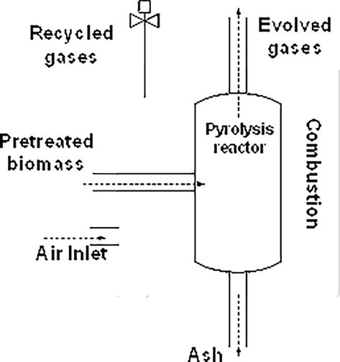

                        Figure 1 : Representation of a pyrolysis process (Armah *et. al*.,2022)

Table 1: The effect of pyrolysis temperature on the biochar properties of some feed stocks (Armah *et. al*.,2022).

|  |  |  |  |  |  |  |
| --- | --- | --- | --- | --- | --- | --- |
| Pyrolysis temperature | Feedstock | Biochar properties | | | | |
| C (%) | H (%) | O (%) | pH | Surface area (m2.g-1) |
| 250 °C | Walnut shells, Corn straw and cobs, Rice straw | 59.99- 75.76 | 4.37-5.67 | 11.04-9.99 | 6.47-9.36 | <8.55 |
| 400 °C | Walnut shells, Corn cobs and corn straw, Rice straw | 76.02- 85.65 | 19.58- 4.04 | 1.69-2.43 | 8.80-10.66 | <8.55 |
| 600 °C | Walnut shells, Corn cobs and corn straw, Rice straw | 89.88- 90.79 | 3.01-3.85 | 6.48-8.14 | 10.00-12.39 | 211.94-320.77 |

Table 2: Products of different pyrolysis methods.

|  |  |  |  |  |  |  |
| --- | --- | --- | --- | --- | --- | --- |
| Types of pyrolysis | Parameters | | | Products (Yield %) | | |
| Temperature (°C) | Retention time (s) | Heating Rate (°C/min) | Gas | Oil | Char |
| Slow pyrolysis | < 600 | 300-350 | 1-10 | 35 | 30 | 35 |
| Fast pyrolysis | >600 | 0.5-10 | 10-200 | 13 | 75 | 12 |
| Flash pyrolysis | 800-1200 | <0.5 | >1000 | 40 (gas+oil) | | 60 |
| Gasification | >750 | 10-20 | - | 85 | 5 | 10 |

The burning of the agricultural crop residues, both *off-situ* and *in-situ*, contributes to the environmental pollution by emission of greenhouse gases (CO2, N2O, CH4), air pollutants (CO, NH3, NOx, SO2, NMHC, volatile organic compounds), particulates matter and smoke. India is anagrarian country and as such large amounts of agricultural wastes are generated every year from each part of the country, which is increasing year after year. The biomass left in the field after the harvest of the economic product is generally termed as agricultural residues. Wastes are also produced in large extent during processing and value addition. Although these residues have a numerous usage from time immemorial, most of the time they are left behind in the field or burned *in-situ*. Thus the large volume of residues generated in the country have great opportunities to be utilised as feedstock for the production of biochar that can be an excellent conditioner as well as amendment to the soil (Das *et. al*., 2021).

**Current status of crop residue production of the country:**

The use of the agricultural residues for the production of biochar is one more step towards the circular economy. The potential agricultural waste residues produced in India in terms of major crops such as rice, wheat, sugarcane and mustard have been depicted in the Figure 2(i), Figure 2(ii), Figure 2(iii) and Figure 2(iv) respectively based on the data of the Normal Estimates of Area, Production and Yield of Selected principal Crops, 2021(Ministry of Agriculture and Farmers’ Welfare, Government of India).The volume of residue generation was calculated based on the residue to grain ratio of the selected crops ( Jain et. al., 2014). The figures shows that these crop residues have the potentiality to be used as feedstock for the production of huge volume of biochar in India.

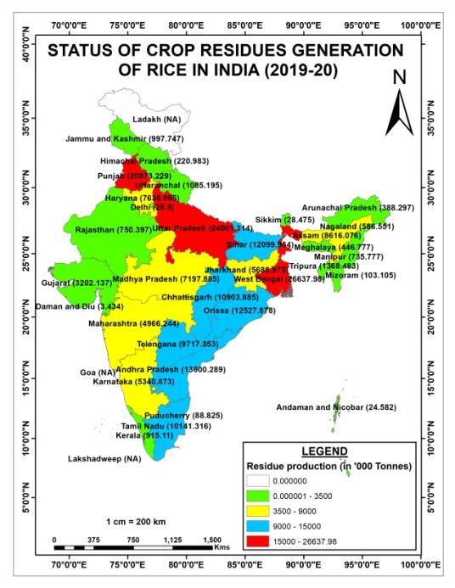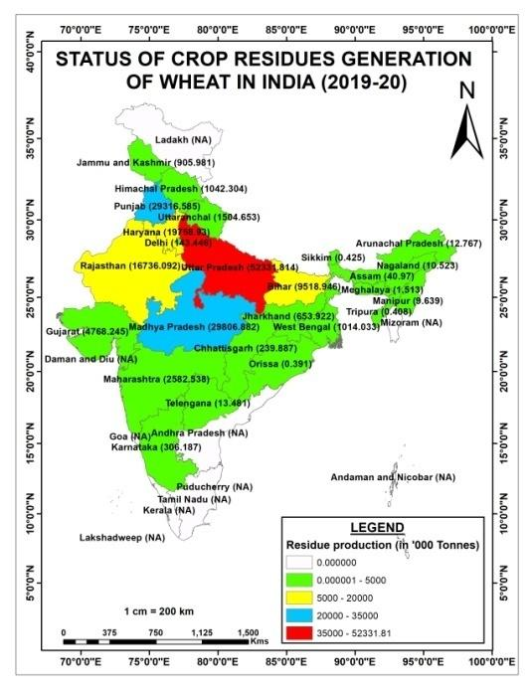

Figure 2

Figure 1

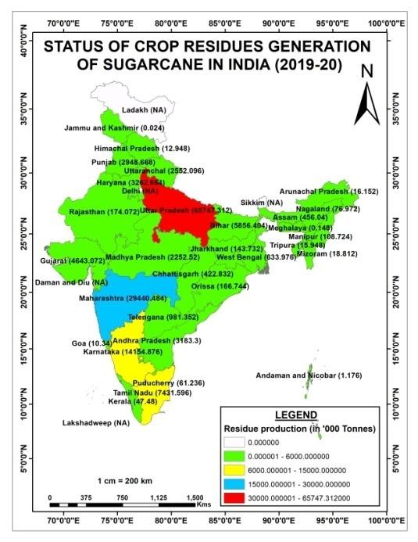    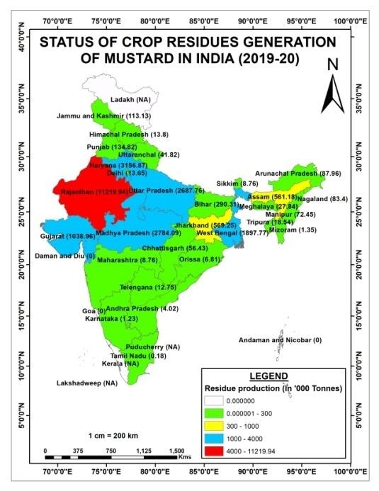

Figure 3

Figure 4

Biochar, with its multipronged utilizationfrom carbon sequestration to application in agriculture to production of valorised products, can play pivotal role in monetization of bio-waste ( Figure 5). Circular economy is considered to be the sustainable model as against the contemporary unsustainable “ take- make- waste” approach and has been gaining momentum worldwide in view of resource crisis and environmental concerns. Thus, the utilization of agricultural waste based feedstock for the preparation of biochar will help all together to attain a circular economy (Neogi *et. al*.,2022).

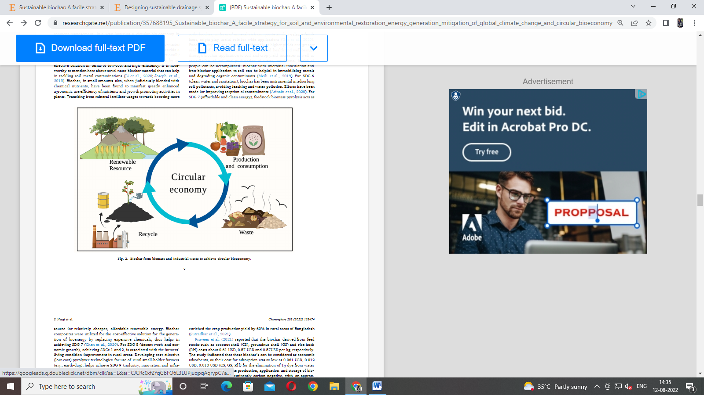

Figure5 :Biochar in circular economy (Neogi *et. al*.,2022).

**Biochar and soil physical health:**

Soil physical health representsprimarily soil texture, soil structure, water holding capacity, aeration, permeability, bulk density etc. to meet plant and ecosystem needs for and get over the processes that may diminish these abilities.

The effect of biochar was reported to be the highest in coarse and medium textured soil in improving the water holding capacity of the soil as compared to the fine textured soil   
(Jeffry *et. al*., 2011). Surface area is an important soil physical health indicator,influencing essential functions of soil fertility, together with water, nutrient retention, aeration, and microbial activity. The surface area of biochar, being typically more than sand and comparable to or higher than clay, causes a net increase in the total soil-specific surface when added as an amendment. The high surface area of biochar modifies the cation exchange capacity and anion exchange capacity of soil by providing space for formation of bonds and complexes with metals and soil nutrients on its surface, which can improve the water and nutrient retention capability of soil (Berglund *et. al*. 2011). A long-term soil column incubation study by Laird *et. al*. (2010) indicated an increase in the specific surface area of an amended clayey soil from 130 to 153 m2 g−1 as the biochar concentration increased from 0 to 20 g kg−1. There are also other associated factors such total porosity or texture which can play important roles in altering the properties of biochar-amended soil surface (Jones *et. al*., 2010).

Application of biochar is also reported to decrease the bulk density of soil. Excluding some rare case of increased bulk density due to column leaching, biochar is an excellent agent for decreasing the bulk density of the soil (Rogovska *et. al*.,2011). However, the difference among the various feedstocks in reducing the bulk density is not significant, although the decrease was significantly greater for high and medium doses than for the lower doses of biochar (Singh *et.al*., 2022). The density of biochar being less (<0.6 g cm−3) as compared to the soil (1.25 g cm−3), the bulk density of the biochar applied soil was affected and reduced (Blanco-Canqui, 2017). As bulk density is directly related to the total porosity of the soil, biochar is also capable in increasing the total porosity (micro- and macro-pores) and thereby increasing the overall soil physical quality because micropores are involved in molecular adsorption and transport while macropores affect aeration and hydrology (Razzaghi *et. al*.,2020).

As observed by Razzaghi *et. al*.(2020), Field Capacity, Permanent Wilting Point as well the Available water holding capacity of soil increase in biochar amended Coarse and medium textured soil. The increase in the soil moisture retention variable may be attributed to the increased micropores due to the application of biochar. (Liu *et. al*., 2017). The smaller size pores are more capable to hold the soil moisture than the macro pores. However, in case of the fine textured soil, the retention variables were seen to be decreasing due to the fact that biochar may block the micropores already existing in the soil.

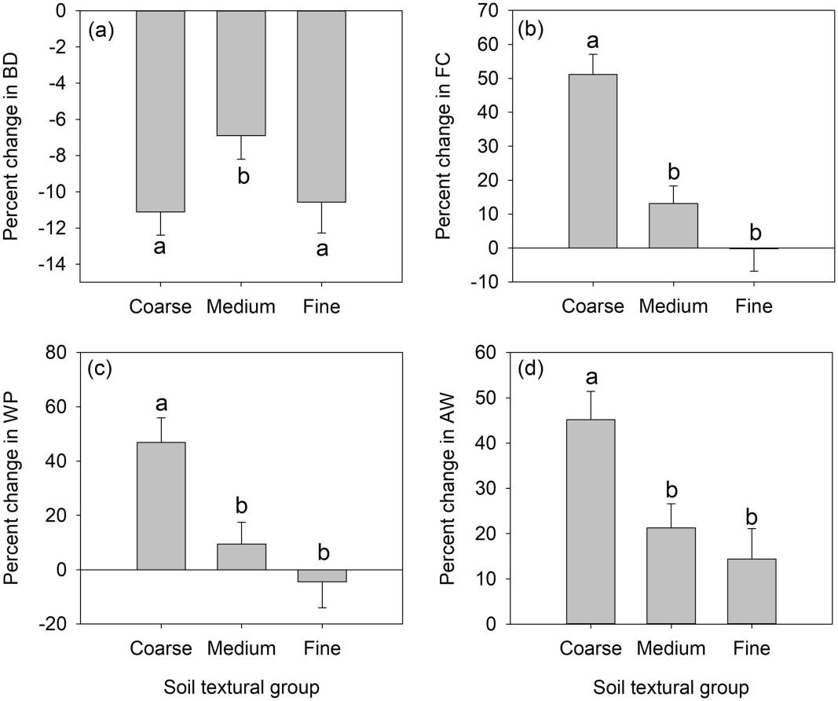

Fig 5: The effect of biochar application on Bulk Density, Field capacity, Permanent Wilting Point and Available Water of soil (Razzaghi *et. al*.,2020).

**Biochar and contaminant remediation**

The present world scenario of ever increasing population at 1.1% per year and the subsequent use of agro-chemicals to increase the productivity to feed such a huge population have led to the contamination of soil as well as water with numerous pollutants as heavy metals, organic pollutants, residual chemicals etc. (Khalid *et. al*. 2020). The effect of biochar in remediation of such contaminants is found significant in several studies. Wood waste based biochar ( WBC)amendments was found to be quite efficient in reducing the concentrations of two metalaxyl (MET) enantiomers (R-MET and S-MET) (You *et. al*. 2021). The possible reduction in the bioavailability of R- and S-MET in the WBC amended soils, may be due to the capability of WBC to eliminate these contaminants from the soil by providing suitable modified soil environment for the degrading bacteria such as *Hydrogenophaga, Methylophilus,* and*Luteimonas* (Boskovic *et. al*. 2021). Bovine manure biochar at a temperature of 700OC is capable of reducing the effect of tetracycline upto 99.70% due to the influences of π-π interactions and hydrophobic effects (Zhao *et. al.,* 2021). Biochar obtained from sugarcane in the agro-industry is capable of removing approximately 70% of thiamethoxam in 60 minutes (Fernandes*et. al*. 2021). Also, biochar synthesized from phosphoric acid-treated rice straw (T-RSBC) is capable of removing atrazine (ATZ), azoxystrobin (AZOXY), and imidacloprid (IMIDA) upto a several extent (Mandal*et. al.* 2021).

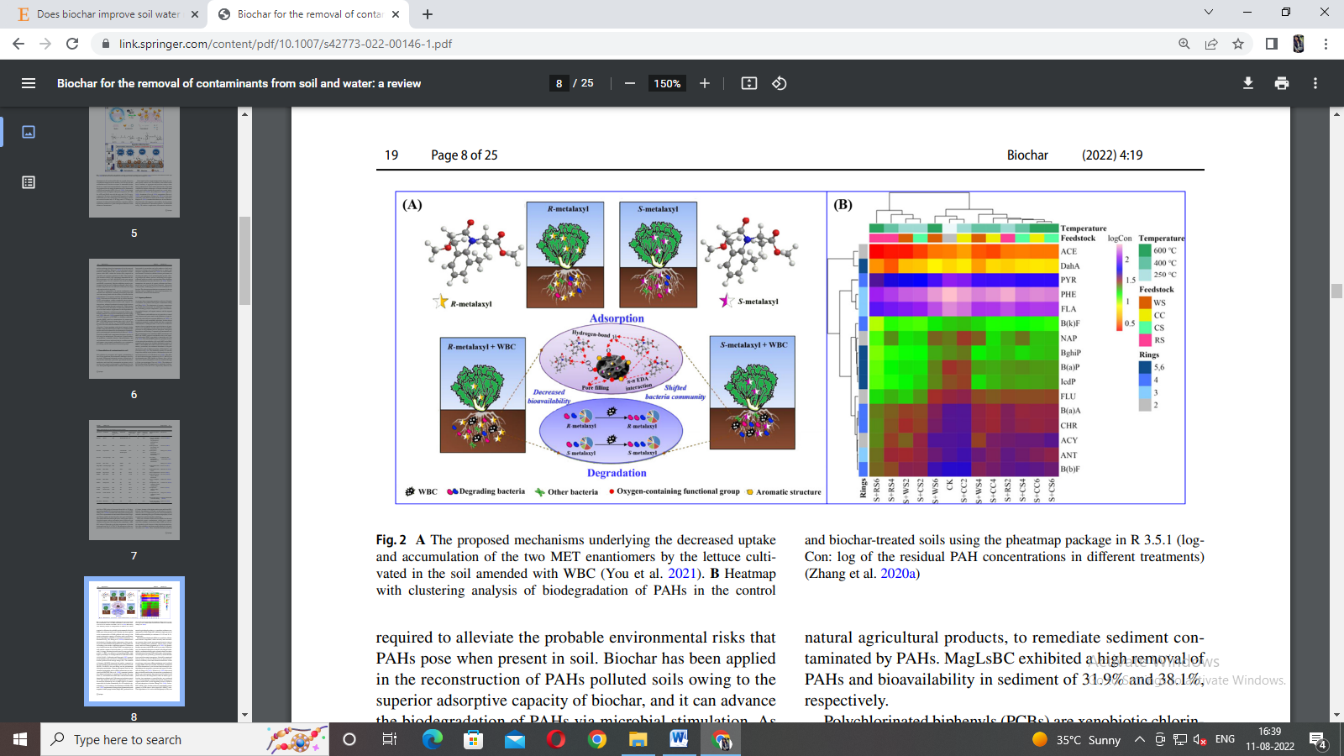

Fig 6 : Mechanisms of actions of WBC in the decreased uptake and accumulation of the two MET enantiomers by the lettuce (You *et. al*. 2021).

The heavy metals, having serious implications on entering the food chain can also be remediated upto several extent with the aid of different biochars. Biochar is capable of adsorbing the various heavy metals by physical-adsorption, ion-exchange interactions, electrostatic attraction, functional groups combination, surface complexation and precipitation which further depends on the properties of the metal itself (Li *et. al*.,2019). According to Nie *et. al.* (2021), animal derived biochars have improved capacity to remove and adsorb the pollutants from the soil as well the water than the plant derived biochars, owing to their relatively high ash content, surface alkalinity, pH and more oxygen groups (such as C–O, C=O). Bone biochar produced at low pyrolysis temperature is capable to immobilize Zn and Cd in polluted soils owing to the abundant surface functional groups (Azeem *et. al*.,2021). Removal efficiency of 92.24% was obtained for Chromium (VI) by biochar obtained from the biomass of *Eichhornia crassipes* (water hyacinth) roots (Giri *et. al*.,2012). Chestnut shell biochar activated with magnetic gelatine increased the As adsorption from 17.5 mg/g to 45.8 mg/g due to an increased surface area and improved magnetic properties (Dai *et. al*.,2017). Removal  efficiency  of  99.09%, 65.95%, 7.98%,  33.93%, 30.48%  and 29.02%,  respectively were obtained for Pb2+, Cu2+, Co2+,  Ni2+,  Zn2+and  Cd2+ with the help of rice husk biochar (Yu *et. al*.,2018).  According to Bai *et. al*.(2022), biochar colloids-mycelial pellets (BC-MP) removed 57.66 % Cadmium (II). In studies performed by Zhou *et. al*.(2017), biochar was  found to be efficient for the  removal  of 99.63% Cu, 98.06% Zn  and 79.6% Mn from sewage and sludge.

**Biochar and Sustainable Development Goals:**

The United Nations has specified seventeen numbers of sustainable developmental goals that are to be fulfilled by 2030. The necessity of judicious consumption of natural resources, cost effective green and clean energy, safe potable water and sanitation, and mitigation strategies for climate change are the strategies that are needed to be implemented to attain these goals. In this regard, biochar can play pivotal role as one of the efficient tools because it is readily available, inexpensive in nature, capable to remediate the contaminated soil as well as water and also efficiently improve the soil conditions and increase water retention and contributes towards food security and productivity. Biochar may contribute towards SGD 1 which signifies  ‘No poverty’ by self-reliance and cost reduction along with rise in crop productivity. In regard to SDG 2, ie., ‘Zero Hunger’, biochar can efficiently contribute by remediating the degraded soil and improving the quality of the soil that in turn would help increase the productivity of the soil. The SDG 3 (Good health and well-being) can be achieved through the use of biochar as biochar when used scientifically is capable of producing good quality food and improving the health of the people by preventing the notorious contaminants from entering the food chain. Biochar with its capability to sorb the contaminants from the soil may also fulfil the SDG 6 (Clean water and Sanitation). Biochar itself is a clean and affordable form of energy that can be generated by the pyrolysis of the farm waste. Thus fulfilling SDG 7 (Affordable and clean energy) biochar is competent to replace the high cost chemicals that the small scale farmers are not able to use. SDG 8 (Decent work and economic growth) can be achieved through the attainment of SDG 1 and 2. SDG 9 (industry, innovation and infrastructure) can be achieved by the development of low cost biochar production kiln that can be used by the poor farmers without any scientific knowledge (Hamid *et. al*.,2020). Regarding  SDG 10 (reduced inequality), bio-char  can  be efficiently used by the small scale farmers to become self-suffcient  and recycle their own farm residues; The availability of low-cost biochar kiln  will help access biochar to the poor farmers. For SDG 11 (sustainable cities and communities), urban abandoned contaminated land may be remediated using the various enriched biochars (Wang *et. al*., 2020). The water conservation and soil health improvement in the urban planting using biochar is also an important aspect (Chen *et. al.*, 2021). Biochar production through residue biomass pyrolysis can help reduce the emission of the harmful green house gas production and contribute to circular economy of the farm which in turn would encourage to fulfil the SDG 12 (responsible consumption and production) and can  encourage ground  based  C storage (SDG  13,  climate  action)  (Kammann *et.  al*.,  2017; Ahmad *et. al.,* 2019). For SDG  15  (life  on  land),  biochar  addition, not only improve the soil fertility but also increase the diversity of beneficial soil microorganisms, ensuring better soil health. Thus through the multiple application ways and benefits of biochar and its role in attaining SDGs can be ascertained (Yu *et. al*., 2020).

**Conclusion:**

The agricultural crop residues has immense potentiality to be converted to biochar as the residue to grain ratio in most of the major crops is more than 1, thus indicating the huge lot of feedstock are generated in the country every season that can be converted to biochar which would rather be burnt, contributing to global warming and green house emission. Thus, more research as well as public awareness is required in this regard that would further come up with sustainable farming and circular economy within the farm.

**References:**

* Ahmad, M.; Ahmad, M.; Usman, A.; Ok, Y.; Wabel, A. (2019) Date palm waste-derived biochar composites with silica and zeolite: synthesis, characterization and implication for carbon stability and recalcitrant potential. *Environmental Geochemistry and Health*. 41:1687–1704
* Al-Rumaihi, A.; Ansari, T. (2022). A review of pyrolysis technologies and feedstock: a blending approach for plastic and biomass towards optimum biochar yield. *Renewable and Sustainable Energy Reviews.* 167:  1123-1134
* Armah, E.K.; Chetty, M.; Adedeji, A.; Estrice, D.E,; Singh, N.; Tshemese, Z. (2022). Biochar: Production, Application and the Future. *Biochar - Productive Technologies, Properties and Application.* 55: 20-28
* Azeem, M.; Ali, A.; Arockiamjeyasundar, P.G.S.; Bashir, S.; Hussain, Q.; Wahid, F.; Ali, E.F.; Abdelrahman, H.; Li, R,.; Antoniadis, V.; Rinklebe, J.; Shaheen, S.M.; Li, G.; Zhang, Z. (2021) Effects of sheep bone biochar on soil quality, maize growth, and fractionation and phytoavailability of Cd and Zn in a mining-contaminated soil. *Chemosphere*. 282:131016-22
* Bai, S.; Wang, L.; Ma, F.; Zhu, S.; Xiao, T.; Yu, T.; Wang, Y. (2020). Self-assembly biochar colloids mycelial pellet for heavy metal removal from aqueous solution.[*Chemosphere*](https://www.sciencedirect.com/journal/chemosphere). 242:125182-90
* Berglund, O.; Berglund, K. (2011) Influence of water table level and soil properties on emissions of greenhouse gases from cultivated peat soil. Soil Biol. Biochem. 43: 923–931
* Biederman, L.A.; Harpole, W.S. (2013) Biochar and its effects on plant productivity and nutrient cycling: a meta-analysis. *GCB bioenergy*. 5(2):202-214.
* Bolan, L.; Hoang, S.A.; Gupta. S.; Hou, D. (2021) Multifunctional applications of biochar beyond carbon storage. *International Materials Review.*67(2): 22-35
* Borel, L.D.; Lira, T.S.; Ribeiro, J.A.; Ataíde, C.H.; Barrozo, M.A. (2018). Pyrolysis of brewer’s spent grain: Kinetic study and products identification. Industrial Crops and Products. 121:388-395
* Boskovic, N.; Bilkova, Z.; Sudoma, M.; Bielska, L.; Skulcova, L.; Ribitsch, D.; Soja, G.; Hofman, J..0 (2021) Conazole fungicides epoxiconazole and tebuconazole in biochar amended soils: degradation and bioaccumulation in earthworms. *Chemosphere*. 274:129700-717
* Canqui, H. (2017) Biochar and Soil Physical Properties. Soil Science Society of America Journal.2017: 687-711
* Cao, X.; Harris, W. (2010) Properties of dairy-manure-derived biochar pertinent to its potential use in remediation. Bioresour. *Technol.* 101: 5222–5228.
* Chen, S.;  Tsang, D.; He, M.; Sun, Y.; Lazu, L.; Hou, D.; Mohanty, S. (2021) Designing sustainable drainage systems in subtropical cities: Challenges and opportunities.*Journal of Cleaner Production*. 280( 2):124418-25
* Dai, Z.; Zhang, X.; Tang, C.; Muhammad, N.; Wu, J.; Xu, J. (2017) Potential role of biochars in decreasing soil acidification - A critical review.*Science of The Total Environment.* 581–582:  Pages 601-611
* Das, S.; Mohanty, S.; Sahu, G.; Rana, M.; Pilli, K. (2021)Biochar: A Sustainable Approach for Improving Soil Health and Environment. Soil Erosion. *Soil Erosion*. 55-67
* Farobie, O.; Amrullah, A.; Bayu, A.; Hartulistiyoso, E. (2022). In-depth study of bio-oil and biochar production from macroalgae *Sargassum* sp. *via* slow pyrolysis. *Royal Society of Chemistry Advances*. **12**: 9567-9578
* Fernandes, J.O.; Bernardino, C.A.R.; Mahler, C.F.; Santelli, R.E.; Braz, B.F.; Borges, R.C.; da, Cunha Veloso, M.C.; Romeiro, G.A.; Cincotto, F.H. (2021) Biochar generated from agro-Industry sugarcane residue by low temperature pyrolysis utilized as an adsorption agent for the removal of thiamethoxam pesticide in wastewater. *Water Air Soil Poll* . 26: 232:67
* Giri, A. K.; Patel, R.; Mandal, S. (2012). Removal of Cr (VI) from aqueous solution by Eichhorniacrassipes root biomass-derived activated carbon. *Chemical Engineering Journal*. 185-186: 71-81
* H. Blanco-Canqui. (2017) Biochar and soil physical properties. *Soil Sci. Soc. Am. J*., 81 (4) : 687-711
* Hamid, Y.; Tang, L.; Hussain, B.; Usman, M.; Rashid, M.; Yang, X. (2020) Efficiency of lime, biochar, Fe containing biochar and composite amendments for Cd and Pb immobilization in a co-contaminated alluvial soil.*Environmental Pollution. 257:*113609-15.
* Jain, Niveta ; Bhatia, Arti; Pathak, Himanshu. ( 2014) Emission of Air Pollutants from Crop Residue Burning in India. Aerosol and Air Quality Research, 14: 422–430.
* Jeffery, S.; Verheijen, F.G.; Kammann, C.; Abalos, D. (2016) Biochar effects on methane emissions from soils: a meta-analysis. *Soil Biol Biochem*. 101:251-258.
* Jeffery, S.; Verheijen, F.G.A.; van der, Velde. M.; Bastos, A.C. (2011) A quantitative review of the effects of biochar application to soils on crop productivity using meta-analysis. *Agriculture, Ecosystems & Environment*.144:175-187
* Jones, B.E.H.; Haynes, R.J.; Phillips, I.R. (2010) Effect of amendment of bauxite processing sand with organic materials on its chemical, physical and microbial properties. *J. Environ. Manag*. 91: 2281–2288
* Kammann, C.; Ippolito, J.; Hagemann, N.; Borchard, N.; Cayuela, M. L.; Estavillo, J. M.; Fuertes-Mendizabal, T.; Jeffery, S.; KERN, J.; Novak, J.; Rasse, D.; Saarnio, S.; Schmidt, H.-P.; Spokas, K.; Wrage-Mönnig, N. (2018). Biochar as a tool to reduce the agricultural greenhouse-gas burden – knowns, unknowns and future research needs. *Journal of Environmental Engineering and Landscape Management*, *25*(2), 114-139.
* Karam, D.; Nagabovanalli, P.; Rajoo, K.S.; Ishak, C.; Abdu, A.; Rosli, Z.; Zulperi, D. (2022). An overview on the preparation of rice husk biochar, factors affecting its properties, and its agriculture application.Journal of the Saudi Society of Agricultural Sciences. 21(3): 149-159
* Khalid, S.; Shahid, M.; Murtaza, B.; Bibi, I.; Naeem, M.A.; Niazi, N.K. (2020) A critical review of diferent factors governing the fate of pesticides in soil under biochar application. *Sci Total Environ*. 711:134645-134657
* Laird, D.A.; Fleming. P.; Davis, D.D.; Horton, R.; Wang, B.Q.; Karlen, D.L. (2010) Impact of biochar amendments on the quality of a typical midwestern agricultural soil. *Geoderma*.158:443-449
* Lehmann, J.; Joseph, S. (2009) Biochar for environmental management: an introduction. Biochar for Environmental ManagementScience and Technology. UK: *Earthscan*:33-46.
* Liu, B.; Dugan, C.A.; Masiello, H.M.; Gonnermann, L. (2017) Biochar particle size, shape, and porosity act together to influence soil water properties
* Mandal, A.; Kumar, A.; Singh, N. (2021) Sorption mechanisms of pesticides removal from efuent matrix using biochar: conclusions from molecular modelling studies validated by single-, binary and ternary solute experiments. *J Environ Manage*. 295:113104
* Medhi, B.K.; Hazarika, I,H.; Hazarika P.P.; Thakuria, R.K.; Swami, S. (2021) Assessment of groundwater arsenic vulnerable zones using Geographic Information System for employing biochar as soil amendment in irrigated rice ecosystem – A case study from Central Assam. *Journal of Environmental Biology*. 42: 462-470.
* Razzaghi, F.; Obour, P.B.; Arthur, E. (2020). Does biochar improve soil water retention? A Systematic Review and Meta-Analysis. *Geoderma* 361:114055-61
* Rogovska, N.; Laird, D.; Cruse, R.; Fleming, P.; Parkin, T.; Meek, D. (2011) Impact of biochar on manure carbon stabilization and greenhouse gas emissions. *Soil Sci. Soc. Am. J*. 75: 871–879.
* Schmidt, H.; Hagemann, N.; Draper, K.; Kammann, C.; (2019). The use of biochar in animal feeding. *Peer J*. 7: e7373-81.
* Schulz, H.; Dunst, G.; Glaser, B. (2013) Positive effects of composted biochar on plant growth and soil fertility. *Agronr Sustain Dev*. 33(4):817-827.
* Singh, H.; Northup, B.K.; Rice, C.; Prasad, P.V. (2022). Biochar applications infuence soil physical and chemical properties, microbial diversity, and crop productivity: a meta-analysis. *Biochar*.  4:8-15
* Tomczyk, A.; Sokolowska, Z.; Boguta, P. (2020) Biochar physicochemical properties: pyrolysis temperature and feedstock kind effects. *Reviews in Environmental Science and Bio/Technology.*19:191–215
* Tripathi, M.; Sahu, J.N.; Ganesan, P. (2016) Effect of process parameters on production of biochar from biomass waste through pyrolysis: A review. Renewable and Sustainable Energy Reviews. *Biochar - Productive Technologies, Properties and Application* 55:467-481
* Wang, L.; Ok, Y.S.; Tsang, D.C.W.; Alessi, D.S.; Rinklebe, J.; Maˇsek, O.; Bolan, N.S.; Hou, D. (2021) Biochar Composites: Emerging Trends, Field Successes and Sustainability Implications. *Soil Use and Management*. 38(1):14-38
* You, X.; Suo, F.; Yin, S.; Wang, X.; Zheng, H.; Fang, S.; Zhang, C.; Li, F. (2021) Biochar decreased enantioselective uptake of chiral pesticide metalaxyl by lettuce and shifted bacterial community in agricultural soil. *J Hazard Mater*. 417:126047-55
* Yu, J.; Zhu, Z.; Zhang, H.; Qui, Y.; Yin, D. (2018) Mg–Fe layered double hydroxide assembled on biochar derived from rice husk ash: facile synthesis and application in efficient removal of heavy metals. *Environmental Science and Pollution Research*. 25: 24293–24304
* Yu, X.; Liu, Y.; Wang, Y.; Feng, X.; Tu, M. (2020).Role of bioengineering and laborers in integration of farmland resources toward to improve dimension of sustainable agriculture in China.*Bioengineered*.11(1)
* Zhao, C.; Hu, L.; Zhang, C.; Wang, S.; Wang, X.; Huo, Z. (2021) Preparation of biochar-interpenetrated iron-alginate hydrogel as a pH-independent sorbent for removal of Cr(VI) and Pb(II). *Environ Pollut*. 287:117303-20
* Zhou, C.; Lv, P.; Yang, L.; Xing, S.; Luo, W. (2018). Biodiesel synthesis over biochar-based catalyst from biomass waste pomelo peel.Energy Conversion and Management. 160:477-485