Morphological Image Processing and Image Registration
Mani Dublish (Assistant Professor, ABSEC Ghaziabad, mani.dublish@abes.ac.in)
Dr. Anita Pati Mishra (Assistant Professor, IMS Noida,patianita2012@gmail.com)
Vinod Kumar (Assistant Professor, ABSEC Ghaziabad, vinod.kumar@abes.ac.in )
Rahul Kumar (Assistant Professor, ABSEC Ghaziabad rahul.kumar@abes.ac.in)
Abstract:
A wide range of image processing techniques known as "morphological operations" modify digital images according to their shapes. Every image picture element in a morphologic procedure links to the rate of the other picture element in its instant area. Morphology is a huge class of image processing techniques that deploy pictures according to their figures. An aid copy is given a structural part by morphological procedures, which results in a production copy of the similar scope. A potent set of techniques for identifying interesting characteristics in an image is the morphological concepts. The fact that dilation and erosion are simple processes has a big advantage in terms of implementation. The term "morphology" is used to refer to a subdivision of natural science that studies the shape and construction of creatures and vegetation. The similar term morphology is employed in this situation as a utensil for Digital images as they are processed using a wide range of procedures known as morphological operations. that take shape into account. Including complement of Image enhancement operations, we can
Based on the attributes of an object's shape that are prearranged in the organizing part, they develop substances in the aid figure. Mathematical Morphology explains the mathematical specifics. The structural element typically has a 33 size and originates at the mid picture element. It is moved across the figure, and respectively picture element rudiments are equated to the customary of primary picture element at that location. The pixel beneath the arranging component's origin is set to a predetermined cost if the two sets of elements satisfy the set operator's requirement (for instance, if the structuring element's set of pixels is a subset of the pixels in the underlying image) (0 or 1 for dual imageries). a structural operator. Morphological processing is pixel. Binary morphology only uses sentence membership and is agnostic to values ​​such as grayscale and color of pixels. I will confirm Some basic set operations and their utility in image processing. Morphologic actions are an extensive range of doppelgänger dealing out actions that develop cardinal imageries created on their shape. In morphologic operations, each doppelgänger picture element corresponds to the value of another picture element in its neighborhood. Via selecting the form and space of neighboring pixels, you can paradigm morphologic operations that are delicate to exact forms of the aid figure. Morphologic processes apply an arranging part, called Strel in Matlab, to the aid copy and produce a production copy of the similar magnitude. Two terms make up morphology, or morphology.
The terms "morphology" and "morphology" both refer to metamorphosis. There are several reasons why an image could change. Noise is one of these elements. Therefore, morphology is thought of as an image processing method that eliminates flaws in an image brought on by noise. The representation of a region's shape, the description of skeletons, the study of surface deviations, and other surface metrological applications are all examples of how morphology is used. Erosion and dilation algorithms are used to perform morphological operations, and MATLAB R2013a is used to verify the outcomes.
Keywords: Image processing Techniques, Morphological operations, Mathematical Specifies, pixels &Binary morphology.

Morphological Image Processing: Introduction
Morphologic photograph dispensation defines quite a few photograph processing strategies that have an effect on the form of functions in a picture. Morphologic processes are normally implemented to eliminate imperfections brought throughout segmentation or we can say that morphology can be a department of natural science that offers with the bureaucracy and consequently the shape of creatures and floras. We use an equal phrase right here in the context of scientific geomorphology as a device of removing photograph additives which might be beneficial in the illustration and explanation of the vicinity form like limitations, frames, etc. purpose of morphology operations are simplified photograph data, keep the critical form traits and cast-off noise.
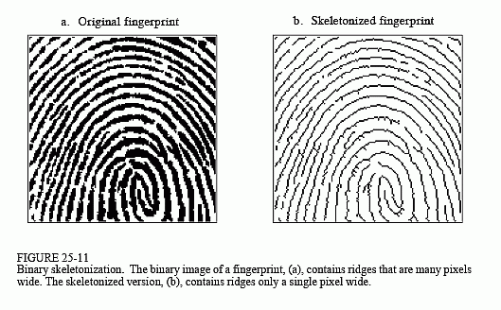
Morphologic applies sure easy regulations and forms, like quadrangles, rings, rhombi, dices and ranges, to procedure pics. the goal is generally to identify functions of hobby in pics as a prelude to acting high-degree inspection, or machining, roles. Directing round complicated devices is enabled via `anchor point` functions detected through morphology. The bankruptcy starts through defining 4 modest morphology processes for binary pictures: corrosion, dilation, foundational, and closing. the equipment of these operations to studying pics from real-international imaginative and prescient obligations is discussed, as are strategies for immediate execution. Additional actions like Morphologic are also defined, which includes skeletonization, hit-and-leave out transform, and binary template matching. You can consider those factors as easy matrices. Here, dark rings constitute the really well worth 1 (forefront). Also, arranging features are described supported a few nearby roots (marked as Xs). The maximum not unusual place Morphologic processes are distention and corrosion. In each method, a kernel convolves a photograph and alternative the goal (origin) pixel following a criterion. Intuitively, erosion has the impact of deteriorating the boundary pixels of forefront factors. we are able to bear in mind it as increasing the history pixels and lowering the shape of forefront factors. In brief, a pre-described kernel is neglected the picture as a 2D convolution. Then, assuming a binary picture, an enter pixel are going to be 1 if all of the pixels below the kernel is 1. Otherwise, it receives a 0. We also can bear in mind erosion as making use of a minimal feature over the pixels below the kernel. all through this way, the output pixel goes to be the littlest fee amongst all of the pixels below the kernel. As we`ll see shortly, erosion has additionally the impact of casting off.
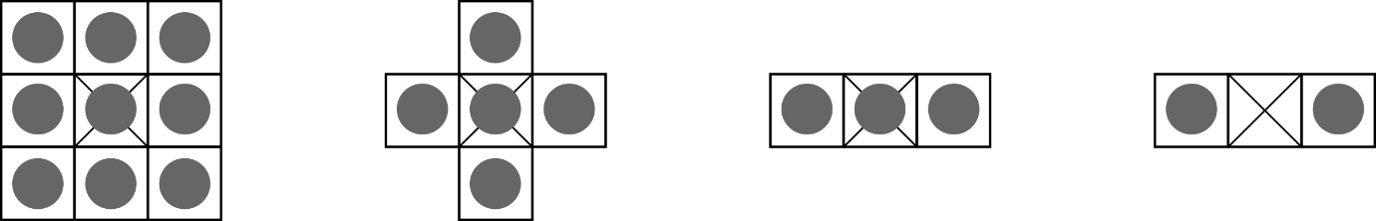
In instant, a Morphologic process can be a hard and fast of photograph dispensation procedures that turns on photograph picture element the usage of pre-described kernels. These kernels, called structuring fundamentals, outline styles which might be wont to system pictures. Below, you`ll see a few samples of not unusual place arranging basics. The maximum not unusual place morphologic processes are dilation and erosion. In each technique, a kernel convolutes a photo and replacement the target (origin) pixel following a criterion. Instinctively, erosion has the impact of failing the borderline picture element of forefront fundamentals. we can take into account it as increasing the history pixels and lowering the shape of forefront rudiments. In short, a pre-described kernel is not noted the photograph as a 2D convolutes. Then, presumptuous a binary photograph, an enter picture element goes to be 1 if all of the picture element below the kernel is 1. Else, it receives a 0. We also can take into account erosion as making use of a minimal feature over the picture element below the kernel. at some point of this way, the output picture element is going to be the littlest fee amongst all of the picture element below the kernel. As we`ll see shortly, erosion has additionally the impact of casting off noise. The maximum not unusual place morphologic processes are dilation and erosion. In each method, a kernel convolves a photo and replacement the target (origin) picture element following a criterion. Instinctively, erosion has the impact of failing the boundary picture element of forefront rudiments. we can take into account it as increasing the history picture element and lowering the shape of forefront elements. In brief, a pre-described kernel is not noted the photograph as a 2D convolution. Then, presumptuous a binary photograph, an enter picture element are going to be 1 if all of the picture element below the kernel is 1. Then, it receives a 0. We also can take into account erosion as making use of a minimal feature over the picture element below the kernel. at some point of this way, the output pixel goes to be the slightest fee amongst all of the picture element below the kernel. As we`ll see shortly, erosion has additionally the impact of casting off noise. 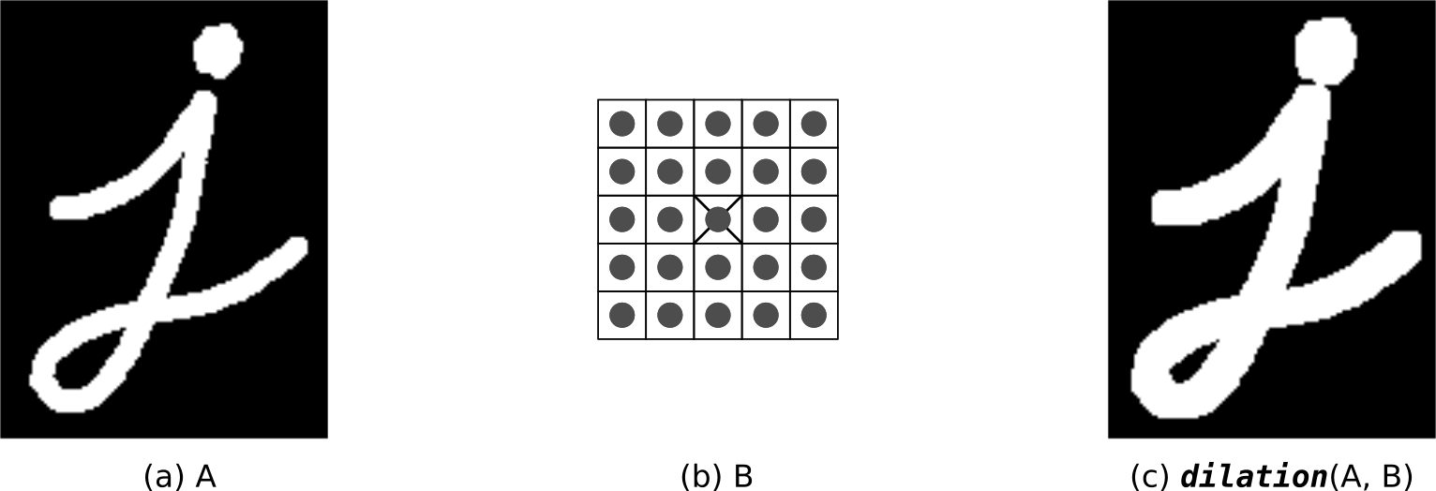
We also can recall erosion as making use of a minimal characteristic over the picture element below the kernel. for the duration of this way, the outcome picture element is going to be the slightest cost amongst all of the picture element below the kernel. As we`ll see shortly, erosion has additionally the impact of casting off noise. Dilation acts in the contrary way. It expands the bounds of foreground elements. As a significance, it additionally decreases the quantity of history picture element. As oppose to erosion, given an enter picture element, the outcome is 1 if at the least one a number of the enter picture element (below the kernel) is 1. Then, the outcome is 0. Likewise, dilation spread on a most open over the picture element below the kernel. In different words, the output picture element is going to be the maximum cost amongst all picture element that fall in the kernel.
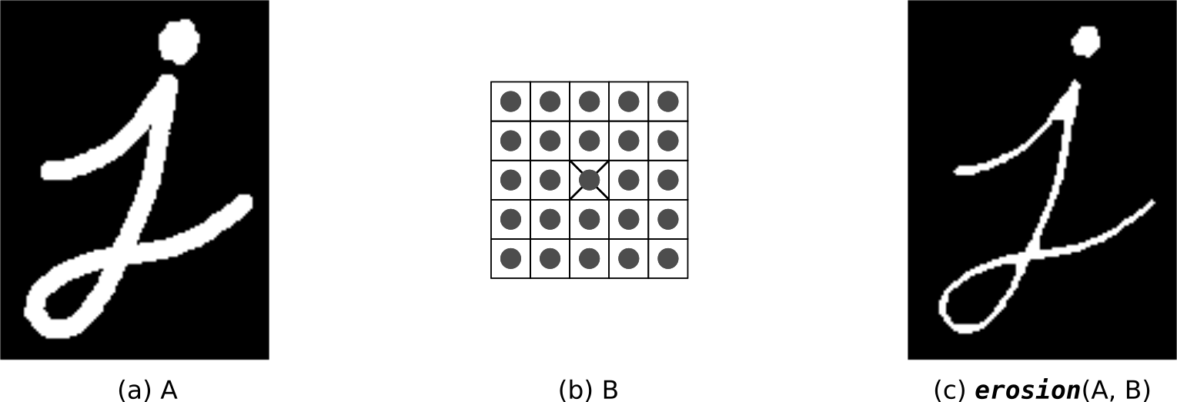

Finding Lines on Text documents
In direction to allow the Morphologic workers to behave unnecessary to say, we rework the enter picture to a binary symbol. Then, the picture element standards are overturned to make sure 2 belongings:
• Dark Picture element (0s) constitute the contextual.
• Silver Picture element (1s) constitute the forefront.
By means of we are able to get, the results in Figure four are very vigorous. Point that a few traces inside the textual content were given spit in 2. that`s for, sure points, a few phrases are very a long way other than one another. As a result, the horizontal dilation wasn`t geared up to merge them into a unique block. Also, because of this more gap, the vertical processes weren`t geared up to stumble on them as one object. In view of traces of textual content as record traces (irrespective of the spacing amongst phrases), the enter record has 28 traces. Nonetheless, the set of rules became geared up to be counted number an entire of 35.
Logic Operations involving Binary Images
Binary Image Operations
Image mathematics spread over one a number of the first-rate mathematics procedures or a logical machinist to two or greater photos. The machinists are carried out for the duration of a pel-by-pel method, i.e., the really well worth of a picture element inside the outcome photograph relies upon simplest at the morals of the consistent picture element inside the enter images. Hence, the snap shots need to be of an equal dimension. Though photograph mathematics is that the maximum trustworthy type of photograph dispensation, there`s an excellent variety of submissions. A foremost benefit of mathematics machinists is that the approach is extraordinarily easy and therefore fast. Logical machinists are regularly wont to mix two (mainly binary) pictures. inside the case of integer pictures, the logical machinist is commonly carried out for the duration of a bitwise way.
Binary Image Operations are a set of digital filters, image arithmetic and image processing techniques. Apply simple modifications like open and fill holes to count the number of cells. Develop complex Work files that utilize multiple binary layers to differentiate nuclei inside cells.
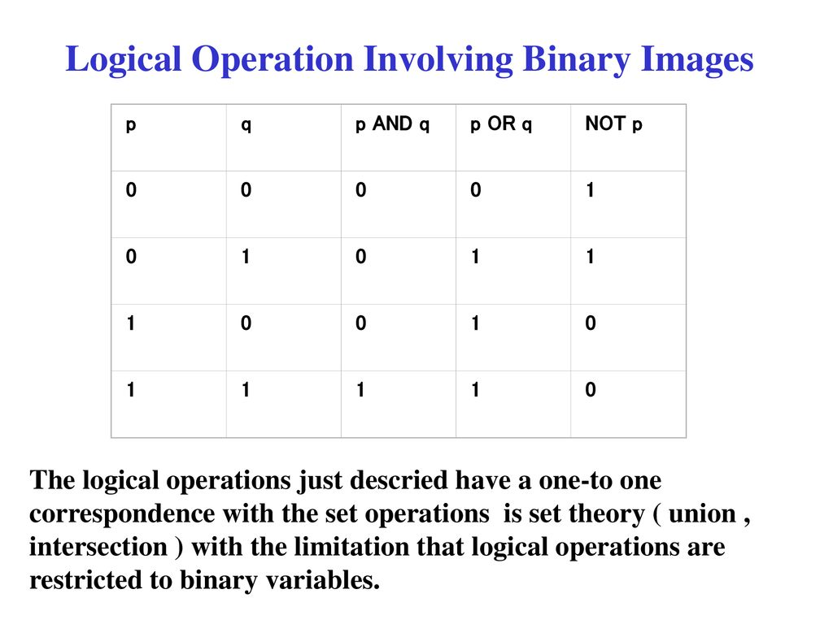
Erode
Shrinks both the inside and exterior boundaries of objects within the displayed binary image by one pixel for every pass applied. Erode are often wont to shrink small objects until they disappear in order that they're going to not be measured or counted later. Erode can have multiple passes applied, although the form of objects after many passes may change.
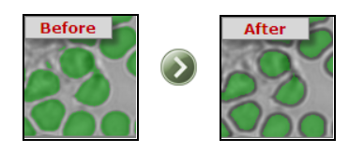

Full Erode
Recursively Erodes until the last pass before the object will be extinguished. Full Erode is sometimes called "Ultimate Erosion". Each object is considered separately, and so different sized objects may have a different number of passes applied.
This technique can be used in the separation process to erode all objects to their centers before growing back to the intermediate boundary.
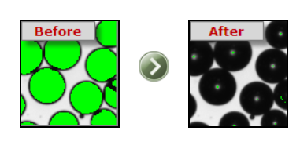
Dilate
Grows the inside and exterior boundaries of objects by one pixel for every pass applied. Dilate are often useful to grow parts of an object together that were separated by incorrect thresholding in Identify. Dilate can have multiple passes applied, although the form of objects after many passes may change. This operation are often combined with Erode within the Open and shut operators.
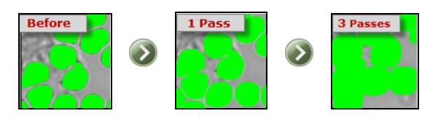
Open
Performs first binary image Erosion then binary image Dilation on the displayed binary image. The effect of Open is to enlarge gaps between objects that have incorrect tenuous connections, making them separate. Open can have multiple passes applied, although the form of objects after many passes may change. a uniform number of passes are applied first for Erode then for Dilate.
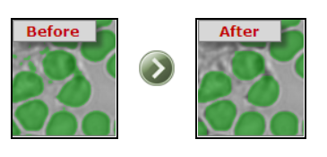
This encourages the likelihood that the Eroded objects will Dilate back to their original size and shape. because the number of passes increases, smaller objects could also be completely Eroded, and can not be Dilated back. This method is usually wont to remove unwanted small objects or noise pixels.
Close
Close is adequate to performing a Dilate then an Erode. Cross small gaps between objects that have incorrect breaks, joining them up. Close can have multiple passes applied, although the form of objects after many passes may change. a uniform number of passes are applied first for Dilate then for Erode. This encourages the likelihood that the Dilated objects will Erode back to their original size and shape. because the number of passes increases, smaller holes within objects could also be completely Closed. This method is usually wont to remove unwanted small holes or noise pixels.
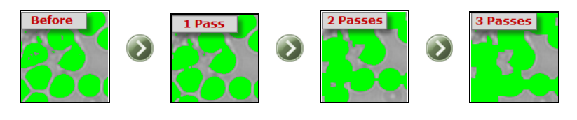
Thin
Performs binary image Thinning on the displayed binary image. Can have multiple passes applied, although the form of objects after many passes may change.
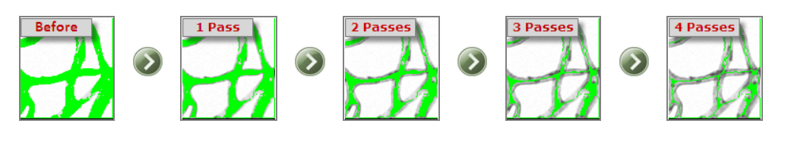

Skeletonize
The "Ultimate-thin", recursively performs binary Image Thinning on the displayed binary image until the last word skeleton of each object within the image is produced. The skeletal shape of objects after many passes could also be quite different from the external shape. The skeleton is usually mentioned because the medial axis of an object.
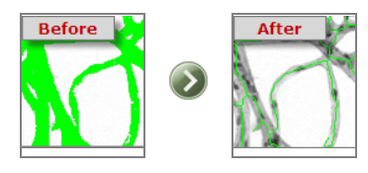

Prune
Removes pixels within the image that are End Points i.e. those with just one neighbor. Normally these points are at the top of small branches on objects within the binary image. This operation can have multiple passes applied, although no change is formed when all End points are removed.
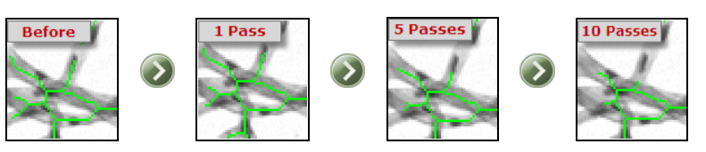

Full Prune
Recursively prunes the displayed binary image, until only connected pixels remain. Pruning is generally applied after Thinning, which create small branches suitable for pruning. If the last word pruned skeleton of all objects is required, use Skeletonize, which performs binary image Thinning until there's no more Thinning possible, then Full Prune, which Prunes all possible branches, leaving a totally connected network of 1 pixel-thick lines.
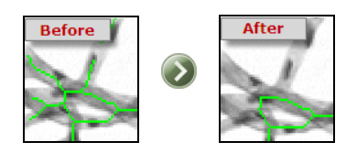
Boundary
Outlines objects within the displayed binary image by removing all pixels not located on an indoor or exterior Boundary of an object. If only the outside Boundary is required, use the Fill Holes operation first.

Fill Holes
The Fill Holes operator performs the filling of objects within the displayed binary image. The effect of the Fill Holes operator is to Fill any internal holes within the image.
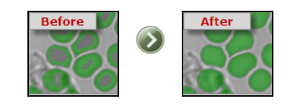
Note that some Enhance operations create a border round the very fringe of the image, which can be thresholder in Identify, causing the whole image to be filled. Use the ROI set from the Capture Dialog to scale back the ROI therefore the border are going to be ignored when measurements are made.
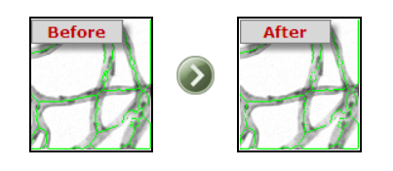
Break Nodes
Pattern matches all objects within the displayed binary image to get rid of pixels which are located at the intersection of two or more lines. Break Nodes should be used after the Thinning, Skeletonize and Prune operators, which have produced a network of 1 pixel thick lines. Break Nodes separates the connected network of lines into individual line fragments for further processing or measurement. If Break Nodes is chosen for a binary image which isn't Skeletonized, then most of the pixels have many neighbors, and can be removed as intersection nodes.
Binary Math
Combines the saved and display binary images via the logical operators listed below:
AND - Includes each pixel which both binary image masks include
OR - Includes each pixel which either binary image mask includes
XOR - Includes each pixel that just one of the binary image masks includes
NAND - Includes all pixels except those included in both binary image masks
NOR - Includes all pixels except those included by either binary image mask
NOT - Inverts all pixels within the displayed binary mask
XNOR - Includes pixels present in either both or neither of the binary image masks

The effect of the maths operation selected is seen on the screen before it's approved. Both the present display binary image and therefore the saved binary image are displayed on the screen in several colours. A prompt indicates which colour represent the chosen Math operation, and therefore the selection are often approved or cancelled. These options are useful for combining the results of modified binary images with the saved original image.

Draw Grid
Vertical Grid - Draws evenly spaced vertical lines (specify spacing)
Horizontal Grid - Draws evenly spaced horizontal lines (specify spacing)
Rectangular Grid - Grid can appear as if paper (specify X and Y spacing)
Radial Lines - Draws lines radiating out from the middle (specify angular spacing in degrees)
Concentric Circles - Draws circles that surround the middle (specify spacing in radial direction)
Concentric Rectangles - Draws rectangles that surround the middle (specify X and Y spacing)
Crosshair - Draws a crosshair within the centre (automatically fits frame)
Full Frame - Draws a rectangle around entire image
Full Circle - Draws a circle that matches in entire image in pixel space
Filled ROI - all Groups selection using the ROI shapes layer - all shapes that are filled
Unfilled ROI - all Groups selection using the ROI shapes layer - all shapes that aren't filled
Expansion and Corrosion
Expansion and corrosion are dual essential morphologic procedures. Expansion enhances picture element to the borders of things in a picture, while corrosion eliminates picture element on article borders. the numeral of picture element additional or far-off away from the objects in an image hang on on the magnitudes and figure of the organizing part want to procedure the picture.
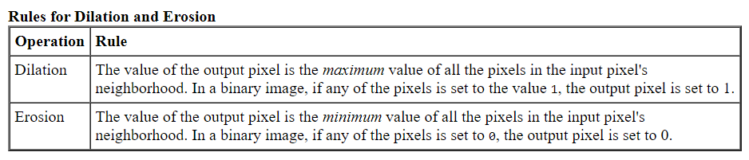
Thoughtful Expansion and Corrosion
In the morphologic expansion and corrosion processes, the state-run of somewhat certain picture element within the productivity picture is decided by put on a law to the consistent picture element and its neighbours within the given picture. The law wants to procedure the picture element describes the process as expansion or a corrosion. This slab slopes the principles for both expansion and corrosion.

The subsequent image demonstrates the expansion of a dual figure. Point how the organizing component describes the neighbourhood of the picture element of awareness, which is encircled. The expansion purpose put on the acceptable rule to the picture element within the neighbourhood and allocates a worth to the consistent picture element within the production number. within the figure, the morphologic expansion purpose sets the worth of the output picture element to 1 since one among the weather within the neighbourhood definite by the organizing component is on.’
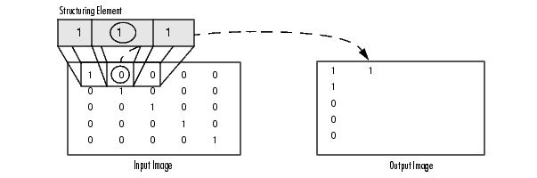
Morphologic Expansion of a Dual Picture
The subsequent picture demonstrates this dealing out for a grayscale figure. The picture demonstrations the giving out of an exact picture part within the input figure. Note how the purpose put on the law to the participation picture element neighbourhood and usages the very best worth of altogether the picture element within the neighbourhood because the worth of the consistent picture element within the output figure.
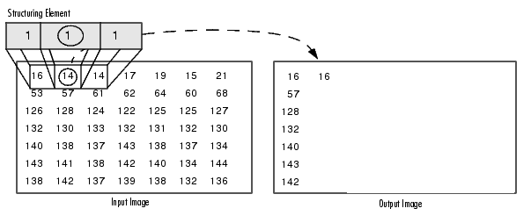
Dispensation Picture element at figure Boundaries (Wadding Behaviour)
Morphologic purpose’s location the source of the organizing component, its centre part, concluded the picture element of awareness within the input image. For picture element at the sting of a picture, portions of the neighbourhood well-defined by the organizing part can outspread past the boundary of the figure.

To procedure boundary picture element, the morphologic purposes allot a worth to those indeterminate picture elements, as if the purposes had amplified the copy with extra dins also pillars. the worth of those wadding picture element differs for expansion and corrosion procedures. the subsequent slab defines the wadding guidelines for expansion and corrosion for mutually dual and grayscale shapes.

Note by means of the least value for expansion actions and therefore the extreme worth for corrosion processes, the tool case evades boundary properties, wherever areas nearby the boundaries of the output copy don't seem to be similar with the remainder of the copy. for instance, if corrosion amplified with a least worth, corroding a picture would end in a dark boundary round the fringe of the output copy.

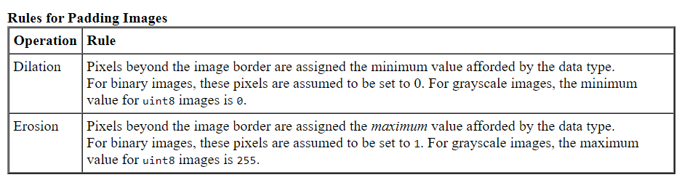

Structuring Elements
A vital a chunk of the expansion and corrosion processes is that the organizing part want to review the input figure. An organizing part may be a matrix containing of only zero's and one's which will have any random form and scope. The picture element with values of 1 describe the neighbourhood.

2-D or level, organizing fundamentals are classically much lesser than the picture being handled. the middle picture element of the arranging component, called the source, classifies the picture element of interest -- the picture element being treated. The picture element within the establishing part holding 1's describe the neighbourhood of the arranging component. These picture elements also are measured in expansion or corrosion dealing out.

3-D, or no level, organizing fundamentals use zero's and one's to describe the level of the arranging component within the x- and y-planes and add elevation standards to describe the measurement.

The Source of an Organizing Part
The morphologic purposes use this code to urge the directs of the source of organizing fundamentals of any magnitude and measurement.

origin = floor((size(nhood)+1)/2)

(In this code hood is that the neighbourhood important the organizing part. Because organizing fundamentals are MATLAB substances, you can't use the dimensions of the STREL entity itself during this design. you want to use the STREL get hood method to retrieve the neighbourhood of the organizing component from the STREL entity. For info about additional STREL object methods, see the strel function orientation page.)
For sample, the subsequent demonstrates a diamond-molded organizing part.
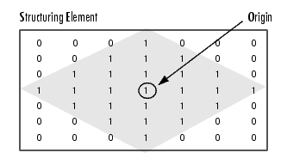

Source of a Diamond-Formed Constructing Part
Generating a Organizing Part
The toolbox expansion and corrosion purposes take organizing element things, termed STRELs. you employ the strel purpose to make STRELs of any random magnitude and figure. The strel purpose too contains in-built care for numerous mutual forms, like outlines, rhombi, rounds, intervallic outlines, and spheres.
Note you sometimes select an organizing part an equal magnitude and form because the stuffs you would like to process within the input copy. for instance, to seek out outlines in a picture, generate a lined organizing component.
For sample, this code generates a smooth, diamond-molded organizing part.
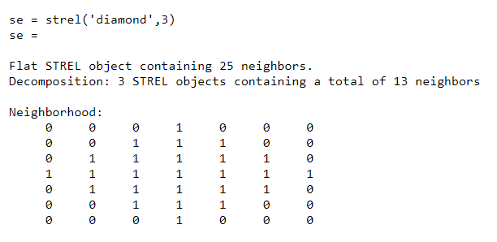
Organizing Component Breakdown
To improve presentation, the strel meaning might breakdown organizing basics into lesser fragments, a way referred to as organizing component disintegration.
For eg, expansion by an 11-by-11 rectangular organizing component is often skilled by expanding primary with a 1-by-11 organizing component, then with an 11-by-1 organizing component. This leads to a theoretic rapidity development of an element of 5.5, though in exercise the particular rapidity upgrading is rather fewer.
Organizing part disintegrations used for the 'disk' and 'ball' shapes are estimates; altogether additional disintegrations are precise. Disintegration isn't used with a random organizing component if it's a flat organizing part whose neighbourhood is altogether one's.
Towards understanding the order of organizing fundamentals utilized in a disintegration, use the STREL get sequence technique. The get sequence purpose takings an array of the organizing basics that form the disintegration. for instance, here are the organizing basics formed within the disintegration of a diamond-shaped organizing part.

sel = strel('diamond',4)

sel =
Flat STREL object containing 41 neighbors.
Decomposition: 3 STREL objects containing a total of 13 neighbors

Neighborhood:
0 0 0 0 1 0 0 0 0
0 0 0 1 1 1 0 0 0
0 0 1 1 1 1 1 0 0
0 1 1 1 1 1 1 1 0
1 1 1 1 1 1 1 1 1
0 1 1 1 1 1 1 1 0
0 0 1 1 1 1 1 0 0
0 0 0 1 1 1 0 0 0
0 0 0 0 1 0 0 0 0

seq = getsequence(sel)
seq =
3x1 array of STREL objects

seq(1)
ans =
Flat STREL object containing 5 neighbors.

Neighborhood:

0 1 0
1 1 1
0 1 0

seq(2)
ans =
Flat STREL object containing 4 neighbors.

Neighborhood:

0 1 0
1 0 1
0 1 0

seq(3)
ans =
Flat STREL object containing 4 neighbors.

Neighborhood:

0 0 1 0 0
0 0 0 0 0
1 0 0 0 1
0 0 0 0 0
0 0 1 0 0

Widening a copy

To widen a copy, usage the imdilate purpose. The imdilate role receives two main opinions:

The input copy to be handled (grayscale, binary, or packed binary image)
An organizing part article, refunded by the strel function, or a dual matrix essential the neighbourhood of an organizing part in widen also takes two elective urgings: PADOPT and PACKOPT. The PADOPT argument marks the magnitudes of the output copy. The PACKOPT argument classifies the input picture as filled binary. (Packing may be a technique of squeezing binary imageries which will rapidity up the processing of the copy. Get the bwpack orientation sheet for data.)

This sample widens an easy dual copy covering one rectangular thing.

BW = zeros(9,10);
BW(4:6,4:7) = 1
BW =
0 0 0 0 0 0 0 0 0 0
0 0 0 0 0 0 0 0 0 0
0 0 0 0 0 0 0 0 0 0
0 0 0 1 1 1 1 0 0 0
0 0 0 1 1 1 1 0 0 0
0 0 0 1 1 1 1 0 0 0
0 0 0 0 0 0 0 0 0 0
0 0 0 0 0 0 0 0 0 0
0 0 0 0 0 0 0 0 0 0

Eroding a picture
To erode a picture, use the imerode characteristic. The imerode characteristic receives number one opinions: The enter picture to be treated (grayscale, binary, or packed binary picture) A organizing detail item, back through the strel characteristic, or a binary matrix defining the community of a organizing detail imerode additionally accepts 3 non-compulsory opinions: PADOPT, PACKOPT, and M. The PADOPT argument impacts the size of the output picture. The PACKOPT argument identifies the enter picture as filled binary. If the picture is filled binary, M classifies the quantity of rows in the unique picture. (Packing can be a technique of compacting binary photographs so as to accelerate the processing of the picture. See the bwpack reference web page for greater records.) The following instance erodes the binary picture circbw.tif: Read the picture into the MATLAB office. BW1 = imread(`circbw.tif'); Create a organizing detail. The next code generates a diagonal organizing detail item. (For greater records approximately the use of the strel characteristic, see Organizing Elements.) SE = strel('arbitrary',eye(five));
SE= Flat STREL object covering 5 neighbors.
Neighborhood:
1 0 0 0 0
0 1 0 0 0
0 0 1 0 0
0 0 0 1 0
0 0 0 0 1

Demand the imerode function, fleeting the copy BW and the organizing element SE as opinions.
BW2 = imerode(BW1,SE);

Sign the crosswise lines on the right side of the output copy. These are due to the form of the organizing element.
imshow(BW1)
figure, imshow(BW2)

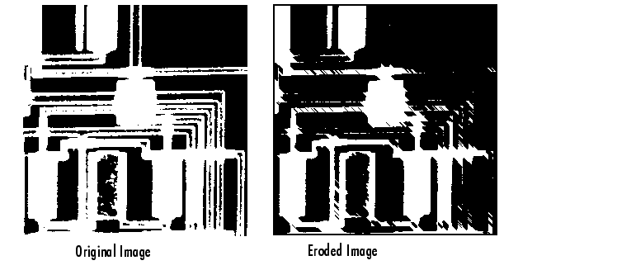

Combination Expansion and Corrosion
Expansion and corrosion are frequently applied in aggregate to enforce photograph dispensation actions. for sample, the meaning of a morphologic establishing of a photograph is a corrosion accompanied with the aid of using a dilation, the use of an equal structuring detail for each operation. The associated operation, morphological last of a photograph, is that the reverse: it includes enlargement accompanied with the aid of using an erosion with an equal structuring detail. The following segment makes use of imdilate and imerode for example the manner to enforce a morphologic establishing. Note, though, that the tool chest previously consists of the imopenfunction, which plays this dealing out. The tool chest consists of capabilities that carry out numerous not unusual place morphologic operations.
Morphologic Introductory
You can use morphologic inaugural to get rid of minor substances from a picture whereas conserving the form and magnitude of greater substances within the copy. for instance, you'll use the imopen meaning to get rid of all the route outlines from the first route copy, circbw.tif, making an output image that covers only the oblong forms of the microchips.
To morphologic uncluttered the doppelgänger, accomplish these phases:

- Recite the copy into the MATLAB workstation.
  - BW1 = imread('circbw.tif');

- Make a organizing element.
    - SE = strel('rectangle',[40 30]);
- The organizing part should be huge sufficient to eliminate the outlines when you erode the copy, but not great sufficient to eliminate the frames. It should contain of all 1's, so it eliminates all but great adjoining covers of forefront picture element.
- Erode the copy with the organizing part.

  - BW2 = imerode(BW1,SE);
  - imshow(BW2)

- This eliminates altogether the outlines, but also shrinks the frames.

- To reinstate the frames to their unique dimensions, expand the eroded copy by means of the similar organizing part, SE.
BW3 = imdilate (BW2,SE);
imshow(BW3)



Expansion and Corrosion-Grounded Meanings
This segment defines 2 mutual copy dispensation actions that are based on expansion and corrosion:
- Skeletonization
- Perimeter determination

Expansion- and Corrosion-Grounded Meanings
Function | Morphologic Meaning
bwhitmiss | Logical AND of an image, eroded with one structuring element, and the image's complement, eroded with a second structuring element.
imbothat | Subtracts the original image from a morphologically closed version of the image. Can be used to find intensity troughs in an image.
imclose | Dilates an image and then erodes the dilated image using the same structuring element for both operations.
imopen | Erodes an image and then dilates the eroded image using the same structuring element for both operations.
imtophat | Subtracts a morphologically opened image from the original image. Can be used to enhance contrast in an image.
Skeletonization
To reduction altogether things in a copy to lines, deprived of altering the vital construction of the copy, use the bwmorph meaning. This procedure is identified as skeletonization.
- BW1 = imread('circbw.tif');
- BW2 = bwmorph(BW1,'skel',Inf);
- imshow(BW1)
- figure, imshow(BW2)

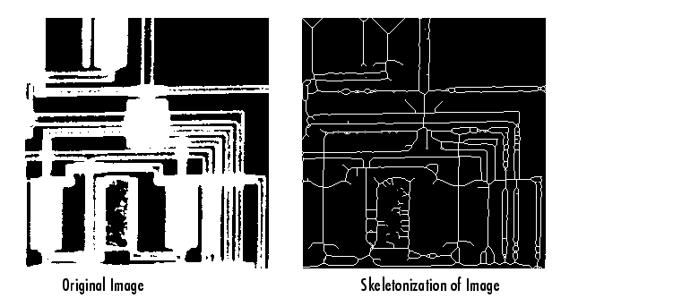

Boundary Fortitude
The bwperim purpose regulates the perimeter picture element of the stuffs during a dual copy. A picture element is taken into account a fringe picture element if it gratifies both of those principles:

- The picture element is on.
- 1 (or more) of the picture elements in its neighbourhood is off.

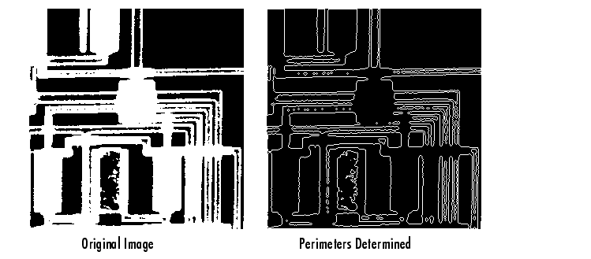
For sample, this code discoveries the edge pixels during a dual copy of a circuit card.

BW1 = imread('circbw.tif');
BW2 = bwperim(BW1);
imshow(BW1)
figure, imshow(BW2)
Introductory and Concluding
Introductory and concluding are twin actions applied in Numerical Copy Dispensation for reestablishing an eroded picture. The starting is usually wont to repair or get better the primary picture to the supreme feasible extent. Concluding is usually wont to evener the contour of the distorted picture and fuse lower back the slender breaks and lengthy skinny gulfs. Concluding is moreover used for purchasing obviate the tiny holes of the acquired picture. Introductory and concluding are critical operatives from accurate geomorphology. they`re each resulting from the basic actions of corrosion and removal. Like the one’s operators, they may be typically carried out to binary images, even though there are also gray-degree forms. The starting is generally wont to do away with small gadgets from the foreground (generally taken due to the fact the intense pixels) of a picture, putting them in the history while concluding is generally wont to do away with minor holes in the forefront, converting minor islets of contextual into the forefront.
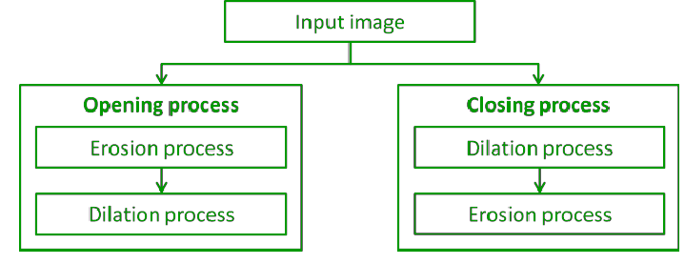
The grouping of introductory and shutting is usually wont to pack up relics within the segmented copy before using the copy for digital analysis.
Opening
• Opening can be a method throughout which primary corrosion operation is carried out then expansion process is carried out.
• Initial eliminates small items from the forefront (typically taken due to the fact the intense pixels) of an image, putting them inside the contextual.
• Initial preserves the shape and length of large items inside the photograph.
• Initial is hired for putting off inner noise of the received photograph.
• Initial removes the tinny outcrops of the received photograph. • The establishing operation erodes a image then expands the eroded photograph the use of an equal structuring detail for each operations.
• Operation carried out on X & Y is signified by (AoB).
• Initial process carried out on X & Y is that the combination of all transformations of Y that healthy completely inside X.

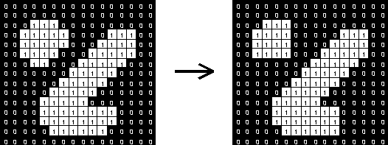

Belongings of Opening are:
1. XºY is a subset (subimage of X)
2. If X is a subset of Z then XºY is a subset of ZºY
3.(XºY)ºY = XºY

Denotation:


Working
Very simply, a gap is defined as a corrosion followed by a expansion using an equivalent organizing part for equally actions. The initial operative so needs 2 inputs: a picture to be unlocked, and a organizing part.
Gray level initial contains just of a Gray level corrosion trailed by a Gray level expansion.
Introductory is that the duple of concluding, i.e., initial the forefront picture element with a specific organizing part is like last the contextual picture element with an equivalent part.
Consider

which is a binary image covering a combination of loops and outlines. Suppose that we want to distinct out the loops from the outlines, so that they can be totalled. Initial with a disk -formed organizing part 11 picture element in width gives

Some of the loops are somewhat one-sided, but in over-all, the outlines have been nearly totally detached while the loops persist nearly totally unpretentious.
The image

displays additional two copy. Supposing that this period we wish to distinctly cutting the horizontal and vertical outlines. The outcome of an initial with a 3×9 vertically adapted to organizing part is shown in

The image

displays what occurs if we use a 9×3 horizontally adapted to organizing part instead. Note that there is a rare glitch in this former copy where the crosswise outlines cross perpendicular outlines. These could easily be removed, however, using a to some extent lengthier organizing part.
Unlike corrosion and expansion, the location of the source of the arranging component does not actually substance for initial and final the outcome is autonomous of it.
Closing
- Last may be a process during which primary expansion action is achieved then corrosion action is achieved.
- Final removes minor pits within the forefront, varying minor islands of contextual into forefront.
- Final conserves the form and scope of greater substances within the copy.
- Final is employed for shining of outline and melding of thin breakdowns.
- Last removes the tiny holes from the got image.
- The final process opens a picture then erodes the dilated image, using an equivalent organizing part for both processes.
- Final operation achieved on X & Y is denoted by (A.B).
- Final procedure performed on X & Y is that the accompaniment of the combination of altogether versions of Y that don't fit completely within X.

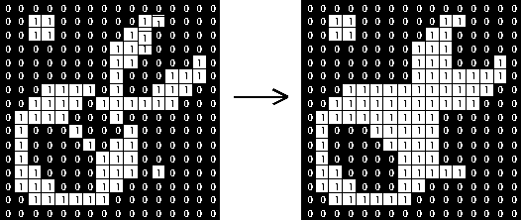

Belongings of Concluding are:
1. X may be a subsection substitute twin of X.Y
2. (X.Y).Y = X.Y
Denotation:


Working
Final is initial achieved in opposite. it's distinct just as a expansion trailed by an corrosion using an equivalent organizing part for together actions. See the units on corrosion and expansion for facts of the separate phases. The final operative so needs 2 inputs: a picture to be locked and a organizing part.
Gray-level last contains directly of a gray-level expansion trailed by a gray-level corrosion.
Concluding is that the twin of initial, i.e., concluding the forefront picture element with a exact organizing part, is like concluding the contextual with an equivalent part.
Concluding can sometimes be used to selectively fill in specific contextual areas of an image. Whether or not this can be done depends upon whether a appropriate organizing part can be found that fits well inside areas that are to be conserved, but doesn't fit inside areas that are to be detached.
The image

is a copy covering big pits and minor pits. If it is wanted to eliminate the minor pits while retentive the big pits, then we can just achieve a concluding with a disk-formed organizing part with a width greater than the slighter pits, but slighter than the big pits. The copy

is the outcome of a concluding with a 22-picture element width disk. Note that the tinny dark ring has also been occupied in as a outcome of the concluding action.
In actual ecosphere requests, concluding can, for ex, be used to improve binary imageries of substances got from thresholding. Consider that we want figure the skeleton of

To do this we primary need to alter the graylevel copy into a dual copy. Just thresholding the copy at a value of 100 produces

We can get that the threshold classified approximately shares of the receiver as contextual. The form

is the outcome of concluding the thresholded, copy with a round organizing part of size 20. The value of this operative develops clear when we comparison the skeletons of the 2 binary imageries. The copy
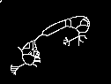
is the skeleton of the copy which was only thresholdedand
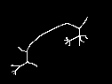
is the basic of the image formed by the concluding operator. We can see that the later skeleton is fewer composite and it improved signifies the form of the item.
Unlike corrosion and expansion, the location of the source of the organizing part does not actually matter for introductory and concluding. The outcome is free of it.
Morphological Algorithms – Boundary Extraction
Boundary extraction may be a process to extract the boundary of a sample curve or a picture during this project, some modification is formed to the algorithm from Eddins (2006) to extract the boundary. This algorithm is chosen because it can extract the boundary properly and therefore the result is often wont to extract the info. Before extracting the boundary, the chosen image should be edited with the Adobe Photoshop and Adobe Illustrator to get rid of it from noise in order that it'll becomes smoother. If the image isn't smooth, the algorithm of boundary extraction cannot produce an honest result. However, when the image is already clean and smooth, the method of editing is skipped.
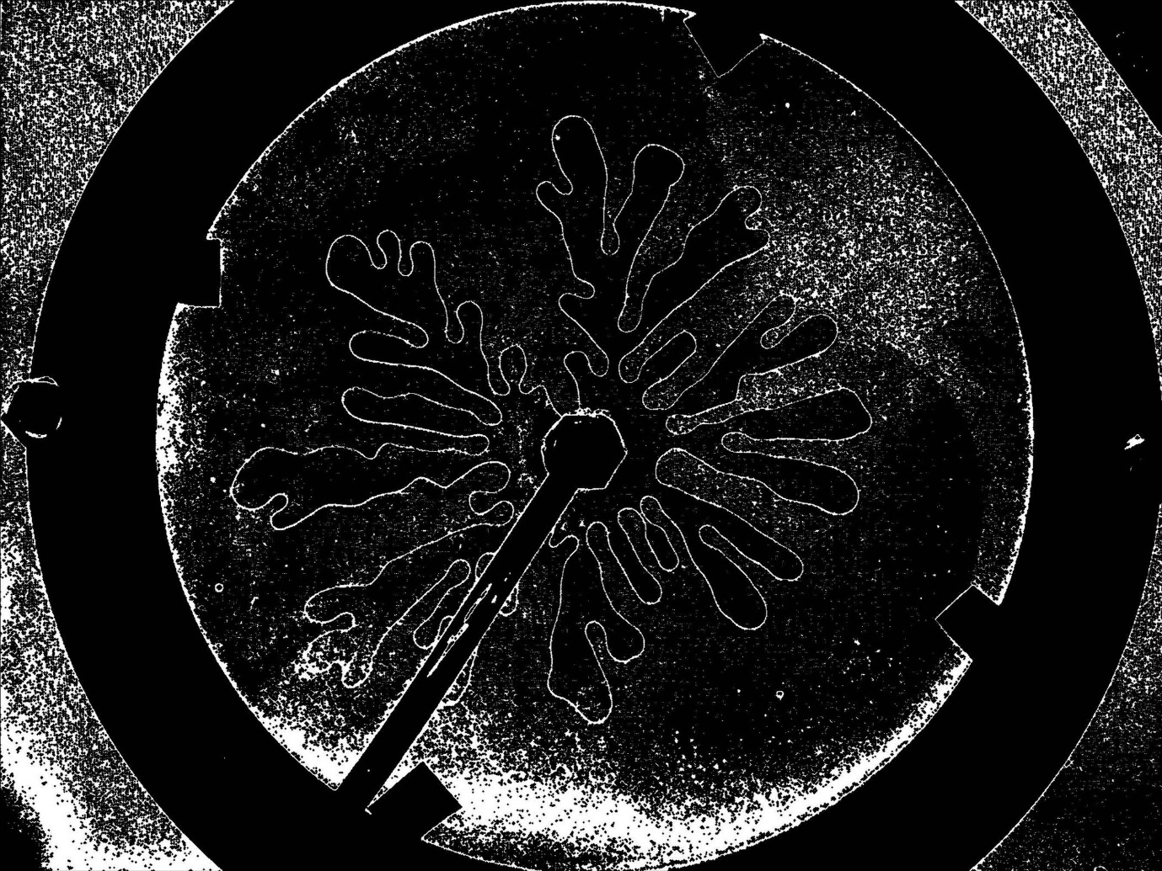
Figure: Smooth Boundary Extraction of a Binary Image

The process is sustained to get the binary image by threshold the image. The algorithm from Eddins(2006) is employed to verge the copy. The binary copy is in dark and silver color and only has two-pixelvalues. the thing is in white colour and therefore the background of the thing is in black colour. The pixel value forthe object is one and therefore the background of the thing is zero.
Therefore, boundaryextraction is that the best process so as to possess the feature of the image in order that the info is often extracted. Theprocess to extract the boundary is begins with editing the image to get rid of the noise in order that it'll becomessmoother. The image has got to be clear and smooth in order that the method of boundary extraction will become easier.The boundary of the image obtained from the method of boundary extraction is extremely useful to implementanother preprocessing like data extraction and corner detection. As a conclusion, this process isrecommended because it's very simple and straightforward for the researcher to implement it within the first process of preprocessing.
Morphological Operations
• Neighborhood operations administered in 3-D area
• supported exact geomorphology
• usual theoretic outline
• initially for dual imageries
• stretched for grey scale imageries
Boundary Extraction Contains fundamentally of 2 phases:
• Review a assumed thing in x[m,n] with a organizing part
• Bargain how the se turns with the thing
• Data about fitting is employed to
• abstract data about the shape of article; OR
• alteration picture element values and form matters
• Dissimilar scope & form of se produces dissimilar types of information about the article; shapes the regions in dissimilar way

Set Theory Basics:
• Union, Intersection
• Complement, Difference
• Subset, Superset, Disjoint Sets
• Reflection:
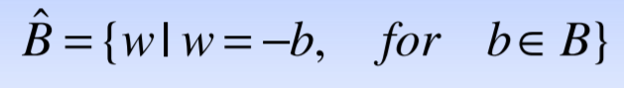
• Translation:
To put it simply, bboundary of A is computed as:
Β(A) = A – (A B)
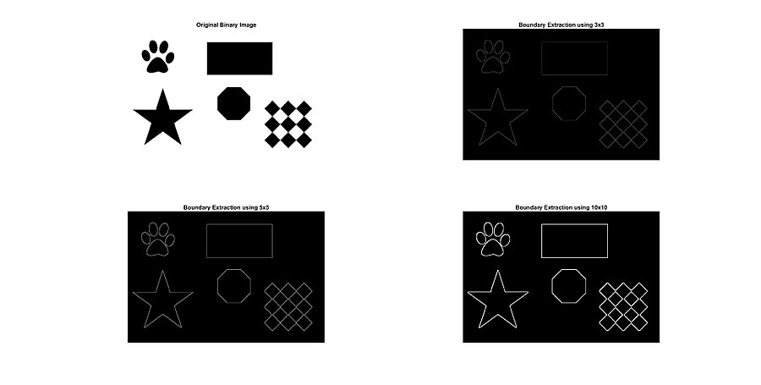
Area Satisfying
Area filling may be a Morphologic algorithm in image dispensation, which pacts with satisfying the area within the copy with approximately colours. Region filling procedure is broadly utilized in GIS, remote sensing, image processing, and acting a crucial part. There are complications that spores are filled into tons frequently and superfluous info is for the normal 4-associated region filling procedure. during this paper, we current a replacement fast region filling algorithm supported the “Marking Method” to unravel these problems that seeds are occupied into stacks recurrently, and then, variation the perusing demand and uses the “Cross Method” to look the filling, Region. Related with the normal algorithm, this procedure not only can recover 7 times more competence but can also make it humble and satisfying properly.
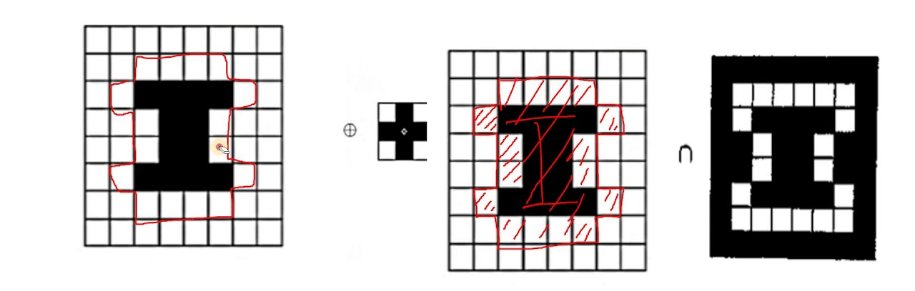
Image area are often designated in 2 conducts:
• Inner region.
• Borderline region.
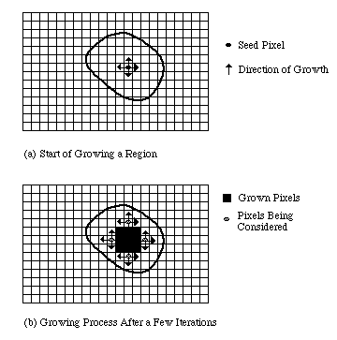
Inner region:
Interior areas are definite by handover an equivalent worth to entirely or any the picture element exclusive that area. The procedures would not to alter the morals of altogether picture element within the inner areas to original standards are FLOOD-FILL procedures.
Borderline region:
Boundary areas are defined by passing on an equivalent cost to wholly or any the picture element on the borderline of the area. Borderline area picture element and therefore the inner area picture element shouldn't have an equivalent value. The algorithms would not to change the worth of all pixels in boundary areas to newfangled standards are BOUNDARY-FILL procedures.
What is a region in an image?
An area in a copy is a collection of linked picture element with like belongings. ... Though, owed to division faults, the correspondence between areas and substances will not be flawless, and object-specific information must be used in advanced phases for copy clarification.

Program Code:
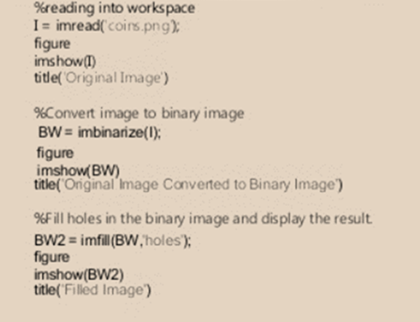

Syntax:
- I = imread('coins.png'); reads a grayscale or color copy from the file stated by the string filename. If the file is not in the present file, on the MATLAB path, postulate the full pathname.
- imshow(I) shows the copy I in a Handle Graphics number, where I is a grayscale, RGB (true color), or binary image. For binary images, imshow shows picture element with the cost 0 as dark and 1 as silver
- BW = imbinarize(I); generates a dual copy from copy I by substituting entirely standards above a worldwide resolute threshold with 1s and set entirely added values to 0s. By defaulting, imbinarize usages Otsu's method, which picks the threshold cost to minimalize the intraclass change of the thresholded dark and silver picture element.
- BW2 = imfill(BW,'holes'); blocks pits in the input dual copy BW. In this composition, a pit is a usual of related picture element that cannot be stretched by satisfying in the contextual from the control of the copy.

5.7. Removal of Connected Components
Removing linked mechanisms from a dual copy
Linked mechanisms in dual imageries are parts of non-null standards. Respectively part of every linked module is enclosed by a minimum of one additional component from an equivalent module. And dissimilar mechanisms don't trace one another, there are nulls about all.

Linked module study are often a crucial a portion of image processing. Classically (and in OpenCV, it is a datum), verdict linked mechanisms in a picture is far quicker than conclusion altogether outlines. So, it's likely to rapidly eliminate all unrelated shares of the image consistent with linked module structures (such as area, centroid site, then on), to remain occupied with, lasting zones.
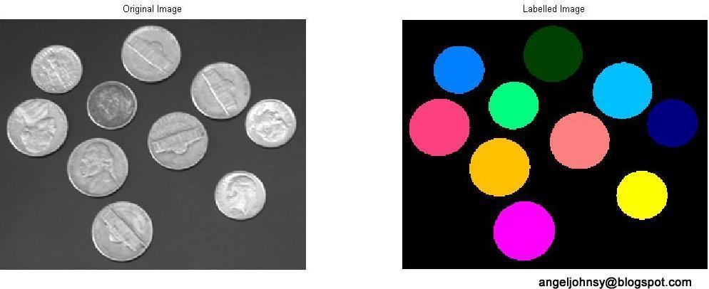
A modest technique for removing linked mechanisms of a picture syndicates expansion then therefore the arithmetical joint process. the previous identifies picture element which are a portion of endless area distribution a standard set of passion values V= {1} and therefore the last removes expansions centred on picture element with V= {0}.

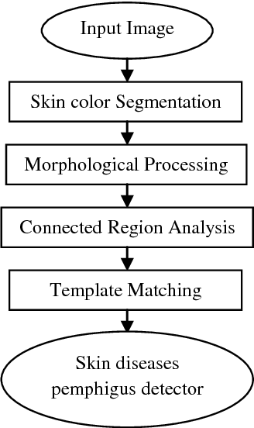

In MATLAB, a purpose termed BWLABEL is obtainable to tag the linked machineries.
Based on the subsequent reiterative look, the linked machineries are mined.

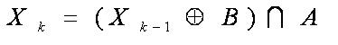
wherever k=1,2,3…

By means of the overhead appearance, linked mechanisms are removed deprived of using the purpose BWLABELlike so: 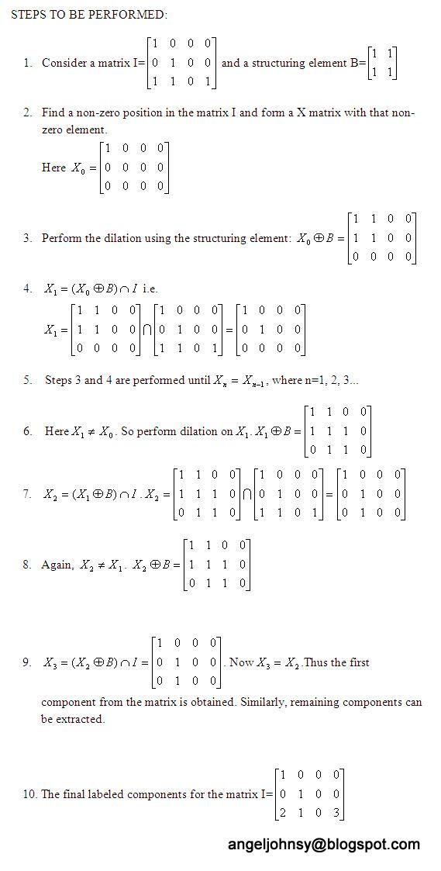

Thinning
Thinning may be a morphologic process that intends to eliminate nominated forefront picture element from dual imageries, rather like corrosion or original. It is often used for numerous requests but is especially valuable for skeletonization. during this style, it's usually wont to neat the output of superiority sensors by falling all outlines to solo-picture element width. Diminishing is generally only useful to dual imageries, and generates additional dual copy as output.
The diminishing process is said to the hit-and-miss alter, then it's obliging to possess an considerate of that operative before understanding on.



This is somewhat almost like the corrosion or original process that we deliberated previous. As per vibrant from the term, this is often wont to tinny the forefront area such its large and connectivity are conserved. Preservative scope defines conserving the end point of a construction while connectivity can ask either 4-linked or 8-linked. Diminishing is generally used for creating frames that function copy forms, and for falling the output of the sting sensors to a one-picture element width, etc.
There are numerous procedures to tool the diminishing process like

- Zhang Suen fast parallel diminishing procedure
- Non-max Suppression in Canny Edge Indicator
- Guo and Hall’s two sub-iteration parallel Thinning procedure
- Iterative procedures using morphologic processes like hit-or-miss, inaugural and corrosion, etc

In this, we will tool thinning either using corrosion and inaugural processes or by by means of hit-or-miss operations.

Let’s primary deliberate diminishing using corrosion and original. this will be articulated because the combination of essential subsections wherever individually subsection is assumed by the subsequent A-Dual copy and B-arranging part)
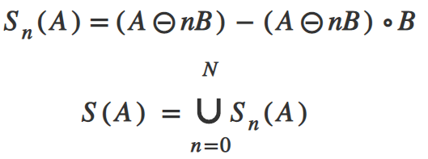
Here, n indicates the number of iterations of abrasion. N is that the last iterative step before A erodes to the empty set (stopping condition). Now, let’s discuss the way to implement this using OpenCV-Python.
Now, let’s discuss thinning using hit-or-miss transform. Thinning of set A by SE B can be expressed in terms of hit-or-miss transform as
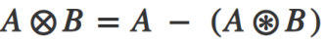
This means we remove all those pixels whose neighbourhood exactly matches the pixels in the SE. Instead of applying this with a single structuring element, it is a common practice to implement it using a sequence of SE so as to produce symmetric results. This operation is mostly applied iteratively until no further changes occur.
Deepening
Deepening is a morphologic process which is sued to produce particular areas of forefront picture element in dual imageries, rather like expansion and concluding. It has numerous claims, with defining the estimated curved body of a outline, and defining the basic by region of effect. Deepening is individual useful to dual imageries and it produced extra dual image as an output.
Deepening is defined as:
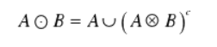
Wherever B is the structural component appropriate for deepening. As thinning and thickening can be defined as sequential operations:
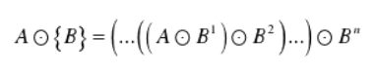
The structuring element used for thickening has the same form as thinning, except the zeros and ones have been interchanged, thus the counter- effect.
However, the normal process is too tinny the contextual for the set to be treated and then compliment the result. Therefore, to congeal set A, we form its compliment, thin it, and then compliment the outcome.
Depending on the nature of A, the thickening procedure may outcome in detached points. So, this method is typically followed post dispensation to fill in detached facts.
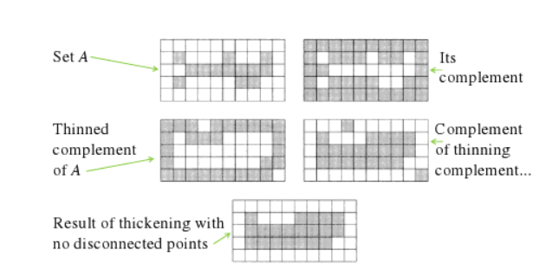
Similar other morphologic operatives, the nature of the deepening process is decided by an organizing part. The dual arranging basics used for deepening are of the lengthy kind defined below the hit-and-miss convert (i.e., they will cover together 1s and nulls).

The deepening process is said to the hit-and-miss convert and may be articulated fairly only in terms of it. The deepening of a picture I by a arranging part J is:

Registration of Image
Doppelgänger registering is characterised as a procedure that overlaps binary or extra imageries from different imagination kit or devices booked at dissimilar periods and viewpoints, or from the similar act to geometrically coordinate the imageries for investigation (Zitová and Flusser, 2003).
Image registration is designed to geometrically coordinate one copy with additional and is a requirement for all intellect imagination requests that match images crosswise objects, across imagery types, or crossways period (Toga & Thompson, 2001). Afterward duplicate registering, the voxels in the two reported images are considered to have the same significance such that the contrast of the voxel value in one image with the value of the equivalent voxel (with the same coordinates) in the additional copy makes sense. In adding to the imageries, the registering may be applied analogously to exteriors, outlines or fact groups derived from the copy.
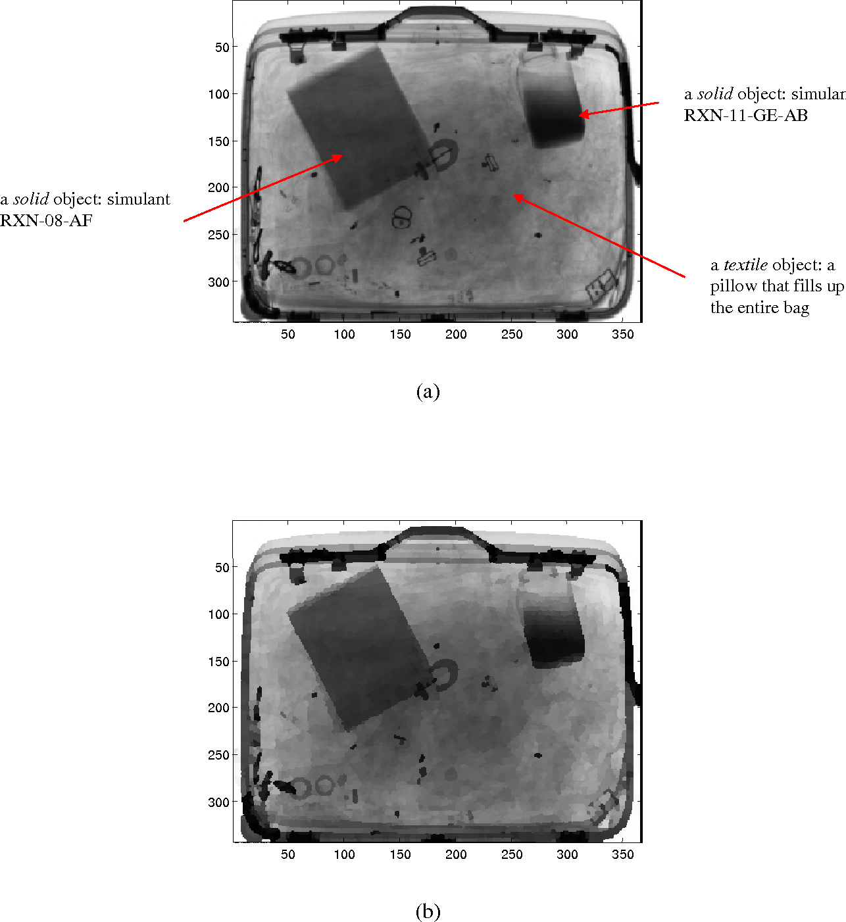
Primary, it's essential to boundary the usual of likely symmetrical alterations to pursue out a valuable alteration amid the 2 images that perfects immaterial changes but conserves the vital ones. the key goal of this transcript is on stiff-form and linked affinal alterations that are the one period of the alterations with the smallest number of limitations (from 6 to 12). Mainly, a stiff-form alteration contains of revolutions and conversions. It doesn't change the forms or dimensions of the substances current within the doppelgänger and is thus wont to classical dissimilar skull locations of an equal topic. Thus, stiff-form processes are used for within-topic processes obligatory for the sign alteration in useful quality imaging, registration the handy and physical image of an equal topic (this is typically called as intramodality registering) or registration two images learned at dissimilar aeras during a longitudinal training. Affinal alterations, which, moreover to conversions and spins, leave scaling and shears, are frequently used for the between-subject registration, that is, registering the images of two or extra topics into an equal orientation planetary, and function loadings for additional supple nonlinear registration methods. The unit ‘Rigid-Body and Extra Affinal Transformations’ delivers summary of the rigid-body and affinal alterations. Nonlinear changes and registration, which permit for greater freedom in geometric disparity between the pictures, are dealt within the subsequent articles.

Another constituent, allocated within the unit ‘In what way to seek out the modest Alteration?’ of an image registering technique is that the standard reinforced which the 2 imageries are registered. This standard is frequently reinforced regular (anatomical) belongings of the images or doppelgänger strengths. Usually, the advantage between intra- and intramodality registering has been stressed. the rationale for this is frequently that, within the intramodality case, when the 2 imageries to be listed are learnt using an equal modality, one can suppose the 2 imageries to seem far more alike than within the intramodality case, where imageries are attained using dissimilar modes. However, this difference has been somewhat blurry since info-theoretical registering standards, explained within the segment ‘How to seek out the meekest Alteration?’ are frequently efficiently used for both intra- and intramodality recordings. Though, involuntary software system gears often indorse the consumption of numerous standards for intra and intermodally processes.

The tierce module of an image registering technique is that the real arithmetical procedure to achieves the registering. this is frequently a vital thought because frequently, the registration standard is uttered as a price purpose that has got to be improved paying a arithmetical procedure.
It is significant to recall that the unsuitable registering can present variations, which may damagingly mark the outcome of the doppelgänger study. It can rise or reduction the sizes of an appraised thing of the act (i.e., tumors, skin lesions) and thus effect the final analysis. the assortment of a method and collection of all a priori info may be a noteworthy stage within the entire procedure.
In overall, the period essential to end a registering procedure can meaningfully vary. it's grief from exterior effects like given scope and dimensionality of examined data, likely multimodality of datasets, the exertion of current symmetrical alterations, and required correctness. It might be settled that individually one stated factor has a rising inclination. Registering approaches in medicinal imaging are first using the whole datasets subsequent in very time composite keys. the higher resolve data with advanced dimensionality taking a better scope of patients taken in numerous sense modality are the graded example to be treated. the final time ingesting is often reduced using numerous speed-ups and heuristics.
Information decrease is one likely way when pyramidic doppelgänger symbols or feature-based approaches working with figurative account are active. The identical procedure is often enabled using prudently chosen optimization methods and estimators for used secondary trials. the normal of used interpolators influences the final computational time, too. The time difficulty, however, is augmented if the correctness and improved toughness are mandatory as it continuously outcomes in answers using the repetitions or backpedalling.
One issue which may reduction the overall period ingesting is that the level of allowable interactivity within the entire procedure. The operator interface can noticeably lower the time difficulty by falling the hunt space, hurrying the optimization procedure, or eliminating disparities. The recorded issues prove potentials within the registering proposal and important changeability of the final time feasting.
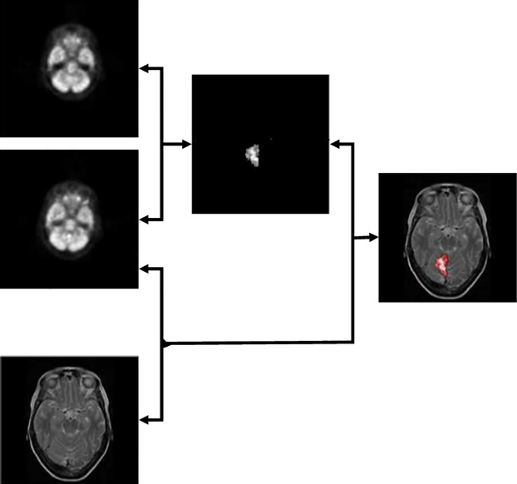
Image registration may be a main stage within the pre-processing of imageries which should be bonded (see above for an instance of an epilepsy detection using SPECT and MRI datasets), which fluctuations to be detected, which excellence should be enlarged by great-resolve or deconvolution or which should be additional used in image info schemes, amongst others; though, involuntary picture registering remnants an exposed problematic. Numerous writers’ emphasis themselves on the making of completely automatic procedures, but since of this the approaches frequently have lesser correctness or speediness. Permitting autoloading method, when the employer can support more precisely reset about portions of the registering or simply discard outwardly incorrect instructions of optimization could rise the toughness and therefore useableness of medicinal doppelgänger registering. The drawback of the employer collaboration is that the harm of objectivity when the productions aren't somewhat lengthier analogous, and thus the repeatability of outcomes is limited.
. Picture Plotting
Picture Plotting A to B
If the projection from B to A is understood then we will
1. Project the coordinates of the B picture element onto the A pixel grid.
2. Find the closest A grid factors for every projected B grid point.
3. Compute the price for the B picture element via way of means of interpolation of the A image.
Note: There isn't anyt any projection returned to B. We have computed the values for every B pixel. If we recognize that the coordinates of A are integers then we will discover the 4 pixels of A that surround (xq, yq) via way of means of quantizing the coordinate values
Mapping Parameters
We can regulate the plotting renovate H and the parameters of the RST matrix as trails:
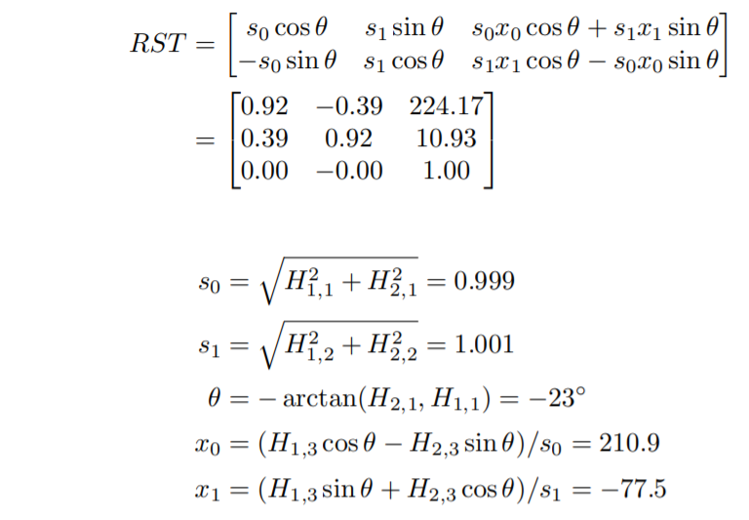
Stereo Imaging –Algorithms to Establish Correspondence
Limited Stereophonic Identical:
Limited stereophonic identical will examine the surrounds of a picture element p inside the left photograph to barely translated positions q inside the proper photograph to estimate the disparity of picture element p. Each picture element is treated disjointedly, without taking the entire photograph context beneath Neath consideration, which frequently consequences in noisy discrepancy images, specifically in non-textured photograph areas motivated with the aid of using any supply of enter noise (e.g., mild flickering, barely various colourings over adjoining digital digicam views, etc.). To estimate the disparity in nearby stereo matching methods, the surroundings of a pixel p inside the left photograph are in comparison to the surroundings of the pixel q inside the proper photograph, wherein q has been translated over a candidate disparity δp in comparison to p, cf. Fig. 1.34. for each pixel p, N candidate disparities (δp1, δp2, …, δpN) is tested (N = 256 and 65,536 for eight and 16-bit intensity maps, respectively), and consequently the candidate disparity main to rock backside matching fee is assigned to pixel presents a quick review of the most used matching costs. Besides selecting a sincere corresponding fee metric, it`s additionally vital to nicely outline the shape of the encircling matching window round pixel p. Indeed, it is usually implicitly assumed that all photo detail inside the window have greater or much less an equal disparity δpi, simply so simply one disparity is frequently reliably assigned to pixel p. As a counter sample, if the corresponding window lies 1/2 of over one item and covers for the alternative 1/2 of some other item mendacity at a actually separate intensity—e.g., the rectangular window of the element silhouette in Fig. 1.34—picture element of diverse disparities and/or in part disclosed picture element (pixels now no longer seen inside the different photograph) are going to be matched together, yielding the best matching fee at a probable incorrect disparity value, very distinct from the vital disparity that need to be assigned to pixel p. Consistent, nearby stereo matching methods consequently take exceptional care of the matching window form, concurring its borders with item borders consists of incline cunnings to admire border objects, describe a manner wherein, starting from picture element p and shifting outward, the window form is constant at an aspect wherein neighbouring picture element shadeation variations begin to be overlarge. This creates matching home windows that by no means go an item's border, for this reason offering greater dependable intensity estimations
. Problematic construction
The usage of stereo identical or inequality approximation for pixel corresponding on in another way uncovered stereo/Multiview photos isn`t forthright. Stereo matching or discrepancy approximation is that the system of locating the pixels inside the multicopy perspectives that correspond to an equal 3-D factor inside the scene. The remedied epiploic geometry simplifies this system of locating correspondences on an equal epiploic line. it is now no longer important to calculate the 3-D factor coordinates to are searching for out the consistent picture element on an equal row of the other photograph. The disparity is that the gap d among a picture element and its straight fit inside the different photograph. Akhavan et al. as compared the frequent methods of acquiring disparity maps from HDR, LDR, and tone-mapped stereo photos. A beneficial assessment amongst them is obtainable, demonstrating that HDR enter may have a huge effect on the same old of the outcome. The predominant purpose of stereo matching is to are searching for out the correspondences among pixels to get one HDR photograph consistent with view for each frame.
Algorithms to Recover Depth:
Deepness awareness is a veritably vital short- position chore for permitting a portable automaton scheme to comprehend three- dimensional relationship of the biosphere planetary matters. There are numerous diverse methods to break the deepness acuity problematic, form from shadowing and stereophonic. Dissimilar methods are grounded on dissimilar hypotheticals and work stylish in dissimilar circumstances. Inn stereo algorithms, chancing the consistent pixels in two imageries of the scene has been honoured as a delicate problem. Pentland was suitable to recover depth by defocused pictures without the correspondence problem in stereo. He noticed in fact that the most natural lens systems were exactly concentrated at only one distance along each compass from the lens to the scene. As the distance between the imaged point and the face of the precise attention rises or drop, the imaged objects compere-aggressively more defocused in addition, some other experimenters have used this miracle to decide algorithms for recovering deepness info.
As shown below, the distorting of the image due to the defocusing is stylish defined by point spread purpose. However, the point spread function is a rectangular amount of horizonless amount of Bessel purposes, If the image is nearly concentrated.
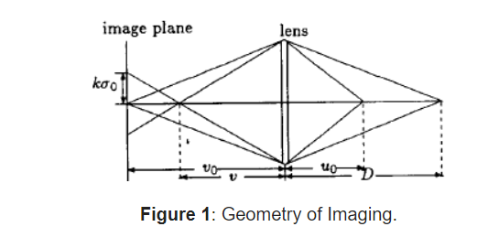
Conclusion:
First, a method for computing a background approximation via blocks analysis was introduced. Then, utilising morphologic operators in mathematics, this approach was expanded. A novel approach to detect the picture backdrop was therefore put forth and is grounded on the usage of morphologic linked changes. Though, a problem was found when the morphologic erosion and dilation were used. Changes for morphologic difference improvement were also announced. These machinists are built on the idea of Weber's rule. Throughout the study, various examples were used to explain how the suggestions made in this work performed. Additionally, the performance of the operators used in this study was compared to other examples provided in the literature. Last but not least, a drawback of the difference improvement changes examined in this study is that they can perform well while executing morphologic operations on various kinds of images.
References:
1.Droske M, Rumpf M (2007) Multiscale joint segmentation and registration of image morphology. IEEE Trans Pattern Anal Mach Intell 29(12):2181–2194.
2. Gu Y, Liu T, Jia X, Benediktsson JA, Chanussot J (2016) Nonlinear multiple kernel learning with multiple-structure-element extended morphological profiles for hyperspectral image classification. IEEE Trans Geosci Remote Sens 54(6):3235–3247
3. Pratima M, Soni MK (2015) Performance analysis of DWT-OFDM and FFT-OFDM using various digital modulation techniques and channel coding. Int J Comput Appl (0975 –8887) 128(11): 34–39
4. Sternberg SR (1986) Grayscale morphology. Comput Vis Graphics Image Process 35(3):333–355
5. Serra J, Soille P (eds) (2012) Mathematical morphology and its applications to image processing, vol 2. Springer Science & Business Media.
6. Batool N, Chellappa R (2015) Fast detection of facial wrinkles based on Gabor features using image morphology and geometric constraints. Pattern Recogn 48(3):642–658
7. Manhas P, Thakral S, Kumar C (2010) Performance analysis of GPRS/EDGE. Int J Electron Eng Res 655–658
8. Hu Z, Wang C, Zhu J, Liu X, Kong F (2016) Bearing fault diagnosis based on an improved morphological filter. Measurement 80:163–178
9. Thornton H (2016) Interaction of morphology and syntax in American Sign Language. Routledge
10. S. Mukhopadhyay and B. Chanda, “A multiscale morphological approach to local contrast
enhancement,” Signal Process. vol. 80, no. 4, pp. 685–696, 2000.
11. A. K. Jain, Fundamentals of Digital Images Processing. Englewood Cliffs, NJ: Prentice-Hall, 1989.
12. J. Short, J. Kittler, and K. Messer, “A comparison of photometric normalization algorithms for
face verification,” presented at the IEEE Int. Conf. Automatic Face and Gesture Recognition,
2004
13. C. R. González and E.Woods, Digital Image Processing. Englewood Cliffs, NJ: Prentice Hall,
1992.
14. R. H. Sherrier and G. A. Johnson, “Regionally adaptive histogram equalization of the chest,”
IEEE Trans. Med. Imag., vol. MI-6, pp. 1–7, 1987.
15. . Majumder and S. Irani, “Perception-based contrast enhancement of images,” ACM Trans. Appl.Percpt., vol. 4, no. 3, 2007, Article 17

