Role of Actinomycetes in diseases control in agriculture and horticulture crops

R. Kannan^{1*}, and T. Seenivasa Moorthy²
^{1*}Assistant Professor,Kalasalingam School of Agriculture and Horticulture (KSAH),
Kalasalingam Academy of Research and Education (KARE), Krishnankoil-626126, Tamil Nadu, India.
²Research Scholar, Kalasalingam School of Agriculture and Horticulture (KSAH), Kalasalingam Academy of Research and Education (KARE), Krishnankoil-626126, Tamil Nadu, India.
ABSTRACT
The actinomycetes as a suitable biofertilizer and biocontrol agent in Agriculture and Horticulture crops compare to other microbes because laboratory to field transfer easily and good self-life under different biotic and abiotic factors. The prokaryotes with the highest commercial and biotechnological value are actinomycetes. Streptomyces spp., a genus of actinomycetes, are widely employed for the manufacturing of antibiotics and agrochemicals as well as biological control agents against fungal phytopathogens such Pythium ultimum, Fusarium oxysporum, Sclerotinia homeocarpa, and Phytophthora fragariae that cause soil-borne diseases. Streptomyces coelicolor HHFA2 starin is responsible for preventing bacterial rot in onions. Streptomyces, Amycolatopsis, Micromonospora, Frankia, and Nocardia actinobacterial strains have been shown to effectively reduce soil-borne diseases while assisting host plants in mobilizing and acquiring macro- and micronutrients. Testing was done on isolates of Actinoplanes philippinensis, Actinoplanes missouriensis, and Streptomyces clavuligerus against Drosophila melanogaster. Synthetic pesticides are widely used, which has resulted in the emergence of pathogens and insect pests that are resistant to them, environmental pollution, contamination of groundwater, and an overall ecological imbalance.

Keywords: Actinomycetes; Habitat; Biofertilizer; biopesticide, Agriculture; Pigments
INTRODUCTION
The major problem to increasing agricultural crop production is the presence of diseases and insect pests. Due to their eco-friendliness, low production costs, and decreased use of non-renewable resources, mode of application potential bacteria with secondary metabolite and antimicrobial capabilities has emerged as one of the most alluring solutions for improving the sustainability of agricultural production. Actinomycetes are a good alternative among them for the control of illnesses and pest insects. Prokaryotic microorganisms called actinomycetes are used as biocontrol agents to treat plant diseases and insect pests. Their synthesis of primary and secondary metabolites with antibiotic properties against a variety of diseases is well documented (1, 2, 6, 7, 8). These prokaryotes are the most valuable in terms of technology and the economy. These make up a significant amount of the biomass of soil-dwelling microorganisms and are capable of producing a wide range of secondary metabolites. Actinomycetes have been found to create a variety of important bioactive metabolites, including those that are insecticides, herbicides, antibacterial, antifungals, and antibiotics. Streptomyces species, which are primarily used for the synthesis of antibiotics and agrochemicals, are responsible for the creation of more than 60% of all known antibiotics (4, 5). Therefore, actinomycetes are an effective alternative for the management of insect pests and diseases, and a number of well-documented publications have examined their potential (1, 2, 7, 8). Streptomyces has been used extensively in the manufacture of antibiotics, fungicides, bactericides, herbicides, insecticides, and acaricides. They are frequently used as wettable powder, wettable granule suspension, wettable spore suspension, and wettable culture filtrate on target crops. The biocontrol of plant diseases is efficient and risk-free for all living creatures, even though it takes some time to take effect. The rhizosphere-colonizing bacteria are great candidates for use as biological control agents against soil borne diseases, as demonstrated by Weller (1988). The lytic enzymes, antibiotics, and secondary metabolites that Streptomyces species produce have been extensively used as potential biological control agents against Phytophthora fragariae, F. oxysporum (11), S. homeocarpa (12), P. ultimum (10), and other fungal phytopathogens (13).

Isolated strain of Streptomyces lavendulae HHFA1 and Streptomyces coelicolor HHFA2 was used in vivo (pots and field) for controlling onion bacterial rot. S. coelicolor HHFA2 application resulted in enhancement in the photosynthetic pigments and some foliar growth parameters of onion plants confirming its growth promoting effect. In order to control the biocontrol of soil-borne plant diseases, actinobacterial, bacterial, and fungal antagonists have been used. Actinobacterial strains of Streptomyces, Amycolatopsis, Micromonospora, Frankia and Nocardia have been demonstrated to successfully lower soil-borne illnesses while supporting host plants in mobilising and absorbing macro- and micronutrients. These distinct actinomycetes with their wide range of plant growth promotion and antagonistic-promoting parameters must be employed for safe agriculture practice. Present study deals on actinomycetes a comprehensive overview of the major soil pathogenic microbes create the diseases that impact chickpea and pigeon pea, as well as prospective control techniques utilising broad-spectrum actinomycetes, mainly Streptomyces spp (19).

Majority actinomycetes strains used in monkhood growth promotion and soil-borne root disease biocontrol after applying a mixed actinomycetes preparation to the soil, we also looked at the long-term effects on disease prevention and plant growth. Sclerotium rolfsii a fungus that can cause southern blight, and Fusarium oxysporum, a fungus that can cause root rot, were both suppressed by the addition of cell-free culture filtrates from the strains Act12 and D74 in A. Carmichaelii (14). Actinoplanes philippinensis, Actinoplanes missouriensis and Streptomyces clavuligerus isolates were tested against Drosophila melanogaster. The three actinomycetes were individually applied against D. melanogaster, and then in combinations of two and all three actinomycetes isolates were used to study synergistic and antagonistic effects between them.

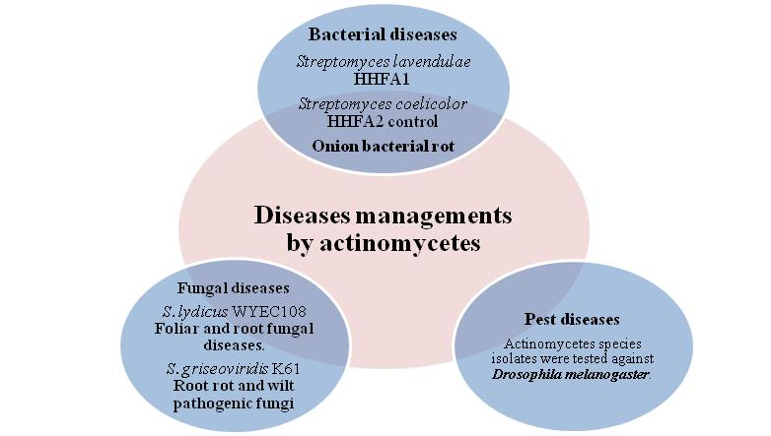
Scientific evidence for this claim is provided by (16) proven actinomycetes effectiveness against Culexquinque fasciatus and (15) very high mortality of larval and pupal stages of Musca domestica reaching up to 90% of mortality following actinomycetes treatments. The ability of actinomycetes to produce the enzyme chitinase, which breaks down the chitin surface of insects and enables the secondary compound to induce kill the organism into the insect body, is particularly responsible for the effective action of these organisms against insects (17).

Figure 1: Actinomycetes as diseases and pest control

Continue using of chemical fertilizer application to agriculture field, it will support soil born pathogen and create huge lose of agriculture productivity and create environment segment pollution and imbalance of ecosystem (3).

MARKET AVAILABLE PRODUCTS
Important producers of enzymes like cellulases, quininases, proteases, and peptidases are actinomycetes. The most crucial enzymes in the process of controlling phytopathogenic fungus are quitinases. Actinovate, a biofungicide obtained from Streptomycetes sp, is used to combat soil- and seed-borne plant infections (Fusarium, Alternaria, Phytophthora, and Pythium) that cause damping-off and root diseases. This includes MYCOSTOP. For fresh market tomatoes, a strain of this species called Streptomyces lydicus WYEC108 has been developed to effectively control fungal plant pathogens. PRESTOP is also used to effectively control the commercially available cucumber diseases Didymella (Mycosphaerella) gummy stem blight and Botrytis grey mould.

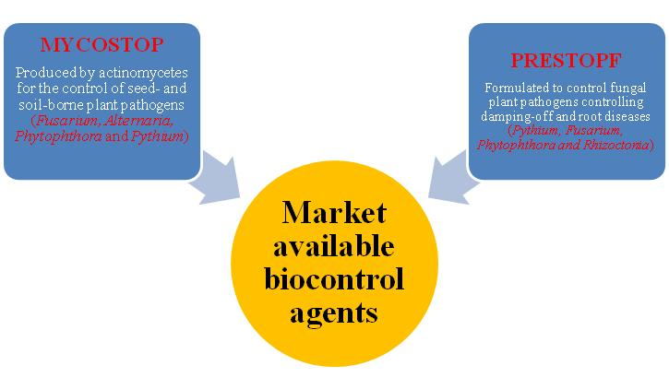
Figure 2: Markedly available products

APPLICATION METHOD OF ORGANIC BIOPESTICIDES AND BIOFUNGICIDES
Drone based spraying
Actinomycetales are characterised by aerial mycelium development and substrates. They are the microorganisms in soil that are most prevalent. They are crucial in the organic matter cycle and prevent the growth of a number of plant diseases in the rhizosphere. Actinomycetes have been investigated as a natural pest management for insects and phytopathogenic fungi that cause significant losses in agriculture due to the presence of enzymes including proteases and chitinase. Actinomycetes are favoured for the management of pests due to their diversity of generated metabolites and facilities for the industrial modification of cultures. Actinomycetes are also a "green" alternative to traditional pesticides because they are organic components of soil and do not harm the environment. Due to their capacity for degradation and capacity to produce stable humus, they also aid in the production and stabilisation of compost piles, which contribute to the long-term sustainability of soil.
Although the management of fungus-related plant diseases by streptomyces is well documented, there aren't many commercial products on the market that use particular strains of the microorganism or its metabolites. The use of prospective microorganisms in biocontrol programmes like S. plicatus connecting their enzymatic characteristics seems practicable to create ways for manufacture by separation of antimicrobial compound, or the direct use of separation of liquid culture, even though it is unmanageable for scale production (18).
For crop spraying on vast regions quickly, drones can transport appropriately sized reservoirs that can be filled with fertilisers, herbicides, or pesticides. Due to its autonomous and pre-programmed operation on predetermined schedules and routes, crop spraying is significantly safer and more economical. Drones can also be set to automatically alter their speed and altitude.
REFERENCES
- Blunt JW, Copp BR, Hu WP, Munro MH, Northcote PT, Prinsep M R (2009) Marine natural products. Nat Prod Rep 26:170–244

- Copping LG, Duke SO (2007) Review-natural products that have been used commercially as crop protection agents. Pest Manag Sci 63:524–554

- Doumbou CL, Salove HMK, Crawford DL, Beaulieu C (2001) Actinomycetes, promising tools to control plant diseases and to promote plant growth. Phytoprotection 82:85–102

- Berdy J (2005) Bioactive microbial metabolites. J Antibiot 58:1–26

- Franklin TJ, Snow GA, Barrett-Bee KJ, Nolan RD (1989) Antifungal, antiprotozoal and antiviral agents. In: Franklin TJ, Snow GA (eds) Biochemistry of antimicrobial action. Chapman & Hall, New York, pp 137–161

- Lei X, Xue Q, Chen Q, Lin C, Shen G, Zhao J (2013) Isolation and evaluation of rhizosphere actinomycetes with potential application for biocontrol of Verticillium wilt of cotton. Crop Prot 43:231–240

- Sharma M (2014) Actinomycetes: source, identification and their application. Int J CurrMicrobiolApplSci3:801–832

- Zahaed EM (2014) Isolation and characterization of soil Streptomyces species as potential biological control agents against fungal plant pathogens. World J Microbiol Biotechnol 30:1639–1647

- Weller DM (1988) Biological control of soilborne plant pathogens in the rhizosphere with bacteria. Annu Rev Phytopathol 26:379–407

- Crawford DL, Lynch JM, Whipps JM, Ousley MA (1993) Isolation and characterization of actinomycetes antagonists of a fungal root pathogen. Appl Environ Microbiol 59:3899–3905

- El-Shanshoury A R, El-Sououd ASM, Awadalla OA, El-Bandy NB (1996) Effects of Streptomyces corchorusii, Streptomyces mutabilis, pendimethalin and metribuzin on the control of bacterial and Fusarium wilt of tomato. Can J Bot 74:1016–1022

- Trejo-Estrada SR, Pasezczynski A, Crawford DL (1998a) Antibiotics and enzymes produced by the biological control agent Streptomyces violaceusnigerYCED-9. J Ind Microbiol Biotechnol 21:81–90

- Valois D, Fayad K, Barasubiye T, Garon M, Dery C, Brzezinski R, Beaulieu C (1996) Glucanolytic actinomycetes antagonistic to Phytophthora fragariaevarrubi, the causal agent of raspberry root rot. Appl Environ Microbiol 62:1630–1635

- Li, Y., Guo, Q., He, F., Li, Y., Xue, Q., & Lai, H. (2020). Biocontrol of root diseases and growth promotion of the tuberous plant Aconitum carmichaelii induced by Actinomycetes are related to shifts in the rhizosphere microbiota. Microbial ecology, 79(1), 134-147.
- Hussain AA, Mostafa SA, Ghazal SA, Ibrahim SY (2002). Studies on antifungal antibiotic and bioinsecticidal activities of some actinomycete isolates. Afr. J. Mycol. Biotechnol. 10:63-80.

- Sundarapandian S, Sundaram MD, Tholkappian P, Balasubramanian V (2002). Mosquitocidal properties of indigenous fungi and actinomycetes against Culexquinque fasciatus Say. J. Biol. Control 16:89-91.

- Brzezinska MS, Jankiewicz U, Burkowska A, Walczak M (2014). Chitinolytic microorganisms and their possible application in environmental protection. Curr. Microbiol. 68(1):71-81.

- Sinha K, Hegde R, Kush A (2014). Exploration on native actinomycetes strains and their potential against fungal plant pathogens Int. J. Curr. Microbiol. Appl. Sci. 3(11):37-45.

- Gopalakrishnan, S., & Srinivas, V. (2019). Management of soil-borne diseases of grain legumes through broad-spectrum actinomycetes having plant growth-promoting and biocontrol traits. In Plant microbe interface (pp. 129-144). Springer, Cham.

