Security Techniques Preliminaries in IOT enabled Application

Dr. Santosh Kumar Sharma¹, Ashish Dwivedi², Jay Prakash Pandey³,
Kriti Vishesh Jaiswal⁴, Dr. Shashikant Upadyay⁵, Banasmita Moharana⁶
sharma.santosh83@gmail.com, dwivedi_ashish01@yahoo.com, jay288.iet@gmail.com, kriti.jaiswal019@gmail.com, skantupadhyay@gmail.com, bansmita84@gmail.com

Associate. Prof. : Dept. of CSE, United University, Prayagraj, India
Research Scholar, Dept. of CSE, United University, Prayagraj, India
Research Scholar, Dept. of CSE, United University, Prayagraj, India
Research Scholar, Dept. of CSE, United University, Prayagraj, India
Assistant Prof. Dept. Applied Mathematics, United University, Prayagraj, India
,

ABSTRACT

A prompted challenge in wireless base technology is datasecurity and connectivity which is addressed. If we consider the primary feature of IoT devices, it is a collaborative approach of sensor network and mobile base smart technologies. The massive increase of internet of things base application for public purpose has a direct impact on network security in terms of infrastructure, authentication and confidentiality. This chapter discussed the different types of cryptography techniques, authentication protocol and security tool to validate the protocols which is used to solve the security threats in every individual layer of IOT framework.
Keywords- Cryptography, Authentication Protocol, IoT, tools, Applications

- INTRODUCTION
Cryptography is a security process to maintain secure data communication by performing different encoding and decoding technique. Cryptography provides security to sensitive and confidential data.[6] Cryptography process is a rich collection of security techniques such as encryption algorithm, authentication code, authentication protocol etc. Cryptography provides a group of methodology which provides security to the data, computer, and private network infrastructure. Gill et al. Cryptography provides different type of security algorithms for creating block cipher and stream cipher mode. In general cryptography provides the security to achieve data integrity, data confidentiality, and authentication services. The basic idea of IoT is to allow autonomous exchange of useful information between invisibly embedded different uniquely identifiable real world devices around us, fueled by the leading technologies like Radio-Frequency Identification (RFID) and Wireless Sensor Networks (WSNs). [3]

II. CRYPTOGRAPHIC TECHNIQUES
- RSA (Rivest–Shamir–Adleman)
RSA algorithm is a well-known public-key cryptography technique and use for providing secure communication. This algorithm is a asymmetric key cryptography technique where two different keys are used to perform encryption and decryption respectively. In this algorithm, we take the prime number and by calculating the product of these two prime numbers, we apply the GCD ( Greatest Common Divisor ) to find out the greatest common divisor. Due to the computation difficulty of multiple functions for the encryption process it makes difficult to break.

Algorithm: RSA is a block cipher in which the plain text and ciphertext are integers between 0 and (n-1) to somen.
Encryption equation: C=mod n
Decryption Equation: P=mod n
KU = (e, n)
KR = (d, n)
We have to find e, d, 4n.

Step by step Process:
- Select two prime numbers P&Q (P≠Q)
- Calculate n=P*Q
- Calculate ø(n)=(P-1)(Q-1)
- Select integer e=gcd(ø (n),e)=1
=>1<e< ø(n)
5) Select d= de ø(n)=1
6) PU(KU)={e,n}
7) PR(KR)={d,n}
Example:
1) Let prime numbers =3, 7
2) N=3*7=21
3) Ø(n)=(3-1)(7-1)=12
- e=>gcd(ø(n),e)=1
=>gcd(12,e)=1
=5
- d=>de mod ø(n)=1
d5 mod 12=1
d=5
- KU=(e,n)=(5,21)
KR=(d,n)=(5,21)

C=mod n
=mod n
=32768 mod n
C=8

m=mod n
=mod 21
=32768 mod 21
m=8
- IDEA (International data encryption algorithm)
This cryptography technique is created in 1991, authored by James Massey on the principal of symmetric block cipher key. IDEA algorithm has replaced the DES technique and holding the patent in several foreign states with the privilege noncommercial use only. Figure 1 showing the operational process of IDEA encryption and figure 2 is showing the key generation process.
Implementation of the Algorithm:
  - The IDEA algorithm used to implement 64-bit blocks and uses the key length of 128-bit.
  - The strength of the IDEA algorithm is its complexity and transformation in the 8- identical series.
  - The cryptography process is reversible principle for encryption and decryption and implements its security preservation policy by combing some different standards:
  - Such as:
    - Modular addition
    - Multiplication
    - Bitwise exclusive OR (XOR)
  - In more detail, these operators, which all deal with 16-bit quantities, are:

Step-1: Bitwise XOR (exclusive OR) symbolic representation ⊕).
Step-2: Addition modulo 2¹⁶ symbolic view is- ⊞).
Step-3: Multiplication modulo 2¹⁶ + 1,
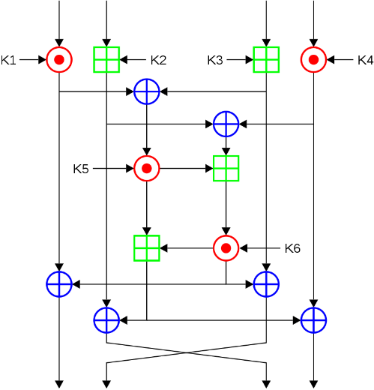

Fig-1: IDEA Operational architecture
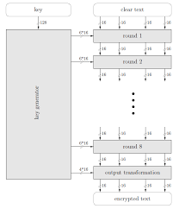

Fig-2: IDEA key generation process

- AES (Advance encryption system)
Rijndael has introduced this algorithm with the consultation of NIST (National Institute of standards & technology, USA) in 2001. [4]
AES has explored the critical functionality of block cipher using four operation named as add round key, substitution of bytes, shift rows and mix columns. The advance encryption systems implement 128 bits block size with the key length of 128, 192 and 256 bits. The working principle of AES is symmetric key management that means the same key will be used for encryption and decryption. Due to its effectiveness of this algorithm, it is included in ISO/IEC 18033-3. This algorithm is available in many encryption packages/ library functions. AES is the first cipher technique that is approved by NSA-National Security Agency for maintaining top-secret information. Four operational process of advance encryption system is shown in figure 3. and operational cycle of AES is discussed through figure 4.
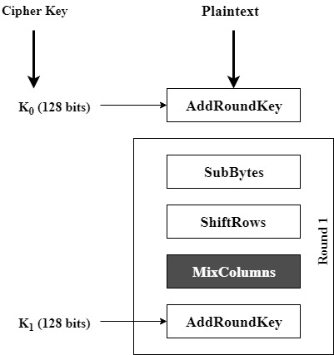

Fig-3: AES operational Architecture

Operational Process:
- Key Expansion: In this round key are resulting from the cipher key.
Here, AES needs a single128-bit round key.
The input to the encryption and decryption algorithms is a single 128-bit block.
This block is copied into the state array, which is modified at each stage of encryption and decryption. After the final stage, the state is copied to an output matrix.
- Add Round Key
- Substitute Bytes
- Shift Rows
- Mix Columns
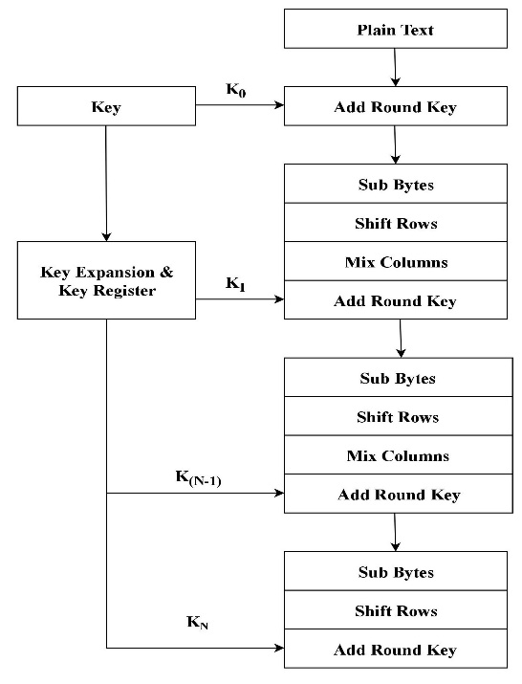
Fig-4: AES cycles of with four operations

- Blowfish
This algorithm is designed by Bruce Schneier in the year 1993 and it is a proven very strong mechanism and till date, no strong cryptanalysis has been found. Before the release of Blowfish, many more algorithm was there and they are covered with license, patents, and agreement of govt. defense dept. Then at that movement bruce had introduced an unpatented cryptography technique which is available in open market but not for commercial use. Blowfish process 64-bit block in two parts i.e left halves and right halves which will process one by one with s-boxes operation. Figure 5 illustrating the 16 rounds of cycle for encryption and decryption. [7]
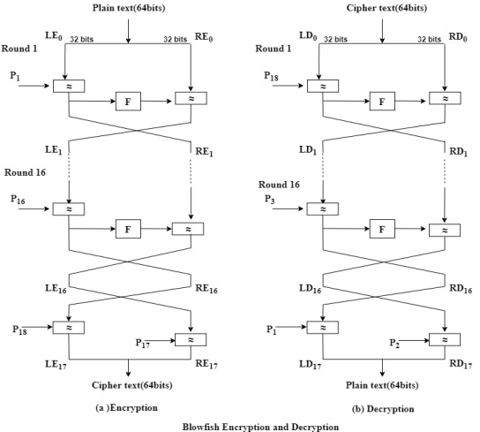
Fig-5: Blowfish encryption and decryption process

Below block diagram figure 6, shown the Blowfish encryption procedure with available four S-boxes with 256-entry individually i.e. S₀, S₁, S₂, S₃

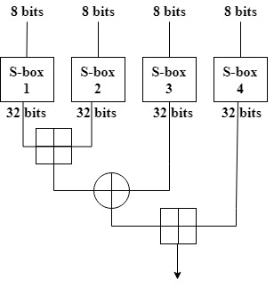
Fig-6: Blowfish encryption
Every round r consists of 4 steps:
Step 1 | Initiate the XOR with left half (L) of the data
Step 2 | Then, start doing XOR the data as input with F-function
Step 3 | Resultant output from the F-function will XOR with the Right halves
Step 4 | Swap L and R and continue, till 16th round for  Getting final cipher

The working principle of blowﬁsh is asymmetric block cipher approach, and it is originated to replace the IDEA algorithm. This blowﬁsh algorithm is used to convert plain text into cipher text which is entrenched with 32–448-bit encryption and work with the block size of 64-bit, operational activity for making ﬁnal cipher is 16 rounds. Operational behavior of blowﬁsh as follows:
BLOWFISH ALGORITHM
Step-1: Initiate the cryptography process.
Step-2: Let message (M)ˆTP(x) //Apply transposition.
Step-3: Arrange the message in permutation order (transposition).
If the permutation order is not ﬁlled, place a dummy value.
Step-4: New confuse matrix [m]ˆCM cipher value.
Step-5: Split the message as blocks in horizontal orders that each block
contains 4-values that is taken as P(X).
Step-6: P(X) ¥ 64 bits.
Step-7: Divide 64 bit into 2 equal halves (32 bit) and named as left (X_{L}) and right (X_{R}).
Step-8: For P_{n}=1 to 16 //if n true then next step otherwise go to Step-11.
Step-9: Perform operation X_{L}, X_{L} ⊕ Pi.
Step-10: Perform operation X_{R} F (X _{L}) XOR X_{R}
{Where F(X_{L})((s1[a]+s2[b] mod 2∧³²)⊕s3[c])+s4[d] mod 2∧³²
Logically it can be expressed as F(XL)
= ((s1[a]+s2[b]%2³²)⊕s3[c])+s 4[d]%2³²}
Step-11: Run Swap ( ) X_{L}&X_{R}.
Step-12: Perform X_{L} and X_{R} operations up to i value 16 and swap operation
(undo the last swap).
Step-13: Perform operation X_{R}=X_{R}⊕P17.
Step-14: Perform operation X_{L} =X_{L}⊕P18.
Step-15: Recombine X_{L} and X_{R.}
Step-16: Stop( )

- Massy Omura (MO)
The Massey-Omura cryptography technique is a private key management technique which has the potential to defeat the many types of attack but suffered with crypto analysis and make it vulnerable from the certain types of threats. MO uses prime modulo which can be calculated easily by the attackers and can expose the entire crypto data. Due to this loophole, the next reverse version came as EMO-1 which replaces the prime modulus with a product of two prime numbers which is revealed as the inherited feature from RSA public cryptography. Figure 7 shows massy-omura with three pass protocol to show its strength.

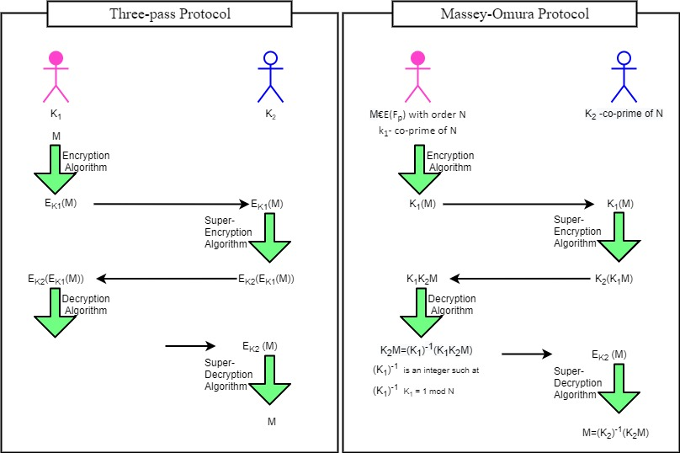

Fig-7: Massy Omura cryptography framework

- LOKI-91 Cryptography
At initial stage LOKI89 was introduced in 1990 by the Australian computer security scientist Lawrie Brown, Josef and Jennifer.
- Loki encryption technique uses 64 bits input length block for processing of plain text. Loki working principle is same as double encryption system but making difference while choosing the S-boxes which use the non-linear criteria that make them more complex and unpredictable with the partial help of "P-permutation" & "Expansion permutation. In LOKI-91 permutation is designed to combine the s-boxes as early as possible.
- In LOKI-89 technique data was suffering from eavesdropping and replay cryptanalysis which made it vulnerable. Due to eavesdropping attack during communication, Knudsen et al.in 1993 made the design of LOKI-91 algorithm.[5]
- In design of LOKI-91 made little changes in s-boxes and in key scheduling management.
- The objective to make a new key scheduling scheme and to minimize the ambiguity of related keys by replacing the first key with the final key.
- It is concluded that Loki91 is better than 89 and it is having potential to handle several diverse attacks which are described by Knudsen and Biham et al. And at last this cryptography technique can be expected as strong achievement in the core applications of block ciphering approach for end to end security. From figure 8 operational process of LOKI-91 is illustrated.
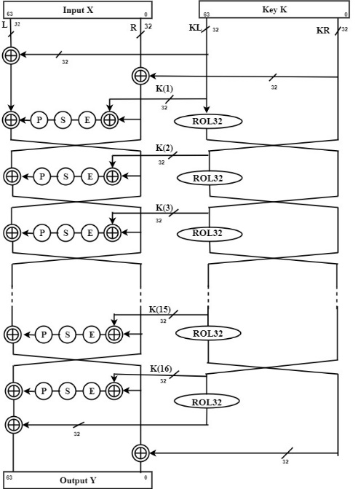

Fig-8: LOKI91 Block Diagram
- Elgamal cryptosystem
Elgamal cryptosystem is a public-key cryptography approach and uses the asymmetric key structure of the cryptography process. Elagmal cryptosystem is derived from the Diffie hellman key exchange algorithm in 1985 by Taher Elgamal.
- Elgamal technique used in free GNU Privacy Guard software with recent versions of PGP and other cryptosystems.
- The Digital Signature Algorithm (DSA) is another form of cryptography. Digital signature is a authentication scheme which is used provide authentication services between to legal parties for making transaction.
H. Cipher Block Chaining
CBC is verified as sequence of secure chain of secret keys to perform encryption. In cipher block chaining encryption started using initial vector which apply on first block of plain text. After successful conversion of first cycle of encryption process, we will receive first set cipher text as C1. This C1 will be the key for next cycle of encryption and it will continue till the entire plain text block will be encrypted means Cn-1.

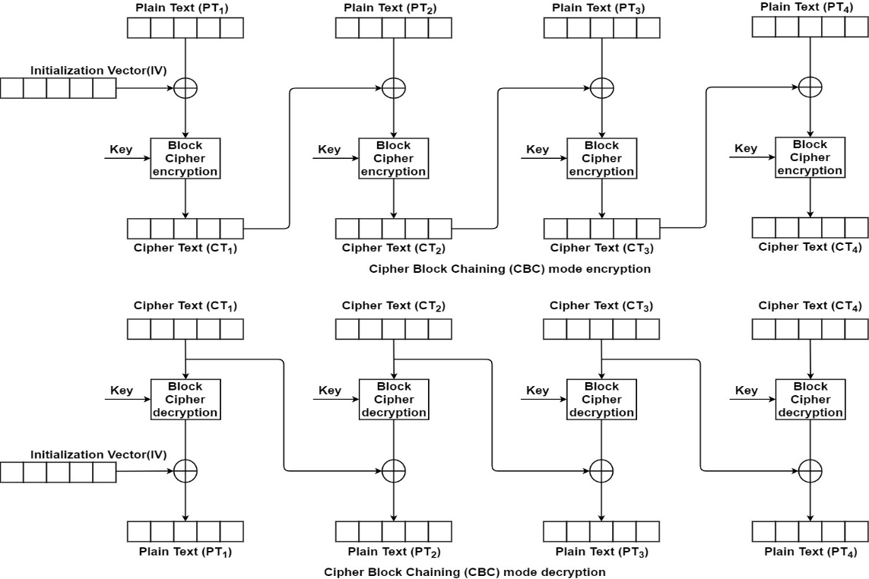

Fig-9: Cipher –Block Chain Cryptography technique
I. TwoFish Algorithm
TwoFish encryption technique is asymmetric block cipher cryptography approach which performs operation on 128 bits plaintext length. This algorithm is available in public domain for the technical concern and usage.[8]. Two fish are available in open source and can be used by anyone without any restriction. If we see the life span of its implementation then it is less than blowfish due to its complexity of usage. Two fish is computational tough due to it complex architecture and maximum distance separable matrix.
III. AUTHENTICATION PROTOCOL
A. Authentication Techniques
Authentication & Authorization Controls
One of the most successful strategies to control the access privilege is authentication process. In authentication process there is a allocation of access privilege to every user individually. All users are allotted unique privilege to access resource base on their role and to restrict each user to access the resources. This two-access technique is to control authentication and authorization respectively must be managed. It should be made sure that only identified and authorized individuals can access the specified types of resources.
Some of the authentication protocols are follows as:
  - Kerberos Authentication Protocol
  - CHAP (Challenge Handshake Authentication Protocol): These protocols use a password hash value to encrypt a challenge string. The remote server uses the encrypted password hash value from its account database to encrypt the challenge string and compare the two results.
  - Certificate-based Authentication
  - Extensible Authentication Protocol

Authorization Control
1. Role-Based Authorization
2. Access Control Lists-File access permission
3. Rule-Based Authorization
4. Remote- Access Consideration

B. Biometrics
Biometric is a authentication terms which is used to verify the physical and behavioral characteristics. In broad sense we use biometric authentication process to verify and measure the human characteristic. Biometric authentication process is used in computer application for identity verification and access control of users. Biometrics works on two properties of human:
1. Physiological
2. Behavioral
Categories of biometric –based authentication technologies:
1. Retina scans: In retina base authentication process we take input of blood plasma of eye to create prototype for verification.
2. Iris recognition: The process works on unique patterns of every Individual using their ring-shaped region which is available in every individual eye.
3. Finger scanning: It is a process to verify the digital pattern of the fingers.
4. Finger vein ID: Finger vein ID is work on the vascular pattern of every individual finger.
5. Facial recognition: Facial recognition authentication systems verify eight different points known as nodal points which available on every human faces.
6. Voice identification systems: It relies on characteristics created by the shape of the speaker’s mouth and throat, rather than more variable conditions such as vocal amplitude and peak graph.
Advantage: In case one-time password tokens are lost or hacked in that case biometric authentication will provide the additional security for access and usage of resources.

C. One Time Password
OTP is an automatic generating technique that produces the set of numeric or alphanumeric values for every single transaction. The same OTP can’t be used for multiple transactions and valid for only one session. OTP is also known as one-time pin and a dynamic password.
Advantage: In this type of passwords, a one-time pin is not vulnerable to replay attacks. Even though attackers are technically capable and having the advance configured technology but they cannot use the OTP for the different transactions and from different machines. OTP follows the temporary address binding with the users machine will valid for privileged sessions only. And if we see the other advantage of OTP then OTP can be predicted by seeing the preceding/ earlier OTP value because its life expires just after the use of OTP verification and validation. At the end, we can say that OTP cannot be misused easily. OTP cannot be predicted by observing the old OTP value, so OTP is a secure authentication tool.

OTP Verification Process
- Email address linked OTP
- Registered Mobile Number of users linked OTP
- IVR base OTP

D. Kerberos Authentication Protocol
Kerberos is a authentication protocol which provides the 3 layers of authentication process using authentication process, ticket granting server and real server. This protocol issues the ticket in phases that work from authentication to granting of the real server. Kerberos is a network authentication protocol that works on the base of token allocation with key and session attributes. It designers aimed to construct client-server model to provides authentication in phases. Kerberos protocol messages are protected against eavesdropping and replay attacks.
Kerberos consists of three types of server:
1. Authentication Server-A_{S}
2. Ticket Granting Server-TG_{S}
3. Real Server-R_{S}
Description:
- When the client would like to commence transaction then he has to authenticate himself by the authentication server (AS) which forwards the username, password token and secret key to communicate with ticket granting server.
- The ticket-granting server will communicate will allocate the token key, session key and secret key to establish the connection with real server for data exchange.
- After the successful completion of the TGT verification process client will get a ticket to send the query to a real server for desired data.
E. Distributed Authentication Security Service:
DASS is a public-key based authentication protocol and developed at Digital Equipment Corporation and documented in RFC 1507.
- In the DASS architecture, a certification hierarchy follows a naming hierarchy. Where certificate authorities (CA) is responsible to allocate certificate to one or more nodes in the naming hierarchy.
- A certificate authority initiates the certificate allocation process to the parent node followed by child node. The certificate authority conducts cross verification using common secret code available between parent and child node.
- DASS uses X.509 syntax for certificates and uses a Certificate Distribution Center (CDC) for the distribution of certificates. This system stores certificates and encrypted private keys.
F. Digital signature
Digital signature is a well-known technique for both side verification and consists of complex mathematical effort for calculating and analyzing the authentication process. Sender and Receiver both must be verified by digital signature to authenticate each other for set of transaction. After got satisfied with authentication process and allotted privilege we approve the sender's integrity. Digital signature is a strong component for providing security in financial services and contract management which help us to make the transactions confidentially.
G. Message Authentication code
This is a small piece of information which is attached with the transmitted message as a secure tag and when it reaches to the receiver side same tag should be received by the receiver and if there are no changes in value then only it is authenticated followed by accepted otherwise rejected. The MAC code is implemented to maintain integrity and authenticity. Figure 10 showing the message authentication code process with sender and receiver.
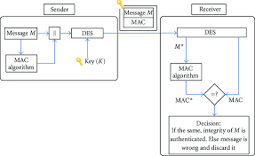

Fig-10: Message Authentication Block Diagram
IV. INTERNET SECURITY SERVICES
A. Securuty Policies and Regulations
The objective of regulating body is to maintain and manage the standard policy for reliable and secure communication. Regulating body is the basic foundation for effective management of security solution. The following facts should be taken care by the regulating body:
- Formation of stable regulatory body.
- Establishment of advisory and informative body.
- The security policy should have a general statement for better understanding purposes.
- The objective of the policy must have a clear goal.
- IOT

B. Internet Protocol Security:

IP security is used to provide the security to every device which is connected with internet. By trapping the IP-address any user can access the particular object legally or illegally. So, stopping this illegal accessibility of internet connected physical devices we provide the security services called IP-security. IPsec is a collection of a security protocol that includes authentication header, encapsulating security payload and setup of virtual private network for secure communication.
IP security is a standard protocol of the IETF (Internet Engineering Task Force) standard suit which provides the security services between two IP sockets and provide the security for data authentication, integrity, and confidentiality using different cryptography technique.
C. Practices of IP Security
For encrypting the application layer data packets, we use IPsec.
- IPsec is used to provide security for the routers which are publicly available over the internet.
- This provides the flexibility to choose the authentication process to authenticate the origin and destination nodes without encryption.
- To enhance network security using IP security we can implement tunnel mode or transport mode of security. IP security carryout the encrypted data between two machines over the network.
D. Broadly IPsec provides three types of security services
- Authentication Header (AH): Authentication header works is to authenticate the sender and detect the error or any alteration found during data transmission. Another responsibility of AH is to assure the integrity of data, P2P authentication as well as protects from anti-replay attack.
- Internet Key Exchange (IKE): IKE is a network security protocol and the purpose of designing this protocol is to exchange the security keys between two endpoint devices. Key management protocol and security association build the composite structure to maintain bidirectional authentication.
- Internet security association shows how to use a security association to setup a secure and authentic connection with IP-security. Figure 11 is shown below to illustrate Internet protocol header and figure-12 is define the structure of tunnel –Transport mode.
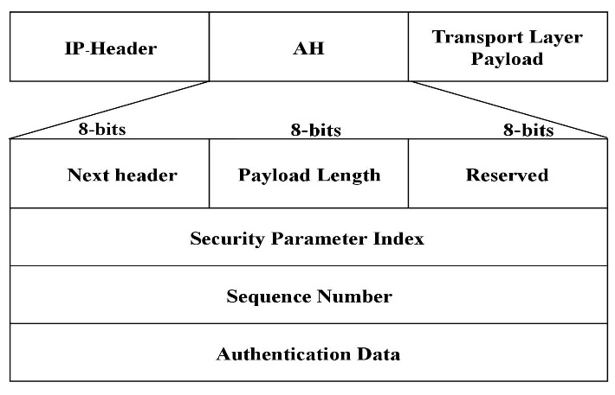

Fig-11: Internet Protocol Architecture
IP security can be categorized in two modes:
- Tunnel Mode: In this mode data is transmitting under the cover of a security shield and provides security to both ends.
- Transport Mode: This technique takes advantage of putting the data in a strong nutshell framework liable for making a pledge to secure communication.
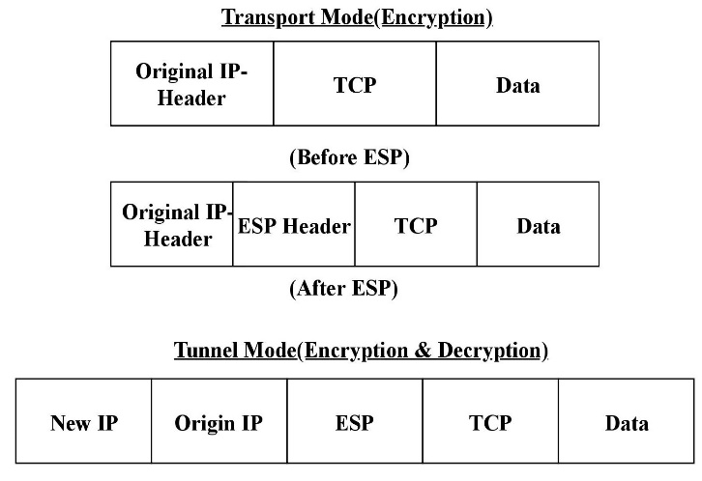
Fig-12: Transport mode & Tunnel Mode (Encryption & Decryption process)
E. Security Association (SA)
The main objective of the security association is to make secure connection between two endpoints networks to create secure communication. Security association provides the security for connection as well as data. An SA is a simplex (one-way) and secure virtual connection which recommends to facilitates secure communication between the two or more-end point. In security association, all security-related primitives, and services logically grouped together. For every security association, there is allocation of machine identity using ID parameters for both endpoints. So, we can conclude that SA is a logical group of security parameter which provides security in two endpoints.
A Security Association contain with three constraints:
- Parameter index for security
- IP security mechanism with IP address.
3. An IP Security Protocol Identifier, IP Security protocols are Authentication Header (AH) and Encapsulating Security Payload (ESP).
Using the concept of Data Structure “Security Association” ( SA ) trust management can be achieved . Making decisions for a packet with the encapsulating and decapsulating using this concept.[2]
F. AVISPA & its modules:
Experimental demonstration is projected using the AVISPA (SPAN) tool that is used to validate the internet security protocol automatically which uses high-level protocol specification language HLPSL. After simulation with the AVISPA tool, we can conclude the existing protocol strength and make enhancement to provide more security. [1]
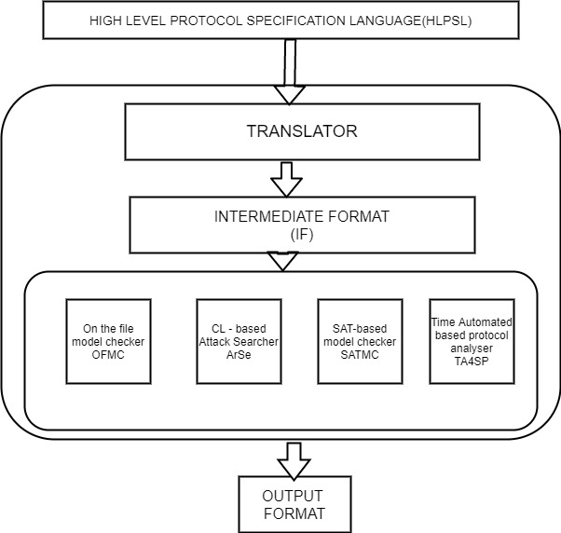

Fig-13- AVISPA TOOL Architecture

Architecture of AVISPA Tool
Figure-12 is showing the working architecture of the tool which is internally separated and integrated for different specific purposes. The HLPSL can implement as expressive and role-based modular language which is used for several cryptographic functions, algebraic operators with their algebraic and security.
Translator HLPSL –IF Translator
IF is used to trigger automatic input to the AVISPA backend tools. IF specifications are automatically input to the back-ends of the AVISPA Tool.
Intermediate format-IF: This IF is used to describe a protocol in terms of rules rewriting which describes an infinite state, transition rule, infinite-state transition along the initial state and property which is related to state-based safety property.
On-the-fly Model-Checker OFMC
This module is powerful due to the integration of several numbers of symbolic and constrained based techniques which is correct and declared itself as complete to guessing different attacks on inferior passwords.
CL-based Attack Searcher CL-AtSe
CL-AtSe created on a modular approach and openly extended for crypto operators and algebraic properties.
SAT-based Model-Checker SATMC
SATMC module is used to construct a proposition with procedural cryptography.
Tree-Automata-based Protocol Analyzer TA4SP:
These Protocols perform their task on the back-end triggered verification process on unbounded protocol verification using resembling knowledge of the intruder by observing regular tree and rewriting semantics
.
HLPSL Notation:
H: hash func, | % Data-type for one-way functions.
PSK1,PSK2,PSK3,PSK4 : symmetric  Key | %Data-type for symmetric keys of router_ITR
G: text | % It is a finite cyclic group generated by an element of prime
played_by | % The parameter ITR appears in the played_by section, which means, intuitively, that ITR denotes the name of the agent who  plays role router_ITR.
def=  local State: nat, | %Note the local section which declares local variables of  router_ITR.
N3,N4: text | %The Nonce is a random number
X, Y, Z :text | % X, Y and Z are variable values which are chosen and computed  from both router_ITR
M,M2,ACK :messages | % acknowledgment
UA, UB, PK_ETR,PK_MS: Public  Key | % Data-type for public keys of router_ITR..
K_ETR, K_MS: {text.public_key}_  inv(public_key), | %Compute keys question by router_ITR
SK: symmetric | %Data-type for symmetric keys (session Key) of router_ITR
EIDPre: messages | %Endpoint Identifiers
GY, Key, L: message, | % GY, Key and L are variable values which are chosen and  computed from router_ETR
init State := 0 | %indicates initialisation of local variables
role map_server (MS,ETR,ITR:  agent, | % This is a role as map_server, with parameters, MS, ETR, and  ITR type agent.
PSK1,PSK2,PSK3,PSK4 : symmetric  key, | %Data-type for symmetric keys of map_server
SND ,RCV : channel(dy), | % The RCV and SND parameters is type channel, indicating that the channel type, in this case (dy), denotes the intruder model to be  considered for this channel.
H: hash func, | % Data-type for one-way functions.
played_by MS | % The parameter MS appears in the played_by section, which  means, intuitively, that MS denotes the name of the agent who plays role map_server.
def=  local State: nat | %Note the local section which declares local variables of  map_server.
N1, N2,N3,N4: text | %The Nonce is a random number
M,M2,ACK :messages | % acknowledgment
PK_ETR,PK_MS: Public key | % Data-type for public keys of map_server.
K_ETR, K_MS: {text.public_key}_  inv(public_key), | %Compute keys question by map_server.
SK: symmetric | %Data-type for symmetric keys (session Key) of router_ETR
init State := 0 | %indicates initialisation of local variables
role the_trusted_ticket_granting  (TKG,ETR,MS: agent, | % This is a role the_trusted_ticket_granting with parameters TKG  ETR and MS type agent.
PSK1,PSK2: symmetric_key, | %Data-type for symmetric keys of the_trusted_ticket_granting.
PUK_ETR , PUK_MS: Public_Key | % Data-type for public keys of the_trusted_ticket_granting.
H : hash_func, | % Data-type for one-way functions.
Snd, Rcv : channel(dy), | % The RCV and SND parameters is type channel, indicating that the channel type, in this case (dy), denotes the intruder model to be  considered for this channel.

V. CNCLUSION
This Paper summarizes the most of the cryptographic techniques along with authentication protocol and the security association factor. This paper also summarizes the security concern over the internet communication. The tools which were used in this paper is AVISPA.

REFERENCES

[1]. Automated Security Protocol Analysis With the AVISPA Tool, Luca Vigano.

[2]. Blaze, M. (1999, April). Trust management and network layer security protocols. In International Workshop on Security Protocols (pp. 109-118). Springer, Berlin, Heidelberg

[3]. Farooq, M. U., Waseem, M., Mazhar, S., Khairi, A., & Kamal, T. (2015). A review on internet of things (IoT). International journal of computer applications, 113(1), 1-7.

[4]. http://nvlpubs.nist.gov/nistpubs/FIPS/NIST.FIPS.197.pdf

[5]. New Types of Cryptanalytic Attacks Using Related Keys, Eli Biham, Journal of Cryptology, vol 7 no 4, pp 229–246, Springer-Verlag, 1994

[6]. Salman, Ola & Abdallah, Sarah & Elhajj, Imad & Chehab, Ali & Kayssi, Ayman. Identity-based authentication scheme for the Internet of Things. 1109-1111. 10.1109/ISCC.2016.7543884, (2016).

[7]. Schneier, Bruce, Applied cryptography, Protocols, algorithms and source code in C, 2nd Ed, 1996.

[8]. Stallings, William, Cryptography and network security - principles and practice (3. Ed.), 2005.

