New Generation Billing System

¹ Pankaj Kunekar, ² Kiran Bari, ³ Kamlesh Dugade, ⁴ Ajay Wagh, ⁵ Gouri Pawar
¹²³⁴⁵Vishwakarma Institute of Technology Pune, India
pankaj.kunekar@vit.edu, kiran.bari20@vit.edu, kamlesh.dugade20@vit.edu, ajay.wagh20@vit.edu, gouri.pawar20@vit.edu

Abstract –
A shopping mall is a type of store that sells a large range of products. This product might be clothing, drinks, books, food, or any other household item. The primary goal of supermarkets is to make all things available to customers while also saving them time. However, customers might become upset when waiting in line at the pay register or while balancing While evaluating the overall price of all items with their available budget before being billed. Shopping malls employ this tactic to alleviate these issues by increasing the number of customers. On weekends in major cities, we may see a massive flash at shopping centers. This is amplified when there is a wide range of deals and discounts. People nowadays buy a range of things and place them in the shopping cart. After you've finished your shopping, go to the counter to get your bill. The accountant gets ready with the bill using the reader, which is a time-consuming operation. As a result, lengthy lines form at the pay registers. This concept proposes the creation of a system at shopping malls to address the aforementioned issue. When a customer selects an item, it will be scanned using a QR code scanner application on our phone, which will scan all of the product's information and will be recognized automatically and stored in our phone's memory as well as the memory of the supermarket's system. On the phone's screen, the name of the item and price of the item will be displayed as well as on the LCD screen (when the unique customer id is entered on super-market system). As a result, the rate is added to the final charge. If a customer decides to remove things from the sharp-witted luggage cart, the customer can remove the item and the cost of that item will be deducted from the entire cost. The same data is sent to the medial billing part through the GSM module.

Keywords -- Scanner, Barcode, Supermarket, Image Processing, Data Mining, Data Prediction

Introduction

We now live in the Internet of Things (IOT) age, where all physical object interactions have become a reality. All of our systems have undergone a fresh revolution as a result of this. This resulted in a number of disagreements in the areas of data management, wireless communication, and real-time decision-making. We used to create bills on paper first, and then we switched to using technology. The barcodes were read and scanned using a barcode scanner. However, later on, we concentrated on the smart billing system, which we implemented using a QR code scanner, which is a scanning program installed on our Android device and used for identification and data collection [1]. The reader may use the android device to access or read the data into the QR scanner. A user may only utilize the QR Scanner on our individual phone without consuming any power. When a buyer buys goods, the first thing he or she does is scan it with a scanner. Our phone comes with a QR scanner application. When a buyer scans the pricing of a product and other information about it when purchasing it, a QR scanner application scans the information and stores it in the phone's and system's memory [2]. And the key part is provided by in-budget shopping, which works in such a manner, that a person may set a budget before visiting a store, which can be advantageous to a client [3]. When a person goes shopping at a mall, he or she uses a trolley and then proceeds to the counter to pay for their purchases. Billing is done via barcodes, which is a lengthy procedure. We must scan each and every item based on barcode labels affixed to that item in this technology. Because we need to scan each individual, it must be done by hand. Labeling is done manually. Another drawback is that barcodes cannot be read from a great distance. As a result, our goal is to create an automatic billing system based on a QR code application on our phone that will be linked to a supermarket's system [4].

Literature Review

Smart shopping Cart

The centered on using autonomous technology to scan products and store them in a mobile database, with payment made via mobile banking [1].

An Ingenious Low-Cost Smart Shopping Cart

According to [2] Customers may utilise bargain-priced smart shopping to assist them pick items at shopping malls and persuade them of the wonderful discounts given on the products.

Smart Cart with Automatic Billing

In [3], this article explains about programmed offers a superstore with an anti-theft control system. It will enable for billing transactions to be completed online, as well as provide customers with shopping ideas.

A Bascart-based automated billing system for shopping malls

In [4] paper has studies about RFID tags are placed on things to speed up the billing process, which are then read by a barcode scanner, which displays the cost of the product on the LCD screen linked to our shopping list.

Shopping Mall Billing Management and Payment System for Smart Goods

In [5] primary difficulty with present research approaches is that they use the separate system for each trolley and then use a wireless communication module to connect it to the billing system. Such recommendations would make the system more complicated, inefficient, and costly.

Using automatic invoicing and machine learning-enabled smart trolleys, optimise shopping goods strategy

In [6] According to a research, consumers waste the majority of their time waiting for billing at a grocery store or shopping center. To get around this problem, a fute cart might be more useful. As soon as the product is added to the basket, scanning and invoicing of the product, as well as certain further uses, may be done.

Using Blockchain Smart Contracts to Digitize Invoices and Manage VAT Payments

In [7] The goal of this research article is to use various methods to solve the challenge of managing and securing taxation data stores.
1The smart contract is deployed into BCN via VAD, for example.
2. The seller keeps track of the hash code."

An Intelligent Invoice Classification Method for Smart Phones Based on Deep Learning

This research [8] proposes a deep learning-based solution for intelligently classifying invoices recorded by cellphones to improve IIR performance. In a short amount of time, the end-to-end approach may instantaneously identify the type of input for diverse invoice images. Experiments show that for 105 invoices, the suggested method can achieve a high classification accuracy of 99.05 percent and a quick running speed of 18.16 seconds...

An Automated Billing System in Shopping Malls Using Bascart

This article [9] starts with attempting to solve the grocery dilemma by building a Bascart-based billing system. Customers receive a direct bill from the billing area, which has already been saved on the host PC, which cuts down on the wait time. Our system's GSM Module is then used to determine the geo-location of the client's mobile phone in order to notify the customer of their purchase details via messages that have already been updated in the database.

Using Blockchain Smart Contracts to Digitize Invoices and Manage VAT Payments

This research shows the integration of the decentralized storage network (DSN) with the smart contract in [10], and we give an original architecture based on Block chain technology to verify transactions, compute VAT, and allow VAT payment (SC).

IOT Based Smart Billing and Direction Controlled Trolley

In [11] This paper assists customers by eliminating the time-consuming procedure of pulling and pushing the trolley, as well as saving time at the billing counter. The automated charging procedure is accomplished via a radio frequency identification (RFID) tag and reader, and obstacle avoidance has also been included to improve trolley efficiency.

Block Chain Digital Invoice System Risk Assessment and System Development Research

This [12] paper, is an example. The purpose of this research is to look at the hazards of the existing electronic invoicing system by applying artificial intelligence automated identification and graphic image processing technologies. The findings demonstrate that the system is efficient, secure, and fair, that it saves time and effort in calculations, and that it is suitable for large-scale invoice monitoring and reimbursement records on the block chain.

The impact of Indian consumer style inventory in determining mall attendance intentions in India

According to [13], the purpose of this study, is to adapt the CSI to the Indian consumer market in order to better understand client purchasing preferences. Furthermore, the goal of this study is to look at the relationship between client shopping preferences and mall visitation intentions. To see if the scales are suitable to the Indian market, the researchers used exploratory factor analysis. Using step-wise regression analysis, the effect of CSI in influencing mall patronage intention is examined. The findings are likely to provide significant insights into Indian customers' purchasing choices as well as critical suggestions for mall marketing strategies.

Shopping Mall Billing Management and Payment System for Smart Goods

In [14], This paper defines system's whose main idea is product barcode scanning, but we use a different For faster and more accurate results, use a barcode scanner. For speedy and reliable results, an Android phone is employed as a barcode scanner in our prototype. This system also makes use of RFID technology to enable for card-based payment. The results of this study are based on simulation and hardware.

Image as a factor for enhancing shopping preferences in Indian malls

In [15] This research examines the influence of image in influencing consumer choices for a certain mall. The data for this study was gathered from 750 respondents who were randomly picked from ten malls in the Delhi NCR (India). All of the data point to the existence of a one-of-a-kind mix of the ideal shopping environment.

Prolem Definition

There are numerous excellent selling tactics for goods and services on the market, but they can cause issues for clients, affecting their monthly budget, which we must overlook. When customers go to a department shop or supermarket, they have a list of products they want to buy, and then they compare the costs of those items to their monthly budget to decide which item to buy. However, there is currently a problem in that when customers attempt to buy various things, they just see a product list without their "Exact Price."[5] When a consumer begins removing items from the shelf, he or she notices additional items that entice them to buy them, which is one cause for the person's monthly (shopping) budget to be disrupted. When a customer goes to the billing counter after that, he must wait for a period of time, which is a time-consuming operation. The person must keep all of his selected things on the elevator, and the billing counter employee will scan all of the goods, along with their quantities, and then create a charge [6]. So, if there are numerous department shops or supermarkets in one location, we want a technical/software solution for both concerns so that our clients are happier with our services and desire to shop from our store again and again.

Objective

The major goal of this project is for the consumer to be able to acquire items in less time and within their budget. The customer may pre-list things on the shopping mall application and shop according to his or her budget. The bill can also be created on the customer's side, and if the shopping exceeds the budget, the customer will be notified on the customer's side. Customers are enticed and ensnared by new marketing methods, and their monthly budgets are frequently disrupted as a result of extra buying. Our system regulates the customer's purchasing according to his or her budget[7]. It saves outdated information such as recent orders and frequent products (purchase history). As a result, our project attempts to address these issues so that our clients are more happy with our services and want to return to our store, which has a variety of departments, Several businesses or supermarkets at one location[8].

Proposed Methodology

The main goal of the future system is to provide expertise related to shopping that is low-cost, simply accessible, and consistent. The RFID-powered automated shopping cart is designed to enhance the entire shopping experience. Consumers of computer electronics stores should have a good grasp of how to shop. Customers may access a range of item details after adding an item to the rough list[9]. When a consumer enters a shopping mall, she or he first grabs a shopping cart. And selects and scans the item and then item goes into the trolley and scanning operation is done with the phone’s QR scanning application with phone’s camera and it will be reflected to the phone’s list with amount and also in the system. At that time, the obtained item can be placed in the cart. While the consumer examines the item's phones, a value of the pick-up item get hold of and stored in the system's memory. And it will acquire the ID details from the storage to display on the system’s display [10]. The system’s display will display the most recent product information as well as the total amount in the cart. It will assist the consumer in staying inside their budgetary constraints. When we push the key on it, it instantly sends the data to the accountant. The block diagram is as follows:

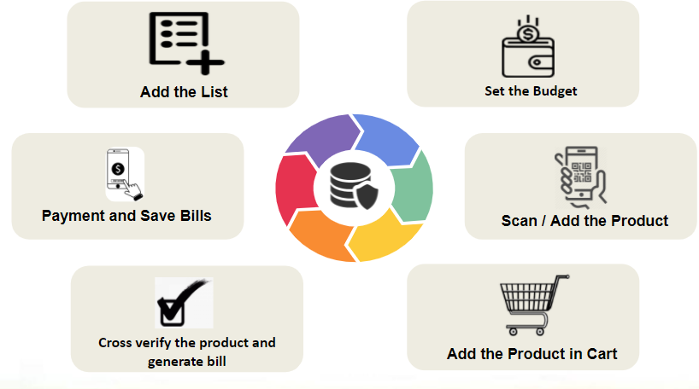Fig 1. Block Diagram of System

Algorithm

The abbreviation QR Code stands for Quick Response Code, and we are all familiar with QR Codes these days. It's used to make secure and fast internet payments. To store data effectively, a QR code utilizes four defined encoding modes (numeric, alphanumeric, byte/binary, and kanji); extensions may also be utilized [11].
A QR Code is a series of black and white squares that can be read using a variety of QR Code Scanners. It is useful nowadays since almost every smartphone has a QR code scanner app. It's also known as ZXing ("Zebra Crossing"), and it's a popular Java API for QR code processing. Its library includes several components, and in our Java example, we'll use the 'core' to create QR codes. We're utilizing the G-QRCODE node js base angular package, which was published in 2015. 5.2.1 is the most recent version.

Innovation

- We understand that new marketing methods entice and capture clients, causing their monthly budget to be disrupted by extra purchasing. As a result, our system regulates the customer's shopping according to his or her budget. So our project provided a solution to the problem by allowing customers to select their own budgets according to their preferences and go shopping; however, if they exceed the limit they set, the consumer will receive a warning message. As a result, customers could shop at their own pace.

- As we all know, Supermarkets have an issue whereby customers are stopped in line at the checkout register owing to a large crowd, and they might become upset before being billed, while calculating the overall price of all purchases with the budget in their pocket. Our initiative uses this method as a tactic to raise the number of consumers in order to alleviate these issues. On weekends in major cities, we may see a massive flash at shopping center’s. This is amplified when there is a wide range of deals and discounts. People nowadays buy a range of things and place them in the shopping cart. After you've finished your shopping, go to the counter to get your bill. The bill is prepared by the paymaster using the QR machine available with them, which is a time-consuming process. As a result, lengthy lines form at the pay registers. This project proposes a system development concept. Retail center’s to address the aforementioned issue When a customer selects an item, it will be scanned using a QR code scanner application on our phone, which will scan all of the product's information and will be recognized automatically and stored in our phone's memory as well as the memory of the supermarket's system On the phone's screen, the name of the item and price of the item will be displayed as well as on the LCD screen (when the unique customer id is entered on super-market system).

Flow of the System

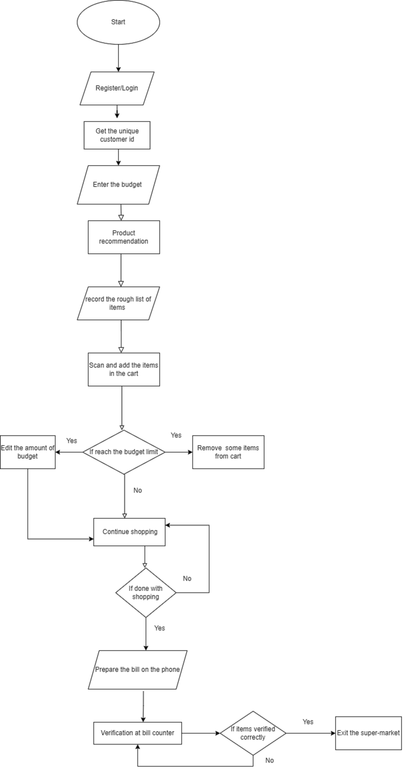

Fig 2. FLOW diagram of System

Future Scope

- LI-FI, NFC, and other communication methods can also be used to implement this system [1][9].
- This system may be improved by employing a Beacon Module instead of an RFID Module, and including a load sensor is also a good idea [6][7].
- Nutritional information for the eatables can be included in addition to the product data.
- Various sensor technologies can be used to accomplish automatic track detection and cart movement [3].
- A shopping budget restriction may be established; if the limit is exceeded, a buzzer should sound to alert you.
- Allowing customers to establish a shopping list ahead of time.
- The same system may be utilized in different locations.

Conclusion

This initiative tries to improve smart shopping by stating that shopping can be made simpler with the use of a smart phone. Simultaneously, the purchasing bill exceeds the budget. To solve this difficulty, we may apply the budget technique for listing goods. By using a supermarket's application with a unique customer id, it's simple to use and there's no need for an extra component because we already have a QR scanner software on our phone. Because of its effective performance, efficient capabilities, and ease of understanding, the execution portion will be done in Java.

References

[1] K. Machike, M. Golait, R. Rathod, R. Petkar, and P. Goche (2017). RFID and ZIGBEE are used in a new smart trolley technology. 5(2): 256-259 in International Journal on Recent and Innovation Trends in Computing and Communication.
[2] Thiyagarajan M, Aejaz M, Kumar M. [2] Thiyagarajan M, Aejaz M, Kumar M. (2017). For a supermarket, an RFID-based sophisticated trolley has been developed. This is a special issue
[3] Prasad JS, Kumar BOP, Roopa D, Arjun AK, Prasad JS, Kumar BOP, Roopa D, Arjun AK, Prasad
JS, Kumar BOP (2011). A low-cost intelligent shopping cart with a unique design. Pages 1-4 in IEEE 2nd International Conference on Networked Embedded Systems for Enterprise Applications.
[4] Karpagam V, Balapriya S, Kalairubini G, Kalaivani A. [4] Karpagam V, Balapriya S, Kalairubini G, Kalaivani A. (2017). |International Journal of Computer Systems 4(3): 55-58. Smart trolley with smart billing.
[5] A. Gade, N. Bhatt, and N. Thakare (2018). A fresh approach to green computing is a survey on energy efficient cloud computing. Helix, vol. 5, no. 5, pp. 3976-3979. https://doi.org/10.29042/2018-3976-3979.
[6 Sangeetha T. Chandrasekar P. Chandrasekar P. Chandrasekar P. Chandrasekar P. Chandrasekar P. Chand (2014). Smart shopping cart with RFID and Zigbee-based automated invoicing system. ICICES 2014, Information Communication and Embedded Systems, pp. 1–4.
https://doi.org/10.1109/ICICES.2014.7033996.
[7] Ms. Rupali Sawant, Kripa Krishnan, Shweta Bhokre, and Priyanka Bhosale (nine) (2015). The smart shopping cart with RFID technology. The International Journal of Engineering is a peer-reviewed journal that publishes
[8] Suprabha Jadhav1, Shailesh Hambarde, "Android-based Automated Cart System Using Raspberry Pi and GSM," International Journal of Science and Research (IJSR), Volume 5Issue 6, June 2016.
[9] SmitaSinghal and Nikhil Agrawal, "Intelligent shopping cart with NFC," Arduino, Volume 9 Issue 3, December 2018.
[10] Tianyi Song and Runinian Li, "IOT applications on secure smart commerce system," IEEE internet of things journal, volume 4 issue 6, 2017.
[11] Himani Pangasa and Nathi Ram Chauhan, "A research on automated shopping," in Himani Pangasa and Nathi Ram Chauhan, "A study on automatic shopping," in Himani Pangasa
[12] Megamall cart", material science and engineering, volume 1, 2019.
[13] Sarika S Pandey, Soumya R Gupta, and Meena M Shaik, "Smart cart with Arduino and RFID," IRJET, Volume 5 issue 3, 2018.
[14] P Kalaivani, C Raan, and S Sandhiya, "An automatic charging system in retail malls based on Bascart," Bulletin of scientific research, volume 1 issue 1, 2019.
[15] https://www.researchgate.net/publication/314818077_Image_as_a_Factor_for_Enhancing_Shopping_Preferences_in_Indian_Malls

