Global Positioning System
*Tamilmounika R¹⁾ Pandiya Kumar D²⁾ Sabthapathy M³⁾ Janarth S⁴⁾
^{1, 3, 4}Ph.D. Scholars, Department of Remote Sensing and GIS, Tamil Nadu Agricultural University, Coimbatore, Tamil Nadu, India
²SRF, Department of Remote Sensing and GIS, Tamil Nadu Agricultural University, Coimbatore, Tamil Nadu, India
*Corresponding author: tamilmounikar@gmail.com
ABSTRACT
Global Positioning System provides three dimensional positioning, navigation, timing services, velocity and altitude to users on a continuous worldwide coverage basis and it is independent of weather, day and night. GPS applications is wide in all fields. This chapter provides the basic knowledge about GPS technology and their application in agriculture.
Keywords – GPS, navigation, altitude, weather, applications, agriculture.
I) INTRODUCTION
The Global Positioning System (GPS) is a global location service maintained by the U.S. government which provides three dimensional course reliable positioning, navigation, timing services, velocity and altitude to users on a continuous worldwide coverage basis and it is independent of weather and time (Upreti and Kumar, 2008). It is a space-based radio navigation system of 24 satellites revolving around the earth twice a day in a very precise orbit with an orbital period of approximately 12 hours (Kaplan, 1996). The satellites are distributed across six orbital planes that are equally spaced at an angles of 55º and continuously transmit signals to the earth. GPS provides information based on the triangulation principle which calculates the user’s location precisely. Earlier GPS was only for military applications, later in the 1980s, it was made available to public users. The GPS was formerly known as the NAVSTAR (Navigation Satellite Timing and Ranging).
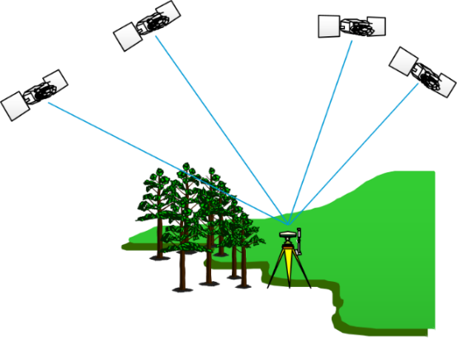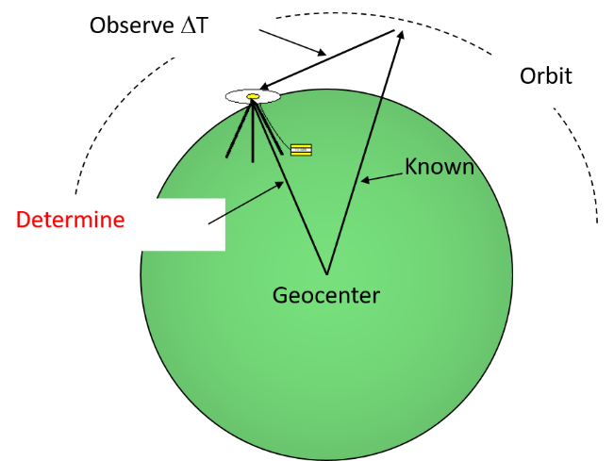
Figure 1 Receiving signals from GPS
II) GPS COMPONENTS
- SPACE SEGMENT
The space segment comprising the constellation of GPS satellites or space vehicles revolving around the earth in an orbit. These satellite generates and transmits the code and carrier phase signals and store and broadcast the navigation message given by the control segment. Stable atomic clocks in satellites regulate these transmissions.
- CONTROL SEGMENT
This segment is also known as the ground segment which is responsible for the control and proper operation of the navigation satellite systems. This segment contains master control station, an alternative station, ground antennas and monitoring stations across the earth.
Functions:
- It controls and maintains the status and configuration of the satellite constellation;
- It predicts ephemeris and satellite clock evolution;
- It keeps the corresponding navigation system time scale;
- It updates the navigation details for all the satellites.
C) USER SEGMENT
The user segment consists of receivers that receives signals and determines pseudoranges to solve the navigation equations to obtain the coordinates and provide a very accurate time. Each GPS receiver is identified by the three-dimensional location (latitude, longitude, and altitude) plus the time.
III) GPS WORKING PRINCIPLE
Trilateration is a basic geometric principle that allows finding one location with a known distance from other, already known locations. The principle of GPS is based on the measurement of pseudoranges between the four satellites and the receiver (Seeber, 2003). The ground-based stations offer accurate tracking of the satellite's orbit at every level and measure the signal transmission time between the four satellites and the receiver. It measures the precise direction, location and speed.
Steps
- GPS receiver receives 1-way ranging signals from several satellites, each transmission is time-tagged and contains the information of satellite’s position.
- The arrival time of the signal is compared with transmission time of a signal.
- The range is calculated by
P= [(Transmission time – Reception time) × Speed of light] (1)
- Each range places the user on a sphere surrounding the satellite, and intersecting multiple of these results in a user position.
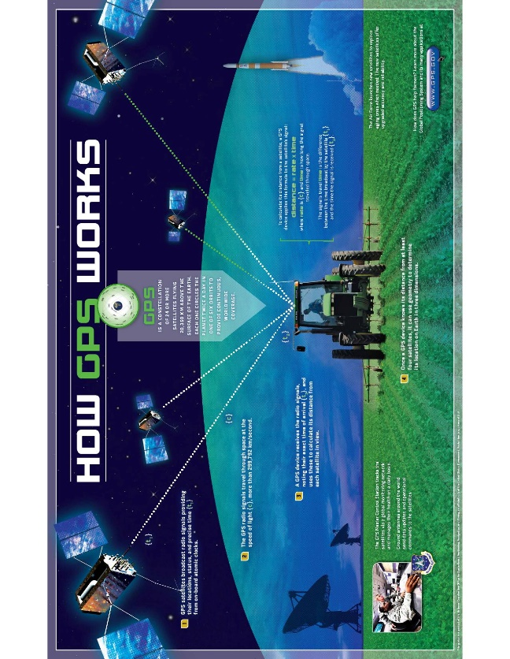
Fig. 2 Working of GPS (Source: GPS.gov)
IV) ACCURACY OF GPS
GPS accuracy is based on the precision of signals that transmitted from the GPS satellites to GPS receivers. The precision and accuracy of GPS are also determined by the number of hindrance that the receiver can obscure and also based on the types of receivers. The majority of GPS receivers have an accuracy range of +/- 10m. Differential Global Positioning Systems (DGPS) are the most accurate forms of GPS receivers.
V) ERRORS IN GPS
Table 1 Sources of error in GPS
Source | Amount of error
Satellite Atomic clocks | 1.5 to 3.6 meters
Orbital errors | < 1 meter
Ionosphere | 5.0 to 7.0 meters
Troposphere | 5.0 to 7.0 meters
Receiver noise | 0.3 to 1.5 meters
Multipath | 0.6 to 1.2 meters
Selective Availability | depends
User error | Up to a kilometer or more
VI) NAVIGATION SATELLITE SYSTEMS
S. No | Name of satellite system | Acronym | Origin | No of Satellites
Global Navigation Satellite System
1 | Navigation Satellite Timing and Ranging System GPS | NAVSTAR GPS | USA | 30
2 | Global Navigation Satellite System | GLONASS | Russia | 24
3 | BeiDou Navigation Satellite System | BEIDOU | China | 30
4 | European Global Satellite Navigation System | GALILEO | European Union | 35
Regional Navigation Satellite System
5 | Indian Regional Navigation Satellite System | IRNSS | India | 7
6 | Quazi-Zenith Satellite System | QZSS | Japan | 5
Table 2 GNSS satellites and their characteristics
Parameter | NAVSTAR GPS | GLONASS | Galileo | Beidou1/2
Position | 10-20 m | 10-20 m | ~10-20 m | ~10-20 m
Velocity | 10 cm/s | 10 cm/s | 20 cm/s | 20/40cm/s
Time | 0.1 µs (15ns) | 20ns | 20ns | 20/50ns
Ellipsoid | WGS84 | PZ# - 90.11 | GTRF | CGCS2000
Master Control | 1 station in US | 1 in Russia | 2 in EU | 1 MCS / 2 UPLOAD St.
Surveillance | 11 stations | 7 | 30-40 | 30 (iGMAS)
Satellites | 30 | 24 | 30 | 35 (GEO-5, IGSO-3, MEO-27)
Orbital planes | 6 Minm 4 sat Ø=15° | 3(120°/45°) | 3(9+1-40°) | 7 (3 IGSO+3 MEO+GEO)
Inclination | 55° | 64.8° | 56° | 55°
Altitude (Km) | 20180near-25820far | 19100-24680 | 23222-28920 | GEO, IGSO, MEO:21528
Ground track repetition | 1 day | 7d 23h 27m28s | 10 days | ~1/7 days / @ after 13 orbits in 10 days
Revolution time | 11h 57m 58s | 11h 15m 44s | 14h 4min | 12h 53min 24s (MEO); 24h
Selective Availability | Off | No | No | -
Anti-spoofing | YES | No | No | YES
Services | 2(SPS,PPS) | 2(SPS,HPS) | OS, SoL, CS, PRS, SAR | OS (B1, B2), Authorized Service (B1, B3)
Frequency bands | 3/8(L1,L2,L3,L4,L5,L1C,L2C,M) | 3 (L1,L2, L3) | 5(L1,E5a,  E5b,E6,L6) | B1I, B2I, B3I*, B1C, B2a
Velocity, c=299792458m/s | 3870 | 3950 | 3675 | ~3.02km/s
Propagation  Time (T-ms) | 67-86 | 64-82 | 77-96 | 71 (21528) -120 (36000)
Distance travelled during T | 260-333m | 252-325m | 285-355m | D=V*t (as per orbit selected)
(Source: Mod. from Nel Samama)

VII) INDIAN REGIONAL NAVIGATION SATELLITE SYSTEM (IRNSS)
Regional navigation satellite system especially for India. IRNSS was own navigation system fully developed and controlled by ISRO. The first satellite IRNSS 1A was launched on Jul 01, 2013. IRNSS was renamed as Navigation Indian Constellation (NavIC) in 2016. NavIC system consists of 8 satellites orbiting at a distance of 36,000 km, approximately. At present, only 7 satellites are active of which 3 satellites in Geostationary Orbit (GEO) and 5 satellites in inclined Geosynchronous Orbit (GSO), it uses the WGS 84 coordinate system for the calculation of user position. It provides the dual frequency user with a targeted position accuracy of better than 20 meters in the coverage area. The objectives of the system is to provide accurate real-time positioning and timing services over India and the region around the country about 1500 km. Most of the constellation is seen by the users all the time and it is independent of existing GNSS systems.
VIII) GPS APPLICATIONS
- Military surveillance
- Terrestrial, Aerial and Marine Navigation
- Disaster management and emergency services
- Precision Agriculture
- Monitoring and preservation of endangered species
- Crustal and seismic monitoring
- Mapping and Geodetic data capture
- Mining operations
- Vehicle tracking and fleet management
- Future of Intelligent Transportation Systems
- Terrestrial navigation aid travelers
- Assists in navigation for drivers
IX) GPS IN AGRICULTURE
Precision agriculture or site-specific farm management is possible only through the integration of remote sensing, Geographic Information Systems (GIS) and Global Positioning System (GPS). With the help of these technologies, massive volumes of geospatial data may be effectively handled and analyzed while being collected in real-time and with precise positional data. The information needed for the improvement of land and water use can be collected easily which is used for farm planning, mapping fields, soil sampling, guiding tractors, scouting crops, variable rate applications, and yield mapping (Abulude et al., 2015).
Site-specific soil sampling, data collection, and data analysis help in site specific application of nutrients will be very much useful for the farmer’s community. GPS enabled data collection from the field to map the accurate location of pest, insect, and weed infestations useful for Crop advisories. Accurate field navigation reduces the repeated applications and skipped areas, and enables maximum ground coverage within a short period.
Accurate yield data will be useful for future site-specific field preparation. The correlation between the crop production techniques and crop yields with land variability is helpful to develop effective soil/plant treatment strategies enhancing crop productivity. The timely availability of spatial information on soil and plant requirements is helpful for site-specific management to increase the agricultural production and protect the environment. Farmers can obtain benefits by combining improved fertilizer and soil amendment use, calculating the economic threshold for insect and weed infestation treatment, and conserving the resources for future use.

REFERENCES
- Abulude, F. O., Akinnusotu, A., & Adeyemi, A. (2015). Global positioning system and its wide applications. Continental Journal Information Technology, 9(1), 22-32.
- Kaplan, E. D., Leva, J. L., & Pavloff, M. S. (1996). Fundamentals of satellite navigation. Understanding GPS- Principles and applications (A 96-41027 11-17), Norwood, MA, Artech House, 1996,, 15-57.
- Nel Samama, "GNSS System Descriptions," in Global Positioning: Technologies and Performance, Wiley, 2008, pp.131-161.
- Seeber, G. (2003). Satellite Geodesy, 2nd completely revised and extended edition. Walter de Gruyter GmbH & Co. KG, 10785, 303-304.
- Upreti, S., & Kumar, M. (2008, March). Perspectives of Global Positioning System (GPS) Applications. In Seminar cum Workshop.
- https://www.isro.gov.in/spacecraft/satellite-navigation
- https://www.gps.gov/applications/agriculture/
- https://www.writemypapers.org/examples-and-samples/research-paper-on-global-positioning-system.html

