Graphene, the next generation nanocarbon: Synthesis, properties and its applications
Anushka Garg ª, Aayushi Kunduª, Soumen Basu ^{b}, Rajeev Mehta ^{c}
ª Research Scholar, TIET-VT Center of Excellence in Emerging Materials, School of Chemistry & Biochemistry, Thapar Institute of Engineering and Technology, Patiala, India
^{b} Affiliate Faculty, TIET-VT Center of Excellence in Emerging Materials, School of Chemistry and Biochemistry, Thapar Institute of Engineering & Technology, Patiala, India
^{c} Coordinator, TIET-VT Center of Excellence in Emerging Materials, Chemical Engineering Department, Thapar Institute of Engineering & Technology, Patiala, India
E-mail: garg.anushka1996@gmail.com, kunduaayushi@gmail.com, soumen.basu@thapar.edu, rmehta@thapar.edu

ABSTRACT
Graphene, the most popular next generation nanocarbon has been in the spotlight from a very long time due to its magnificent properties such as high Young’s modulus, high electron mobility, high thermal conductivity, greater surface area, strength and flexibility. Due to these exceptional features, they are in high demand in various fields. The applications of these advantageous materials are linked to the properties they possess. In this chapter, new developments and trends regarding the different synthesis routes for graphene production, their properties and applications have been summarized.

Keywords- graphene; nanocarbon; synthesis routes; thermal conductivity; electron mobility

- INTRODUCTION
Graphene, the mother of all graphitic materials is a two-dimensional nanocarbon in which carbon atom is covalently bonded to each other forming six-membered aromatic rings and each layer further is connected via Van der Waal forces [1]. The graphitic forms comprise of fullerenes (zero-dimensional), carbon nanotubes (one-dimensional) and graphite (three-dimensional) [2]. Although, the rolling of graphene sheets leads to the formation of carbon nanotubes, the properties of these two are very different. Graphene possesses some magnificent properties such as high surface area, high Young’s modulus, greater electron mobility, exceptional thermal properties due to which they can be broadly applied to the areas of sensing, photocatalysis, Li-ion batteries, polymer composites, optical devices and other [3]. Graphene production at a large scale require certain curbs to be overcome for being exploited in various fields.
Graphene production can be categorized by two different approaches: the top-down method (mechanical and chemical exfoliation, chemical fabrication) and the bottom-up approach (chemical vapor deposition, pyrolysis, epitaxial growth, and plasma synthesis) [4]. In the later approach, graphene is synthesized using a low molecular weight source of hydrocarbon. Single-layered graphene sheets can be produced via this method. However, the cost of the process makes it unsuitable for scale-up reactions. The top-down approach uses a highly organized graphitic precursor to synthesize GO using intensive exfoliation, which may be chemical or mechanical [5]. The top-down approach is more favourable than bottom-up as they have the potential for mass production and are cost-effective, although they are not amenable to single-layer graphene synthesis [6]. The essential mechanism involved in the top-down method involves incorporation of oxygen-based functionalities into the hydrocarbon layers by utilizing several oxidizing reagents like potassium permanganate (KMnO₄), sodium nitrate (NaNO₃), or potassium chlorate (KClO₃) in acidic mixtures to promote sufficient oxidation [7]. The most popular technique for mass production reported till now is Hummer’s method which uses graphite as a precursor [8]. This method involves utilization of an oxidizer, KMnO₄ (instead of KClO₃, resulting in the formation of toxic ClO₂ gas during the process) and addition of sodium nitrate (for in-situ formation of nitric acid instead of employing nitric acid as an extra solvent in conventional Staudenmaier or Hoffmann method). The disadvantages of using this approach cannot be underestimated since it includes intensive oxidation and mechanical exfoliation to form GO.
In 2010, Tour and co-workers used an improved method for the graphene oxide synthesis. In their technique, they excluded the use of NaNO₃ while surplusing the amount of KMnO₄ and carrying out the reaction in a mixture of H₂SO₄/H₃PO₄ in the ratio 9:1. These parameters helps to enhance the oxidation efficiency. GO synthesized by improved method was comparatively more oxidized than the Hummer’s method [9].
The commonly used precursor in the above-mentioned processes is graphite [10]. Graphite contains nicely-stacked graphene layers which can be extracted by harsh exfoliation techniques to obtain the few layers. However, graphite has a lot disadvantages being utilized on a large scale such as rising cost, regional localization (restricted to a specific region), difficult to source from naturally available sources and synthesis of graphite on a laboratory scale (expensive method). However, the demand for graphite is increasing day by day due to its explosive utilization in Li-ion batteries [11]. The global graphite market is forecast to grow from US$16.4b in 2017 to US$26.8b by 2025, for a CAGR of 8.5%. Therefore, due to these increasing demands and cost, researchers across the world are shifting to much more accessible and environment friendly precursors such as plastic waste, biomass, coal, etc [12].
In 2021, Lee and co-workers synthesized graphene oxide from anthracite coal using the newly developed one-pot process. This one-pot process involves the utilization of a single acid, HNO₃. The method does not exploit mixed acids in combination which were being used earlier [13]. Coal is an excellent candidate to replace graphite as its microstructure possess disordered graphitic domains which can be extracted and reduced further to obtain multi-layer graphene [14]. Coal is abundantly available natural resource which overcomes the flaws observed for graphite [15]. The mechanism behind the one-pot method is the oxidative scissoring of coal for graphitic domains and purification of coal prior to that for eliminating the non-desirable minerals [16]. This anthracite coal-derived graphene oxide has been further used as a biosensor depicting superior interaction with single stranded DNA aptamer, which could result in higher sensitivity chemiluminescence resonance energy transfer-based biosensors [13].
Graphene was isolated in 2004 by scotch tape method and from that point it has been the evolvement of academic equivalent of a gold rush becoming the major topic of research for material physicists and chemists, engineers and device designers [17]. Literature has been flourished in the past with research on exploring different dynamics and properties of graphene [18]. Monolayer graphene possesses massless dirac fermions and better crystal quality internally which owes for remarkable electronic properties, greater thermal stability, superior strength, and anomalous half integer quantum Hall effect [19]. Graphene shows high concentration of charge carriers and ballistic transport referring to zero-band gap nature. Single-layer graphene being defect free is the strongest ever tested material. The intrinsic strength of the monolayer membrane was measured to be 130 GPa by Hone and co-workers [20]. However, graphene at very low concentration in the composite system can enhance the properties to a very high level. Therefore, it is also exploited widely in the composites as a semiconductor, nanofiller and others to enhance the performance of the existing systems [21].
In recent times, nanoscience and material chemistry has boomed which eventually found their way in the variety of applications such as aerospace, automotives, sports industry, marine industry, packaging materials, electronic devices, home decor, marine boats, and defence sector as shown in figure 1. Graphene is extremely sensitive to the environment because of its sensing abilities. This sensitive nature covers magnetic field analysis to genetic material sequencing. 20% stretchability is the major range when using such sensors which is the major advantage for crystalline graphene [22]. Now-a-days, where solar cell technology is employed, graphene acts as the active medium or as a transparent material for electrode. The large surface area of graphene, chemically stable nature, viability and limpidness to functionalized owes them all to the biomedical applications of graphene [23].
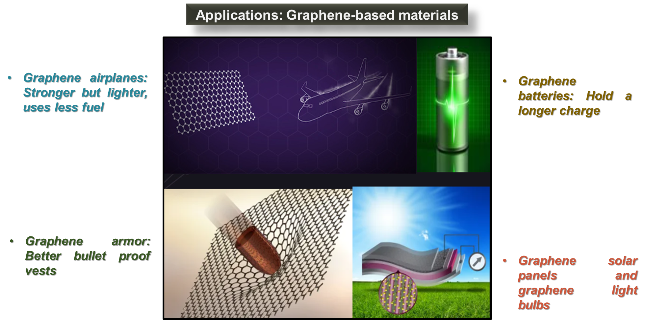
Figure 1: Applications of different graphene-based materials
In this chapter, different synthesis routes along with graphene properties and applications have been discussed in detail. The chapter opens with the introductory section to the different sections for exploration of graphene potential.
- SYNTHESIS OF GRAPHENE: DIFFERENT ROUTES
The different synthesis routes for graphene are CVD (chemical vapor deposition), epitaxial growth on Si based substrate, liquid phase reduction of oxides of graphene, chemical reduction, thermal reduction (usually involves high temperature range), microwave assisted techniques, etc [24]. These approaches are categorized under top-down and bottom-up approach. CVD involves a substrate on which volatile gas molecules gets adsorbed. CVD occurs in an enclosed chamber where graphene is of high purity and quality. The by-products were toxic in nature due to the precursors being volatile in nature. Mechanical exfoliation approach popularly known as Scotch tape method in which graphene layers are pulled apart by force. On repetitive peeling of layers, the layers split into few layers of graphene. However, the method is quite slow (not extendable for commercialization) and can be only used to study properties of graphene at a small scale. Recently, electrochemical exfoliation of graphite to yield graphene has gained significant attention. This method includes the utilization of different graphite forms like foils, rods, plates and powder in a non-aqueous and aqueous electrolytic solutions and electric current for the expansion of electrodes. Another spurting approach is pyrolysis which is advantageous in consequent production of high purity graphene films over SiC (silicon carbide) substrate at high temperatures. But this method is also incompetent for commercialization .
Bottom-up approaches require expensive setup, costly precursors and are laborious to deal with. Therefore, the most common method used till date is the Hummer’s method (top-down) (by Hummer’s and Offeman, 1958) as depicted by figure 2. This method utilizes KMnO₄ as the oxidizing agent and reduction by using chemical agents such as hydrazine hydrate, ascorbic acid, etc [25]. Paulchamy et al., 2016 utilized Hummer’s method and its modified version to obtain graphene by using graphite flakes as the precursor. The XRD spectra shows the diffraction peak at 2θ=10⁰ , which is mainly due to the graphite oxidation. The FTIR analysis confirms the presence of C-O and C=C bonding in the material [26]. Due to the excess utilization of these unwanted hazardous chemicals and rising cost of graphite for graphene production, researchers are shifting their interest towards better choice of precursors which are environment friendly, readily available, cost-effective such as coal, biomass, plastic waste, etc [27]. Fig. 1 represents the different precursors, mostly commonly employed synthesis scheme and different graphene derivatives which can be procured.
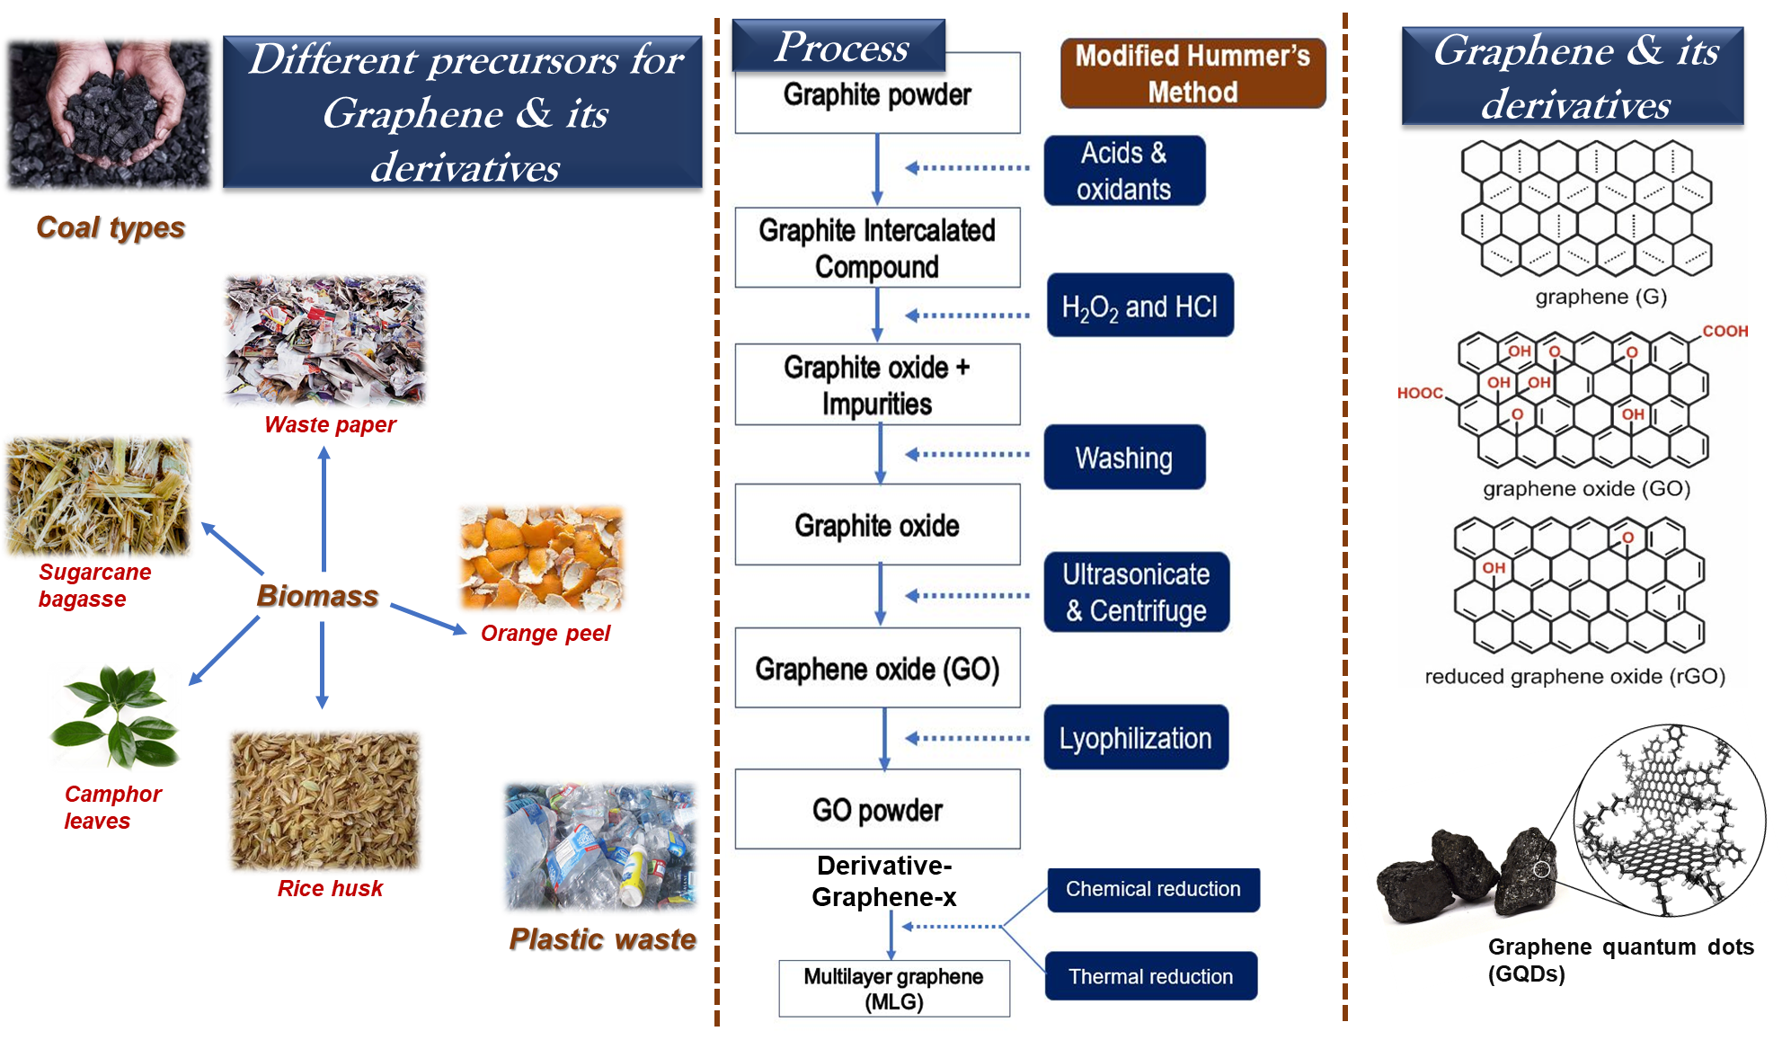
Figure 2: Different precursors and general synthesis scheme for graphene and its derivatives
The quality and quantity of the yield depends upon the method being utilized to synthesize graphene [28]. Lee et al., 2021 investigated the graphene synthesis by using one-pot process. The method had certain evident advantages in the terms of eliminating the use of harsh precursors and hazardous chemicals. The one-pot process involved the use of a single acid (not mixed acids) i.e., HNO₃. The method was based on oxidative scissoring of anthracite coal (source of carbon). The yield for graphene oxide was near around 5% (via Hummer’s method from graphite) and 40% (via the one-pot method from coal) [13].
Therefore, graphene production via robust approach (scalable to industrial level) and eco-friendly precursors needs to be tackled first for graphene’s full potential to be utilized.
- PROPERTIES AND APPLICATIONS OF THE NANOCARBON: GRAPHENE
Graphene possesses some extraordinary features such as strong chemical resistance, large specific surface area (2,630 m²/g), high Young’s modulus (1100 GPa), high thermal conductivity (5,000 W/mK), and high electron mobility (2×10⁵ cm² V⁻¹ s⁻¹) represented in figure 3 [29]. For achievement of multi-functional aspects of different polymeric materials, graphene is usually employed as a reinforcement to form composites. These polymeric composites having graphene as reinforcement can effectively as nano sensors, automobile components, conductive inks, membranes, solar cells, biomedical engineering, drug delivery, solar cell panels, home décor, sports equipment, and defence sector [30]. Graphene being extremely sensitive to environment owes to its ability as a nano sensor. In case of high-performance integrated logic circuits, graphene with a zero-band gap can’t be expected to become a planar channel material. Still other graphene electronic applications can be explored. Stroller and co-workers worked on preparation of ultra-capacitor using chemically-altered graphene materials. The specific capacitance came out to be 135 F/g (aqueous electrolytes), 99 F/g (organic electrolytes) and 75 F/g in ionic electrolytes. These types of capacitors are referred to as electrochemical capacitors [31]. Graphene based conducting polymers and graphene/CNTs are also used for their conductive nature. Enhanced mechanical properties of graphene are beneficial in case of regenerative medicines [32]. Graphene and its derivatives are also employed in biomolecule imaging through transmission electron microscopy (TEM). Moreover, the large aromatic surface area of graphene helps in biomolecule adsorption [33]. With the bio-interface between DNA-graphene, reversible detection of complementary DNA is possible using FET (field-effect transistor).
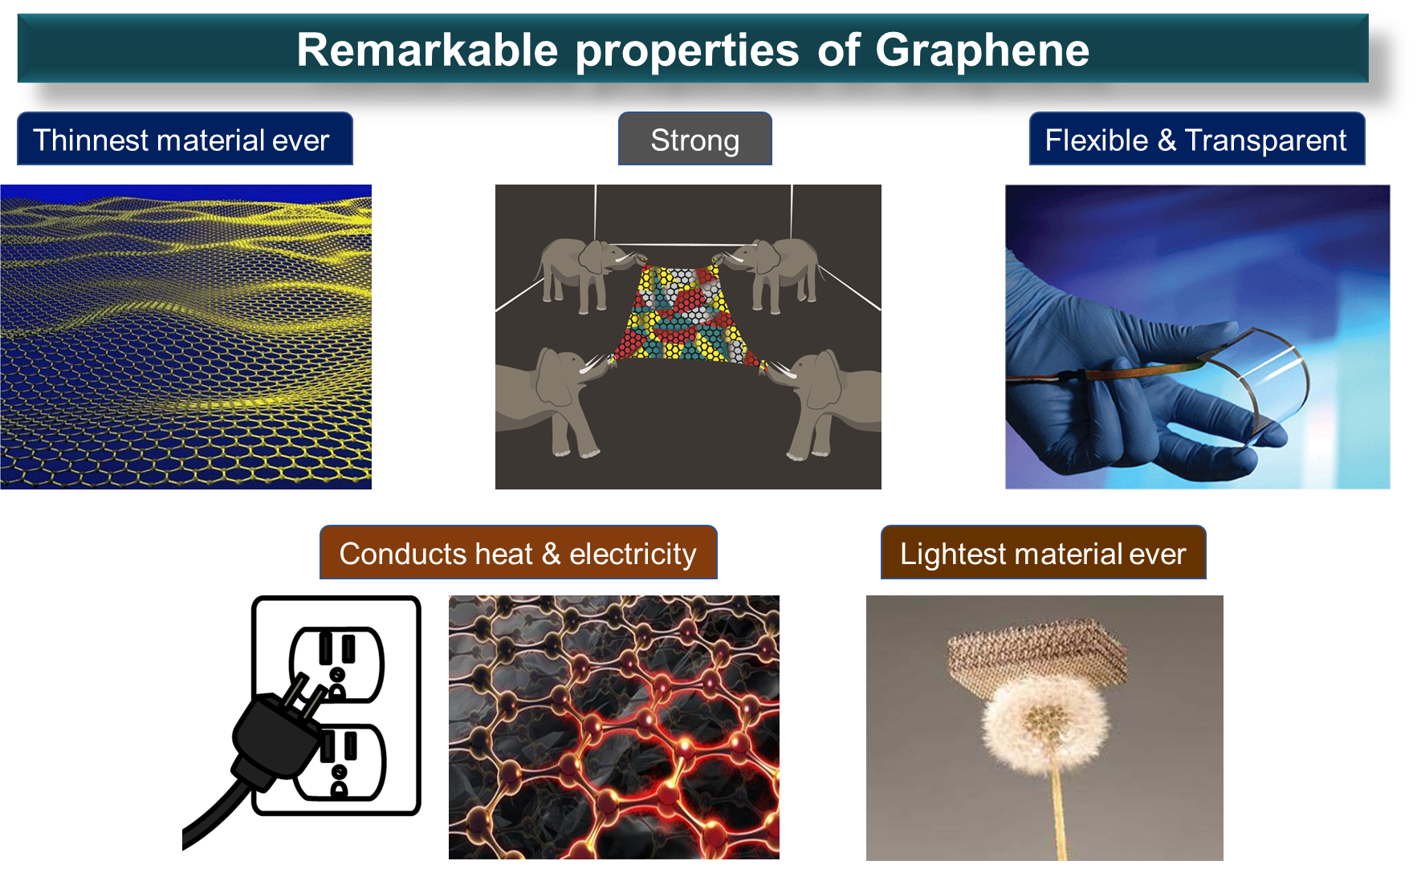
Figure 3: Properties of graphene
Recently, membrane technology has emerged as a significant remedy for environmental pollution [34]. Graphene membrane contains nanopores and are susceptible for easy functionalization. These characteristics makes it ideal for higher selectivity, greater permeate flux and improved stability through controlled pore size and shape [35]. The thermal conductivity for mono layer graphene is 5300 W/mK. Polyamide-reduced graphene nanocomposites had been utilized for LED thermal management [36]. Graphene composites also finds its application in wastewater treatment. Owing to the high surface area of graphene, the pollutants easily adsorb on its surface. However, graphene due to high recombination rate is generally used with other 2D materials which develop a heterojunction for overcoming the fast recombination rate issue [37]. Conclusively, we can say that graphene properties are linked to the applications they are used in. To quote some, faster electron-mobility accounts for lasers, transistors; conductivity and large surface area for sensing application; high optical transmittance, greater electrical conductivity for transparent conductive films; linear band structure for field effect transistors; quantum hall effect for ballistic purposes; feasible gas absorption for contamination control; hardness for construction materials, etc.
Though several technically feasible methods are being used these days, there are still some difficulties in exploring graphene’s full potential practically.
- CONCLUSION
Advancements in graphene and related properties make it an ideal next generation nanocarbon to be utilized in various fields. Graphene has been accepted as an efficient sensor, polymer composite material, as a nanofiller or reinforcement, bioimaging of biomolecules, in membrane separation technology, and others. The one-pot process discussed is new and has sufficient potential for mass scalability as it avoids the use of mixed acids and involves coal as the carbonaceous precursor for graphene. This opens the gateways for taking graphene from laboratory scale to industrial level to fully utilize it in diverse areas of research and actual practice.

REFERENCES
[1] C.N.R. Rao, K. Biswas, K.S. Subrahmanyam, A. Govindaraj, Graphene, the new nanocarbon, J. Mater. Chem. 19 (2009) 2457–2469. https://doi.org/10.1039/b815239j.
[2] G. Yang, L. Li, W.B. Lee, M.C. Ng, Structure of graphene and its disorders: a review, Sci. Technol. Adv. Mater. 19 (2018) 613–648. https://doi.org/10.1080/14686996.2018.1494493.
[3] K.S. Subrahmanyam, and Graphene Mimics, (2012) 149–159.
[4] M.S.A. Bhuyan, M.N. Uddin, M.M. Islam, F.A. Bipasha, S.S. Hossain, Synthesis of graphene, Int. Nano Lett. 6 (2016) 65–83. https://doi.org/10.1007/s40089-015-0176-1.
[5] N. Kumar, R. Salehiyan, V. Chauke, O. Joseph Botlhoko, K. Setshedi, M. Scriba, M. Masukume, S. Sinha Ray, Top-down synthesis of graphene: A comprehensive review, FlatChem. 27 (2021) 100224. https://doi.org/10.1016/j.flatc.2021.100224.
[6] C. Moreno, M. Vilas-Varela, B. Kretz, A. Garcia-Lekue, M. V. Costache, M. Paradinas, M. Panighel, G. Ceballos, S.O. Valenzuela, D. Peña, A. Mugarza, Bottom-up synthesis of multifunctional nanoporous graphene, Science (80-. ). 360 (2018) 199–203. https://doi.org/10.1126/science.aar2009.
[7] G. Shao, Y. Lu, F. Wu, C. Yang, F. Zeng, Q. Wu, Graphene oxide: The mechanisms of oxidation and exfoliation, J. Mater. Sci. 47 (2012) 4400–4409. https://doi.org/10.1007/s10853-012-6294-5.
[8] N. Cao, Y. Zhang, Study of Reduced Graphene Oxide Preparation by Hummers’ Method and Related Characterization, J. Nanomater. 2015 (2015). https://doi.org/10.1155/2015/168125.
[9] D.C. Marcano, D. V. Kosynkin, J.M. Berlin, A. Sinitskii, Z. Sun, A. Slesarev, L.B. Alemany, W. Lu, J.M. Tour, Improved synthesis of graphene oxide, ACS Nano. 4 (2010) 4806–4814. https://doi.org/10.1021/nn1006368.
[10] L. Sun, B. Fugetsu, Mass production of graphene oxide from expanded graphite, Mater. Lett. 109 (2013) 207–210. https://doi.org/10.1016/j.matlet.2013.07.072.
[11] X. Li, Y. Lei, L. Qin, D. Han, H. Wang, D. Zhai, B. Li, F. Kang, Mildly-expanded graphite with adjustable interlayer distance as high-performance anode for potassium-ion batteries, Carbon N. Y. 172 (2021) 200–206. https://doi.org/10.1016/j.carbon.2020.10.023.
[12] N. Raghavan, S. Thangavel, G. Venugopal, A short review on preparation of graphene from waste and bioprecursors, Appl. Mater. Today. 7 (2017) 246–254. https://doi.org/10.1016/j.apmt.2017.04.005.
[13] S.Y. Lee, R.L. Mahajan, A facile method for coal to graphene oxide and its application to a biosensor, Carbon N. Y. 181 (2021) 408–420. https://doi.org/10.1016/j.carbon.2021.05.007.
[14] U. Sierra, P. Álvarez, C. Blanco, M. Granda, R. Santamaría, R. Menéndez, Cokes of different origin as precursors of graphene oxide, Fuel. 166 (2016) 400–403. https://doi.org/10.1016/j.fuel.2015.10.112.
[15] A. Kundu, B. Maity, S. Basu, Coal-derived graphene quantum dots with a Mn2+/Mn7+ nanosensor for selective detection of glutathione by a fluorescence switch-off-on assay, New J. Chem. 46 (2022) 7545–7556. https://doi.org/10.1039/d2nj00220e.
[16] S.B. Lyubchik, L.Y. Galushko, A.M. Rego, Y. V. Tamarkina, O.L. Galushko, I.M. Fonseca, Intercalation as an approach to the activated carbon preparation from Ukrainian anthracites, J. Phys. Chem. Solids. 65 (2004) 127–132. https://doi.org/10.1016/j.jpcs.2003.10.006.
[17] E.P. Randviir, D.A.C. Brownson, C.E. Banks, A decade of graphene research: Production, applications and outlook, Mater. Today. 17 (2014) 426–432. https://doi.org/10.1016/j.mattod.2014.06.001.
[18] A.K. Geim, Graphene prehistory, Phys. Scr. (2012). https://doi.org/10.1088/0031-8949/2012/T146/014003.
[19] L. Liu, M. Qing, Y. Wang, S. Chen, Defects in Graphene: Generation, Healing, and Their Effects on the Properties of Graphene: A Review, J. Mater. Sci. Technol. 31 (2015) 599–606. https://doi.org/10.1016/j.jmst.2014.11.019.
[20] C. Lee, X. Wei, J.W. Kysar, J. Hone, Measurement of the elastic properties and intrinsic strength of monolayer graphene, Science (80-. ). 321 (2008) 385–388. https://doi.org/10.1126/science.1157996.
[21] D.G. Papageorgiou, I.A. Kinloch, R.J. Young, Mechanical properties of graphene and graphene-based nanocomposites, Prog. Mater. Sci. 90 (2017) 75–127. https://doi.org/10.1016/j.pmatsci.2017.07.004.
[22] J. Liu, S. Bao, X. Wang, Applications of Graphene-Based Materials in Sensors: A Review, Micromachines. 13 (2022). https://doi.org/10.3390/mi13020184.
[23] Y. Yang, A.M. Asiri, Z. Tang, D. Du, Y. Lin, Graphene based materials for biomedical applications, Mater. Today. 16 (2013) 365–373. https://doi.org/10.1016/j.mattod.2013.09.004.
[24] P. Avouris, C. Dimitrakopoulos, Graphene: Synthesis and applications, Mater. Today. 15 (2012) 86–97. https://doi.org/10.1016/S1369-7021(12)70044-5.
[25] A. Saini, A. Kumar, V.K. Anand, S.C. Sood, Synthesis of Graphene Oxide using Modified Hummer’s Method and its Reduction using Hydrazine Hydrate, Int. J. Eng. Trends Technol. 40 (2016) 67–71. https://doi.org/10.14445/22315381/ijett-v40p211.
[26] P.B. Arthi G, L. BD, A Simple Approach to Stepwise Synthesis of Graphene Oxide Nanomaterial, J. Nanomed. Nanotechnol. 06 (2015) 1–4. https://doi.org/10.4172/2157-7439.1000253.
[27] Y. Yan, F.Z. Nashath, S. Chen, S. Manickam, S.S. Lim, H. Zhao, E. Lester, T. Wu, C.H. Pang, Synthesis of graphene: Potential carbon precursors and approaches, Nanotechnol. Rev. 9 (2020) 1284–1314. https://doi.org/10.1515/ntrev-2020-0100.
[28] L.L. Shiau, S.C.K. Goh, X. Wang, M. Zhu, M. Sahoo, C.S. Tan, C.S. Lai, Z. Liu, B.K. Tay, Effects of precursors’ purity on graphene quality: Synthesis and thermoelectric effect, AIP Adv. 10 (2020). https://doi.org/10.1063/1.5142310.
[29] V.B. Mbayachi, E. Ndayiragije, T. Sammani, S. Taj, E.R. Mbuta, A. ullah khan, Graphene synthesis, characterization and its applications: A review, Results Chem. 3 (2021) 100163. https://doi.org/10.1016/j.rechem.2021.100163.
[30] T.K. Das, S. Prusty, Graphene-Based Polymer Composites and Their Applications, Polym. - Plast. Technol. Eng. 52 (2013) 319–331. https://doi.org/10.1080/03602559.2012.751410.
[31] Y. Zhu, S. Murali, M. Stoller, S. Rodney, Graphene-Based Ultracapacitors, (2010) 2–3.
[32] P. Bellet, M. Gasparotto, S. Pressi, A. Fortunato, G. Scapin, M. Mba, E. Menna, F. Filippini, Graphene-based scaffolds for regenerative medicine, Nanomaterials. 11 (2021) 1–41. https://doi.org/10.3390/nano11020404.
[33] M. Saeedimasine, E.G. Brandt, A.P. Lyubartsev, Atomistic Perspective on Biomolecular Adsorption on Functionalized Carbon Nanomaterials under Ambient Conditions, J. Phys. Chem. B. 125 (2021) 416–430. https://doi.org/10.1021/acs.jpcb.0c08622.
[34] A. Garg, S. Basu, N.P. Shetti, K.R. Reddy, 2D materials and its heterostructured photocatalysts: Synthesis, properties, functionalization and applications in environmental remediation, J. Environ. Chem. Eng. 9 (2021) 106408. https://doi.org/10.1016/j.jece.2021.106408.
[35] S. Homaeigohar, M. Elbahri, Graphene membranes for water desalination, NPG Asia Mater. 9 (2017) e427–e427. https://doi.org/10.1038/am.2017.135.
[36] E.C. Cho, J.H. Huang, C.P. Li, C.W. Chang-Jian, K.C. Lee, Y.S. Hsiao, J.H. Huang, Graphene-based thermoplastic composites and their application for LED thermal management, Carbon N. Y. 102 (2016) 66–73. https://doi.org/10.1016/j.carbon.2016.01.097.
[37] J. Liu, F. Chen, Q. Yao, Y. Sun, W. Huang, R. Wang, B. Yang, W. Li, J. Tian, Application and prospect of graphene and its composites in wastewater treatment, Polish J. Environ. Stud. 29 (2020) 3965–3974. https://doi.org/10.15244/pjoes/117660.

