Advancement in biotechnological approaches against borer complex in Saccharum spp.

¹Udavant R N
Dept. of Agricultural Entomology
VNMKV, Parbhani
Maharashtra, India
udavant.rajesh1997@gmail.com
²Ritu Rani
Dept. of Agricultural Botany
VNMKV, Parbhani
Maharashtra, India
riturani2278@gmail.com
³Vishnu Priya Kathula
Dept. of Agronomy,
CUTM Paralakhemundi (gajapati)
Odisha, India
kvishnupriya2411@gmail.com

Introduction
Sugarcane (Saccharum spp.), a perennial grass, is widely grown as a vegetatively propagated crop in the tropics and sub-tropics of the world. It generates 40% of the globe's bio-fuel output as well as about 80% of the saccharin demands. By introducing the E20 program, India's new biofuel policy also emphasizes the manufacturing of biofuels. The 10% ethanol mix in fossil fuels under the Government of India's E10 initiative was successfully finished in March 2022. (ESY 2021-22). According to government estimates, a successful E20 program may reduce import costs by 30,000 crore rupees. Each year, a variety of factors impact cane and sugar output. One of the many biotic and abiotic constraints limiting sugarcane output is insect pests, which cause more than 10% of crop losses globally [6]. The primary biotic agents of this loss in subtropical and tropical regions are top shoot borer (Scirpophaga excerptalis), stalk borer (Chilo infuscatellus Snellen), internode borer (Chilo sacchariphagus indicus), and early shoot borer.
Borers' immediate effects include dead hearts, poor tillering, tunneling of leaves and stalks, stalk breaking, side shoots, and roots; they also cause cane weight loss, eye bud sprouting, and poor juice quality, all of which contribute to output losses. The invasion of opportunistic microorganisms like Fusarium moniliformae [Went] & Colletotrichum falcatum [Sheldon] through the holes of borers is what causes indirect harm. The expense of agriculture is greatly increased by the chemical and biological treatment of these pests. The most effective and affordable pest management strategy is the creation of resistant cultivars.
Specifically, interspecific hybridization between Saccharum officinarum, which has a high sugar content, and Saccharum spontaneum L., which includes resistance genes, is the principal method used to generate standard sugarcane cultivars. The transmission of undesirable characteristics together with beneficial features results from this strategy of rearranging the DNA of both parents. To solve this issue, much backcrossing is needed, which is quite challenging and time-consuming. Additionally, at a certain point, crop output and quality can only be increased by using cutting-edge technologies with diverse tissue culture techniques and genetic engineering owing to sugarcane's limited genetic diversity and complex genomic structure. Transgenic technology has a tremendous potential to create borer resistance with the aid of many transformation procedures such as biolistics, electroporation, agrobacterium-mediated, and genome editing tools. The present genomics efforts that are illuminating the structure, function, and interactions of sugarcane genes have the potential to transform crop development initiatives and might prove helpful in breeding superior varieties with desired traits like insect resistance.
Sugarcane fingerprinting and marker-assisted selection: -
Numerous DNA marker systems, including RFLP, RAPDs, SSR, ribosomal DNA, and others, have been invented for sugarcane and have substantially aided in the identification of elite genetic stocks. Recently, 180 sugarcane varieties were fingerprinted using SSR markers, and information from the database could be used to identify variations of unknown or disputed origin [10]. In order to identify sugarcane strains resistant to biotic stressors, novel high-throughput marker systems including SNPs, and ESTs markers are being developed.
Genetic engineering in Sugarcane: -
Sugarcane [chromosome no. 80-116] is a very attractive fit for genetic engineering owing to its complex polyploidy nature, fluctuating fertility, and G x E interactions. Sugarcane has a very complicated genome that is more than 10GB in size. This crop is a fine fit for genetic modification owing to the development of high-frequency in vitro regeneration systems from diverse explants. The development of genetically engineered sugarcane plants relies on varied variables, including the tissue culture regeneration technique and explants employed for regeneration.
Gene transfer methods: -
Utilizing a variety of gene transfer strategies, the genes discovered for resistance to borers in other species of sugarcane or another organism can be transferred in agronomically superior and sensitive genotypes, they are effectively divided into two types.: -
1) Vector-mediated gene transfer
2) Vector less/direct DNA transfer
Vector mediated gene transfer: -
It may be of two types namely agrobacterium-mediated and virus-mediated transformation.
A) Agrobacterium vector-mediated gene transfer: - It has been demonstrated to be more stable and dependable than artificial methods of gene transfer. The Agrobacterium Framework was historically the first effective plant engineering method for transformation in 1983. Two members of the agrobacterium genus, A. tumefaciens, and A. rhizogenes are often responsible for gene manipulation in plants. When introduced into plants, A. tumefaciens and A. rhizogenes both produce diseases known as hairy root and crown gall, respectively. It is an avirulent strain of A. radiobacter. The following three methods are typically used to inoculate plant cells with agrobacterium.
1) Infection of wounded plants: - An in vivo inoculation is carried out by decapitating seedlings to obtain tumors made of Agrobacterium transformed cells after seedlings or well-established plants have first been produced in vitro under aseptic conditions. The Calli that are transforming are eliminated and utilized for regeneration.
2) Co-cultivation: - During the cell wall reformation period, the isolated protoplast and Agrobacterium are maintained in suspension culture for 24–40 hours at a rate of 100 bacteria per protoplast. Exposure to the selective agent in media helps in the identification of transformed cells.
3) Leaf disc method: - In reality, any tissue that may serve as a suitable source for the beginning of entire plant differentiation is employed using this technique, such as leaf discs, root and shoot buds, etc. Agrobacterium suspension is often used to incubate freshly emerging cotyledon leaf discs for a few hours to a few days before being transferred to a bacteriostatic media to kill the bacteria. The explant is then moved to a selective medium where only cells that have transformed will survive.
It has been widely used to create transgenics using agrobacterium-mediated transformation, but this method also has several prerequisites. The plant species from which the explant is obtained must produce acetosyringone or a similar chemical for activating viral genes. The artificial addition of synthetic acetosyringone can get over this restriction. The Agrobacterium that is being utilized for induction has to have extra explant cells. Transforming tissues and cells must be able to grow back into whole plants.
B] Virus-mediated gene transfer: - Due to the high frequency of transformation, the virus-mediated gene transfer technique of gene transfer is also equally beneficial. Systemic viral infections are preferable because they spread the gene throughout all of the cells in plants and transplants. A viral vector should have a wide host range, be virulent, mechanical in nature, manipulative, and have a high seed transmission rate. It must be able to carry extra genetic information due to severe packing restrictions. For this, viruses from the Caulimoviruses, geminivirus, and RNA virus families are typically utilized.
Vectors less/direct DNA transfer: -
This method of DNA transfer relies on giving plant cells the raw DNA directly. There are some successful examples where Cry genes cry1A, cry1A(b), and cry1Aa3 has been incorporated into sugarcane against sugarcane borers using various method of transfer. It is accomplished using a variety of techniques, including electroporation, particle bombardment/projectile/biolistic, microinjection, macroinjection, silicon carbide fibre-mediated transformation, liposome-mediated transformation, ultrasound-mediated DNA transfer, Pollen transferred DNA, and chemically-mediated transformations, among others. Under the command of the CaMV 35S promoter, an abridged cryIA(b) gene encoding the active portion of the Bacillus thuringiensis δ-endotoxin was produced in transgenic sugarcane. By electroporating healthy cells, genetic change was made possible. Despite the limited expression of CryIA(b), transgenic sugarcane plants demonstrated considerable larvicidal efficacy.
The biolistic DNA approach is the most practical, reliable, and often used method for direct gene transfer; yet, it frequently results in complicated transgene integration patterns, which may make further analysis challenging. Contrarily, the agrobacterium-mediated transformation has become more popular due to its ease of use, ability to generate single-copy transgenic cells, and capacity to transfer large DNA segments effectively without significant rearrangement.
Approaches for biotechnological improvement regarding borer complex in sugarcane: -
A] Transgenic approach: -
Development of Bt-sugarcane
Since the larvae of diverse species either feed from the roots or dig through the stem, spraying insecticidal chemicals on plant surfaces is useless [3]. Genetically engineered plants that produce Bt Cry proteins can effectively control rootworms and stem borers while simultaneously reducing the environmental costs of using conventional pesticides [12]. A chimeric protein called Cry 1A has domains I and II from the C-terminal half of Cry1Ac and a nearly similar domain III from Cry1Fa. Notably, the phylogenetic trees grouping domains I and II reveal that the proteins Cry1Ab and Cry1Ac are neighbours, with domain III being their primary point of divergence. Bacillus thuringiensis, which expresses the combination of Cry2Ab and Cry1A, may defend against a wide range of extremely harmful lepidopteran pests, including the sugarcane borer [7].
Due to commercial agreements between companies, these insecticidal proteins have been layered, offering dual protection against above- and below-ground insect pests [8]. The goal of combining several cry genes is to protect against a wider range of insect pests while delaying the emergence of resistance when multiple insecticidal proteins are active against the same insect species. The two lepidopteran active Cry proteins, Cry2Ab and Cry1A, are combined in the MON 89034 insecticide. Several commercially available products include Cry1A ^{[2]}. It has been well understood since the development of Bt crops that the possibility of insect resistance poses the greatest threat to their long-term sustainability [13]. While it is well known that the Cry1A and Cry2A proteins do not interact, it has been shown that these proteins connect to diverse sites in a variety of heliothine species. Given that the reconfiguration of binding to the insect midgut is the stage of the mode of action that is the most often linked to insect resistance to Cry proteins [4].In borers with Cry1A proteins, cross-resistance to Cry1Fa has been seen on multiple occasions [9]. Furthermore, it has been shown that some insect species, particularly S. frugiperda, are capable of attaching both Cry1A and Cry1Fa proteins to the same binding sites.
PCR and Southern blot analyses are used to predict and follow the expected stable integration of cry genes within the sugarcane genome. The multiple copies of external genes in transgenic lines may be determined via Southern blot analysis. To validate the existence or lack of a specific transcript and the steady state RNA levels, i.e., expression of the cry genes, further RT-PCR analysis can be utilized. In order to distinguish altered cells, the kanamycin (herbicide) resistance gene is typically utilized as a selectable marker. To determine a minimal fatal dosage, the culture medium is mixed with a selection medium containing kanamycin at multiple concentrations (0, 25, 50, 75, 100, 125, and 150 mg/l). All transgenic Bt sugarcane lines include a significant number of Bt proteins that are stably effective against Lepidopteran insect pest control due to stable transmission and greater expression of cry genes.
Genome editing approach using CRISPR-cas9 tool: -
The RNA-guided nucleases used in the most cutting-edge genome editing technique named Clustered Regularly Interspaced Short Palindromic Repeat, shortly called CRISPR/Cas9 system has a lot of potential because of their easy, effective, and versatile nature. The effectiveness of CRISPR/Cas9-mediated plant crop gene editing depends on the availability of efficient delivery methods for the gene editing components and an appropriate plant regeneration system [1][11].
CRISPR-Cas9 provides a considerably more focused route to crop development in comparison to other techniques as they do not reorganize genetic information and merely swap out inferior gene versions for better ones. The sugarcane genome is complicated, so technology was originally concentrated on genes that likely regulate features like leaf colour and herbicide resistance so they could assess whether the alterations were effective [1].
It would be advantageous to use genome editing by the intervention of CRISPR/Cas9 for sugarcane to increase multiplexing capacity, adaptability, and ease of design in comparison to TALE's (Transcription activator-like effectors). Genome editing reagents and their delivery must be optimized in order to successfully co-edit a large number of copies or alleles. Several strategies have been examined to enhance plant transformation using CRISPR/Cas9, including optimization of the promoters to drive and express Cas9. [15].Every method approach has benefits and drawbacks. Although only a very few plant species can regenerate from protoplasts, PEG-mediated delivery of CRISPR reagents utilizing the transitory protoplasts technique seems beneficial for gRNA validation [16].
Contrarily, haploid microspores, or juvenile pollen grains, may be quickly and readily extracted from a wide range of species and employed as targets for transforming and early detection of gene editing activities. Despite having various benefits over traditional plant transformation-based systems, a viable microspore-based gene editing method employing electroporation, biolistic, and Agrobacterium-mediated delivery has relatively poor efficacy for the regenerating of microspore-edited plants.
Fig 1: Illustration of the Cas9/sg RNA Ribonuclease system
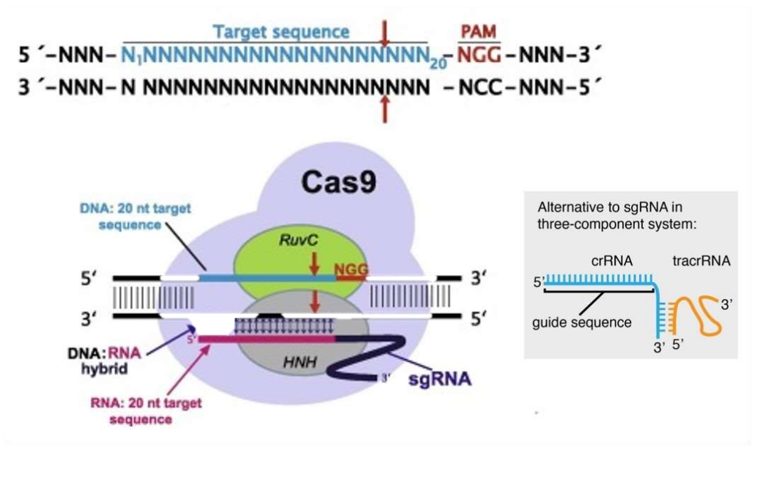
Although several reports of successful CRISPR-mediated gene editing effectiveness are still affected by a number of parameters. The frequency of gene editing in tropical plant species will be determined by the effectiveness of varying levels of conditions including efficient gRNA designing, assembly of multiple gRNA cassettes, delivery of Cas9 and gRNA vectors or ribonucleoproteins (RNP), effective detection of the gene editing event, and the selection and regeneration of edited plantlets.
In contrast to traditional biotechnological procedures, this technology can be employed very efficiently to develop sugarcane borer-resistant lines in a short amount of time and with a high level of precision. CRISPR/Cas9 is developing into a practicable technique for the production of non-transgenic genome-edited crops in order to mitigate the adverse impacts of climate change and ensure the future food security of the expanding populations in tropical countries.
Omics approaches: -
Plant breeding and transgenic technologies may be more precisely applied by combining the use of genomes, proteomics, transcriptomics, and metabolomics. The molecular processes underlying insect tolerance to herbicides, cold, salt, and drought stressors have been better-understood thanks to omics [14].
This approach helps in understanding the complex interaction between genes, proteins, & metabolites. The Gene remodelling mechanism alters the gene expression by new regulatory networks and also helps in the generation of new genes. The major limitation of sugarcane improvement is its large genome size. The genomic library of sugarcane cultivars requires>100,000 clones of BAC (Bacterial Artificial Chromosomes). Transcriptomic approaches can be used as an effective tool for the functional characterization of borer-resistant genes.
It reduces the complexity of data and targets as only active genes are analyzed. Proteomics is a major field of functional genomics but sugarcane proteomics is quite complicated due to the non-availability of standard protein extraction protocols. Rather, the isozyme pattern has already been used as a tool in sugarcane varietal identification and taxonomy. With the help of metabolomics, we can indicate the performance of plants under different environmental conditions including biotic and abiotic stresses.

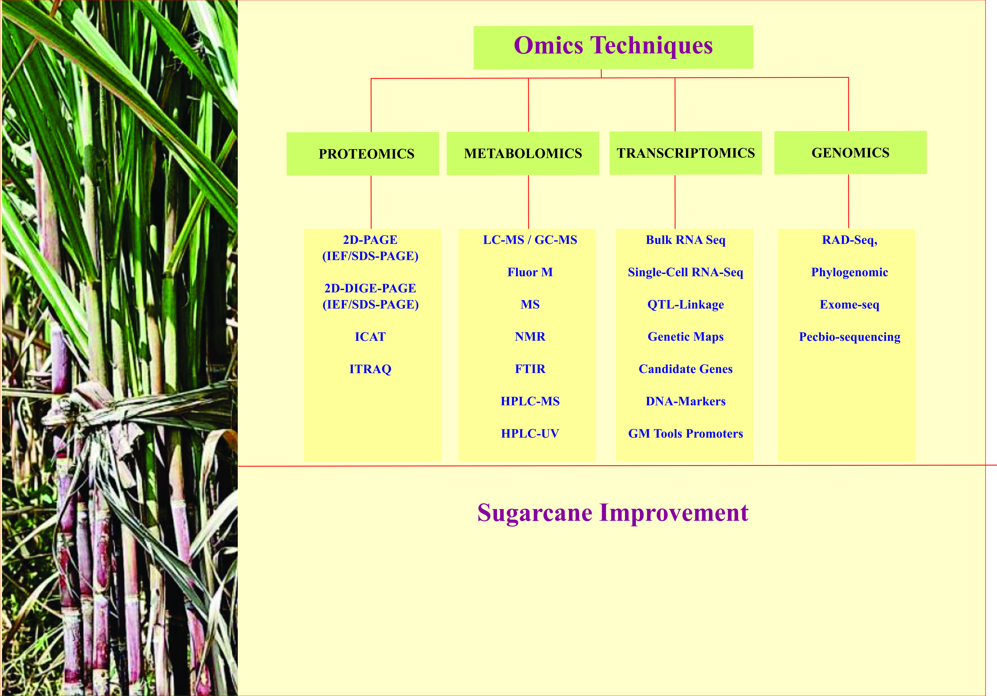
Fig 2: Graphical strategy showing the role of biotechnological interventions for the development of sugarcane. Abbreviations: LC, SDS, Sodium dodecyl sulphate; PAGE, polyacrylamide gel; 2D-DIGE, Two-dimensional difference gel electrophoresis; iTRAQ, Isobaric tags for relative and absolute quantitation; Liquid chromatography; MS, Mass spectrometry; GC, Gas chromatography; Flour-M, Gas chromatography; NMR, Nuclear magnetic resonance; FTIR, Fourier-transform infrared spectroscopy; HPLC, High-performance liquid chromatography; UV, Ultraviolet light; QTL, Quantitative trait loci; GM, Genetics modification; ICAT, Isotope-coded affinity tag; RAD-Seq, Restriction site-associated DNA sequencing.
Metabolome (a set of all the metabolites in a species) is used as a tool for understanding metabolic regulations. MS (Mass spectroscopy) and NMR (Nuclear Magnetic resonance) techniques are commonly used for metabolic profiling. These integrated approaches mainly rely on computational analysis, bioinformatics, and various analytical methods. It is a futuristic approach with great potential for developing reliable sugarcane clones with desirable traits. [17]; [5]
Conclusion
Being an important source of food and biofuel, biotechnology can be implemented substantially in Sugarcane to improve its utility to a tremendous level. Hi-Tech breeding methods using rDNA technology, DNA markers and other biotechnological tools already has been used to improve the lines for several quality traits and against insect pests. Due to the complex polyploidy of cane species, functional genomics using transcriptomics and metabolomics along with bioinformatics and computational analysis can be proved as a genuinely revolutionary method to understand its physiology, structural and functional integrity of genomes, and responses to biotic and abiotic stresses. There is another method for directed mutation in the specific genes has been discovered in the model plant, Arabidopsis thaliana in 2000, popularly called TILLING (Targeting Induced Local Lesions in Genomes). It already has been used as a tool for reverse genetics in Maize, soybean, wheat, rice tomato, etc. and can be successfully implied in sugarcane against borer complexes too, where highly heterozygous mutant lines can be maintained as a variety due to vegetative propagation.
References
Altpeter F, Springer NM, Bartley LE, Blechl A, Brutnell TP, Citovsky V, Conrad L, Gelvin SB, Jackson D, Kausch AP, Lemaux PG, Medford JI, Orozo-Cardenas M, Tricoli D, VanEck J, Voytas DF, Walbot V, Wang K, Zhang ZJ, Stewart, C. Neal., Advancing Crop Transformation in the Era of Genome Editing. The Plant Cell. (2016) doi:10.1105/tpc.16.00196
Alvarez-Alfageme, F., Devos, Y., Camargo, A. M., Arpaia, S., & Messéan, A. Managing resistance evolution to transgenic Bt maize in corn borers in Spain. Critical Reviews in Biotechnology, 2022, 42(2), 201-219.
Benade, M. Effect of cuticle surface and external structures of Lepidoptera larvae on entrapment of pesticide droplets (Doctoral dissertation, North-West University (South Africa) 2022.
Jakka, S., Ferré, J., Jurat-Fuentes, J. L., Soberón, M., Gao, Y., & Bravo, A. Cry toxin binding site models and their use in strategies to delay resistance evolution. Bt Resistance: Characterization and Strategies for GM Crops Producing Bacillus thuringiensis Toxins, eds Soberón M, Gao Y, Bravo A (Centre for Agriculture and Biosciences International, Oxfordshire, UK), 2015, 138-149.
Kaur, K. et al. Role of sugarcane bagasse and bamboo for adsorption of hydrolyzed dyes from Textile effluent: An overview. Journal of Applied and Natural Science, 2018, 10(3): 864 - 875
Leslie, Graeme. Pests of sugarcane. In Sugarcane, ed. G. James, 2004, 78–100. Oxford: Blackwell Science.
Lin, S., Oyediran, I., Niu, Y., Brown, S., Cook, D., Ni, X., ... & Huang, F. Resistance allele frequency to Cry1Ab and Vip3Aa20 in Helicoverpa zea (Boddie)(Lepidoptera: Noctuidae) in Louisiana and three other southeastern US states. Toxins, 2022, 14(4), 270.
Matten, S. R., Frederick, R. J., & Reynolds, A. H. The United States Environmental Protection Agency insect resistance management programs for plant-incorporated protectants and use of simulation modeling. In Regulation of agricultural biotechnology: the United States and Canada (pp. 175-267). 2012, Springer, Dordrecht.
Pinnos, D., Wang, Y., Hernández-Martínez, P., He, K., & Ferré, J. Alteration of a Cry1A Shared Binding Site in a Cry1Ab-Selected Colony of Ostrinia furnacalis. Toxins, 2022, 14(1), 32.
Piperidis, G., Piperidis, N., & D’Hont, A.. Molecular cytogenetic investigation of chromosome composition and transmission in sugarcane. Molecular Genetics and Genomics, 2004, 284(1), 65-73.
Ran, G., Ying, L., Li, L., Yan, Q., Yi, W., Ying, C., Wu, H., Ye, X. Resveratrol ameliorates diet-induced dysregulation of lipid metabolism in zebrafish (Danio rerio). 2017 PLoS One. 12:e0180865.
Romeis, J., Naranjo, S. E., Meissle, M., & Shelton, A. M. Genetically engineered crops help support conservation biological control. Biological Control, 2019, 130, 136-154.
Sanchis, V. From microbial sprays to insect-resistant transgenic plants: history of the biopesticide Bacillus thuringiensis. A review. Agronomy for sustainable development, 2011, 31(1), 217-231.
Van Emon JM. Bioanalytical methods for food contaminant analysis. Journal of AOAC International. 2010 Nov-Dec;93(6):1681-1691. PMID: 21313795.
Wang, Y., Cheng, X., Shan, Q., Zhang, Y., Liu, J., Gao, C., and Qiu, J.L. Simultaneous editing of three homoeoalleles in hexaploid bread wheat confers heritable resistance to powdery mildew. Nat. Biotechnol. 2015, 32: 947–951
Woo Jo, K. N., , K. S., Yi, S., Yang, D. Y., Lim, H. S., Wang, Y., Cheng, H., & Edwards, R. L. Nature, 2015, 526 (7571), E2–E3. https://doi.org/10.1038/nature14977
Yan, Dawei & Zhang, Xiaoming & Zhang, Lin & Ye, Shenghai & Zeng, Longjun & Liu, Jiyun & Li, Qun & He, Zuhua., 2015. The Plant Journal.

