Analysis Of Cloud Performance Using Cloud Simulators For Multi-Scale Applications

Balaraju Lakshmi, Aruna Pavate
Asst. Prof., St. Francis Institute of technology,
Mumbai Maharashtra
balarajulakshmi@sfit.ac.in, arunapavate@sfit.ac.in

ABSTRACT

Cloud Computing is most commonly adopted technology not only by the IT users but as well as researchers. Before deploying any application in real cloud, it is necessary to check with all possible input in order to audit and analyze expected outcome. IT users as well as researchers finds convenient to use the cloud simulation tools to test the developed applications and its scenarios. The most appropriate and accurate simulator gives detailed insight in application study and updating. Many simulators are available for all current technologies. This work aims at comparative analysis of three simulators which can be used for the simulation of multiscale applications. The analysis of these tools is performed using literature surveys and experimentation of multiscale applications. The detailed study shows that CloudAnalyst is most accurate tool currently for multiscale application still few challenges and issues faced in simulation, which need to be resolved. Further the table of analysis gives overall summary of the simulators, helps IT users and researchers to select appropriate tool for multiscale and related applications. The main contribution of this work is to unique view of classification in which, the classification, comparison and analysis is performed by analyzing the code and the actual experiment on the simulators. The proposed comparative analysis gives quick overview and knock to decision making of simulator selection to the cloud practitioners.

Keywords—Cloud Computing, Simulation tools, CloudSim, CloudAnalyst, CloudReports.

1. INTRODUCTION

The cloud and the cloud computing are one of the most current development in the domain of computer technology. Now a day, IT infrastructure and software’s are available to the end users as services using standard pay-as-per use such as infrastructure as service, platform as service, software as service. Cloud computing become more popular as there is advancement in the technologies like utility computing, grid computing, virtualization, web computing and other many technologies. Algorithm and architectures are the major areas of research in the cloud computing domain [1]. It is very difficult in the real scenario to execute real time applications and design new algorithms. For executing real time applications, it is required to consider to security issues as well as performance of the system. To resolve such challenges, cloud computing simulators helps system implementation by considering real time scenarios. Simulators play a significant role in designing new methods like algorithms, observing the security threats, measuring quality and performance of the system. To get the correct environment for executing system in real time scenario, choosing the right simulator is a very tedious and challenging task. As per some cloud practitioners, it is necessary to test and analyze multi-scale applications in a simulated environment to avoid further complications and to get the accurate results. The simulated environment gives the clue to its users to think on what part of the problem they can work and can find better solution or resolve the problem. Testing and validation of such things on real cloud environment such as AWS or GPE is costly and time consuming and also requires special training which is product specific. Usage of simulators saves this cost, time and energy of the work and gives insight of the problems.
In spite of the benefits given by the simulator, the results given by the simulator are not exactly same as that of real cloud. Sometimes surprising results may be produced by the simulators due to its restricted environment testing but from beginner to advance practitioner or researcher, it is necessary to study the preliminary analysis of cloud applications in order to solve the issues faced by such applications. Tools discussed in the related work relevant for task specific testing and validation. There are no cloud simulators which helps for all kind of task validation on cloud, hence it is necessary to study the best simulator for multiscale applications. Following are the research objectives:
1. To study and analysis of most commonly adopted simulations tools for multiscale cloud applications
2. To regulate most appropriate simulator for modeling and simulation of multiscale applications.
The remaining work is organized as section II discusses related works addressing the use of cloud simulators, section III elaborate the most commonly used three cloud simulators, section IV discusses the result and analysis.

2. RELATED WORKS
Many tools developed for simulation in cloud for numerous tasks from application modeling to data center modeling. Cloud simulators have been increasingly get used by many researchers for experimenting using different applications and algorithms [2]- [10]. Many researchers have explored the comparative analysis of different cloud simulators [11]- [13]. This section discussed various cloud simulators explored by researchers. On the other hand, this work does concentrate on detailed study about most commonly preferred cloud simulators. There are number of simulators available for cloud computing environment each of one having unique and different functionalities. These tools include CloudSim[14], CloudAnalyst[15], GreenCloud[16]-[18], NetworkCloudSim[19], Emusim[20], MDCSim[21], iCanCloud[22], CloudExp[23],FederatedCloudSim[24], DynamicCloudSim[25], TeachCloud[26], WorkflowSim[27], ElasticSim[28], MR-CloudSim[29], CloudSimSDN[30], CEPSim[31], CDOSim[32],CloudSched[33], secCloudSim[34], GroudSim[35], MDCSim[36], SimIC[37],SPECI[38], and many more. Recently, more sophisticated tools are also contributed by the researchers. Few of them are CloudSimPlus [39],PriDynSim[40] and ECSNet++[41].

Even though, 2009 was startup for the cloud simulators, a period of three years from 2012 to 2014 can be considered as revolutionary period in cloud simulation community as maximum tools developed during this period of time. Calheiros et. al [42] developed the well-known and widespread tool named CloudSim in 2009. This is first tool which support wide range of input and output parameters. Inspite of non-GUI support, the tool is still most favorite tool amongst the researchers. It is basically used for modeling and simulation of infrastructure of data center [43], basic cloud applications, cost-benefit analysis of resources and algorithmic solutions of Data center and Virtual Machines selection. Depending on the study by different authors cloud simulators categorized into General cloud modelling, Energy Aware Provisioning, Middleware Supervision, Economic Modelling and Application Modelling.
Reference No. | Simulator | Cloud Simulator Categories | Purpose
[15] | CloudAnalyst | General cloud Modelling | Modeling and simulations large scaled applications
[19] | NetworkCloudSim | Application Modelling | Modeling and simulation of the parallel applications.
[20] | EMUSim | Application Modelling | Simulation and performance monitoring of Cloud Computing Applications
[22] | iCanCloud | General cloud Modelling | Simulation of pay-as-you-go scenarios and additional features of flexibility, scalability, performance and usability.
[23] | CloudExp | Application Modelling | Evaluating numerous components in cloud environment like processing cloud systems’ elements, Service Level Agreement (SLA) constraints, web-based applications, Service Oriented Architecture (SOA) etc.
[25] | DynamicCloudSim | VM Provising | Simulation of heterogeneous cloud data centers
[27] | WorkFlowSim | Application Modelling | Experimentation of scientific workflow in distributed systems,
[28] | ElasticSim | VM Provising | Workflow simulations in cloud with detailing of resources such as runtime auto-scaling and stochastic task execution times.
[29] | MRCloudSim | VM Provising | Modeling and simulation of MapReduce computing.
[31] | CEPSim | General cloud Modelling | Complex events processing in cloud environment
[32] | CDOSim | VM Provising | Simulating of cloud deployment
[33] | CloudShed | VM Provising | Real-time virtual machine allocation in a cloud data center
[34] | SecCloudSim | VM Provising | Experimentation of cloud security.
[35] | GroudSim | General cloud Modelling | Computational grids and clouds
[36] | MDCSim | Energy aware provising | Modeling and simulation for multi-tier data center for performance and power consumption monitoring.
[37] | SimIC | General cloud Modelling | Designing and experimenting inter-cloud simulation of large-scale resource management
[38] | SPECI | Middleware Supervision | Scalable data centers simulation
[39] | CloudSimPlus | General cloud Modelling | Simulation of software engineering principles for software improvement.
[40] | PriDynSim. | Application Modelling | Priority base I/O bound applications
[42] | ECSNet++. | VM Provising | Develop the tool for simulating Internet-of-things (IOT) applications using fog and cloud computing
[44] | EdgeNetworkCloudSim | VM Provising | Placement of Service Chains in Edge clouds.
[45] | FTCloudSim | Middleware Supervision | Service reliability enhancement mechanisms .
[46] | FederatedCloudSim | Middleware Supervision | Simulating experiments on resource and services by cloud brokers.
[47] | CloudSimSDN | Middleware Supervision | Modeling and simulation of software-defined cloud data centers.
[48] | Cloud2Sim | General cloud Modelling | Simulation of the concurrent and distributed cloud
[49] | GreenCloud | Energy aware Provising | Reduce data center power consumption, energy-aware cloud computing data centers.
[51] | DCSim | VM Provising | Evaluation of dynamic virtualized resource management
[51] | CloudReports | Energy aware Provising | Energy-aware cloud computing environments
[52] | DISSECT-CF | Energy aware Provising | Foster energy-aware scheduling in infrastructure in cloud
[53] | PICS | VM Provising | IAAS simulation experiments

Table1: Categorizations of cloud simulators
Each tool is used for specific task testing and validation. There is no such tool which is used for all-task- validation. Hence according to our applicability, it is necessary to study the best simulator for multiscale applications study.

3. METHODOLOGY

For the study of multiscale applications with practical experimentation, three most commonly simulation tools are selected as CloudSim, CloudAnalyst and CloudReports

  - CloudSim

CloudSim is an open source software framework based on java which supports many features such as creation of CloudSim entities, queuing and processing of events, communication among components and regulation of the simulation clock, scheduling and provisioning. The cloudsim simulator screen after setting parameter is shown in the figure 1. The first step is to install cloudsim on your local system. Following steps discusses about the simulation workflow.
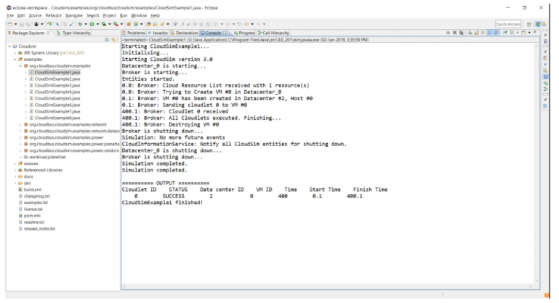
Figure 1: CloudSim after parameter setting

Simulation Workflow:

Main method

Assigning the Number of users such that user count= number of brokers

Initialize the simulation (with current time, number of users and trace flag)

Create datacenter

Create datacenter broker

Create Virtual Machine

Submit virtual machine to datacenter broker

Create Cloudlet(s)

Submit Cloudlets to Datacenter broker

Send call to start simulation

Stop simulation (no events to run

Print the status

PrintCloudletList()

  - CloudAnalyst

Cloud Analyst framework based on CloudSim framework, designed for verifying the performance of large scale applications used over several data centers. CloudReports can be used for implementing IaaS framework with based authentication for evaluation of cloud security [52]. The CloudAnalyst screen is shown in the figure 2.

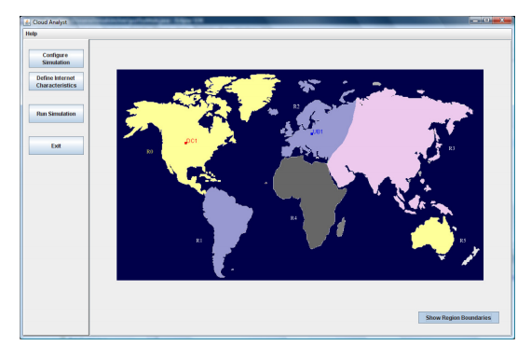
Figure 2 : CloudAnalyst Screen

Simulation Workflow:
1. Define the number of users using Configure Simulation Screen
2. Define hardware and assign the data centers
3.Assigning virtual machines for the multi-scale applications using configuration screen.
4. In configuration screen select the advanced tab for fine tuning the parameters using advanced tab
5. Run Simulation

  - CloudReports
CloudReport [51] is an extension for the CloudSim simulator which supports elasticity to create virtual machines with custom-build configurations, datacenters and hosts also helps to generate reports in the form of charts. CloudReport core components include data center, customer, host, virtual machines, storage area networks and networks as shown in figure 3.
Simulation Workflow:
- Selection of random number of data centers
- Host on data centers configured as per different parameters like RAM size, processing power, network bandwidth and so on.
- Cloudlets are modeled using parameters like length of input, output files, bandwidth, memory and so on
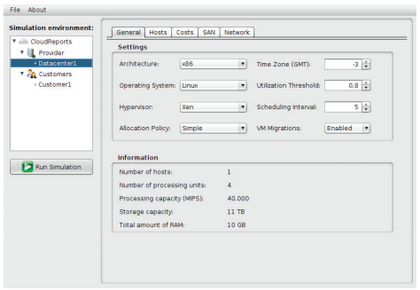
Figure 3 : CloudReport Screen

- RESULTS AND DISCUSSION

For detailed study, the selected tools are analyzed theoretically first and then by performing various experiments in it. Analysis of the simulation frameworks completed using different methods like conjectural analysis,

Conjectural Analysis

The tools are studied by exploring their functionality, code complexity, tool availability theoretical complexity is analyzed on the basic of their performance by space and time complexity

Simulator practice utilization Analysis

First challenge is to determine which tools are more popular amongst the researchers and what is their scope of functionality. The practice utilization analysis of such tools is checked at preliminary task using google scholar which has further result as shown in Table 2

Table 2: Analysis of Cloud Simulator popularity
Tool | Main Citations (Source: google scholar  , as on 15th Jan 2020) | Search results
CloudSim | 1192+4107+491 | 14100
CloudAnalyst | 605+202 | 1690
CloudReports | 26+11 | 475

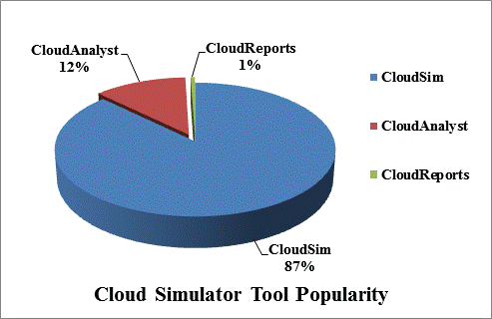

Figure 4: Cloud simulator popularity

The above data is represented using pie-chart as shown in figure 4. This shows that CloudSim is most popular amongst the researchers though it is generic tool and generally not used for cloud application simulation. Hence next popular tool after CloudSim is CloudAnalyst, which is extension of CloudSim further gives more detailed results for multiscale applications.

Experimental Performance Analysis

For the experimental result and analysis, the multiscale applications have been simulated on three selected tools CloudSim, CloudAnalyst and CloudReports. A multiscale application in cloud is that one which operates on multiple segments. It can be viewed as the application which consists of multiple requests of variable data type and data size, such application and its typical minor parameters are experimented in using three tools. For the experimental setup, all these tools are executed on Windows 7 platform. The experimental parameters used in the experiment are same. Following Table-3 is the list of parameters considering multiscale application and Table-4 is list of parameters used for data center setup in the experiments.

Table-3: Parameters tune for Multiscale Application
Parameter | Value
Cloudlet length (number of requests) | 50,000
File Size | 500 Bytes
No. of users  /customers | 1000

Based on following selected criteria, the tools can be ranked on the basis of quality of selected parameters given by each tool. These qualities are represented by numerical values where lowest values indicate highest rank.

Table-4: Parameters tune for data centers
Parameter | Value
Image Size | 1000
Processing Elements | 1
RAM | 512
Bandwidth | 100000
Priority | 1
Hypervisor | Xen
Scheduling | Dynamic
Policy | Workload
Data Center Broker Policy | Round Robin

Based on following selected criteria, the tools can be ranked on the basis of quality of selected parameters given by each tool. These qualities are represented by numerical values where lowest values indicate highest rank.

Table-5 : Ranking number given to the simulator with respect to comparison parameter
Tools→ | Rank to the tools
Parameter | CloudSim | CloudAnalyst | CloudReports
Citations and popularity | 3 | 2 | 1
User Friendliness | 1 | 3 | 2
GUI Support | 2 | 3 | 3
Open Source | 3 | 3 | 3
Coding Updation | 2 | 3 | 2
Modification of GUI, Layout | 1 | 3 | 3
Compactness | 1 | 2 | 2
Ease of understanding | 1 | 3 | 3
Complexity | 1 | 2 | 3
Performance w.r.t. response time | 2 | 3 | 1
Output parameters | 3 | 2 | 1

Parameter | CloudSim | CloudAnalyst | CloudReports
User friendliness | Less | More | More
GUI Support | No | Yes | Yes
VM Allocations  Algorithms | Round robin | Round Robin  Active Monitoring | Round Robin
DC Selection Algorithms | Round Robin | Round Robin | Round Robin
Input Parameters  with respect to multiscale applications | File size | Data Size | File size Number of customers
Output Parameters | Resource utilization | Response time | Resource utilization, CPU Utilization
Scope of simulation | 1.Large scale data centers  Virtualization  2. Application containers  3. Energy-aware computational resources  4. Data center network topologies  5.Message-passing applications  6. Federated clouds  7. User-defined policies | 1.Large scale data centers  2.Large scale applications  3.Cost benefit analysis of large applications  4. Social networking applications | 1.Infrasture as a Service  2. Green Computing  3.Hardware Scaling  4.Experiments based on server and data center components in detail
Algorithm Addition Opportunity in | Service Broker Policy, VM, Scheduler Policy | Service Broker Policy, VM Scheduler Policy, Load Balancing Policy | Service Broker Policy, VM Scheduler Policy, Load Balancing Policy, CPU Utilization Policy, RAM Utilization Policy, Bandwidth Utilization  Policy
Strengths | Generalized Simulation | Generalized Simulation | Generalized Simulation
Limitations considering  multiscale applications | File type is not considered | Data type is not considered | Data type and number of  requests per user is not considered
Lacking Parameters | Data type, no. of requests per user, response time per request, throughput, number of requests processed | Data type, throughput, number of requests processed | Data type, no. of requests per user, response time per request, throughput, number of requests  processed
Size on Disk | 63.9 MB | 7.35 MB | 33.4 MB
No. files in tool | 12,291 | 398 | 774

Table 6: Parameters of consideration for simulators comparison

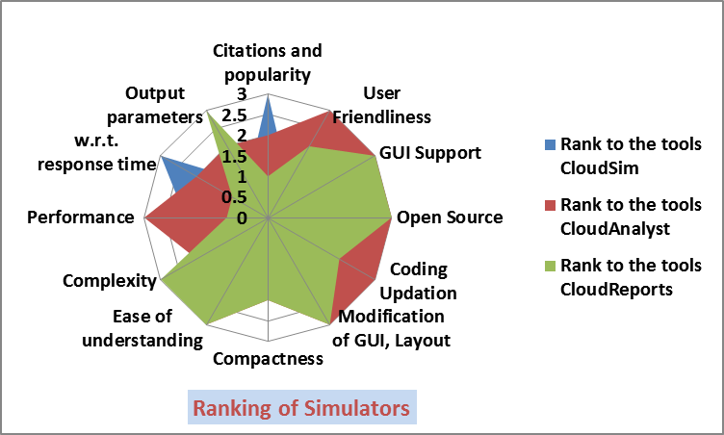
Figure 5: Ranking of Cloud Simulators with respect to simulation of multiscale applications

Figure 5 represents by plotting data using radar chart, it is observed that most of the area covered by CloudReports and CloudAnalyst, hence these two simulators are best at the moment for multiscale applications. CloudAnalyst has occupied maximum area, hence CloudAnalyst is best player in these three simulators game of multiscale applications.

Following are the research Challenges noted in selected simulation tools:

Need to incorporate more input parameters
There are many parameters in multiscale applications such as data type, data size, file extensions etc. In this case data type is not at all considered in any of the tool. Hence the tool can be updated with the parameter also other parameters such as file extension can be considered. In simulation of cloud applications various types of applications are considered which further need to be extended for more modern and sophisticated applications.

Need to incorporate more output parameters
Currently all the simulators have focused on various response times. Along with this there are many other factors, based on which performance can be analyzed. Along with response time, waiting time turnaround time, throughput also plays important role in performance analysis.

Modeling SAAS Layer
There is need to model and simulate entire SAAS layer in simulator. Detailed SAAS layer should include simulation of all requirements of applications hosted on cloud systems and their experimentation should be given as nearer realistic results.

Direct Support to multiscale applications

Currently no simulator is dedicated for multiscale applications. Multiscale applications are the real time applications that are being used by majority of cloud users, which further need to study for better and effective utilization. For better development of such applications and their deployment, for such applications study, dedicated tools are necessary.

- CONCLUSION

In this work, three simulation tools have been studied namely CloudSim, CloudAnalyst and CloudReports. These simulators are generally used for large scaled applications modeling. The detailed comparative analysis using theoretical as well as experiment of multiscale applications has performed by considering different paramerters. This work analyzed that none of the tool is perfect for multiscale applications, but CloudAnalyst is best tool at the moment for multiscale applications. There are still many issues and challenges yet need to be analyzed using cloud simulation tool. Also, it is necessary to develop new simulation environment tool explicitly for multiscale applications.

REFERENCES

- Divya Kumawat1, Aruna Pavate2, Suvarna Pansambal3,” Fog Computing and Its Comparative Study with Other Cloud Based Technologies “, IOSR Journal of Engineering (2018) IOSRJEN ISSN (e): 2250-3021, ISSN (p): 2278-8719 Volume 7, PP09-12
- Xue F, Su Q. Intelligent task scheduling strategy for cloud robot based on parallel reinforcement learning. Int J Wirel Mobile Comput. 2019;17(3):293–9.
- Naranjo PGV, Pooranian Z, Shojafar M, Conti M, Buyya R. FOCAN: a Fog-supported smart city network architecture for management of applications in the Internet of Everything environments. J Parallel Distrib Comput. 2019;132:274–83
- Garg D, Kumar P. Evaluation and improvement of load balancing using proposed cuckoo search in CloudSim. In: International Conference on advanced informatics for computing research, 2019, pp 343–358
- Singh BP, Kumar SA, Gao XZ, Kohli M, Katiyar S. A study on energy consumption of DVFS and Simple VM consolidation policies in cloud computing data centers using CloudSimToolkit. Wirel Pers Commun. 2020
- Zhang H, Shi J, Deng B, Jia G, Han G, Shu L. MCTE: minimizes task completion time and execution cost to optimize scheduling performance for smart grid cloud. IEEE Access. 2019;7:134793–803
- Alresheedi SS, Lu S, Elaziz MA, Ewees AA. Improved multiobjective salp swarm optimization for virtual machine placement in cloud computing. Human-centric Comput Inf Sci. 2019;9(1):15.
- Abdel-Basset M, Abdle-Fatah L, Sangaiah AK. An improved Lévy based whale optimization algorithm for bandwidth-efcient virtual machine placement in cloud computing environment. Clust Comput. 2019;22(4):8319–34
- Mahmud R, Srirama SN, Ramamohanarao K, Buyya R. Quality of Experience (QoE)-aware placement of applications in Fog computing environments. J Parallel Distrib Comput.2019;132:190–203
- Annamalai S, Udendhran R (2019) Role of Cloud Computing in On-Line Social Networking and In-Depth Analysis of Cloud-Sim Simulator. In: Novel Practices and Trends in Grid and Cloud Computing, p. 34–46.
- Panwar, R., & Mallick, B.A comparative study of load balancing algorithms in cloud computing International Journal of Computer Applications, 2015, 117(24).
- Fakhfakh, F., Kacem, H. H., & Kacem, A. H. (2017, May). Simulation tools for cloud computing: A survey and comparative study. In 2017 IEEE/ACIS 16th International Conference on Computer and Information Science (ICIS) (pp. 221-226).
- Bahwaireth, K., Benkhelifa, E., Jararweh, Y., & Tawalbeh, M. A. (2016). Experimental comparison of simulation tools for efficient cloud and mobile cloud computing applications. EURASIP Journal on Information Security, 2016(1)
- Calheiros RN, Ranjan R, Beloglazov A, De Rose CA, Buyya R. CloudSim: a toolkit for modeling and simulation of cloud computing environments and evaluation of resource provisioning algorithms. Softw Pract Exp. 2011.
- Wickremasinghe B, Calheiros RN, Buyya R. Cloudanalyst: a cloudsim-based visual modeller for analysing cloud computing environments and applications. In: Proceedings of 24th IEEE International Conference on advanced information networking and applications (AINA), 2010
- Kliazovich D, Bouvry P, Audzevich Y, Khan SU. GreenCloud: a packet-level simulator of energy-aware cloud computing data centers. J Supercomput. 2012
- Chen G, He W, Liu J, Nath S, Rigas L, Xiao L, Zhao F. Energy-aware server provisioning and load dispatching for connection-intensive internet services. In: 5th USENIX Symposium on networked systems design and implementation, Vol. 8, pp. 337-350, 2008, April.
- hang L, Peh LS, Jha NK. Dynamic voltage scaling with links for power optimization of interconnection networks. In: Proceedings of the Ninth International Symposium on high-performance computer architecture, (HPCA-9 2003), 2003
- Garg SK, Buyya R. Networkcloudsim: Modelling parallel applications in cloud simulations. In: Proceedings of the 2011 Fourth IEEE International Conference on Utility and Cloud Computing (UCC), 2011, December,
- Calheiros RN, Netto MA, De Rose CA, Buyya R. EMUSIM: an integrated emulation and simulation environment for modeling, evaluation, and validation of performance of cloud computing applications. Softw Pract Exp. 2012.
- Lim SH, Sharma B, Nam G, Kim EK, Das CR. MDCSim: a multi-tier data center simulation, platform. In: Proceedings of IEEE International Conference on Cluster Computing and Workshops (CLUSTER’09), August 2009.
- Nunez A, Vazquez-Poletti JL, Caminero AC, Castané GG, Carretero J, Llorente IM. iCanCloud: a flexible and scalable cloud infrastructure simulator. J Grid Comput. 2012
- Jararweh Y, Jarrah M, Alshara Z, Alsaleh MN, Al-Ayyoub M. CloudExp: a comprehensive cloud computing experimental framework. Simul Model Pract Theory. 2014.
- CCB '14: Proceedings of the 2nd International Workshop on CrossCloud SystemsDecember 2014 Article No.: 3 Pages 1–5
- Bux M, Leser U. Dynamiccloudsim: simulating heterogeneity in computational clouds. Future Gener Comput Syst. 2015.
- Yaser Jararweh, Zakarea Al-Shara, Moath Jarrah, Mazen Kharbutli, Mohammad Alsaleh. TeachCloud: a cloud computing educational toolkit. International Journal of Cloud Computing, Inderscience Publishers, 2013, 2 (2/3), pp.237
- Chen W, Deelman E. Workflowsim: A toolkit for simulating scientific workflows in distributed environments. In: Proceedings of the 2012 IEEE 8th International Conference on E-Science (e-Science), 2012, October
- Cai, Z., Li, Q. & Li, X. ElasticSim: A Toolkit for Simulating Workflows with Cloud Resource Runtime Auto-Scaling and Stochastic Task Execution Times. J Grid Computing 15, 257–272 (2017).
- Jung, Jongtack & Kim, Hwangnam. (2012). MR-CloudSim: Designing and implementing MapReduce computing model on CloudSim. 504-509. 10.1109/ICTC.2012.6387186.
- Lantz B, Heller B, McKeown N. A network in a laptop: rapid prototyping for software-defined networks. In: Proceedings of the 9th ACM SIGCOMM Workshop on Hot Topics in Networks, 2010, October
- Higashino WA, Capretz MA, Bittencourt LF. CEPSim: modelling and simulation of complex event processing systems in cloud environments. Future Gener Comput Syst. 2016
- F. Fittkau, S. Frey and W. Hasselbring, "CDOSim: Simulating cloud deployment options for software migration support," 2012 IEEE 6th International Workshop on the Maintenance and Evolution of Service-Oriented and Cloud-Based Systems (MESOCA), Trnto, 2012, pp. 37-46, doi: 10.1109/MESOCA.2012.6392599.
- , W., Xu, M., Chen, A., Li, G., Wang, X., Chen, Y.: Open-source simulators for cloud computing: comparative study and challenging issues. Simul. Model. Pract. Theory 58, 239–254 (2015)
- U. U. Rehman, A. Ali and Z. Anwar, "secCloudSim: Secure Cloud Simulator," 2014 12th International Conference on Frontiers of Information Technology, Islamabad, 2014, pp. 208-213, doi: 10.1109/FIT.2014.47
- Ostermann S, Plankensteiner K, Prodan R, Fahringer T. GroudSim: an event-based simulation framework for computational grids and clouds. In: European Conference on parallel processing, Springer, Berlin, Heidelberg, 2010, August
- Lim SH, Sharma B, Nam G, Kim EK, Das CR. MDCSim: a multi-tier data center simulation, platform. In: Proceedings of IEEE International Conference on Cluster Computing and Workshops (CLUSTER’09), August 2009
- Sotiriadis S, Bessis N, Antonopoulos N, Anjum A. SimIC: Designing a new inter-cloud simulation platform for integrating large-scale resource management. In: Proceedings of the 2013 IEEE 27th International Conference on Advanced Information Networking and Applications (AINA), 2013, March
- Sriram, I. (2009, December). SPECI, a simulation tool exploring cloud-scale data centres. In IEEE International Conference on Cloud Computing (pp. 381-392). Springer, Berlin, Heidelberg.
- Silva Filho, M. C., Oliveira, R. L., Monteiro, C. C., Inácio, P. R., & Freire, M. M. (2017, May). CloudSim plus: a cloud computing simulation framework pursuing software engineering principles for improved modularity, extensibility and correctness. In 2017 IFIP/IEEE Symposium on Integrated Network and Service Management (IM) (pp. 400-406). IEEE
- Jain, N., Grozev, N., Lakshmi, J., & Buyya, R. (2015, November). PriDynSim a Simulator for Dynamic Priority Based I/O Scheduling for Cloud Applications. In 2015 IEEE International Conference on Cloud Computing in Emerging Markets (CCEM) (pp. 8-15). IEEE
- Amarasinghe, G., de Assunção, M. D., Harwood, A., & Karunasekera, S. (2019). ECSNeT++: A simulator for distributed stream processing on edge and cloud environments. Future Generation Computer Systems.
- Calheiros, R. N., Ranjan, R., Beloglazov, A., De Rose, C. A., & Buyya, R. (2011). CloudSim: a toolkit for modeling and simulation of cloud computing environments and evaluation of resource provisioning algorithms. Software: Practice and experience, 41(1), 23-50.
- Asad W. Malik, Kashif Bilal, S. U. Malik, Zahid, Anwar et al. "CloudNetSim++: A GUI Based Framework for Modeling and Simulation of Data Centers in OMNeT++", IEEE Transactions on Services Computing, 2017
- Seufert, M., Kwam, B. K., Wamser, F., & Tran-Gia, P. (2017, July). Edgenetworkcloudsim: Placement of service chains in edge clouds using networkcloudsim. In 2017 IEEE Conference on Network Softwarization (NetSoft) (pp. 1-6).
- Zhou, A., Wang, S., Sun, Q., Zou, H., & Yang, F. (2013, December). Ftcloudsim: A simulation tool for cloud service reliability enhancement mechanisms. In Proceedings Demo & Poster Track of ACM/IFIP/USENIX International Middleware Conference (pp. 1-2).
- Kohne, A., Spohr, M., Nagel, L., & Spinczyk, O. (2014, December). FederatedCloudSim: a SLA-aware federated cloud simulation framework. In Proceedings of the 2nd International Workshop on CrossCloud Systems (pp. 1-5).
- Son, J., Dastjerdi, A. V., Calheiros, R. N., Ji, X., Yoon, Y., & Buyya, R. (2015, May). Cloudsimsdn: Modeling and simulation of software-defined cloud data centers. In 2015 15th IEEE/ACM International Symposium on Cluster, Cloud and Grid Computing (pp. 475-484). IEEE.
- Kathiravelu, P. (2016). An elastic middleware platform for concurrent and distributed cloud and mapreduce simulations. arXiv preprint arXiv:1601.03980.
- Liu, L., Wang, H., Liu, X., Jin, X., He, W. B., Wang, Q. B., & Chen, Y. (2009, June). GreenCloud: a new architecture for green data center. In Proceedings of the 6th international conference industry session on Autonomic computing and communications industry session (pp. 29-38).
- Tighe, M., Keller, G., Bauer, M., & Lutfiyya, H. (2012, October). DCSim: A data centre simulation tool for evaluating dynamic virtualized resource management. In 2012 8th international conference on network and service management (cnsm) and 2012 workshop on systems virtualiztion management (svm) (pp. 385-392). IEEE.
- Sá, T. T., Calheiros, R. N., & Gomes, D. G. (2014). CloudReports: An extensible simulation tool for energy- aware cloud computing environments. In cloud computing (pp. 127-142). Springer, Cham.
- Kecskemeti, G. (2015). DISSECT-CF: a simulator to foster energy-aware scheduling in infrastructure clouds. Simulation Modelling Practice and Theory, 58, 188-218
- Kim, I. K., Wang, W., & Humphrey, M. (2015, June). Pics: A public iaas cloud simulator. In 2015 IEEE 8th International Conference on Cloud Computing (pp. 211-220). IEEE.

