Dependence of Population Growth with Food Production, Per Capita Income and Variations of Birth-Death Rates through Population Theories
Arunima Konar^{1*}, Arindam Ghosh², Piyali Dutta³ and Ananya Ghosh⁴
*Corresponding email-Id: arunima.k@snuniv.ac.in

^{1*}Department of Agricultural Economics, ²Department of Agricultural Extension, ³Department of Horticulture and ⁴Department of Agronomy.
School of Agricultural Sciences, Sister Nivedita University, Newtown, Kolkata
Introduction:
Population growth depends on food production as well as food supply, standard of living, per capita income, crude birth rates and crude death rates. The Theory of Population is studied because the supply of labour depends upon population and its growth. Observing the abnormal growth of population and consequent fall in the standard of living.
- Malthusian Theory of Population:
Thomas Malthus (1760-1834) an English Clergyman first studied population growth in various countries of Europe. Later he wrote a book entitled, “An Essay on the Principles of Population” in 1798. His theory is popularly known as Malthusian Theory of Population. To quote the theory in his own words,
“By nature, human food increases in a slow arithmetic ratio, man himself increases in a quick geometric ratio unless want and vice stop him”
1.1 Rapid growth of population:
Thomas Malthus theorized that populations grew in geometric progression. Population increases very rapidly. Geometric progression means increase by multiplication. A geometric progression is a sequence of numbers where each term after the first is found by multiplying the previous one by a fixed, non-zero number called the common ratio. For example, in the sequence 2, 10, 50, 250, 1250, the common ratio is 5.
1.2 Slow growth of food supply:
The food supply of a country increases at a much slower rate. He stated that food production increases in arithmetic progression. An arithmetic progression is a sequence of numbers such that the difference between the consecutive terms is constant. For example, in series 2, 5, 8, 11, 14, 17, the common difference of 3. He derived this conclusion due to the Law of Diminishing Returns. From this, we can conclude that populations will grow faster than the supply of food. This exponential population growth will lead to a shortage of food.
As a result of the difference between the rate of growth of population and the rate of growth of food supply we find that in every country, sooner or later, food shortage occurs. This is the stage of over-population.

1.3 The Malthusian Cycle:

When this stage comes, grave problems arise. Shortage of food causes malnutrition, famine, disease and pestilence. Hunger leads to invasions and war. These are called by Malthus, the positive checks. As a result of the operation of the positive checks, population is reduced and the balance with food is restored. But the balance is a short-lived one. For, the inherent urge to multiply soon asserts itself and population again increases and overtakes the food-supply.

The sequence of events (called the Malthusian Cycle) can be shown as follows:
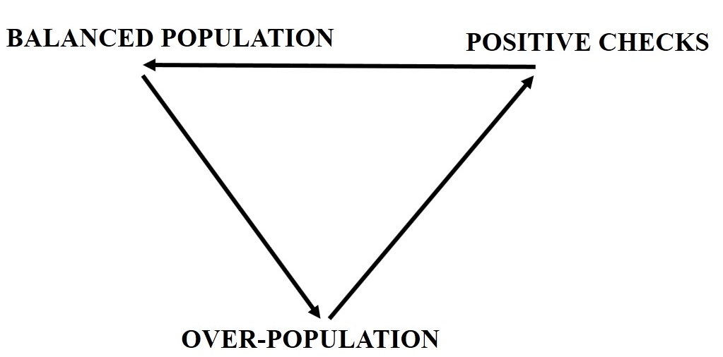

Fig1. Malthusian Cycle

1.3.1 Positive checks/ Natural checks:

These are the checks caused by the nature when man fails to take control of the situation. These checks cause the reduction of excess population and thereby bring and equilibrium between demand and supply. We have often the famines, epidemics, wars, floods, earthquakes, etc. These positive checks are caused by nature.

1.3.2 Preventive Checks:
To correct the imbalance, Malthus also suggested using preventative measures to control the growth of the population. These measures include family planning, late marriages, and celibacy (abstinence from marriage), moral restraints.
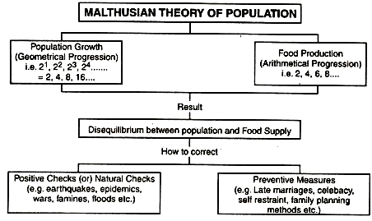
1.4 The Malthusian Trap/ Malthusian Population Trap /point of crisis/ Malthusian Check/ Malthusian Catastrophe/ Malthusian Spectre/ Malthusian Crisis/ Malthusian Crunch:
Malthusian Trap is the idea that higher levels of food production created by more advanced agricultural techniques create higher population levels, which then lead to food shortages because the higher population needs to live on land that would have previously used to grow crops.
Even as technological advancement would normally lead to per capita income gains, theorizes Malthus, these gains are not achieved because in practice the advancement also creates population growth. Once the population exceeds what food supplies can support, this supposedly creates a Malthusian crisis with widespread famine as well as rampant disease. This ends up decreasing the population to earlier levels.
The reality, however, has been that population growth has not itself created the crisis that Malthus predicted. We will discuss the ways in which the Malthusian Trap has been disproven in the following section.
We can determine the total amount of food needed by multiplying the population in any period by the amount of food required to keep one person alive. Because population grows exponentially, food requirements rise at an increasing rate, as shown by the curve labelled “Food required.” Food produced, according to Malthus, rises by a constant amount each period; its increase is shown by an upward-sloping straight line labelled “Food produced.” Food required eventually exceeds food produced, and the Malthusian trap is reached at time t1. The faster the rate of population growth, the sooner t1 is reached.
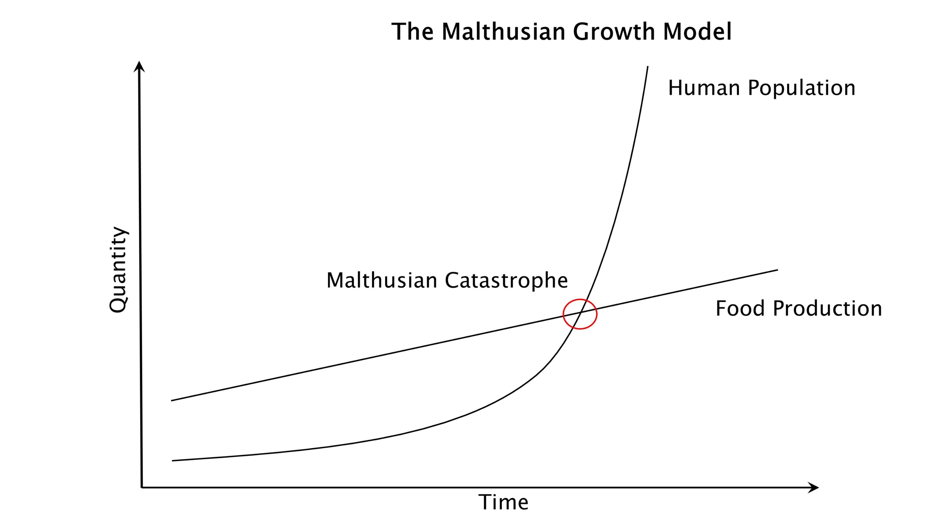
Fig2. Malthusian Trap

1.5 Criticism of Malthusian Theory of Population:
This theory was criticized by many economists on several grounds. Some of the important ones are presented below:
- Growth formulas not correct: Presenting the mathematical precision for population growth and food production was objected because as these ratios are found to be unrealistic. There were no instances in the world, where this trend of population growth and food production recorded and the case of doubling population.
- The effects of additional population: Malthus did not foresee the scientific advances that are bound to come in agricultural production, even in the presence of operation of law of diminishing returns.
- Less agricultural production: Malthus did not consider total production of nation but confined to agricultural production alone while presenting his theory. In fact it is total production of a country which gives the true picture of its economic position. Consider the example of Great Britain. It was not self-sufficient in agricultural production but it could make great progress through its industrial production. Less agricultural production cannot make the country over-populous.
- Economic growth and per capita income: It were viewed that increase in population would cause greater demand for food gains, ignoring its contribution in the population of goods and services. Further it was criticised that increase in population in an overpopulated country is a matter of serious concern, as it imposes heavy strain on the limited resources of the nation. In respect of an under populated country, increase in population is a welcome sign and it helps to raise economic growth and per capita income.
- Education and civilization: Malthus also failed to view that the education and civilization would transform the people to have small families. Hence, there would be no danger of over population.
- Natural calamities: Natural calamities which are in fact the acts of nature are commonly found everywhere regardless of whether a particular country is over populated or under populated. So, the statement that natural calamities would occur only in the over populated countries to reduce population is not true.
- Optimum Theory of Population:
The Optimum Theory of Population appeared as a reaction to the Malthusian theory. Criticizing the approach of the Malthusian Theory of Population, modern economists Edwin Cannon and Carr Saunders of London School of Economics have developed a new theory known as Optimum Theory of Population. Initially, Prof. Sidgwick gave the foundation of the optimum theory in his principles of political economy.
It is also called Modern Theory of Population. In recent years, Prof. Robbins, Dalton and Carr- Saunders have refined and polished the theory and put it in a more presentable form. This theory is an improvement over the Malthusian Theory.
2.1 Statement of the Theory:
The founders of the theory state it as “Given the natural resources, stock of capital and the state of technical knowledge, there will be a definite size of population with the per capita income. The population which has the highest per capita income is known as optimum population”.
2.2 Optimum Population:
The economists like Carr Saunders considered ‘optimum population’ as that which produces maximum welfare. On the other hand, Prof. Cannon defined this theory in terms of ‘return to labour’. He remarked, “Knowledge and circumstances remaining the same, there is what may be called maximum return when the amount of labour is such that both an increase and decrease in it would diminish proportionate return.” Similarly, Bounding has rightly observed, “Optimum population is that at which standard of living is maximum.”
2.3 Under-Population:
If the actual population in a country is less than the optimum or ideal population, there will not be enough people to exploit all the resources of the country fully. Thus, the population and the per capita income will be lower. In other words, if the per capita income is low due to too few people, the population is then under population.

2.4 Over-Population:
If the actual population is above the level of optimum population, there will be too many people to work efficiently and produce the maximum goods and the highest per capita income. As a result, the per capita income becomes poorer than before. This is the stage of over population. In other words, if the per capita income is low due to too many people, the population under these circumstances would be over population.
2.5 Assumptions:
The optimum theory is based on two important assumptions:
- The proportion of working population to total population remains constant as the population of the country increases.
- As the population of a country increases, the natural resources, the capital stock and state of technology remain unchanged.
2.6 Diagrammatic Representation of the Theory:
The optimum Theory of Population can be shown by the diagram as follows:
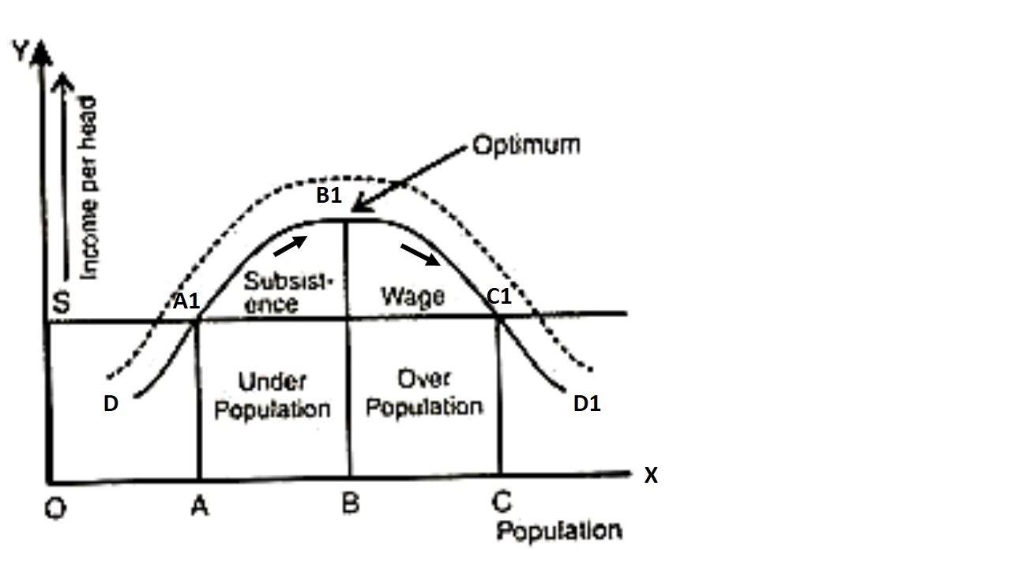
Fig3. Optimum Theory of Population
Let, OX represents population and OY represents income or product (per head). The curve DB1D1 shows the income per head corresponding to the different sizes of population. The maximum income is BB1 is achieved when population is OB. Therefore, OB is the optimum population. At this level of population (optimum population) the per capita output is highest and is equal to BB1. A glance at the diagram shows that when population is OA, the income per head is AA1, which is less than BB1. When population is OC, the income per head is CC1, which is also less than BB1. That means, any further increase of population beyond the BB1 leads to reduction of output per capita.
If the actual population of a country is less than the optimum population BB1, it is under populated and if it is more, it is over-populated.
Therefore, the curve DB1D1 is ‘hunch’ shaped. It shows the effect of population growth, with constant resources, on income per head.
2.7 Dalton’s Formula for Maladjustment:
Dalton’s maladjustment means the extent of deviation of population from optimum size of population. To measure maladjustment, Dalton gave the following formula:
M = (A – O)/ O
Where, M = maladjustment
A = Actual population
O = Optimum population
If A is less than O, the country is under-populated. If A is greater than O, the country is over-populated.
A positive ‘M’ indicates that the country is over-populated.
A negative ‘M’ indicates that the country is under-populated.
A zero value of ‘M’ indicates that the actual population is equivalent to optimum population.
2.8 Criticism of Optimum Theory of Population:
- A static concept: The concept of optimum population is a static concept, inapplicable and irrelevant to a dynamic world. The size of the optimum population depends on the capital resources, the techniques of production, the modes on business organizations and the rate of investment. As all these factors are constantly changing, optimum must be fluctuating figure.
- Not measurable: The curve DB1D1 shows the real income (or the product) per head, the line BB1 shows the maximum income and OB is the optimum population. Unfortunately, the curve cannot plot with accuracy.
- It is materialistic: In concentrates attention on the maximization of the real income per head of the population, real income constitutes a large number of goods and services, some of which do not bring the welfare of the people.
- Not useful: According to Myrdal, the theory “is a speculative figment of the mind without any real connection with the world”. The optimum theory cannot be used for the purpose of formulating a population policy.
- Malthusian Theory vs. Optimum Theory:
- Population growth:
The Malthusian Theory is a theory of population growth. It discusses the rate of growth of population and the effects of such growth on the community.
The Optimum Theory is not a theory of population growth. It discusses the relationship between the number of people living in a country and its productive resources.
- Food supply and total output:
The Malthusian Theory concentrate attention on food supply.
The Optimum Theory concentrate attention on the total output, industrial as well as agricultural.
- Over-population vs. optimum population:
The Malthusian Theory defines over-population in terms of food supply. A country is over-populated if it does not produce enough food to feed its population.
The Optimum Theory defines over-population in terms of productivity. A country is over-populated if it contains more people than what is required for the best utilisation of its productive resources.
iv. Pessimism vs. Optimism:
The Malthusian Theory is highly pessimistic. He defined those men are bound to go through the cycle of over-population, misery, and death, a short period of balance between food and population and again over-population.
The Optimum Theory is highly optimistic. There is no danger from population increase as long as it does not exceed the number required for the optimum utilisation of the productive resources of the country.
v. Dynamic theory vs. static theory:
The Malthusian Theory is a dynamic theory. It deals with the course of population growth over a period of time.
The Optimum Theory is static in its approach. It considers the population problem with reference to a particular stage in the country’s development.
The Malthusian Theory has a large number of believers even now. The Optimum Theory has been practically discarded by modern economists. The current trend is to prefer the biological approach to the population: The Theory of Demographic Transition.
- The Theory of Demographic Transition- The Logistic Curve:
The rate of growth of population varies from time to time in every country. If the rate of population growth is graphically charted it looks like the ~ shaped curve known in mathematics as the Logistic Curve. This shows that population increases first very slowly then comparatively rapidly and finally becomes either stationary or declines.
Stage I: It is known as the early stage of development of a country. There are obstacles to the growth of population like lack of security, lack of food, unfavourable social customs. Therefore, population grows slowly. This situation is found in tribal communities and primitive civilisations.
Example: Bangladesh Rainforest Tribes
Stage II: It is known as the intermediate stage of development of a country. These obstacles are removed and population grows rapidly during the intermediate stage of demographic transition. This stage has been termed as the stage of “Population Explosion”. The impact of this explosion in the overall economy of a country can be measured from the fact that it creates an imbalance in the economy. For a balanced adjustment of the economic instability, a period of transition is required and hence the theory is termed as the theory of demographic transition.
Example: among the Aryans in ancient India and in U.S.A. in the 19th century the rate of population growth was high.
Stage III: It is known as the final stage of development of a country. As soon as community reaches an advanced stage of civilisation, the rate of growth becomes steady or declines.
Example: This situation is found in U.K., France and other European countries.
Thus, demographic evolution of a society can be evaluated from the relationship between variations of birth and death rates and the growth rate of population.
In this figure, Crude birth rate and death rate is measured on Y- axis and time on X- axis. AB is the stage-I, high fluctuating stage. This stage is a state of high birth and death rates culminating in low population growth overall. Here, both birth and death rates are quite high. Birth rates and death rates are effectively in balance. Stage-I is found in Bangladesh Rainforest Tribes as present world examples.
BD is the stage-II, expanding stage. The shaded portion BCDFB is the natural increase in population. In stage II, BCD is the birth rate. Here, BC portion represents a consistently high birth rate and after the point C, birth-rate falls and the death-rate remains low throughout the stage-II. This situation is found in Peru, Sri Lanka, Kenya as present world examples.
DE is the stage-III, low fluctuating stage. Traditionally considered to be the final stage, this is one of demographic stabilization, in which both birth and death rates are low. This means that the overall population stays fairly low. This situation is found in Canada, Japan and USA as present world examples.
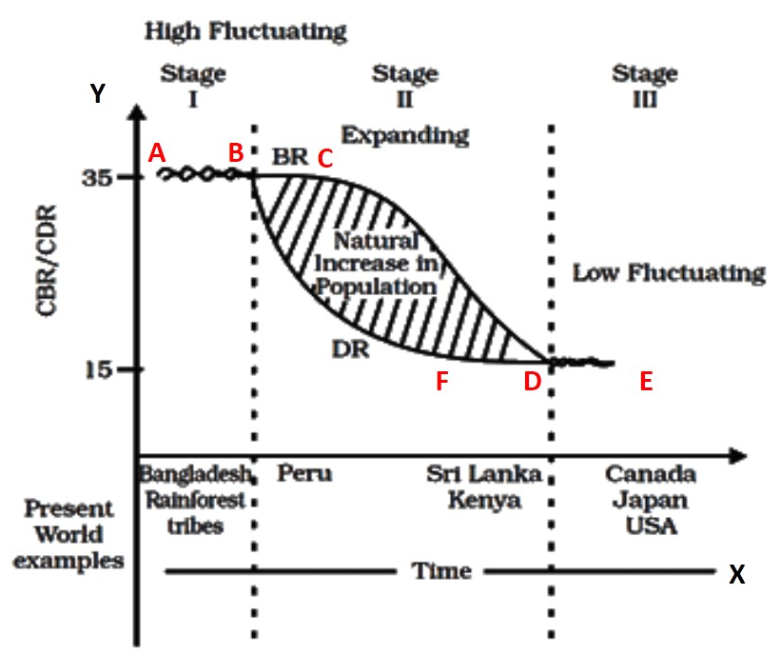
Fig4. Logistic Curve
- Determinants of Population Growth:

Fertility:
Fertility, occurrence of birth per year, is one of the most important indicators of population growth. Fertility is a general term with many varieties. But two most important measures of fertility are Crude Birth Rate (C.B.R.) per year and General Fertility Rate (G.F.R.) per year. Crude birth rate is the number of births per year per thousand, expressed by the formula
CBR = B/P × 1,000
Where, B is number of birth/year and P is the total population.
This measure gives us the idea of net increase of population per year in a region but fails to give us the potential increase in future course of time as every person (male and female, both) is taken into consideration.
The General Fertility Rate or G.F.R. is, however, considered only for reproductive females. It is expressed by the formula
GFR = B/P × 1,000
Where B is the no. of birth per year while P refers to the number of productive women.
Fertility decline has been given priority in underdeveloped and developing countries to check the population growth. Improvement of mass education system, reduction of child death and expansion of family control programme are the keys to check disproportionate fertility rate in developing countries. Besides these social transformations, rapid economic growth along with enhancement of employment opportunities also curb fertility rates. Compared to developed countries, where fertility rate per woman is only 1.6, it is still 3.1 in developing countries. Despite all sorts of social, political and economic problems, however, some developing countries are able to reduce fertility rate per woman.

Mortality:
Mortality is expressed by crude death rate (C.D.R.) per thousand per year, i.e.,
CDR = D/P × 1,000
Where, D is the number of deaths per year and P is the number of populations.
Mortality is a vital determinant of population growth and indicates general health, living standard, economic condition, nutrition and degree of development of the respective society.
Low mortality rate reflects improved health facility, low child mortality, and effective preventive measures against epidemics.
  - Life Expectancy:
Economic development is positively correlated with life expectancy. More developed the country, higher the life expectancy. Life expectancy at birth is increasing worldwide in the last few decades, thanks to antibiotics and modern health facilities. Life expectancy in developed regions is now 71.2 years for males and 78.6 years for females. In developing countries, these figures are 62.4 and 65.3 years, respectively. In sharp contrast in underdeveloped countries, life expectancy of males and females are 51.5 and 53.6 years only.

Migration:
Migration is shifting of people from one place to another for residential and occupational reasons. It influences the fundamentals of population structure within a region. It also reflects economic scenario of regions. Migration may be of two types — in migration or immigration and out-migration or emigration. Migration, therefore, is reallocation of human resources that eventually disrupts normal population growth.
In developing countries, migration is generally rural to urban, in developed countries it is urban to urban. In underdeveloped countries, rural to rural migration is often discernible. Most of these migrations occur for better financial opportunities.
Push factors are liable for out-migration which includes war, famines, political unrest, economic disorder, ethnic conflict etc. Pull factors invite in-migration when more financial opportunities and political stability exist at a region.
Conclusion:
Hansen and many other economists gave the opinion that a positive rate of population growth is desirable in most of the rich countries. In developed countries the rate of population greater than the zero-population growth.
References:
Frederic Benham., Frank Walter Paish., and Anthony J. Culyer. 1973. Benham’s Economics: A General Introduction. Chapter IX.
Albert Greer Weidler., 1901. The Malthusian Theory of Population and a Study of Present Population Influences.
Coontz, S. H., 1957. Population theories and their economic interpretation. The Economics of Subsistence Agriculture. 3rd ed. London: Macmillan.
John C., Caldwell and B. K Caldwell. 2007 Demographic transition theory. Springer Netherlands
https://www.economicsdiscussion.net/theory-of-population/top-3-theories-ofpopulation-with-diagram/18461
https://www.economicsdiscussion.net/population/the-optimum-theory-of-population-with-diagram/4473

