The flipside of digitization
with special reference to India

Dr. Nasheman Bandookwala
Assistant Professor
Department Of Rural Economics
Mahadev Desai Gramseva Sankul
Gujarat Vidyapith, Randheja

Dr. Hitesh .N.Jagani
Assistant Professor
Mahadev Desai Gramseva Sankul,
Gujarat Vidyapith, Randheja
Abstract
The incredible and tremendous usage of digital platform across world and in India has resulted into a horrendous situation where society and nations are vulnerable to cyber crime. A cyber crime is one that uses computer as means for perpetuating further crimes. It is defined as an unlawful act committed through computers and computer is used as tool or target or both. A criminal is not constrained by geographical location as cyber space is boderless and free flowing. The criminals are not abide with the law of one nation and has many escape windows. Countries across world are attending to this problem with bilateral and multi- lateral agreements. The present study is about understanding internet user in counties of world and cyber crime e in India and its states. Growth in cyber crime in India. Digital India campaign has propelled internet usage and crime as well. The study is an overview of cyber crime in India as a whole.
Key-words: Digitization, Cyber crime, cyber space
Introduction:
Across world digitization and digital transformation over the past few decades has advanced incredibly. . The use of digital platform is unavoidable for individual, organizations and countries to compete with their counterparts. The speed at which of technological is advancing shows no signs of slowing, and this has pushed us to catastrophic. The major threat to this is phenomenal Cyber crimes across globe. Cybercrime, also known as computer crime, where the computers are used as an instrument to commit illegal activities. In other words computer is used as subject or object of crime. It is necessary to understand minute difference between crime and cyber crime. The crucial and the most obvious difference between the two heads- crime and cyber crime is proof of the offense. Conventional offenders, mostly if not always end up leaving traceable hints of a crime, either in the form of fingerprints or physical proofs On the contrary, the crime committed through virtual/digital networks leaves no proof of the criminals/ cuber criminals . Moreover, the class of perpetrators as well differ. In frivolous and conventional crimes usually includes illiterate, unorganized people mainly from the downtrodden sections of the society, the so called low level criminals indulging into crime to make ends meet.. But, the culprit of cyber-crimes are usually educated professionals, organized criminal gangs, ideological hackers (hacktivists), etc.
Objectives :
1. To understand digital platforms and crimes through digitization
2. To evaluate Internet user and cyber crime across countries of world
3. To analyze internet user and cyber crime in states of India
4. To evaluate impact of cyber crime on economy
History of digitization
Digital era fundamentally began with the arrival of computers in the 1950s. Since then, the non-stop march of digital platforms has transformed nearly everything into computer-friendly -binary 1s and 0s and has completely changed the way we work, think, communicate, shop, bank, and even how we relax and entertain ourselves. Transformation of human living pattern post digital era is exceptional. Some milestone of digital era are
1956 – The IBM company – a giant in computers hardware introduced the business world to magnetic disks and random access data with the 305 RAMAC and the 650 RAMAC (Random Access Memory Accounting). This was first used in United Airlines’ reservation system.
1960 : The launching Sabre flight-reservation system by b American Airlines launched was another huge milestone in digital era. The 84,000 telephone calls per day were processed and voluminous storage of 807 megabytes of reservations, flight schedules, and seat inventory was treported.
1968 -The American libraries began using Machine Readable Cataloging (MARC) records.
1971- Project Gutenberg was initiated with the target of making copyright-free works that can be electronically made available to everyone.
1979- The launch of Customers, Operations, and Services Master Online System by FedEx.
1984- The Census Bureau of the US for the first time asked respondents about their computer use in the home. As per one report at that time, 8% of all U.S. households owned a personal computer. Further by 2016, 89% of US households reported computer ownership (including smartphones), 81% had a broadband Internet connection.
1991- At Finland , the first 2G cellular network was launched
1994- The extra cheese pizza was ordered online from Pizza Hut , marking Ithe first ecommerce transaction.
2003- The electronic payments surpassed cash and checks in US consumers stores for the first time,
2014- The Internet users worldwide reached 3 billion.
The advances in Optical Character Recognition, Intelligent character recognition and machine learning technology resulted into transforming paper documents into fully digital assets faster, easier and with high degree of accuracy. But this transformation carried with it a vice of crime - Cybercrime. It is imperative to understand about when and how Cybercrime started.
1981– Ian Murphy, popularly known as Captain Zap, was the first person who committed of a cyber crime. He hacked into the AT&T network and changed the internal clock so that the charges off-hours rate were also applied to peak hours. He was punished with 1,000 hours of community service and 2.5 years of probation.
1982– A 15 year old boy wrote a virus named Elk Cloner. It was one of the first known viruses in the digital platform. It attacked Apple II operating systems and spread by floppy disk.
1983– The movie War Games was released and hacking was known in public domain.The movie revolved around the hacking done by a teenage boy into government computer system and bring world to nearly Third World war.
1988– Robert T. Morris jr., a graduate student at Cornell, released a self-replicating worm onto the Defense Department’s APRANET. The worm infects more than 600,000 networked computer. Mr. Morris was punished with a $10,000 fine and 3 years probation
1994– The World Wide Web was launched, A student in the UK uses the information to hack into Korea’s nuclear program, NASA and other US agencies using only a Commodore Amiga personal computer and a “blueboxing” program found online.
1995– Macro-viruses were invented. These viruses written in computer languages embedded within applications. They run when the application is opened like word processing or spreadsheet documents andhackers can easily deliver malware. The opening of unknown email can also bring such virus. Macro-viruses as said are very hard to detect and is one of the leading cause of computer infection.
1999 – The Melissa Virus was released. The Melissa Virus was a macro-virus used for hacking email accounts and sending out mass-mailings. The virus writer was accused of causing more than $80 million in damages to computer networks and sentenced to 5 years in prison.
Categories of cyber crime
Network or device crime : (1) Virus (2) Malware (3) Dos attack
Participated in criminal activities : (1) Phishing emails (2) Cyber stalking (3) Identity theft
Crime can be at individual level, property crime or Government level crime 017 to 2019 93,000 cases of cyber crime were reported in India
Internet User Across Countries of world
The world wide usage of internet has phenomenally increased between 2005 to 2019 from 16% to 53% respectively. However, the relative increase usage of internet is more in developed from 8% to 47% that account to 39% while in that of developed countries the increase is 35% between 2005 to 2019. Table :1
Table :1 Internet user world wide
 | 2005 | 2010 | 2017 | 2019
World population | 6.5 billion | 6.9 billion | 7.4 billion | 7.75 billion
World Wide | 16% | 30% | 48% | 53.8%
Developed Countries | 51% | 67% | 81% | 86%
Developing Countries | 8% | 21% | 41% | 47%
Source :wikipedia.org/wiki/List_of_countries_by_number_of_Internet_users
The interesting scenario emerges when country wise use of internet is analyzed. The highest use of internet is at USA with 95.5% of its population being internet user. Followed by Germany, France and Japan with 93.3%,91.5% and 91.5% respectively. India and China reports 61.6%and 69.3% internet user respectively. The country with least internet user among listed here is Afghanistan with only 10.9% of its populace being internet user. In the world among all countries Somania in Africa has only 1.9% of population using internet.
Table : 2 Internet user country wise 2020-2021
Countries | Population | Internet user | % of Population
China | 1,427,647,786 | 988,990,000 | 69.3%
India | 1,352,642,280 | 833,710,000 | 61.6%
USA | 327,096,265 | 312,320,000 | 95.5%
Germany | 83,124,418 | 77,794,405 | 93.3%
Japan | 127,202,192 | 116,350,000 | 91.5%
France | 64,990,511 | 59,470,000 | 91.5%
Malaysia | 31,528,033 | 25,343,685 | 80.4%
Yemen | 28,498,683 | 7,548,512 | 26.5%
Srilanka | 21,228,763 | 7,121,116 | 33.5%
Nepal | 28,095,714 | 10,078,000 | 35.9%
Bhutan | 754,388 | 388,541 | 51.5%
Afghanistan | 37,171,921 | 4,068,194 | 10.9%
Source : wikipedia.org/wiki/List_of_countries_by_number_of_Internet_users t

Chart : 1 Country wise percentage of internet user
his is why opening unknown ail attachments can be very risky. Macro-viruses are Cyber crimeC

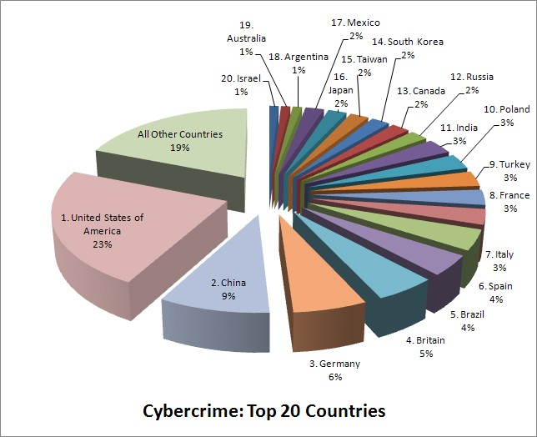
ll hard to detect and are a leading cause of computer infection.

Table :3 Cybercrime in the countries of world
Countries | Cyber crime
China | 9%
India | 3%
USA | 23%
Germany | 6%
Japan | 2%
France | 3%
Britain | 5%
Source :https://www.enigmasoftware.com/top-20-countries-the-most-cybercrime/

State wise internet user in India 2019-20
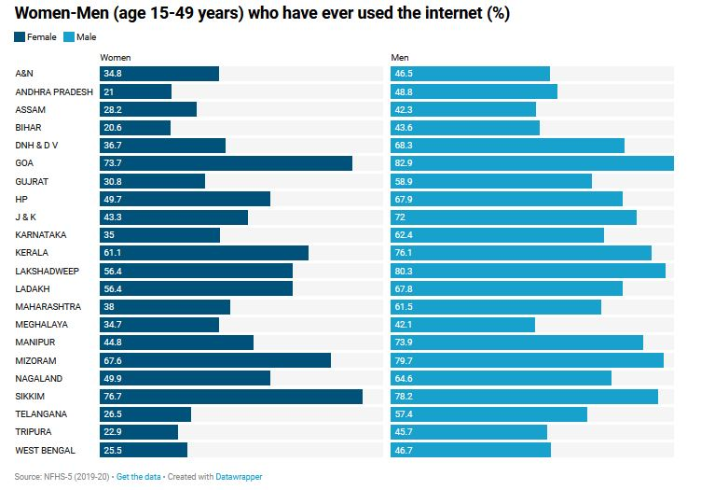
The state wise internet users in India exhibits a very surprising outcome with Sikkim being the sate with highest Men and women using internet 78.2% and 76.7% repectively. Followed by Goa with 73.7% women and 82.9% men using internet . While banglore being hub of information technology Karnataka reports low internet user of 62.4% male and 35% female. Gujarat has 58.9% male user and 30.8% female internet users.
Turning the lime light to cyber crime, The states of Karnataka register cyber crime highest cyber crime among states of India , with Banglore being the part of Karnataka and hub of Information technology. Followed by Uttar pradesh on 28th rank out of 29 states of India. Gujarat is on 18th rank among states of India. The lowest cyber crime of only 3 cases registered is at Nagaland, but the stae might have less internet user .
Cyber crime in states of India 2019
State | Cases Pending Investigation from Previous Year | Cases Reported during the year | Cases Reopened for Investigation | Total Cases for Investigation (Col.3+ Col.4+ Col.5) | Rank
Andhra Pradesh | 1456 | 1886 | 6 | 3348 | 24
Arunachal Pradesh | 9 | 8 | 0 | 17 | 4
Assam | 2181 | 2231 | 0 | 4412 | 26
Bihar | 619 | 1050 | 0 | 1669 | 20
Chhattisgarh | 101 | 175 | 0 | 276 | 12
Goa | 38 | 15 | 0 | 53 | 6
Gujarat | 253 | 784 | 0 | 1037 | 18
Haryana | 191 | 564 | 0 | 755 | 15
Himachal Pradesh | 61 | 76 | 0 | 137 | 8
Jammu & Kashmir | 181 | 73 | 1 | 255 | 11
Jharkhand | 1554 | 1095 | 0 | 2649 | 22
Karnataka | 7996 | 12020 | 0 | 20016 | 29
Kerala | 380 | 307 | 2 | 689 | 14
Madhya Pradesh | 367 | 602 | 0 | 969 | 17
Maharashtra | 6514 | 4967 | 1 | 11482 | 27
Manipur | 119 | 4 | 0 | 123 | 7
Meghalaya | 97 | 89 | 0 | 186 | 9
Mizoram | 7 | 8 | 0 | 15 | 3
Nagaland | 1 | 2 | 0 | 3 | 1
Odisha | 1532 | 1485 | 0 | 3017 | 23
Punjab | 348 | 243 | 1 | 592 | 13
Rajasthan | 364 | 1762 | 0 | 2126 | 21
Sikkim | 1 | 2 | 0 | 3 | 2
Tamil Nadu | 483 | 385 | 1 | 869 | 16
Telangana | 1513 | 2691 | 12 | 4216 | 25
Tripura | 29 | 20 | 0 | 49 | 5
Uttar Pradesh | 4173 | 11416 | 0 | 15589 | 28
Uttarakhand | 99 | 100 | 0 | 199 | 10
West Bengal | 715 | 335 | 0 | 1050 | 19
Total | 31382 | 44395 | 24 | 75801
Source : https://ncrb.gov.in/sites/default/files/crime_in_india_table_additional_table_chapter_reports/Table%209A.1_1.pdf
The damages of digitization to the economy
The data says that approximately to $600 billion , nearly 1% of global GDP is lost due to cyber crime each year ( Report on Economic Impact of cyber crime-No slowing down,2018). The twentieth century has made the idea of a global village a reality, where digital platforms has interconnected and enmeshed the world economies, cultures, behaviors, lives and habits. India is no exception, with over 560 million internet users as of 2020, making Indis a second-largest internet population in the world
Cybercrime in India caused 1.25lakh crores loss in 2019. This dreadful scenario therefore needs holistic approach to combat these crimes in all walks of life and particularly in digital space. Additionally, the country should set up Computer Crime Resource Centre, a composite body that comprises of experts and professionals. Such bodies will establish rules, regulations and standards of authentication for each citizen’s working in an organisation , firm or government bodies. Forensics commission should be also be established, which will be responsible for the training of forensics personnel/law enforcement agencies. Above all, strict and stern law to combat computer and cyber related crimes should be published to fight and lessen such crimes. Critical infrastructure in the country, collaborative effort from business organizations , Government offices, training young minds at school level and creation of indigenous structure for building secure and cyber-resilient environment in the country is inevitable

References
- Juneed Iqbal Bilal Maqbool Beigh (2017), ‘ Cyber crime in India : Trends and challenges’,International Journal of innovation and Advancement in computer science ,pp187-196
- https://ncrb.gov.in/sites/default/files/crime_in_india_table_additional_table_chapter_reports/Table%209A.1_1.pdf
- https://www.enigmasoftware.com/top-20-countries-the-most-cybercrime/
- wikipedia.org/wiki/List_of_countries_by_number_of_Internet_users to
- Kumar Sanjeev and Manhas Anupama ,202, “Cyber crime in India , Trends and Prevention” ,Galaxy International Interdiscriplinary Journal, Vol 9 Issue 5
- Kapila Pallavi, 2020 Research gate “Cyber Crimes and Cyber Laws in India: An Overview”https://www.researchgate.net/publication/350107577_
- https://www.ibm.com/ibm/history/exhibits/storage/storage_350.html
- https://www.sabre.com/files/Sabre-History.pdf
- https://eric.ed.gov/?id=ED029663
- https://www.theatlantic.com/technology/archive/2015/03/a-brief-history-of-the-atm/388547/
- http://www.gutenberg.org/wiki/Gutenberg:About
- https://mip.pmi.org/cosmos
- https://www.census.gov/content/dam/Census/library/publications/2018/acs/ACS-39.pdf
- https://whatsag.com/mobile-technology/the-history-of-2g.php
- https://www.entrepreneur.com/article/230620
- https://www.atmmarketplace.com/news/electronic-payments-surpass-cash-checks/
- https://www.emarketer.com/Article/Ecommerce-Sales-Topped-1-Trillion-First-Time-2012/1009649
- https://www.internetlivestats.com/internet-users/
- https://www.exelatech.com/press-release/mastercard-request-pay-solution-powered-exela-software-receives-enrollment

***************

