Global Positioning System
*Tamilmounika R¹⁾ Pandiya Kumar D²⁾ Sabthapathy M³⁾ Janarth S⁴⁾
^{1, 3, 4}Ph.D. Scholars, Department of Remote Sensing and GIS, Tamil Nadu Agricultural University, Coimbatore, Tamil Nadu, India
²SRF, Department of Remote Sensing and GIS, Tamil Nadu Agricultural University, Coimbatore, Tamil Nadu, India
*Corresponding author: tamilmounikar@gmail.com
ABSTRACT
Global Postioning System provides three dimensional positioning, navigation, timing services, velocity and altitude to users on a continuous worldwide coverage basis and it is independent of weather, day and night. GPS applications is wide in all fields. This chapter provides the basic knowledge about GPS technology and their application in agriculture.
Keywords – GPS, navigation, altitude, weather, applications, agriculture.
I) INTRODUCTION
The Global Positioning System (GPS) is a global public service brought by the U.S. government that provides three dimensional course reliable positioning, navigation, timing services, velocity and altitude to users on a continuous worldwide coverage basis and it is independent of weather, day and night (Upreti and Kumar, 2008). It is a space-based radio navigation system of 24 satellites revolving around the earth twice a day in a very precise orbit with an orbital period of approximately 12 hours (Kaplan, 1996). The satellites are distributed across six orbital planes that are equally spaced at angles of 55º and continuously transmit signals to the earth. GPS provides information based on the triangulation principle which calculates the user’s location precisely. Earlier GPS was only for military applications, later in the 1980s, it was made available to public users. The GPS was formerly referred to as the NAVSTAR (Navigation Satellite Timing and Ranging).
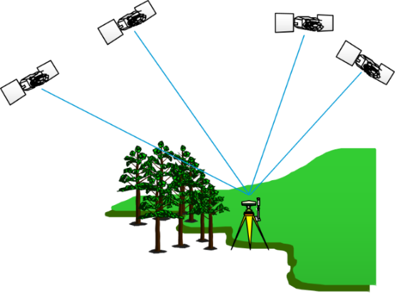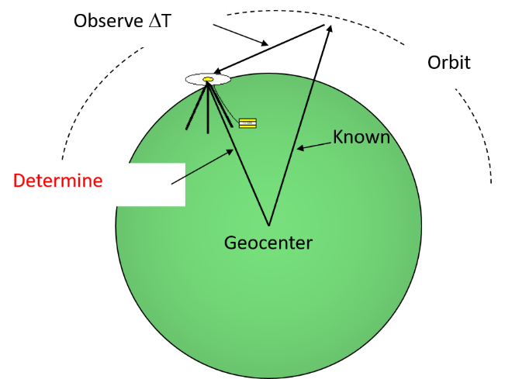
Figure 1 Receiving signals from GPS
II) GPS COMPONENTS
- SPACE SEGMENT
The space segment consists of GPS satellites to generate and transmit code and carrier phase signals and store and broadcast the navigation message given by the control segment. Stable atomic clocks in satellites regulate these transmissions.

- CONTROL SEGMENT
The control segment is also known as the ground segment which is responsible for the proper operation of the GNSS. The control segment contains Master Control Station and 5 Monitoring Stations across the globe.
Their functions are to
- control and maintain the status and configuration of the satellite constellation;
- predict ephemeris and satellite clock evolution;
- keep the corresponding navigation system time scale;
- update the navigation messages for all the satellites.
C) USER SEGMENT
The user segment consists of GPS receivers that receive signals and determine pseudoranges to solve the navigation equations to obtain the coordinates and provide a very accurate time. Each GPS receiver is identified by the three-dimensional location (latitude, longitude, and altitude) plus the time.
III) GPS WORKING PRINCIPLE
Trilateration is a basic geometric principle that allows finding one location with a known distance from other, already known locations. The principle of GPS is based on the measurement of pseudoranges between the four satellites and the user (Seeber, 2003). The ground-based stations offer accurate tracking of the satellite's orbit at every level and measure the signal transmission time between the four satellites and the receiver. The measure, in turn, is the precise direction, place, and speed.
Steps
- GPS receiver receives 1-way ranging signals from several satellites - each transmission/ephemeris is time-tagged and contains the satellite’s position.
- The time of arrival of the signal is compared with time-of-transmission of a signal.
- The delta-T is multiplied by the speed of light to obtain the range:
P= [(Transmission time – Reception time) × Speed of light] (1)
- Each range puts the user on a sphere about the satellite and intersecting several of these yields a user position.
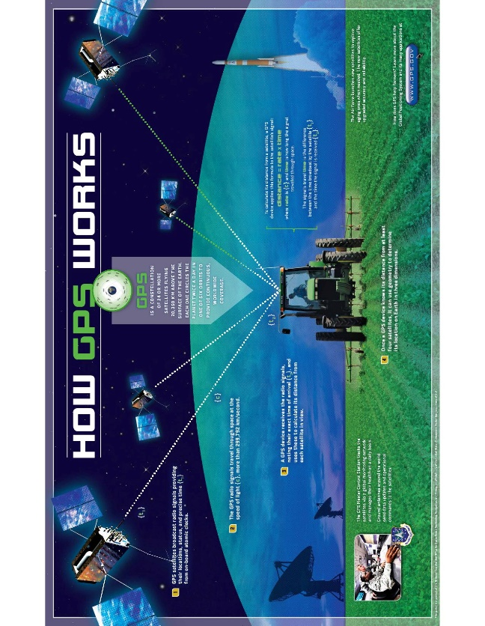
Fig. 2 Working of GPS (Source: GPS.gov)
IV) ACCURACY OF GPS
GPS accuracy depends on the precision of signals that emanate from GPS satellites to GPS receivers. The precision and accuracy of GPS are also determined by the number of obstacles that the receiver can obscure and the types of receivers. Most the GPS receivers have an accuracy range of +/- 10m. Differential Global Positioning Systems (DGPS) are the most accurate forms of GPS receivers.
V) ERRORS IN GPS
Table 1 Sources of error in GPS
Source | Amount of error
Satellite clocks | 1.5 to 3.6 meters
Orbital errors | < 1 meter
Ionosphere | 5.0 to 7.0 meters
Troposphere | 5.0 to 7.0 meters
Receiver noise | 0.3 to 1.5 meters
Multipath | 0.6 to 1.2 meters
Selective Availability | depends
User error | Up to a kilometer or more
VI) GLOBAL NAVIGATION SATELLITE SYSTEM
- NAVSTAR GPS - Navigation Satellite Timing and Ranging System GPS (USA)
- GLONASS - Global Navigation Satellite System (Russia)
- BEIDOU - BeiDou Navigation Satellite System (China)
- GALILEO - European Global Satellite Navigation System (European Union)
VII) REGIONAL NAVIGATION SATELLITE SYSTEM
- IRNSS - Indian Regional Navigation Satellite System (India)
- QZSS - Quazi-Zenith Satellite System (Japan)
Table 2 GNSS satellites and their characteristics
Parameter | NAVSTAR GPS | GLONASS | Galileo | Beidou1/2
Position | 10-20 m | 10-20 m | ~10-20 m | ~10-20 m
Velocity | 10 cm/s | 10 cm/s | 20 cm/s | 20/40cm/s
Time | 0.1 µs (15ns) | 20ns | 20ns | 20/50ns
Ellipsoid | WGS84 | PZ# - 90.11 | GTRF | CGCS2000
Master Control | 1 station in US | 1 in Russia | 2 in EU | 1 MCS / 2 UPLOAD St.
Surveillance | 11 stations | 7 | 30-40 | 30 (iGMAS)
Satellites | 30 | 24 | 30 | 35 (GEO-5, IGSO-3, MEO-27)
Orbital planes | 6 Minm 4 sat Ø=15° | 3(120°/45°) | 3(9+1-40°) | 7 (3 IGSO+3 MEO+GEO)
Inclination | 55° | 64.8° | 56° | 55°
Altitude (Km) | 20180near-25820far | 19100-24680 | 23222-28920 | GEO, IGSO, MEO:21528
Ground track repetition | 1 day | 7d 23h 27m28s | 10 days | ~1/7 days / @ after 13 oribts in 10 days
Revolution time | 11h 57m 58s | 11h 15m 44s | 14h 4min | 12h 53min 24s (MEO); 24h
Selective Availability | Off | No | No | -
Anti-spoofing | YES | No | No | YES
Services | 2(SPS,PPS) | 2(SPS,HPS) | OS, SoL, CS, PRS, SAR | OS (B1, B2), Authorized Service (B1, B3)
Frequency bands | 3/8(L1,L2,L3,L4,L5,L1C,L2C,M) | 3 (L1,L2, L3) | 5(L1,E5a,  E5b,E6,L6) | B1I, B2I, B3I*, B1C, B2a
Velocity, c=299792458m/s | 3870 | 3950 | 3675 | ~3.02km/s
Propagation  Time (T-ms) | 67-86 | 64-82 | 77-96 | 71 (21528) -120 (36000)
Distance travelled during T | 260-333m | 252-325m | 285-355m | D=V*t (as per orbit selected)
(Source: Mod. from Nel Samama)

VIII) INDIAN REGIONAL NAVIGATION SATELLITE SYSTEM (IRNSS)
Regional navigation satellite system especially for India. The first IRNSS 1A satellite was launched on Jul 01, 2013. IRNSS was renamed Navigation Indian Constellation (NavIC) in 2016. NavIC satellites are placed at either geostationary (GEO) or geosynchronous (GSO) orbits at about 36,000 km, it uses the WGS 84 coordinate system for the calculation of user position. It provides the Dual frequency user with a targeted position accuracy of better than 20 meters in the coverage area.
Objectives
- To provide reliable position, navigation and timing services over India and its neighbourhood about 1500 km.
- Most of the constellation is seen by the user all the time.
- Independent of existing GNSS systems.
X) GPS APPLICATIONS
- Terrestrial, Aerial and Marine Navigation
- Disaster Management
- Precision Agriculture
- Monitoring and preservation of endangered species
- Crustal and seismic monitoring
- Vehicle tracking and fleet management
- Future of Intelligent Transportation Systems
- Integration with mobile phones
- Precise Timing
- Mapping and Geodetic data capture
- Terrestrial navigation aid for hikers and travelers
- Visual and voice navigation for drivers
XI) GPS IN AGRICULTURE
Precision agriculture or site-specific farm management is possible only through the combination of the Global Positioning System (GPS) and geographic information systems (GIS). With the help of these technologies, massive volumes of geospatial data may be effectively handled and analyzed while being collected in real-time and with precise positional data. Through the use of GPS, GIS, and remote sensing, the information needed for improving land and water use can be collected.
In precision agriculture GPS-based applications are used for planning farms, mapping fields, soil sampling, guiding tractors, scouting crops, variable rate applications, and yield mapping (Abulude et al., 2015).
Site-specific soil sampling, data collection, and data analysis help in site specific application of nutrients will be very much useful for the farmer’s community. GPS enabled data collection from the field to map the accurate location of pest, insect, and weed infestations useful for Crop advisories.
GPS allows farmers to accurately navigate to specific locations in the field, year after year, to collect soil samples or monitor crop conditions. Accurate field navigation reduces repeated applications and skipped areas, and enables maximum ground coverage within a short period.
Accurately monitored yield data useful for future site-specific field preparation. The correlation of farm production techniques and crop yields with land variability is helpful to develop effective soil/plant treatment strategies enhancing crop productivity.
The timely availability of spatial information on soil and plant requirements is helpful for site-specific management to increase agricultural production and protect the environment.
Farmers can obtain additional benefits by combining improved fertilizer and soil amendment use, calculating the economic threshold for insect and weed infestation treatment, and conserving natural resources for future use.

REFERENCES
- Abulude, F. O., Akinnusotu, A., & Adeyemi, A. (2015). Global positioning system and its wide applications. Continental Journal Information Technology, 9(1), 22-32.
- Kaplan, E. D., Leva, J. L., & Pavloff, M. S. (1996). Fundamentals of satellite navigation. Understanding GPS- Principles and applications (A 96-41027 11-17), Norwood, MA, Artech House, 1996,, 15-57.
- Nel Samama, "GNSS System Descriptions," in Global Positioning: Technologies and Performance , Wiley, 2008, pp.131-161.
- Seeber, G. (2003). Satellite Geodesy, 2nd completely revised and extended edition. Walter de Gruyter GmbH & Co. KG, 10785, 303-304.
- Upreti, S., & Kumar, M. (2008, March). Perspectives of Global Positioning System (GPS) Applications. In Seminar cum Workshop.
- https://www.isro.gov.in/spacecraft/satellite-navigation
- https://www.gps.gov/applications/agriculture/
- https://www.writemypapers.org/examples-and-samples/research-paper-on-global-positioning-system.html

