Morphological Image Processing and Image Registration Ms. Mani Dublish Dr. Anita Pati Mishra Mr. Vinod Kumar Mr. Rahul Kumar
Assistant Professor Assistant Professor Assistant Professor Assistant Professor
ABES Engg College Ghaziabad IMS Noida ABES Engg College Gzb ABES Engg College Ghaziabad
mani.dublish@abes.ac.in patianita2012@gmail.com vinod.kumar@abes.ac.in rahul.kumar@abes.ac.in
Abstract:
A wide range of image processing techniques known as "morphological operations" modify digital images according to their shapes. Every image pixel in a morphological process corresponds to the value of the other pixels in its immediate vicinity. Morphology is a large category of image processing techniques that manipulate images according to their shapes. An input image is given a structural element by morphological procedures, which results in an output image of the same size. A potent set of techniques for identifying interesting characteristics in an image is the morphological concepts. The fact that dilation and erosion are simple processes has a big advantage in terms of implementation. The term "morphology" is used to refer to a branch of biology that studies the shape and structure of animals and plants. The same word morphology is employed in this context as a tool for Digital images as they are processed using a wide range of procedures known as morphological operations. that take shape into account. Including complement of Image enhancement operations, we can
Based on the attributes of an object's shape that are encoded in the structuring element, they process objects in the input image. Mathematical Morphology explains the mathematical specifics. The structural element typically has a 33 size and originates at the centre pixel. It is moved across the image, and each pixel's elements are compared to the set of underlying pixels at that location. The pixel beneath the structuring element's origin is set to a predetermined value if the two sets of elements satisfy the set operator's requirement (for instance, if the structuring element's set of pixels is a subset of the pixels in the underlying image) (0 or 1 for binary images). a structural operator. Morphological processing is pixel. Binary morphology only uses sentence membership and is agnostic to values ​​such as grayscale and color of pixels. I will confirm Some basic set operations and their utility in image processing. Morphological operations are a broad range of image processing operations that process digital images based on their shape. In morphological operations, each image pixel corresponds to the value of another pixel in its neighborhood. By choosing the shape and size of neighboring pixels, you can construct morphological operations that are sensitive to specific shapes of the input image. Morphological operations apply a structuring element, called Strel in Matlab, to the input image and produce an output image of the same size. Two terms make up morphology, or morphology.
The terms "morphology" and "morphology" both refer to metamorphosis.There are several reasons why an image could change.Noise is one of these elements.Therefore, morphology is thought of as an image processing method that eliminates flaws in an image brought on by noise.The representation of a region's shape, the description of skeletons, the study of surface deviations, and other surface metrological applications are all examples of how morphology is used.Erosion and dilation algorithms are used to perform morphological operations, and MATLAB R2013a is used to verify the outcomes.
Keywords:Image processing Techniques,Morphological operations,Mathematical Specifies,pixels &Binary morphology.

Morphological Image Processing: Introduction
Morphological image processing (or morphology) describes a variety of image processing techniques that affect the form (or morphology) of features in a picture. Morphological operations are typically applied to get rid of imperfections introduced during segmentation or we will say that morphology may be a branch of biology that deals with the forms and therefore the structure of animals and plants.
We use an equivalent word here within the context of mathematical morphology as a tool of extracting image components that are useful within the representation and outline of the region shape like boundaries, skeletons, etc. goal of morphology
operations are simplified image data, preserve the essential shape characteristics and eliminate noise.
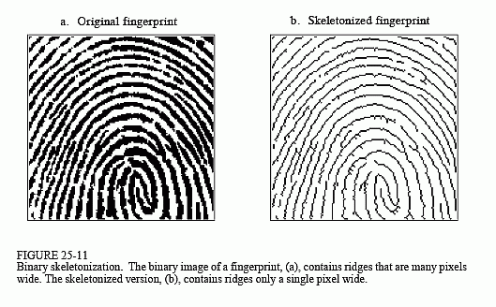
Morphology applies certain simple rules and shapes, like squares, circles, diamonds, cubes and spheres, to process images. the target is typically to spot features of interest in images as a prelude to performing high-level inspection, or machining, functions. Navigating around complex objects is facilitated using ‘anchor point’ features detected by morphology. The chapter begins by defining four basic morphology operations for binary images: erosion, dilation, opening, and shutting . the appliance of those operations to analyzing images from real-world vision tasks is discussed, as are techniques for fast implementation. Further operations like morphology also are described, including skeletonization, hit-and-miss transform, and binary template matching.
You can imagine these elements as simple matrices. Here, black circles represent the worth 1 (foreground). Also, structuring elements are defined supported some local origin (marked as Xs).

The most common morphological operations are dilation and erosion. In both methods, a kernel convolves a picture and substitute the target (origin) pixel following a criterion.

Intuitively, erosion has the effect of deteriorating the boundary pixels of foreground elements. we will consider it as expanding the background pixels and reducing the form of foreground elements.

In short, a pre-defined kernel is omitted the image as a 2D convolution. Then, assuming a binary image, an input pixel are going to be 1 if all the pixels under the kernel is 1. Otherwise, it gets a 0.

We can also consider erosion as applying a minimum function over the pixels under the kernel. during this way, the output pixel is going to be the littlest value among all the pixels under the kernel. As we'll see shortly, erosion has also the effect of removing noise.

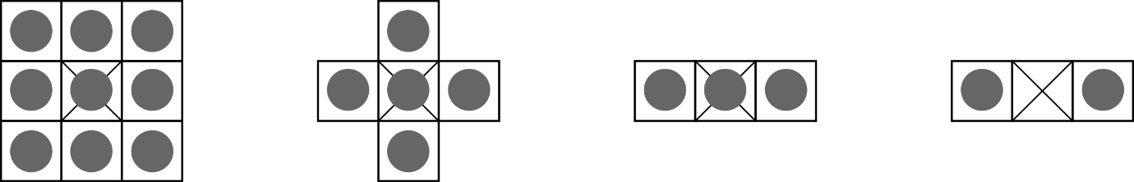
In summary, a morphological operation may be a set of image processing algorithms that acts on image pixels using pre-defined kernels. These kernels, referred to as structuring elements, define patterns that are wont to process images. Bellow, you'll see some samples of common structuring elements.
The most common morphological operations are dilation and erosion. In both methods, a kernel convolves a picture and substitute the target (origin) pixel following a criterion.
Intuitively, erosion has the effect of deteriorating the boundary pixels of foreground elements. we will consider it as expanding the background pixels and reducing the form of foreground elements.
In short, a pre-defined kernel is omitted the image as a 2D convolution. Then, assuming a binary image, an input pixel are going to be 1 if all the pixels under the kernel is 1. Otherwise, it gets a 0.
We can also consider erosion as applying a minimum function over the pixels under the kernel. during this way, the output pixel are going to be the littlest value among all the pixels under the kernel. As we'll see shortly, erosion has also the effect of removing noise .The most common morphological operations are dilation and erosion. In both methods, a kernel convolves a picture and substitute the target (origin) pixel following a criterion.
Intuitively, erosion has the effect of deteriorating the boundary pixels of foreground elements. we will consider it as expanding the background pixels and reducing the form of foreground elements.
In short, a pre-defined kernel is omitted the image as a 2D convolution. Then, assuming a binary image, an input pixel are going to be 1 if all the pixels under the kernel is 1. Otherwise, it gets a 0.
We can also consider erosion as applying a minimum function over the pixels under the kernel. during this way, the output pixel is going to be the littlest value among all the pixels under the kernel. As we'll see shortly, erosion has also the effect of removing noise .

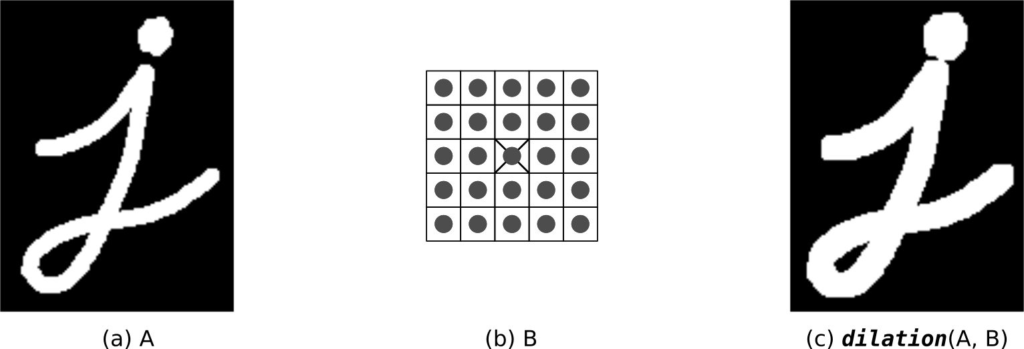
We can also consider erosion as applying a minimum function over the pixels under the kernel. during this way, the output pixel are going to be the littlest value among all the pixels under the kernel. As we'll see shortly, erosion has also the effect of removing noise .
Dilation acts within the opposite way. It expands the boundaries of foreground elements. As a consequence, it also reduces the amount of background pixels. As oppose to erosion, given an input pixel, the output is 1 if a minimum of one among the input pixels (under the kernel) is 1. Otherwise, the output is 0.
Similarly, dilation applies a maximum ope over the pixels under the kernel. In other words, the output pixel are going to be the utmost value among all pixels that fall within the kernel.
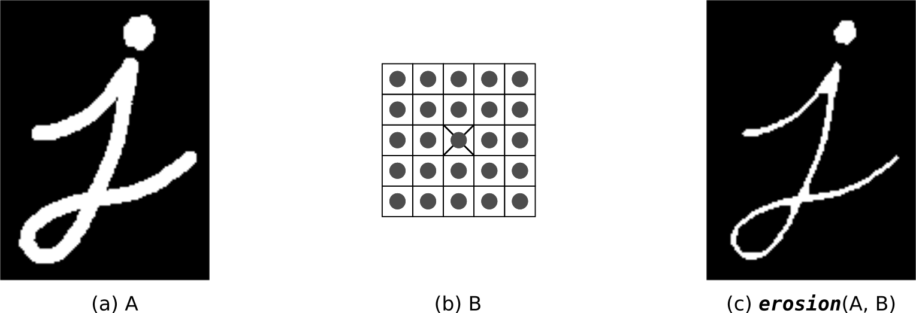

Finding Lines on Text documents
In order to permit the morphological operators to act needless to say , we transform the input image to a binary representation. Then, the pixel values are inverted to ensure 2 properties:
- Black Pixels (0s) represent the background.
- White Pixels (1s) represent the foreground.

As we will see, the leads to Figure 4 are very robust. Note that some lines within the text got spit in 2. that's because, in certain points, some words are very far aside from one another . As a result, the horizontal dilation wasn’t ready to merge them into a singular block. Also, due to this extra gap, the vertical operations weren’t ready to detect them as one entity.
Considering lines of text as document lines (regardless of the spacing among words), the input document has 28 lines. Nevertheless, the algorithm was ready to count a complete of 35 lines.

Logic Operations involving Binary Images
Binary Image Operations
Image arithmetic applies one among the quality arithmetic operations or a logical operator to 2 or more images. The operators are applied during a pixel-by-pixel way, i.e. the worth of a pixel within the output image depends only on the values of the corresponding pixels within the input images. Hence, the pictures must be of an equivalent size. Although image arithmetic is that the most straightforward sort of image processing, there's a good range of applications. A main advantage of arithmetic operators is that the method is extremely simple and thus fast.
Logical operators are often wont to combine two (mostly binary) images. within the case of integer images, the logical operator is generally applied during a bitwise way.
Binary Image Operations are a set of digital filters, image arithmetic and image processing techniques. Apply simple modifications like open and fill holes to count the number of cells. Develop complex Workfiles that utilize multiple binary layers to differentiate nuclei inside cells.
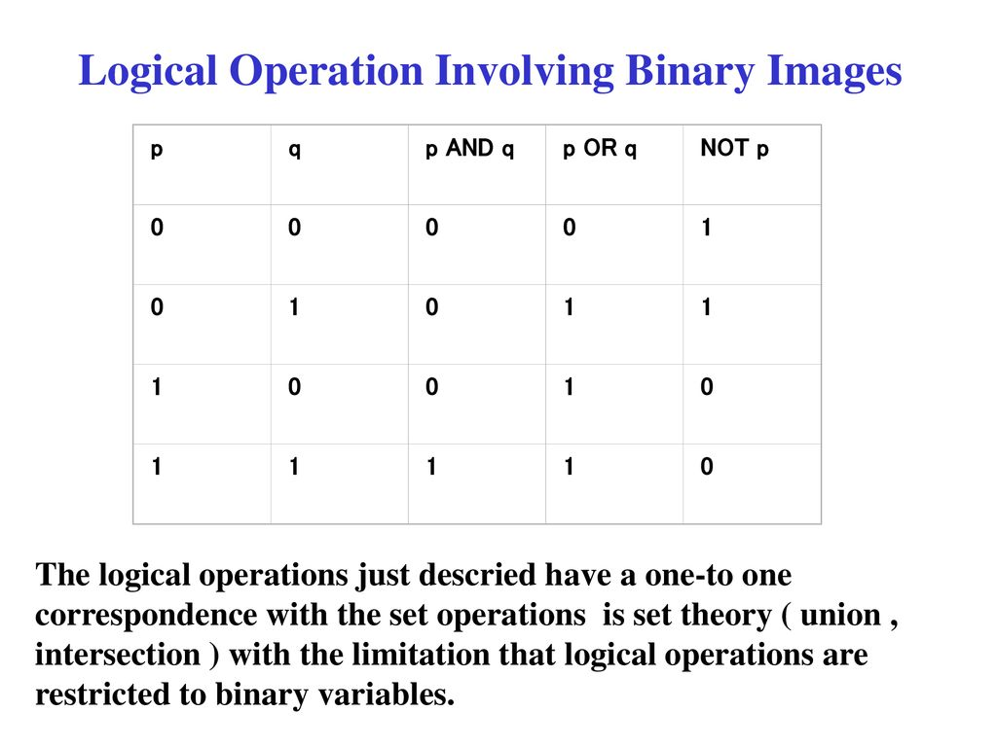
Erode
Shrinks both the inside and exterior boundaries of objects within the displayed binary image by one pixel for every pass applied. Erode are often wont to shrink small objects until they disappear in order that they're going to not be measured or counted later. Erode can have multiple passes applied, although the form of objects after many passes may change.
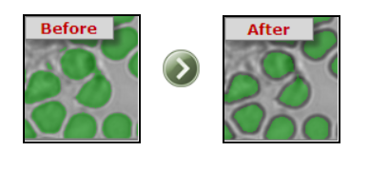

Full Erode
Recursively Erodes until the last pass before the object will be extinguished. Full Erode is sometimes called "Ultimate Erosion". Each object is considered separately, and so different sized objects may have a different number of passes applied.
This technique can be used in the separation process to erode all objects to their centers before growing back to the intermediate boundary.
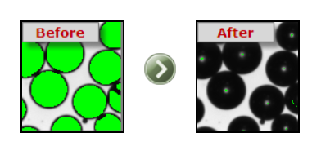
Dilate
Grows the inside and exterior boundaries of objects by one pixel for every pass applied. Dilate are often useful to grow parts of an object together that were separated by incorrect thresholding in Identify. Dilate can have multiple passes applied, although the form of objects after many passes may change. This operation are often combined with Erode within the Open and shut operators.
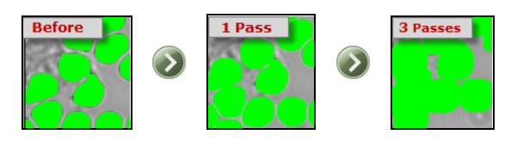
Open
Performs first binary image Erosion then binary image Dilation on the displayed binary image. The effect of Open is to enlarge gaps between objects that have incorrect tenuous connections, making them separate. Open can have multiple passes applied, although the form of objects after many passes may change. a uniform number of passes are applied first for Erode then for Dilate.
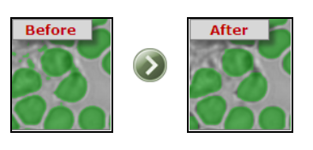
This encourages the likelihood that the Eroded objects will Dilate back to their original size and shape. because the number of passes increases, smaller objects could also be completely Eroded, and can not be Dilated back. This method is usually wont to remove unwanted small objects or noise pixels.
Close
Close is adequate to performing a Dilate then an Erode. Cross small gaps between objects that have incorrect breaks, joining them up. Close can have multiple passes applied, although the form of objects after many passes may change. a uniform number of passes are applied first for Dilate then for Erode. This encourages the likelihood that the Dilated objects will Erode back to their original size and shape. because the number of passes increases, smaller holes within objects could also be completely Closed. This method is usually wont to remove unwanted small holes or noise pixels.
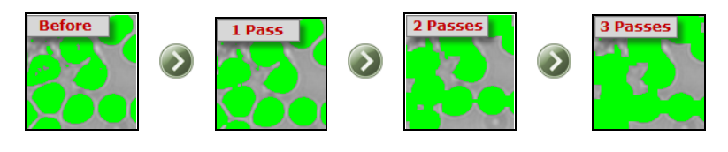
Thin
Performs binary image Thinning on the displayed binary image. Can have multiple passes applied, although the form of objects after many passes may change.
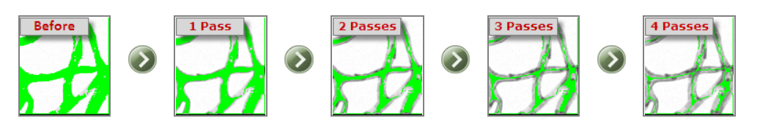

Skeletonize
The "Ultimate-thin", recursively performs binary Image Thinning on the displayed binary image until the last word skeleton of each object within the image is produced. The skeletal shape of objects after many passes could also be quite different from the external shape. The skeleton is usually mentioned because the medial axis of an object.
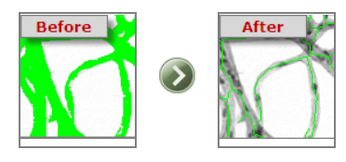

Prune
Removes pixels within the image that are End Points i.e. those with just one neighbor. Normally these points are at the top of small branches on objects within the binary image. This operation can have multiple passes applied, although no change is formed when all End points are removed.
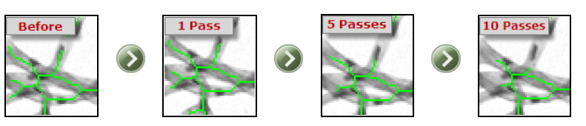

Full Prune
Recursively prunes the displayed binary image, until only connected pixels remain. Pruning is generally applied after Thinning, which create small branches suitable for pruning. If the last word pruned skeleton of all objects is required, use Skeletonize, which performs binary image Thinning until there's no more Thinning possible, then Full Prune, which Prunes all possible branches, leaving a totally connected network of 1 pixel-thick lines.
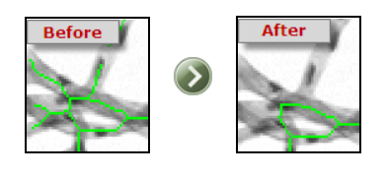
Boundary
Outlines objects within the displayed binary image by removing all pixels not located on an indoor or exterior Boundary of an object. If only the outside Boundary is required, use the Fill Holes operation first.

Fill Holes
The Fill Holes operator performs the filling of objects within the displayed binary image. The effect of the Fill Holes operator is to Fill any internal holes within the image.
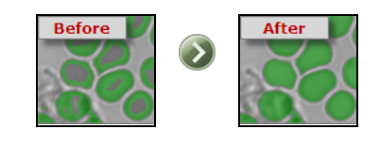
Note that some Enhance operations create a border round the very fringe of the image, which can be thresholder in Identify, causing the whole image to be filled. Use the ROI set from the Capture Dialog to scale back the ROI therefore the border are going to be ignored when measurements are made.
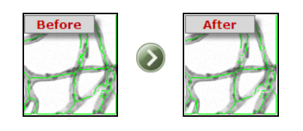
Break Nodes
Pattern matches all objects within the displayed binary image to get rid of pixels which are located at the intersection of two or more lines. Break Nodes should be used after the Thinning, Skeletonize and Prune operators, which have produced a network of 1 pixel thick lines. Break Nodes separates the connected network of lines into individual line fragments for further processing or measurement. If Break Nodes is chosen for a binary image which isn't Skeletonized, then most of the pixels have many neighbors, and can be removed as intersection nodes.
Binary Math
Combines the saved and display binary images via the logical operators listed below:
AND - Includes each pixel which both binary image masks include
OR - Includes each pixel which either binary image mask includes
XOR - Includes each pixel that just one of the binary image masks includes
NAND - Includes all pixels except those included in both binary image masks
NOR - Includes all pixels except those included by either binary image mask
NOT - Inverts all pixels within the displayed binary mask
XNOR - Includes pixels present in either both or neither of the binary image masks

The effect of the maths operation selected is seen on the screen before it's approved. Both the present display binary image and therefore the saved binary image are displayed on the screen in several colours. A prompt indicates which colour represent the chosen Math operation, and therefore the selection are often approved or cancelled. These options are useful for combining the results of modified binary images with the saved original image.

Draw Grid
Vertical Grid - Draws evenly spaced vertical lines (specify spacing)
Horizontal Grid - Draws evenly spaced horizontal lines (specify spacing)
Rectangular Grid - Grid can appear as if paper (specify X and Y spacing)
Radial Lines - Draws lines radiating out from the middle (specify angular spacing in degrees)
Concentric Circles - Draws circles that surround the middle (specify spacing in radial direction)
Concentric Rectangles - Draws rectangles that surround the middle (specify X and Y spacing)
Crosshair - Draws a crosshair within the centre (automatically fits frame)
Full Frame - Draws a rectangle around entire image
Full Circle - Draws a circle that matches in entire image in pixel space
Filled ROI - all Groups selection using the ROI shapes layer - all shapes that are filled
Unfilled ROI - all Groups selection using the ROI shapes layer - all shapes that aren't filled
Dilation and Erosion
Dilation and erosion are two fundamental morphological operations. Dilation adds pixels to the boundaries of objects in a picture, while erosion removes pixels on object boundaries. the number of pixels added or far away from the objects in a picture depends on the dimensions and shape of the structuring element wont to process the image.
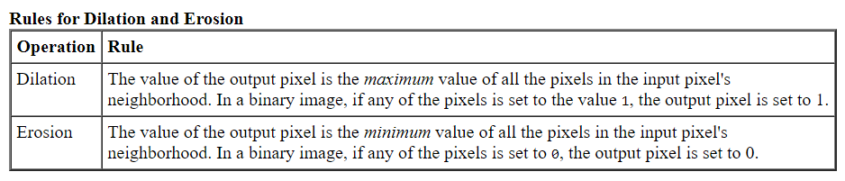
Understanding Dilation and Erosion
In the morphological dilation and erosion operations, the state of any given pixel within the output image is decided by applying a rule to the corresponding pixel and its neighbors within the input image. The rule wont to process the pixels defines the operation as dilation or an erosion. This table lists the principles for both dilation and erosion.

The following figure illustrates the dilation of a binary image. Note how the structuring element defines the neighbourhood of the pixel of interest, which is circled. The dilation function applies the acceptable rule to the pixels within the neighbourhood and assigns a worth to the corresponding pixel within the output image. within the figure, the morphological dilation function sets the worth of the output pixel to 1 because one among the weather within the neighborhood defined by the structuring element is on.’
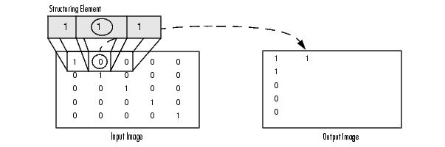
Morphological Dilation of a Binary Image
The following figure illustrates this processing for a grayscale image. The figure shows the processing of a specific pixel within the input image. Note how the function applies the rule to the input pixel's neighbourhood and uses the very best value of all the pixels within the neighbourhood because the value of the corresponding pixel within the output image.
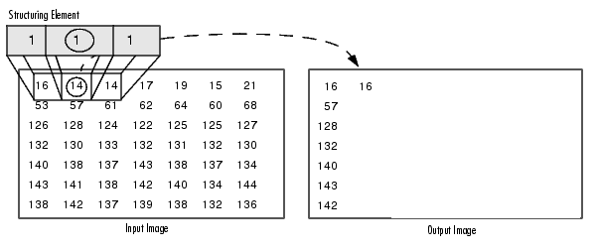
Processing Pixels at Image Borders (Padding Behaviour)
Morphological functions position the origin of the structuring element, its centre element, over the pixel of interest within the input image. For pixels at the sting of a picture , parts of the neighbourhood defined by the structuring element can extend past the border of the image.

To process border pixels, the morphological functions assign a worth to those undefined pixels, as if the functions had padded the image with additional rows and columns. the worth of those padding pixels varies for dilation and erosion operations. the subsequent table describes the padding rules for dilation and erosion for both binary and grayscale images.

Note By using the minimum value for dilation operations and therefore the maximum value for erosion operations, the toolbox avoids border effects, where regions near the borders of the output image don't appear to be homogeneous with the remainder of the image. for instance, if erosion padded with a minimum value, eroding a picture would end in a black border round the fringe of the output image

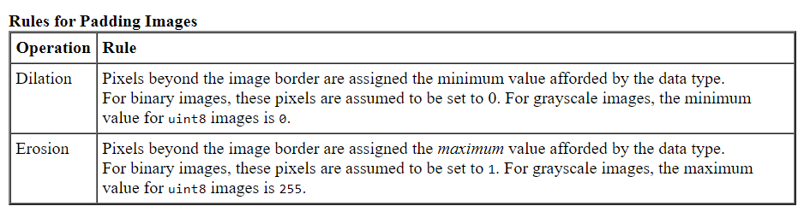

Structuring Elements
An essential a part of the dilation and erosion operations is that the structuring element wont to probe the input image. A structuring element may be a matrix consisting of only 0's and 1's which will have any arbitrary shape and size. The pixels with values of 1 define the neighbourhood.

Two-dimensional or flat, structuring elements are typically much smaller than the image being processed. the middle pixel of the structuring element, called the origin, identifies the pixel of interest -- the pixel being processed. The pixels within the structuring element containing 1's define the neighbourhood of the structuring element. These pixels also are considered in dilation or erosion processing.

Three-dimensional, or no flat, structuring elements use 0's and 1's to define the extent of the structuring element within the x- and y-planes and add height values to define the dimension .

The Origin of a Structuring Element
The morphological functions use this code to urge the coordinates of the origin of structuring elements of any size and dimension.

origin = floor((size(nhood)+1)/2)

(In this code hood is that the neighbourhood defining the structuring element. Because structuring elements are MATLAB objects, you can't use the dimensions of the STREL object itself during this calculation. you want to use the STREL get hood method to retrieve the neighbourhood of the structuring element from the STREL object. For information about other STREL object methods, see the strel function reference page.)
For example, the subsequent illustrates a diamond-shaped structuring element.
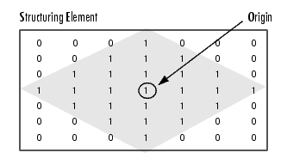

Origin of a Diamond-Shaped Structuring Element
Creating a Structuring Element
The toolbox dilation and erosion functions accept structuring element objects, called STRELs. you employ the strel function to make STRELs of any arbitrary size and shape. The strel function also includes built-in support for several common shapes, like lines, diamonds, disks, periodic lines, and balls.
Note you sometimes choose a structuring element an equivalent size and shape because the objects you would like to process within the input image. for instance, to seek out lines in a picture, create a linear structuring element.
For example, this code creates a flat, diamond-shaped structuring element.
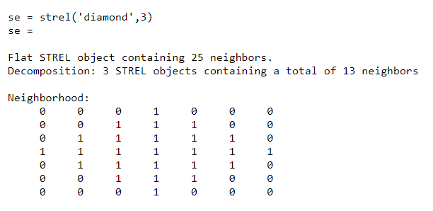
Structuring Element Decomposition
To enhance performance, the strel function might break structuring elements into smaller pieces, a way referred to as structuring element decomposition.
For example, dilation by an 11-by-11 square structuring element are often accomplished by dilating first with a 1-by-11 structuring element, then with an 11-by-1 structuring element. This leads to a theoretical speed improvement of an element of 5.5, although in practice the particular speed improvement is somewhat less.
Structuring element decompositions used for the 'disk' and 'ball' shapes are approximations; all other decompositions are exact. Decomposition isn't used with an arbitrary structuring element unless it's a flat structuring element whose neighbourhood is all 1's.
To view the sequence of structuring elements utilized in a decomposition, use the STREL get sequence method. The get sequence function returns an array of the structuring elements that form the decomposition. for instance, here are the structuring elements created within the decomposition of a diamond-shaped structuring element.

sel = strel('diamond',4)

sel =
Flat STREL object containing 41 neighbors.
Decomposition: 3 STREL objects containing a total of 13 neighbors

Neighborhood:
0 0 0 0 1 0 0 0 0
0 0 0 1 1 1 0 0 0
0 0 1 1 1 1 1 0 0
0 1 1 1 1 1 1 1 0
1 1 1 1 1 1 1 1 1
0 1 1 1 1 1 1 1 0
0 0 1 1 1 1 1 0 0
0 0 0 1 1 1 0 0 0
0 0 0 0 1 0 0 0 0

seq = getsequence(sel)
seq =
3x1 array of STREL objects

seq(1)
ans =
Flat STREL object containing 5 neighbors.

Neighborhood:

0 1 0
1 1 1
0 1 0

seq(2)
ans =
Flat STREL object containing 4 neighbors.

Neighborhood:

0 1 0
1 0 1
0 1 0

seq(3)
ans =
Flat STREL object containing 4 neighbors.

Neighborhood:

0 0 1 0 0
0 0 0 0 0
1 0 0 0 1
0 0 0 0 0
0 0 1 0 0

Dilating a picture

To dilate a picture, use the imdilate function. The imdilate function accepts two primary arguments:

The input image to be processed (grayscale, binary, or packed binary image)
A structuring element object, returned by the strel function, or a binary matrix defining the neighbourhood of a structuring element in dilate also accepts two optional arguments: PADOPT and PACKOPT. The PADOPT argument affects the dimensions of the output image. The PACKOPT argument identifies the input image as packed binary. (Packing may be a method of compressing binary images which will speed up the processing of the image. See the bwpack reference page for information.)

This example dilates an easy binary image containing one rectangular object.

BW = zeros(9,10);
BW(4:6,4:7) = 1
BW =
0 0 0 0 0 0 0 0 0 0
0 0 0 0 0 0 0 0 0 0
0 0 0 0 0 0 0 0 0 0
0 0 0 1 1 1 1 0 0 0
0 0 0 1 1 1 1 0 0 0
0 0 0 1 1 1 1 0 0 0
0 0 0 0 0 0 0 0 0 0
0 0 0 0 0 0 0 0 0 0
0 0 0 0 0 0 0 0 0 0

Eroding a picture
To erode a picture, use the imerode function. The imerode function accepts two primary arguments:
The input image to be processed (grayscale, binary, or packed binary image)
A structuring element object, returned by the strel function, or a binary matrix defining the neighborhood of a structuring element
imerode also accepts three optional arguments: PADOPT, PACKOPT, and M.
The PADOPT argument affects the dimensions of the output image. The PACKOPT argument identifies the input image as packed binary. If the image is packed binary, M identifies the number of rows within the original image. (Packing may be a method of compressing binary images which will speed up the processing of the image. See the bwpack reference page for more information.)
The following example erodes the binary image circbw.tif:
Read the image into the MATLAB workspace.
BW1 = imread('circbw.tif');

Create a structuring element. The following code creates a diagonal structuring element object. (For more information about using the strel function, see Structuring Elements.)
SE = strel('arbitrary',eye(5));
SE=

Flat STREL object containing 5 neighbors.

Neighborhood:
1 0 0 0 0
0 1 0 0 0
0 0 1 0 0
0 0 0 1 0
0 0 0 0 1

Call the imerode function, passing the image BW and the structuring element SE as arguments.
BW2 = imerode(BW1,SE);

Notice the diagonal streaks on the right side of the output image. These are due to the shape of the structuring element.
imshow(BW1)
figure, imshow(BW2)

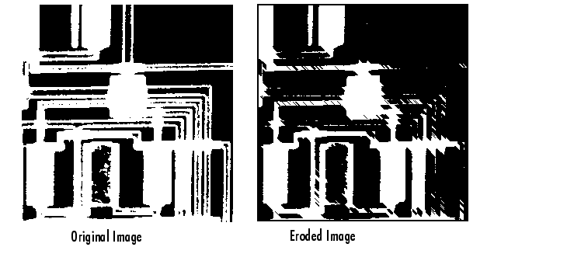

Combining Dilation and Erosion
Dilation and erosion are often utilized in combination to implement image processing operations. for instance, the definition of a morphological opening of a picture is an erosion followed by a dilation, using an equivalent structuring element for both operations. The related operation, morphological closing of a picture, is that the reverse: it consists of dilation followed by an erosion with an equivalent structuring element.

The following section uses imdilate and imerode for instance the way to implement a morphological opening. Note, however, that the toolbox already includes the imopenfunction, which performs this processing. The toolbox includes functions that perform many common morphological operations. See Dilation- and Erosion-Based Functions for an entire list.
Morphological Opening
You can use morphological opening to get rid of small objects from a picture while preserving the form and size of larger objects within the image. for instance , you'll use the imopen function to get rid of all the circuit lines from the first circuit image, circbw.tif, creating an output image that contains only the oblong shapes of the microchips.
To morphologically open the image, perform these steps:

- Read the image into the MATLAB workspace.
  - BW1 = imread('circbw.tif');

- Create a structuring element.
    - SE = strel('rectangle',[40 30]);
- The structuring element should be large enough to remove the lines when you erode the image, but not large enough to remove the rectangles. It should consist of all 1's, so it removes everything but large contiguous patches of foreground pixels.
- Erode the image with the structuring element.

  - BW2 = imerode(BW1,SE);
  - imshow(BW2)

- This removes all the lines, but also shrinks the rectangles.

- To restore the rectangles to their original sizes, dilate the eroded image using the same structuring element, SE.
BW3 = imdilate(BW2,SE);
imshow(BW3)



Dilation- and Erosion-Based Functions
This section describes two common image processing operations that are based on dilation and erosion:
- Skeletonization
- Perimeter determination

Dilation- and Erosion-Based Functions
Function | Morphological Definition
bwhitmiss | Logical AND of an image, eroded with one structuring element, and the image's complement, eroded with a second structuring element.
imbothat | Subtracts the original image from a morphologically closed version of the image. Can be used to find intensity troughs in an image.
imclose | Dilates an image and then erodes the dilated image using the same structuring element for both operations.
imopen | Erodes an image and then dilates the eroded image using the same structuring element for both operations.
imtophat | Subtracts a morphologically opened image from the original image. Can be used to enhance contrast in an image.
Skeletonization
To reduce all objects in an image to lines, without changing the essential structure of the image, use the bwmorph function. This process is known as skeletonization.
- BW1 = imread('circbw.tif');
- BW2 = bwmorph(BW1,'skel',Inf);
- imshow(BW1)
- figure, imshow(BW2)

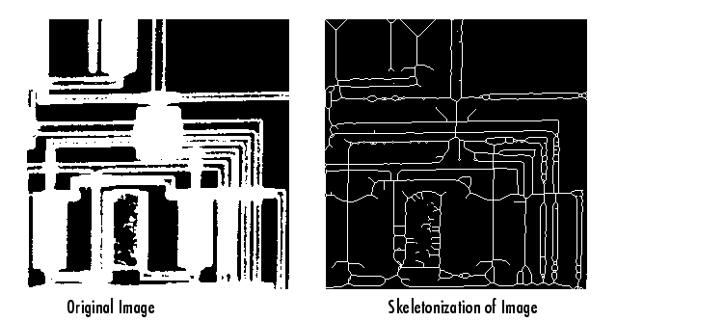

Perimeter Determination
The bwperim function determines the perimeter pixels of the objects during a binary image. A pixel is taken into account a fringe pixel if it satisfies both of those criteria:

- The pixel is on.
- One (or more) of the pixels in its neighbourhood is off.

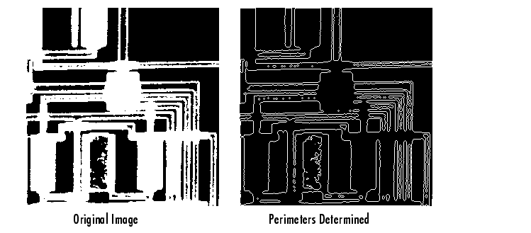
For example, this code finds the perimeter pixels during a binary image of a circuit card.

BW1 = imread('circbw.tif');
BW2 = bwperim(BW1);
imshow(BW1)
figure, imshow(BW2)
Opening and Closing
Opening and shutting are dual operations utilized in Digital Image Processing for restoring an eroded image. The opening is usually wont to restore or recover the first image to the utmost possible extent. Closing is usually wont to smoother the contour of the distorted image and fuse back the narrow breaks and long thin gulfs. Closing is additionally used for getting obviate the tiny holes of the obtained image.
Opening and shutting are two important operators from mathematical morphology. they're both derived from the elemental operations of abrasion and deletion. Like those operators, they're normally applied to binary images, although there also are gray-level versions. The opening is usually wont to remove small objects from the foreground (usually taken because the bright pixels) of a picture , placing them within the background whereas Closing is usually wont to remove small holes within the foreground, changing small islands of background into the foreground.
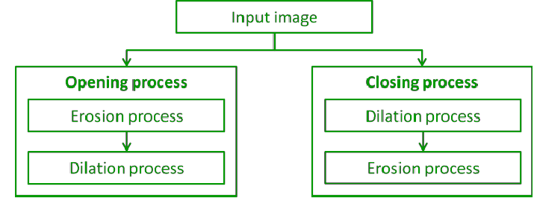
The combination of opening and shutting is usually wont to pack up artifacts within the segmented image before using the image for digital analysis.
The combination of Opening and shutting is usually wont to pack up artifacts within the segmented image before using the image for digital analysis.
Opening
- Opening may be a process during which first erosion operation is performed then dilation operation is performed.
- Opening removes small objects from the foreground (usually taken because the bright pixels) of a picture , placing them within the background.
- Opening preserves the form and size of larger objects within the image.
- Opening is employed for removing internal noise of the obtained image.
- Opening eliminates the skinny protrusions of the obtained image.
- The opening operation erodes a picture then dilates the eroded image using an equivalent structuring element for both operations.
- Operation performed on X & Y is represented by (AoB).
- Opening operation performed on X & Y is that the union of all translations of Y that fit entirely within X.

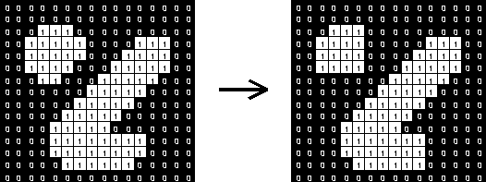

Properties of Opening are:
1. XºY is a subset (subimage of X)
2. If X is a subset of Z then XºY is a subset of ZºY
3.(XºY)ºY = XºY

Denotation:


Working
Very simply, a gap is defined as an erosion followed by a dilation using an equivalent structuring element for both operations. The opening operator therefore requires two inputs: a picture to be opened, and a structuring element.
Gray level opening consists simply of a Gray level erosion followed by a Gray level dilation.
Opening is that the dual of closing, i.e. opening the foreground pixels with a specific structuring element is like closing the background pixels with an equivalent element.
Consider
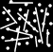
which is a binary image containing a mixture of circles and lines. Suppose that we want to separate out the circles from the lines, so that they can be counted. Opening with a disk -shaped structuring element 11 pixels in diameter gives

Some of the circles are slightly distorted, but in general, the lines have been almost completely removed while the circles remain almost completely unaffected.
The image
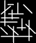
shows another binary image. Suppose that this time we wish to separately extract the horizontal and vertical lines. The result of an opening with a 3×9 vertically oriented structuring element is shown in

The image

shows what happens if we use a 9×3 horizontally oriented structuring element instead. Note that there are a few glitches in this last image where the diagonal lines cross vertical lines. These could easily be eliminated, however, using a slightly longer structuring element.
Unlike erosion and dilation, the position of the origin of the structuring element does not really matter for opening and closing the result is independent of it.
Closing
- Closing may be a process during which first dilation operation is performed then erosion operation is performed.
- Closing removes small holes within the foreground, changing small islands of background into foreground.
- Closing preserves the form and size of larger objects within the image.
- Closing is employed for smoothening of contour and fusing of narrow breaks.
- Closing eliminates the tiny holes from the obtained image.
- The closing operation dilates a picture then erodes the dilated image, using an equivalent structuring element for both operations.
- Closing operation performed on X & Y is represented by (A.B).
- Closing operation performed on X & Y is that the complement of the union of all translations of Y that don't fit entirely within X.

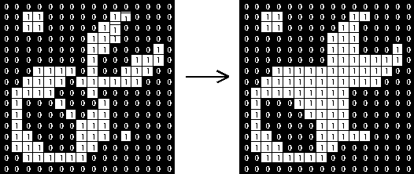

Properties of Closing are:
1. X may be a subset subimage of X.Y
2. (X.Y).Y = X.Y
Denotation:


Working
Closing is opening performed in reverse. it's defined simply as a dilation followed by an erosion using an equivalent structuring element for both operations. See the sections on erosion and dilation for details of the individual steps. The closing operator therefore requires two inputs: a picture to be closed and a structuring element.
Gray-level closing consists straightforwardly of a gray-level dilation followed by a gray-level erosion.
Closing is that the dual of opening, i.e. closing the foreground pixels with a specific structuring element, is like closing the background with an equivalent element.
Closing can sometimes be used to selectively fill in particular background regions of an image. Whether or not this can be done depends upon whether a suitable structuring element can be found that fits well inside regions that are to be preserved, but doesn't fit inside regions that are to be removed.
The image

is an image containing large holes and small holes. If it is desired to remove the small holes while retaining the large holes, then we can simply perform a closing with a disk-shaped structuring element with a diameter larger than the smaller holes, but smaller than the large holes.
The image

is the result of a closing with a 22 pixel diameter disk. Note that the thin black ring has also been filled in as a result of the closing operation.
In real world applications, closing can, for example, be used to enhance binary images of objects obtained from thresholding. Consider that we want compute the skeleton of

To do this we first need to transform the graylevel image into a binary image. Simply thresholding the image at a value of 100 yields

We can see that the threshold classified some parts of the receiver as background. The image

is the result of closing the thresholded, image with a circular structuring element of size 20. The merit of this operator becomes obvious when we compare the skeletons of the two binary images. The image
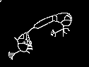
is the skeleton of the image which was only thresholdedand
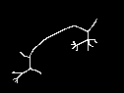
is the skeleton of the image produced by the closing operator. We can see that the latter skeleton is less complex and it better represents the shape of the object.
Unlike erosion and dilation, the position of the origin of the structuring element does not really matter for opening and closing. The result is independent of it.
Morphological Algorithms – Boundary Extraction
Boundary extraction may be a process to extract the boundary of a sample curve or a picture during this project, some modification is formed to the algorithm from Eddins (2006) to extract the boundary. This algorithm is chosebecause it can extract the boundary properly and therefore the result are often wont to extract the info . Before extracting theboundary, the chosen image should be edited with the Adobe Photoshop and Adobe Illustrator to get rid of itfrom noise in order that it'll becomes smoother. If the image isn't smooth, the algorithm of boundary extractioncannot produce an honest result. However, when the image is already clean and smooth, the method of editing isskipped.
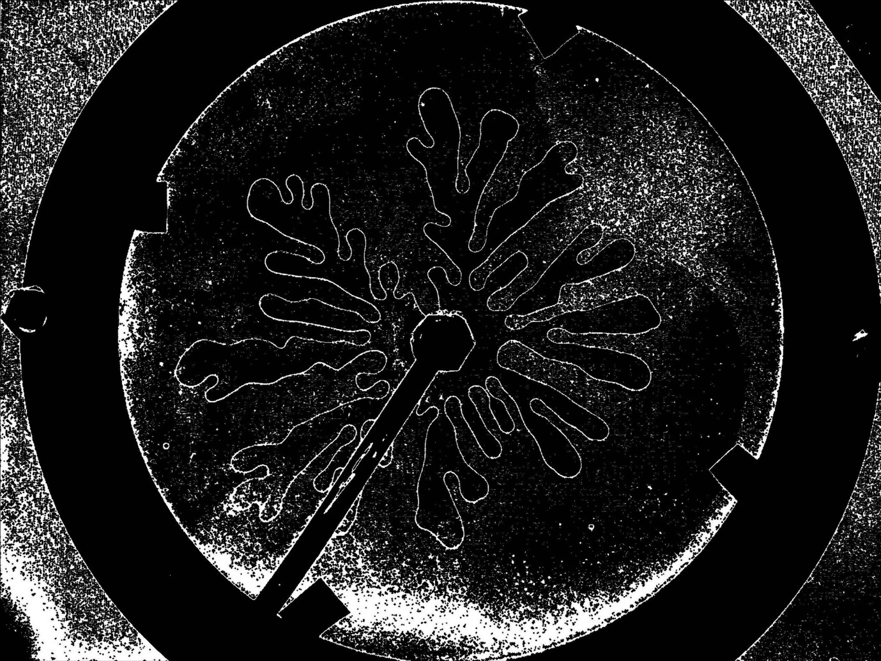
Figure: Smooth Boundary Extraction of a Binary Image

The process is sustained to get the binary image by threshold the image. The algorithm from Eddins(2006) is employed to threshold the image. The binary image is in black and white color and only has two-pixelvalues. the thing is in white colour and therefore the background of the thing is in black colour. The pixel value forthe object is one and therefore the background of the thing is zero.
Therefore, boundaryextraction is that the best process so as to possess the feature of the image in order that the info is often extracted. Theprocess to extract the boundary is begins with editing the image to get rid of the noise in order that it'll becomessmoother. The image has got to be clear and smooth in order that the method of boundary extraction will become easier.The boundary of the image obtained from the method of boundary extraction is extremely useful to implementanother preprocessing like data extraction and corner detection. As a conclusion, this process isrecommended because it's very simple and straightforward for the researcher to implement it within the first process of preprocessing.
Morphological Operations
• Neighborhood operations administered in
spatial domain
• supported mathematical morphology
• set theoretical framework
• originally for binary images
• extended for grey scale images
Boundary Extraction Consists essentially of two steps:
• Probe a given object in x[m,n] with a structuring
element (se)
• Find how the se fits with the thing
• Information about fit is employed to
• extract info about the shape of object; OR
• change pixel values and shape objects
• Different size & shape of se yields different kinds
of info about the object; shapes the regions in
different way

Set Theory Basics:
• Union, Intersection
• Complement, Difference
• Subset, Superset, Disjoint Sets
• Reflection:
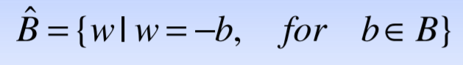
• Translation:
To put it simply, bboundary of A is computed as:
Β(A) = A – (A B)
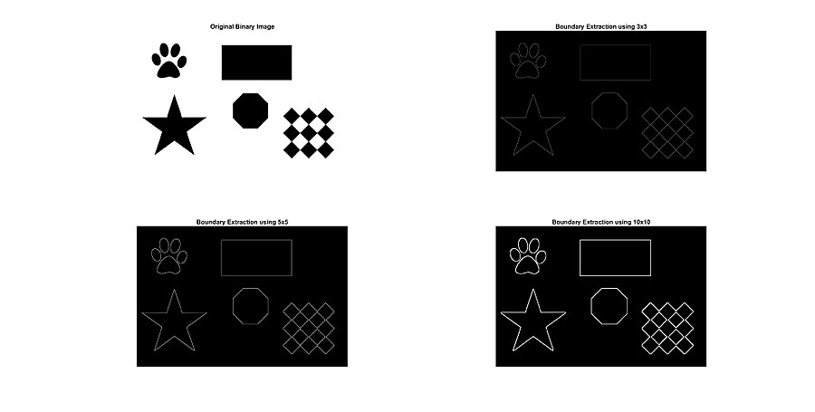
Region Filling
Region filling may be a Morphological algorithm in image processing, which deals with filling the region within the image with some colors. Region filling algorithm is widely utilized in GIS, remote sensing, image processing, and plays a crucial role. There are problems that seeds are filled into stacks repeatedly and redundant information is for the normal 4-connected region filling algorithm. during this paper, we present a replacement fast region filling algorithm supported the “Marking Method” to unravel these problems that seeds are filled into stacks repeatedly, and then, change the scanning order and uses the “Cross Method” to look the filling Region. Compared with the normal algorithm, this algorithm not only can improve 7 times more efficiency but can also make it simple and filling correctly.
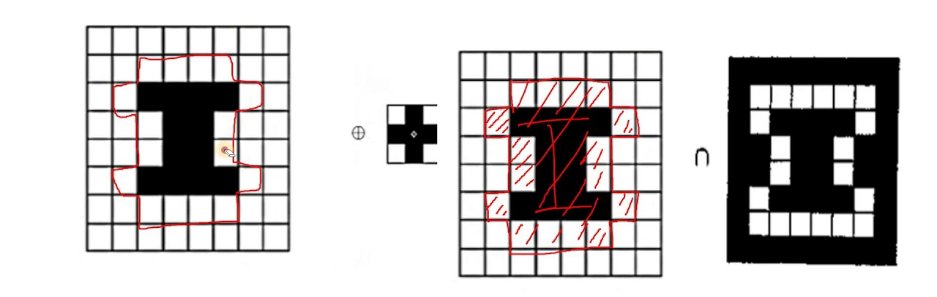
Image region are often selected in two ways:
• Interior region.
• Boundary region.
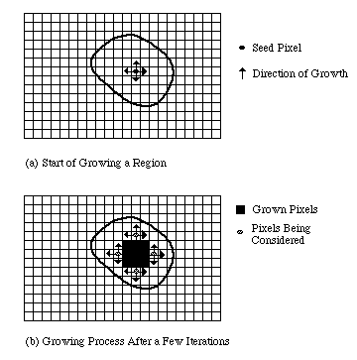
Interior region:
Interior regions are defined by assigning an equivalent value to all or any the pixels inside that region. The algorithms wont to change the values of all pixels within the interior regions to new values are FLOOD-FILL algorithms.
Boundary region:
Boundary regions are defined by assigning an equivalent value to all or any the pixels on the boundary of the region. Boundary region pixels and therefore the interior region pixels shouldn't have an equivalent values. The algorithms wont to change the worth of all pixels in boundary regions to new values are BOUNDARY-FILL algorithms.
What is a region in an image?
A region in an image is a group of connected pixels with similar properties. ... However, due to segmentation errors, the correspondence between regions and objects will not be perfect, and object-specific knowledge must be used in later stages for image interpretation.

Program Code:
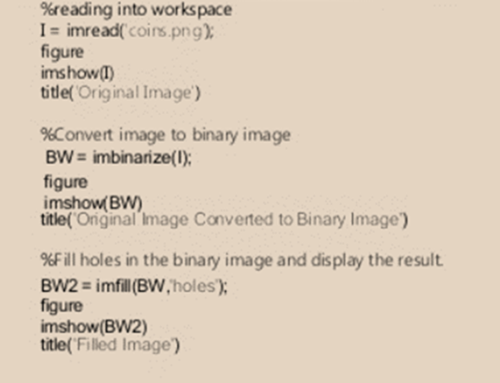

Syntax:
- I = imread('coins.png');reads a grayscale or color image from the file specified by the string filename. If the file is not in the current folder, or in a folder on the MATLAB path, specify the full pathname.
- imshow(I) displays the image I in a Handle Graphics figure, where I is a grayscale, RGB (true color), or binary image. For binary images, imshow displays pixels with the value 0 (zero) as black and 1 as white
- BW = imbinarize(I); creates a binary image from image I by replacing all values above a globally determined threshold with 1s and setting all other values to 0s. By default, imbinarize uses Otsu's method, which chooses the threshold value to minimize the intraclass variance of the thresholded black and white pixels
- BW2 = imfill(BW,'holes'); fills holes in the input binary image BW. In this syntax, a hole is a set of background pixels that cannot be reached by filling in the background from the edge of the image.

5.7. Extraction of Connected Components
Extracting connected components from a binary image
Connected components in binary images are areas of non-zero values. Each element of every connected component is surrounded by a minimum of one other element from an equivalent component. And different components don't touch one another, there are zeros around all.

Connected component analysis are often a crucial a part of image processing. Typically (and in OpenCV, it is a fact), finding connected components in a picture is far faster than finding all contours. So, it's possible to quickly exclude all irrelevant parts of the image consistent with connected component features (such as area, centroid location, then on), to continue working with, remaining areas.
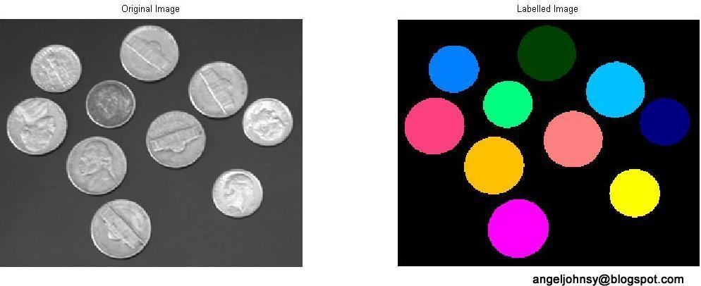
A simple method for extracting connected components of a picture combines dilation and therefore the mathematical intersection operation. the previous identifies pixels which are a part of endless region sharing a standard set of intensity values V={1} and therefore the latter eliminates dilations centered on pixels with V={0}.

A couple points to keep in mind while performing extraction of components in MATLAB:

- Read an image (A) and convert it into binary image.
- Define a structuring element (B).
- Initialize the Label matrix with zeros.
- Find a non-zero element position in the input matrix A.
- Initialize a matrix X with zeros and place 1 in the non-zero element position found in the previous step.
- Perform dilation using the structuring element B on matrix X. i.e. imdilate(X,B);
- Perform intersection with the matrix A. Y= A&imdilate(X, B).
- Check whether Y==X. If no, then X=Y and perform steps 6 and 7 again else stop the iteration.
- Find the non-zero elements position in the Y. In matrix Label place a number N in those positions. N is for labeling the connected components.
- Similarly, place zero in those positions in the input matrix A.
- Again find a non-zero element position in the matrix A. If found, goto step 5 else stop the iteration.
- Using the labels the connected components can be extracted.

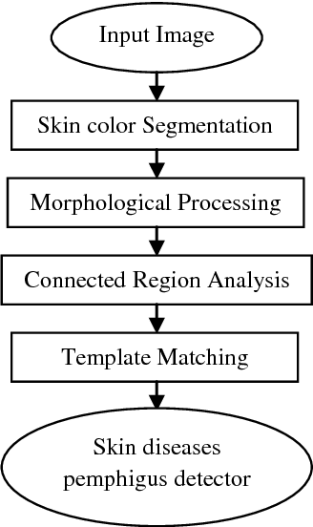

In MATLAB, a function called BWLABEL is available to label the connected components.
Based on the following iterative expression, the connected components are extracted.

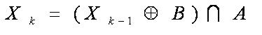
where k=1,2,3…

Using the above expression, connected components are extracted without using the function BWLABELlike so: 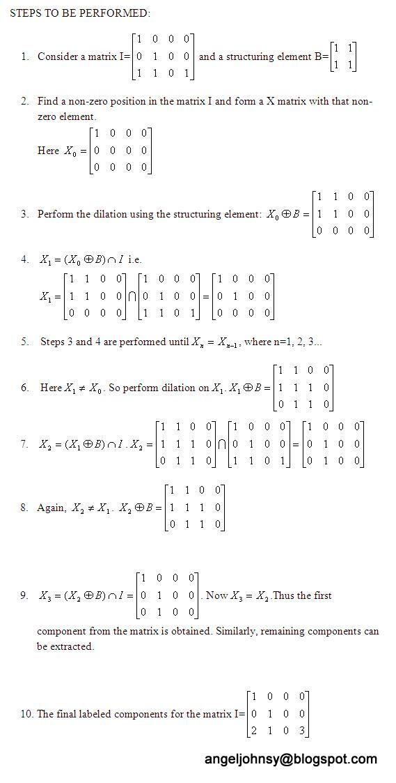

Thinning
Thinning may be a morphological operation that intends to remove selected foreground pixels from binary images, somewhat like erosion or opening. It is often used for several applications but is especially useful for skeletonization. during this mode, it's commonly wont to tidy the output of edge detectors by reducing all lines to single-pixel thickness. Thinning is generally only applied to binary images, and produces another binary image as output.
The thinning operation is said to the hit-and-miss transform, then it's helpful to possess an understanding of that operator before reading on.



This is somewhat almost like the erosion or opening operation that we discussed earlier. As clear from the name, this is often wont to thin the foreground region such its extent and connectivity are preserved. Preserving extent means preserving the endpoints of a structure whereas connectivity can ask either 4-connected or 8-connected. Thinning is usually used for producing skeletons that function image descriptors, and for reducing the output of the sting detectors to a one-pixel thickness, etc.
There are various algorithms to implement the thinning operation like

- Zhang Suen fast parallel thinning algorithm
- Non-max Suppression in Canny Edge Detector
- Guo and Hall’s two sub-iteration parallel Thinning algorithm
- Iterative algorithms using morphological operations like hit-or-miss, opening and erosion, etc

In this, we will implement thinning either using erosion and opening operations or by using hit-or-miss operations.

Let’s first discuss thinning using erosion and opening. this will be expressed because the union of skeleton subsets where each subset is given by the subsequent A-Binary image and B-structuring element)
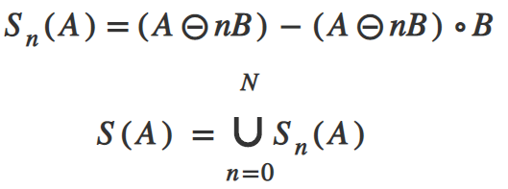
Here, n indicates the number of iterations of abrasion. N is that the last iterative step before A erodes to the empty set (stopping condition). Now, let’s discuss the way to implement this using OpenCV-Python.
Now, let’s discuss thinning using hit-or-miss transform. Thinning of set A by SE B can be expressed in terms of hit-or-miss transform as
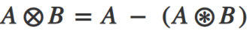
This means we remove all those pixels whose neighbourhood exactly matches the pixels in the SE. Instead of applying this with a single structuring element, it is a common practice to implement it using a sequence of SE so as to produce symmetric results. This operation is mostly applied iteratively until no further changes occur.
Thickening
Thickening is a morphological operation that is sued to grow selected regions of foreground pixels in binary images, somewhat like dilation and closing. It has several applications, including determining the approximate convex hull of a shape, and determining the skeleton by zone of influence. Thickening is only applied to binary images and it produced another binary image as an output.
Thickening is defined as :
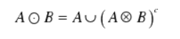
Where B is the structural element suitable for thickening. As thinning and thickening can be defined as sequential operations:
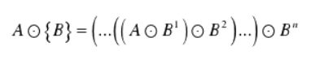
The structuring element used for thickening has the same form as thinning, except the zeros and ones have been interchanged, thus the counter- effect.
However, the usual procedure is to thin the background for the set to be processed and then compliment the result. Therefore, to thicken set A, we form its compliment, thin it, and then compliment the result.
Depending on the nature of A, the thickening procedure may result in disconnected points. Therefore, this method is usually followed post processing to fill in disconnected points.
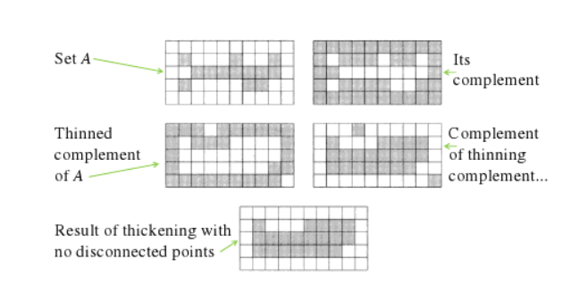
Like other morphological operators, the behavior of the thickening operation is decided by a structuring element. The binary structuring elements used for thickening are of the extended type described under the hit-and-miss transform (i.e. they will contain both ones and zeros).

The thickening operation is said to the hit-and-miss transform and may be expressed quite simply in terms of it. The thickening of a picture I by a structuring element J is:

Registration of Image
Image registration is characterised as a process that overlays two or more images from different imaging equipment or sensors taken at different times and angles, or from the same scene to geometrically coordinate the images for analysis (Zitová and Flusser, 2003).
Image registration is designed to geometrically coordinate one image with another and is a requirement for all brain imaging applications that match images across objects, across imaging types, or across time (Toga & Thompson, 2001). After image registration, the voxels in the two reported images are considered to have the same significance such that the contrast of the voxel value in one image with the value of the corresponding voxel (with the same coordinates) in the other image makes sense. In addition to the images, the registration may be applied analogously to surfaces, contours or point sets derived from the image.
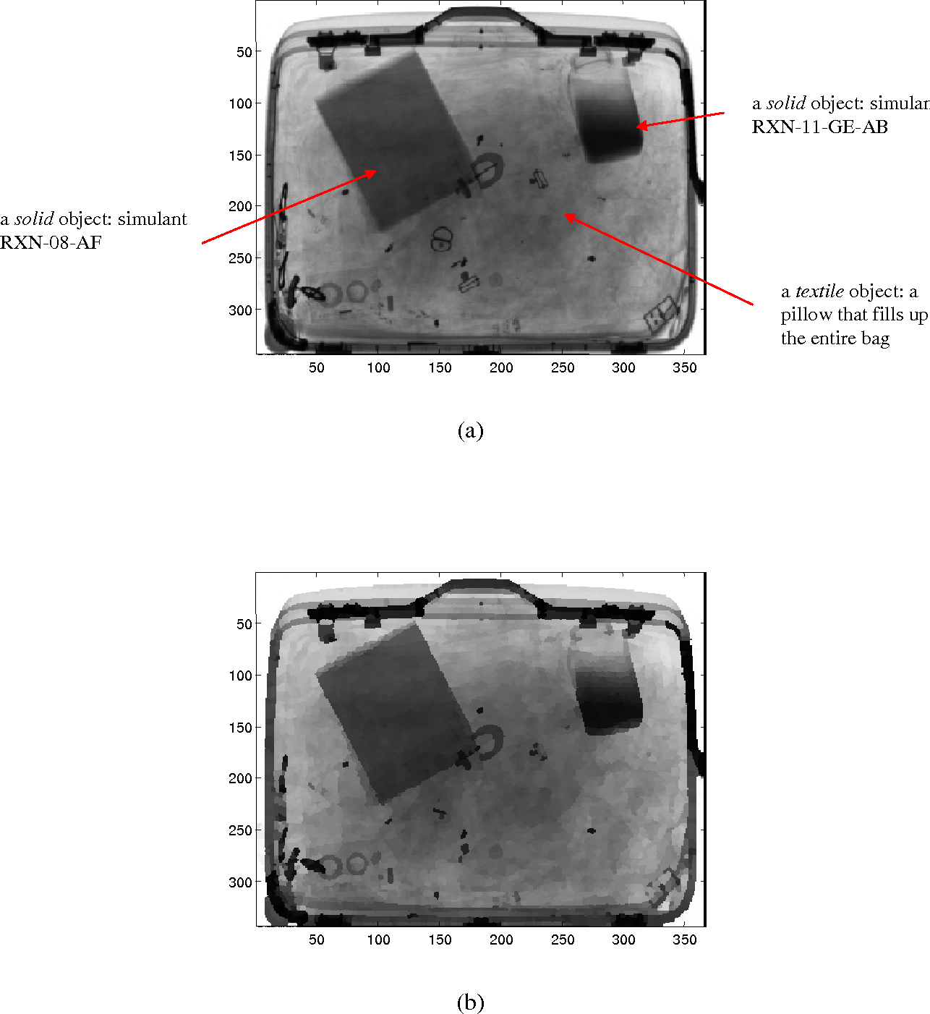
First, it's necessary to limit the set of possible geometric transformations to seek out a useful transformation between the 2 images that ameliorates irrelevant differences but preserves the important ones. the main target of this text is on rigid-body and related affine transformations that are the only class of the transformations with the fewest number of parameters (from 6 to 12). Particularly, a rigid-body transformation consists of rotations and translations. It doesn't alter the shapes or sizes of the objects present within the image and is therefore wont to model different head positions of an equivalent subject. Thus, rigid-body registrations are used for within-subject registrations required for the motion correction in functional resonance imaging (fMRI), registering the functional and structural image of an equivalent subject (this is usually termed as intramodality registration) or registering two images acquired at different times during a longitudinal study. Affine transformations, which, additionally to translations and rotations, leave scaling and shears, are often used for the between-subject registration, that is, registering the pictures of two or more subjects into an equivalent reference space, and function initializations for more flexible nonlinear registration techniques. The section ‘Rigid-Body and Other Affine Transformations’ provides overview of the rigid-body and affine transformations. Nonlinear transformations and registration, which permit for greater freedom in geometric variation between the pictures, are dealt within the subsequent articles.

The second component, dealt within the section ‘How to seek out the simplest Transformation?’ of a picture registration method is that the criterion supported which the 2 images are registered. This criterion are often supported geometric (anatomical) properties of the pictures or image intensities. Traditionally, the excellence between intra- and intramodality registration has been stressed. the rationale for this is often that, within the intramodality case, when the 2 images to be registered are acquired using an equivalent modality, one can expect the 2 images to seem far more alike than within the intramodality case, where images are acquired using different modalities. However, this distinction has been somewhat blurred since information-theoretic registration criteria, explained within the section ‘How to seek out the simplest Transformation?’ are often effectively used for both intra- and intramodality registrations. However, automatic software tools often recommend the utilization of various criteria for intra and intermodally registrations.

The third component of a picture registration method is that the actual numerical algorithm o performs the registration. this is often a crucial consideration because often, the registration criterion is expressed as a price function that has got to be optimized employing a numerical algorithm.
It is important to recollect that the inappropriate registration can introduce changes, which may negatively affect the result of the image analysis. It can increase or decrease the dimensions of an evaluated object of the scene (i.e., tumors, skin lesions) and thus influence the ultimate diagnosis. the selection of a way and collection of all a priori information may be a significant step within the whole process.
In general, the time necessary to end a registration process can significantly vary. it's suffering from external influences like given size and dimensionality of analyzed data, possible multimodality of datasets, the complexity of present geometric differences, and demanded accuracy. It might be concluded that each one mentioned factors have a growing tendency. Registration methods in medical imaging are preferably using the entire datasets resulting in very time complex solutions. the upper resolution data with higher dimensionality capturing a bigger size of patients taken in several modalities are the stratified sample to be processed. the ultimate time consumption are often decreased using various speed-ups and heuristics.
Data reduction is one possible direction when pyramidal image representations or feature-based methods working with symbolic description are employed. The matching process are often facilitated using carefully chosen optimization techniques and estimators for used auxiliary measures. the standard of used interpolators influences the ultimate computational time, too. The time complexity, however, is increased if the accuracy and better robustness are required because it always results in solutions utilizing the iterations or backtracking.
One factor which may decrease the general time consumption is that the level of allowed interactivity within the whole process. The user interaction can pronouncedly lower the time complexity by reducing the search space, accelerating the optimization process, or removing mismatches. The listed factors demonstrate possibilities within the registration design and significant variability of the ultimate time consumption.
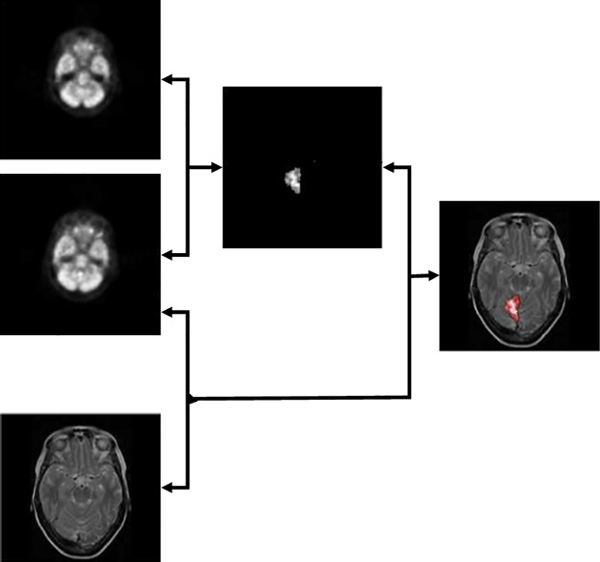
Image registration may be a key step within the pre-processing of images which should be fused (see above for an example of an epilepsy detection using SPECT and MRI datasets), which changes to be detected, which quality should be increased by super-resolution or deconvolution or which should be further utilized in image information systems, among others; however, automatic image registration remains an open problem. Many authors focus themselves on the creation of fully automated algorithms, but because of this the methods often have lower accuracy or speed. Allowing semiautomatic approach, when the user can help more accurately initialize some parts of the registration or easily reject apparently wrong directions of optimization could increase the robustness and thus usability of medical image registration. The disadvantage of the user interaction is that the loss of objectivity when the outputs aren't any longer comparable, and therefore the repeatability of results is restricted.
. Image Mapping
Image Mapping A to B
If the projection from B to A is known then we can
1. Project the coordinates of the B pixels onto the A pixel grid.
2. Find the nearest A grid points for each projected B grid point.
3. Compute the value for the B pixels by interpolation of the A image.
Note:There is no projection back to B. We have computed the values for each B pixel. If we know that the coordinates of A are integers then we can find the four pixels of A that surround (xq, yq) by quantizing the coordinate values

Mapping Parameters
We can determine the mapping transform H and the parameters of the RST matrix as follows:
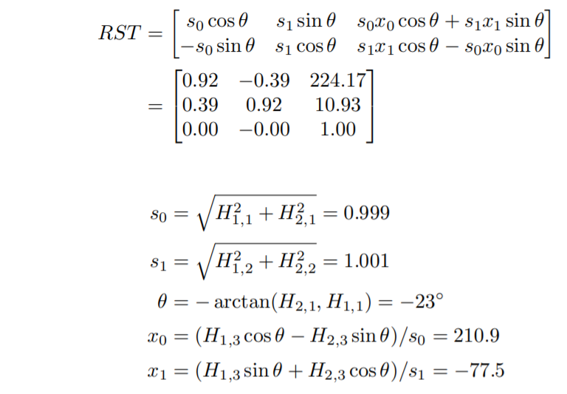
Stereo Imaging –Algorithms to Establish Correspondence
Local Stereo Matching
Local stereo matching will compare the environment of a pixel p within the left image to slightly translated positions q within the right image to estimate the disparity of pixel p. Each pixel is processed separately, without taking the complete image context under consideration , which frequently leads to noisy disparity images, especially in non-textured image regions influenced by any source of input noise (e.g., light flickering, slightly varying colors over adjacent camera views, etc.).
To estimate the disparity in local stereo matching methods, the environment of a pixel p within the left image are compared to the environment of the pixel q within the right image, where q has been translated over a candidate disparity δp compared to p, cf. Fig. 1.34. for every pixel p, N candidate disparities (δp1, δp2, …, δpN) is tested (N = 256 and 65,536 for 8 and 16-bit depth maps, respectively), and therefore the candidate disparity leading to rock bottom matching cost is assigned to pixel provides a short overview of the foremost used matching costs.
Besides choosing an honest matching cost metric, it's also important to well define the form of the encompassing matching window around pixel p. Indeed, it's always implicitly assumed that each one pixels within the window have more or less an equivalent disparity δpi, in order that just one disparity are often reliably assigned to pixel p. As a counterexample, if the matching window lies half over one object and covers for the opposite half another object lying at a really different depth—e.g., the oblong window of the thing silhouette in Fig. 1.34—pixels of various disparities and/or partially disoccluded pixels (pixels not visible within the other image) are going to be matched together, yielding the simplest matching cost at a possibly wrong disparity value, very different from the important disparity that ought to be assigned to pixel p.
Reliable, local stereo matching approaches therefore take excellent care of the matching window shape, coinciding its borders with object borders includes gradient calculations to respect border objects, describe a way where, ranging from pixel p and moving outward, the window shape is fixed at an edge where neighboring pixel color differences start to be overlarge. This creates matching windows that never cross an object's border, hence providing more reliable depth estimations.
Problem formulation
The use of stereo matching or disparity estimation for pixel matching on differently exposed stereo/multiview images isn't straightforward. Stereo matching or disparity estimation is that the process of finding the pixels within the multicopy views that correspond to an equivalent 3D point within the scene. The rectified epipolar geometry simplifies this process of finding correspondences on an equivalent epipolar line. it's not necessary to calculate the 3D point coordinates to seek out the corresponding pixel on an equivalent row of the opposite image.
The disparity is that the distance d between a pixel and its horizontal match within the other image. Akhavan et al. compared the various ways of obtaining disparity maps from HDR, LDR, and tone-mapped stereo images. A useful comparison among them is obtainable , illustrating that HDR input can have a big impact on the standard of the result.
The main goal of stereo matching is to seek out the correspondences between pixels to get one HDR image per view for every frame.
Algorithms to Recover Depth
Depth perception is a very important low-level task for enabling a mobile robot system to understand three-dimensional relationship of the world space objects. There are many different approaches to solve the depth perception problem, shape from shading and stereo. Different approaches are based on different assumptions and work best in different situations. Inn stereo algorithms, finding the corresponding pixels in two images of the scene has been recognized as a difficult problem. Pentland was able to recover depth by defocused images without the correspondence problem in stereo. He noticed in fact that the most biological lens systems were exactly focused at only one distance along each radius from the lens to the scene. As the distance between the imaged point and the surface of the exact focus increases or decrease, the imaged objects become pro-aggressively more defocused in addition, some other researchers have used this phenomenon to derive algorithms for recovering depth information.
As shown below, the blurring of the image due to the defocusing is best described by point spread function. If the image is almost focused, the point spread function is a square sum of infinite number of Bessel functions.
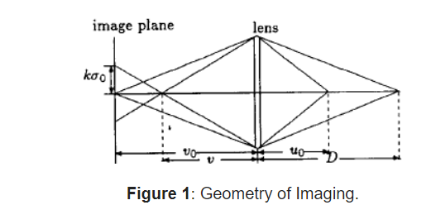
Conclusion:
First, a method for computing a background approximation via blocks analysis was introduced. Then, utilising morphological operators in mathematics, this approach was expanded. A novel approach to detect the picture backdrop was therefore put forth and is based on the usage of morphological linked transformations. However, a problem was found when the morphological erosion and dilation were used. Transformations for morphological contrast enhancement were also introduced. These operators are based on the idea of Weber's law. Throughout the study, various examples were used to explain how the suggestions made in this work performed. Additionally, the performance of the operators used in this study was compared to other examples provided in the literature. Last but not least, a drawback of the contrast enhancement transformations examined in this study is that they can perform well while executing morphological operations on various kinds of images.
References:
1.Droske M, Rumpf M (2007) Multiscale joint segmentation and registration of image morphology. IEEE Trans Pattern Anal Mach Intell 29(12):2181–2194.
2. Gu Y, Liu T, Jia X, Benediktsson JA, Chanussot J (2016) Nonlinear multiple kernel learning with multiple-structure-element extended morphological profiles for hyperspectral image classification. IEEE Trans Geosci Remote Sens 54(6):3235–3247
3. Pratima M, Soni MK (2015) Performance analysis of DWT-OFDM and FFT-OFDM using various digital modulation techniques and channel coding. Int J Comput Appl (0975 –8887) 128(11): 34–39
4. Sternberg SR (1986) Grayscale morphology. Comput Vis Graphics Image Process 35(3):333–355
5. Serra J, Soille P (eds) (2012) Mathematical morphology and its applications to image processing, vol 2. Springer Science & Business Media.
6. Batool N, Chellappa R (2015) Fast detection of facial wrinkles based on Gabor features using image morphology and geometric constraints. Pattern Recogn 48(3):642–658
7. Manhas P, Thakral S, Kumar C (2010) Performance analysis of GPRS/EDGE. Int J Electron Eng Res 655–658
8. Hu Z, Wang C, Zhu J, Liu X, Kong F (2016) Bearing fault diagnosis based on an improved morphological filter. Measurement 80:163–178
9. Thornton H (2016) Interaction of morphology and syntax in American Sign Language. Routledge
10. S. Mukhopadhyay and B. Chanda, “A multiscale morphological approach to local contrast
enhancement,” Signal Process. vol. 80, no. 4, pp. 685–696, 2000.
11. A. K. Jain, Fundamentals of Digital Images Processing. Englewood Cliffs, NJ: Prentice-Hall, 1989.
12. J. Short, J. Kittler, and K. Messer, “A comparison of photometric normalization algorithms for
face verification,” presented at the IEEE Int. Conf. Automatic Face and Gesture Recognition,
2004
13. C. R. González and E.Woods, Digital Image Processing. Englewood Cliffs, NJ: Prentice Hall,
1992.
14. R. H. Sherrier and G. A. Johnson, “Regionally adaptive histogram equalization of the chest,”
IEEE Trans. Med. Imag., vol. MI-6, pp. 1–7, 1987.
15. . Majumder and S. Irani, “Perception-based contrast enhancement of images,” ACM Trans. Appl.Percpt., vol. 4, no. 3, 2007, Article 17

