AN EXPERIMENTAL STUDY ON BACTERIAL CONCRETE WITH EFFECT OF DIFFERENT BACTERIA ON THE STRENGTH OF CONCRETE

# ABSTRACT:

The worldwide utilization of cement is second just to water. As the interest for concrete as a development material increments, so likewise the interest for Portland concrete. Concrete is a tough development material delivered by blending Portland concrete, water, totals and added substances with extraordinary extent. Changing the fixings and creation technique for ordinary cement is significant concerning maximum usage of concrete as a development material.. This pattren presents the aftereffects of a trial examination did to assess the impact of Bacillus Subtilis and Bacillus Licheniformis on the compressive strength, water retention and its self-recuperating properties. An endeavor is made to recuperate these breaks by the expansion of the microbes in the substantial and furthermore to increment of the strength of the substantial. Every microscopic organisms of fixation ar added. Tests were performed at the ages of 7, 28 and 56 days. It is found that the breaks in the substantial have been recuperated and the development of calcite precipitation is noticed utilizing Scanning Electron Microscopy (SEM). In the current venture here is an endeavor made to fill the breaks with the assistance of microscopic organisms which has a self-mending property. Calcite development of separated microbes which can deliver calcite hastens on reasonable media enhanced with a calcium source.

Watchwords: Bacillus Subtilis, Bacillus Licheniformis, SEM.

## I. Presentation

## Bacterial concrete or self mending substantial tops off the breaks created in structures by the assistance of bacterial response in the substantial subsequent to solidifying. Kinds of microorganisms, its component and arrangement of bacterial cement is talked about. In present day days, the utilization of innovation has taken the norms of development to another significant level. Concrete as a champion among the most regularly used improvement materials, expects a critical part in many fields. It has been extensively used as a piece of the improvement of designs, dams, storing

## tanks, sea ports, roads, ranges, tunnels, cable cars and various structures. Concrete is generally a mix of water, all out (coarse and fine), and bond. Bond is the most basic piece of the strong material. It ties the aggregates and makes up for the shortcomings among coarse and fine particles. High compressive quality, openness, sturdiness, and moreover appropriate conduct with stronghold bars, low worth, direct preparation and credibility of tossing in needed shapes and sizes make concrete the material of choice for certain applications. Despite strong's positive conditions, it has a high penchant to approach divides empowering powerful synthetics to go into the design.

## BENEFITS OF BACTERIAL CONCRETE

• Self-fixing of breaks with no outside assistant.

• Huge expansion in strength when contrasted with typical cement.

• Obstruction towards freeze-defrost assaults.

• Decrease in penetrability of cement.

**HISTORY OF MICROBIOLOGY**

**•** Microorganisms ar little living creatures, single-celled prokaryotic creatures. Minute creatures come in different shapes and the sizes.

• Microorganisms ar a ubiquitous in every ara on Earth, creating in soil, acidic underground aquifers, radioactive waste, water, and some place down in the Earth's outside layer, and also in regular issue and the live gatherings of plants and animals. There ar normally 40 million bacterial cells in a gram of soil and 1,000,000 bacterial cells in a milliliter of fresh water; overall, there ar approximately five nonillion (5×1030) microorganisms on Earth (Whitman et al. 1998, Vol.95) molding a huge region of the planet biomass.

**SCOPE & WORK**

* Foster a bacterial cement by presenting the microscopic organisms' of bacillus family (Bacillus Subtilis).
* To find the ideal measurement of microorganisms expected for bacterial cement
* To decide the practical bacterial cells by sequential weakening technique.
* To know the presence of voids by ultrasonic heartbeat speed test.

# II LITERATURE REVIEW

SakinaNajmuddinSaifee et .al1 distributed a paper on Critical examination on Bacterial Concrete. In this paper they examined about the various sorts of microbes and their applications. The bacterial cement is a lot of valuable in expanding the sturdiness of cemetous materials, fix of limestone landmarks , fixing of substantial breaks to exceptionally strong breaks and so forth. It additionally helpful for development of minimal expense tough streets , high strength structures with seriously bearing limit,

disintegration avoidance of free sands and minimal expense tough houses. They have likewise informed about the functioning standard of bacterial concrete as a maintenance material. It was likewise seen in the review that the metabolic exercises in the microorganisms occurring inside the substantial outcomes into expanding the general exhibition of cement including its compressive strength. This concentrate additionally clears up the substance interaction for remediate breaks.

III: MATERIALS AND METHODOLOGY

**MATERIALS AND METHODS**

The materials used in the present study ar

Cement (OPC – 53 grade), Fine aggregate (sand), Coarse aggregate, Barite powder, Calcium Carbide, RTPP Fly ash, Water

**Cement**

53 grade OPC manufactured by Zuari Cement Company Conforming to IS. 12269 is used.

**Table:1 Cement Properties**

|  |  |  |
| --- | --- | --- |
| S.No. | Characteristics | Value |
| 1 | Specific gravity | 3.05 |
| 2 | Normal Consistency | 31% |
| 3 | Initial and Final setting times | 30min. to 480min. |

**Fine Aggregate**

Natural Sand obtained from local river bed Cheyyeru is used in the present investigation

**Table: 2 Properties of fine aggregate**

|  |  |  |
| --- | --- | --- |
| S. No | Property | Results |
| 1 | Specific gravity | 2.68 |
| 2 | Fineness Modulus | 2.57 |
| 3 | Bulk Density | 1530Kg/m3(Compat) |

**Coarse Aggregates**

20mm crushed granite aggregate obtained from local stone crusher is used in the present investigation.

**Table: 3 Coarse Aggregate Physical Properties**

|  |  |  |
| --- | --- | --- |
| S. No | Property | Results |
| 1 | Specific gravity | 2.7 |
| 2 | Fineness Modulus | 4.42 |
| 3 | Bulk Density | 1636Kg/m3(Compat) |

Microscopic organisms

In this assessment the bacillus pasteurii microorganisms is used .Sporosarcina pasteurii in the past known as Bacillus pasteurii from additional laid out logical groupings is a bacterium with the ability to speed up calcite and solidify sand given a calcium source and urea, through the methodology of microbiologically impelled calcite precipitation or regular cementation. Bacillus pasteurii has been proposed to be used as a normally steady natural improvement material.

WATER

The most affordable however the main element of cement is water. The water which is utilized for blending cement ought to be perfect and liberated from destructive pollutions, for example, oil, soluble base, corrosive and so on convenient water was utilized for blending and relieving work.

**BACTERIAL CONCRETE OR SELF-HEALING CONCRETE**

This commonplace issue of separating in building has many fixes prior and a short time later thusly the break. One of the accommodating strategy is Bacterial Concrete or Self-Healing Concrete. The technique of self-fixing of makes or self-filling laugh fiercely of breaks by the assistance of bacterial response in the solid following solidifying is known as Self-Healing Concrete. It will in general be watched that little parts that happen in a plan of width in the degree of 0.05 to 0.1mm gets totally fixed in somber dry and wet cycles.

BIOCONCRETE MECHANISM

Precisely when the solid is blended in with microorganisms (bacillus subtilus), the minuscule natural substances go into a slow express, a staggering plan like seeds. The microorganisms require is all preamble to the air to affect their capacities. Any parts that ought to happen give the huge show. Right when the breaks frame, microorganisms closeness to the split, fires accelerating calcite important stones. Precisely when a solid development is harmed and water begins to spill through the parts that show up in areas of strength for the, spores of the microorganisms encourage on contact with the water and enhancements.

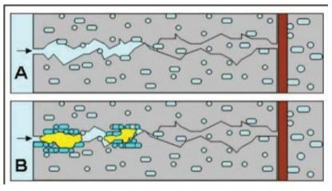

CULTIVATION OF BACTERIA

The unadulterated culture of microscopic organisms i.e. Bacillus Subtilis is safeguarded on supplement agar inclines.

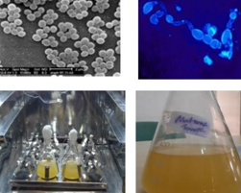

Fig. Bacteria in incubator MIX PROPORTIONING

**MIX DESIGN**

**Standard grade concrete (M40)** Mix proportion 1: 1.76: 2.71: 0.45 Cement : 400 Kgs

Fine aggregate : 704 Kgs Coarse aggregate: 1084 Kgs Water : 180 Lt

MIXING OF CONCRETE

Blend configuration can be characterized as the way toward choosing reasonable elements of cement, for example, bond, totals, water and deciding their relative extents with the question of creating cement of required least quality, workability and toughness as financially as could be expected under the circumstances.

PHASE - I

The phase-I of investigation is carried out to culture the bacteria

PHASE – II

The phase-II of investigation is carried out to study the strength behavior of bacterial concrete.

**IV EXPERIMENTAL INVESTIGATION**

Blend configuration can be characterized as the most common way of choosing appropriate elements of cement and deciding their relative extents with the object of creating cement of specific least strength and toughness as financially as could be expected. In our examination we have made M40 grade of cement. The blend proportion acquired after the blend plan according to IS 456: was given in pervious part

.Further, we have poured the substantial in the 3D shape Molds and six distinct examples were made which ar as per the following

a. M 40.

b. 15 ml treatment

c. Concrete with 30 ml treatment

d. Concrete with 45 ml treatment

e. Concrete with 60 ml treatment.

f. Concrete with 75 ml treatment

**METHODS OF MIXING BACTERIAL SOLUTION INTO CONCRETE**

There ar various techniques for blending the bacterial arrangement in the substantial which ar viz.

Direct Mixing

Roundabout Mixing

Infusion strategy

Projecting OF CUBES AND CURING

When the substantial is totally blended the substantial is poured in the 3D square, compaction is been finished by the vibration machine. Substantial solid shapes were taken out from the Molds after 24 hrs. Also, they were placed into the restoring tank. Relieving was finished for 7, 14 and 28 days for all examples viz. Customary, 15 ml, 30 ml, 45 ml, 60 ml and 75 ml.

Trial TEST ON BACTERIAL CONCRETE

Different test ar performed on bacterial cement to come by the outcomes in different structures these exploratory techniques ar summed up beneath Slump cone test

The substantial rut test is an experimental test that actions usefulness of new concrete. The rut cone test shows the way of behaving of a compacted substantial cone under the activity of gravitational powers. The test is completed with a Molds called as rut cone. The rut cone is put on an even and a non-retentive surface and filled in three layers of new concrete, each layer being packed multiple times with a standard packing bar.

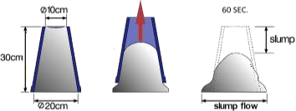

Showing the Slump Height.

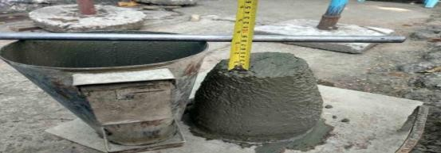

Fig: Slump Cone

Tests

. Compressive strength test

Water absorption

UPV test

Plate count test

Experimental procedure to obtain plate count test of bacterial solution

To begin with blending of 24hr. Hatched 1 g solid material from each piece was finished by rolling the test tube between the palms to guarantee even scattering of cell in the way of life. By using sterile pipette, aseptically exchange of 0.1ml bacterial suspension to the test tube containing 10 ml waterfall infusion was finished. Quantities of reasonable microbes ar corresponding to the quantity of bacterial provinces. Quantities of bacterial provinces ar checked by utilizing state counter.

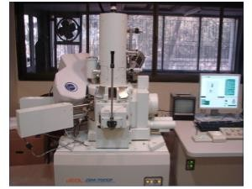

**Fig: Scanning Electron Microscope Machine**

V RESULTS

Tests performed:

Compressive strength test

Water absorption

UPV test

Plate count test

COMPRESSIVE STRENGTH TEST

Concrete cubes of sizes 150mm×150mm×150mm were tested for crushing strength. Compressive strength depends on loads of factor such as w/c ratio, cement strength, excellence of concrete material and excellence control during manufacture of concrete. These cubes ar tested by compression testing machine after 7 days, 14 days or 28 days curing. The sample is placed centrally on the base plate of machine and the load have to be apply gradually at the rate of 140 kg/cm2 per minute till the specimen fails.

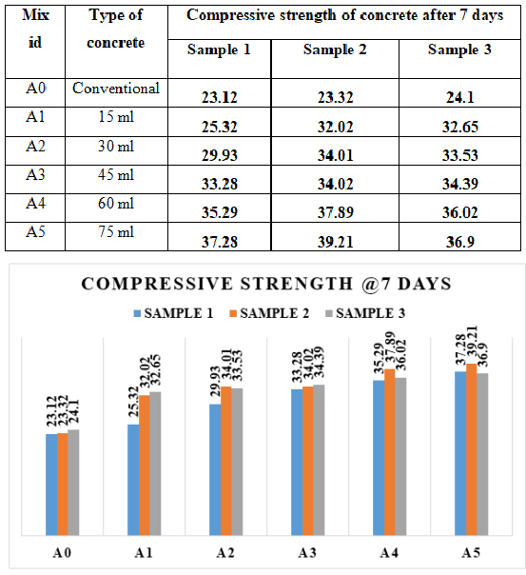Table: COMPRESSION TEST RESULT @ 7 DAYS

**Fig.: Compressive Strength test results Table: COMPRESSION TEST RESULT**

@28 DAYS

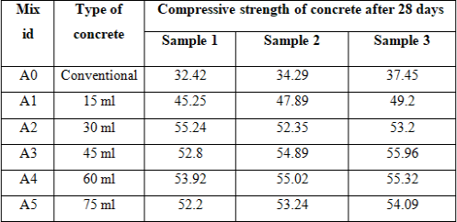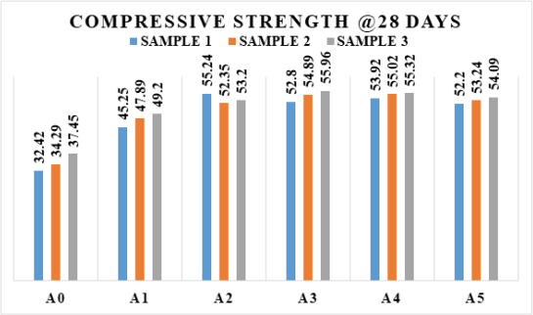

**Fig.: Compressive Strength test results**

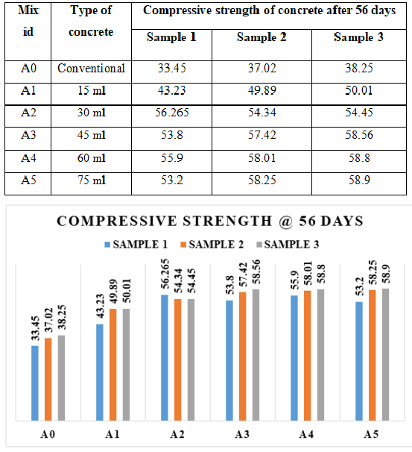

Fig.: Compressive Strength test result

From the above the graphs we can clearly notice that the compressive strength of the cubes increment, as we see from A0 to A1 the strength of cubes moves ahead by this we make an inference that increases in the volume of bacterial solution increase in the compressive strength of the cubes. According the mix we did addition of bacterial solution in the increment order i.e. 15ml 30ml 45ml 60ml 70 ml. Actually we have taken 3 cubes in each sample so by the way we got three results in each sample. On average of the three results we can conclude that increment in the bacterial solution gives more strength and cars concrete not to crack by their mechanism.

Water Absorption:

The 150mm x150 mm x 150 mm cube after casting were immersed in water for 28 days and 60 days curing. These specimens were then oven dried for 24 hours at the temperature110°C until the mass became constant and again weighed. The weight’s was noted as the dry weight (W1) of the cylinder. After that the specimen was kept in hot water at 85°c for 3.5 hours. Then this weight was noted as the wet weight (W2) of the cylinder.

%water absorption= [(W2-W1)/W1] x100

Where, W1 = Oven dry weight of cylinder in grams W2 = after 3.5 hours wet weight of cylinder in grams.

Table: % WATER ABSORPTION TEST RESULT.

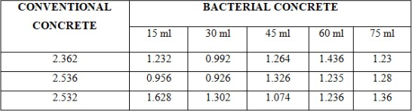

**ULTRA SONIC PLUSE VELOCITY TEST**

Ultra-sonic pulse velocity test was carried out to know the presence of voids in the internal structure of the concrete cubes. The results so obtained after conducting the test ar tabulated below table. This results shows that of all samples tested the trouble time of 30ml and 45ml bacterial concrete found to be much lesser, again velocity is also higher.

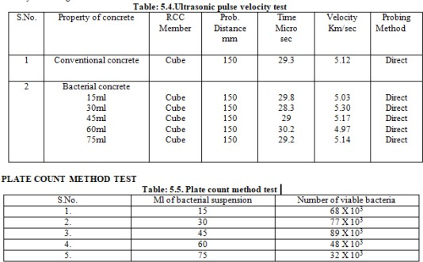

CONCLUSION

The microorganisms which ar known to be dissolvable base safe,

for instance they fill in customary living spaces depicted by a fairly high pH. Additionally, these strains can convey spores which ar resting cells with intense cell walls that shield them against silly environmental mechanical-and substance stresses. Thusly these specific microorganisms could might go against the high internal significant pH values (12-13 for Portland concrete based cement), and remain sensible for a long time as well, as spore reasonableness for up to 200 years is accounted for.

Compressive strength of the significant is start extending while we carry organisms into the significant differentiation with show concrete

In this adventure we worked with UPV test and plate load include system by how the speed and number of bacterial cell present in the significant was resolved probably

Water maintenance test is in like manner done where from the examination we can assume that we got further developed achieves the microorganisms significant differentiation with conventional concrete.

By the way extension in microorganisms in the significant prompts development in the strength and moreover we can evidently see that no breaks considering part of organisms.

FUTURE SCOPE

More survey expected to reduce the cost of self-retouching concrete.

Further survey expected to beat on the constraints of bacillus subtilis organisms.

More work should be done on the long effect of microorganisms on human life.

Can be used in the advancement of plane runways, platforms and dams decreasing the help cost.

Holding wall advancement.

REFERENCES

P chitra, Bai Shibi Varghese. An exploratory assessment on the strength properties of fly trash based bacterial significant International Journal of Innovative Research in Advanced Engineering (IJIRAE) ISSN: 2349-2763 Issue 08, Vol 3

(August 2016)

V S Reddy, M V S Rao, S Sushma. Probability Study on Bacterial Concrete as an innovative self break recovering system. Overall Journal of Modern Trends in Engineering and Research, e-ISSN No.:2349-9745, Vol 2, Issue 7, [July-2015] Special Issue of ICRTET'2015, Date: 2-4 July, 2015, PP 642-647.

Babarao Ashish Gawande, Yash Suneel Khandekar and Ojas Pravin Rahate, Applicability of Concrete Treated with Self-Healing Bacterial Agents. Overall Journal of Civil Engineering and Technology, 7(5), 2016, pp.275-283.

Abhishek Thakur, Akshay Phogat and Khushpreet Singh, Bacterial Concrete and Effect of Different Bacteria on the Strength and Water Absorption Characteristics of Concrete: A Review. Overall Journal of Civil Engineering and Technology, 7(5), 2016, pp.43-56.

Mohit Goyal, P. Krishna Chaitanya. Direct of Bacterial Concrete as Self Healing Material, International Journal of Emerging Technology and Advanced Engineering ,ISSN 2250-2459, Volume 5, Issue 1, January 2015,PP 100-103 N.GaneshBabu. An exploratory focus on strength and break properties of self recovering cement.