Pinky Saikiaª, Subrat Jyoti Borahª
ªJoya Gogoi College, Khumtai, Golaghat, Assam-785619
Email: pompipinkysaikia@gmail.com, subratjb@gmail.com

Abstract
Nanoscience and nanotechnology attracts considerable attention in the recent time and has become one of the most important area of research because of their unique properties and applications as catalyst, sensors, electronics, medicine, bio-sciences, drug delivery, opto-electronics, abatement of pollution etc. It is highly multidisciplinary which deals with all branches of science. Nanomaterials are the chemical substances having the structure with at least one dimension of 1-100 nm. They possess different important properties such as high surface area, surface energy, crystal structure, physiochemical stability etc. Due to these properties, they have many applications in different field including catalysis. In this chapter, we have discussed only recent application of carbon based nanomaterials, metal-oxide based and clay/LDH based nanomaterials in the field of catalysis.
Keywords: Nanoparticles; Metal-oxide nanoparticle; Clay supported nanomaterials; LDH; Characterizations; Catalysis
1. Introduction:
Nanomaterials are a set of substances having at least one dimension is in nanometer range (1-100 nm). These includes nanoparticles, nanofibers and nanoplates [1]. Nanoparticles exhibit improved physico-chemical properties which correspond neither to those of free atoms or molecules making up the particles nor to those of bulk solids with same chemical composition. Nanotechnology involves the use of nanomaterials in various fields like chemical and textiles industries, sensors, catalysis, biotechnology, electronics, medicine to provide better and improved technologies to the society [2-9]. Nanoparticles have large value of surface area due to distribution of large fraction of the atoms on the surface and are used as catalyst in different fields of research [8-9]. Due to their some unique properties including optical, magnetic, electrical, and other properties, they have greater impacts in the field of electronics, medicine, and catalysis [10]. These are also widely used in areas of medical diagnostics, material modification, abatement of environmental pollutants and biotechnology which requires further modification of nonmaterial into different structure with different features. The most important feature is the catalytic application [1].
Nanomaterials can be synthesized mainly by two approaches-top down and bottom up approach (Figure 1) [11]. Top down approach includes- mechanochemical processing, electroexplosion, sputtering, laser ablation, lithography, electrospining etc. [11] whereas bottom up approach includes- chemical vapour deposition, plasma arcing, wet chemical methods etc. [11]
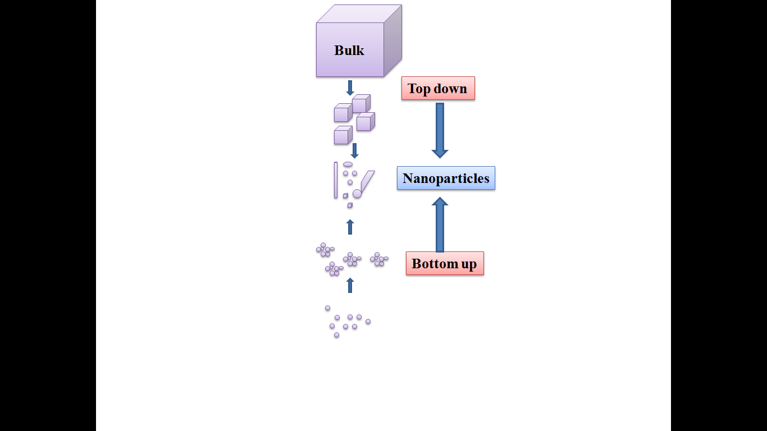
Figure 1: Schematic representation of synthesis of nanomaterials
In recent years, synthesis and application of Nanomaterials becomes one of the interesting field of research in Nanoscience and Nanotechnology due to their potential applications in science and industry [12].On the other hand, use of nanomaterials in catalysis is the another driving force for the development of the chemical industry. In recent years, the use of metal nanomaterials as heterogeneous catalysts is an important field of research [13-16] due to their high catalytic activity and selectivity for specific reactions. Nanocatalysts were used for catalytic chemical reactions such as the oxidation reaction [13], the reduction reaction [14], coupling reaction [15,16] and the electrochemical reaction [17-21]. They have attracted more attention to researchers as they act as a bridge between atoms and bulk materials. In addition to this, they have some properties like the surface and interface effect, small size effect, quantum size effect and macroscopic quantum tunnel effect, potential applications like catalysis, biology, medicine and so on.
Catalytic nonmaterials can be classified into the three types as shown in Figure 2.
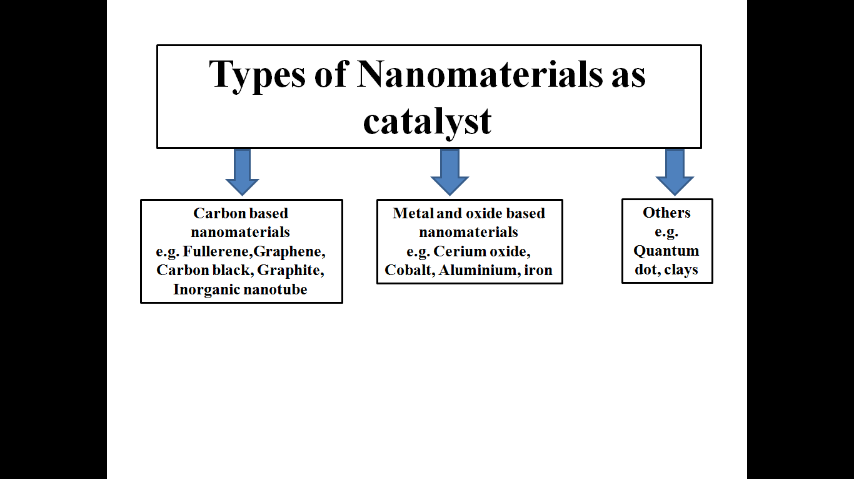
Figure 2: Different types of Nanomaterials used as catalyst
The catalytic nanomaterials can be characterized by different technique such as small-angle X-ray scattering, BET analysis, X-ray diffraction techniques , Temperature programmed oxidation (TPO) Temperature programmed reduction (TPR), SEM and TEM [22-24] etc. Table 1 shows different characterization technique for nanomaterials.

Table 1: Different Characterization Techniques used for Nanomaterials [24]
Techniques | Characterizations
Transmission electron microscopy (TEM) | It is used to determine the shape, size and crytallinity of nanomaterials
X ray diffraction (XRD) | To determine the crystal structure
UV-visible Spectroscopy | Used for light absorption and scattering
X ray photoelectron spectroscopy (XPS) | Used to determine the chemical composition
BET analysis | Determine the surface area of nanomaterials
Scanning electron microscopy (SEM) | Used to determine the shape and assembly structure
Energy dispersive X ray analysis (EDX) | It gives the chemical composition of different components present in the nanomaterials
Scanning tunneling microscopy(STM) | Used for the identification of size and shape of nanomaterials
Ultraviolet photoelectron spectroscopy (UPS) | It determines the electron valence band
X ray emission spectroscopy (XES) | It also determines the electron band gap
Near-edge X-ray absorption fine structure (NEXAFS) | Used for the determination of chemical composition

In this chapter we have discussed about the recent applications of some nanomaterials in the field of catalysis.

2.1 Application of carbon based nanomaterials:
Carbon is one of the unique element found in the universe and it becomes 6th important common element in the universe and the 4th most common element in the solar system and also 17th most common element in the Earth’s crust [25]. Due to the ability of carbon to catenate the study of carbon science become one of the most important fields of nanoscience, materials science, engineering and biology also [26]. Different lower dimensional allotropes of carbon are known such as graphite, activated carbon, carbon nanotube, Fullerene (C₆₀) family, polyaromatic molecules [27-30] and graphene [31-33] etc. And they have attracted substantial attention in the field of research due to their different application such as electronics and semiconductor industry, data storage devices, sensors and bioelectronics,composite materials, energy research, catalysis,biomedicine and theranostics [34]. The structure and application of some carbon based nanomaterials are discussed below:
2.1.1. Graphite:
The word Graphite was derived from the Greek word “graphein” [35]. Graphite is characterized by lustrous black sheen features with physically greyish-black and opaque in nature [26]. In Graphite carbon atoms are arranged in hexagonal ring structure in which atoms are held together by strong covalent bond and the layers are held together by van der Waals forces which results the capability of layers to move past each other exhibiting soft and slippery physical properties[26]. It possesses the flaky like morphology as shown in Figure 3.
Figure 3: Field emission scanning electron micrographs of graphite [26].
Due to the delocalization of π-electrons of carbon atom Graphite has an ability to conduct electricity [26]. Graphite possesses both metal and non-metallic properties, high thermal and electrical conductivity due to which it is used for the preparation of electrode and electrical arc lamp [36].
2.1.2. Buckminsterfullerene:
It was discovered by Harry Kroto and Richard Smalley of University of Sussex and Rice University [26]. Due to their unique photo physical and photochemical properties they attracted significant attention in the field of research [26]. Fullerene consists of sp² bonded carbon atom of different size in the form of hollow sphere as shown in Figure 4 [37]. Fullerene has the ability to act as sensitizer and used for blood sterilization, cancer therapy [34] etc. It has diverse application in the field of nanomedicine such as antimicrobial, antiviral, and antioxidant agents [38, 39].On the other hand, Fullerene can also be used for the production of cosmetics in human skin care.
Figure 4: Structure of Fullerene [39]
2.1.3. Carbon nanotube:
Carbon nanotubes are allotrope of carbon in the form of hollow cylinder consists of graphene sheets as shown in Figure 5[26,34,40]. Depending upon the no of grapheme sheet carbon nanotubes are classified into two types one is single wall carbon nanotube (SWCNT) which can be formed by rolling of single graphitic sheet; another is multiwall carbon nanotube (MWCNT) which can be formed by the rolling of few graphitic sheet with an interlayer spacing of 3.4Å [40]. Their diameter varies from 0.4 nm to 2.5 nm and few nm to 100 nm [34]. The layers in MWCNT are held together by van der Waals force. Due to their unique mechanical, electrical and structural diversity, fast electron transfer rate, high surface area, it exhibits superior strength, flexibility, electrical conductivity and magical behaviour towards various application including biosensor, medical diagnosis and treatment of various diseases, catalysis [40,41] etc.
Figure 5: Structure of CNT [40]

2.1.4. Graphene:
Graphene was first introduced by Mouras and co-workers as “graphitic intercalation compounds (GIC)” [40]. Graphene consists of planner graphitic sheet of sp² hybridized carbon network with carbon-carbon bond length of 1.42Å and an interlayer spacing of 3.4Å as shown in Figure 6 [40]. Due to their unique optical, electrical, chemical properties, high surface area, chemical purity and free π electrons it attracts attention in the field of research [34]. It is used as biosensor, drug delivery, treatment of various diseases including cancer therapy etc [34,40-41]. Different derivatives of graphene like graphene oxide, reduced graphene oxide, few layer graphene oxide, chemically changed graphene oxide has been developed [34]. Among these graphene oxide and reduced graphene oxide have many application in sol-gel chemistry. Graphene oxide is used as biosensor, cellular imaging, nanoprobes, anticancer drug delivery [34] etc.
Figure 6: Structure of Graphene sheet [40]
Graphene and other graphene based nanpmaterials can be synthesized by different methods such as hydrothermal method, thermal annealing, chemical vapour deposition (CVD), photoreduction, Graphene oxide exfoliation methods [40-43] etc. The most common techniques used for the characterization of Graphene based nanomaterials are - XRD, FT-IR, UV-Visible spectroscopy, Thermogravimetric analysis (TGA), SEM-EDXA, HRTEM, AFM, Raman spectroscopy, X-ray photo electron spectroscopy (XPS), Atomic Force Microscopy (AFM) etc. Graphenes based nanomaterials are also used as catalyst in different reaction like oxygen reduction reaction (ORR), water splitting, Fischer-Tropsch synthesis (FTS), CO₂ reduction, water treatment, air purification [43]. Different researchers have used graphene based nanomaterials as catalyst in different applications some of them are shown in Table 2.
Table 2: Different types of graphene based nanomaterials and their uses as catalyst [43]

Graphene based nanomaterials | Application as catalysts
Pt-M (M=Co,Ni) supported reduced Graphene Oxide nanocomposite | Used as electro catalyst in Oxygen Reduction Reaction
Pt/G-porous carbon nano fiber nanomaterial, Ag/Nitrogen doped reduced graphene oxide | Used as electro catalyst in Oxygen Reduction Reaction
Nitrogen doped Graphene | As electrocatalyst in Oxygen Reduction Reaction
N−S/G, Pt/CNT-G | Hydrogen Evolution Reaction
N−P/G, Co−N/G, N-PC@G | Hydrogen Evolution Reaction, Oxygen Reduction Reaction
N-GQDs/g-C₃N₄ | water splitting reaction
Cu₂O/FLG, Pt/TiO₂-rGO | water splitting
Fe/rGO, Ru/G | F-T synthesis
CZZA/rGO, Cu/p-NG, Pt-rGO, ZnO/G | CO₂ reduction
Mn-MGO, NRGO@Co, NG, CN/RGO/ZS, CN-G, TiO₂/G/Cu₂O | water treatment
MnO₂/G, ZnO/G, TiO₂/G | air purification
Pd/N-rGO | Hydrogenation
Co/NG | Oxidation

2.2. Application of metal oxide-based nanomaterials:
Due to some unique properties such as optical properties, higher ductility at elevated temperatures, cold welding properties, paramagnetic behaviour, catalytic and selective activity metal oxide nanoparticles are also widely used in the field of nanotechnology [43]. These are used for the development of functional nanomaterials and have lots of application from semiconductor to insulator [44]. Different types metal oxides such as CuO, ZnO, SnO₂, Al₂O₃, MgO, Fe₃O₄, ZrO₂, AgO, TiO₂, CeO₂ etc. are useful in the fields of materials chemistry, medicine, agriculture, information technology, biomedical, optical, electronics, catalysis, environment, energy, and sensor [45].The metal oxide nanomaterials are also used as gas sensing for different types of gases like carbon dioxide, CO, O₂, O₃, methane, nitric oxide, nitrogen dioxide, ammonia, hydrogen sulphide, hydrogen gas etc [45]
In the recent years noble metal-based nanomaterials have attracted attention in the field of nanotechnology due to their unique chemical and physical properties [46]. Different types of noble metal such as Au, Ag, Pt, and Pd supported on TiO₂, CeO₂, ZrO₂ and Clay etc. These can be prepared by various methods such as impregnation, hydrothermal, photodeposition, chemical reduction, solvothermal, co-precipitation, deposition and precipitation method [46-47] etc. These are mainly used as a catalyst in degradation of pollutants, waste minimization, energy conversion, water splitting and different types of organic reactions like Sonogashira, Heck, Miyaura-Suzuki-type reactions and other C-C bond formation reactions [47]. Different types of noble metal oxide nanomaterials and their application as catalyst reported by different researchers [47] are shown in Table 3.
Table 3. Different types of noble metal-metal oxidebased nanocomposite and their application as catalysts [47].
Noble-metal based nanomaterials | Applications as catalysts
TiO₂ NP-Au | Photooxidation of acetone and 2-propanol
Au @TiO₂ | Photocatalytic CO₂ reduction
Au/TiO₂ | Photoelectrochemical water splitting
Ag@Cu₂O | Photodegradation of methyl orange
Ag@ZnO | Photodegradation of rhodamine-B
Au-ZnO | Photodegradation of methylene blue
TiO₂/Au | Photocatalytic H₂ generation
Pt/Cu₂O-TiO₂ | Photocatalytic CO₂ reduction
Pt/rGO@TiO₂, Pt/C-Mn_{x}O_{1+x}, Pt/MnO₂/GS | Methanol oxidation
Pt/CeO₂-NBs | Formic acid oxidation
Pt/SnO₂, Pd-Mn₃O₄ | Electrochemical H₂ evolution
Pd-Mn₃O₄/carbon black | Electrochemical O₂ evolution
ZnO/Au | Photoelectrochemical water splitting
ZnO/Au | Dye sensitize solar cell
Pt/CeO₂, Pt/TiO₂ | CO oxidation
Au-SnO₂, Fe₂O₃-Au | 4-nitrophenol reduction
Ag@Cu₂O | Suzuki–Miyaura cross-coupling
Au/TiO₂ | Photocatalytic activity
TiO₂ NP-Au | Photoelectrochemical measurement
ZnO NP-Au | Photodegradation of methylene blue
Fe₃O₄@Montmorillonite | C-C bond formation reaction

2.3. Application of Clay based nanomaterials:
According to geologist clay is the geological materials with size greater than 4 μm [48]. Clays are aluminosilicate and arranged in layered structure. Each layer is composed of tetrahedral silica [SiO₄]⁴⁻and octahedral alumina [AlO₃(OH)₃]⁶⁻[48]. These tetrahedral and octahedral layers are combined to form each layer and the apex of tetrahedrons and octahedrons are occupied by oxygen whereas; the interlayer contains metal ion [48]. The layers are stacked together by van der Waals forces of interaction [48].
Clay minerals are classified into four major groups, including the montmorillonite/smectite group, kaolinite group, illite group and chlorite group [49]. Table 4 shows different groups of clay minerals and their composition.

Table 4: Types of Clay Minerals [49]
Group | Layer Type | Group Members | Layer Charge | General Chemical Formula | Remarks
Smectite | 2:1 | montmorillonite,  saponite, pyrophyllite,  nontronite, talc,  vermiculite | 0.5-1.2 | (Ca, Na, H) (Al,  Mg, Fe, Zn)₂  (Si,Al)₄O₁₀(OH)₂  xH₂O | x indicate the variable  amount of water  molecules
Kaolinite | 1:1 | kaolinite, dickite, nacrite | ~ 0 | Al₂Si₂O₅(OH)₄ | group members are  polymorphs
Illite | 2:1 | Illite | 1.4-2.0 | (K,H)Al₂ (Si,Al)₄O₁₀  (OH)₂ xH₂O | x indicate the variable  amount of water  molecules
Chlorite | 2:1:1 | amesite, cookeite,  chamosite, daphnite | Variable | (Fe, Al, Li, Mg, Zn,  Cr)₄₋₆(Al, Si)₄  O₁₀(OH, O)₈ | sometimes placed as a  separate group in  phyllosillicate

Among the various clay minerals, Montmorillonite clay is the most widely studied clay of the smectite group [50-51]. It is a hydrated 2:1 layered aluminosilicate of the smectite group and composed of two tetrahedral silicate sheets, which are bonded to either side of an octahedral aluminate sheet. Isomorphous substitution of Si⁴⁺ and Al³⁺ by lower valence cations such as Mg²⁺ results in charge imbalance in the clay structure. It is balanced by hydrated exchangeable cations which occupy the position between clay layers. The montmorillonite clay structure is pictorially is shown in Figure 7. The modified montmorillonite clay has attracted much attention of the chemists because of their large applications in various catalytic reactions [51]. Montmorillonite clay can be modified by treatment with mineral acid under controlled conditions to give partially delaminated clay with higher surface area and contain micro and mesopores with diameters 0-10 nm. This highly porous material can be advantageously used as a support for generation of metal nanoparticles.
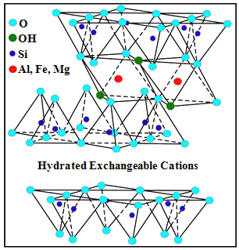
Figure 7: Structure of Montmorillonite clay [51]
Clay based nanomaterials can be characterized by different techniques such as X-ray diffraction (XRD), scanning electron microscopy (SEM), transmission electron microscopy (TEM), atomic force microscopy (AFM), UV-Vis spectroscopy, Fourier Transform Infrared (FT-IR) spectroscopy, NMR spectroscopy, Thermogravimetric analysis (TGA), Differential scanning calorimetry (DSC) etc [48].
Due to their interesting physicochemical properties such as high surface area, swelling, ion exchange and active broken-edge M-O⁻ bonds clay-based nanomaterials have many applications in the field of absorption, adsorption and catalysis etc [52]. The Bronsted and Lewis acid character and cation exchange capacity of clays leads them to use as catalyst for organic transformation reaction such as esterification of β-keto esters, Friedel-Crafts reactions, addition, oxidation, epoxidation, hydrogenation, allylation, alkylation, acylation, diazotization, rearrangement, isomerization, cyclization condensation, hydrogenation reaction[52]. Different types of clay-based nanomaterials such as TiO₂-pillared clay supported V₂O₅ catalyst can be used for the selective oxidation of H₂S containing water and ammonia [52]. Clay based catalyst are also useful for the conversion of biomass-based and biomass-derived feedstocks to some useful feedstocks [52]. Al/M pillared montmorillonite clays (where M= Fe, Cu, Mn) are employed for the degradation of organic pollutants [52].
In recent years anionic clay-based materials like Hydrotalcite type materials are more useful in many applications starting from adsorption to catalysis [53-55]. Layered double hydroxide (LDH) also known as anionic clays are 2D nanomaterial as shown in the following Figure 8 with structural formula of [M ²⁺_{1- x}M³⁺_{x}(OH)₂](A^{n−})_{x/n}.mH₂O (where, M²⁺ and M³⁺ are divalent and trivalent metals, respectively; A^{n−} is the interlayer anion).
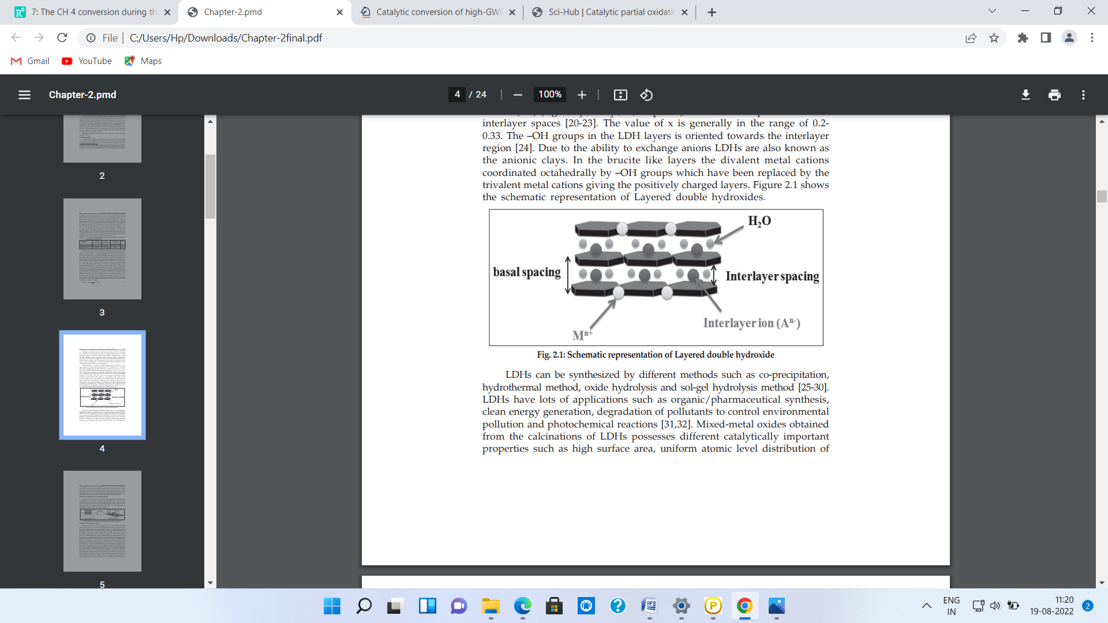
Figure 8: Schematic representation of Layered Double Hydroxide
They have attracted attention in the field of research due to their unique properties such as high surface area, uniform atomic level distribution, acid-base bifunctionality, high thermal stability, memory effect [53-55]. LDH based nanomaterials are used as photocatalyst or photoelectrocatalyst for the conversion of solar energy to clean chemical reagent [54].These are also used as environmental catalyst for the treatment of green house gases such as N₂O, CO₂, CH₄ oxidation to useful feedstocks [54]. Now-a-days oxygen evolution reaction becomes one of the great challenges for researcher for example, Ni-Fe LDH, Ni-Co LDH, Co-Fe LDH and Ni/Co/Fe LDHs are used as electrocatalyst for water splitting reaction to hydrogen and oxygen evolution [55].
The clay supported metal nanoparticles have found wide range of applications in various fields such as catalysis, biology, electrochemical sensor and electronics etc. Due to growing environmental concern, researchers have attracted for heterogeneous system of metals in catalysis. Clay supported silver nanoparticles have been used as active catalysts for various organic transformations like three component coupling reaction, rearrangement reaction, cycloaddition reaction, oxidation reaction etc [56-58]. Cu⁰ -nanoparticles supported on montmorillonite clay used for different catalytic reactions such as alcohol oxidation, C-N cross coupling, coupling of alkyl azide and terminal alkyne to form 1,2,3-triazole and other C-C bond formation reaction [59, 60]. Gold nanocrystals stabilized on modified montmorillonite have been used as highly efficient catalyst for the three-component coupling reaction aldehyde, amine and alkyne to synthesize propargylamine which is a biologically active molecule. Clay supported Pd-nanoparticles have been used active catalyst for Suzuki–Miyaura coupling reaction in aqueous medium with recyclability of the catalyst [50]. Fe₃O₄ magnetic nanoparticles supported on modified montmorillonite have been used as active catalyst for BV Oxidation, synthesis of dihydropyrimidones [59-61]. Schematic representations of some of the reactions [56-61] are listed below.
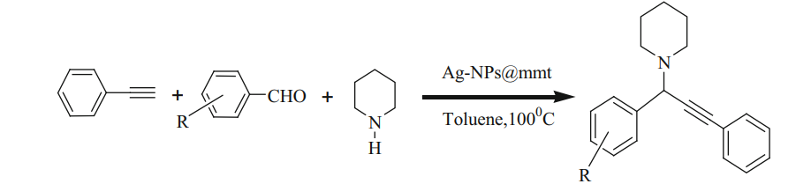
Scheme1: Synthesis of propargylamine using Silver nanoparticles supported on modified montmorillonite (Ag-NPs@mmt)

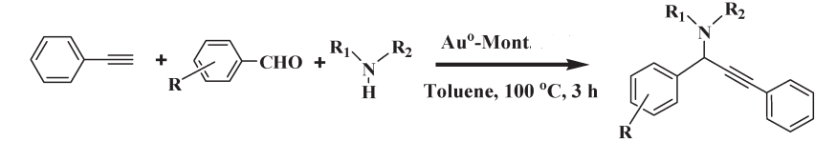
Scheme 2: Three-component coupling reaction of aldehyde, amine and alkyne catalysed by gold nanocrystals stabilized on montmorillonite.

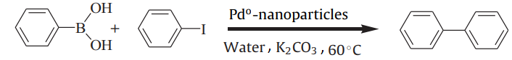
Scheme 3: Clay supported Pdº-nanoparticles catalyzed Suzuki–Miyaura reaction between iodobenzene and phenylboronic acid

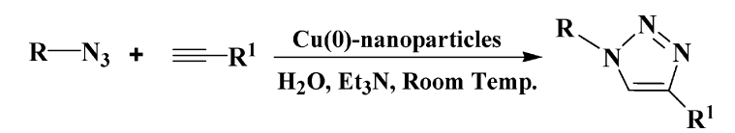
Scheme 4: 1,3-dipolar cycloaddition of azide and terminal alkynes catalysed by clay supported Cu(0)- nanoparticles.

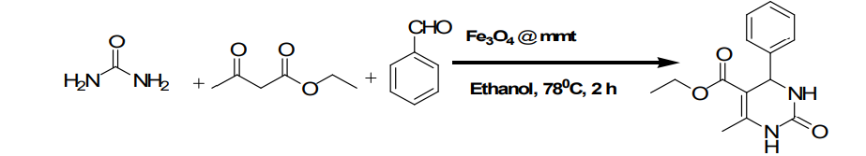
Scheme 5: Montmorillonite clay supported Fe₃O₄ nanoparticles (Fe₃O₄@mmt)catalysed three-component condensation reaction to synthesize DHPMs (Dihydropyrimidones)

Scheme 6: Baeyer-Villiger Oxidation catalysed by magnetic Fe₃O₄nanoparticles stabilized on montmorillonite using H₂O₂ as oxidant.

3. Conclusion:

The carbon based nanomaterials like graphene, carbon nanotube has undoubtedly make attention towards nanoscience research due to their unique properties and has diverse used in optics, electronics, and energy storage as well as in catalysis.
Supported metal nanoparticles and other non-metal based nanocomposites are also become one of the new and novel sustainable catalyst for future research work and these nano catalysts are far better compared to conventional catalyst. Supported nano catalyst exhibited large surface area and are used for different organic and inorganic transformations like oxidation, reduction, coupling reaction and synthesis biologically important compounds etc. Due to their high efficiency, such nano catalysts may be useful large-scale synthesis of fine and bulk chemicals.
In addition to this clay-based nanomaterials have also many applications in catalysis due to their unique physicochemical properties such as high surface area, swelling, ion exchange and active broken-edge M-O⁻ bonds. LDH based nanomaterials also act as an efficient environmental catalyst for the treatment of green house gas to useful feedstock and become another diverse field of research.

4. References:
[1] N. Sharma, H. Ojha, A. Bharadwaj, D.P. Pathak. Preparation and catalytic applications of nanomaterials: A review.RSC Adv., 2015, 5, 53381-53403.
[2] K. J. Klabunde, S. Winecki, Nanoscale Materials in Chemistry, Wiley, New York, 2001, 1-13.
[3] C. N. R. Rao, G. U. Kulkarni, P. John Thomas, P. P. Edwards .Metal nanoparticles and their assemblies. Chem. Soc. Rev., 2000, 29, 27.
[4] C. P. Poole Jr., F. J. Owens, Introduction to Nanotechnology, Willy-Interscience, 2003.
[5] J. M. Campelo, D. Luna, R. Luque, J.M Marinas, A.A Romero Sustainable Preparation of Supported Metal Nanoparticles and Their Applications in Catalysis. Chem.Sus. Chem., 2009, 2, 18-45.
[6] H. Brune, H. Ernst, A. Grunwald, W. Grünwald. Nanotechnology assessment and perspectives, Springer,2006.
[7]Y. Na, S. Park, S. B. Han, H. Han, S. Ko, S. Chang. Ruthenium-Catalyzed Heck-Type Olefination and Suzuki Coupling Reactions: Studies on the Nature of Catalytic Species. J. Am. Chem. Soc., 2004, 126, 250-258.
[8] P.P.Sarmah, D.K. Dutta. Chemoselective reduction of a nitro group through transfer hydrogenation catalysed by Ru⁰-nanoparticles stabilized on modified Montmorillonite clay. Green Chem., 2012, 14, 1086-1093.
[9] S.J. Borah, D.K. Das. Modified Montmorillonite Clay Stabilized Silver Nanoparticles: An Active Heterogeneous Catalytic System for the Synthesis of Propargylamines Catal. Lett., 2018, 148(12), 3669-3677.
[10] A. Alagarasi. INTRODUCTION TO NANOMATERIALS, 2016
[11] R.J.Varghese, E.M. Sakho, S. Parani, S. Thomas, O.S. Oluwafemiand, J. Wu. 2019. DOI: https://doi.org/10.1016/B978-0-12-813337-8.00003-5.
[12] M. Ghoranneviss, A.Soni, A. Talebitaher, N. Aslan. Journal of Nanomaterials. Volume 2015, http://dx.doi.org/10.1155/2015/892542.
[13]D.K. Dutta, J.B. Borah, P.P. Sarmah, Catal. Rev.2015, 57, 257–305.
[14]T. Yasukawa, A. Suzuki, H. Miyamura, K. Nishino, S. Kobayashi. J. Am. Chem. Soc. 2015,137, 6616–6623.
[15] S. Zhang, X.T. Shen, Z.P. Zheng, Y.Y. Ma, Y.Q. Qu. J. Mater.Chem. A 2015, 3, 10504–10511.
[16] S. Zhang, J. Li, W. Gao, Y.Q. Qu. Properties of oxides on the catalytic activity of Pd for C-C coupling reactions. Nanoscale 2015, 7, 3016–3021.
[17]W.J. Zhou, Z.H. Zhou, S.Q.Song, W.Z. Li, G.Q. Sun, P. Tsiakaras, Q. Xin. Pt based anodecatalysts for direct ethanol fuel cells. Appl. Catal. B Environ. 2003, 46, 273–285.
[18] A.V. Tripkovic, K.D. Popovic, B.N. Grgur, B. Blizanac, P.N. Ross, N.M. Markovic. Methanolelectrooxidation on supported Pt and PtRu catalysts in acid and alkaline solutions. Electrochim. Acta, 2002, 47, 3707–3714.
[19]J.H. Choi, K.J. Jeong, Y.J. Dong, J.H. Han, T.H. Lim, J.S. Lee, Y.E. Sung. Electro-oxidationof methanol and formic acid on PtRu and PtAu for direct liquid fuel cells. J. Power Sources 2006,163, 71–75.
[2]. Y. Shen, K.J. Xiao, J.Y. Xi, X.P. Qiu. Comparison study of few-layered graphene supportedplatinum and platinum alloys for methanol and ethanol electro-oxidation. J. Power Sources 2015,278, 235–244.
[21] M.L. Xiao, L.G. Feng, J.B.Zhu, C.P.Liu, W. Xing, Rapid synthesis of a Pt -Ru nano-spongewith different surface compositions and performance evaluation for methanol electrooxidation. Nanoscale 2015, 7, 9467–9471.
[22] J. Virkutyte, S Rajender ,RSC Adv., 2012,2, 1533-1539 .
[23]S. Noor, K. K.Sudipta, S. R. Anupam, M Paramita, R Susmita, Catal. Sci.Technol.,2013,3, 3303-3316.
[24] Y. Li, G. A. Somorjai. Nanoscale Advances in Catalysis and Energy Applications. Nano Lett. 2010, 10, 2289–2295. DOI: 10.1021/nl101807
[25]Y. Zhang, Q.Z.Yin . Carbon and other light element contents in the Earth’s core based on first-principles molecular dynamics. Proc. Natl. Acad. Sci. USA 2012, 109, 19579–19583.
[26] S. Nasir, M. Z. Hussein, Z. Zainal, N. A. Yusof. Carbon-Based Nanomaterials/Allotropes: A Glimpse of Their Synthesis, Properties and Some Applications. Materials 2018, 11, 295; doi:10.3390/ma11020295.
[27]M.M.Titirici, R.J.White, , N. Brun, V.L. Budarin, D.S. Su, F. Del Monte, J.H.Clark, M.J. MacLachlan.Sustainable carbon materials. Chem. Soc. Rev. 2015, 44, 250–290.
[28] Loos, M. Allotropes of Carbon and Carbon Nanotubes. In Carbon Nanotube Reinforced Composites; Elsevier:Amsterdam, The Netherlands, 2015; pp. 73–101.
[29] Deng, J.; You, Y.; Sahajwalla, V.; Joshi, R.K. Transforming waste into carbon-based nanomaterials. Carbon, 2016, 96, 105–115.
[30] Rodríguez-Reinoso, F. The role of carbon materials in heterogeneous catalysis. Carbon, 1998, 36, 159–175.
[31]Allen, M.J.; Tung, V.C.; Kaner, R.B. Honeycomb carbon: A review of graphene. Chem. Rev. 2010, 110, 132–145.
[32] Geim, A.K.; Novoselov, K.S. The rise of graphene. Nat. Mater. 2007, 6, 183-191.
[33] K.S. Novoselov, V.I. Fal, L. Colombo, P.R. Gellert, M.G. Schwab, K. Kim. A roadmap for graphene. Nature, 2012, 490, 192–200.
[34] K. D. Patel, R. K. Singh, Hae-Won Kim. Carbon-based nanomaterials as an emerging platform for theranostics. Mater. Horiz., 2019, DOI: 10.1039/c8mh00966j.
[35]A. Conly. Mining carbon to decrease the carbon footprint. Scientia, 2017, 112, 17-20.
[36]Bowers, B. History of Electric Light and Power; Peter Peregrinus Ltd.: London, UK, 1982; 55, 71-72.
[37] H.W. Kroto, J.R. Heath, S.C. O’Brien, R.F.Curl, R.E. Smalley. C60: Buckminsterfullerene. Nature, 1985, 318,162-163.
[38] Q. Liu, L. Wei, J. Wang, F. Peng, D. Luo, R. Cui, Y. Niu, X. Qin, Y. Liu, H. Sun, J. Yang and Y. Li, Nanoscale, 2012, 4, 7084-7089.
[39] Y. Huang, M. Liu, J. Chen, C. Gao and Q. Gong, Eur. Polym. J., 2012, 48, 1734-1744.
[40] K. Yang, D. Maiti, X. Tong, X. Z. Mou.Carbon Based Nanomaterials for Biomedical Applications: A Recent Study. Frontiers in Pharmacology, 2018.
[41] P. Hu, C. Huang, L. Zhang, Sci. China Ser. B, 51, 2008, 866–871.
[42] Introduction to nanomaterials: synthesis and applications R. Jose Varghese, El hadji Mamour Sakho, Sundararajan Parani, Sabu Thomas, Oluwatobi S. Oluwafemi and Jihuai Wu
[43] M.Hu, Z. Yao, X. Wang. Graphene-Based Nanomaterials for Catalysis. Ind. Eng. Chem. Res. 2017, 56, 3477-3502. DOI: 10.1021/acs.iecr.6b05048.
[44] M. S. Chavali, M.P. Nikolova. Metal oxide nanoparticles and their applications in nanotechnology. SN Applied Sciences ,2019, 1:607.
[45] F. D. Leila, D. Joshua , Swartz and David W. Wright. The Biomimetic Synthesis of Metal Oxide Nanomaterials. Nanomaterials for the Life Sciences Vol. 2: Nanostructured Oxides. Edited by Challa S. S. R. KumarCopyright © 2009 WILEY-VCH Verlag GmbH & Co. KGaA, Weinheim. ISBN: 978-3-527-32152-0
[46] C. Ray, T. Pal. Recent advances of metal-metal oxide nanocomposites and their tailored nanostructures in numerous catalytic applications.
[47] I. Ahmad, F. A. Fazal Rahim. Clay Based Nanocomposites and Their Environmental Applications.Nanomaterials and their Fascinating Attributes, 2018, Vol. 2, 166-190.
[48] F. Uddin. Clays, nanoclays, and montmorillonite minerals. Metall. Mater. Trans., A Phys. Metall.Mater. Sci., 2008, 39(12), 2004-2814
[49] C. H. Zhou. An overview on strategies towards clay-based designer catalysts for green and sustainable catalysis. Appl. Clay Science, 2011, 53 87–96.
[50] B.J. Borah, S.J. Borah, K. Saikia, D.K. Dutta. Efficient Suzuki–Miyaura coupling reaction in water: Stabilized Pd⁰-Montmorillonite clay composites catalyzed reaction. Applied Catalysis A: Gen, 2014, 469, 350.
[51] F. Wang, F. Pan, G. Li, P. Zhang, N. Wang. Construction of spherical montmorillonite supported Cu-based catalyst doping with a covalent organic framework for 4-nitrophenol removal. Applied Clay Science, 2021, 214, 106278.
[52]. L.A.Galeano, M. Angel Vicente, A.Gil. Catalytic Degradation of Organic Pollutants in Aqueous Streams by Mixed Al/M-Pillared Clays (M = Fe, Cu, Mn). Catalysis Reviews: Science and Engineering, 2014, 56:239-287.
[53]. C. Li, M. Wei, D. G. Evans, X. Duan. Layered Double Hydroxide-based Nanomaterials as Highly Efficient Catalysts and Adsorbents. Small, 2014. DOI: 10.1002/smll.201401464.
[54] P. Saikia, R.L. Goswamee. Catalytic partial oxidation of CH₄ to syn gas (H₂/CO) in presence of N₂O over periclase type SiO₂@Ni(Mg,Al)O catalyst synthesized by non aqueous route. Catal.Commun., 2019, 119:1-5.
[55] Zhengyang Cai, Xiuming Bu, Ping Wang, Johnny C. Ho, Junhe Yangand Xianying Wang. Recent advances in layered double hydroxide electrocatalysts for the oxygen evolution reaction. J. Mater. Chem. A, 2019, 7, 5069-5089.
[56] J. Safaei Ghomi, M. Ghasemzadeh. Silver iodide nanoparticle as an efficient and reusable catalyst for the one-pot synthesis of benzofurans under aqueous conditions. J. Chem. Sci.,2013 125, 1003.
[57] H. Cong, C.F. Becker. Silver nanoparticle-catalyzed Diels-Alder cycloadditions of 2'-hydroxychalcones. J. Am. Chem. Soc., 2010, 132, 7514.
[58] H. Ahmed, M.K. Hossain. Supported nanocatalysts: recent developments in microwave synthesis for application in heterogeneous catalysis. Material Advances, 2022, 3, 859.
[59] B. J.Borah, D.K.Dutta, P.P.Saikia, N.C.Barua, D.K.Dutta. Stabilization of Cu(0)-nanoparticles into the nanopores of modified montmorillonite: An implication on the catalytic approach for “Click” reaction between azides and terminal alkynes. Green Chem., 2011, 13,3453.
[60] P.K. Saikia, P.P. Sarmah, D.K. Dutta. Stabilized Fe₃O₄ magnetic nanoparticles into nanopores of modified montmorillonite clay: a highly efficient catalyst for the Baeyer–Villiger oxidation under solvent free conditions Green Chem.,2016 18, 2843.
[61] D.K. Dutta. Recent advances in metal nanoparticles supported on Montmorillonite as catalysts for organic synthesis J. Mat. Nanosci. 2019, 6(1), 19-31.

